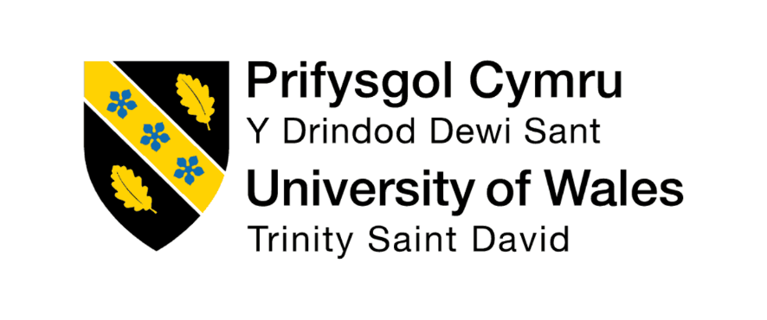

INTEGRATED HUMAN CAPITAL BLUEPRINT
Building a Culture of Innovation & Future Work Practices at Aether Innovations

Programme: Master of Business Administration (MBA)
Module: Human Capital Management
Module Code: LCMB7023

Assessment Type: Individual Report – HR Strategy

Submitted by:
Tirth Patel
2532962

Submitted to:
Gladius Kulothungan
Ejike Udeogu

Word Count: 2533 Words
Submission Date: 20 March 2026

Table of Contents
PART 1: HR STRATEGY – BUILDING A CULTURE OF INNOVATION AND FUTURE WORK PRACTICES 3
1.1 Strategic Context and Introduction 3
1.2 Analysis of Current Organisational Practices 3
1.2.1 Organisational Culture in Technology Firms 3
1.2.2 Existing Work Practices 4
1.3 Developing an Innovation-Driven Culture 4
1.3.1 Innovation Sprints and Agile Thinking 4
1.3.2 Promoting Intrapreneurship 4
1.3.3 Cross-Functional Collaboration 5
1.3.4 Role of Leadership in Innovation 5
1.4 Designing Future Work Practices 5
1.4.1 Hybrid Work Model 5
1.4.2 Digital Collaboration Environment 6
1.4.3 Employee Wellbeing and Flexibility 6
1.5 Impact on Employee Performance and Motivation 6
1.6 Conclusion 7
PART 2: REFLECTIVE ANALYSIS 8
2.1 Reflection Using Kolb’s Learning Cycle 8
2.1.1 Concrete Experience 8
2.1.2 Reflective Observation 9
2.1.3 Abstract Conceptualisation 9
2.1.4 Active Experimentation 9
2.2 AI and Future Professional Development 10
REFERENCES 11

PART 1: HR STRATEGY – BUILDING A CULTURE OF INNOVATION AND FUTURE WORK PRACTICES

1.1 Strategic Context and Introduction
Aether Innovations is a fast-growing technology company with around 300 employees and is now struggling with the main organisational issues, such as stagnant growth, high employee turnover, and declining customer satisfaction. These issues suggest a lack of alignment between organisational culture, work practice, and strategic objectives. The culture of innovation is a must in the extremely competitive and rapidly changing technology industry to maintain growth and a competitive edge. Such organisations that promote creativity, teamwork, and learning are in a better position to adjust to market changes and create value to the customer (Awad and Martín-Rojas, 2024).
The present report is dedicated to the creation of an innovation-based organisational culture and future work practices in the present modern context. In particular, this would bring in the initiatives of collaborative working conditions, flexible working models, and strategies of employee empowerment. Aligning culture and work practices to organisational goals will enable Aether Innovations to increase employee engagement, performance enhancement, and provide a long-term success base.

1.2 Analysis of Current Organisational Practices

1.2.1 Organisational Culture in Technology Firms
Organisational culture in the technology industry is often defined by the level of performance, innovativeness, and fast outcomes (Taghizadeh et al., 2020). Most companies experience a high intensity of competitiveness, and workers in these companies are pushed with high expectations to achieve strenuous goals and constantly come up with innovative ideas. The model of organisational culture proposed by Schein is that there are three levels of culture: artefacts, values, and underlying assumptions. Most tech firms have more invisible artefacts like high-paced work and performance metrics that are indicative of more underlying principles of efficiency, competitiveness, and success.
But these types of performance-based cultures usually lead to unintentional challenges. The workers are also likely to be under a lot of stress and burnout because of the continuous pressure to deliver (Jacobs, 2024). Too much emphasis on short-term performance may restrain innovation by restricting creativity and risk-taking. Consequently, the organisations might not be able to balance both the performance and the employee well-being through the culture.

1.2.2 Existing Work Practices
The structured office-based context and the long working hours continue to impact traditional work practices in most of the technology companies (Arshad et al., 2025). Even though the industry is changing, most organisations still prefer using set schedules and strict work arrangements. Such practices do not usually satisfy the needs of a contemporary workforce where flexibility and autonomy are highly appreciated.
This may adversely affect the work-life balance due to reduced job satisfaction and employee turnover because of the absence of flexible working options. In the long term, the long working hours and the lack of control over the working schedules can decrease productivity and motivation (Balderson et al., 2021). When it comes to Aether Innovations, these practices give way to dissatisfaction and a lack of engagement among employees. Thus, it is evident that more flexible and employee-centric work practices that facilitate performance and well-being are needed.

1.3 Developing an Innovation-Driven Culture

1.3.1 Innovation Sprints and Agile Thinking
The introduction of innovation sprints with the help of agile thinking is necessary to create a culture of innovation in Aether Innovations. Innovation sprints are brief, timed intervals during which the employees are concerned with idea generation, testing, and refinement (Rahbar, 2025). The resulting sprints promote quick experimentation where teams can come up with creative work solutions without the element of failure. Agile thinking supports this strategy by enhancing flexibility, adaptability and iterative improvement. Through the implementation of innovation sprints, staff members have a chance to leave their routine tasks and engage in creative problem-solving.

1.3.2 Promoting Intrapreneurship
The other important strategy of establishing an innovation-driven culture is intrapreneurship. It entails motivating the staff to behave as entrepreneurs in the organisation by creating and introducing new ideas, products or processes (Huang et al., 2021). This will empower the employees as it will enable them to have ownership of their ideas and to experiment and innovate. In Aether Innovations, the intrapreneurship can be promoted to a great extent to improve employee engagement and organisational creativity. When employees feel that they are trusted and regarded as important, they will be more willing to give new ideas and be initiative takers. Intrapreneurship also facilitates continuous improvement and makes organisations stay competitive in fast-changing markets.

1.3.3 Cross-Functional Collaboration
The cross-functional collaboration is critical in improving innovation in organisations (Ahmad, Boit, and Aakula, 2023). It entails the integration of the employees across the various departments, including marketing, technology, finance and HR, to collaborate towards a common activity and purpose. Such variety in the point of view brings about greater creativity and efficiency in problem-solving.
Cross-functional teams will enable organisations to overcome organisational silos and enhance interdepartmental communication at Aether Innovations. Employees working in functions can exchange knowledge, skills, and insight when they work together, and more innovative solutions are achieved. It is also a way of promoting a team work and shared responsibility that promotes organisational culture.

1.3.4 Role of Leadership in Innovation
Leadership is vital in the process of creating and maintaining an innovation-based culture (Davis, 2024). Transformational leadership, specifically, is very efficient in the sphere of innovation promotion as it puts emphasis on inspiring and motivating workers to reach a new level of performance. Leaders using this style would promote creativity, promote new ideas and foster a culture where employees feel comfortable to take risks. The leaders need to encourage the culture of openness and experimentation at Aether Innovations. This involves rewarding innovative efforts, constructive feedback and promotion of ongoing learning.

1.4 Designing Future Work Practices

1.4.1 Hybrid Work Model
A hybrid work model is one of the strategies that modern organisations such as Aether Innovations should adopt. This is an integration of both the remote and office-based work, where the employee has the option of the location of work depending on the work and personal preferences. Flexibility is another thing that is being appreciated by workers in the technology sector, and hybrid working provides this (Nauman, 2025). It helps people to be more time-saving, which results in better work-life balance and job satisfaction. In the organisational view, hybrid work will be productive, since employees in an environment where they feel relaxed and not bound tend to perform better. It also enables organisations to tap more talent pool since geographical barrier is minimised.

1.4.2 Digital Collaboration Environment
The environment of a powerful digital collaboration is needed to promote the hybrid and remote work practices (Yasmin and Tanaka, 2022). The organisations should invest in the new high-level digital tools, including Microsoft Teams, Slack, and project management systems, to facilitate seamless communications and coordination. These applications enable real-time working, virtual meeting and effective sharing of information between the employees. In the case of Aether Innovations, the introduction of digital collaboration systems may enhance the teamwork process, decrease the communication gaps, and increase the overall performance. They enable employees to access work-related information wherever and whenever they want, and this makes the cloud-based platforms support flexibility and continuity.

1.4.3 Employee Wellbeing and Flexibility
Well-being of the employees is one of the crucial elements of future work practices. Companies should put physical and mental health as a priority, offer it through the support system, including counselling services, wellness initiatives, and flexible working schedules (Raghuwanshi, 2025). Well-being is beneficial as it will decrease stress levels and burnout, as well as enhance job satisfaction. In Aether Innovations, a healthy work-life balance can address the issue of employee engagement and retention greatly. Flexible working enables employees to balance between personal and professional lives more efficiently, which will result in increased motivation and productivity.

1.5 Impact on Employee Performance and Motivation
The effect of the innovation-driven culture development at Aether Innovations is a positive and direct influence on employee performance and motivation. Employees become more involved and dedicated to their jobs when organisations foster creativity, cooperation and lifelong learning. The innovation-oriented practices, including intrapreneurship, cross-functional teamwork, and flexible work conditions, allow employees the chance to bring in ideas and own their work, which leads to improvement in personal and organisational performance (Pelica et al., 2024).
Self-Determination Theory can be used to explain this relationship as it highlights the role of autonomy, competence and relatedness in motivation. Organisations enhance intrinsic motivation by ensuring freedom in the workplace by implementing a flexible work culture and granting employees decision-making authority (Joy, 2025). In the case of the chance to acquire new skills and engage in new projects, this increases the feeling of competence among the employees. Teamwork also helps to build relationships, which results in a conducive working environment.
This means that employees will become more proactive, creative and dedicated to the achievement of organisational goals. This will result in increased productivity, job satisfaction and turnover. Thus, the culture of innovation is critical in maintaining organisational performance in the long term.

1.6 Conclusion
To solve the problems encountered in Aether Innovations, it is important to develop a culture centred on innovation and implement future methods of work. Innovation sprints, intrapreneurship, and cross-functional collaboration are some of the strategies that promote creativity, engagement, and continuous improvement. Flexibility and satisfaction of staff are improved by implementing hybrid work patterns, virtual collaboration technologies and wellbeing programs.
A combination of these strategies can ensure the organisational culture aligns with the current workforce demands, resulting in a positive employee output, staff retention, and organisational performance. Finally, innovation and flexible working are a long-term road to growth and competitive power in the technology industry.

PART 2: REFLECTIVE ANALYSIS

2.1 Reflection Using Kolb’s Learning Cycle
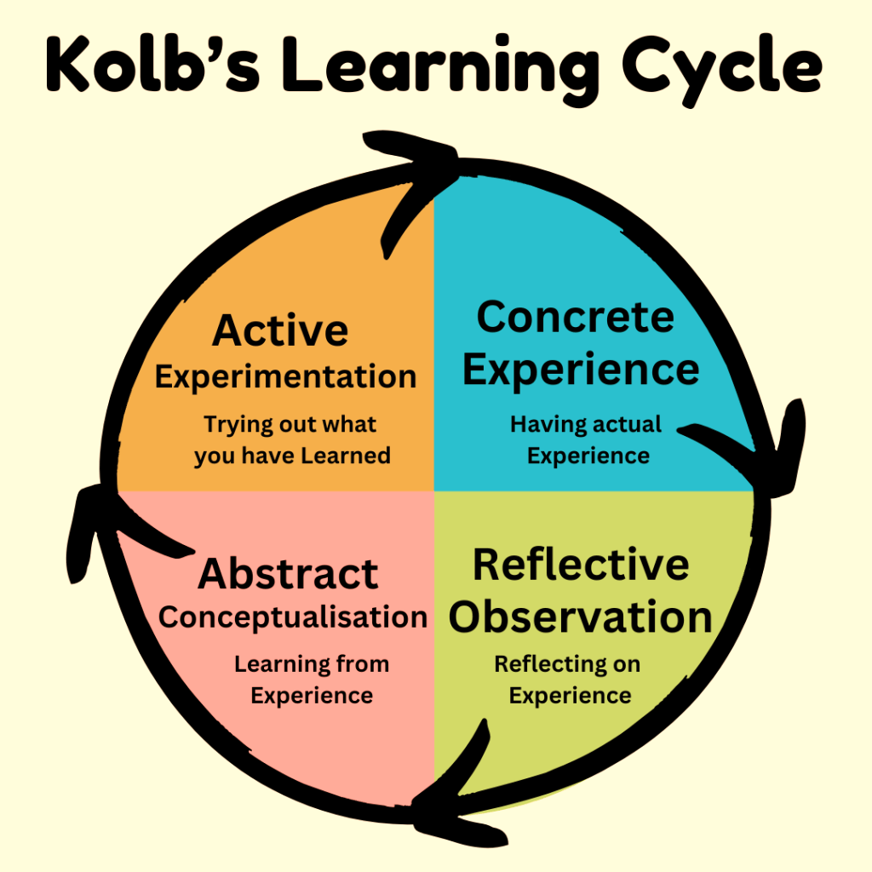

2.1.1 Concrete Experience
This module has taught me the in-depth knowledge of Human Capital Management and its strategic significance in contemporary organisations (Wijenen-Meijer et al., 2022). I researched organisational culture, innovation, employee engagement and performance management. Among the most useful things I learned was the impact that HR practices can have a direct contribution to the success of the organisation, especially in such a dynamic industry as technology. I also got to know about the current practices like innovation-oriented cultures, intrapreneurship, and flexible work designs and models, which are more applicable in the current business world.
My involvement in the Aether Innovations case was useful because it allowed me to put theoretical knowledge to practical use. It enabled me to evaluate organisational issues like high turnover and low engagement of employees and suggest appropriate HR solutions. This experience enabled me to realise how all the HR practices are interrelated and how they aid the overall organisational performance.

2.1.2 Reflective Observation
On reflection of my learning experience, I realised that HR goes much deeper into strategy than I knew. My initial view of the field of HR at the start of the module was that it was primarily an administrative task concerned with recruiting and managing employees. Nevertheless, with the help of this module, I realised that innovation, performance, and organisational culture are essential factors driven by HR (Botelho, 2020).
I also learned that a good and supportive working environment should be created. The work practices that were common in traditional organisations, like job roles and working hours, are becoming ineffective in modern organisations. Flexibility, autonomy and growth opportunities are now appreciated by employees. I have noted that organisations that embrace innovation and teamwork have greater results in regard to employee retention and performance.

2.1.3 Abstract Conceptualisation
By taking this module, I gained a better idea about how theoretical models can be used to address real-life organisational problems. To illustrate, I came to know how such things as organisational culture and innovation can be described based on the existing theories. The organisational culture model proposed by Schein helped me gain insight into how values, behaviours and assumptions underlie the work environment. In the same manner, the idea of intrapreneurship showed how empowerment of employees can lead to innovation in organisations (Moghaddas et al., 2020).
I also realised that Self-Determination Theory has relevance in explaining the motivation of employees. This theory emphasises the importance of autonomy, competence and relatedness in improving employee involvement. The connection of these theoretical ideas with practical outcomes, including the models of hybrid work and cross-functional collaboration, allowed me to comprehend how organisations can enhance the level of satisfaction of employees and their performance. The entire learning process at this phase allowed me to fill the gap between theory and practice, and critically analyse HR strategies and their effect on organisational performance.

2.1.4 Active Experimentation
I will use the acquired knowledge and skills during this module in my future professional practice. I would like to use a strategic approach to HR as I would emphasise the engagement of employees, their innovativeness, and constant improvement (Azevedo et al., 2021). As an example, I will promote teamwork, working conditions and facilitate flexible working arrangements to promote satisfaction and high production among employees.
I will also make sure to build my leadership skills in order to facilitate the culture of innovation in organisations. I can make my contribution in developing a more dynamic and high-performing workplace by promoting the implementation of ideas and initiatives among employees. I will also keep enhancing my HR practices knowledge through academic research and industry developments. I will seek to employ technology and balance data-driven methods to aid the decision-making process and remain human-centred. This will ensure that I am not obsolete in a fast-growing business world and can play my part in ensuring the success of organisations.

2.2 AI and Future Professional Development
The increased application of Artificial Intelligence (AI) is revolutionising the manner in which organisations are run, especially in Human Resource Management and decision-making processes. Recruitment screening, tracking employee performance, and data analysis are some of the tasks done using AI technologies (Shenbhagavadivu et al., 2024). Such tools enhance effectiveness, minimise human error and help organisations to make quicker and more knowledgeable decisions. Concerning the environment of the contemporary business, AI is greatly influential in business productivity and in strategic planning.
Even with these benefits, AI is not able to eliminate human abilities. Emotional intelligence, creative thinking, and critical thinking are just some of the skills that will always be needed when handling people and promoting innovation. In my opinion, AI is to be seen as a facilitating tool, not a human substitute. I would like to apply AI in order to make my work better, such as through data analysis or efficiency, but with judgment and problem-solving, I still tend to use my own judgment.
I understand that to be competitive in the AI-driven world, I have to constantly improve my most valuable professional competencies. Critical thinking will facilitate the analysis of complex situations, whereas innovation and problem-solving will be aided by creativity. The emotional intelligence will assist me in dealing with relationships and being an effective leader (Dasgupta, 2023). Flexibility and lifelong learning will be essential in the process of keeping pace with technology. With human skills and the abilities of AI, I will be able to guarantee career development in the long-term and help to make the organisation successful.

REFERENCES
Ahmad, T., Boit, J. and Aakula, A., 2023. The role of cross-functional collaboration in digital transformation. Journal of Computational Intelligence and Robotics, 3(1), pp.205-42.
Arshad, I.A., Ali, A. and Audi, M., 2025. Evaluating Remote and Office-Based Work: A Multidimensional Analysis of Employee Outcomes in the Evolving Workplace. Bulletin of Management Review, 2(2), pp.187-216.
Awad, J.A. and Martín-Rojas, R., 2024. Digital transformation influence on organisational resilience through organisational learning and innovation. Journal of Innovation and Entrepreneurship, 13(1), p.69.
Azevedo, M.C.D., Schlosser, F. and McPhee, D., 2021. Building organizational innovation through HRM, employee voice and engagement. Personnel Review, 50(2), pp.751-769.
Balderson, U., Burchell, B., Kamerāde, D., Wang, S. and Coutts, A., 2021. An exploration of the multiple motivations for spending less time at work. Time & Society, 30(1), pp.55-77.
Botelho, C., 2020. The influence of organizational culture and HRM on building innovative capability. International journal of productivity and performance management, 69(7), pp.1373-1393.
Dasgupta, M., 2023. Driving creativity and innovation through emotional intelligence (EI): A systematic literature review. Journal of Innovation Management, 11(3), pp.1-29.
Davis, J., 2024. Role of strategic leadership in fostering a culture of innovation within organizations. International Journal of Strategic Management, 3(5), pp.1-13.
Huang, L.Y., Yang Lin, S.M. and Hsieh, Y.J., 2021. Cultivation of intrapreneurship: A framework and challenges. Frontiers in Psychology, 12, p.731990.
Jacobs, C., 2024. Occupational stress and burnout. In Burnout Syndrome-Characteristics and Interventions. IntechOpen.
Joy, R., 2025, March. The role of autonomy in ISP compliance decisions in flexible work environments. In 2025 59th Annual Conference on Information Sciences and Systems (CISS) (pp. 1-6). IEEE.
Moghaddas, S.Z., Tajafari, M. and Nowkarizi, M., 2020. Organizational empowerment: A vital step toward intrapreneurship. Journal of Librarianship and Information Science, 52(2), pp.529-540.
Nauman, M., 2025. Enhancing Hybrid Work Flexibility through Employee Performance: A moderated mediation model. International Journal of Social and Business Studies, 3(2), pp.43-64.
Pelica, R.O., da Palma, P.J. and Velez, M.J., 2024. A Review on Intrapreneurship: Individual Level With an HRD Focus. Human Resource Development Review, p.15344843251413896.
Raghuwanshi, B., 2025. Study how HRM practices contribute to employee well-being, including mental health initiatives, work-life balance, and stress management programs (Doctoral dissertation, Dublin, National College of Ireland).
Rahbar, A., 2025. Innovative Management. ScienceOpen Preprints.
Shenbhagavadivu, T., Poduval, K. and Vinitha, V., 2024. Artificial intelligence in human resource: the key to successful recruiting and performance management. Shodhkosh Journal of Visual and Performing Arts, 5(6).
Taghizadeh, S.K., Rahman, S.A., Hossain, M.M. and Haque, M.M., 2020. Characteristics of organizational culture in stimulating service innovation and performance. Marketing Intelligence & Planning, 38(2), pp.224-238.
Wijnen-Meijer, M., Brandhuber, T., Schneider, A. and Berberat, P.O., 2022. Implementing Kolb s experiential learning cycle by linking real experience, case-based discussion and simulation. Journal of medical education and curricular development, 9, p.23821205221091511.
Yasmin, L. and Tanaka, H., 2022. The future of work: Remote collaboration and digital transformation. Journal of Emerging Technology and Digital Transformation, 1(2), pp.136-145.

