Managing Enterprise in the 21st Century
Business Plan

By
George-lucian Sibov-medinschi
UWTSD ID: 1906678

Table of Contents
Introduction 3
Task 1 Business Plan 4
Executive Summary 4
Company Description 5
Products and Services 6
Market Analysis 6
Strategies and Implementation 8
Operational plans 10
Skills and Experience 14
Back-up plan 15
Conclusion 16
Reference 17

Introduction
The 21st century is familiar with the globalization and the existence of giant business enterprises which have expanded their business in countries after countries and continents after continents. Due to the large volume of business organizations and their wide operational scales, different business industries and fields have become much competitive (Alonzo, 2007). And the availability of modern systems and digital technologies have made the existing business organization able to operate their business with successful contexts. In this competitive environment the establishment of new business is much complex and challenging for which, the entrepreneurs have to determine all the necessary and potential business aspects to ensure the successful development new business entity. And the making of effective business plan is needed for implementing the plan and ensure effective business operation starting. For proper business plan essential and potential facts and issues are needed to be considered as represented in following business plan.

Task 1 Business Plan

Executive Summary
The business plan is covered with distinctive concerns and facts which are needed for establishing a restaurant business organization and starting the operations for gaining business goals and objectives (Young, 2007). The primary intentions of making this business plan are in following.

Mission statement
The mission statement is this business plan is opening a restaurant business with an aim of providing ethnic dishes and food item of Asian countries to the customers. The mission of the business is gaining business excellency through performing extraordinary restaurant business (Stutely, 2012). The restaurant will provide better customer service than the nearby competitors and provide the best operational efficiency to the employees through making them trained and motivated. The ‘Foodie’s Food’ will try to gather customer loyalty and strong market position through offering finest quality of food and greater ambience and customer experience for making the restaurant the primary choice of the customer for selecting eating place.

Business objectives
To achieve the business goal of becoming foodie’s first choice, the business has identified several potential business objectives which will help the business to create integrated business approach (Rule, 2004). These objectives are-
- Having lower profit margin of 15% only for penetrating the market in preliminary stage.
- Increasing profit margin after assessing 6 months periodical results.
- Creating and small restaurant for cost and resource saving.
- Making sales of more than $1000000 annually.
- Making integrated marketing through using digital and printed media.
- Making of investment return within 4 - 6 years.
- Making employee training programs to make them skilled and for better business operational outcomes (Rainsford and Bangs, 2001).
- Focusing on the search engine optimization for customer convenience.
- Implementing customer recommendations and opinions for better customer service.

Key to success
To establish a successful business organization and achieve the business goals, the business will be focused on several succession factors as showing below.
- Innovative and attractive interiors based on intellectual and abstract arts to attract the customers.
- Greater quality and unique food items.
- Developing and convenient menu for the customers (Oleksak and Oleksak, 2010).
- Focusing on the customer experience and recommendation.
- Focusing on employee retention issues.
- Optimized use of the resources for cost and expense saving.

Company Description
Start-up business
The start of the business if planned as opening a new restaurant business under the name of ‘Foodie’s Food’. The restaurant will be an ethnic restaurant to provide the traditional taste of the Indian food items (Hardill and Baines, 2011). There will be a trademarked business logo for the business which is the representation of foodaholic friendship.

Figure: business logo sample
Location
The business will be established in adjacent place of university in Cardiff to provide ethic food taste and experience to the university students. The location is selected based on the business potentiality of the products will be offered (Fullen, 2014).

Ownership and management
The business will be a partnership business of two friends whom had been together in school. While studying the school they had planned opening the restaurant after certain time periods in meantime of which they will working on gaining professional aspects for performing effective business operations (Ford, Bornstein, Pruitt and Young, 2010).

Products and Services
Product description
The offered products of the restaurant will be the ethnic food items Indian subcontinent which are much renowned for their greater unique and spicy tastes (Effron, Gandossy and Goldsmith, 2015). The mostly famous food items along with different local items along with salads, appetizers and desserts will be provided, and they will be categorised under the breakfast, launch, snacks and dinner menu. Along with the food items different ethnic drinks items will be available also.

Service description
There will defend service category for the customers as there will be offering of giving recommendation and opinions for their desired food items (Alonzo, 2007). There will be delivery system available through using third party like delivery channels.

Market Analysis
Market segmentation and positioning
Market segmentation and positioning is significant approach of business functions to find out the most suitable target customers for the business (Young, 2007). For the Foodie’s Food restaurant, the ideal market segment is the young peoples whom go around with friends and take foods. Moreover, the food lovers from all age range will be targeted through best food taste and quality.
Target market
The target customer of Foodie’s Food business is the university students and young aged peoples.

The young aged food lovers and friend circles is targeted in first place (Stutely, 2012). Moreover, there have different travelling people’s diverse areas who are targeted to provide unique food experience for strong brand value.

Competitors
There have several restaurants are providing ethnic food items of Indian subcontinents which strong competitive threats to the business (Rule, 2004). As the Indian food culture and diversification is widely renowned so people are getting attracted to the Indian food items gradually. Some of the key competitors of Foodie’s Food are Salkaara, Maya, Mowgli’s, Gateway of India, Jasan and other restaurants around Cardiff providing Indian dishes and foods.

SWOT analysis
The SWOT analysis is a potential business tools to identify the Strength, Weakness Opportunities and Threats for opening a new restaurant business (Rainsford and Bangs, 2001). Here the SWOT of Foodie’s Food restaurant provided below.
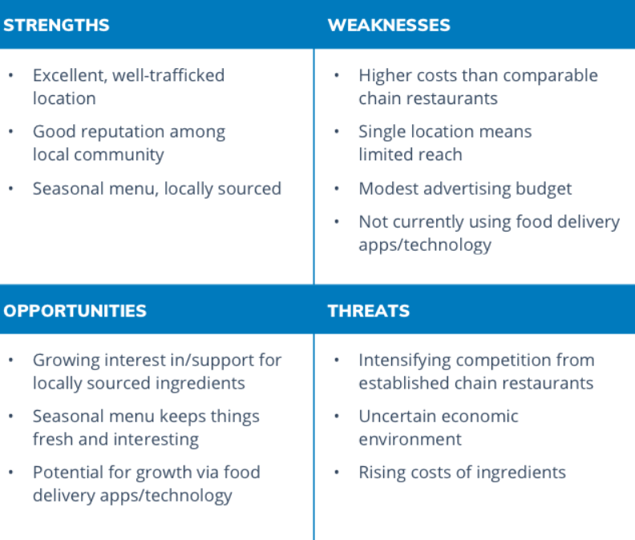
Figure: SWOT analysis of Foodie’s Food

Strategies and Implementation
Competitive advantage
The strategic decision of opening the business near the university area will bring competitive advantage of gaining university students and young friend circles whom are the key target market of the business (Oleksak and Oleksak, 2010). Moreover, the integrated marketing through using the university student’s review and recommendation will create people’s attraction toward the business, and business will be able to grow fast.

Marketing and promotions
There will be strategic implementation of integrated marketing approach trough combining the significant market concerns like advertisement in potential platforms, making communication and public relations with the customer, making special offers to premium customers whom will be elected based on purchasing frequency (Hardill and Baines, 2011). Moreover, there will be implementation of customer service aspects for improving the service levels from the recommendation of the customers.

Sales strategies
The forecasting of the sales volume will help to collect the necessary resources and inventories for making sales with forecasted time periods and the forecasting efficiency will be achieved through motoring daily sales volume.
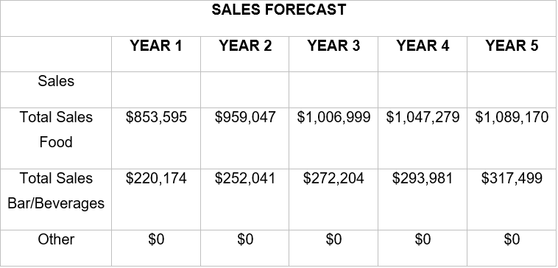
Figure: sales forecast of Foodie’s Food
For making the desired sales there will be package and seasonal offers to entice the customers for choosing the expected menu items (Fullen, 2014). Moreover, in different traditional and occasional events there will be special sales discounts upon specific amount of purchase.

Milestone
To successfully start the new restaurant, Foodie’s Food restaurant has some key milestones which are needed to accomplished to ensure the starting and effective execution of the starting operations (Ford, Bornstein, Pruitt and Young, 2010). These milestones are-
- Site selection
- Buying equipment and items for kitchen and interior design
- Making website
- Menu creation
- Construction of business workplace
- Buying furniture
- Employment and scheduling the employees
- Restaurant designing
- Inventory buying

Operational plans
Financial considerations
The financial assets needed to be considered to determine the business requirements and distribution of the financial resources effectively (Effron, Gandossy and Goldsmith, 2015). The start-up requirements and funding of the business provided below-
Start-up expenses | $436,198
Assets | $270,058
Total Requirements | $706,256
Long term liabilities | $350,000
Planned investment | $380,000
Total Funding | $730,000
Table: start-up requirements and funding of the business

Financial statements
The finical statements are produced to make financial projections to make the bossiness operations (Alonzo, 2007).
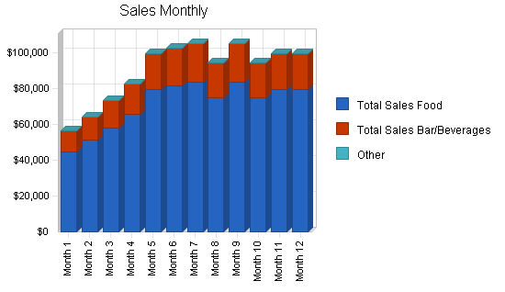
Figure: monthly sales projection
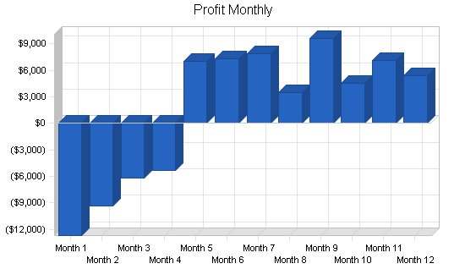
Figure: monthly profit projection
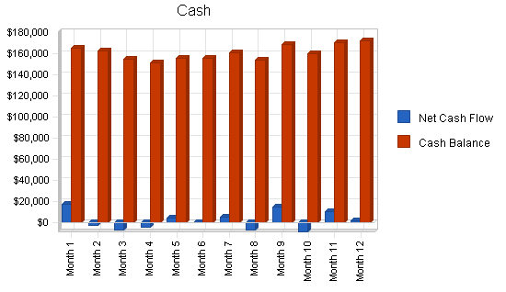
Figure: monthly cash flow projection

Figure: Break-even analysis
The projected monthly sales, profit margin, breakeven point and cash flow will allow the business to monitor and review the operations to ensure the desired operational outcomes (Young, 2007).
Pricing and profits
The product price range will be $3 to $13 as this restaurant will be a medium ranged restaurant at primary stage, and profit margin will be kept lower to penetrate the market (Stutely, 2012).
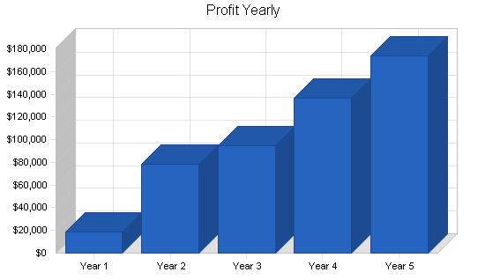
Figure: yearly profit projection
Inventory operations
The response of the customer will help to determine which inventories are needed much and which are needed less and thus, the inventory management will be performed through making schedules to ensure the availability of the necessary inventories effectively (Rule, 2004).

Suppliers
The suppliers will be selected on contractual basis as the collection raw materials for ethnic dishes and food items is complex, so making contract with suppliers will decrease pressure on managerial pressure (Rainsford and Bangs, 2001).

Employees
Employees or human resource is one of the core elements of the business organization. For performing the business operations, primarily 8 - 10 employees will be employed and it will be assessed that which figure of employees would be appropriate for the business. To appoint the most eligible and potential employees, there will several testing and review programs to be acknowledged their experience and professional competency level (Oleksak and Oleksak, 2010).

Skills and Experience
Project experience
The entrepreneurs have worked on different research and analytical projects to gain personal and professional proficiency (Hardill and Baines, 2011). Through working on different business projects, they have learned how to undertake a new project and work on finding the potential project outcomes.

Academic experience
Both of the entrepreneurs or business partners had gained graduation and well academic experience (Fullen, 2014). From the academic activities and performances, they have gathered integrated knowledge including theoretical aspects and approaches to start and operate a business operation usefully.

Job experience
Both of the entrepreneurs have part time and fulltime job experiences of working in several restaurants. As this two friends had planned opening a restaurant business in years of time ago, since then they had continued to working in separate functional areas of restaurant like the customer service, accounting assistant, kitchen staff, waiter to gather integrated knowledge and experience so that they would be able to start and operate and successful restaurant business (Ford, Bornstein, Pruitt and Young, 2010) .
Skills
Skills and competencies are needed to perform the business operations and successfully achieve the goals. Moreover, the effective skills and professional proficiency enable individuals to carry out efficient and optimized resource outcomes. In case of Foodie’s Food business, the business owners have distinctive experience and skills for making better strategic decision and business such through using the research and analysis skills they would be able to understand the situations and environment to make most suitable decisions (Effron, Gandossy and Goldsmith, 2015). The employees and workers would be guided and trained with modern business philosophies and customer service experiences to provide the best dining experience and making the local customers loyal to the business.

Back-up plan
Due to the dynamic business environment and customer’s changing behavioural patterns, there might be appearance of challenging business position to perform the operations successfully and achieve the goals (Alonzo, 2007). For which, the Foodie’s Food restaurant also has a back plan to change the operational procedures and business perspectives. There would be a focus on providing distinctive drinks and beverage offering or products if the main plan doesn’t go well. And also, there will be offering of a combined food items based on different traditional foods from diverse geographical areas to ensure the carrying on of the business.

Conclusion
The above business plan of Foodie’s Food restaurant has been covered with the necessary and important business aspects which needed for establishing and starting new business organization effectively. The different planning consideration and aspects indicate the potential future and business success if the operational plans are implanted and would be executed within the desired outcomes. The market favourability and business target show the future of attending the customers needs within their desired expenses and customer service experience which carry the business ability to grab the opportunities and achievement of the business goals and objectives.

Reference
- Alonzo, R., 2007. The Upstart Guide To Owning And Managing A Restaurant. New York: Kaplan Pub.
- Effron, M., Gandossy, R. and Goldsmith, M., 2015. Human Resources In The 21St Century. London: John Wiley & Sons.
- Ford, B., Bornstein, J., Pruitt, P. and Young, E., 2010. The Ernst & Young Business Plan Guide. Chichester: John Wiley & Sons.
- Fullen, S., 2014. Opening A Restaurant Or Other Food Business Starter Kit. Atlantic Publishing Group Inc.
- Hardill, I. and Baines, S., 2011. Enterprising Care?. Bristol: Policy Press.
- Oleksak, M. and Oleksak, M., 2010. Intangible Capital. Santa Barbara, Calif: Praeger.
- Rainsford, P. and Bangs, D., 2001. The Restaurant Start-Up Guide. Chicago: Dearborn.
- Rule, R., 2004. Rule's Book Of Business Plans II. Irvine, CA: Entrepreneur Media.
- Stutely, R., 2012. The Definitive Business Plan. Harlow: Financial Times Prentice Hall.
- Young, P., 2007. Business Plan. Chandni Chowk, Delhi: Global Media.

