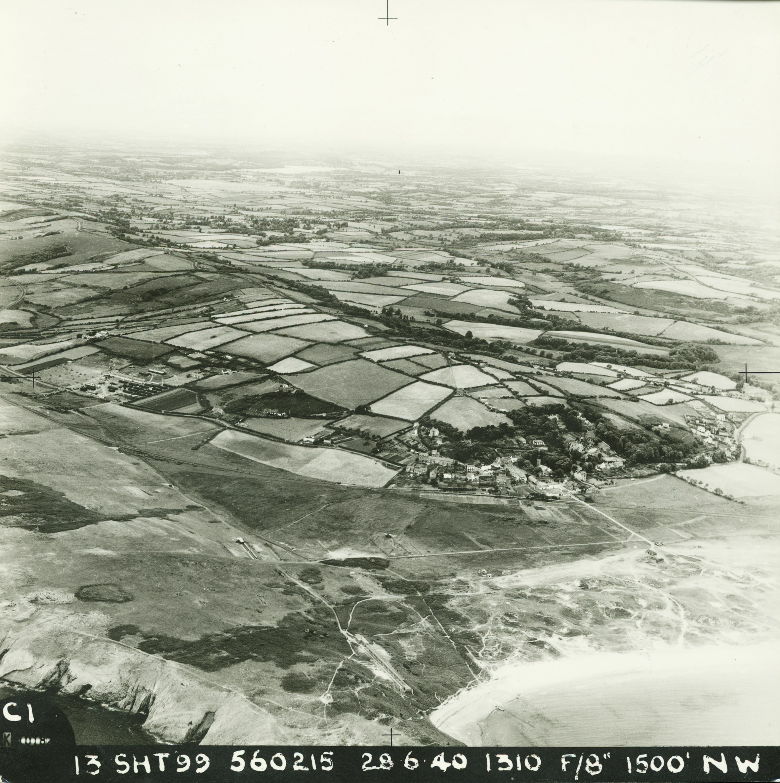

A dissertation by Kimberley Robinson,
Student number: 1707907.

An Investigation into the Development and Value of Penally’s Heritage.





Contents
List of images. iii
Abstract. v
Introduction. 1
Location Map. 3
Chapter One. 4
Penally’s Military History. 8
The History of Penally Camp. 10
Penally World War One Practice Trenches. 14
Penally Practice Trench Plans. 16
Chapter Two, Excavation. 17
. 17
Map of excavation trenches. 20
Protected area perimeter around Practice Trenches in Penally. 21
21
Practice Trench Plans and Features. 22
Drawings of Excavation Trenches. 23
Trench One. 24
Trench One Discussion and Finds. 25
Trench Two. 27
Trench Two. 28
28
Trench Two Discussion and Finds. 28
Trench Four. 29
Trench Four Discussion and Finds. 30
30
Ordinance Survey Map published in 1889, showing Trench Three. 31
Trench Three. 32
Trench Three Discussion and Finds. 32
Yeomanry Field. 33
33
Discussion 33
Chapter Three. 34
Community Walks. 34
Community School Visit. 36
Penally’s Heritage on Display. 38
The Volunteers. 39
Case study, female. 40
Case study, male. 40
Discussion. 42
Conclusion. 44
References. 45
Books. 45
Internet Sources. 46
Email. 46
Personal Communication, Non structured interviews 46
Images 46
Transparent plates. 49

List of images.

Fig 1. Maps, Wales. (Source: https://en.wikipedia.org). Pembrokeshire (Source: https://www.pinterest.co.uk) and Co-ordinates for Penally Practice trenches (Source: https://coflein.gov.uk).
Fig 2. Digging Trenches in Yeomanry Field. (Source: Gomer Press). Penally. (Source: https://coflein.gov.uk).
Fig 3. Bell tents at Penally Military Camp Photograph. (Source: Roger Thomas).
Fig 4. Penally Musketry Camp (Source: National Archives Wales).
Fig 5. Penally Camp Accommodation. (Source: Roger Thomas).
Fig 6. Map of the scheduled area (Source: Wessex Archaeology).
Fig 7. Maps of Penally Practice Trenches (Source Wessex Archaeology).
Fig 8. The three areas of investigation covered in the community excavation (Source: Dyfed Archaeological Trust).
Fig 9. Photograph of British troops loading a Vickers 2 inch Medium Trench Mortar Bomb (Source: British Government 1918).
Fig 10. Location of Trenches (Source: Dyfed Archaeological Trust).
Fig 11. Perimeter of protected area (Source: Dyfed Archaeological Trust).
Fig 12. Drone photograph of trenches 1,2,4, (Source: Dyfed Archaeological Trust).
Fig 13. Arrangement of the defensive line. (Source; War Office).
Fig 14. Diagram of fire supervision and communication trenches (Source: War Office).
Fig 15. Drawing of Trenches 1, 2, 4, (Source: Charlie, Dyfed Archaeological Trust).
Fig 16. Drawing of Trench 1, (Source: Charlie, Dyfed Archaeological Trust).
Fig 17. Trench 1 (Source: Author) and picture of finds (Source: Alice Pyper, Dyfed Archaeological Trust).
Fig 18. Drawing of Trench 2 (Source: Charlie, Dyfed Archaeological Trust).
Fig 19. Black and White photograph, Life in the Trenches (Source: www.Liverpoolecho.co.uk), Coloured Plates (Source: Dyfed Archaeological Trust).
Fig 20. Drawing of Trench 4 (Source: Charlie, Dyfed Archaeological Trust).
Fig 21. Black and White, British Vickers machine gun. Photographed circa 1914-1918 (Source: https://commons.wikimedia.org), All other coloured plates of trench 4 (Source: Authors).
Fig 22. Magnified Ordinance Survey Map published in 1889, showing Trench 3. (Source: National Archives Wales).
Fig 23. Ordinance Survey Map published in 1889, showing trench 3. (Source: National Archives Wales).
Fig 24. Top Left Zulu Wars 1897 (Source: www.artgallery.nsw.gov.au), top right, excavated rifle range, Trench 3. Bottom left bullet finds (Source: Dyfed Archaeological Trust), left 2, volunteers, right 1, corrugated structure in Trench 3 (Source: Author 2019) right 2, volunteers braving the rain. (Source: Author 2019).
Fig 25. Geophysics images of Yeomanry Field (Source: Charlie, Dyfed Archaeological Trust).
Fig 26. Community Talk (Source: Author)
Fig 27. School visit left (Source Author), centre, Children Playing, (Source: Alice Pyper Dyfed Archaeological Trust), right, A British soldier inside a trench on the Western Front during World War I, 1914–18. (Source: www.britannica.com).
Fig 28. Community Talk (Source: Author)
Fig 29. The Volunteers (Source: Author)
Fig 30. Memories (Source: Dyfed Archaeological Trust).

Abstract.

I was volunteering with the Dyfed Archaeological Trust on a community dig at the site of World War One practice trenches in Penally, Pembrokeshire. The question which surfaced was why excavate a modern military monument? It became evident that the subject of the dig was relevant in providing a method of connecting with the past and to touch people on an emotional level. This demonstrates that archaeology is not just about the common approach in conditions of collecting artefacts and displaying them in a museum, but archaeology in the field acts as a theatre which brings memories alive and connects with an individual’s personality and experience. The importance of local modern military heritage within the community educates, heals, commemorates, offers new skills and sometimes closure. It builds a greater knowledge of an area’s heritage by developing an understanding of an area's history and involving the community. Without the community excavations the military heritage in our communities would be forgotten and disappear, disabled in their decrepit state. The significance of the continual management of these military sites is one that is recognised amongst professionals and local people. From reviewing statistics, and working alongside other individuals on the excavation, it has been possible to explore the question.

Introduction.
What is demonstrated in this dissertation are the values of community excavations, and to whom those values connect. After questioning the need to excavate a World War One monument, the answer became apparent after being accepted by Dyfed Archaeological Trust as a volunteer on a three week dig. The excavation was on the west coast of Wales, on M.O.D land and in the Pembrokeshire Coast National Park (www.coflein.gov 2019 see map, fig 1). After personal observation and communicating with other volunteers, it was possible to comprehend the significance of digging up a World War One practice trench. What was noticed was that archaeology and excavation in the field demonstrates more than recording or surveying and finding objects, although that is of equal value. I intend to argue that significant value comes from the unique experience of excavation. Excavation enables a shared experience involving members of the community who develop the local heritage together. An excavation draws in people’s interest which unites to their own Identity, offering a chance to explore the past on a private level, connecting with memories and offering comfort, commemoration, and sometimes closure.
The importance of local heritage is demonstrated in Peter Fowler’s book, Heritage, Management, Interpretation, and Identity on a discussion explaining heritage as a discipline and exploring values connected to heritage. This gives clarification and understanding to a varied subject. In Comes I, by Mike Pearson. Mike Pearson who writes about memories from the past, within the landscape, connecting a memory and place, demonstrating there is more to a place than just a location on a map. So, by keeping memories alive, it proves a deserved respect of past people’s heritage intertwined within the surrounding area and land (2006). Other principles such as connections with the past such as memory and identity have been confirmed by Michael Shanks in Experiencing the Past. Shanks and Michael Pearson in Theatre Archaeology suggest that “archaeology is something which is more of a relationship with the past” and demonstrates that archaeology can be a platform which contains a personal narrative (Shanks and Pearson 2001 p11). John Schofield publications are used to support the evidence of value surrounding excavations and in protecting our military heritage, Modern Military Matters is a testimony of the need for public knowledge and conservation of military sites. Other books used to argue the relevance of community excavations by John Schofield are: Combat Archaeology and Aftermath, acknowledging the connection of embodiment surrounding archaeology in military sites. Martin Gegner and Bart Ziino, The Heritage of War, confirms that memories of war can build relationships and allow communities to authenticate their individual involvements of war (2012).
These publications and the authors’ ideologies have been considered in writing this dissertation to demonstrate the value of archaeology as a positive discipline. This dissertation will validate that archaeology does act as an education beyond its skill, as a therapy in a way to rehabilitate a person’s past and to bring a solace. After experiencing a modern military monument excavation, my desire is to create awareness of the need for more community excavations. There is so much out there to excavate, to generate more heritage consciousness within our communities. From practice it is clear, excavations positively benefit a lot of people from different groups of society in an intangible way. This dissertation will employ two case studies providing testimony to the personal investigation, including the deep set military heritage surrounding Penally Village, covering the story of community involvement at the time of the excavation, showing the depth of magnitude the excavation had impacted on some of the individuals involved.

Location Map.

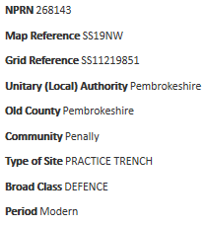
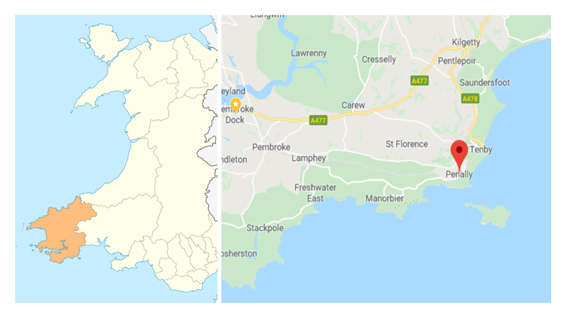
Fig 1. Map of Wales ( https://en.wikipedia.org 2020). Pembrokeshire Coast, Penally Village (www.pinterest.co.uk 2020), and coordinates for the Penally World War One practice trenches. ( https://coflein.gov.uk 2020).

Chapter One.

The village of Penally is in the county of Pembrokeshire and lies within the boundary of the Pembrokeshire Coast National Park (www.coflein.gov.uk 2019). The church which was built there is mentioned by Edward Laws in his publication, The History of Little England beyond Wales, noting the architecture of the font within, of Norman styling (Laws 1888 p379). The Penally village community of today work hard to protect their local heritage by interacting within the Penally History Group. The society is predominantly made up of a retired generation, who respect the memories of Penally’s past involvement within the military. This is validated by a Roll of Honour erected for the fallen from Penally in both World Wars. Displayed by the History Group in the village centre (David, a Penally History Group member 2019). This sits within the village demonstrating the need to recollect past relatives who lost their lives in battle. It is a monument that commemorates those victims providing a sense of value of the past and memory (Scofield 2005 p 56). When Dyfed Archaeological Trust approached Penally Heritage Society and suggested an involvement with an excavation on the World War One trenches that sit overlooking the village, it caused an excited stir of emotions (David 2019). One member of the public showed more enthusiasm and need for involvement in the community excavation than others of the neighbourhood. He almost claimed ownership, as if it were his personal quest to unearth his practice trenches. David Howard in Heritage, Management, Interpretation and Identity categorises this as an individual recognised as “an insider” (2003 p113). This gentleman served the army in his youth and a relation of his dug the practice trenches in Yeomanry Field (mentioned in the next chapter). Most often our local heritage has a personal value on a grand scale because it is the usual framework of our lives, it is compassion drawn from direct poignant understanding (Howard 2003 p113). The long term residents of Penally can relate to this, in terms of historical military engagement, as the village sits side by side the Penally training camp. It is overlooked by the training ground surrounding the northern side of the village. In geological terms Penally is surrounded by military activity and has become the backdrop of village life.
Most communities have been moved by the World Wars, and they continue to be affected in the present day and will do for many generations if the memories of those wars are kept alive (Schofield 2004 p1). World War One was one of the most horrifying battles any soldier and beast has ever, or will ever, endure again. This war cost millions of lives, for four years the war raged on, but remained static, neither army making any ground. Each side just killed each other over a ground which was a sea of mud, whilst being bombarded continually by ammunition from above and face on (Laffin 1987 inlay). The hell that these men were put through must never be forgotten because of the undeniable terror of it all.
Every one of us has been affected by war, sometimes through a way of experience and other times by survival (Schofield 2004). War cannot be ignored. Politically the heritage of war has been a construction of nations and as a result it has created identities, these identities come as winners and losers. War gives movement to the military, it creates labour and produces materials and creates industry, war shapes mentalities and feelings (The Heritage of War Gregner and Ziino 2012 p1). War will follow you; war will never let you forget. War turns its victims into heroes and in return provides a never ending trauma through the generations to come (Gregner and Ziino 2012). In the education system we learn about it, to a certain level, perhaps in a filtered way (Schofield 2005). Many people have relations in the forces or family who have perhaps died or survived in military action, giving them a reason to be interested, making a connection with an identity. There are countless books in the shops on the subject, war can be witnessed in documentaries or on the news giving an account or understanding (Schofield 2005). War is shameful, and shameful for people creating those wars. Although some accept war as a necessary act of maliciousness, there are others who demonstrate against it and refuse to accept the need for it taking a passive stand against it. (Schofield 2005 P15). Whether we choose to forget or forgive or carry out acts of remembrance it is undeniably unavoidable that all of us are involved or affected by the acts of war. What has been created from the act of war is now part of a new culture forced by conflict, giving a platform to create intangible and tangible heritage long after those wars are ended (Gregner and Ziino 2012). This is done by preserving and exhibiting and excavating on a community level. It is up to the heritage professionals to work with the material and the evidence left behind. The remains from war should be protected and utilised for lessons for the future generations (Schofield 2005), so to never forget the millions of lives that were destroyed.
John Schofield describes the vast loss of land British communities have had to give in support for the defence of their country. “In February 1944 11.5 million acres were under the control of the military, that is 20% of British Land” (2004 p1). “In September 1939, the area of land used for military training was 235 thousand acres, this had risen to 9.8 million in training acres” (2004 p7). This vast military training area has scars in the earth, that hold a memory as well as every village and town, holding onto the memories of wars, whether those memories were of the physical attack of bombing raids or the company of troops. (Schofield 2004). Many of those memories are entangled within the local communities and veteran survivors. But memories fade, and along with it any survivors (Schofield 2004 p7). It is vital that we as a nation see the value of our military heritage and conserve it. Schofield notes that there have been surveys to assess the number of monuments and the condition in which they were in. “English Heritage commissioned a monument audit and discovered that a minimum of 16% of recorded monuments No longer exist” (Combat Archaeology Schofield 2005 p82). In archaeological terms studies discovered 44% of land containing valuable deposits have been lost since 1995 (Schofield 2005 p82), indicating complementary values surrounding excavation.
What is demonstrated by conserving heritage and future management of heritage sites can offer to provide a tangible link to the country's history for future generations and to make a clear picture of that past. The value of heritage has a different meaning to every person and every community and from all different cultures (Schofield 2004). Places of recognised heritage have gained public appreciation through archaeology and architectural antiquity, however, there is a more intangible significance which can bring value, not only from admiration but from a longing and conserving memory (Howard 2003 p72). Sometimes places can be important even though they have no artefacts and sometimes there is nothing to see (Howard 2003). Sometimes it is not important to see anything, it is about a sense of connection with a place and the landscape, a sense of identity and, furthermore, identity plays a large part in the successful presentation of heritage.
When heritage is managed concerning the interpretation of people's identity, this can guarantee that the audience will connect with the subject presented and be satisfied (Howard 2003 p 11). It is in the public interest that sites are preserved and remain there for admiration and contemplation, a space to visit and reflect, to give a sense of place uniting memories (Schofield 2014 p2). The important issue is to acknowledge that heritage is about people, and what connects with them through their feelings (Howard 2003 p50). When any military site is visited, (such as the excavations mentioned in chapter two), the outcome of being in close contact to these monuments conjure up a density of feeling on a personal and communal level (Schofield 2014 p49). Local archaeologists and heritage professionals understand the connection of identity and memory regarding the interest in these sites and accept the importance, not only at a regional level but on a national and worldwide level (Schofield 2004). It is important to accept heritage as a study of the past which connects with present day meaning as in the excavations at Penally Practice Trenches, coinciding with the anniversary of the D-Day Landings. Heritage sites have agency, they can represent remembrance, nostalgia, and memory (Howard 2003). “Heritage holds commemorative and symbolic values, social values, and spiritual values” (Aftermath Readings in Archaeology of Recent Conflict, John Schofield 2009 P4). Values where identities can connect with a meaning of a place, values that relate to people’s identity being involved around social interaction such as community excavations (Schofield 2009), values which inspire and can bring questioning and judgement (Schofield 2009). The heritage of war is a device which has brought awareness to local heritage and history. It has brought people together physically and emotionally; the memory of war has a connection with a community’s identity (Gregner and Ziino 2012).
Empiricism, strict adherence to basic principles, and critical analysis are part of the practice of archaeology (Shanks and Tilley 1987 p5). Archaeological methodologies capture and collect material culture for retelling of histories, which create the Heritage that serves communities values, opening important debate and creating social interaction (Scofield 2005). Archaeology could be death, or rot, it is abandoned buildings crumbled into ruin and decay (Theatre Archaeology, Pearson and Shanks 2001). It is old, broken and forgotten, trampled on (such as the Penally Practice Trenches), graffitied on, burnt out, and neglected. As Michael Shanks explains in: Experiencing the Past, one part of the archaeological method is the planning around the field work (Shanks 1992). This includes, surveying, drawing excavation and working on the recovered objects. This is all just procedural and quantifiable, with an end procedure of object presentation (Shanks 1992), which is all relevant within the science. The discipline of archaeology studies the material evidence of the past, it tries to find an understanding of objects found in the ground (Shanks 1992). Some archaeologists are content to clean, label, and analyse, others prefer the survey, the excavation, statistical reviewing of environments, or identifying plant and bodily remains. Archaeology is an independent science, it is possible to suggest then that archaeology is the root and responsible for creating a web of tangible and intangible heritage, from seeing and to feeling its worth. It could also be said then that archaeology is not just a science, archaeology is a tool, ‘archaeology can be interpreted as development of embodiment’ (Shanks 1992). It creates “Faith, Emotion and Intuition” (Shanks 1992 p18). Nevertheless, there is a value which was spectated and experienced on a personal level and that brought more excitement and interest than measuring, drawing and material finds. Shanks suggests ‘archaeology is a project of embodiment’ (1992 p1), which stretches the body and the mind (1992). What the archaeologist can do is use the project of excavation as a foundation to present and connect with modern consequences, of that past time. Instead of archaeology just as a project of presentation all on its own, it can connect to individuals searching for a sentimental connection (Shanks 1992). (Demonstrated in the case studies in chapter three).

Penally’s Military History.

To understand how deep the foundation of this sentimental connection has related with the communities surrounding Penally, it is important to understand the deep rooted history. Peoples heritage is developed from the historical past (Howard 2003). The communities of Pembrokeshire have had a loyal involvement with the defence of the British Isles for generations. It is stated on the Pembroke Yeomanry Papers dating from [ c. 1800-1987] from Archives Wales that in 1794 the British government formed a mounted force In Pembrokeshire. This cavalry was a volunteer position in those early days, and this first organised mounted military was called the Yeomanry. It was created to support Britain’s internal military defence against France (https://archives.wales 2019). According to the Pembrokeshire Territorial Association Records dated 1888-1967, the Pembrokeshire Territorial Army Association was formed in the mid-19th century, it was then that the Pembrokeshire Rifle Volunteers formed in 1880. In 1908 the Volunteer Corps were divided into ten companies, which battalion became the 4th battalion of the Welsh Regiment, this was disbanded in 1967. (https://archives.wales 2019). However, what is interesting is that in Penally there is a field called the “Yeomanry” Field, this is evidence of this force using the local land in Penally for its training of troops, (see Fig 2). The Insider, a resident of Penally who was mentioned earlier in this chapter, is related to one of these men who dug practice trenches in this field (David 2019), earning him his devoted passion to this archaeological project.
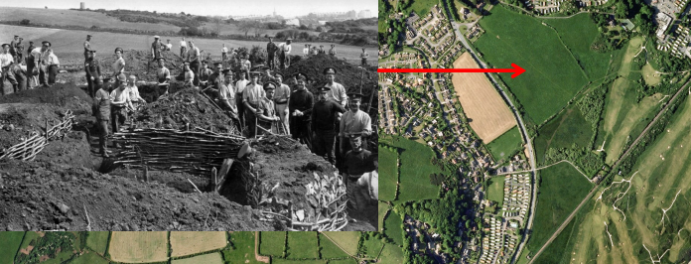
What can be seen in the photo are the materials that were used at the time. These consist of wooden woven lengths of tree branches, comparable to wicker panels staked in the trench sides to stop the slumping of the earth. The Manual of Field Engineering describes the woven panels as hurdles and were generally made “6 feet long and 2ft 9inches” from top to bottom.
Fig 2. Photograph by Mortimer Allen and shows the work at Penally Camp at around 1914 (Gomer Press 1988), now known as Yeomanry Field and an aerial view of Yeomanry field by Toby Driver (https://coflein.gov.uk 2019).

The “web” was then made by a procedure called “randing” (1911)’. These hurdles were one of the most useful forms of fortification, either as separate panels or as one continuous construction built concurrently with the walls or parapet (War Office 1911 p13). Although none of this material was found in the excavation, (mentioned in chapter two). The supporting material which was found was of corrugated iron, this was found in Trench two and on the rifle range, in Trench three.
The Penally coastal landscape which was used in the 19th Century is still used today for Army training, grazing and public leisure. It is managed by The Defence Training Estate in the UK, and is controlled by Headquarters DTE, the land is separated into 12 locally based areas. The Defence Training Estate in Pembrokeshire (DTE P) contains four zones within these areas. These are Castlemartin training area and ranges, Manorbier training facility, Penally training camp, and the training area at Templeton. Together, these four locations cover an impressive size of 6,630 acres (2,685 hectares) (https://assets.publishing.service.gov.uk 2019). Within these areas the land has been untouched by the farmer’s plough or commercial building construction, creating a haven for ecology, biology, archaeology and heritage (An Environmental History of the UK Defence Estate, 1945 to the present. Marianna Dudley 2012). Over hundreds of years the range has been left for the use of target practice for all war weapons of the past to the present day. Countless boots have trodden in all weathers to strengthen the mind and body for war (Dudley 2012), and to give the skill to defend a country.

The History of Penally Camp.

Not only did the army use the purpose built barracks for accommodation, but when space to accommodate the forces became an issue because of the amount of men, it was important to request housing within the local communities, such as houses, hotels, barns and even castles were called for to be used by the Army (Schofield 2004 p14). With potential soldiers using the Penally land for training, it was vital to have somewhere where they could rest and be accommodated. In the village of Penally, there is the training camp that was used for those training with the military, this camp is still in use today, and this is known locally as “Penally camp”. Penally Training Camp is positioned next to the Pembrokeshire Coast National Park, Tenby town is to the east and Pembroke town is to the west (https://assets.publishing.service.gov.uk. 2019). It was built in 1860 and was an infantry school that was used to train Militia units (Roger Thomas 2019). Originally the service men were housed underneath canvas tents, these tents were called bell tents and accommodated ten men at one time (Roger Thomas 2019 see fig 3, and 4 for plans for Musketry Camp).
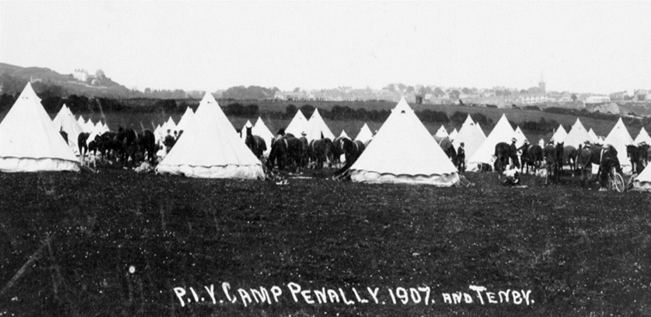

Fig 3. Bell tents at Penally Military Camp Photograph provided by (Roger Thomas 2019).

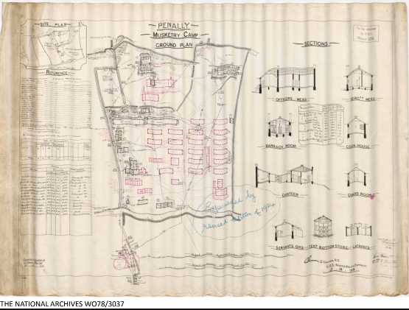
Fig 4. Plans for the musketry camps in Penally (National Archives 2019).

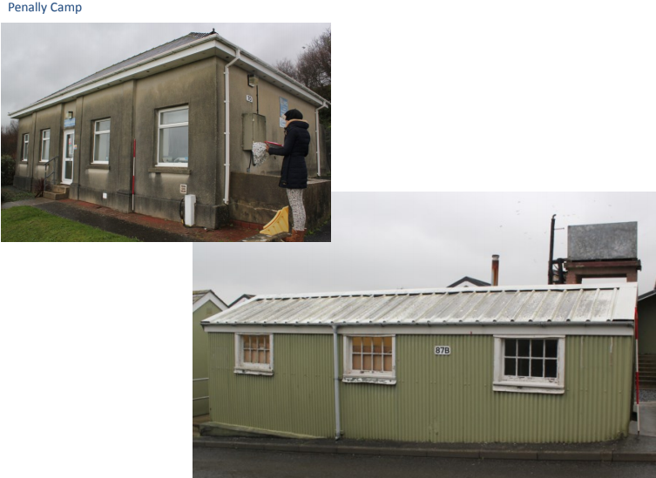
Over time the amount of men enrolling increased to as much as one thousand at a time, the sheer quantity of these men who had to be housed called for more permanent housing. It was in 1860 when following the Crimean War, fears of a French invasion took hold and it was this camp that supported the exercise for musketry training (see fig 4). As well as Penally Camp being built a shooting range was built nearby within a year. Some of the original camp buildings still stand, and are still in use today, such as the classrooms and training facilities (https://assets.publishing.service.gov.uk.2019 , (see fig 5). The rectangle buildings, which are more like huts, were made of timber clad or corrugated iron (see fig 5) and would house twenty two military men, and up to thirty at one time if needed. The heating for these huts consisted of little iron pot belly stoves, it was easy to identify an officer building because they had multiple chimneys, as the higher rank of the army had a fire each. Washing and shaving had to be done outside in communal washing areas where hygiene was endured in the open air. (Roger Thomas 2019). Penally Camp continued to be used through World War One and World War Two and is used presently for the training of the modern day British Army. Camp accommodation can contain other structures for managing an army force, including latrines, and washing facilities, incinerators, kitchens, food stores, and armoury store buildings (Schofield 2004 p14).
Fig 5. Penally training camp buildings. (Roger Thomas 2019).

Penally Camp is now not only used for the present day army, it can also be used by groups who need accommodation for local activities https://assets.publishing.service.gov.uk 2019), such as the volunteers for the excavation on Penally World War One practice trenches. What this demonstrates is the extensive military establishment and the involvement within the communities of Pembrokeshire over hundreds of years. The military history is embedded within the local memories of the people of Penally, Pembrokeshire and undeniably any soldier ever trained there, as well as the soldier’s family and friends. and has fundamentally been the core of Penally’s heritage, and military heritage on a regional scale.

Penally World War One Practice Trenches.

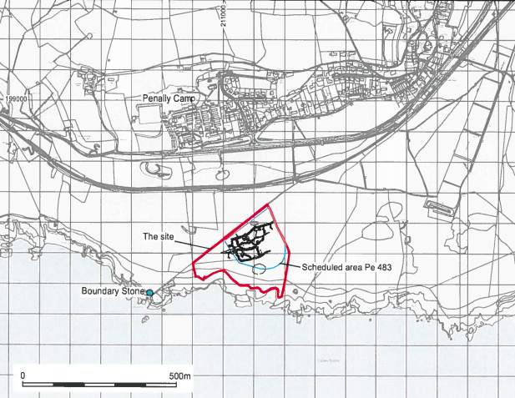
Beneath the contours of the coastal M.O.D land are networks of World War One practice trenches which have survived as sad reminders of the training which was given to recruits before they were sent to their possible death on the Western Front (www.coflein.gov.uk 2019). Scheduled monument, reference number PE483, is covering an area of approximately two hectares which is a triangular shape and situated just south of the Penally camp, the
Fig 6. Map of the scheduled area (Wessex Archaeology 2004).

ground is used for grazing sheep (Archaeological Desk Based Assessment and Condition Survey Wessex Archaeology 2004 p1). The practice trenches of World War One are sat on top of the Pembrokeshire cliff tops at ninety metres high overlooking and sloping down towards the Penally camp. To the north of the trenches are the views of St Margaret’s Island and Caldey Island as if you were standing from the rear of the trenches looking south. The cliffs mark the southern boundary and sheep fencing alongside a National Park public footpath mark the northern side. A drystone low wall and wire fence mark the east edge and the west boundary merges with the cliff path creating a narrowing point (Wessex Archaeology 2004 p5, See fig 6).
On August 4th, 1914 Great Britain declared war on Germany. It was thought that the war was not going to last long (Wessex Archaeology 2004), so it is suggested that the digging of the trenches in Penally was not completed that year and they were probably dug in the summer of 1915. The troops in (fig 2) who are photographed digging trenches in Yeomanry Field are all wearing the cap badges of the Royal Engineers (Wessex Archaeology). But no evidence had been found yet to identify who dug the practice trenches. In the aerial photograph showing the plans of the trenches (fig 7) it shows the two main trenches having an indented pattern, almost like a squared zig zag. It was thought this was designed to prevent the blast of artillery travelling along the trench, and to slow movement in the trench just in case the trench was captured by the enemy. This would give areas of cover for fighting background within the trench (Wessex Archaeology 2004). What can be seen in (fig 7) are the complex associated features that make up the practice trenches fortifications, and what can be identified in the remaining features, that are still visible, are support lines connected by communication trenches. The trenches are sloping to the north with main defensive parapets and transverses on that side. Other structures noted could include a possible First Aid post or shelter, many of the features have been distorted by erosion, slumping or trampled by sheep. The Monument is free to walk around and consists of panoramic views over the village of Penally and towards Tenby and out to the sea.

Penally Practice Trench Plans.

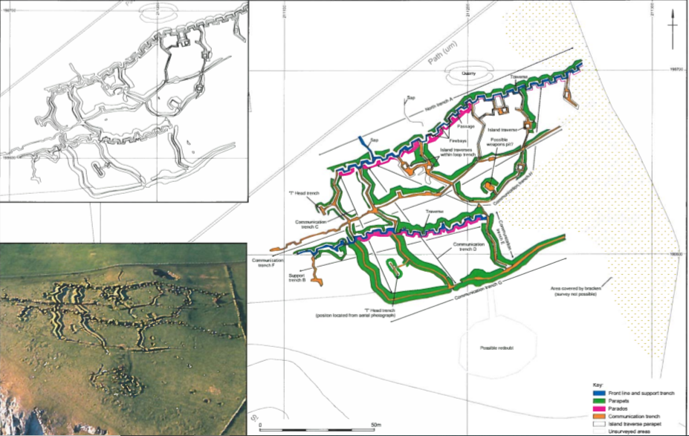
Fig 7. Maps of Penally Practice Trenches (Wessex Archaeology 2004).

Chapter Two, Excavation.

.
The Dyfed Archaeological Trust was approved with the financial backing to complete an archaeological investigation to expand the knowledge and understanding of the archaeological evidence of the Penally Range. The purpose of the excavation was to reconnoitre how the trenches were used in the First World War and successive wars during the twentieth century. With the data collected it is expected that this knowledge will aid a future understanding to manage and conserve the protected monument and other monuments of its kind in the British Isles (Murphey 2019). The work forms part of a group of valuations investigating the archaeology of the First and Second World Wars, which have been funded by Cadw across Wales. Over the centenary of the First World War varied themes have been discovered and placed out in the research programme for Conflict Archaeology which have been approved by the Conflict Archaeology Advisory Panel (WelCAAP) (Murphey 2019). The three areas which were investigated are as follows.
- The World War One Practice Trenches.
- The Rifle Rage, near Giltar Point.
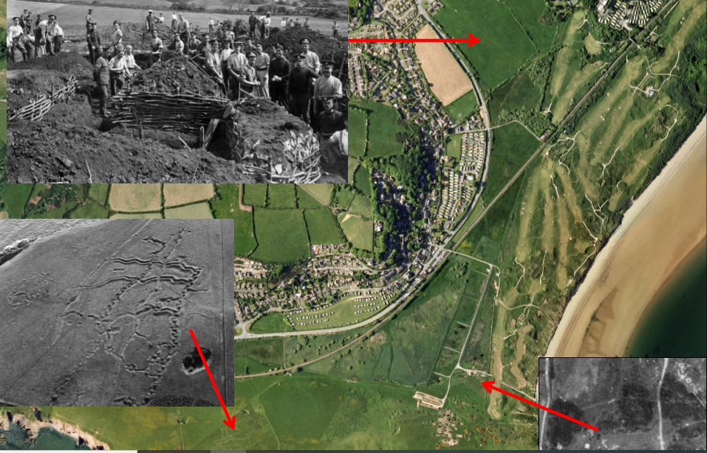
- Yeomanry Field.
Fig 8. The three areas of investigation covered in the community excavation (Dyfed Archaeological Trust 2019).
Points on (Fig 8), identify the areas which the Dyfed Archaeological Trust examined. The top picture has already been mentioned in Chapter Two, named Yeomanry Field. The location on the bottom left of the picture is the First World War practice trenches. Up on the cliff tops is the original rifle range opposite what is called Giltar Point which was built in the 19th century, this location sits behind the modern rifle range of today (see fig 8, bottom right). Both sites were excavated in the summer of 2019 which I personally attended over a three -week period. The position was voluntary to gain more experience in practical archaeology within the field, to advance experience and to acquire additional excavation skills. The volunteers derived from assorted walks of life, from accomplished archaeologists with degrees in the subject, to the more veteran volunteer who had been indulging in the science for 20 years including, office workers, retired adventurers and ex-veterans of the armed forces who work in conjunction with Operation Nightingale. All volunteers were invited to stay at Penally Camp and were provided with a packed lunch every day. The little brown paper bags supplied by the camp kitchens were the cause of endless meat pasty jokes, which kept spirits high in the rain soaked Pembrokeshire mornings.
Before any of the organisers or volunteers could enter M.O.D land it was important to be briefed in Health and Safety issues, such as be aware of live ammunition whilst digging or walking or going near any of the proposed sites. The two warnings put in place by an army official filled everyone present with a little unease and exchanging glances, raised eyebrows and nervous giggles amongst the team proved no one was prepared for either warning. The first cautionary was to watch out for the British Trench Mortar Bombs! (see fig 9). These are appropriately called ‘Toffee Apples’ by the army troops. The long thin end of the bomb was put down the barrel of a mortar and was fired out of it by an explosive charge, it had a throwing type trajectory which was used to fire into enemy trenches (Laffin 1987 p103). Its course of aim was not very straight when it was flying to meet its target and very often just split into two and never fragmented on landing, failing to cause the harm intended (Laffin 1987). It was brought to everyone’s attention on this excavation that it was very common for this bomb to be found. It weighs nearly twenty kilos (Laffin 1987) and could explode causing injury if dug up.

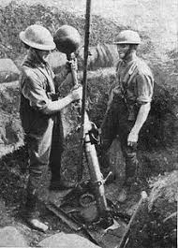

Fig 9. Photograph of British troops loading a Vickers 2 inch Medium Trench Mortar Bomb (British Government 1918).

It was at this stage of the archaeological experience, I started to realise the horror that anyone on the receiving end of these missiles was a forbidding reality and an intangible connection started to form with people of the past.

Along with the first warning there was one more. The Turkish troops called the next potential threat to be taken into consideration whilst excavating MOD land ‘The Cricket Ball.’ This grenade was an iron ball that had a lump at the top, which was the fuse, once lit the small device will ignite the explosive centre, causing many casualties in a confined space such as a defensive trench (Laffin 1987 p38). There are stories of the Australian and New Zealand troops catching the grenades and throwing them back to explode in the Turkish Troops trench. What the Turkish began to do was hold onto the grenades a little longer, this resulted in losses to hands and fingers amongst the troops (Laffin 1987).
Trench one, two and four of the excavation were at the area of ground where the Practice Trenches are, the Dyfed Archaeological Trust decided to put all the trenches in the area outside the protected area, just on the edge of the listed monument, (see Fig 10, 11 and 12). Actual published features of World War One practice trenches (see Fig 13, 14).

Map of excavation trenches.
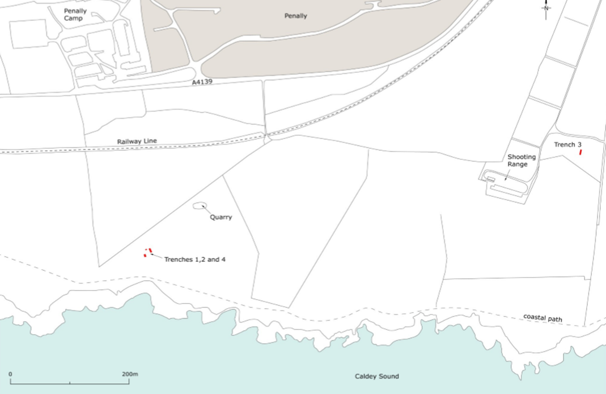
Figure 10. Location of Trenches (Dyfed Archaeological Trust 2019).

Protected area perimeter around Practice Trenches in Penally.
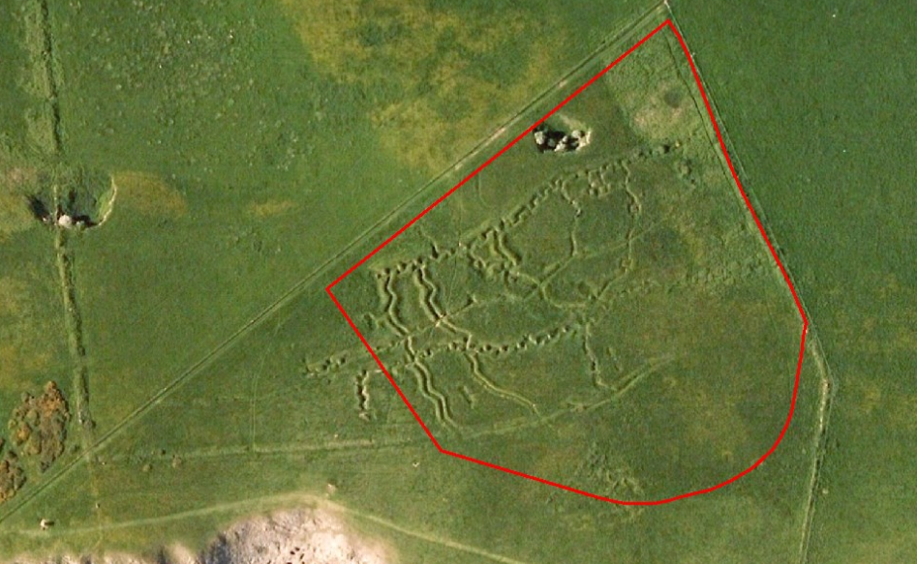
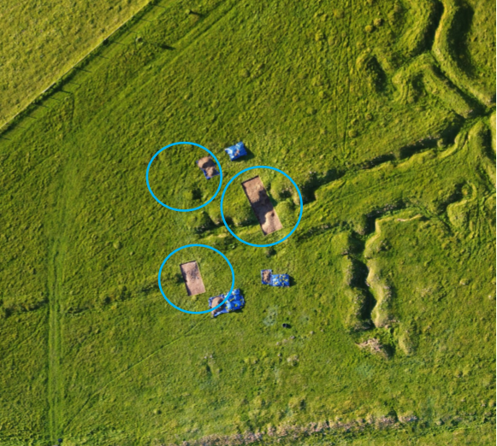
Fig 11. Perimeter of protected area (Dyfed Archaeological Trust 2019).
Fig 12. Trenches 1,2,4, (Dyfed Archaeological Trust 2019).

Practice Trench Plans and Features.
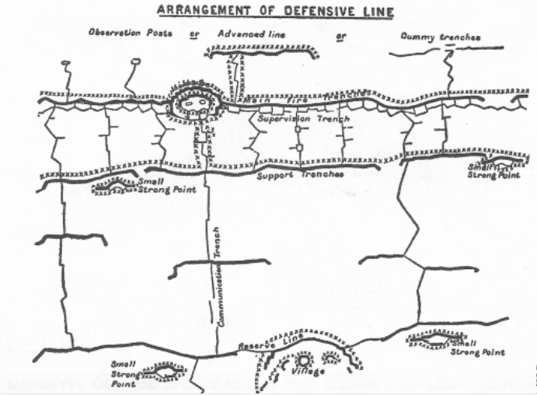
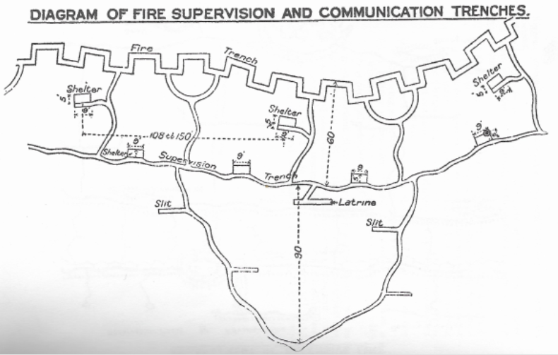
Fig 13. (War Office 1916 p73).
Fig 14. (War Office 1916 p74).

Drawings of Excavation Trenches.

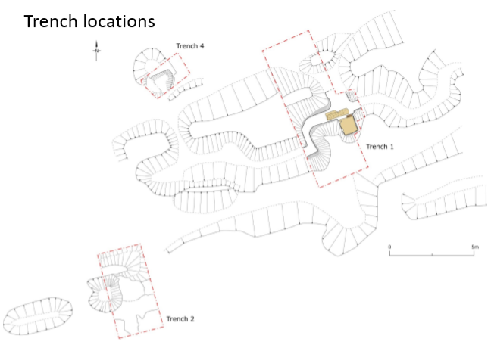

Fig 15. Excavation Trenches 1, 2, 4, (Dyfed Archaeological Trust 2019).

Trench One.
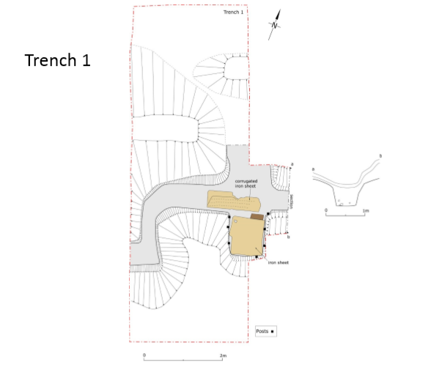
Fig 16. Trench One (Dyfed Archaeological Trust 2019).

Trench One Discussion and Finds.
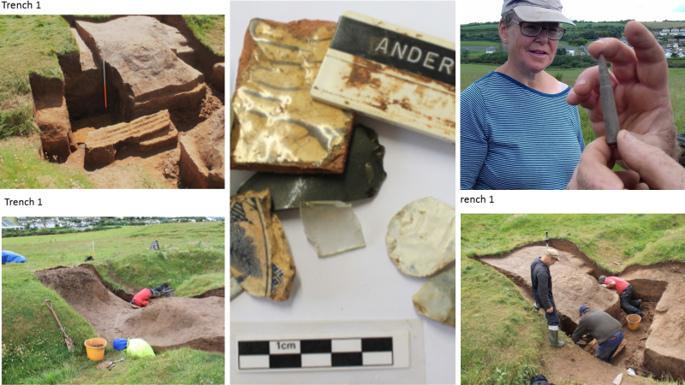

Fig 17. Trench One (Author 2019) and finds (Dyfed Archaeological Trust 2019).

It took until the last week of the excavation to get to the bottom of the trench, the slopping sides of the walls of the defence had slumped, from years of being trodden over by walkers and farm stock. One unexplainable feature was a square cut out of it: 0.98. x 0.83 and a depth of 1.37 meters, (see fig 17), top left (Dyfed Archaeological Trust 2019.) The recess had a metal floor although this was left in place and was not investigated further. The metal floor was kept in place until the back-fill of the trench at the end of the excavation. A sheet of corrugated iron had folded on itself as the earth had slumped down on it, this was possibly the roof of the recess, but it is hard to tell. As observing plans of early trench systems, it is not possible to confirm identity of the excavated space. Trench two was proposed to have been on the defensive line and no shelters are marked there. However, there are shelters on the communication line and supervision trenches (see Fig 14). As these are practice trenches it could be easily regarded to have not built these trenches to the plans as defined in the Trench Warfare book written by the Home Office. The only evidence of any firing of ammunition was a fully loaded bullet causing a stir amongst the volunteers. Other finds conjured up imaginary memories from the past such as light green glass bottle stopper from the company ’Aire & Calder Bottle Co’, who operated in Castleford and London in 1836-1913 who made the glass storage jars and bottles for mainly jam, fruit and other food consumables. This gave Dyfed Archaeological Trust a confirmation of date and possible food consumption among the troops who had obviously just dug this trench as an exercise as there were no bullets found.
Visions of young men digging the trenches high up on a headland in the Welsh summer feasting on fruit possibly sent from family in London, to be sent to their imminent death….

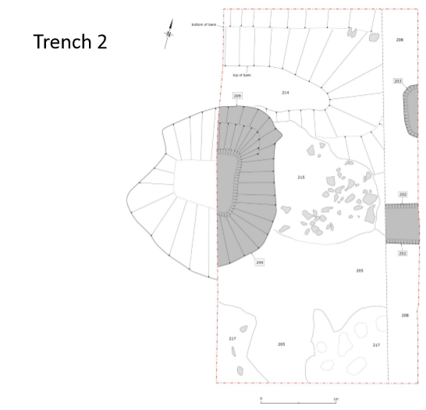
Trench Two.

Fig 18. Trench two (Dyfed Archaeological trust 2019).

Trench Two.

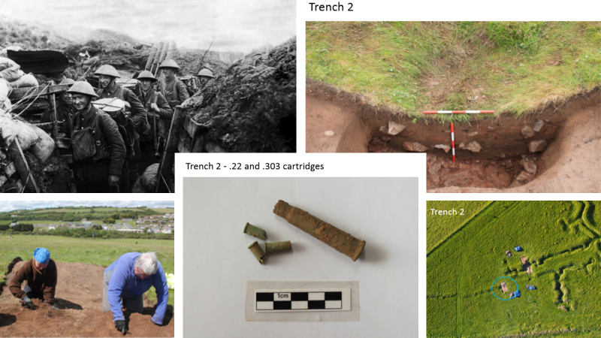

Fig 19. Trench Two, Top Left (www.liverpoolecho.co.uk 1918), Top Right, Bottom Left, Middle (finds) and right (Dyfed Archaeological Trust 2019).

Trench Two Discussion and Finds.

Interestingly in Trench Two there was a hollow or circular shape where the earth was easily scooped out and an obvious manmade space, which could just be seen on the surface of the grass as a slight depression. It is not possible to identify what these two hollows were used for and again the layout is not identifiable on the plans in fig 13, 14 However, it is stated in the Trench Warfare manual that the service men used to dig two holes and tunnel to each other as opposed to digging the trench from the top (War Office 1916) there were two types of bullet found in this trench, the 22 long rifle bullet has been in use since 1871 onwards (R Thomas 2019). The larger of the finds was a 303, used from 1889 (R Thomas 2019).

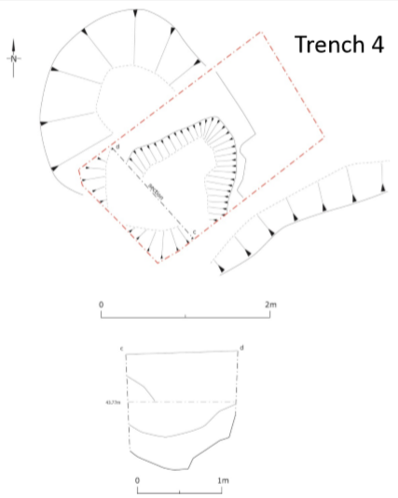
Trench Four.
Fig 20. Trench Four (Dyfed Archaeological Trust 2019).

Trench Four Discussion and Finds.

Trench Four was the last to be dug on the final week, it was thought to have been a machine gun pit, which does comply with the map in (fig 13). Along with some pottery from the 19th and 20th centuries a part of a flit blade and flint flake was found, possibly Neolithic (Dyfed Archaeological Trust 2019). Other exciting finds were two skeletons, one of a rabbit and the other a small British carnivore, which has no relevance to the topic of excavation but still an exciting, educational find for the children on site that day.

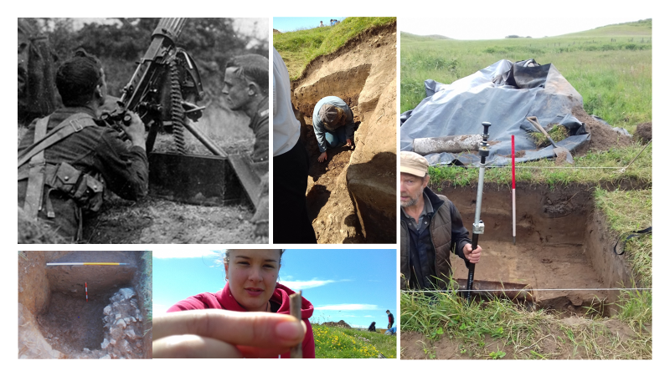

Fig 21. Trench Four, Top left, British Vickers machine gun, shown set up for anti-aircraft purposes. Photographed circa 1914-1918 (https://commons.wikimedia.org 2015). All other plates (Authors 2019).

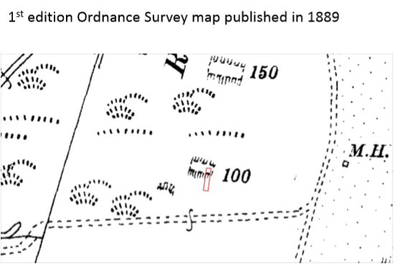
Ordinance Survey Map published in 1889, showing Trench Three.
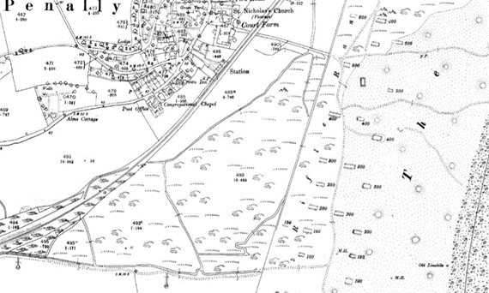
Fig 22. Close up of position of Trench 3, on a map from 1898, marking the original firing ranges (National Archives Wales 2019). Below, Fig 23. Copy of original map (National Archives Wales 2019).

Trench Three.
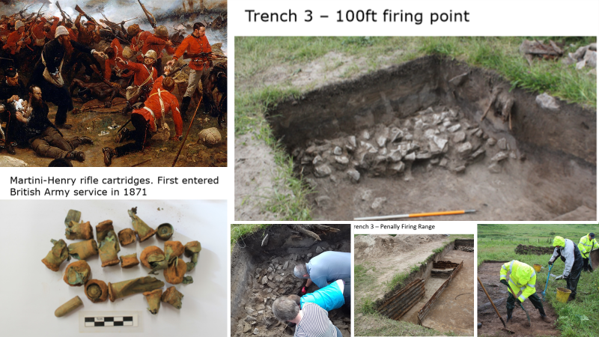
Fig 24. Trench Three, top Left Zulu Wars 1897 (www.artgallery.nsw.gov.au 2020), top right, excavated rifle range, Trench Three. Bottom left bullet finds (Dyfed Archaeological Trust 2019), left 2, volunteers, right 1, corrugated training structure in Trench Three (Author 2019) right 2, volunteers braving the rain. (Author 2019).

Trench Three Discussion and Finds.
This trench was excavated on the result of the geophysical survey, after investigating the area there appeared to be an oblong shaped anomaly running East of the present day firing rage. This was found to be a corrugated purpose built tunnel possibly to train troops through, there was an abundance of barbed wire excavated which was evidence of it being anchored in different areas, again this was thought to of been some training facility (Dyfed Archaeological Trust 2019). The find was very interesting with the bullets being identified by Roger Thomas as the same used in the Anglo-Zulu War fought in 1897 between the British Empire and the Zulu Kingdom (Thomas 2019). There were many cartridges retrieved which date back from 1916-18, these were found by the corrugated iron structure. Other types were found that originated from the other side of the trench, these consisted of one Snider bullet dated from 1870-1880s and a Martini-Henry bullet 1880-90. Roger Thomas describes the Martini-Henry as a breech loading single-shot lever-actuated rifle that was used by the British Army. It was used in service in 1871, which replaced the Snider Enfield, a muzzle-loader converted to the cartridge system (2019). It was concluded that the West end of the trench was a training facility and the East end of the trench was part of the original firing rage which was positioned pointing in the opposite direction of the present day firing range pointing out to the ocean. This does correspond with the ordinance survey map of 1889 in (fig 22 and 23).

Yeomanry Field.
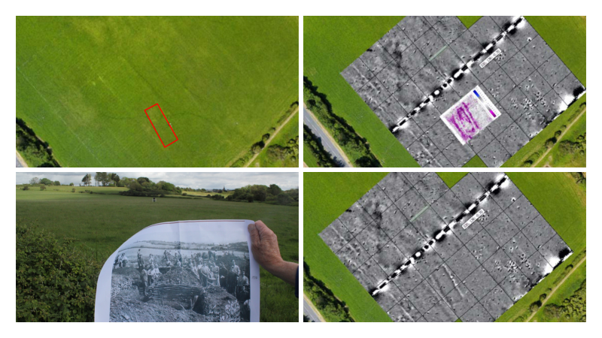
Fig 25. Geophysical survey results from Yeomanry field (Dyfed Archaeological Trust 2019).

Discussion
Yeomanry Field underwent a geophysical survey, to find any evidence of trench building or a suggestion of military use in the past. The name of the field and the surviving photograph from the Old Pembrokeshire Collection gives an indication that it was used once, perhaps for the Yeomanry to camp and train. What the geophysical survey revealed was a square shape, which is thought to be a building of some sort. No evidence of trench building was discovered. However, there is talk that the next community excavation in Penally would include an excavation in the Yeomanry Field (Dyfed Archaeological Trust 2019).

Chapter Three.

Community Walks.
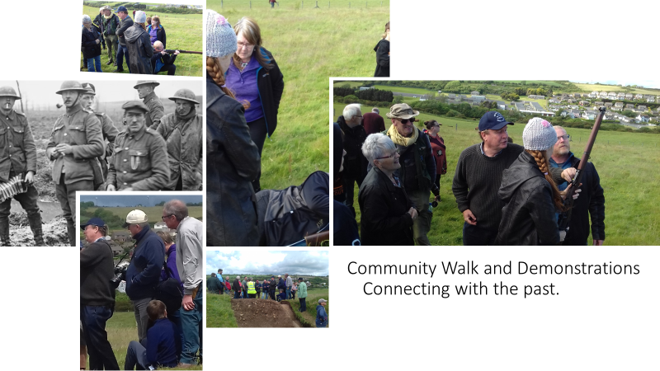
Fig 26. A community’s connection with the past (Author 2019) Men at the trenches (https://www.bbc.co.uk 2020).

The community that surrounded the excavation were brought together by the action of the organisers within the project. These involvements enhanced the experience and understanding of the subject being investigated and gave the general public an opportunity to view the excavation. Such actions included a series of organised walks open to the surrounding public as free of charge tours and a presentation of the excavation halfway through the project, undertaken by Roger Thomas, Local Military Historian. Roger has worked on various projects researching the use of M.O.D land, and because of this there have been several schemes since mapping these areas, which amount to over eight hundred individual sites (Thomas 2019). His involvement in the planning and research for the excavation, presentation, and live interpretation (Howard 2003) in conjunction with the excavation have been an asset to the people of Penally and the surrounding communities. This has given awareness into the military heritage integrated in the village, which has been discussed in Chapter One. What was interesting was the publics’ eagerness to demonstrate their own experiences, with using items which would have been used in war time that Roger had brought to stimulate interest, discussion, and connecting with the past (see fig 26). Archaeology can encompass the materiality of that given subject, providing mental stimulation and a social experience embedding and connecting with personalities and reminiscence (Pearson and Shanks 2001 p10). Being able to handle items which have been used in war offers ‘sensorium’ (Pearson and Shanks p10) which touches cultural understanding in a personification of senses (Pearson and Shanks). People were eager to share stories of their military life, and there was no denying the excitement in which the public shared.

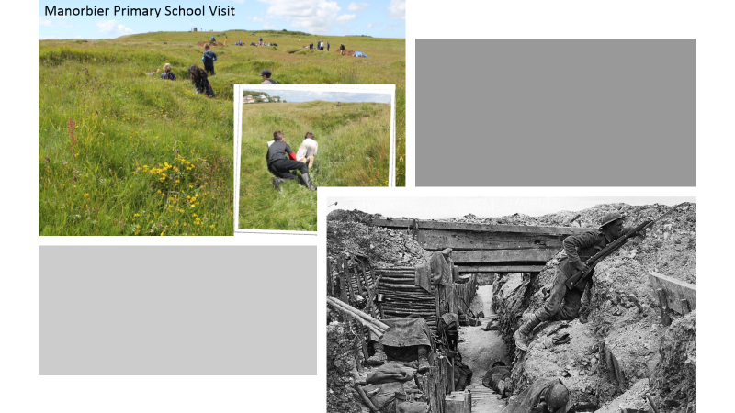
Community School Visit.

Fig 27. Left, (Author 2019), centre, (Dyfed Archaeological Trust 2019), right, A British soldier inside a trench on the Western Front during World War I, 1914–18. (www.britannica.com 2020).

A sunny day was perfect for children from the local primary school to visit the excavation. Not only did the children run and play amongst the grass covered cushioned practice trenches re-enacting history and establishing an appreciation and reverence for the past (Peter Fowler 1992 p 15). The children were able to take part in the excavation after the necessary drawing, photographing, and recording had been completed on Trench Two. Once the volunteers and professionals had finished using the trench, before it was back filled with the removed soil, it opened an opportunity for all the children to take part in the project in a practical way. The children were given trowels to scrape the earth to experience the role of an archaeologist and discuss the narrative of the excavation. There is a great importance for children to be able to have hands on experience, providing a foundation of possible future pursuits, and generating an interest in the cultural history being explored (Neil Cossons 2000 p25). Not only do the children benefit from this education as enriching their lives, but also so do the parents. The children go home to their mothers and fathers and exchange an interest which enlightens the family home too (Cossons 2000 p25). When children are introduced to this experience it creates a curiosity, this interest will inspire the knowledge and with that understanding brings satisfaction. It is this enjoyment which leads to a dedication and then leads to a better quality of life (Cossons 2000p25). In a survey by MORI who asked three thousand people in England, should school children be allowed the prospect to find out about the country’s historic environment- 98% agreed with that statement (Cossons 2000p25),96% agreed that the historical environment was essential in teaching the past (Cossons 2000p25). From the squeals of delight coming from the children on this community excavation at Penally Practice Trenches, it was evident that the day was a success, and is something of value which could be brought to every community excavation.

Penally’s Heritage on Display.

The communities are attracted to our historical environment, people are happy to learn more about the past and our surrounding heritage. People need to understand heritage, they want their children and grandchildren to come to know the struggles of the past, they want to discuss it and be involved and take part in any way they can (Cossons 2000 p23). As part of the community excavation event, an exhibition, talk and another guided walk as a final farewell and follow up to the excavation took place. The location of this event was held in Penally village hall at the end of the summer of 2019. Some of the village attended, the history group, and some volunteers from the excavation, the re-union experienced a sentiment of meeting long lost friends, hours in the trenches seems to have that effect. All the evidence which was found on the excavation was displayed on tables on show for the public to view, and a Power Point and discussion was undertaken by organisers of the Dyfed Archaeological Trust. Penally History Group had added to the display showing the pictures and the Roll of Honour of the local fallen victims of war who had come from the village, and other information representing the military heritage of Penally, all this was a popular event and a perfect ending to the community excavation.
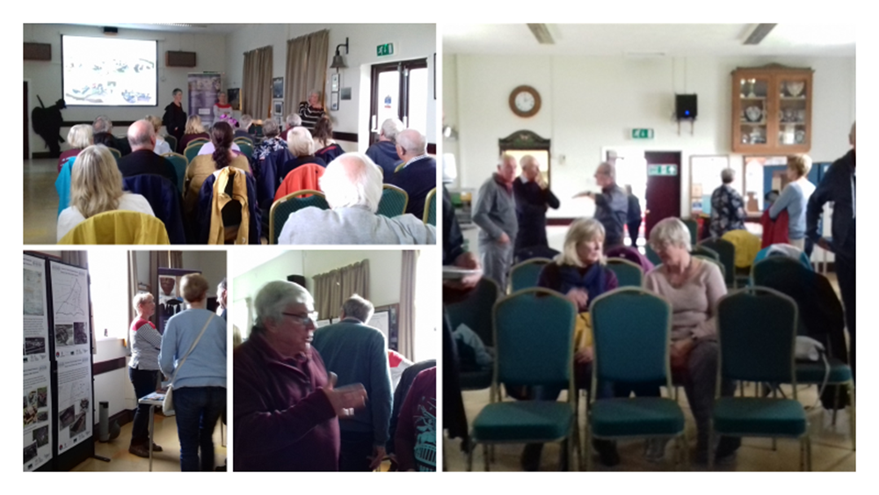
Fig. 28. Presentation of excavation and Penally’s heritage on show (Author 2019).

The Volunteers.

The community excavations would undoubtedly not be possible without the help of volunteers (Organiser 1, 2019). These people who offer their help in support of excavations are from all walks of life. It is hard not to get to know the people who work alongside you, and it is remarkable to discover some have been volunteering for decades as archaeologists (Organiser 1, 2019). This shows people’s passion for projects such as this. Although there were the one or two who were there for something other than experience and enjoyment of digging trenches and enjoying the art of archaeology these two people brought an understanding and discovery of an equal value in excavation. Two people: one male, one female helped give a personal appreciation of why they volunteered. It was these two people who finalised the validation of importance, demonstrating the intangible value that community excavations can hold.
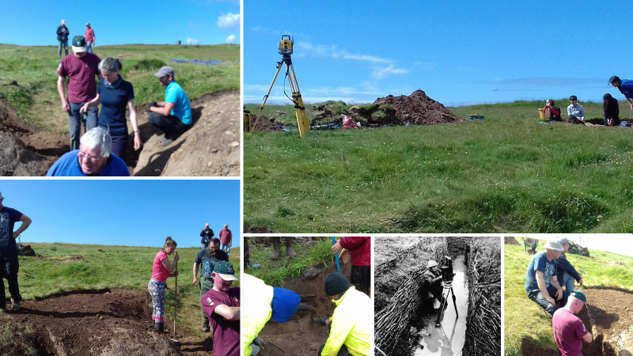
Fig 29. Volunteers, (Author 2019).

Case study, female.
Alison was a 49 year old first time volunteer; she had no interest practicing Archaeology. However, she was interested in the subject of the excavation because her grandfather served in World War One. Alison had worked in an office ever since leaving school. This was the first time Alison had experienced working outside. This was evident from her clothes she came to excavate in. After days of speaking with Alison it became clear what drew Alison to this excavation. Alison explained that her grandfather had spent his younger years as a World War One glider pilot, and he had survived the war and grown to an old man before his recent death. Alison felt by being at the excavation brought her closer to her grandfather’s memory. Since her grandfather’s death she had become more increasingly attentive in the subject of war and the military as it brought about a familiarity and comfort to be around the subject. What astonished me was Alison and myself found we had a connection, the man who was her grandfather served in the same glider pilot regiment of a close friend and ex-employer of mine. After the excavation while every volunteer left the site, Alison just sat on the site with tears in her eyes. After enquiring if she was alright, Alison said she was reluctant to leave her memorable experience behind, she wanted to sit and contemplate before she had to return to her office and back to the reality of normal working life. As discussed in the first chapter of this dissertation, it is confirmed that places have value (Scofield 2005 p81). This represents the diversity of opinions which stretch over a varied type of community which have different values to different places (Schofield 2005 p81). Alison told me she found a comfort to her own life to share in her grandfather’s footsteps and had visited numerous military heritage sites to feel that same feeling of peace as she felt at Penally, and will continue to do so, to keep her memory of her grandfather alive.

Case study, male.
Julian (48) served in the military for most of his life since leaving school. In the first rainy week Julian opened very quickly about his past family life, explaining since his experience of army tours in Iraq and Afghanistan his mental state had suffered. He was quick to explain that his wife and children had left him two years previously, and he did not hold this against them because of the effects of his PST causing mood swings and unrest in the family home. I asked him why he was here? It is odd for a man who had served his country most of his life to want to be back on the training range again because of his illness. Julian then explained he was being supported by a group called Ground-breaking Heritage, who work close to Operational Nightingale (www.breakinggroundheritage.org.uk 2018). This scheme which was set up in 2005, offering a new way of life after military service (www.breakinggroundheritage.org.uk 2018). It offers the interest of heritage and archaeology as a way to restore mental health issues as a way of therapy (www.breakinggroundheritage.org.uk 2019). The society was set up by an ex-military man on the understanding that being in her Majesty’s Service, serving and protecting your country will create an identity which is hard to escape in conventional life after leaving the Military. The use of archaeology and heritage as an option for future employment and training has given Julian the light at the end of a long tunnel of recovery, and he is starting to reduce his medication because of the alternatives which have been provided for him (Julian 2019).
Julian also shared the Diary of Lieutenant John Gibson Pitt 8th Battalion AIF from the First World War, who was Julian’s grandfather. Since being interested in archaeology Julian has sought to find evidence in the Archives of a man, who he was so familiar with and could identify with his own past serving in the military.
The diary he found was dated from October 15th, 1915 to 1918 providing an insight of a day to day life in the army, in which he travels all around the world, noting archaeological sites such as the Egyptian pyramids. With several accounts of digging trenches daily in between holding off the enemy. One such day on Friday Mar 18th, 1915.
Parade 8.30. Filling in trenches which is a good sign. Worked harder than I have ever done before since I joined the AIF. Dismissed 3.15 pm. (Gibson 1915).

Historical accounts of war written by first hand witnesses provide a personal description of what was going on at the time they were written, which stipulates a close up of the arrangements which the men of war had to undertake, describing the structures, realm and the feeling of those men whilst undertaking their duty to their country (Scofield 2005 p81). Julian whose past conflict had some social relevance and significance with the project of excavation at Penally held a notion of ownership of the place in which he worked (Schofield 2005 p88).

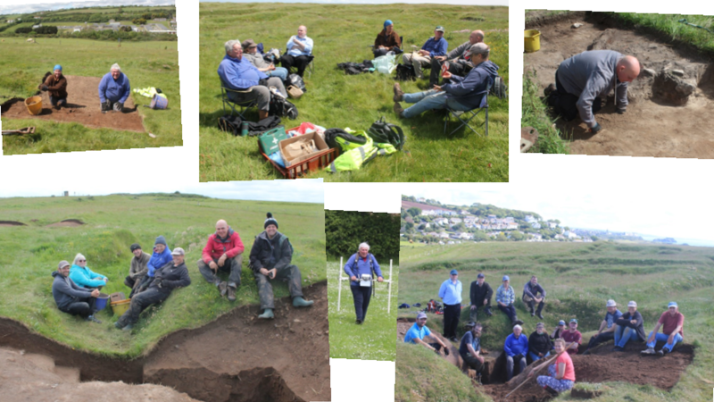
Fig 30. Memories. (Dyfed Archaeological Trust 2019).

Discussion.

Why dig up something which is already documented and relatively a modern monument?
The response from fellow volunteers such as Alison and Julian have drawn up a positive response in validating the original question and it is evident that they hold a deep value to the topic under investigation. This feedback shows that Alison and Julian have regarded the remnants of the past as a means for current objectives, as opposed to wanting to obtain a supply of information (Shanks 1992 p9). This information does not exclude archaeology as a science (Shanks 1992 p9), However, it does validate the value of community excavations on projects of modern military heritage within our surrounding communities. It has now been proven that the art of archaeology and the practice of obtaining information and background of an artefact is a more modern approach to archaeology, which acts as a valuable method of rehabilitation. All types of approaches of archaeology embody a variety of antidotes, remedies for extreme thinking, paradoxically within the means of obtaining understanding. Archaeology of today can act as a therapy (Shanks and Tilley 1987 p8). It could be said that archaeology is the root of the process which expands like a web of branches offering tangible and intangible heritage, generating, preserving, providing reflection, offering a service, giving Identity, exposing a value and giving rebirth to something which would have confidently been forgotten otherwise. Archaeology is a project of embodiment, which stretches the mind and offers sentimental connection and in some cases closure.
An objective of planning, preparation, presentation, and funding can consume more time of any excavation than the job itself, it is time consuming, costly and a drain on day to day resources (Organiser one 2019). It is common to plan a three weeks excavation over a twelve-month period to only find when you get the final decision on funding the whole project has be rejected (Organiser one 2019). What this shows is the waste of time and resources, causing frustration and the loss of time a team has undergone in preparation and investigation for that project. The planning for the excavation on the Penally World War One Practice Trenches had been in discussion since 2013, however, the financial submission was put forward by the Dyfed Archaeological Trust in 2017/2018 and from that the Defence Infrastructure Organisation, National Lottery Heritage Fund, Cadw, Pembrokeshire Coast National Parks, and Penally History Group supported the project (Pyper 2019). The financial support from these companies funding the community excavations provides a platform for projecting heritage and offering awareness from all walks of life. Not only does an event such as an excavation create an awareness of one’s surrounding heritage, it educates, it heals, it connects a community with the past creating a respect and understanding for those responsible for making a community’s history (Pearson 2006). Archaeology and excavation in the field is not just about recording or surveying. I argue that significant value comes from the unique experience of excavation. Excavation enables a shared experience involving members of the community, who develop the local heritage together. The importance of local heritage is demonstrated in this dissertation and it shows the hardship of past generations, it brings memories alive, bringing about a deserved respect of past people’s past, intertwined within the surrounding area and land (Pearson 2006).
The issue that has been discussed brings attention to the importance for archaeology as a constructive discipline. It acts as an education beyond its proficiency, as a therapy, as a method to rehabilitate or connect to a person’s past, such as Alison’s and Julian’s, that are mentioned in the case studies. My desire is to create awareness of the need for more community excavations, especially in Pembrokeshire as there is so much to excavate to generate more heritage consciousness within our communities. It is important to share the knowledge that is waiting to be discovered.

Conclusion.

This dissertation has validated the need to excavate modern military monuments and has argued the importance of community excavations within our towns and villages. What has been demonstrated is that a community’s deep rooted history is the underlying force of the people’s heritage. It is that heritage which can be excavated to be regenerated or analysed as part of a project, using the past to connect with people of the future. It gives education, exploring memory, opening discussion, whilst offering new skills, and bringing a psychological satisfaction. What has been shown are the values that connect the people when a community excavation is organised, those values offer to unite memories with a personal identity. Archaeology is there to record and to measure, to draw and to plan. However, what has been proved in this dissertation is that the empirical nature of excavation can contribute to communities, not only in a tangible way but an intangible way. This gives a comfort and a personal privilege of unearthing the past, by bringing people close to the reminiscences which they hang on to, to feel a sense of closeness to things that are lost and gone forever.

References.

Books.

Cossons, N. (2000). Power of Place: The future of the historic environment. 1st ed. London: English Heritage.
Davies, R. (1988). Old Pembrokeshire. 1st ed. Llandysul: Gomer Press.
Dudley, M. (2012). An Environmental History of the UK Defence Estate, 1945 to the present. London: Bloomsbury Publishing.
Fowler, P. J. (1995). The Past in Contemporary Society: Then, Now 2nd ed. London: Routledge
Gregner, M. and Ziino, B. (2012). The Heritage of War. 1st ed. London: Routledge.
Howard, P. (2003). Heritage: Management, Interpretation, Identity, 1st ed. London: Continuum.
Laws, E. (1888). The History of Little England beyond Wales. London: the British Library.
Pearson, M. (2006). In Comes I. 1st ed. Exeter: University of Exeter Press.
Sarkar, D. (1998). Missing in Action: Resting in Peace? 1st ed. Worcester: Ramrod Publications.
Shanks, M. (1992). Experiencing the Past. 1st ed. London: Routledge.
Shanks, M. and Tilley, C.Y. (1987). Social theory and archaeology. Cambridge: Polity Press.
Pearson, M. and Shanks, M. (2001). Theatre/Archaeology. 1st ed. London: Routledge.
Schofield, J. (2004). Modern Military Matters: studying and managing the twentieth-century defence heritage in Britain. 1st ed. York: York Publishing Services LTD.
Schofield, J. (2005). Combat archaeology material culture and modern conflict. 1st ed. London: Gerald Duckworth and Co limited.
Schofield, J. (2009). Aftermath: Readings in the Archaeology of recent conflict. 1st ed. Springer: New York.
Office, War. (1916). Notes for Infantry Officers on Trench Warfare. 1st ed. Uckfield: The Naval and Military Press.
Wessex Archaeology. (2004). Condition Survey and Desk-Bases Assessment, reference: 53268.02-Wessex Archaeology, Salisbury, Wiltshire.
Office, W. (1911). Manual of Field Engineering 1911. 2nd ed. Amsterdam: Fredonia Books

Internet Sources.
Archives Wales. 2019. online catalogue. [ONLINE] Available at: https://archives.wales/. [Accessed 14 October 2019].
https://assets.publishing.service.gov.uk/government/uploads/system/uploads/attachment_data/file/43344/dte_info_leaflet_pembroke.pdf

Email.
Pyper, A. (2019). Presentation Saturday. [E-mail] Message to KL Robinson (kimonthefarm@gmail.com). Sent 7th October 2019, 11.57am. Available at: Gmail.com [Accessed 7 October 2019].
Murphey, F. (2019). Volunteer Information Penally. [E-mail] Message to KL Robinson (kimonthefarm@gmail.com). Sent 14th May 2019, 4.27 pm. Available at Gmail.com [Accessed 22 October 2019].
Personal Communication, Non structured interviews.
Organiser 1, anonymous. (2019). Medium. Receiver of communication, 12 August.
Thomas, R, (2019). Medium. Receiver of communication, 20th June.
David, Penally History Society, (2020). Medium. Receiver of communication 7th October.
Julian, Operation Nightingale volunteer, (2019). Medium. Receiver of communication June.
Alison, volunteer, (2019). Medium. Receiver of communication June.

Images
Fig. 1, Co-ordinates, Coflein, (2020), PENALLY FIRST WORLD WAR PRACTICE TRENCHES [ONLINE]. Available at: https://coflein.gov.uk/en/site/268143/details/penally-first-world-war-practice-trenches [Accessed 17 October 2019].
Wikipedia, (2010), Wales Pembrokeshire locator map.svg [ONLINE]. Available at: https://en.wikipedia.org/wiki/File:Wales_Pembrokeshire_locator_map.svg [Accessed 17 October 2019].
Pin interest, (2020), Map of Penally [ONLINE]. Available at: https://www.pinterest.co.uk/pin/434386326555369044/ [Accessed 17 October 2019].
Fig. 2, Photograph of men digging trenches, Davies, R. (1988). Old Pembrokeshire. 1st ed. Llandysul: Gomer Press.
Toby Driver. (2019), Penally village [ONLINE]. Available at: https://coflein.gov.uk/en/site/268105/images/ [Accessed 17 October 2019].
Fig. 3, Penally Camp, Bell Tents. Thomas, Roger (2019).
Fig. 4, Plans for the Musket camps in Penally (National Archives 2019).
Fig. 5, Penally Camp accommodation, Thomas, Roger (2019).
Fig. 6, Wessex Archaeology. (2004). Condition Survey and Desk-Bases Assessment, reference: 53268.02-Wessex Archaeology, Salisbury, Wiltshire.
Fig. 7, Dyfed Archaeological Trust. Pyper, A. (2019). Presentation Saturday. [E-mail] Message to KL Robinson (kimonthefarm@gmail.com). Sent 7th October 2019, 11.57am. Available at: Gmail.com [Accessed 7 October 2019].
Fig. 8, Dyfed Archaeological Trust. Pyper, A. (2019). Presentation Saturday. [E-mail] Message to KL Robinson (kimonthefarm@gmail.com). Sent 7th October 2019, 11.57am. Available at: Gmail.com [Accessed 7 October 2019].
Fig. 9, Photograph of British troops loading a Vickers 2 inch Medium Trench Mortar Bomb Government, British. (1918). "The Great War" Volume 11 page 443, edited by H W Wilson. 1st ed. London: British Government.
Fig. 10, Location of excavation trenches, Dyfed Archaeological Trust. Pyper, A. (2019). Presentation Saturday. [E-mail] Message to KL Robinson (kimonthefarm@gmail.com). Sent 7th October 2019, 11.57am. Available at: Gmail.com [Accessed 7 October 2019].
Fig. 11, Protected Perimeter, Dyfed Archaeological Trust. Pyper, A. (2019). Presentation Saturday. [E-mail] Message to KL Robinson (kimonthefarm@gmail.com). Sent 7th October 2019, 11.57am. Available at: Gmail.com [Accessed 7 October 2019].
Fig. 12, Trenches 1,2,4, Dyfed Archaeological Trust. Pyper, A. (2019). Presentation Saturday. [E-mail] Message to KL Robinson (kimonthefarm@gmail.com). Sent 7th October 2019, 11.57am. Available at: Gmail.com [Accessed 7 October 2019].
Fig. 13, Office, War. (1916). Notes for Infantry Officers on Trench Warfare. 1st ed. Uckfield: The Naval and Military Press.
Fig 14, Office, War. (1916). Notes for Infantry Officers on Trench Warfare. 1st ed. Uckfield: The Naval and Military Press.
Fig. 15, Trench drawings 1,2,4, Dyfed Archaeological Trust. Pyper, A. (2019). Presentation Saturday. [E-mail] Message to KL Robinson (kimonthefarm@gmail.com). Sent 7th October 2019, 11.57am. Available at: Gmail.com [Accessed 7 October 2019].
Fig. 16, Trench 1, Drawing, Dyfed Archaeological Trust. Pyper, A. (2019). Presentation Saturday. [E-mail] Message to KL Robinson (kimonthefarm@gmail.com). Sent 7th October 2019, 11.57am. Available at: Gmail.com [Accessed 7 October 2019].
Fig.18, Trench 2, Dyfed Archaeological Trust. Pyper, A. (2019). Presentation Saturday. [E-mail] Message to KL Robinson (kimonthefarm@gmail.com). Sent 7th October 2019, 11.57am. Available at: Gmail.com [Accessed 7 October 2019].
Fig.19, Black and white: Echo, (1918), Carrying party of the 1/7th King's Liverpool Regiment, 156th Brigade, 55th division bringing up rations in containers to the men in the trenches in the La Bassee Canal Sector. [ONLINE]. Available at: https://www.liverpoolecho.co.uk/incoming/gallery/pictures-world-war-one-colour-7533649 [Accessed 20 October 2019].
Fig. 20, Trench 4, Dyfed Archaeological Trust. Pyper, A. (2019). Presentation Saturday. [E-mail] Message to KL Robinson (kimonthefarm@gmail.com). Sent 7th October 2019, 11.57am. Available at: Gmail.com [Accessed 7 October 2019].
Fig. 21, Wikimedia Commons contributors Publisher: Wikimedia Commons, the free media repository., (2015), British Vickers machine gun, shown set up for anti-aircraft purposes. Photographed circa 1914-1918. [ONLINE]. Available at: https://commons.wikimedia.org/w/index.php?title=File:British_Machine_Gun_LOC_ggbain_24930.jpg&oldid=153010274 [Accessed 24 March 2020].
Fig. 22, Zoom in of Ordinance survey map of Penally published in 1889, showing trench 3, (National Archives 2019)
Fig. 23, Full Map, Ordinance survey map of Penally published in 1889, showing trench 3, National Archives 2019)
Fig. 24, Alphonse-Marie-Adolphe de Neuville 1836-1885, (1880), Défense de Rorke's Drift. [ONLINE]. Available at: https://www.artgallery.nsw.gov.au/collection/?view=detail&images=true&dept=western/pre1900&db=object&browse=western/pre1900/browse&id=3225 [Accessed 23 March 2020].
Finds, Dyfed Archaeological Trust, Pyper, A. (2019). Presentation Saturday. [E-mail] Message to KL Robinson (kimonthefarm@gmail.com). Sent 7th October 2019, 11.57am. Available at: Gmail.com [Accessed 7 October 2019].
Author’s own plates of volunteers.
Fig. 25, Geophysical survey of Yeomanry Field by Charlie of the Dyfed Archaeological trust, Pyper, A. (2019). Presentation Saturday. [E-mail] Message to KL Robinson (kimonthefarm@gmail.com). Sent 7th October 2019, 11.57am. Available at: Gmail.com [Accessed 7 October 2019].
Fig. 26, Roger Thomas and his talks on the Penally Practice trenches. Authors own plates (2019)
BBC, (2020), Infantry soldiers lived in trenches for up to weeks at a time. [ONLINE]. Available at: https://www.bbc.co.uk/bitesize/topics/zqhyb9q/articles/zkqtrj6 [Accessed 24 March 2020].
Fig. 27, Primary School Children playing at Penally practice trenches, Centre Picture, Author’s own Plate. (2019).
Children playing at the practice trenches, Dyfed Archaeological trust Pyper, A. (2019). Presentation Saturday. [E-mail] Message to KL Robinson (kimonthefarm@gmail.com). Sent 7th October 2019, 11.57am. Available at: Gmail.com [Accessed 7 October 2019].
Hulton Archive, (2020), A British soldier inside a trench on the Western Front during World War I, 1914–18. [ONLINE]. Available at: https://www.britannica.com/topic/trench-warfare [Accessed 24 March 2020].
Fig. 28, Penally’s heritage on display, Authors own plates (2019).
Fig. 29, Volunteers, Authors own plates (2019)
Fig. 30, Memories, Dyfed Archaeological Trust. Pyper, A. (2019). Presentation Saturday. [E-mail] Message to KL Robinson (kimonthefarm@gmail.com). Sent 7th October 2019, 11.57am. Available at: Gmail.com [Accessed 7 October 2019].

Transparent plates.
Front Page, Plate 1. Royal Air force, (1947), Penally [ONLINE]. Available at: https://coflein.gov.uk/en/site/268105/details/penally [Accessed 10 October 2019].

