  Level 5 -ACCC5003 Network Operating System and Security - Assignment 2 | Abstract  Level 5 -ACCC5003 Network Operating System and Security  1813127_Wing Yan Yuen

Group 2

Wing Yan Yuen _ 1813127

University of Wales Trinity Saint David

Table of Contents
Abstract 3
Worksheet 1 4
Worksheet 2 5
Worksheet 3 6
Worksheet 4 6
Worksheet 5 7
References 8

Abstract

The Observational Tasks involve each student undertaking their own reading/literature review into the topics discussed. These tasks are to be completed strictly on an individual basis.

Worksheet 1

Building the NOS infrastructure using Active Directory

A). State the benefits of using Type 2 Hypervisor Virtualisation software in your design. Evaluate the strengths and weaknesses of the VirtualBox platform used in your network

Using the hypervisors can be able to address to many users in the organizations, even the big organizations or the small one. The functions are such as cloud computing, server management, and simply running programs which is compatible with an operating system you don’t have. It is very flexible, and it can be able to work from anywhere. The VirtualBox I were using is called VMware Fusion which is simply installed the window iso file and window server then I can easily to run the server-side and client-side operating. It may be a weakness which is the network connection. It has to rely on the stable connection of network in the reality.

B). Explain with use of diagrams the significance of the following terms, Active Directory Forests, Trees, Parent and Child Domains.

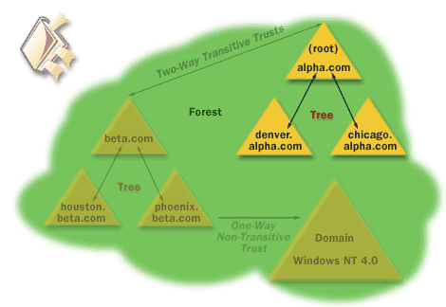Figure 1

In this diagram (Figure 1), it shows the Parent Domain (Windows NT 4. 0) then there are two child domains, (Alpha.com & beta.com). Then the Root develops two connections, becoming a tree.
In our domain, we set up a parent domain (UWTSD.com) and the set up another forest tree (msdsc.uwtsd.com) to manager different types of users. For example, our university has many campuses, a different campus has their own tree relationship diagram. It is easily to manager different types of data and personal details etc.

Trust relationship: A logical relationship established between domains that allows pass-through authentication, providing for users in a trusted domain to access resources in a trusting domain, without having a user account in the trusting domain

C). Investigate and document the main roles and responsibilities of an Active Directory Domain Controller

Active Directory is the central repository in which all objects in an enterprise and their respective attributes are stored. It is a hierarchical, multi-master enabled database, capable of storing millions of objects. Because it is multi-master, changes to the database can be processed at any given domain controller (DC) in the enterprise regardless of whether the DC is connected or disconnected from the network.

D). What actions could we take in the event of a Domain Controller becoming unavailable.

We can set up serval users from client-side computer to be the controllers. They have fully privilege to access the domain, making changes and managing the domain etc. the domain controllers can set up the controller’s privilege in group policy.

Worksheet 2

Resource Management in Active Directory: Users, Computers and Groups

Individual Observational Tasks:
1). Investigate the minimum password complexity requirements required as part of modern Network Operating System implementations.
I am using window 10. There are two types of password. One is simple pin number to access the window 10 when it starts the operating system. Another one is the account user. The password has to be matched the complexity that window setting. Here is the information from Window.
The password contains characters from three of the following categories:
- Uppercase letters of European languages (A through Z, with diacritic marks, Greek and Cyrillic characters)
- Lowercase letters of European languages (a through z, sharp-s, with diacritic marks, Greek and Cyrillic characters)
- Base 10 digits (0 through 9)
- Non-alphanumeric characters (special characters): (~!@#$%^&*_-+=`|\(){}[]:;"'<>,.?/) Currency symbols such as the Euro or British Pound are not counted as special characters for this policy setting.
- Any Unicode character that is categorized as an alphabetic character but is not uppercase or lowercase. This includes Unicode characters from Asian languages.

2). State the advantages and disadvantages of using Groups in Active Directory

Advantages:

It is a flexible system for group users. The users under the group can log in anywhere and anytime. The domain controllers easily manage all users to be different group to share several types of sensitive data. The big advantage is easily to share accouchements or data at the same time. Users get the information as same as other users in the group. The domain controllers can manage the privilege for users to access the sensitive data. Using AD (active directory) can be increase scalability.

Disadvantages:

It can be expensive as we need window server 2019 license and we have to upgrade our hardware to suit the requirements of the server. And it doesn’t suit for Mac operating system as well. It restricts the window operating system. (but not really with VirtualBox).
But the big disadvantage is about the network stability. Once the network is not stable or under maintenances, all users under the AD won’t be able to use any services from the domain.

Worksheet 3

Resource Management in Active Directory: Managing access to files /folders and controlling domain user environments

a). Discuss the two different types of permissions in use within windows network environments

In general, permissions enable users to perform specific actions on computer resources like files or folders. Permissions are always assigned to resources, and not users. Permissions are given by users, typically administrators, which have a permission to edit permissions.

In Task 3, we set up the file who was given the fully access by administers then we set up other users for the access only “read”. Mainly two types of permissions in use, administers and users.

b). Evaluate the benefits of the NTFS File system in comparison with other network operating system’s file systems

The inherited permissions are set on the parent object. The “allow” permission will grant specific permission for specific user, group or computer. The “deny” permission will do the opposite. The file owner can always change the NTFS permissions, even if we specifically deny access to the file itself. We have to take ownership of the file, which allows us to become the owner of the affected files. Like we did in the task 3, we set up the privilege access for the administers and IT users. The normal users only read the file which we share to the group.

c). Identify the main benefits of using groups in an Active Directory domain.

As we mentioned the benefits of using AD domain, the users can access the same files with certain access and they can read the file or log in whenever they want and wherever they are. It is very flexible for users to work at their home.

d). Discuss the benefits of using Group Policy and Organisational Units to manage a domain’s
resources.

First of all, manging the network in the organization unit becomes a lot easier if we have all of our users connected through group policy. We can manage their access and view who has been changing or read the resources. The domain controllers can be able to manage the resources with certain users. you can implement company-wide policies such as certain web restrictions to prohibit staff from accessing particular websites.

Secondly, Network security is a huge priority for all businesses. we can use Group Policy to set requirements for when users set their passwords. You can require the use of both capital and lowercase letters, numbers, and/or symbols, or even restrict unidentified users from remote computers to access our group or domain.

Thirdly, the main benefit is that using the group policy is easier to save the cost and time. Mainly the time with the resources shared in the group.

Worksheet 4

Planning and Deploying DNS in the network infrastructure

Q). State some principal advantages of using the DHCP service in network infrastructures.

DHCP is a service that automatically assigns an IP (Internet Protocol) number to the computer that requests it
All IP assignments depend on the DHCP Server. So, if the DHCP server is problematic, all of the computers in the network then will not get IP from the Server. And therefore, the network will not connect or not work properly.
Therefore, DHCP Server must be maintained properly in order to the computing system in your office wouldn’t be disturbed.
If a computer is connected to 5 to 10 computers in a network, using a manual IP isn’t a problem and will not onerous. But when the computer is connected to hundreds or thousands of computers in a network, DHCP is really recommended to reduce the complexity of IP configuration on the computer.

Q). With the aid of diagrams, explain the 4 stages process involved with assigning DHCP
Clients with IP addresses. You should describe the stages that both client and server
enter, and the processes involved.

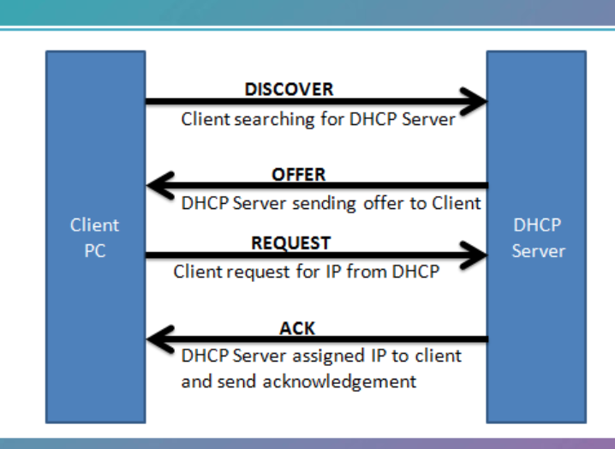 Figure 2

DHCP job is to assign IP addresses, subnet mask, gateway and other options to clients requesting DHCP service.

The figure 2 shows that the process of getting an IP address from a DHCP server involves 4 steps and called DORA.
DHCP uses port UDP 67 DORA stands for Discover Offer Request Ack First the client sends DHCPDISCOVER broadcast (IP 255.255.255.255) message.

DHCP Dora process is handling by a SERVER called DHCP SERVER that dynamically distributes network configuration parameters, such as IP Addresses for interface or services

Q). What are some of the potential threats/dangers that could occur when using a DHCP
service.

If attackers are able to compromise a DHCP server on the network, they might disrupt network services, preventing DHCP clients from connecting to network resources. By gaining control of a DHCP server, attackers can configure DHCP clients with fraudulent TCP/IP configuration information, including an invalid default gateway or Domain Name System (DNS) server configuration.
There are several types of threats:
Firstly, Unauthorized DHCP servers can issue incorrect TCP/IP configuration information to DHCP clients.
Secondly, DHCP servers can overwrite valid DNS resource records with incorrect information.
Thirdly, DHCP can create DNS resource records without ownership defined.
Fourth, Unauthorized DHCP clients can obtain IP addresses ...etc

Worksheet 5

Network Administration using DHCP

Q1) Describe how the Recursive Query and Iterative Query Processes resolve DNS Client Requests?

A recursive query is a kind of query, in which the DNS server, who received users query will do all the job of fetching the answer, and giving it back to users. During this process, the DNS server might also query other DNS server's in the internet on users behalf.

Suppose the user wants to browse www.example.com, and user resolve.conf file has got the following entry.
[root@myvm ~]# cat /etc/resolv.conf
nameserver 172.16.200.30
nameserver 172.16.200.31

In an iterative query, the name server, will not go and fetch the complete answer for users query, but will give back a referral to other DNS server's, which might have the answer. In the previous example our DNS server 172.16.200.30, went to fetch the answer on behalf of the resolver, and provided users with the final answer.

Q2) Explain the significance of root hints and how this process enables us to resolve names that are not managed (or kept in an authoritative DNS server in our network)?

Q3) We have a Server called Server1, this server will be hosted in a subdomain called ‘subcontA’ with a root domain called nwtraders.msft, answer the following questions:

(1). What is the exact FQDN for this host.

nwtraders.msft

(2). Illustrate how the Domain Name System breaks up this FQDN into Host and
Domain Namespace.

Q4) Explain how DNS Zones are used in DNS, give examples to illustrate the use of multiple
zones and how these can be used to manage resource records of domains. What
important factors/characteristics do we need to be aware of?

References:

https://www.dnsstuff.com/what-is-hypervisor

https://www.distributednetworks.com/active-directory/module2/domain-forest.php

https://support.microsoft.com/en-gb/help/197132/active-directory-fsmo-roles-in-windows

https://docs.microsoft.com/en-us/windows/security/threat-protection/security-policy-settings/password-must-meet-complexity-requirements

