

LEVEL 4

SEMESTER 1

MODULE CODE: SHSS4077
Making Safety Personal
aSSESSMENT TYPE: Project
Assessment/Component: 2

COMPONENT WEIGHTING: 30 %

WORD COUNT: 1,500 WORDS

MODULE TUTOR: Graham Harvey

SUBMISSION DETAILS:
Work as part of a small team (between three and five people) to produce an interpretive brochure/ leaflet/ poster relating to a site that you have visited for outdoor pursuits.
Your publication MUST provide details of:
- the natural environment at the site (specific species, ecosystems etc.).
- how outdoor practitioners should behave at the site in order to minimise their environmental impact
- key safety considerations for individuals participating in specific activities at the site
Each team member will submit a copy of the completed leaflet AND a 500-word summary/ reflection of his or her personal contribution to the project. The summary must also include a full list of reference material used in preparing the leaflet.
Submit via Turnitin
6th December 2019

School of Sport, Health & Outdoor Education

Assessment Feedback Sheet

Student No./ Name:

Personal Evaluation – to support your academic progress please complete the section below BEFORE submitting your work.
What do you consider to be the best aspects of this work? |  |  | I like the design of the poster and the ratio of written work to pictures.
Which aspects do you consider could have been improved in this piece of work? |  |  | I think that the poster could have been more specifically orientated to an outdoor activity instead of an overview of the area.
What have you found most satisfying whilst undertaking this submission? |  |  | I’ve found the researching a local place to be quite interesting as it’s given insight to the area around where I am living and made me want to go and visit the place for myself.
ASSESSMENT CRITERIA | Learning  Outcomes |  | GRADE
ASSESSMENT CRITERIA |  |  | Poor  < 20% | Weak  20-29% | Unsatisfactory  30-39% |  | Satisfactory  40 – 49% | Good  50 – 59% | Very Good  60 – 69% | Excellent  70 – 84% |  | Exceptional  85– 100% | %
Identify the key natural features of the chosen site | 4 |  |  |  |  |  |  |  |  |  |  |  | 20%
Clearly outline a code of environmentally sensitive practice for outdoor practitioners s using the site | 1,4,5 |  |  |  |  |  |  |  |  |  |  |  | 20%
Clearly outline safety guidelines for individuals participating in outdoor activities SPECIIFCALLY at the site. | 1,2,3,4 |  |  |  |  |  |  |  |  |  |  |  | 20%
Reflection on personal contribution to the project | 1 |  |  |  |  |  |  |  |  |  |  |  | 20%
Evidence of research and reading relevant to both the activity and venue | 2,3, 4, 5 |  |  |  |  |  |  |  |  |  |  |  | 20%
It is expected that students will present work that is proof read, correctly referenced and adheres to the Assessment Checklist. Therefore a range of 0 – 10 marks will be deducted for non-completion of any of the points on the checklist below.
TUTOR COMMENTS:

Submission date:  via Turnitin |  | Return date:  (at least within 4 weeks) |  |  |  | Tutor: |  |  |  |  | Mark:

Assignment Checklist

- Please complete the Personal Evaluation section of the Assessment Feedback sheet, add your name and details, and paste the whole of this assignment document into the front of your assignment

- Submission is a single word file, clearly labelled with your name and module code
- Font style - Times New Roman, size -12 for text and 14 for headings
- Ink colour – black only
- Line spacing – 1.5 line spacing and 2cm- 2.5cm page margins
- Quotations more than three lines to be indented 1 line spacing
- One line space between paragraphs, paragraphs must be left aligned
- Pagination (your assignment should have page numbers)
- All tables and figures are internally referenced and have a title
- Word count checked and written at end of text (before references and any appendix)
- Assignment is within 10% of the word limit (excluding references and any appendices)
- All references in the text are included in the reference list
- Correct referencing following the Harvard style, as described in the Palgrave study skills book ‘Cite them Right’.
- Correct spelling using UK English
- Correct use of punctuation
- Grammar and syntax correct- double check anything that has a green line under it
- I have read my assignment out loud to myself and it makes sense and is easy to read
- Somebody else has read my work and it makes sense to him or her!
- I have checked and I have not plagiarised
Failure to follow these guidelines will cost you marks
I grouped with Daniel and Isaac in to make the poster for a specific venue. We decided early on that we were going to do Llansteffan a local beach that’s located 8 miles from Carmarthen. We found it hard in the beginning to get together and make a start on the poster as we were preoccupied with other assignments. We decided in a group chat that we would each choose a topic and do some independent research before coming together and making a start.

I decided to do wildlife that could be found on walks and in the area. I found this fairly difficult as there were only a couple of sites that offered broad information on what could be found in the south of wales. It took me some time to find anything that was specific to Llansteffan. No one in the group is able to drive, which made visiting the area hard. There were some plans to visit through the course and the outdoor adventure society. Unfortunately, I wasn’t available when they were going as I was either ill or at home. I tried to make plans with a friend of mine but her car broke down when she came.

We were able to meet as a group and pool the information that we had gathered we used Isaac’s laptop. Whilst Isaac and Daniel designed it I tried to do some research on the safety precautions that you need to take when on the beach. This worked well and we were able to get the bones of poster done. This made it easier to see what we needed to do and how the poster was going to shape up.

Again, we decided what information needed to be on the poster and where it needed to go, we each did some independent research and came back to pile it on to the poster again. I found some pictures that we could use. Whilst we were all together we got the main bulk of the poster done I was able to write the Safety information and environmental code of conduct.

Personally, I think that I could have done a better job by making more of an effort to go to the site that we had chosen, I was the only one in the group that had not visited the site. This made it hard to visualise what the site, and made the internet the only source that I could use for pictures and to gather information. I think I could have also done more research in my own time as when we came together I didn’t have much to say about the wildlife even though that’s what I said I was going to research. Other members in the group did the wildlife page whilst I focused on other areas. As a group I think it would have been better to meet more frequently giving us more time to plan a visit. It would also give us more time to plan the poster and discuss ideas.

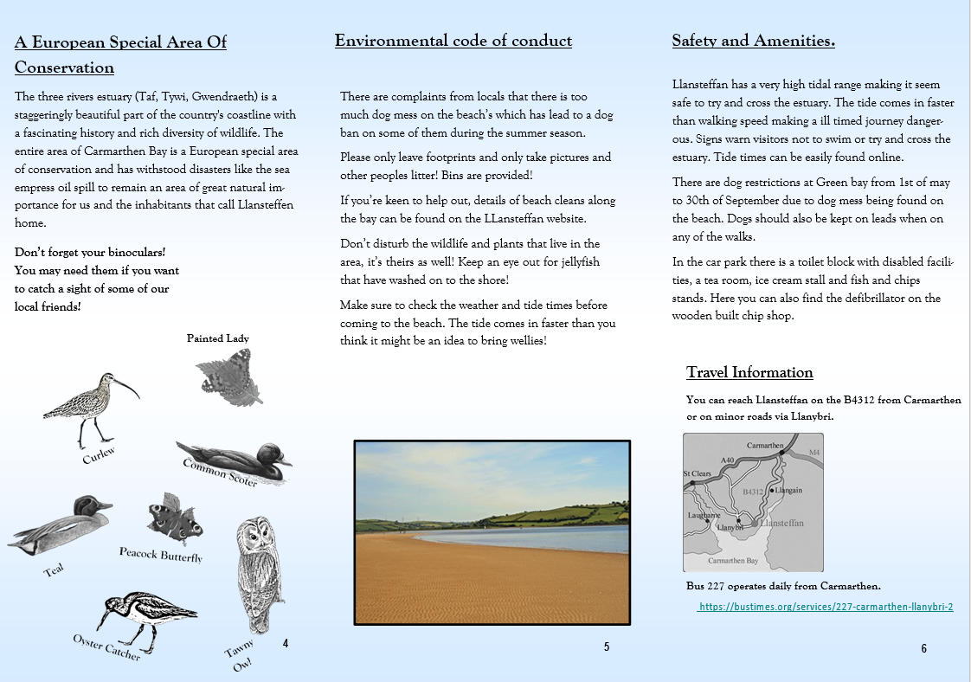
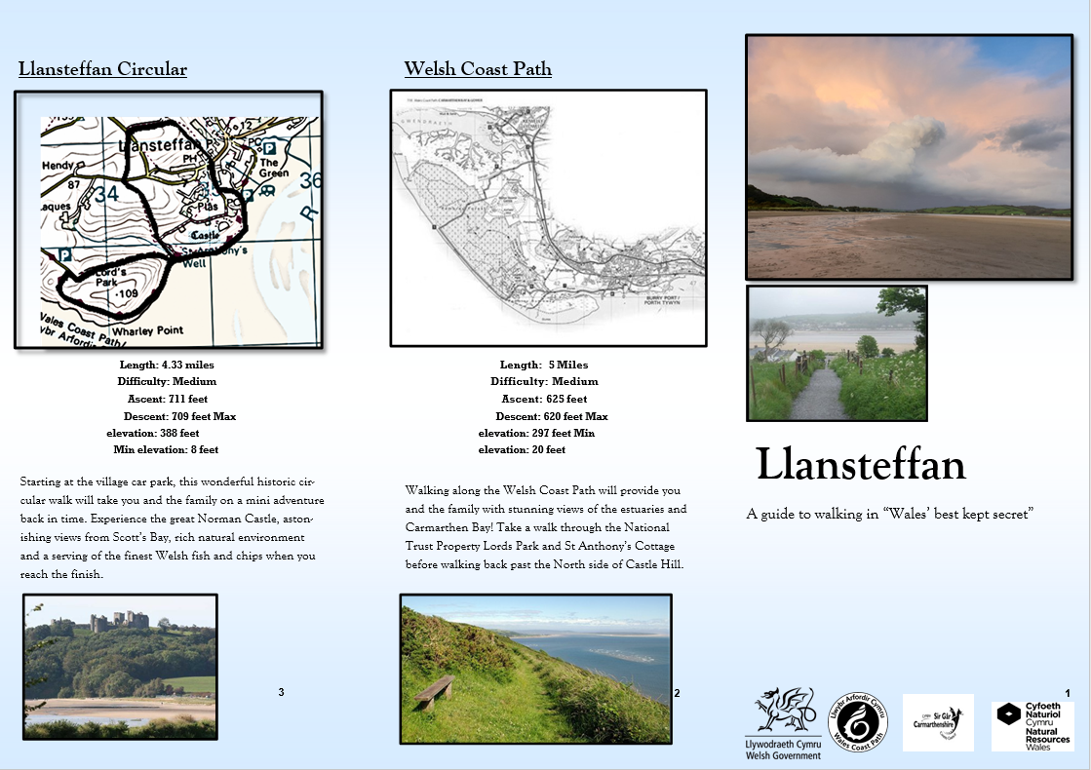
Reference List:

Carmarthenshire County Council (ND) Carmarthenshire Nature Recovery Plan. Available at: https://www.carmarthenshire.gov.wales/media/1218310/coastal-habitats.pdf (Accessed: 3rd December 2019)
Carmarthen Bay & Estuaries European Marine Site (2019) Pressures and Threats. Available at: http://english.cbeems.org/the-ems/pressures-threats/ (Accessed: 3rd December 2019)
Llansteffan Tourism Association (2016) Welcome to Llansteffan. Available at: http://www.llansteffan.com/ (Accessed: 4th December 2019)
The Castles of Wales (2009) Llansteffan Castle. Available at: http://www.castlewales.com/llanstef.html (Accessed: 3rd December 2019)
Tide Times (2019) Ferryside Tide Times. Available at: https://www.tidetimes.org.uk/ferryside-tide-times (Accessed: 3rd December 2019)
Walk the Wales Coast Path (2019) Keeping Safe on the Wales Coast Path. Available at: https://www.walkthewalescoastpath.co.uk/keeping-safe-on-the-wales-coast-path/ (Accessed: 3rd December 2019)
Walk the Wales Coast Path (2019) Walk the Wales Coast Path from Llansteffan to Ferryside via Caerfyrddin (Carmarthen). Available at: https://www.walkthewalescoastpath.co.uk/routes/walk-the-wales-coast-path-from-llansteffan-to-ferryside-via-caerfyrddin-carmarthen/ (Accessed: 3rd December 2019)
Walk the Wales Coast Path (2019) Walk the Wales Coast Path from Laugharne to Llansteffan. Available at: https://www.walkthewalescoastpath.co.uk/routes/walk-the-wales-coast-path-from-laugharne-to-llansteffan/ (Accessed: 3rd December 2019)

