BMSW5104
Managing Projects in the Organisation

Student name: IONUT DINU
Student ID:1812392
Lecturer name: Yajesh Kumar

Executive Summary
The organisation recruits skilled employees so that by using their knowledge and skill the company can be beneficial. Companies use the employee’s skill and knowledge to conduct projects in the organisation. So, project management is an important part of the organisation and the project manager needs to demonstrate effective skill and knowledge to manage different projects. The project manager needs to share effective skills and have knowledge about project management tools and techniques to manage projects in the organisation successfully. This report will outline a different way to manage the project in the organisation and the skill required by the manager for successful project management.
Table of Contents
Executive Summary 2
Introduction 4
The usefulness of project management tools and techniques 5
Work Breakdown Structure 5
Gantt Chart 6
Critical Path Method 6
Program Evaluation and Review Technique 7
PI Matrix 7
Implementation of a project within the workplace 7
Project Goal 8
Project Deliverables 8
Stakeholder Mapping 8
Stakeholder Communication 9
Project Schedule 11
Project Cost 12
Risk Management 12
Project Communication Method 14
Kotter’s Change Management Model 15
Implementing the project change management for the selected organisation 16
Critical evaluation of the ability to manage a project 17
Project manager skills for managing Projects 17
Personal Development Plan 18
Conclusion 20
References 21

Introduction
Every organisation needs to conduct a project for their benefit because project helps an organisation to solve a different problem. When managing the project, employees in a company plays a crucial role because their characteristics help the organisation to conduct the project. However, the project planners also need to ensure suitable tools and techniques of project management, rather the project can be unsuccessful. The project ensured is this project and overall knowledge provided in this essay is based on the working experience in Virgin Active. Appropriate project management tool and techniques are used for this purpose and their advantages and disadvantages are also discussed.

The usefulness of project management tools and techniques
Project management is an art which requires completing a project by ensuring organising, leading and reporting skill (Heerkens, 2015). Project is the way to plan the activities of an organisation, hence, the outcome can be easily calculated. For instance, an organisation such as Virgin Active that is a health club ensures different project such as marketing campaign, making exercise irresistible and ensuring exercise equipment that helps the customers to keep fit. Moreover, if the manager of Virgin Active plans to do anything which will benefit their customers, stakeholders and organisation it will be considered as a project. Successful management of a project is beneficial for any organisation as it ensures effective use of the organisation’s resource. Moreover, it helps the organisation to achieve the desired goal.
According to Lock (2000) to manage a project in an organisation, a project manager needs to share qualities such as effective communication skill, leadership skill, problem-solving skill and good decision-making skill. Moreover, the project manager needs the knowledge of project management tools and techniques such as Work Breakdown Structure, Gantt chart, Critical Path Method, Program Evaluation and Review Technique, PI Matrix, Risk Register and Feasibility Study (Silvius, Schipper and Van den Brink, 2012). These tools and techniques are used to ensure successful completion of the project, to maintain quality, to reduce possible risk and to ensure complete the project within the projected time. Below the usefulness of these project management tools and techniques are discussed that I experienced while working in Virgin Active along with their advantage and disadvantage-

Work Breakdown Structure
Work Breakdown Structure is an important project tool when managing a project. From the experience, while working in Virgin Active, it can be said Work Breakdown Structure has many advantages. For instance, it helps to break down major tasks in small parts, therefore, handling or completing the tasks become easier (Deeprose, 2002). Moreover, Work Breakdown Structure shows the activities need to be completed in a project, hence, no tasks are avoided and the project completes successfully. For easier understanding, Work Breakdown Structure is presented as a diagram so the project manager does not need to go in detail, rather, he can just look in the diagram to understand which works needs to be completed and which tasks are the priority. However, there are some disadvantages also. For instance, the employees engaged with the project can feel the pain to complete plenty of tasks at one go, without detail description the manager can get distracted to understand a task, moreover, the step by step task can be a pain for employees as they may demand to complete the easier tasks first (Baguley, 2008). An organisation such as Virgin Active uses this project management tools to manage their projects. For instance, if the organisation needs to ponder a better system to attract people towards fitness club, then, the organisation uses this tool to describe the task needs to be done to attract the people in the society.

Gantt Chart
Gantt Chart is another project management tool which is useful to complete the activities of a project within a time. Gantt chart is used in a project to demonstrate the amount of activities that need to be completed within a project time. Gantt chart is a project also helps to set a milestone for the activities, hence, the employees engaged with the project can easily complete the tasks. The advantage of using the Gantt chart is it describes the part of the project already achieved and the part of the project needs to be completed. Moreover, Gantt chart helps to reduce extra cost because when the employees working in a project will follow Gantt chart, they will ensure to conduct the activities within the projected time, hence, the extra cost can be easily reduced. An organisation such as Virgin Active uses this project management tool to reduce the cost of the project and to complete the project within time. However, there are some disadvantages also. For instance, it creates pressure on the employees, hence, the work quality can get affected. Moreover, the chart needs to be constantly updated to describe the amount of task needs to be done.

Critical Path Method
Holmes (2002) defines Critical path method is the way to define the longest path project manager can need to complete a project. However, by analysing the longest path, the project manager can find out the minimum time requires to complete the project. Hence, planning the budget becomes easier. The advantage of this technique is it helps the manager to reduce timelines, moreover, with the help of this technique project manager can compare the planned progress and actual progress of the project. The biggest disadvantage of Critical path method is it can be used for a big project. For instance, if the organisation Virgin Active wants to operate its activity in a new place, then this technique cannot be used to analyse the time required to operate activities in a new place. Moreover, if the project manager uses this technique, it is difficult to start the second task before completing the first task because the activities are related to each other.

Program Evaluation and Review Technique
Program Evaluation and Review Technique is similar to the Gantt chart and CPM method which is also defined as PERT techniques. The advantage of using this technique is, the project planner can analyse the required task needs to complete the project. Moreover, the technique specially defines the time requires to conduct each task and also identifies the minimum time requires to complete the whole project. The disadvantage of this technique is it is mostly time focused, moreover, when the project manager needs to share resources between two projects this technique cannot be used.

PI Matrix
Lewis (2017) defines PI Matrix or probability impact is the tool to analyse the risk associated with a project. Project planner uses this tool to identify the high, medium and low impact of risks on the project. The advantage of PI Matrix is it helps the project planner to plan and create a risk response plan to manage the project risks suitably and enables the project management team to complete the project smoothly. The disadvantage of PI Matrix is it often avoids big risks; hence, it can lead to bigger issues. For instance, in April 2014, three customers of Virgin Active got injured when the suspended ceiling collapsed. However, this matrix is most effective when focusing on individual risks.
So, from the above discussion, it is clear that project management tools and techniques are important for project managing. Because, these tools and techniques help to reduce cost, risk and ensure successful completion of the project.

Implementation of a project within the workplace
Virgin Active is a health club that provides the scope to its customers to keep fit. The organisation offers different program so that customers of different age can enjoy sound health. The company is planning to conduct a project to increase customer flow and aware people about the importance of sound health. For this purpose, the project planner has to follow different steps to complete the project. Moreover, it is also needed to discuss the plan with the stakeholders of the organisation such as employees, investor, government agencies, shareholders and customers. Below a detailed plan of this project is provided along with the discussion about the way the plan is going to be implemented.

Project Goal
The setting project goal is the first step in the implementation of a project. In this case, the goal needs to be clear so that the associated stakeholders can understand the aim of the project and the result the project will achieve (Milosevi and Srivannaboon, 2006). In the term of setting goal, if it satiates the need of the stakeholders, then the chance of project success increases. For instance, the goal of this project is to increase customer flow and aware people about the importance of sound health. The stakeholders will be benefitted by the goal of this project because the owner will be benefitted with increased profit, the customers will get sound health and the employees can have the scope to get rewards.

Project Deliverables
In the project deliverables, the project planner needs to set some objectives that the project needs to achieve to meet with the goals. This way, the employees working for the project gets to know which work is the priority and needs to be done. Moreover, the project manager gets the scope to organise which employees will conduct which work and can lead them accordingly for the successful completion of the project. The objectives of this project of Virgin Active are-
- Ensure social media marketing to aware people about good health.
- Provide suitable offer for the customers that can create interest in them to join the fitness club.
- Ensure different departments for the women, men and adults so that all of them can exercise differently.
- Ensure suitable equipment’s to reduce risk in the fitness club.

Stakeholder Mapping
Stakeholder mapping is an important part of any project because when the project manager can identify the stakeholders, it will be helpful to manage their expectations suitably. Moreover, engaging with stakeholders can help the project manager with creative ideas and invaluable insights. By identifying the stakeholder, it will also get easier to select an appropriate communication path, hence, misconception can be reduced. Below the tool is showed that can be used for stakeholder mapping-
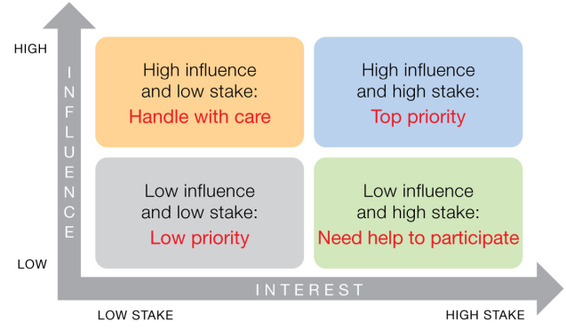
Figure 1: Stakeholder mapping- power and interest
(Heerkens, 2015)
Based on the above tool, it can be said that a project has stakeholders that have both interest and power on a project. So, by identifying the stakeholders it can be easier to manage them. For instance, the organisation Virgin Active wants to conduct a project which is to aware people through social media about the importance of exercise and fitness, moreover, the organisation ensure advertisement that will engage customers with the organisation. In this case, government agencies are key stakeholders that have a high influence on the project but low interest. To meet with their expectations, the project manager needs to ensure a project plan that does not violate the rules and regulations of that community. The rivals of Virgin Active are also a stakeholder of the company, so they can be put in the second quadrant. They will be given low priority as they cannot affect the project directly. However, employees, investors and shareholders are a major stakeholder of this project and they need to be managed carefully. Their influence and power on the project are high, hence, they can be put in the third quadrant. Customers are also major stakeholders of this project; hence, they can be put in the fourth quadrant. In this case, the project manager needs to inform details about the project to them, so that they can be engaged with the project.

Stakeholder Communication
Communication with the stakeholders is part of stakeholder management in project management. As different stakeholders contribute to the project in different ways, it is needed to maintain a good relationship with them with the help of flawless communication. An organisation such as Virgin Active manages big projects so the communication plan with the stakeholders also needs to be creative, hence, misconceptions can be avoided effectively. The major stakeholders of the Virgin Active project are government agencies, investor, shareholders, local companies and employees. So, the project manager needs to make a communication plan that will outline the individuals that are given priority for communication (Deeprose, 2002). For instance, the plan will show, the stakeholder to communicate, the reason for communication and the medium will be used for communication and how often the communication will take place. So, with this communication plan, the project manager can manage communication with important stakeholders throughout the project, hence, valuable insights can be gained and the project will also be successful. Below a stakeholder communication plan for the project of Virgin Active is provided-
Audience | Message | Medium | Schedule
Top Management | Budget, Changes needed in the project plan, Strategies, Issues, Technological Requirements, Project report | Meetings, Formal Paper, Based Reports | Weekly
The Project Team | Roles, Responsibilities, Progress Reports, Issue resolution | Meetings, Demos, Bulletin Board, Workshops, Email | As required
Project Manager | Goals, Deliverables, Timetables, Risk, Budget, Competencies | Meetings, Formal Paper, Based Paper, Progress Report | As required
Resource Manager | Budget, Scope, Project Overview | Email, Meetings | Weekly
Government Agencies | Project Overview, Process, Regulations, Safety Act | Email, Meetings | Weekly
Customers | Project Objectives, Customer benefits, Timeframe | Social Media, Email | Weekly

Project Schedule
To manage a project, it needs to plan the activities that will be carried out throughout the project. For this purpose, the WBS tool, Gantt chart is required to plan the activities and also for defining the time requires to complete each task (Milosevi and Srivannaboon, 2006). When the project tasks will be defined, the project manager can define the resources needs to complete each of these tasks, hence, the budget can be presented to complete the project. Moreover, after defining the project tasks and time required to complete each task, suitable employees can be selected that can complete the project suitably. Below a WBS of this project is provided-

After defining the task, it is required to present the Gantt chart so that the employees can be well aware of the time to complete each task of the project. The Gantt chart is effective to reduce the project cost, moreover, the Gantt chart helps the project manager to complete the project within time. Below a Gantt chart of this project is provided-

Project Cost
The project cost defines the required resource requires to complete the project. In this case, the project planner defines the cost by focusing on each task of the project. The budget plan for this project is provided below-
Initial investment | Cost
Advertisement Cost | 150 €
Employee Cost | 300 €
Technology Cost | 350 €
Equipment Cost | 200 €
Research Cost | 170 €
Total | 1170 €

Risk Management
Risk management is the process of identifying, controlling and assessing possible threats of the project (Heerkens, 2015). Some risks of the project include, the goal and objectives of the project are not well-defined, project timeframe is not clearly defined, no control over employees and employees have a lack of skills and competencies. Moreover, managing risks of the project also give the demonstration of the project management skills and knowledge. Absence of leadership skill of the project manager can be a suitable reason most risks are unseen when managing a project. The possible risks for a project can be market risk, financial risk, technology risk, people risk and process risk. However, a project manager can use a risk breakdown structure to identify possible risks of a project. Below a risk breakdown structure is provided-
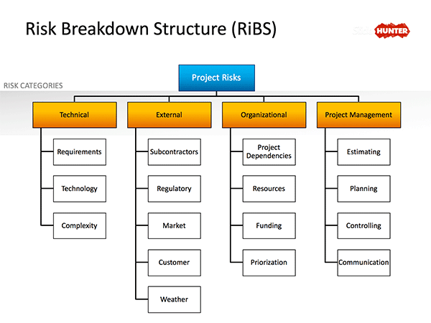
Figure 2: Risk Breakdown Structure
There are also other ways to identify risks in a project. For instance, the project manager can ensure SWOT analysis, Brainstorming and the Delphi Technique to identify the risks associated with a project (Deeprose, 2002). With the brainstorming technique, the project manager can generate ideas to find the solution of a wide variety of problems, moreover, the project manager also can apply experienced facilitator to generate amassing ideas to solve specific issues. For instance, if the project manager of Virgin Active face issues such as technological attachment, he can brainstorm to afford the best technology that will attract customers to engage with the health club. SWOT analysis is also helpful to identify risks of the project and it can also assess to identify strength, weakness and opportunities of a project. Below a risk management plan is provided-
Steps of the risk management plan | Risk management process
Step 1: Risk identification | Virgin Active and its project manager identify the risks in this step before starting the project. The identified risks are poor communication approach, busy timeframe, poor cash flow, lower compliance with regulations and lower skills of the employees.
Step 2: Risk analysis | Most of the problems come from ineffective financial, business and human resource management.
Step 3: Risk management tools evaluating | To manage the risks, the project manager will use data analysis techniques to document the project assumption league, risk register and overall reports.
Step 4: Risk management tools selection | To identify the risks, project manager conducts root cause analysis, SWOT analysis, probability calculation and matrix calculation.
Step 5: Risk monitoring and control | The project manager will monitor the internal and external project environment, drivers of project plan changes and cost escalation and actions of competitors.

Project Communication Method
Communication is an important part of project management because for completing the different task, resolving issues or to make changes in the current plan, project managers need to communicate with different stakeholders (Heerkens, 2015). Below different communication methods are described that can be used to manage projects in the organisation-
Face to Face Communication
Face to face communication is the method when project managers communicate with the stakeholders directly. In face to face communication, 58 % of communication takes place through body language, 35 % of communication takes place through words are said and the rest is through the content or words that are spoken. This is an effective method of communication as the stakeholders can understand a lot and if they need to ask any question, they can also ask directly.
Electronic Media
The project manager also can use different electronic media for communication. E-mail, video call and instant texts are some of the ways to communicate through electronic media. This type of electronic media is used to distribute short information. However, in the case of using electronic media, the project manager needs to ensure he has good knowledge about the medium, because, if the information is sent to the wrong pupil it can be a risk for the project. Moreover, an appropriate sentence and words need to be used so that the receiver can understand appropriately the information sent by the sender.
Written
Written communication is used by the project manager in a specific situation. For instance, if the project manager wants to communicate with the resource manager regarding project budget, he ensures written communication. In this case, a written budget plan is submitted and a formal report is sent to the top management so that they can be also aware of the budget (Silvius, Schipper and Van den Brink, 2012). Moreover, to draft the project plan and to ensure the project objectives and schedule is acknowledged by all the stakeholders, written communication is used. The documentation helps to avoid forgetting small tasks and if the project manager wants to change the project plan, he can change the plan suitably with the help of written communication.

Kotter’s Change Management Model
Kotter’s change management model is used to embed change effectively in the organisation. The model consists of eight steps; however, the first step is crucial among these steps. According to Kotter, if an organisation needs to set change, 75% of the company’s management has to be on board, therefore an urgency will create which will help the organisation to set the change. Below the eight steps are described-
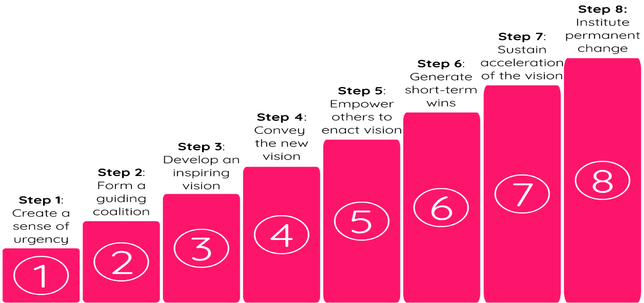
Figure 3: Kotter’s Change Management Model
(Baguley, 2008)
The first step of the change model is to create a sense of urgency. So, at first, the project manager has to make stakeholders understand the importance of the change in the organisation and the way they will be beneficial from the change. In the next step, Kotter’s propose to form a guiding coalition. A project manager cannot embed change alone, hence, it is needed to identify key people that can help embed change into the organisation. The third step is developing an inspiring vision. When the stakeholders will understand the way, they will be benefitted from the change, they will not insist to embed the change into the organisation. The fourth step is to communicate the vision to the stakeholders; hence, they will know about the benefit of the change. In the next step, the project manager needs to encourage the stakeholders to enact vision. That means the project manager has to help others to avoid any kinds of obstacles. The next step is creating short-term wins. So, the project manager needs to make people aware of the benefit of the change after each phase of the project. The seventh step is to sustain the vision. That means the project manager needs to repeat the above steps to keep the stakeholders motivated. The last step is to anchor the change. That means the project manager needs to support the change continuously so that the change can be seen in every aspect of the organisation.

Implementing the project change management for the selected organisation
The organisation Virgin Active wants to embed change into their organisation which is to change the way of attracting customers to the organisation. For this purpose, Kotter’s change management model can be applied to embed change in the organisation. At first, the project manager needs to ensure a meeting with the top management of the organisation to discuss the benefit of the change for the organisation. For instance, the organisation wants to use social media and give special services to customers to increase customer flow. This is a big change for the organisation as the employees only know the old way of advertisement which is giving advertisement in the newspaper or to provide leaflet. This traditional way is costly for the organisation and the owner and other stakeholder gets less benefit. So, it is necessary to embed change in the company to reduce advertisement cost and increase profit margin. In this case, the project manager will identify some skilled employees to work critically and help the organisation to embed change (Silvius, Schipper and Van den Brink, 2012). Next, the project manager will plan the vision which has to be short and easily understandable. After that, the project manager will discuss the benefit of the change to the stakeholders so that they get influenced. Therefore, the project manager will work with the employees to remove any obstacles that can impede the change. The project manager of Virgin Active also needs to ensure short-term wins so that the employees stay motivated. However, the project manager needs to motivate the employees continuously so that the short-term wins do not deceive them, hence, the project manager can embed change into the organisation.

Critical evaluation of the ability to manage a project

Project manager skills for managing Projects
Despite working with other employees, a project manager needs certain skills to manage projects in the organisation. The skills a project manager needs to have is reflected below with the help of Belbin’s team model-
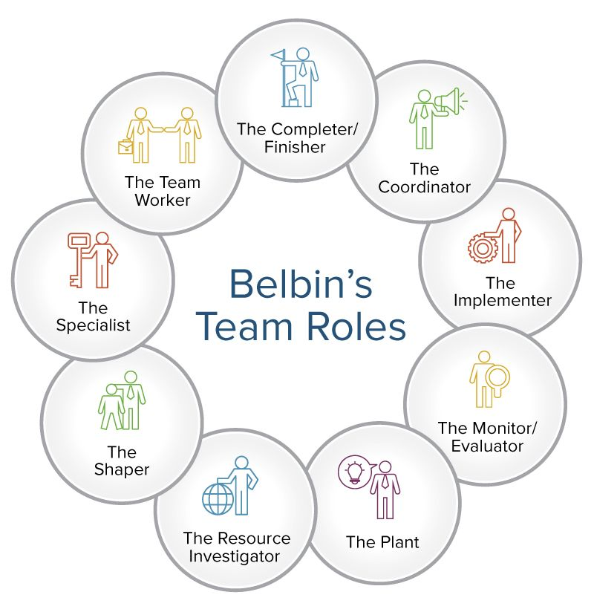
Figure 4: Belbin's team model roles
(Silvius, Schipper and Van den Brink, 2012)
A project manager needs to be confident and he must clarify the goals clearly so that others can easily understand him, hence, a project manager needs to be an effective coordinator. The project manager also needs to have the skill of an implementer. It will enable the project manager to change ideas into action and organise works suitably. Sober is another important skill of a project manager, moreover, a project manager needs to focus on all the options and judges accurately which makes him an effective evaluator. A project manager also needs to be creative and free-thinking which will help him to become a good planner. For managing projects, a project manager needs to be communicative that can help him to get valuable insights from a different person, moreover, a project manager needs to explore opportunities which can help him to become resource investigator. The project manager also needs to be a shaper and for this purpose, he must have the skill to take challenging works and works under pressure. The project manager also needs to be a specialist in his area; therefore, he needs to provide knowledge and help others to manage projects suitably. Teamworking is another skill a project manager needs to adhere because it will enable him to work in co-operative projects. A project manager also needs to have the ability to search for obstacles and tackle these obstacles and complete work until the project is completed. So, based on Belbin’s team model, these following skills are important for a project manager to manage projects in the organisation.

Personal Development Plan
A project manager always works hard to develop his knowledge and skill so that he can contribute his competencies for the welfare of the organisation. Below a personal development plan is provided which a project manager can follow to develop his skills and knowledge-
Objectives | What to do for achieving the objective? | Required timeframe for achieving the objective | Achievement progress | Further development strategies
Learn new skills | I need to work with top managers and take new courses to learn new skills. | 2 years | Progressing | Professional Courses involvement and learning.
Become an effective professional | I need to work on my communication skill, leadership skill and technological skill to become an effective professional. | 2 Years | Progressing | Working and learning from work.
Improve management and leadership skill | Outside of the workplace, I can manage a small group of people to improve management and leadership skills. | 1 year | progressing | Need to Involve more in team working in a different role.
Improve communication skill | I need to learn different languages for this purpose I can engage with the professional course. | 6 Months | progressing | Practicing the languages so that can communicate more precisely.

Conclusion
Project management is important for every organisation because it helps a company to know what they need to do to increase the efficiency of their organisation. In this essay, a project is ensured which is based on the organisation Virgin Active. The company wants to increase customer flow in their organisation so they ensure a project which helped them to increase customer flow in the organisation. By ensuring the project, the project planner also able to know the risk factor they need to consider to complete the project. Moreover, with suitable project management tools, the project is completed successfully.

References
Baguley, P., 2008. Project Management. London: Hodder Education.
Boulmetis, J. and Dutwin, P., 2014. The ABCs of evaluation: Timeless techniques for program and project managers (Vol. 56). John Wiley & Sons.
Bradley, K., 2002. Understanding PRINCE2. SPOCE Group.
Burke, R. (2013). Project management. Hoboken, N.J.: Wiley.
Deeprose, D., 2002. Project Management. Oxford, U.K.: Capstone Pub. Farnham: Ashgate Pub.
Engwall, M. and Jerbrant, A., 2003. The resource allocation syndrome: the prime challenge of multi-project management?. International journal of project management, 21(6), pp.403-409.
Hedeman, B., Van Heemst, G. and Fredriksz, H. (2010). Project Management. Zaltbommel: Van Haren Pub.
Heerkens, G. (2015). Project management. [Place of publication not identified]: Mcgraw-Hill
Heerkens, G., 2015. Project Management. [Place of publication not identified]: Mcgraw-Hill Education.
Holmes, A. (2002). Risk management. Oxford, U.K.: Capstone Pub.
Ibisworld.com. 2020. Ibisworld - Industry Market Research, Reports, And Statistics. [online] Available at: <https://www.ibisworld.com/united-kingdom/market-research-reports/takeaway-fast-food-restaurants-industry/> [Accessed 17 March 2020].
Kendrick, T. (2004). The project management tool kit. New York: AMACOM/American
Knutson, J. and Bitz, I. (2009). Project management. New York, NY: AMACOM.
Lewis, J. (2017). Fundamentals of project management. New York: American Management Association.
Lock, D. (2000). Project management. Brookfield, VT: Gower. Management Association.
Milosevic, D.Z. and Srivannaboon, S., 2006. A theoretical framework for aligning project management with business strategy. Project Management Journal, 37(3), pp.98-110.
Silvius, G., Schipper, R. and Van den Brink, J. (2012). Sustainability in Project Management.
Tinnirello, P. (2000). Project management. Boca Raton: Auerbach.
Van Der Merwe, A.P., 2002. Project management and business development: integrating strategy, structure, processes and projects. International Journal of Project Management, 20(5), pp.401-411.
Work breakdown structure (WBS) handbook. (2010). Washington, D.C.: National Aeronautics and Space Administration

