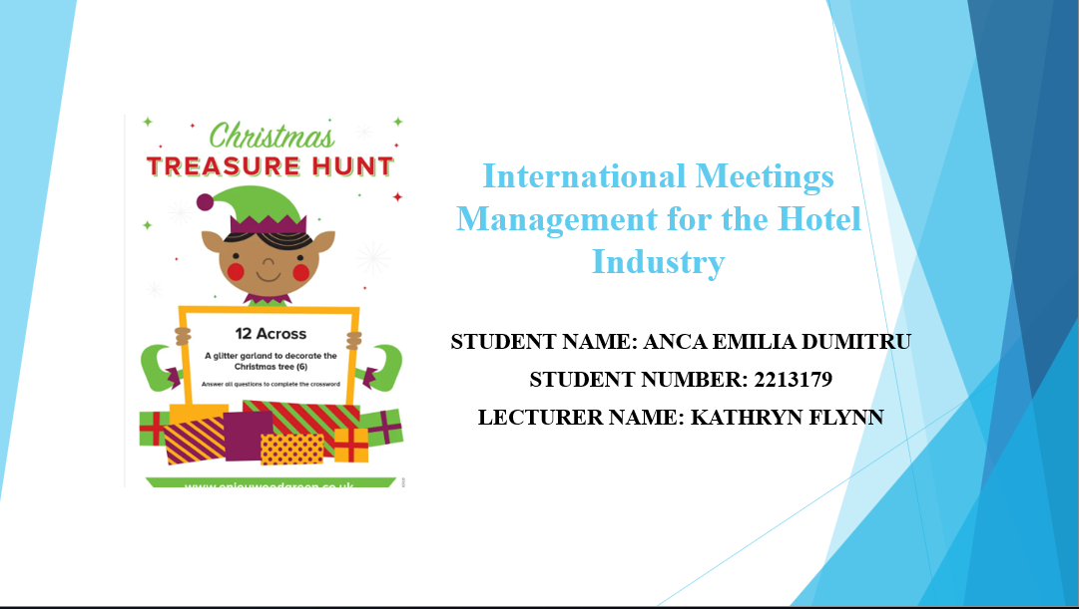
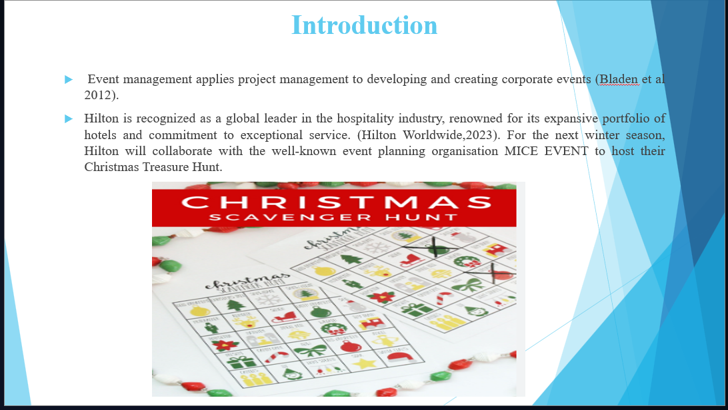

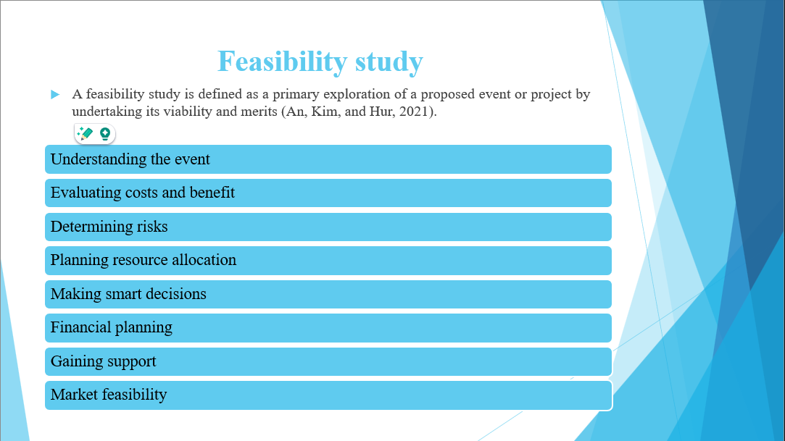
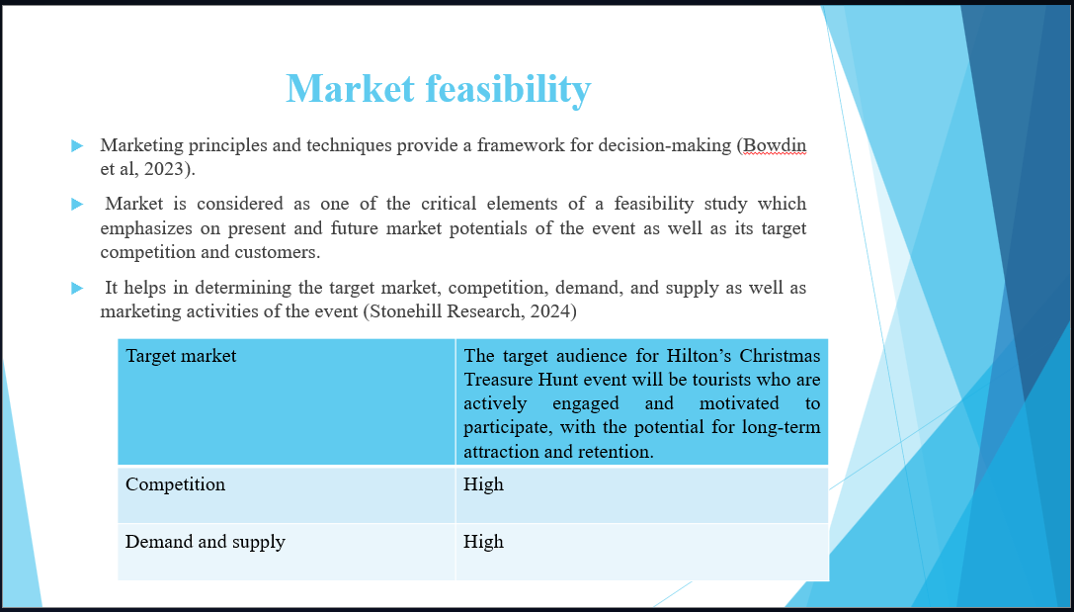
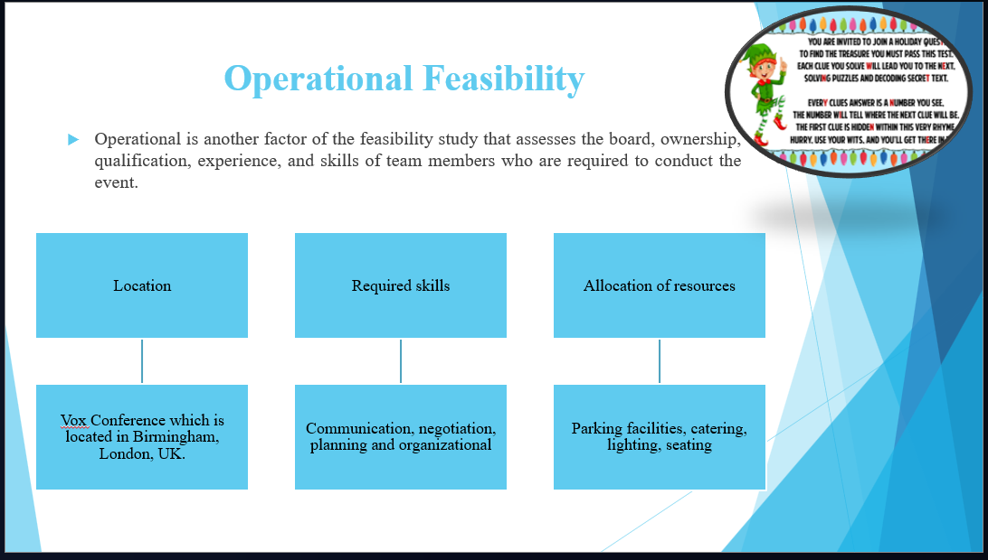
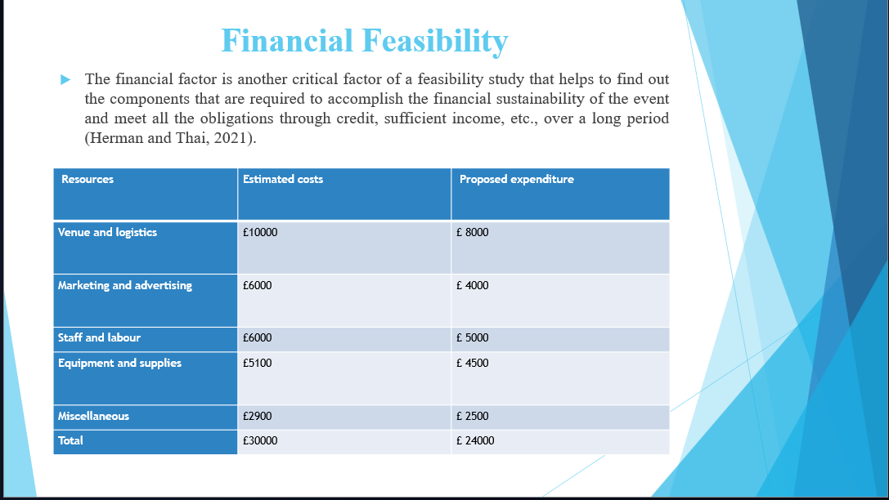
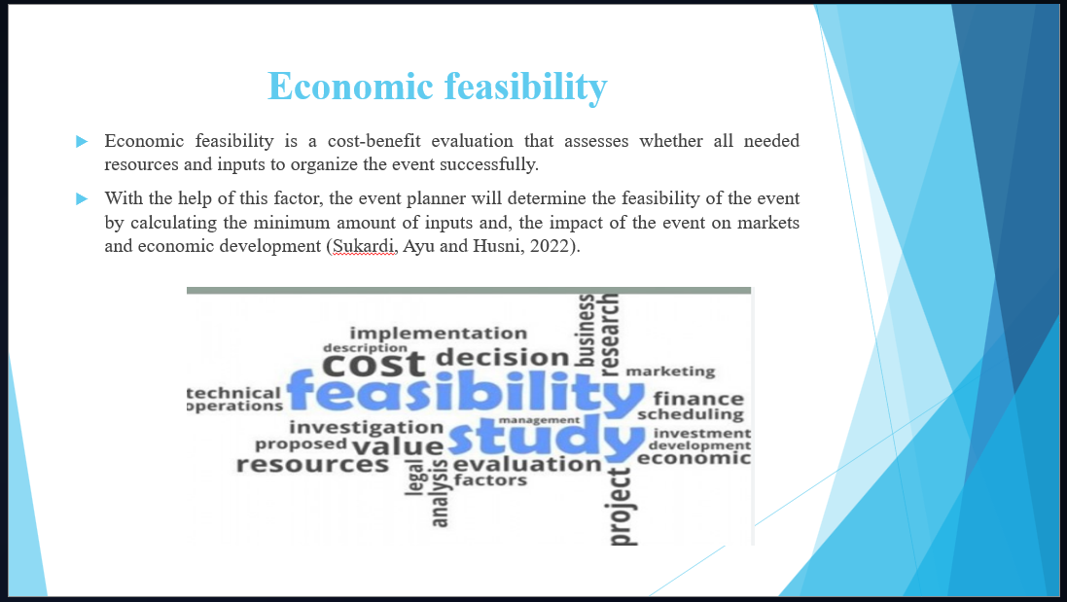
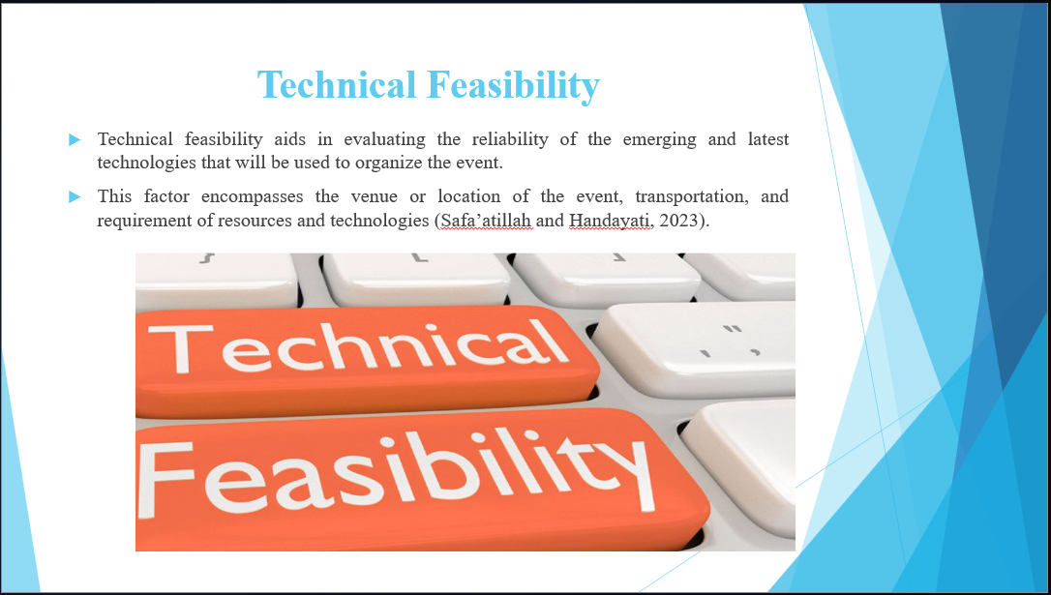
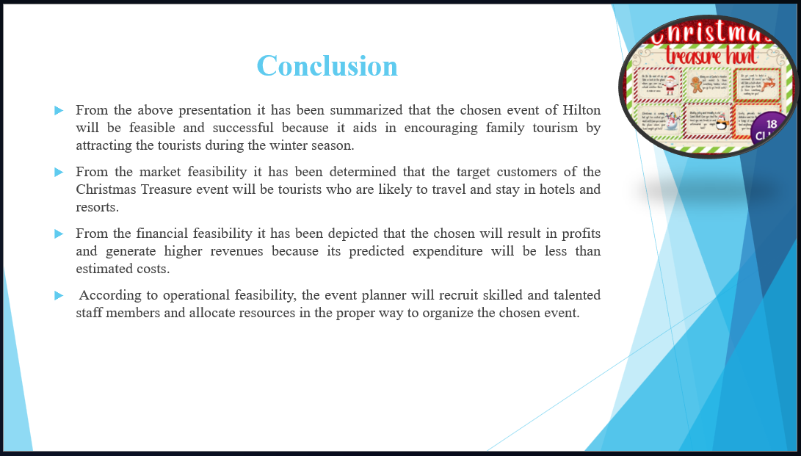



References

- Ahn, S.J., Levy, L., Eden, A., Won, A.S., MacIntyre, B. and Johnsen, K., 2021. IEEEVR2020: Exploring the first steps toward standalone virtual conferences. Frontiers in Virtual Reality, 2, p.648575.
- Berry, G. and Shabana, K.M., 2020. Adding a strategic lens to feasibility analysis. New England Journal of Entrepreneurship, 23(2), pp.67-78.
- Bladen, C. et al (2012). Events Management: An Introduction. Abingdon: Routledge Seven.
- Bowdin, G., Allen, J., O’Toole, W., Harris, R., and McDonnell, I. (2023) Events Management. Oxford: Elsevier
- Corona-Sobrino, C., García-Melón, M., Poveda-Bautista, R. and González-Urango, H., 2020. Closing the gender gap at academic conferences: a tool for monitoring and assessing academic events. PLoS One, 15(12), p.e0243549.
- Hagen, D., 2021. Sustainable event management: new perspectives for the meeting industry through innovation and digitalisation? Innovations and Traditions for Sustainable Development, pp.259-275.
- Hendra, F., Supriyono, S., Efendi, R., Rosalinda, R. and Indriyati, R., 2021. A business feasibility analysis of small and medium enterprises for product strategy determination. Scientific Journal of Reflection: Economic, Accounting, Management and Business, 4(3), pp.421-431.
- Herman, M.I. and Thai, M.T., 2021. Striving for sustainable value chain establishment: a multiple feasibility analysis approach. Journal of Agribusiness in Developing and Emerging Economies, 11(4), pp.379-395.
- Hilton (2023). Hilton Brands | Global Hospitality Company. [online] Hilton.com. Available at: https://www.hilton.com/en/corporate/.
- https://www.etsy.com/uk/listing/1086227696/christmas-treasure-hunt-christmas
- https://www.queen-of-theme-party-games.com/kids-christmas-treasure-hunt.html
- Ignatyeva, M., Yurak, V. and Pustokhina, N., 2020. Recultivation of post-mining disturbed land: Review of content and comparative law and feasibility study. Resources, 9(6), p.73.
- Indeed Editorial Team, 2024. What Is a Feasibility Study? Definition, Benefits, and Types. Online. Available through: < https://www.indeed.com/career-advice/career-development/feasibility-studies>
- Jothr, O.A., 2024. Developing the Methodology of the Financial Aspect in the Economic Feasibility Studies of Industrial Project. International Journal of Finance and Business Management (IJFBM), 2(2), pp.81-98.
- Kanstrup, M., Rudman, A., Göransson, K., Andersson, E., Lauri, K.O., Rapoport, E., Sunnergård, L., Bragesjö, M., Andersson, E., Iyadurai, L. and Holmes, E.A., 2021. Reaching people soon after a traumatic event: an exploratory observational feasibility study of recruitment in the emergency department to deliver a brief behavioral intervention via smartphone to prevent intrusive memories of trauma. Pilot and feasibility studies, 7, pp.1-10.
- Martins, J, 2024. How to conduct a feasibility study: Templates and examples. Online. Available through: < https://asana.com/resources/feasibility-study>
- Nobrega, S., Ghaziri, M.E., Giacobbe, L., Rice, S., Punnett, L. and Edwards, K., 2021. Feasibility of virtual focus groups in program impact evaluation. International journal of qualitative methods, 20, p.16094069211019896.
- Nobrega, S., Ghaziri, M.E., Giacobbe, L., Rice, S., Punnett, L. and Edwards, K., 2021. Feasibility of virtual focus groups in program impact evaluation. International journal of qualitative methods, 20, p.16094069211019896.
- Safa’atillah, N. and Handayati, R., 2023. An Analysis of the Study of Home Industry Business Feasibility. Almana: Jurnal Manajemen dan Bisnis, 7(3), pp.508-516.
- Samrose, S., McDuff, D., Sim, R., Suh, J., Rowan, K., Hernandez, J., Rintel, S., Moynihan, K. and Czerwinski, M., 2021, May. Meetingcoach: An intelligent dashboard for supporting effective & inclusive meetings. In Proceedings of the 2021 CHI Conference on Human Factors in Computing Systems (pp. 1-13).
- Stonehill Research (2024). Event Management Services Market Trends, Growth Opportunities, and Forecast Scenarios The Event Management Services market research reports provide a comprehensive analysis of the current market conditions, industry trends, and key challenges faced by players in the industry. The reports highlight t. [online] Linkedin.com. Available at: https://www.linkedin.com/pulse/event-management-services-market-trends-analysis-forecasted-7bzrc [Accessed 15 Oct. 2024].
- Sukardi, L., Ayu, C. and Husni, S., 2022. The Financial and Economic Feasibility Analysis: A Value-Added Approach. Tec Empresarial, 17(2), pp.17-33.
- Visit Monmouthshire, 2024. Event feasibility study. Online. Available through: < https://www.visitmonmouthshire.com/information/events-management/feasibility>

