Task 1: Locating Sources
Identify and locate three different sources (a report, a journal article, and a website) related to the question
“What employability skills do business graduates need to succeed in the modern workplace?”
Show how you used keywords, search terms, and Boolean operators to find them, and explain how you know which type of source each one is and why it is appropriate for the research question.

Source Type & Why It Is Appropriate | URL/DOI | What search engine did you use? Google/Online Library/Library AI Assistant | Keywords/Boolean Operators Used
Journal Article | Preparing a Graduate Talent Pipeline for the Hybrid Workplace: Rethinking Digital Upskilling and Employability - University of Wales Trinity Saint David | Library uwtsd | employability AND business graduates IN a work place
Online Article | What skills do employers expect from business graduates in 2026 | Google | online article based on “What employability skills do business graduates need to succeed in the modern workplace?”

Task 2: Evaluating Information (CRAAP Test)
Your colleague has forwarded you a source from a peer reviewed journal, and they are not sure whether it is appropriate to use and has asked for your help. Your task is to evaluate the source by using the CRAAP Test to assess its appropriateness.
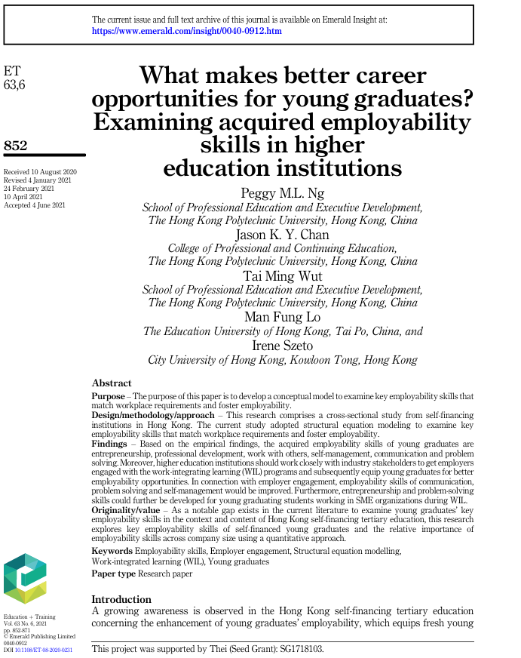

CRAAP Test
Currency | Yes within the 5 year.
Relevance | Yes it is relevant as the key words are relevant to the source .
Authority | Peggy M.L. NG  Jason K . Y . CHAN  Tai Ming Wut  Man Fung Lo  Irene Szeto
Accuracy | Yes it has been supported by someone.
Purpose | Yes it is relevant as the purpose of the article is to develop conceptual model to examine key employability skills that match work place requirements and foster workplace.

Task 3: Source Analysis
Your manager has provided you with a short extract from a source and has asked you to analyse the source by Identifying one strength, one weakness, and providing a brief explanation of the strength and weakness identified.
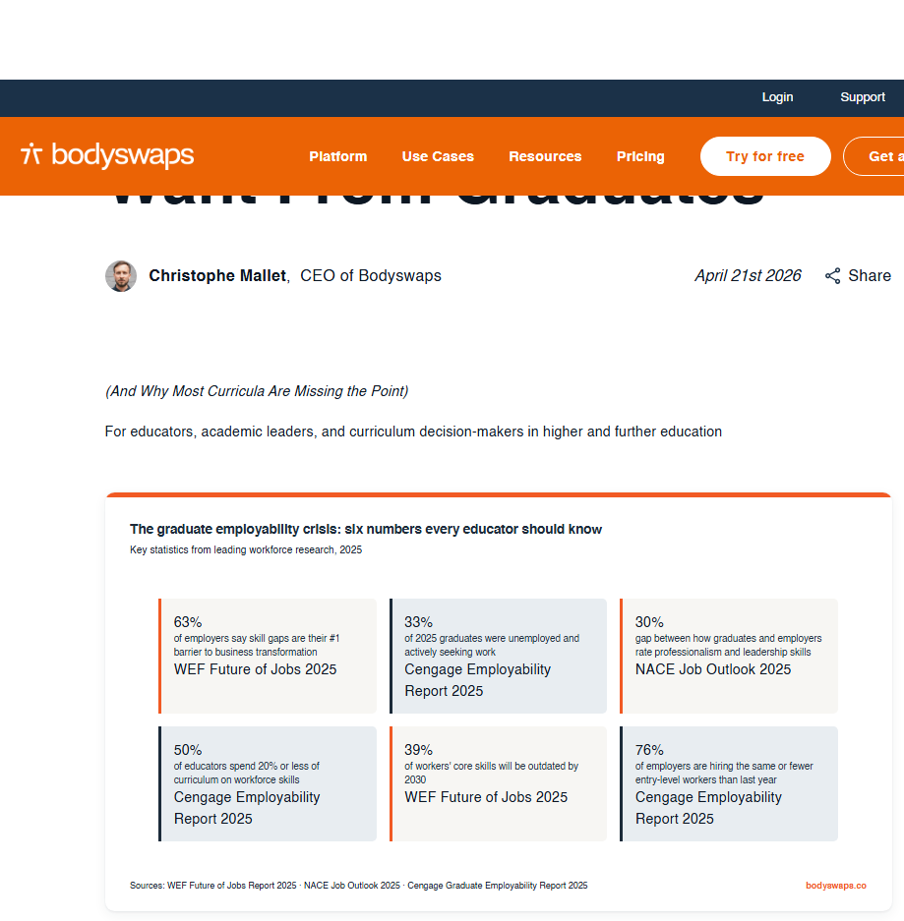
.

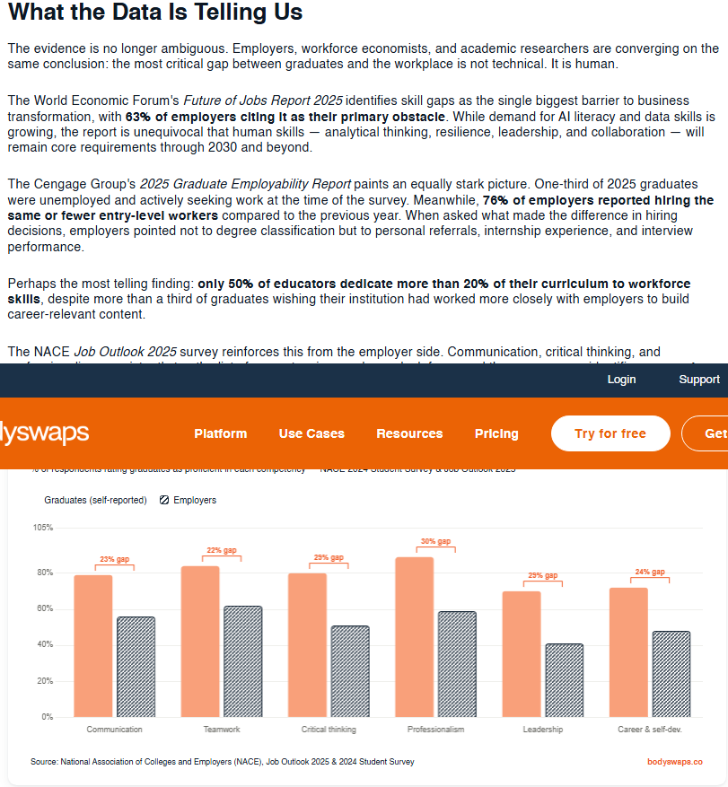

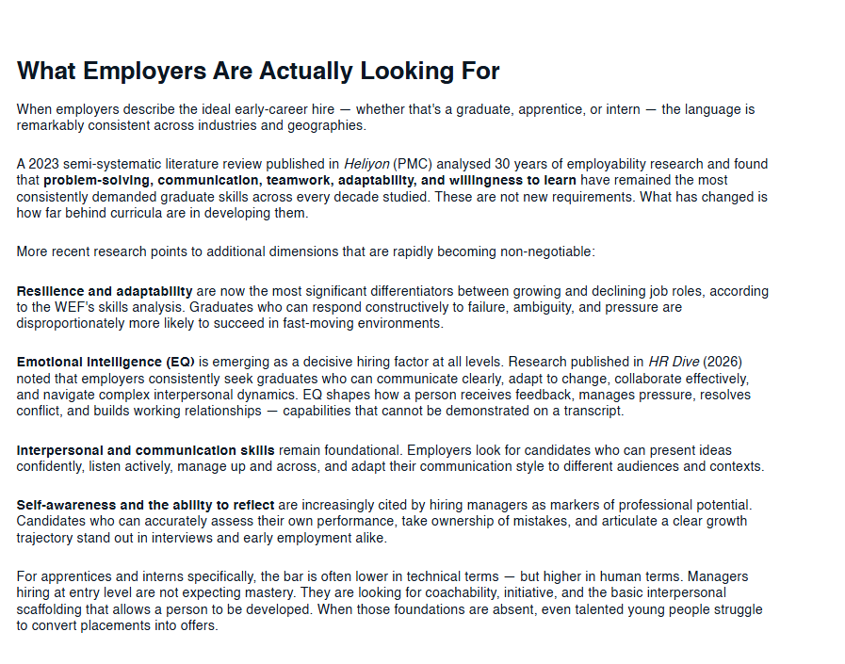

Please click the link, if you wish to read the article online.
What Employers Actually Want From Graduates

Strength of the Source:

The strength on this source would be that is has been published within this year, so any information or statistics is new evidence. Showing charts with the information to back them. Some of the information is also referenced so again the information is backed with evidence of this being true with the link added if more information is needed.

Weakness of the Source:

The source weakness would be that there is a lot of information on the same topic,

