

Enterprise and Innovation Group Project

EIGP Individual Report

Computer Networks and Security
Elliot Barnett

Contents
Introduction 3
Development 3
The Market and Competitors 7
The Marketing Plan 11
Conclusion 11
References 11

Introduction
This is a report is written by Elliot Barnett. Within his team, he was assigned to report and research on marketing analysis, marketing plan and his contribution to the product. The marketing plan was split, and he was told to research and report the target market, promotion strategy, product price, place of development and the distribution of the product. The creation of the brand such as logos, posters, etc was assigned to the development and design team.

Development
Elliot’s contribution to the prototype includes:
- Creating a website for the user to view the current stock
- Learning PHP and running an apache server to create a QR code generator
- Create a QR code generator
Firstly, he created a website that allows the user to find out about our start-up and see what we have to offer. It also includes a QR code generator for the user to create a QR code to place on their preferred wristband. Below are a couple of screenshots of the website and the code that goes with the website and the QR code generator.
The first screenshot is the homepage of the website where the user can navigate or view what the start-up is currently working on. There is also the code for the webpage to the right.
The second screenshot shows the current stock on the webpage and the QR code generator. The code for this webpage is located underneath.
Lastly, the contact page where the user can view where we are located and how to contact us if they need any further assistance.
Lastly the implementation of the QR code generator. Firstly, he used and learned the language PHP to create the QR code image. Then he implemented it into the website for the user to create and save the QR code that they have created. Also, to allow the PHP code to work he had to create and run an apache localhost server to allow the code to function and create a QR code. Below are some screenshots of the code and the generator.
Below are screenshots of the code and website, sadly the website could be hosted on a server due to the cost and could only be run locally. There is no link for the current website, but the screenshots will show evidence of the website being built.

Website home page
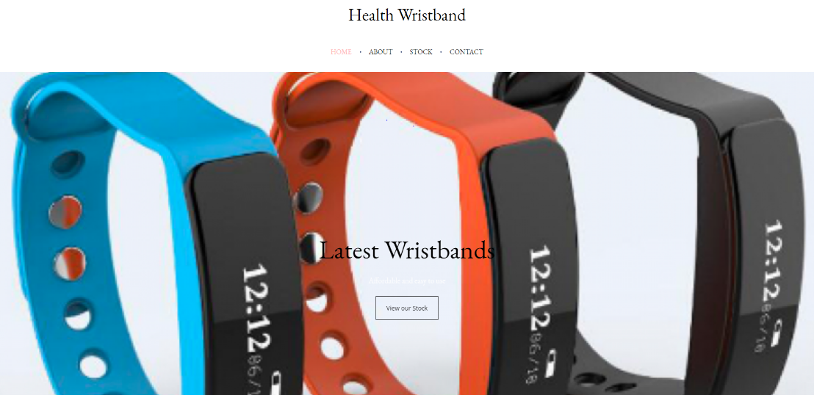
Code for the home page
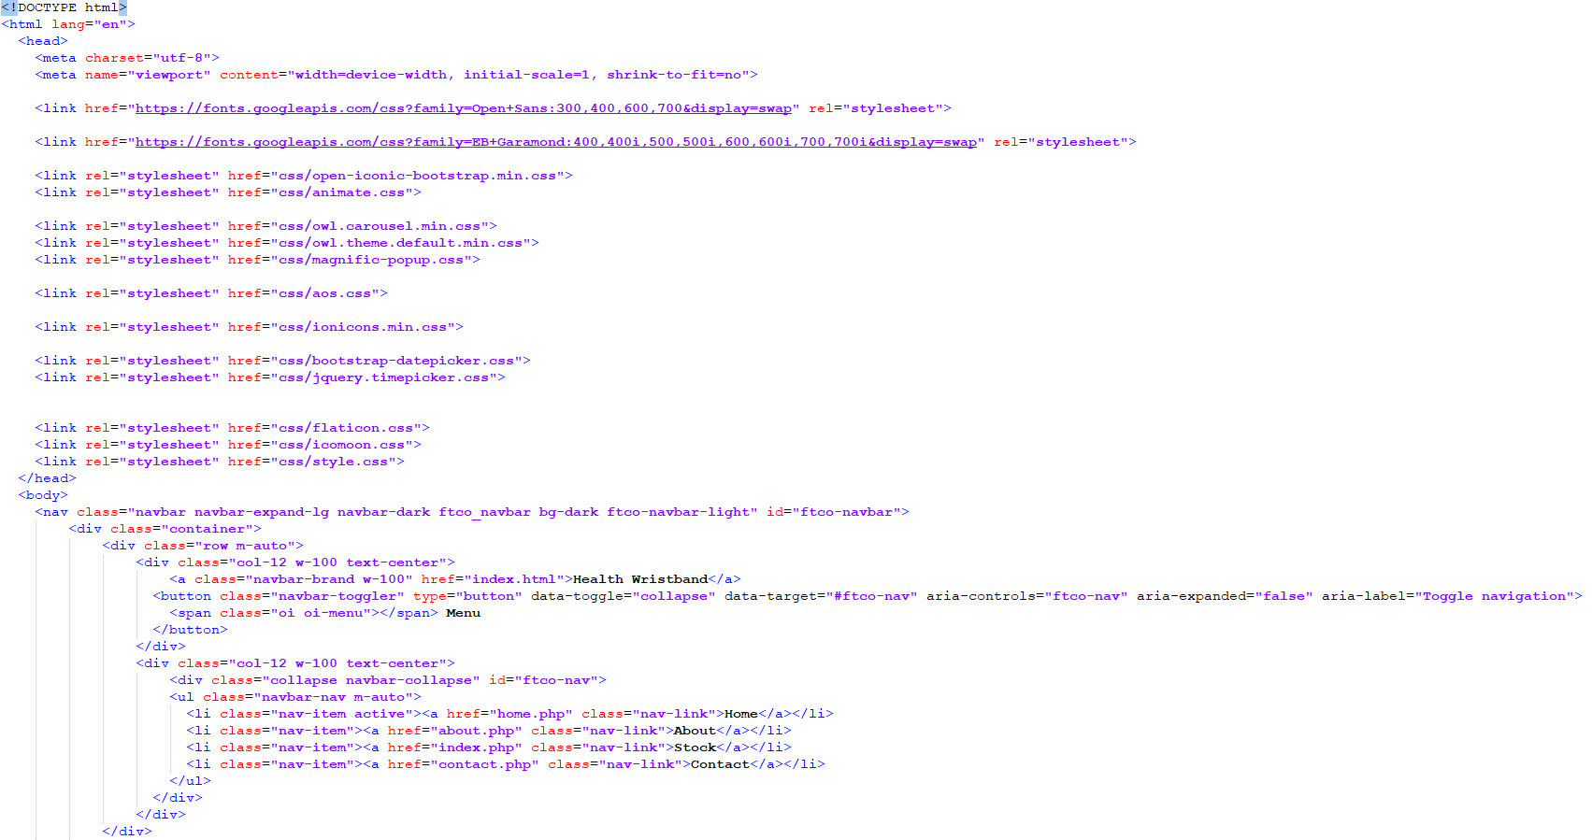

QR generator on the website

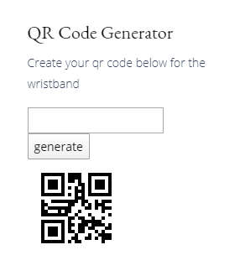

Contact page
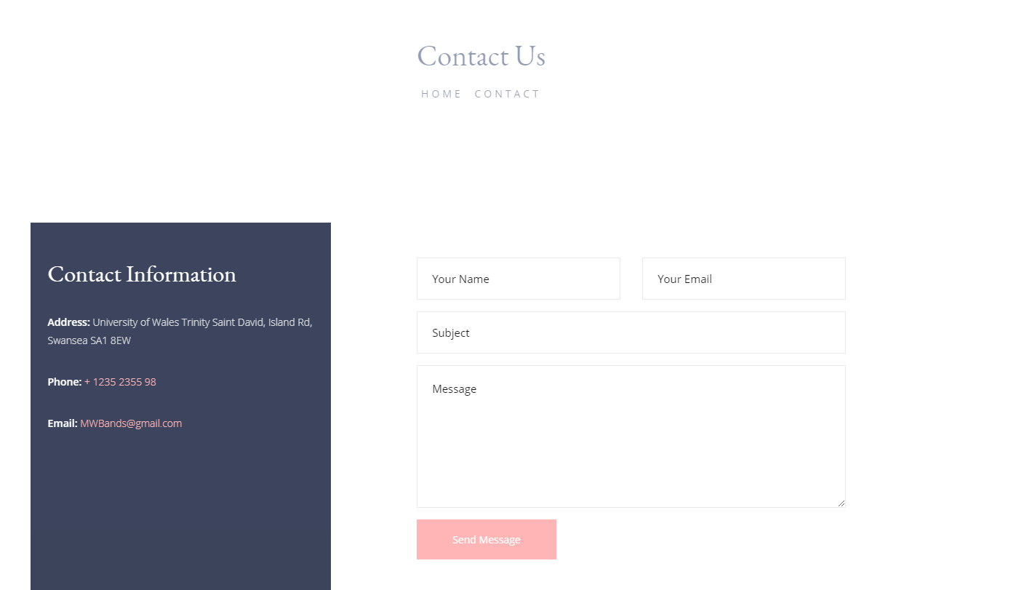
Google maps code / Contact page
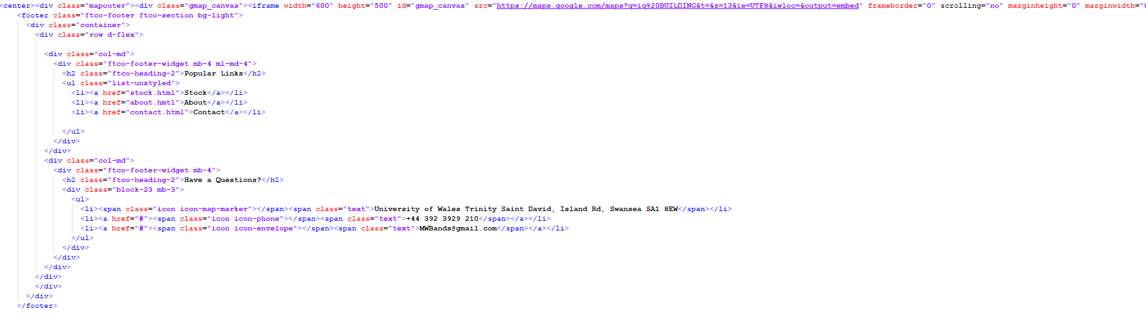
Google maps image
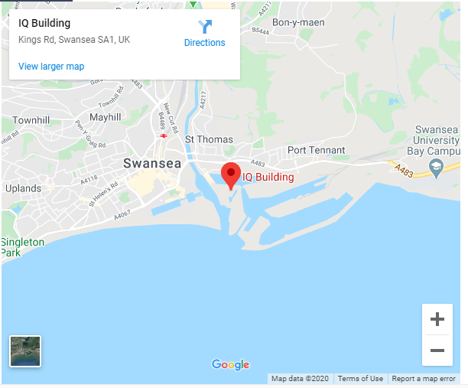

Code of the QR code generator
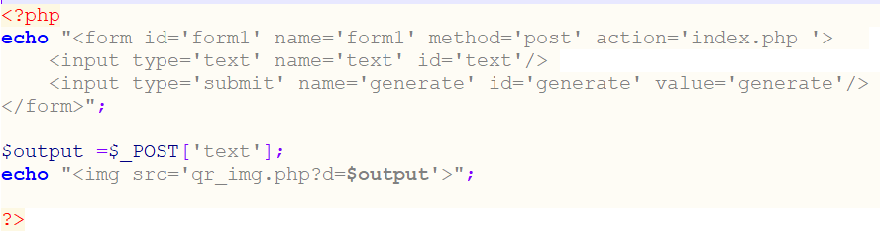

Skills Developed
- Creating a website using PHP/HTML
- Learnt PHP
- Learned how to run a local server with apache
- Created a QR code generator using PHP
- Created a QR code to put on the wristband

The Market and Competitors
The current market for medical wristbands is rising but the market is small right now. The bigger market that covers all sorts of smart wristbands shows that there is a lot of growth in the current market. In 2019 there was a 7.6% growth in medical alert systems, this would be a potential market for our medical wristband if it had newer technologies such as an alert button or a fall detection system. The current medical alert market is valued at 5.9 billion dollars and is predicted to rise even more in the next couple of years [1]. From other sources, there are predictions that the current market will double in size by the year 2024 [2]. To make sure that our product fits in with the current market we will have to develop more technological features on it such as, fall detection system, an alert system or a computer chip that stores all the user's data within it.

Competitors

Below is a list of the current competitors for our product:
- Tap2Tag [1]
- Elegant medical alert [2]
- The ID Band Company [3]
- Ahead Solutions [4]
- Alibaba [5]

Tap2Tag

Tap2Tag is a wristband company that sells smart wristbands and devices that perform different things such as GPS wristbands, medical wristbands, etc. The one product that is very similar to our current prototype is the medical wristband v2 [6]. It contains a QR code and NFC technology to allow users to scan the device for their data. The wristband costs £17.99 and is available in many different colours. Their unique selling point is the quality of the wristband with not only a QR code but also NFC which is compatible with most mobile phones in this current day of age.

Elegant Medical alert

Elegant medical alert is a business that sells wristbands, bracelets and other smart technologies related to people who need medical assistance. The one similar product that they have is a medical leather ID bracelet [7], the price of the wristband is £90. Their unique selling point is there is an option to engraving details or a QR code on the piece of steel on the wristband.

The ID Band Company

The ID Band company is a company that sells a variety of different medical wristbands. There are a couple of different wristbands that are similar to the teams, but there is one that stands out and that is the silicon medical ID wristbands [8]. It costs £23.22 per wristband but can be bought in bundles to save money. Their unique selling point is the ability to add data and a QR code to the wristband.

Alibaba

Alibaba is a business that sells a variety of different stuff from smart devices to masks etc. They sell a lot of medical wristbands, but most are for bulk buying for use in a hospital. There is one medical wristband on their website that is similar to ours and that is a DIY engraving medical wristband [9]. The unique selling point of this wristband is the ability to store data on the user but without showing the data to the public and keeping it discrete. This wristband can only be bulk bought. It’s a good price of £75 for 50 wristbands.

PEST Framework
To analyse the current environment outside of the start-up Elliot will be using a PESTEL framework to help prepare the start-up against any external factors that may impact the start-up.
P – Political
E – Economic
S – Social
T – Technological

Political
The general data protection act would influence the business because the data that is stored on the wristband must be developed and delivered in a secure way due to the personal information on the QR code. Also, there must be no less than a minimum wage salary for employees due to the employment law [12].
Economic
Economically the start-up will be influenced by sales and demands because the number of sales and demands will determine whether the start-up will succeed or not. The cost of supplies will financially hurt the start-up if there are no plans for the number of supplies that will need to be bought, and also there are a lot of competitors out there that have more efficient ways of producing and selling their products [12].
Social
When looking into the sales and reviews of similar products, the writer found that there were a lot of good reviews on similar products in the market and found that there were a lot of reviews very recently which shows that there are wristbands selling [10].
Technological
The start-up would need access to multiple 3D printers and laser cutters to produce the wristband. Also, computers for the development of the product and to promote the product on social media sites [13].

Feedback on the product idea
To gain feedback on the idea there is a survey that is created to see what people are interested in the medical wristband, also the option for them to add what they would like on the wristband. Below is a screenshot of the results and the survey. The more critical questions are at the front of the questionnaire to make sure that the user answers the first. This prevents the user from getting bored.
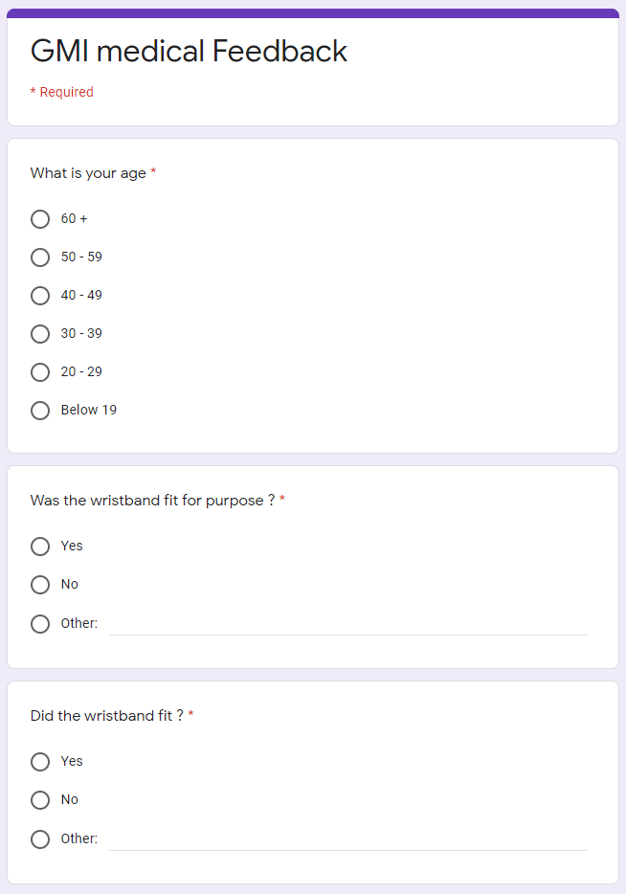
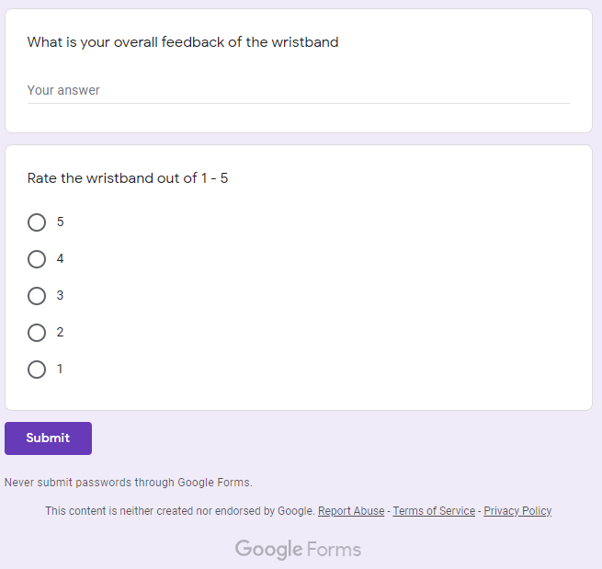

The Marketing Plan
Our prototype is a medical wristband that has a QR code on the front of it that stores all of the medical information about the user. The benefits of our prototype include:
- Easy to wear and adjustable to most wrist sizes
- User can create the QR code to go on the wristband
- The medical information on the wristband is easy to access with a QR code scanner which can be downloaded on most smartphones these days.
- The wristband does not show people that it looks like a medical wristband from a distance.
Our target market for people of any age who always need to have emergency medical information on them. From researching the current market and the development team showing the prices of the materials and printing. It would work out at £5 per wristband for the start-up to make a little profit on every order.

Promotion
To promote the product the start-up used social media websites like Facebook, Twitter, etc, to advertise the start-up and the product that is being sold. Also, to communicate with our users the start-up has a feedback form on the website for users to send reviews on the product.

Development
To develop the wristband the start-up is first going to take small precautions on only supplying a limited amount to see whether customers are buying the product, this means that all stock will be printed and developed at the current start-up supplier (Lauren’s parents business). The start-up will only be selling wristbands online due to the financial cost of running a shop etc.

Conclusion
To conclude Elliot has contributed to the product by creating a QR code and QR code generator to allow the development team to assign a QR code to the wristband. He has also reported and analysed the current competitors and market and created a marketing plan. From the research on the current market, there could be a lot of future developments that could be implemented onto the wristband to make it more unique and popular in the current market.

References

[1] | “Market Watch,” [Online]. Available: https://www.marketwatch.com/press-release/76-growth-for-medical-alert-systems-market-size-to-reach-10700-million-usd-by-2025-2019-06-10.
[2] | “Research Nester,” [Online]. Available: https://www.researchnester.com/reports/smart-bracelet-market/562.
[3] | “TAP2TAG,” [Online]. Available: https://www.tap2tag.me/what-is-tap2tag-medical-alert/.
[4] | “elegantmedicalalert,” [Online]. Available: https://www.elegantmedicalalert.com/id-band-qr-medical-alert-bracelet.html.
[5] | “theidbandco,” [Online]. Available: https://www.theidbandco.com/Medical-Bracelets.
[6] | “AHEAD SOLUTIONS,” [Online]. Available: https://www.aheadsolutions.co.uk/medical-identity-qr-code-card-and-wristband.html.
[7] | “Alibaba,” [Online]. Available: https://www.alibaba.com/showroom/qr-code-medical-bracelet.html.
[8] | “Tap2Tag,” [Online]. Available: https://www.tap2tag.me/black-adj-wristband-qr-v2.
[9] | “Elegant Medical Alert,” [Online]. Available: https://www.elegantmedicalalert.com/Stainless_Steel_Brown_Leather_Band_Medical_ID_Bracelet.html.
[10] | “The ID band company,” [Online]. Available: https://www.theidbandco.com/Premier-Silicone-With-Clasp.
[11] | “alibaba,” [Online]. Available: https://www.alibaba.com/product-detail/DIY-Engraving-medical-bracelet-with-stainless_62189402954.html?spm=a2700.galleryofferlist.0.0.12bf10772uKUK3.
[12] | “The ID Band Company,” [Online]. Available: https://www.theidbandco.com/Customer-Comments.

Appendix
Self-reflection
Elliot has developed technical skills and employability skills that were developed by helping and producing a start-up. As stated in the report Elliot has developed a lot more technical and employability skills. These include:
Technical Skills
- Creating a website using PHP/HTML
- Learnt PHP
- Learned how to run a local server with apache
- Created a QR code generator using PHP
- Created a QR code to put on the wristband
Employability skills
- Working working with a team
- Communicating with a team to produce an end product
- Communicate the different aspects of the business to people
- Collaborating with different roles within the team.
Team Progress sheets

TEAM PROGRESS SHEET
A complete log of the activities and work completed.

Page Break
Team Progress Sheet

11/03/2020
It has been decided, we are using resin in a 3D printer to create the section where the barcode will go and will be using a silicone strap to keep the band on the wearer's wrist. The holder will be created on the 14/03/2020 and the band will be completed within a couple of days after this. The final prototype will be completed around a week before the final pitch.

09/03/2020
The team is still edging more towards using a 3D printer, we have been evaluating the original designs for an RFID chip and have decided to change up the original plans. The team no longer wants to use an RFID chip and are instead going to use a barcode – we feel as though this would be a better option as there are many complications with RFID chips not being readable through some materials.
26/02/2020
There were no formal meetings over the past two weeks however the team has been discussing different options over Facebook Messenger. We are toying with the idea of 3D printing a medical band – this seems like a good idea. There are 3d printers on campus however it seems like there may be a better option available, allowing a team member access to Maya.

12/02/2020
Team meeting today was focusing around attempting to understand and review a bunch of materials that we feel maybe a good idea – we discussed using recycled materials but as of now it doesn’t seem like a feasible idea, maybe in the near future but not for the final prototype. The meeting lasted a long duration of time – 1hr, and still we have not decided properly upon a material we want. We are, however, still confident on being able to complete the tasks within the correct amount of time.

29/01/2020
The progress made today was heavily focused on discussing materials, member of the team highlighted that making bands out of recycled materials may be a good idea and would be more economically friendly, this idea was well accepted by the group and is a definite possibility to take this forward.
Note: materials still seem to be the primary issue, this needs to be resolved

23/01/2020
Health Helpers
Having done well in the presentation the team were feeling reassured and pleased with the progress of the pitch. The team has decided that the primary aim of today is to discuss materials which is proving to be our primary issue, whilst we are still leaning towards using silicone we are still unsure as to what we want to do. This task is now our primary focus.
Notes: need to get together to discuss materials

16/01/2020
Health Helpers
Today the team came in early to rehearse for our pitch, which is also today. Rehearsals went well and team members seem to be benefitting from the role switch, which has allowed each team member to work more productively.
Team received the overall grade of 78% on our pitch. The team were very pleased.

15/01/2020
Health Helpers
The team have finished their own sections of the presentation so today’s meeting was mainly to merge the presentation together and to rehearse. The group seem to have completed great work and the presentation tomorrow looks promising.
Notes: pitch is tomorrow, so the group should come in early to practice.

14/01/2020
Health Helpers
The main focus of today’s meeting was to further discuss the materials that we need, what suits the band best, and to discuss the next presentation we have and our progress. It’s been a week since our last meeting so in this time a lot of work was done. The team is still unsure about what materials we should be using to create the band but are still leaning towards using silicone. The team then discussed the progress on our own sections of the presentation and came together to solve minor issues.
Notes: the teams focus is to complete the presentation that is on the ^{16th} of Jan – team is making great progress but worried about the development of the band.

07/01/2020
Health Helpers
The team got together today to discuss how each member had coped preparing for the presentation – there were some issues found primarily within the role distribution, it seems there were a rather large amount of crossed lines making some tasks hard for some members to complete, so the roles were switched. Lauren and Connors roles had a bit of a shake-up but the group were confident in this change and believed it would allow for a better experience for both team members. The group also put together the preliminary design for the next presentation that we have – task moving forward is to start working on the presentation and rehearse.

*Christmas Break*

13/12/2019
Health Helpers
Christmas break is essentially right around the corner, this meeting was taken as a chance to discuss any important factors in regards to the development of the band and how it would work. Team has another presentation about the band after Christmas break – tasks were distributed and discussed so each team member knew what they were doing. Overall, today’s meeting was rather large and covered a lot of basis. Successful day.

07/12/2019
Health Helpers
Having completed the first presentation on the idea of the product, the group has decided that it is time to start planning for the actual production of a prototype – the meeting today primarily focused on talking about which materials could be used and how to make it work for a large demographic. As the team have decided that it is within our best interest to attempt to make a partnership with the NHS, the user base would be quite large, meaning we would have to accommodate for allergies people of different sizes. As it stands we are looking at silicone for the band, with metal clasps holding the band together on the wearers wrist. The RFID chip would be inserted into the rubber band.
Notes: As the group is not yet entirely sure on the materials of the products needed, we shall continue to discuss this.

04/12/2019
Health Helpers
Present: All group
Today’s progress was good, today was the day of the presentation. The group met up roughly an hour early in order to rehearse before it was time to go to the actual presentation. Rehearsals went very well. The presentation went well too, this was a success for the team.
Notes: The team should meet up again within the next few days to discuss the progress of the next task.

Date 03/12/2019
Team Name: Health Helpers
Present: Lauren Davies, Elliot Barnett, Joshua Batchelor, Nicholas Evans,
Kaylie Shoulder
Absent: Connor Stock
Goals: As the first pitch should be presented tomorrow, the main aim of today is to ensure the entirety of the presentation is completed to the best of our ability; it should be missing no information and all sections should be completed. The group should ideally run through the presentation to ensure that everyone has stayed within their allocated time and have enough information. Presentation should be cleaned up to look presentable.

Team Report #5:
Today the team completed a series of tasks – the presentation was completed, and each member of the team was able to practice their sections of the presentation. We are pleased with the progress of the group today and we have gone over the presentation to ensure that each section is completed, and the designs align with each-other to ensure consistency within the group’s sections. Final touches were made and facts were fact-checked.

Date: 27/11/2019
Team Name: Health Helpers
In Attendance: Connor Stock, Elliott Barnett, Kaylie Shoulder, Lauren Davies, Nicholas Evans
Apologies: Joshua Batchelor

Team Goals: The primary aim of today's session is to continue to develop our first pitch which shall be presented on the 6th of December; each member has been assigned a specific section of the presentation and this now enables us to start the correct development. We are limited to a week, so it should be done by then. This is todays focus. Some other sub-tasks are to consider which brands of product we want to use for our product and research the price.

Team Report #4: Today the team agreed on a presentation design and started the development of the pitch – we have made great progress today. We will continue to develop our presentations within our own time. It will be completed by the deadline.
Notes: The team should find time to practice the pitch beforehand in order to ensure the team delivers it correctly on the day and we each know the timings.

Date: 20/11/2019
Team Name: Health Helpers
In Attendance: Elliot Barnett, Joshua Batchelor, Lauren Davies, Kaylie Shoulder
Apologies: Connor Stock
Absent: Nicholas Evans
Team Goals: The primary goals of today's session is to discuss the type of tech-start-up we want to establish ourselves with (such as ltd, partnership); joined with this, the team needs to start discussing our first pitch/presentation and development of this must commence as of today. The team should also create documentation regarding the values and objectives of the team.

Progress report 3: The team discussed our start-up label but are yet to conclude which fits best, however LTD is favourable. The pitch design and creation were initiated today, which needs to be completed by December 1 to allow the team time to rehearse. A complete document of the team values and objectives was completed.

Date 13/11/2019
Team Name: Health Helpers
In Attendance: Connor Stock, Lauren Davies, Elliot Barnett, Kaylie Shoulder, Joshua Batchelor [ Nick Evans]
Apologies: All members in attendance today
Team Members & Roles:
Kaylie Shoulder: Group Leader
Lauren Davies: Graphical Design Expert and Electronics Expert
Elliott Barnett: Financial Expert and Innovation
Joshua Batchelor: Expert Researcher and Documentation Aid
Connor Stock: Documentation Aid and Innovation Aid
Nick Evans: Sales expert, presentations and sales pitches, innovating
Team Goals: Complete a meeting regarding previous activities, conduct a market competitor analysis to see what the competition is, and complete a PEST test.
Progress report 2: The team successfully distributed the first tasks to be completed with a timeframe of a week. Product designs were completed along with a document documenting industry competition and potential partnerships.
Date: 06/11/2019
Team Name: Health Helpers
In Attendance: Kaylie Shoulder, Elliot Barnett, Joshua Batchelor
Apologies: Lauren Davies, Connor Stock
Team Member & Roles:
As of today, the majority of roles remain undecided within our team. We are actively working on this by completing tests and surveys attempting to determine who is best suited to each role.
Currently, only the Team Leader has been allocated and that is Kaylie Shoulder.
The other members of the team are Elliot Barnett, Connor Stock, Joshua Batchelor, Lauren Davies
Team Goals: The goals of today are to get the fundamentals of the project down – this means that a requirement specification should be drawn up, along with the initial designs of the prototype.
Progress Report 1: There were three tasks to completed today – these tasks were: outline and determine the initial requirements for the project, design the prototype, and complete the team progress report. The requirement specification was completed by Joshua Batchelor, the prototype design was completed by Elliott Barnett, and the progress sheet was completed by Kaylie Shoulder.
Notes: As the team was able to complete the goals of today, it was decided that we would like to review the requirements and designs as a group at our next meeting to ensure that everyone is happy with the current state of the project – this meeting would be deemed as a priority task as these fundamentals are essentially the skeleton of the project and thus we believe that everyone should be happy and comfortable with what has been completed to date. After the meeting has been conducted, we will then go on to finalise our initial documentations and discuss what should be completed next.

Evidence of attending an industry networking event
For attending an industry event we traveled to the BT Tower for a talk and a guide on how BT work and how the telephone/internet lines work and how phones connect with 4g towers around wales. This gave us an idea of how we can implement a GPS device into the wristband that connects to the cellular towers around the world.
Below are some pictures that were taking when attending the talk/guide.



