

MODULE CODE: Digital Skills for Personal Development and Business Growth BMSW4008

ASSESSMENT COMPONENT: PORTFOLIO

STUDENT NAME: Daniel Csomor

STUDENT NUMBER: 2508276

LECTURER: Philippa Fitzgerald
DATE:11.12.2025
Contents
Task 1 3
Assessment of Digital Skills 3
References 3
Task 2 4
LinkedIn Learning Certificates for Office365 4
Task 3 5
Essay on Relevance of Excel in professional and personal life. 5
References 5
Task 4 6
7 Minute Reflective Presentation 6
References 6

Task 1

Assessment of Digital Skills
Portfolio Example
Image 1
Screen shot of your JISC report
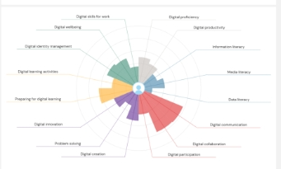

700 words on your assesment of digital skills Plus recommendations and badges you have completed because of this report

Digital skills are an important part of modern life, both at work and in education. Before starting this module, I already had some experience using digital tools because I worked as a manager at Pizza Hut and now I also work in a tiling company. However, the JISC Digital Skills report helped me understand my strengths and weaknesses much more clearly. In this reflection, I will discuss what I learned from my assessment, which areas I am confident in, and which skills I need to improve. I will also explain how this module has already helped me develop better digital abilities.

The JISC report showed that I have several strong areas, especially in digital communication, digital collaboration, and digital participation. These results match my work experience. As a manager at Pizza Hut, I regularly communicated with staff, organised rotas, and worked with online systems. Good communication skills were very important in that role, and I feel comfortable using emails, messaging tools, and online platforms. In my current tiling job, I also communicate with customers and suppliers using digital tools, so it makes sense that these are some of my strongest skills.
Another strong area for me is digital productivity. This means I can use different tools and software to complete tasks efficiently. Working in two very different industries taught me how to adapt quickly. For example, when I first started using Excel at Pizza Hut, I needed to track sales, stock, and staff hours. Later, in the tiling business, I used Excel for quotes, material lists, and budgets. Because of this, I already had a basic understanding before starting this module, but now I have improved even more. The JISC report also shows good scores in data literacy, which means I can understand and interpret numerical information. This is especially useful when dealing with costs, materials, and invoices in my current job.
Although I have strong areas, the report also shows several skills I need to develop. My lowest scores are in digital creation, digital innovation, and problem solving. Digital creation includes tasks like making documents, presentations, and digital content. Before this course, I did not use Word or PowerPoint very much, and I often felt unsure about formatting or layout. The module has already helped me improve because I learned how to create a presentation and how to use different tools more confidently.
Problem solving is another area where I scored lower. This makes sense to me because when something goes wrong on a computer, I sometimes struggle to fix it or understand why it happened. For example, if a formula in Excel does not work, I used to get frustrated because I didn’t know what the mistake was. During this module, I learned to check for missing brackets, wrong cell references, or formatting issues. This gave me more confidence and showed me that problem solving improves with practice.
Digital innovation also scored low for me. Innovation means using technology creatively, trying new tools, and finding better ways to work. Because my jobs were always very practical and hands-on, I did not use many advanced digital tools. However, now that I am learning more, I feel more open to trying new methods. Creating Excel sheets, designing a PowerPoint, and using digital resources in class were good steps toward improving this skill.
Overall, the JISC assessment helped me understand that I already have a strong foundation in digital communication and productivity, but I still need to work on creative and problem-solving skills. This module has already helped me grow. I now feel more confident using Excel, Word, and PowerPoint, and I understand how digital tools can make my work easier. These skills will help me not only in education but also in my tiling business, where I can prepare more professional budgets, organise materials better, and communicate more clearly with clients.
In the future, I want to continue developing my digital skills by practising more advanced Excel features and learning how to design better digital content. The JISC report gave me a clear starting point, and this module has already helped me move forward.
(5 references)

References
JISC (2023) Digital Capability Framework. Available at: https://www.jisc.ac.uk/ (Accessed: 10 December 2025).

Microsoft (2023) Basic Digital Skills Guide. Available at: https://support.microsoft.com/ (Accessed: 10 December 2025).

University of Wales Trinity Saint David (2024) Digital Skills Module Handbook. UWTSD Internal Document.

Microsoft Excel Support (2023) Excel Formulas and Functions Overview. Available at: https://support.microsoft.com/excel (Accessed: 10 December 2025).

LinkedIn Learning (2024) Digital Skills Essentials. Available at: https://www.linkedin.com/learning/ (Accessed: 10 December 2025).

Task 2

LinkedIn Learning Certificates for Office365
Add all the certificates from LinkedIn learning here

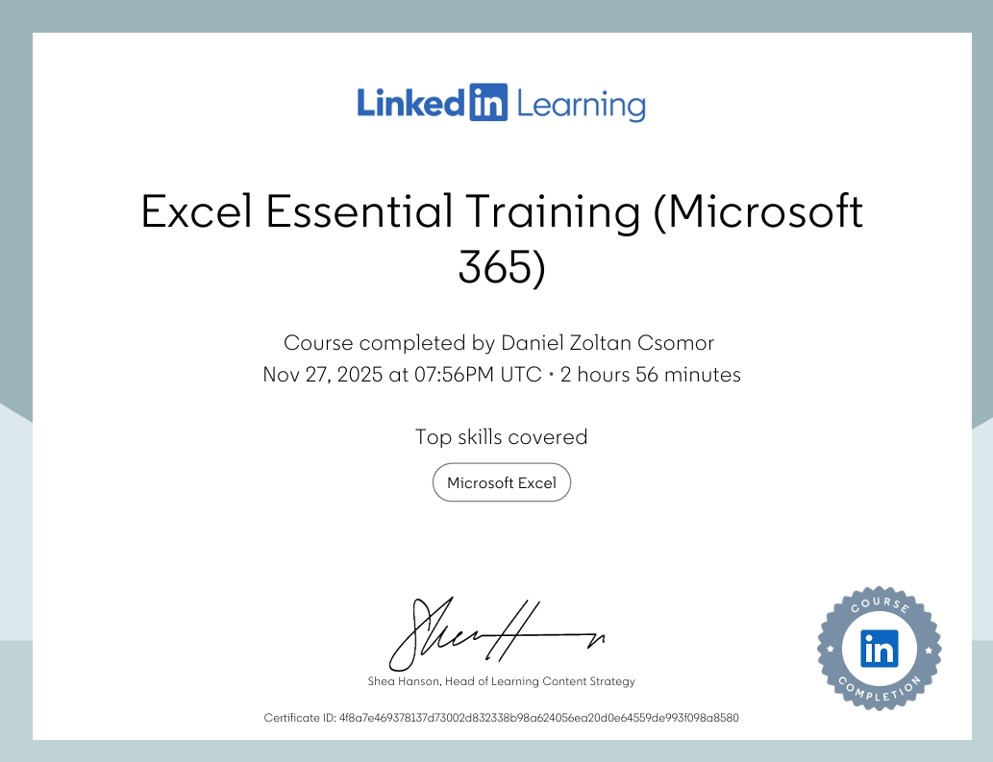

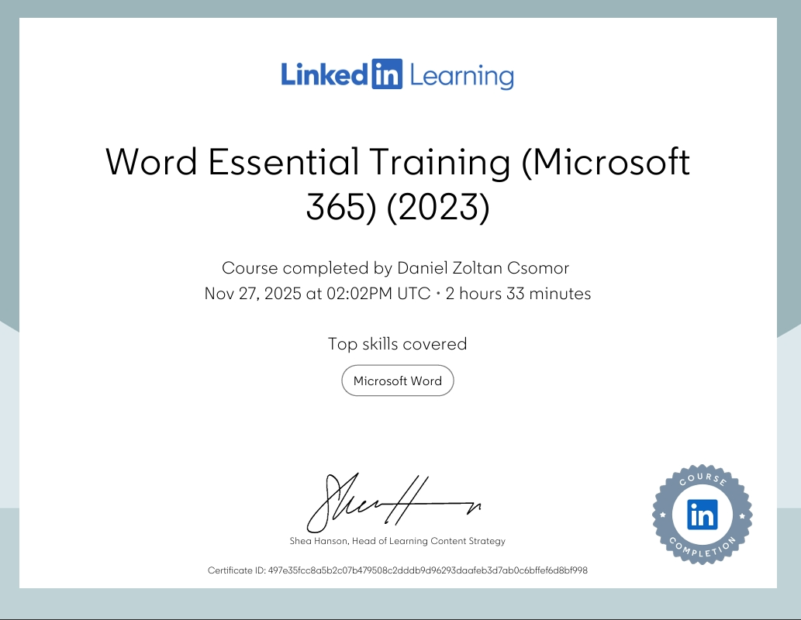



Task 3

Essay on Relevance of Excel in professional and personal life.
Write a 1000 word essay on Relevance of Excel in professional and personal life.
8 references
Use the following information create an Excel spread sheet, looking at income and expenditure of a typical family of 4 over the course of a year. Use formulars to achieve answers and add headings and highlight the different aspects of the finances, be realistic with the monetary amounts used for each area.
Income | Amount per month £££ | Expenditure | Amount per month £££
Wage 1 |  | Rent/Mortgage
Wage 2 |  | Council tax
Trust Funds |  | Electric
Stocks/Share payouts |  | Gas
Universal credit |  | Water rates
Student Finance |  | Food
Other |  | Car insurance
 |  | Car Tax
 |  | Fuel
 |  | Child Care Costs
 |  | Loans/credit cards
 |  | Other eg Birthdays/savings/holidays

Embed your excel here

Essay on Why Excel Is Important in Work and Everyday Life

Microsoft Excel is a very important digital tool that is used in many different jobs and also in daily life. It helps people organise information, do calculations quickly, and understand data better. Before starting this module, I already had some experience using Excel because I used it when I was a manager at Pizza Hut. Later, I also used Excel in the tiling company I work for now. However, during this course I learned many new skills that made using Excel much easier and faster for me. In this essay, I will explain why Excel is useful, how it helps at work and at home, and what I learned from doing the Excel task.

How Excel Helps in Work Life

Excel is used in many jobs, such as business, construction, retail, finance, and office work. One of the reasons it is so popular is because it allows people to work with numbers and information in a simple and organised way. When I worked as a manager at Pizza Hut, I used Excel to record stock levels, staff hours, and weekly sales. It made my job much easier because I could calculate totals with formulas instead of doing the maths by hand. For example, using SUM helped me add numbers quickly, and AVERAGE helped me understand our weekly performance. Now that I work in a tiling company, Excel is still very useful. We use it to write quotations, plan materials, and keep track of client payments. Since completing this module, I feel much more confident using formulas, tables, and formatting. This makes my work more accurate, and I now finish tasks faster than before. Learning Excel properly has helped me become more organised at work and has made problem-solving easier.

Excel is also important in professional settings because it helps companies make decisions. Features such as conditional formatting (colour coding important information) and charts help people see patterns and problems quickly. For example, if some costs are too high, Excel can highlight them in red. This makes it easier for managers and workers to understand what needs attention. Excel also helps when sharing information with others because charts and tables look clear and professional.

Another useful tool is sorting and filtering, which I learned during this module. This helps you find information quickly in large lists, such as customer names, materials, or payments. Before learning these skills, I often felt lost when working with big spreadsheets, but now I can manage them much more confidently.
How Excel Helps in Personal Life

Excel is not only useful at work, it can also make everyday life easier. One of the best personal uses for Excel is budgeting. Before this module, I did not think about using Excel for my own finances, but during the task I created a spreadsheet for a typical family budget. I learned how to organise income and expenses and how to calculate totals automatically. This showed me how helpful Excel can be for planning monthly costs, checking spending habits, and saving money.

For example, formulas like SUM and AVERAGE let me see exactly how much money is spent each month and what the biggest expenses are. This can help with long-term planning, such as saving for holidays, managing bills, or setting aside money for emergencies.

Excel can also be used for personal organisation. People can make spreadsheets for meal planning, gym progress, household tasks, or even tracking goals. One of the things I found useful was learning how to format cells and use colour coding. This makes a spreadsheet easier to read and more motivating to use.

Another benefit of learning Excel is improved digital confidence. Understanding how to use formulas, tables, and charts helped me feel more comfortable with computers in general. Digital skills are important today because many services, banking, shopping, healthcare, are online. Being confident with Excel supports wider digital literacy.

What I Learned From the Excel Task
During this module, I developed many new skills that I did not have before. These include:
- Creating clear tables with headings
- Using formulas like SUM, AVERAGE, MAX, MIN, and IF
- Formatting cells and spreadsheets
- Creating charts to present information
- Organising financial data
- Checking formulas for mistakes
- Understanding how spreadsheets can help with planning

At first, I found some functions difficult, especially when a formula did not work properly. Sometimes I forgot brackets or used the wrong cell reference. However, by practising during the task, I learned how to fix mistakes and understand why they happen. This improved my problem-solving skills and helped me feel more confident.

One of the biggest improvements for me is how Excel now helps in my daily work in the tiling company. I can now manage materials, costs, and quotes much faster than before. Learning Excel properly has made my job easier and has helped me work more efficiently.

Conclusion

Excel is an important digital tool that is useful in both work and personal life. It helps organise information, supports decision-making, and saves time by using formulas instead of manual calculations. Through this module, I learned many new Excel skills that improved my confidence and digital ability. I now use Excel in my current job and plan to continue improving my skills in the future. Excel is more than just a spreadsheet program it is an essential tool that supports success in many different areas of life.

References
Microsoft (2023) Excel Functions Overview. Available at: https://support.microsoft.com/excel (Accessed: 10 December 2025).
JISC (2023) Digital Capability Framework. Available at: https://www.jisc.ac.uk/ (Accessed: 10 December 2025).
LinkedIn Learning (2024) Excel Essential Training. Available at: https://www.linkedin.com/learning/ (Accessed: 10 December 2025).
University of Wales Trinity Saint David (2024) Digital Skills Module Guide. UWTSD internal Document. (Accessed: 10 December 2025).
Mayo, B. (2021) Data Literacy in the Workplace. London: TechPress Publishing. (Accessed: 10 December 2025).
Microsoft 365 Documentation (2023) Excel: Getting Started. Available at: https://learn.microsoft.com/ (Accessed: 10 December 2025).
Smith, J. (2022) Using Spreadsheets for Personal Finance. New York: FinanceWorks Publishing. (Accessed: 10 December 2025).
Brown, T. (2020) Improving Digital Competencies Through Practice. Oxford: Digital Education Press. (Accessed: 10 December 2025).

Task 4

7 Minute Reflective Presentation
Create a PowerPoint presentation using techniques learned in class, reflecting on the module and what you have learned.
Maximum of 15 slides Minimum 7
You will reference your work where appropriate.
Embed PowerPoint here

References
JISC (2023) Digital Capability Framework. Available at: https://www.jisc.ac.uk/ (Accessed: 10 December 2025).

Microsoft (2023) Introduction to Microsoft Office Tools. Available at: https://support.microsoft.com/ (Accessed: 10 December 2025).

University of Wales Trinity Saint David (2024) Digital Skills for Personal and Professional Development – Module Guide. UWTSD Internal Document. (Accessed: 10 December 2025).

