Student Name: Farhan Sajid Rahman Student ID: 1802359
Module: ACDA5005 Smart & Connected Devices

Visualisation of IoT data

Abstract
With the use of PHP and HTML, appropriate methods and tools have been used to build a website interface on data that has been collected by IoT devices. The collected data consists of three sensors gathering the amount of rainfall per hour and a timestamp of the scan. The website interface assists with looking over and letting the user interpret the data that was acquired. Features that were developed will allow several ways of filtering the information, giving visual representation with graphs that can be displayed in different styles, a login required for security of data and more.

Table of Contents
Visualisation of IoT data 0
Abstract 0
Table of Contents 1
1. Introduction 2
2. Implementation 2
2.1 Features 2
2.1.1 IoT Data Transfer – 2
2.1.2 Login – 2
2.1.3 Data Retrieval and Filtering – 3
2.1.4 Graphs – 3
3. Conclusion 3
4. Appendices 4
4.1 Appendix A – Data transferral code 4
4.2 Appendix B – Login Security 4
4.3 Appendix C – Search database by rainfall amount 5
4.4 Appendix D – Data Filters Available 5
4.5 Appendix E – Creating a Graph 6

Keywords:
IoT – Internet of Things

1. Introduction
Throughout the report, discussion will take place on the technicalities, features and code from the process of implementing and applying suitable methods to create a website interface for monitoring data from IoT devices. In this case, it is from three sensors that receive rainfall readings per hour, it gathers the rainfall amount and the timestamp, and is stored into their individual flat text files. The data from these sensors will then be uploaded to a database table with the use of a PHP script.

2. Implementation
The implementation of the website interface used various programming techniques to provide solutions to tasks and several features have been implemented for a sensible display of the data obtained from the sensors. This section discusses what has been accomplished.

2.1 Features
Features implemented within the website will be discussed within this section.

2.1.1 IoT Data Transfer –
A script was required for transferring each of the data that was collected by the sensors and put into a database. There are three sensors and they all served information in the same format, and this raised the fact that a loop can be used to go through each of the text files to accomplish the same task in one go, saving the need to repeat code and creating separate scripts for transferral of the data. A ‘while’ loop was used for the simplicity of iterating until a condition was met, in this case it continues transferring data from each sensor until the current sensor id meets the number of sensors there are. If there were to be more sensors added in the future, simply changing the value of the variable ‘amtOfSensors’ will work if the format of data is saved the same as the others. Additionally, there were measures that had to be thought about to prevent duplicate data being transferred and avoiding reading sensors containing no new data. These issues were simply solved by wiping the file after each data transferral to prevent duplicates being uploaded, and for sensors containing no data, using an if statement to check the file size where if it is 0, it will skip and continue to the next iteration and next sensor data to transfer.
See 4.1 appendix A for code of looping through each sensor

2.1.2 Login –
For security purposes, pages and viewing the data is held behind a login page, and the technique used to protect the information and pages, is by only allowing it to be viewed once a session has started, after either logging in or creating an account. This technique is being used because there is a global PHP variable that can be accessed on each page after calling the function ‘session_start()’ in the PHP header. The global variable ‘$_SESSION’ can then be used and be assigned a unique id to it, in this case it will be the username on login. Each page then simply uses an if statement at the beginning for checking if the person browsing has a session set, and if not, the content will not be displayed to them. Every session automatically ends after the user closes the browser or logs out.
See 4.2 appendix B for login security code example

2.1.3 Data Retrieval and Filtering –
After the rainfall data has been transferred onto the database, retrieving and neatly displaying the information was the next step for interpreting the data easily. To accomplish this, several queries were written and the output that was given were printed onto a HTML table. A measure had to be taken to not attempt printing data if the amount of results equalled to 0, and a built in function gave the ability to do that, where it returns the number of rows from the query result and allows storing it onto a variable for use within an if statement where it will instead print out different text if none was found.

2.1.3.1 The filtering forms which were added:
To complete this, the same execution was done for each of these forms except for one search. This mainly only required making changes to the query code written.
- Displaying all sensor rainfall data
- Displaying Sensor 1, 2 or 3 data – A button form for viewing each sensor
- Display data by ascending or descending date
- Display data by ascending or descending rainfall amount
- Search to only display a rainfall amount of an entered value – A search that was implemented to view the database by the entered value of rainfall that was input. The value the user entered was stored in a variable used within the query. See 4.3 appendix C for code
See 4.4 appendix D for image of filters available

2.1.4 Graphs –
Visualisation of the database was completed for easier interpretation, and it was done using the ‘phpMyGraph5.0’ library to create graphs, it gave the simple ability of choosing several graph styles from just a change of the function name, and then easily allowed outputting it onto the page as an image. Two graph styles were completed, and forms were added to set the data on the graph either by all sensor information or by an individual sensor the user chooses. The code for implementing the graph simply queries the information it requires, stores that information within an array and gets passed into the parameters of the graphs library function.
See 4.5 appendix E for the code of creating a graph

3. Conclusion
In conclusion, the website interface provides several filtering features to interpret the data from each of the sensors and is secured behind a login that is required to view any page, even when attempting by entering the link. Also to mention, the data transferring script provides a fast way to send all information from each of the sensors to the database and can be easily changed to support more by editing a value of the amount there are, given that the format stays the same as the others. Additionally, further ways for interpreting the data is given through visual representation of the data with two styles of graphs, one being a column and another being a line where the user can also filter between sensors or display all information.

4. Appendices

4.1 Appendix A – Data transferral code
Part of the transferral of all the sensor data code.
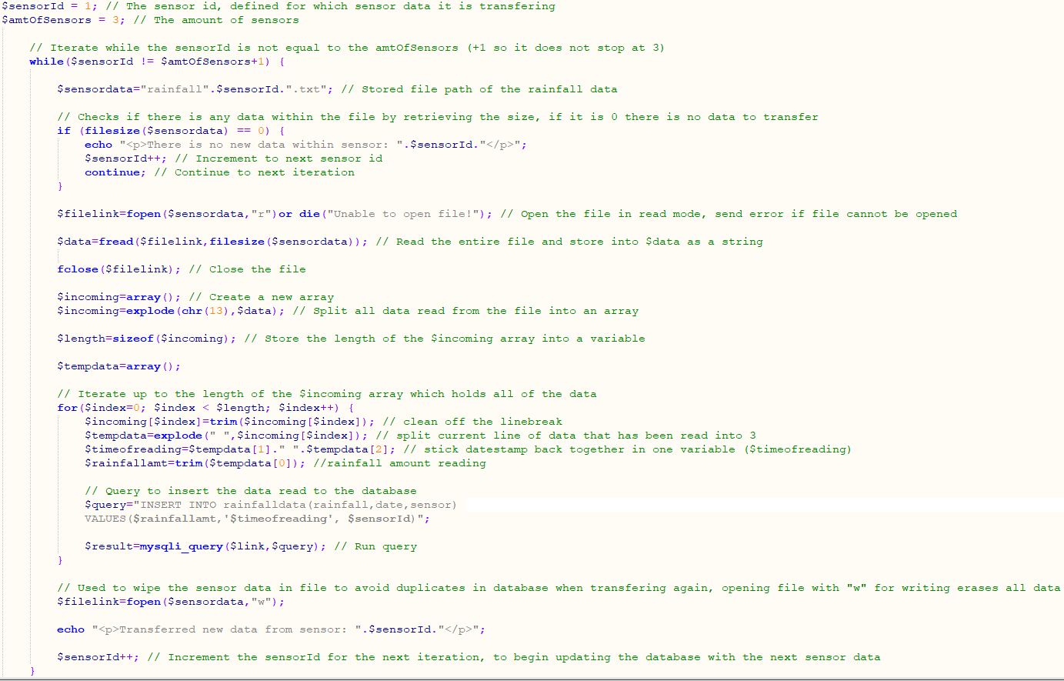

4.2 Appendix B – Login Security
Preventing users viewing a page until a $_SESSION is initiated with a username. Example code below is from the homepage where if the session does not exist, it will show the login page, whereas if it does, it will display different content.
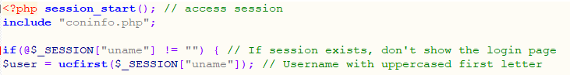
Assigning the ‘$_SESSION’ global variable as the username when the user logs in:

4.3 Appendix C – Search database by rainfall amount
Code used to print out records found from the rainfall amount entered by user.
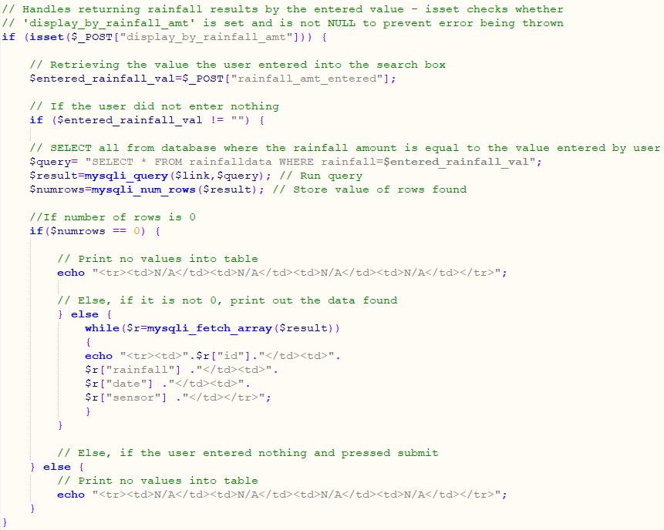

4.4 Appendix D – Data Filters Available
The filters available to view and interpret the data.
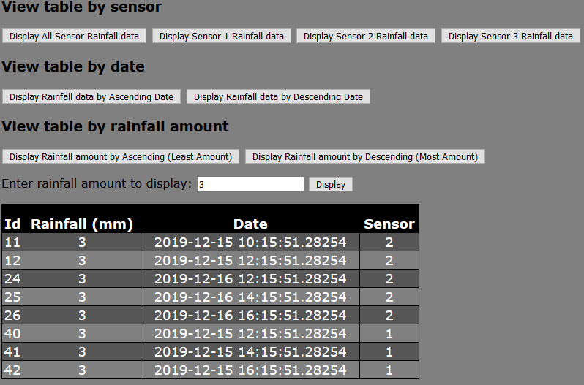

4.5 Appendix E – Creating a Graph
Code used to create a line graph for sensor 1 data.
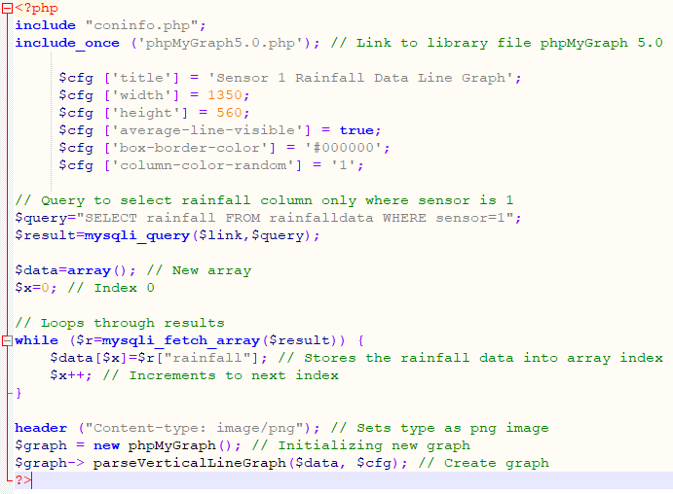
Then shown as an image using this code after user clicks the button.


