

MSc Computer Networks and Cyber Security
ACCA7028: Prof. Carlene Campbell

Wales Institute for Science and Art
University Of Wales Trinity Saint David
Swansea

December 2, 2021

CONTENTS
Purpose……………………………………………………………………………………………………………………………………
Scope……………………………………………………………………………………………………………………………………
Introduction……………………………………………………………………………………………………………………………………
- Penetration testing……………………………………………………………………………………………………………………………………
Penetration Testing Stages……………………………………………………………………………………………………………………………………
1.2. Pen testing methods……………………………………………………………………………………………………………………………………
1.3. Use of pen testing……………………………………………………………………………………………………………………………………
1.4. Things to be tested……………………………………………………………………………………………………………………………………
1.5. Causes of vulnerabilities ……………………………………………………………………………………………………………………………………
1.6. Pen test tools and companies……………………………………………………………………………………………………………………………………
1.6.1 criteria’s for selecting the best pen test tool……………………………………………………………………………………………………………………………………
1.6.2. recommended pen test tools……………………………………………………………………………………………………………………………………
1.7. Pen testing type ……………………………………………………………………………………………………………………………………
1.8. Different approaches to pen testing ……………………………………………………………………………………………………………………………………
1.8.1 Black box pen testing ……………………………………………………………………………………………………………………………………
1.8.2 white box pen test……………………………………………………………………………………………………………………………………
1.8.3. Gray box pen test ……………………………………………………………………………………………………………………………………
1.9. Pen Testing Techniques……………………………………………………………………………………………………………………………………
1.10. Pen test process ……………………………………………………………………………………………………………………………………
1.10.1 This process can be categories as follow……………………………………………………………………………………………………………………………………
2.1. Cross Site Request Forgery (CSRF) ……………………………………………………………………………………………………………………………………
2.1.1. how to defend against CSRF attacks……………………………………………………………………………………………………………………………………
2.1.2. passive reconnaissance email harvesting with the harvest……………………………………………………………………………………………………………………
2.2. Clickjacking……………………………………………………………………………………………………………………………………
2.2.1. why I choose Acunetix……………………………………………………………………………………………………………………………………
2.2.2. Advantages of using Acunetix……………………………………………………………………………………………………………………………………
2.2.3. how to defend against click jacking ……………………………………………………………………………………………………………………………………
2.2.4. how to fix clickjacking ……………………………………………………………………………………………………………………………………
2.2.5 classification ……………………………………………………………………………………………………………………………………
2.3. cookies without HTTPONLY flag set ……………………………………………………………………………………………………………………………………
2.3.1. how to fix it ……………………………………………………………………………………………………………………………………
2.3.2. classification ……………………………………………………………………………………………………………………………………
3) Finding vulnerabilities in the website using Nessus……………………………………………………………………………………………………………………………………
3.1 advantages of Nessus ……………………………………………………………………………………………………………………………………
3.2 some important information about the host which we discovered using the Nessus tool………………………………………………………………………………………………
3.2.1 Operating system identification: ……………………………………………………………………………………………………………………………………
3.2.2 jQuery Detection……………………………………………………………………………………………………………………………………
3.2.3 SSL Root Certification Authority Certificate Information………………………………………………………………………………………………………………………
3.2.4 PHP Version Detection……………………………………………………………………………………………………………………………………
3.2.5 OpenSSL Version Detection ……………………………………………………………………………………………………………………………………
3.2.6 Nessus SYN scanner……………………………………………………………………………………………………………………………………
3.2.7 Apache HTTP Server Version……………………………………………………………………………………………………………………………………
3.2.8 Service Detection……………………………………………………………………………………………………………………………………
3.2.9 SSL Perfect Forward Secrecy Cipher Suites Supported…………………………………………………………………………………………………………
3.2.10 SSL Cipher Suites Supported……………………………………………………………………………………………………………………………………
3.2.11 HTTP/2 Cleartext Detection……………………………………………………………………………………………………………………………………
3.2.12 HSTS Missing from HTTPS Server……………………………………………………………………………………………………………………………………
3.2.13 Web mirroring……………………………………………………………………………………………………………………………………
3.2.14 Web Application Sitemap……………………………………………………………………………………………………………………………………
3.3 some vulnerabilities discovered ……………………………………………………………………………………………………………………………………
3.3.1 SSL Cipher Suites Supported……………………………………………………………………………………………………………………………………
3.3.2 SSL Self-Signed Certificate……………………………………………………………………………………………………………………………………
3.3.3 SSL Certificate Cannot Be Trusted……………………………………………………………………………………………………………………………………
3.3.4 HTTP TRACE / TRACK Methods Allowed……………………………………………………………………………………………………………………………………
3.3.5 jQuery 1.2 < 3.5.0 Multiple XSS……………………………………………………………………………………………………………………………………
3.3.6 PHP < 7.3.28 Email Header Injection……………………………………………………………………………………………………………………………………
3.3.7 PHP 7.2.x / 7.3.x < 7.3.22 Memory Leak Vulnerability………………………………………………………………………………………………………………
3.3.8 PHP < 7.3.24 Multiple Vulnerabilities……………………………………………………………………………………………………………………………………
3.3.9 PHP Unsupported Version Detection……………………………………………………………………………………………………………………………………
3.3.10 Browsable Web Directories……………………………………………………………………………………………………………………………………
3.3.11 Web Application Potentially Vulnerable to Clickjacking ……………………………………………………………………………………………………
3.4 using zenmap to scan the host (healios-pharma.com) ……………………………………………………………………………………………………………………………………
3.4.1 advantages of zenmap and why some people will prefer it to Nmap ……………………………………………………………………………………………………
3.4.2 scanning our host (healios-pharma.com) using zenmap ……………………………………………………………………………………………………………
3.5 Using the command uniscan on Linux to detect vulnerabilities on our host. ………………………………………………………………………………………………………
3.5.1 some important findings we discovered using uniscan on the host ………………………………………………………………………………………………………
3.6 finding weaknesses using N-STALKER tool and solution……………………………………………………………………………………………………………………………………
3.6.1 advantages of N-STALKER ……………………………………………………………………………………………………………………………………
3.6.2 screen shots of vulnerabilities discovered using n-stalker …………………………………………………………………………………………………………………
3.7 scan results found using Nikto scanner ……………………………………………………………………………………………………………………………………
3.8 budget …………………………………………………………………………………………………………………………………………………………..
3.8.1. cost to fix vulnerabilities discovered and fix……………………………………………………………………………………………………………………………………
4 Research into cyber security incident and defensive technique case study……………………………………………………………………………………………………………
4.1 process and procedure to recover deleted files ……………………………………………………………………………………………………………………………………
4.1.1 procedure to protect and document the evidence ……………………………………………………………………………………………………………………………………
4.1.2 data analysis ……………………………………………………………………………………………………………………………………
4.1.3 evidence assessment……………………………………………………………………………………………………………………………………
4.1.4 recovering the deleted files……………………………………………………………………………………………………………………………………
5 Conclusion…………………………………………………………………………………………………………………………………………………………..

Figures

Figure 1: the pen test process
Figure 2: black box pen test
Figure 3: white box pen test knowledge
Figure 4: Gray box pen test (translucent test)
Figure 5: methods of pen testing
Figure 6: IP address discovery and ports
Figure 7: operating system discovery
Figure 8: version and traceroute discovery
Figure 9: covering tracks
Figure 10: vulnerabilities found using Nmap
Figure 11: scan results using whois
Figure 12: clickjacking and cookies vulnerabilities found using acunetix
Figure 13: root certification authority for Healios
Figure 14: SSL Perfect Forward Secrecy Cipher Suites Supported
Fig 15: linkable contents
Figure 16: expired SSL Cipher Suites
Figure 17: Self-Signed Certificate SSL
Figure 18: expired ssl certification chain and solution
Figure 19: how to disable trace and track method
Figure 20: jQuery version installed and its fixed version
Figure 21: PHP version installed an its fixed
Figure 22: PHP version installed an its fixed for memory vul
Figure 23 : récent PHP version installed for multiple vulnerability
Figure 24: php version supported
Figure 25: browsable directories on the host
Figure 26: click jacking pages in the host (healios-pharma.com)
Figure 27: scanning the host using GUI of Nmap
Figure 28: sign in page of host hidden from users
Figure 29: vulnerabilities discovered using N-Stalker scanner
Figure 30: nikto scan result
Figure 31: budget table
Figure 32: time table for execution
Figure 32: empty USB drive LATO (F:)
Figure 33: deleted files from 2021 was discovered
Figure 34: extraction of file to selected folder
Figure 35: Retrieved files

Purpose
This research and testing are been carried out to help Healios Pharmaceutical Company (HPC) who have been working hard to come up with the Covid 19 vaccine to help people. They are on the verge of coming up with the cure of the Covid 19 which will save millions of lives. They want to be totally sure their security system is well protected and save from intruders/attackers who might one to hack the system to compromise it or steal sensible information they have been working on. So, the decided to hire a pen tester who will perform all the various test on the website to make sure it is well secured and all areas of vulnerabilities are discovered and dealt with reassuring the company they are free and save from any sort of attacks. While doing this test, we make sure the company rules and guidelines are being followed to avoid policy breach which might put you the pen tester into serious problems.
This testing was carried out on the period of December to January 2022 and some initial findings were discovered on different covers, and the full outcome of our testing struggle is been shown in this report and recommendations are been made where necessary.

Scope
The scope of this research is to perform a real-life pen testing on HPC website. We aim to analyze the website for weaknesses, technical flaws and vulnerabilities. We are going to perform black-box penetration testing on the website bring out all its vulnerabilities and document how they can be exploited.
We will use the OWASP top 10 and other relevant attack techniques to guide us on the kind of attacks we will carry out on the website. Then we will write a detail report of all our findings on the website.
Application Authentication Landing Page
HPC Portal https: https://healios-pharma.com/

Introduction
Penetration testing of a website points out vulnerabilities which can be exploited by an attacker for his/her malicious reasons. Websites are perhaps one of the most valuable assets to businesses and organizations. The ability to provide customers and users with a well secured and safe online experience is very important now our days and helps maintain and increase the reputation of your organization and customers and user gain more trust and confidence in you.
Now our days a lot of people turn to rely a lot on technology which has caused us to be more exposed to security risks and attacks especially on websites and web applications which are one of the most well-known causes of data breach against companies/organizations. Though some of these attacks are automated, not aimed at a particular target, there has been a rapid increase on website attacks which are targeted by cyber criminals, anonymous group and organized criminal gangs. The exist various motive for target attacks which are: [1]
- Malware injection
- Website defacement
- Denial-of-service (DOS)
- Trying to obtain access to backend database which contains sensible information.
Penetration testing on the company’s website or web app helps us point out all the security flaws that exist in the fundamental code, which may result in cyber-security vulnerability been exploited if present.
The experience pen tester will try to identify the recent web vulnerabilities and security flaws in your website or app, then applies successful security measures to mitigate the probability of security breach.
The reason for carrying out this test is to secure and protect important data/information unauthorized users who may try to gain unauthorized access to the system. As soon as a vulnerability identified, it is exploited to gain access to the network or system which contains sensible information. [2]

Penetration testing
A penetration test (pen test) is the procedure of pointing out security vulnerabilities in an app or website by assessing the network or system with different malicious attacks/techniques. After the evaluation of the system the vulnerable areas of the system is been exploited through an authorized simulated attack [2]. A pen tester is also known as an ethical hacker and he helps discover vulnerabilities of our web applications, network, and computer system through penetration testing.
Pen testing helps assess the defense of any company or organization giving you a result on whether the systems is strong enough to stop security breaches or weak. Pen testing report provides corrective measures which can be taken into consideration to mitigate the risk of the system or network being attacked. [2]

Penetration Testing Stages
Pen testing process has 5 main stages which are:
- Planning and reconnaissance:
This first stage involves defining the extent and goals of the test, the system to be tested and methods used in testing. It also involves intelligence/information gathering (e.g., mail server, domain names, and network) which helps us in understanding the working of a target and its vulnerabilities.
- Scanning:
Next stage is the understanding of how target app will react to different intrusion attempts. This is done by:
- Dynamic analysis - where the code of an app in progress is been examined. This method of scanning is more practical, as it gives a real time scenario of an app’s performance.
- Static analysis – here an app code is been examined to determine its behavior while in running state. The entire code can be scanned by these tools in one go.

- Gaining access:
Web app attacks like SQL injection, cross site scripting, backdoors etc. are been used in this stage to discover the targets weaknesses. The ethical hacker then tries to exploit these vulnerabilities, by data theft, traffic interception, privilege escalation etc. to have an understanding of what damage can be caused on the system.

- Maintaining access:
In this stage the goal is to see if we can use the vulnerability to obtain lasting presence in the system been exploit. The goal here is to take as a model developed persistent threats, which hides itself in the system for months/years stealing organizations most sensitive information.

- Analysis:
At this stage, the compiled pen test report is been provided detailing:
- All exploited vulnerabilities
- Sensitive information which was gained
- The total time spent by the pen tester in the system without being detected
Pen tester/security personnel then analyze all these information to help configure a company’s WAF setting and help patch security vulnerabilities protecting the organization against future attack [3]

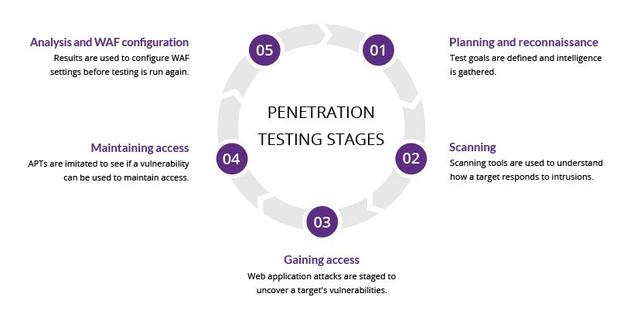
Figure 1: the pen test process

Pen testing methods
- External testing
Here the assets of companies visible on the internet is been targeted e.g., the organisations website, domain name servers (DNS), web apps and emails. The goal here is to obtain access and get sensible information.
- Internal testing
Here the ethical hacker with who has access to an app behind a firewall mimics an attack by a malicious insider. This can be a case where phishing attack was used to still employee’s credentials.
- Blind testing
Here only the name of the targeted company/organisation is been given to the tester. Security personnel are been given a real-time scenario on how an authentic app attack is been carried out.
- Double-blind testing
Here no prior knowledge of the simulated attack is been known by the security personnel. Like in the real-world scenario there is no time for them to strengthen their defence before the attack is carried out.
- Targeted test
Here the security personnel and tester both works together and update each other of their movements. This is an important training practice that gives real time feedback to the security team from the hackers’ point of view [3]

Use of pen testing
Remember the WannaCry Ransome attack which happened in may 2017. More than 2 million computers were locked off worldwide and the attackers asked for a Ransome to be payed to them in bitcoins crypto currency. This attack affected a lot of big organisations worldwide. With such massive form of attacks going on out there it is very important for organisations to do pen testing in their system on a regular interval to protect the system against breaches.
- Used in securing users’ data/information
- Used in finding security weaknesses/vulnerabilities in a web app or websites
- Used in the discovery of loopholes in a system
- It Is used as part of a software release cycle by many clients
- Helps to protect financial or sensitive information while it’s been transferred through different systems
- Helps in the implementation of an efficient security strategy [2]
Organisations/companies need to pick out security issues that exist in the computer system and internal network. With the help of these information gathered, companies can plan a security defence against any hacking attempt. Information security and data privacy are they greatest concern now our days.

Things to be tested
- Hardware
- Software (i.e., applications, OS and services)
- Processes
- Network
- End-user behaviour

Causes of vulnerabilities
- Connectivity: hackers can easily hack systems connected to an unsecured network i.e., open connections
- Human errors: human factors like coding errors, sharing password, phishing sites, insider threats etc. can cause security breaches.
- Password: we use password to stop unauthorized access. Password should be strong mixed letters, numbers and characters in your password. Do not tell anyone your password or write it down somewhere people can easily see it. easy to guess passwords should not be used.
- Bad configuration of a system: if a system is wrongly configured it leaves weaknesses for attackers to hack the system and get whatever information they want.
- Complexity: now our days systems are made up of a lot of features to satisfy users need and the more features available the easier it makes it for the system to get attacked
- Lack of trained staffs: if your staff has no knowledge on vulnerabilities and all they may make errors which will led to the system being attacked.

Pen test tools and companies
Standard vulnerabilities present in a website or app can easily be identified using automated tools. These tools help us scan codes to identify errors in them or if they are malicious to the system which might cause a security breach.
Security weaknesses in systems can be identified using pen test tools to examine data encryption techniques and trying to figure out hard-coded values like passwords and usernames.

1.6.1 criteria’s for selecting the best pen test tool

- It should easily scan your system
- Detailed vulnerability logs and reports should easily be detailed
- Easy re-verification of previous exploit found
- Easy to use, deploy and configure
- Vulnerabilities should easily be classified based on severity and immediately fixed

1.6.2. recommended pen test tools

- Intruder
- Acunetix
- PowerShell- suite
- Zmap
- Wireshark
- Aircrack-ng
- Metasploit
- Nmap etc

Pen testing type
It is always a good habit as a pen tester to familiarise yourself with the different types of pen testing available, as engagement vary on depth, duration and focus. The common ones include: [4]
- Internal/external infrastructure pen testing: an evaluation of an on site and cloud network infrastructure, made up of switches, routers, firewalls, devices and system host. To carry out a test, the number of external and internal IPs to be tested need to be known, number of sites and their subnets. [4]
- Wireless pen testing: it finds unauthorised, open, and less secured hotspots or WIFI then connects to them. This test targets organisations WLAN and protocols. It also helps point out bad access points, WPA vulnerabilities. Here testers need to know number of guest networks and wireless network, SSIDs. [1] [2]
- Web app testing: here we can verify if the app is exposed to security weaknesses using software. The security vulnerabilities are been checked using this software in the particular environment. Here there is the evaluation of clients’ app and website delivered over the internet. Trying to discover building and coding flaws that can easily be exploited. Before carrying out this kind of test, access the static page, dynamic page and number of applications that require testing. [4] [2]
- Mobile app testing: this testing is done on OS like android, IOS to bring to identify authorisation, authentication, session handling and data leakage problems. The OS and version needs to be known in order for this test to be carried out [4]
- Social engineering test: here the aim is to make people reveal sensitive information like important business information, passwords etc. this test mostly targets helpdesk employees and carried out through internet or phone.
The main cause of vulnerabilities is human errors. Security policies and standards should be put in place and followed by all staff to prevent social engineering attacks. [2]
- Remote dial up war dial: modems in that area or zone are been searched and connection attempts are made by brute force or password guessing in order to get access to the system
The above is how pen testing is categorized

Different approaches to pen testing
They exist different approaches in pen testing and different vulnerabilities they try to exploit. The amount of information given to the pen tester will determine the scope and approach they will use to solve the problem.
These approaches include:
- Black box
- Grey box
- White box

1.8.1 Black box pen testing
Black box pen test (external pen test) is one in which the pen tester is given little to no information at all about the organisations infrastructure in which the test has to be performed on. The advantage of this technique is that you simulate a real-world cyber-attack, where the pen tester takes the role of a uniformed attacker [5]
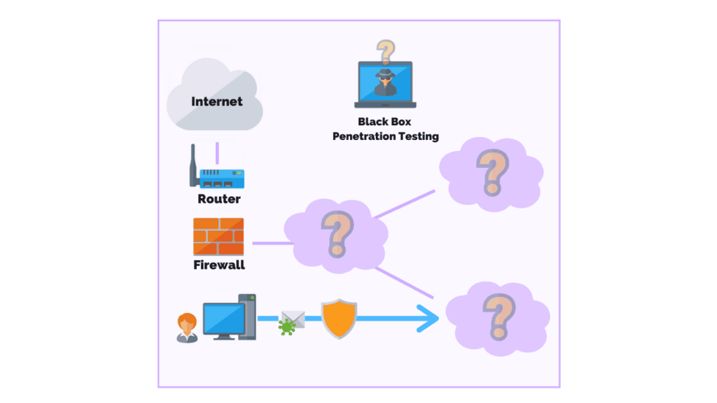
Figure 2: black box pen test
This is one of the longest types of pen test carried out it might take up to 2 months to complete it. Regarding the time and effort used to plan, perform, test, and write the report business can pay close to £10,000-£25,000 depending on the scope of the project. The best and easy way to carry out a black box test is to perform or deploy a series of exploits known to work. This method is known as the “trial and error” method; however, this requires a high level of technical skills.

1.8.2 white box pen test
White box testing (glass box, clear box, or internal pen testing) is the pen test in which the pen tester has complete access and knowledge to the organisation architecture and source code. White pen tester aims on conducting a comprehensive security audit of the organisations system and the pen tester is been provided with as much information about the system as possible.
This makes the test less complicated and difficult since the pen tester has knowledge and a lot of information which a black box tester doesn’t have like app design, codes etc [5]
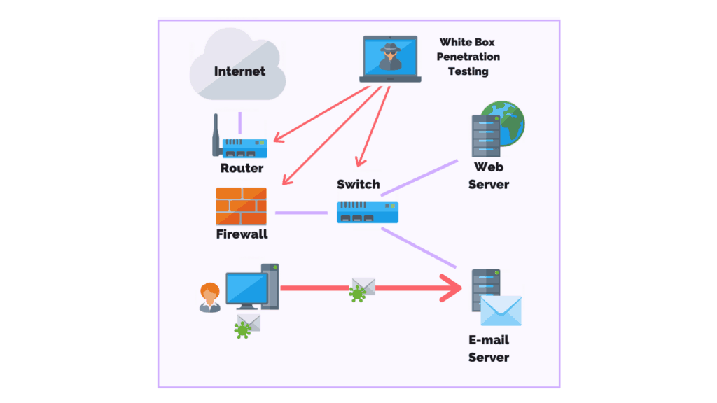
Figure 3: white box pen test knowledge
The disadvantage here is that give all the access and information to the pen tester it will take time for them to choose on what area to start and focus on. Also, expensive and advanced tools like debuggers are needed in this method of testing. This test may cost £4,000-£20,000 to conduct and it takes like two to three weeks to complete it.

1.8.3. Gray box pen test
Here, the tester has partial access and knowledge to the system or web app. Here the pes tester first tries to gain users privileged on a host then later on tries. To escalate this privileged to a domain admin.
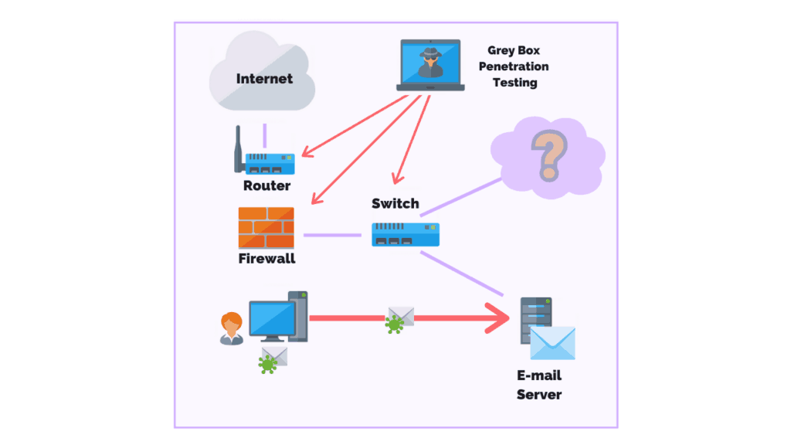
Figure 4: Gray box pen test (translucent test)

One important advantage in this test Is that the report provided gives a more efficient assessment and focus on the network security system.
For example, instead of conducting a trial-and-error method pen testers conduct a Gray box test which gives reviews on the network diagram spotting areas with high risk and countermeasures can be taken to tackle the problem. [5]

Pen Testing Techniques
- Manual Penetration Test
- Using automated penetration testing tools.
- Combination of both manual and automated processes.

Manual pen test: finding vulnerabilities using automated tools is quite difficult because some vulnerabilities can only be found by manually scanning. Based on the knowledge and skills attackers have on an app, it will help them conduct a good attack.
Humans can perform social engineering. Manual checks are made up of: business logics, design and code verification.

Pen test process
This are the processes pen test agencies and pen tester carry on. Vulnerability identification in the system is the first step and most important step. Countermeasures are done on the vulnerabilities found to correct them on till the system becomes negative to all test carried out.

This process can be categories as follow

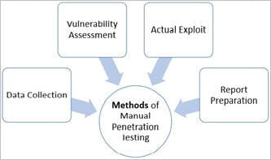
Figure 5: methods of pen testing

- Data collection: the exist several ways to collect data including google search which helps us get information on the system being targeted. The source code of the web page can also be used to analyze techniques in order to obtain more information on the system, plugins and software version. The exist different free tools out there which can help you get information like database, software version, hardware used etc.
- Vulnerability assessment: we can find the security vulnerabilities in the system based on the information we collected in the first process. This information collected helps pen testers carry out and attack in regards to the weaknesses identified.
- Actual exploit: this is one of the most important steps it needs knowledge, technique and skills to carry out the attack on the system been targeted. Experience pen testers then launch the attack.
- Results in analysis and preparation of the report: after the pen test has been completed, a detailed report is been prepared in order to take corrective actions to secure the system. All vulnerabilities discovered are listed and their recommended corrective actions to in this report. This vulnerability report is customizable depending on the requirements of your organization. [2]

- Penetration testing on the website
The first step here we will try to discover the IP address of the website using its domain name and find open ports in the website
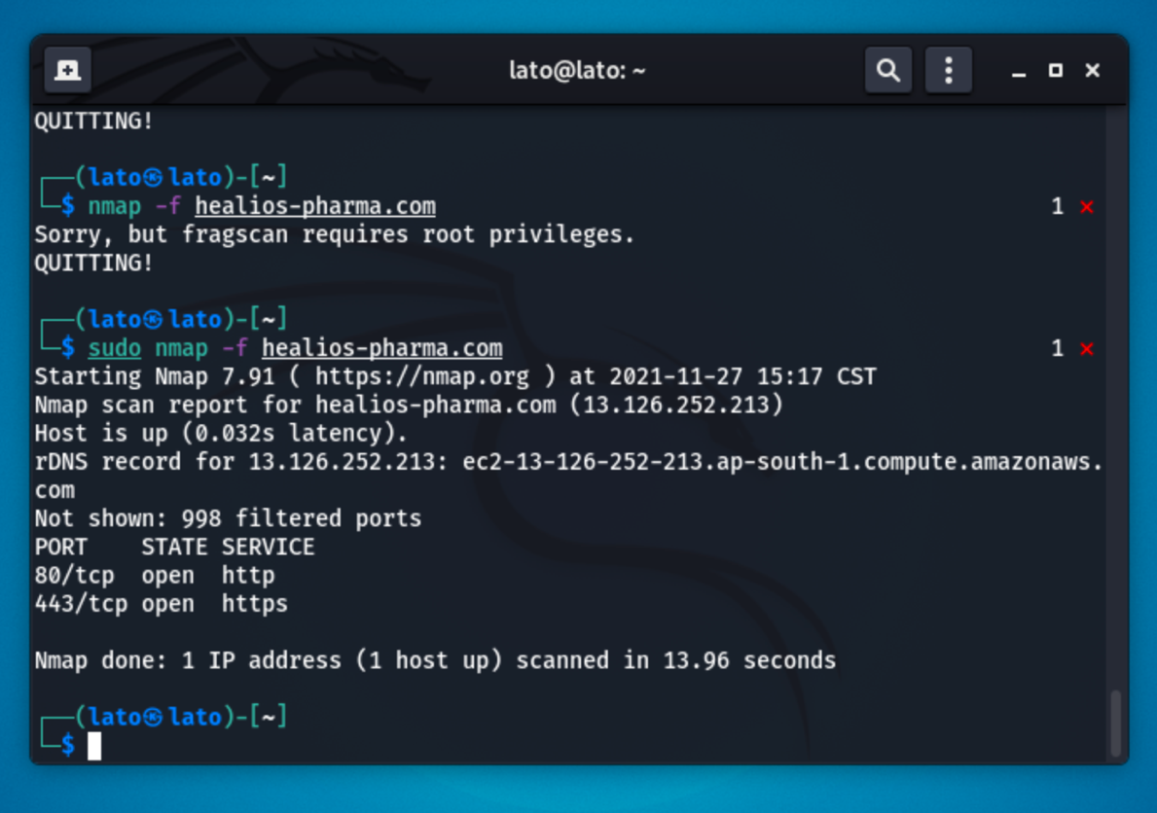
Figure 6: IP address discovery and ports
After performing the scan on the URL of the given website (https://Healios-pharma.com) we discovered its IP address which is 13.126.252.213 and found out the host is up. Out of the 1000 port scanned just 2 ports were open and all the rest not shown. Port 80 and port 443 TCP ports were opened running http and https services
We were also able to discover the operating system our target is using with the following Nmap command sudo nmap -O healios-pharma.com

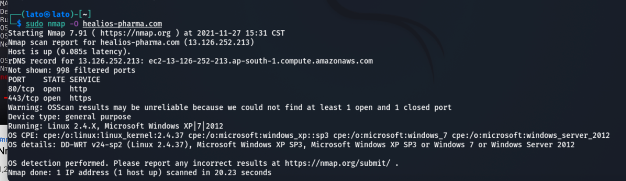
Figure 7: operating system discovery
The operating system is running a linux 2.4.X and a Microsoft Window xp|7|2012 and its servers.
We were also able to detect the OS, version, traceroute and scrip scanning using the -A
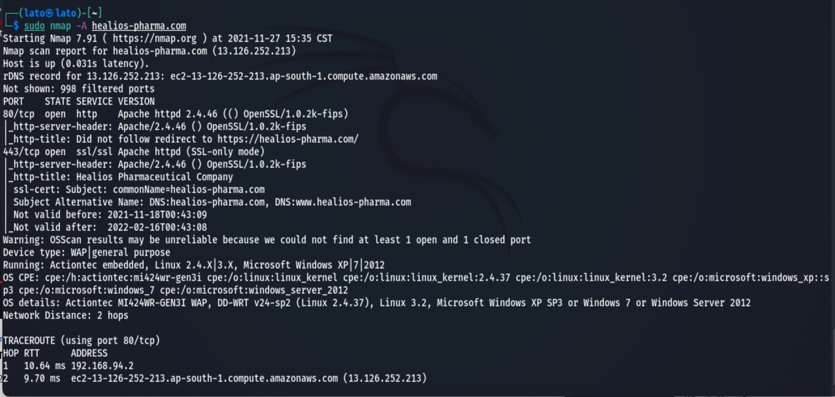
Figure 8: version and traceroute discovery
We found the OS, version of the protocols which is Apache httpd 2.4.46 on port 80 running service http and Apache httpd (SSL-only mode) running service ssl/ssl. the distance between the network and your local network and the trace route.
When scanning a network, a lot of traffic is been send and received so u can easily be tracked. we want to avoid being found so in order for me to scan this website and make sure no one finds us easily we will cover our tracks using the following command in the figure below
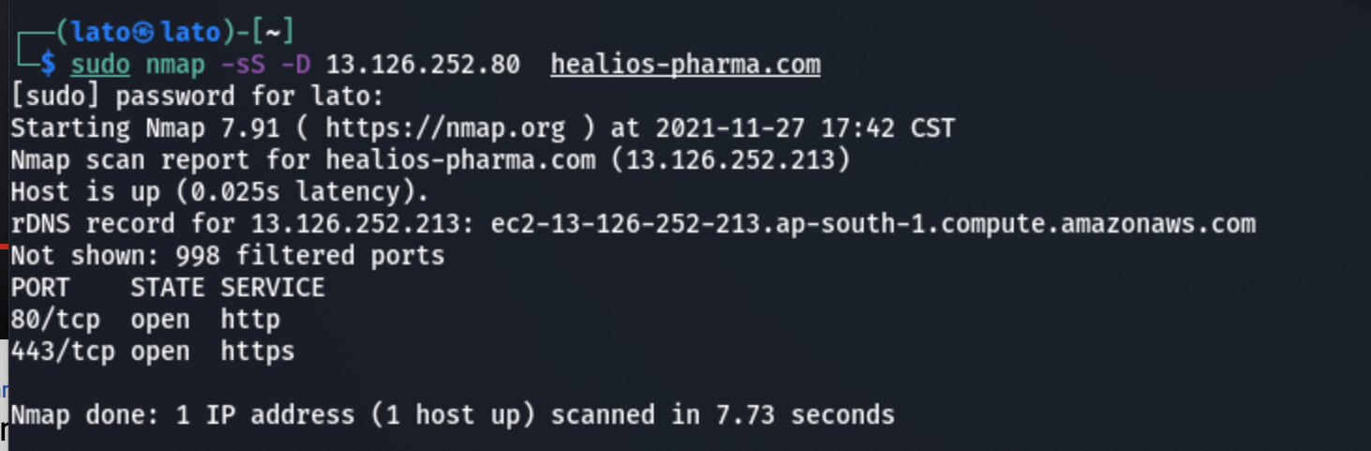
Figure 9: covering tracks
The D stands for decoy and we give in a decoy IP address and it targets it sends a duplicate traffic and confuse anyone trying to track you.
- Next, we are going to use the following script to scan our host to find open ports and in addition will scan to find vulnerabilities that can be exploited (sudo nmap –script vuln healios-pharma.com)

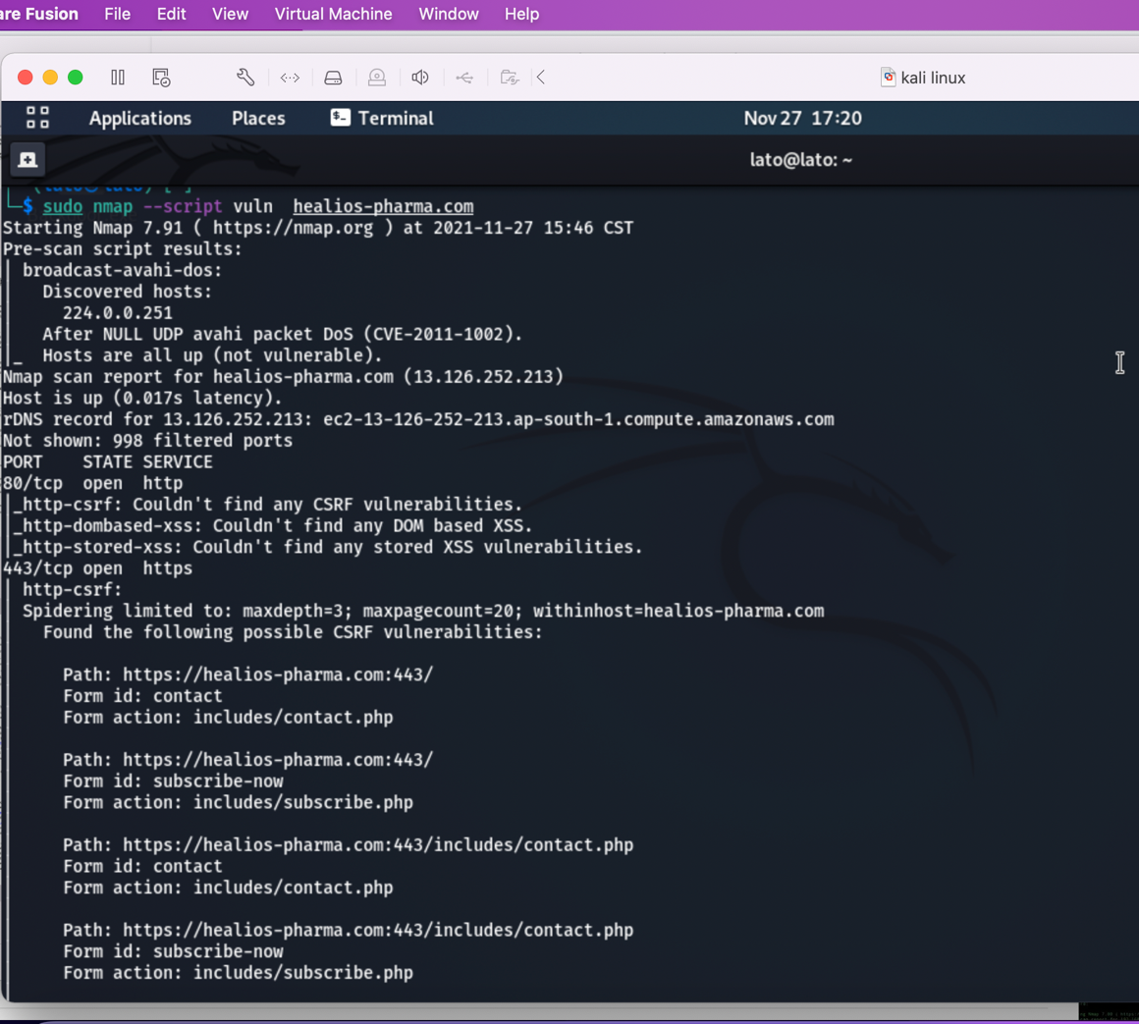

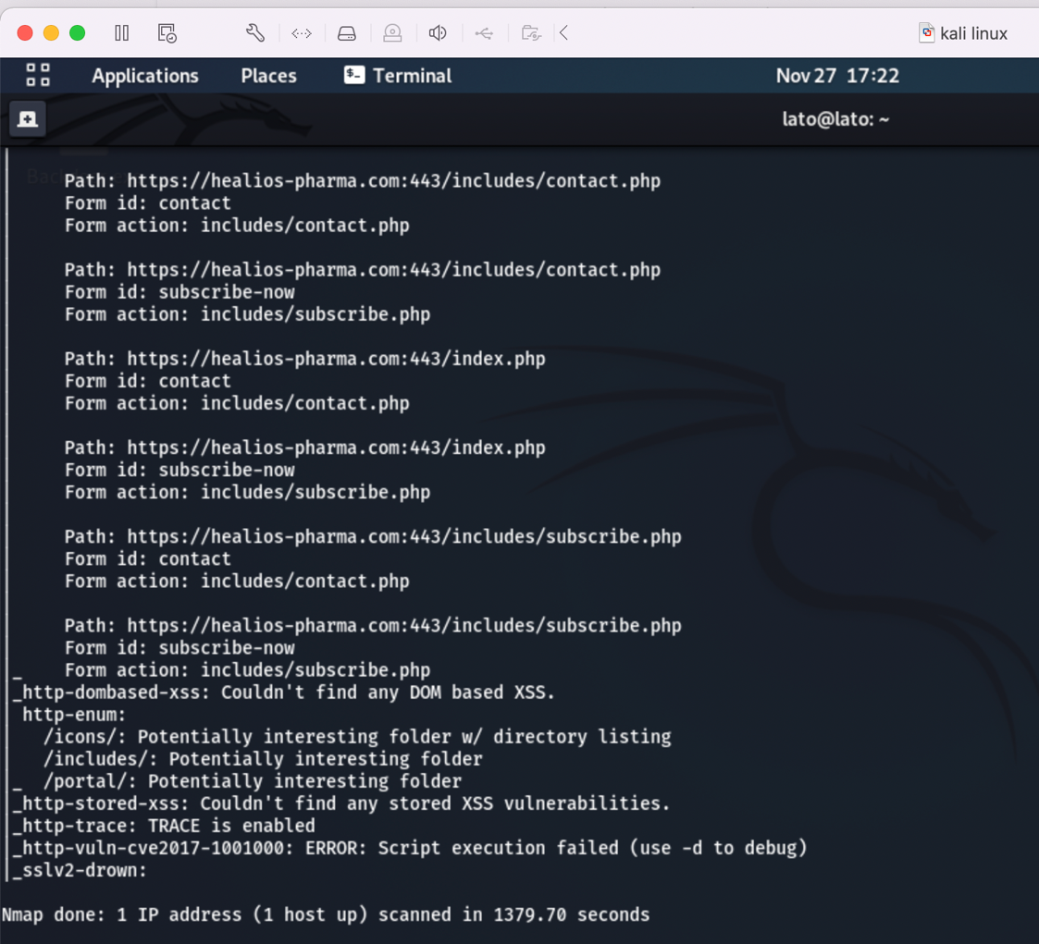
Figure 10: vulnerabilities found using Nmap
The following possible CSRF vulnerabilities were found:
Path: https: healios-pharma.com:443/includes/subscribe.php
Form id: contact
Form action: include/contact.php etc all the rest as shown in (figure 10)

2.1. Cross Site Request Forgery (CSRF)
This attack forces end users to perform unwanted actions on a web app in which they are authenticated to. Attackers may trick users by sending them links through emails or chats when clicked the attacker can easily carry out his actions a successful CSRF attack can make the user to perform state changing request like changing email, fund transfer etc. if this attack is successful on the admin of the system the attacker can compromise the entire web app. Browsers request automatically has all cookies included in them that’s one reason why a CSRF attack can be carried out.

2.1.1. how to defend against CSRF attacks
- CSRF token should be added to all state changing request and make sure they are been validated on the back end.
- Synchronize token pattern should be used for stateful software’s
- Double submit cookies should be used for stateless software
- Custom request headers should be used
- Standard headers should be used to verify the origin
- For state changing operation GET request should not be used.
The login page of this website is hidden which makes it a little bit difficult to carry out the CSRF attack.

2.1.2. passive reconnaissance email harvesting with the harvester
We tried finding emails related to the website using email theHavester but could not find any then we used whois and had a bunch of information like the phone number emails etc. as shown in the figure below
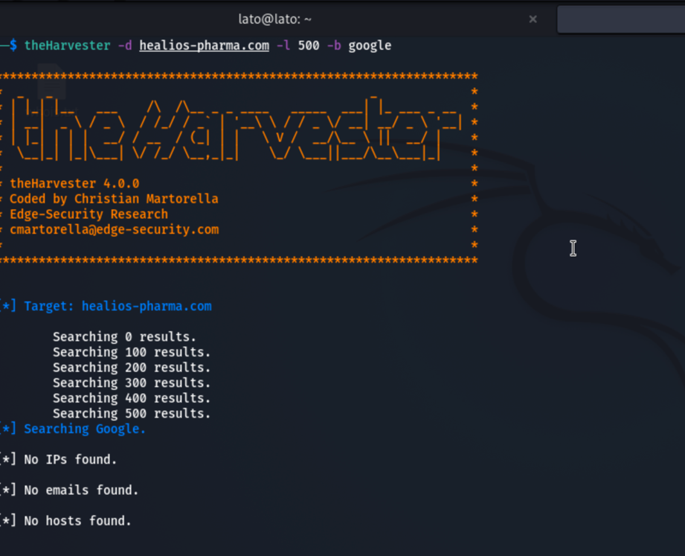
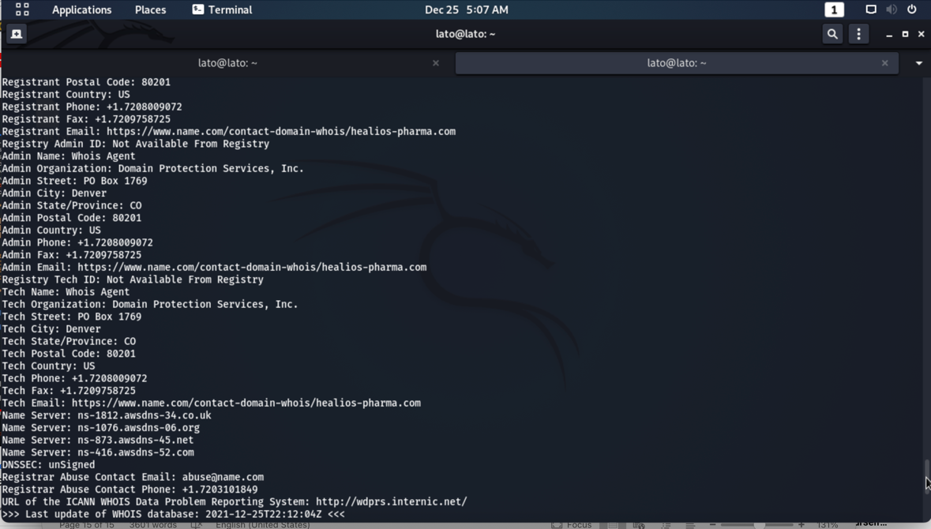
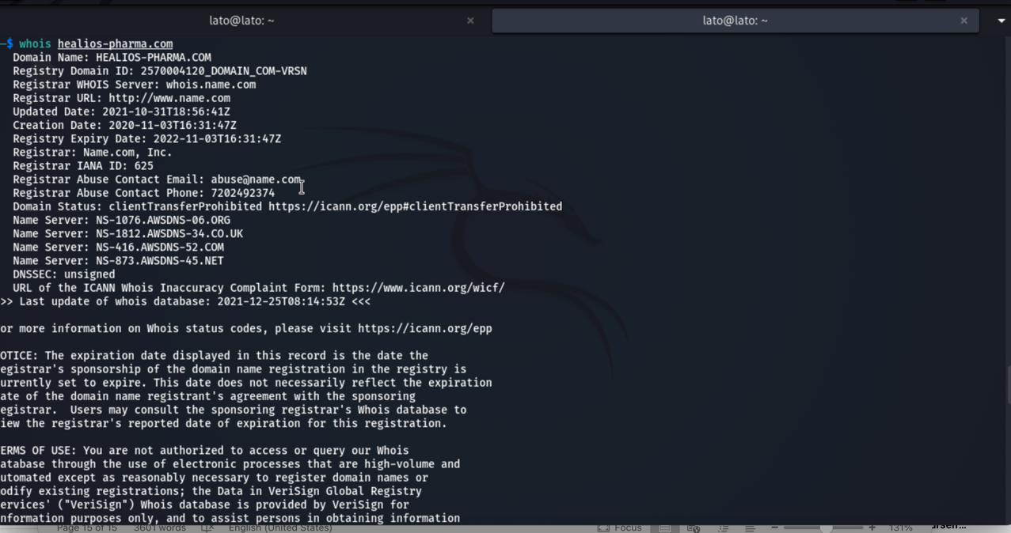
Figure 11: scan results using whois

2.2. Clickjacking
Using the web application testing tool called Acunetix we were able to find out some vulnerabilities which can be exploited in the website. Click jacking (UI redress attack, user interface redress, UI redressing) is a spiteful way in which web users are been tricked to click on something different from what he/she recognise they are clicking on, as a consequence sensitive and confidential information are been revealed or their computer is been taken control over by the hacker when the click on apparently on the harmless web page. The clicks done by the user are been hijacked by the attacker on the page and routed to another page owned by some other domain, app, or both.
It is also possible to hijack key strokes using same method. Using well-structured iframe, text boxes, and stylesheets a user can type in their password, bank details and other sensitive information thinking it’s been typed in the legitimate frame while its instead goes to an invisible frame controlled by the attacker.
The server did not return an X-FRAME-OPTION header which means that the website is vulnerable to clickjacking attack. The X-FRAME OPTION HTTP response header can be used to tell whether a browser should be allowed to render a page inside a frame or not.
The vulnerability affects http://healios.com/
Discovered by Scripting (Clickjacking_X_Frame_Options.script)
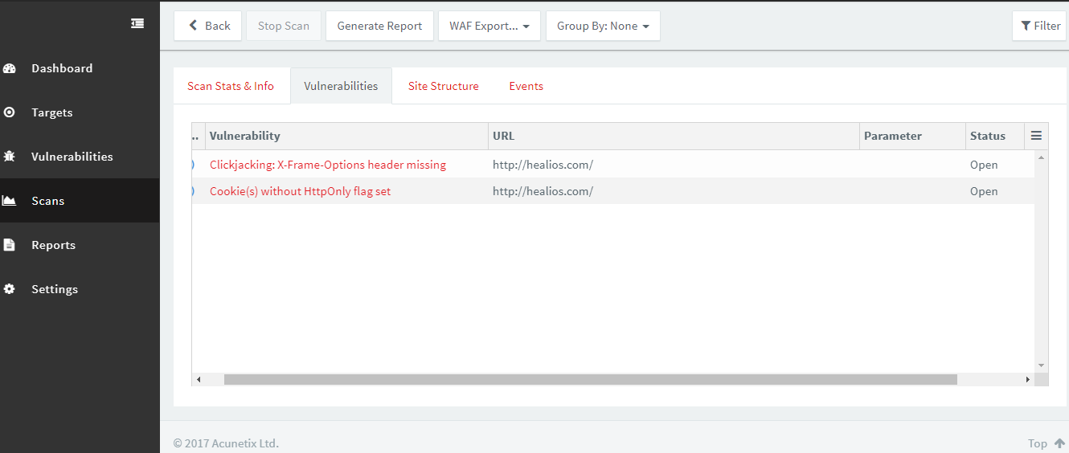
Figure 12: clickjacking and cookies vulnerabilities found using acunetix

2.2.1. why I choose Acunetix
Acunetix is a strong automated web app testing tool that helps examine websites by checking for all forms of weaknesses like: cross site scripting, sql injections etc. any website or app available over the internet can be scanned using Acunetix it uses http and https protocols.
It gives us a unique and strong feature for analyzing custom and off shell web apps. It has an advance crawler which can locate almost all files [6]

2.2.2. Advantages of using Acunetix
- because of its capabilities to provide a lot of information about vulnerabilities, it enables you to locate and fix them quicker
- since it understands the behavior of the web app, when scanning the website, it reduces false positive.
- alerts the user of misconfiguration problems or sensitive information which are been exposed
- tells you how to better secure your web app settings
- more sql injections can be detected using this [6] etc.

2.2.3. how to defend against click jacking
The exist several methods to prevent this form of attack
- A defensive code is been implemented in the UI to make sure that the current frame is the most top level.
- The proper CSP (content security policy) should be sent, frame ancestors directive response headers which the browser gets instruction from to stop framing coming from other domains.
- JavaScript code should be implemented in the page to prevent it from loading in a page
- Use the SameSite cookies attribute to prevent the inclusion of session cookies
- Multiple attack vectors should be used when securing website and system
- Anti-clickjacking Add-ons should be used on the client site of the website some browsers like Firefox have them [7]

2.2.4. how to fix clickjacking
Clickjacking is caused when third party websites gain permission and use iframe to embed the vulnerable site. Setting up HTTP Headers to prevent the website from been iframed will help stop this attack. This can be done when servers are been configured on the two-response header: JavaScript code and X-Frame-Options Content-Security-Policy that stops the iframe. Third way is use JavaScript code to burst the frame.
- X frame option: it is a respond header. It is used to protect websites against clickjacking. We can use this to tell whether a browser is allowed to render a web in iframe or not by setting its value as follow:
X-FRAME-OPTIONS: DENY: using this no site will be allowed to load page in a frame
X-FRAME-OPTIONS: SAMEORIGIN: here the page can still be used as long as the site adding it to the frame is same as the one serving it
X-FRAME-OPTIONS: ALLOW-FROM uri: here if this is been specified, the site can only be displayed in the frame by specified URL. Doesn’t work anymore with new browsers [8]
- HTTP Content-Security-Policy: this header allows admins of websites manipulate resources which user agents load for a given page.

2.2.5 classification

CWE
CWE-693
CVSS Base score: 6.8 — AV:N/AC:M/Au:N/C:P/I:P/A:P
Access Vector: Network
Access Complexity: Medium
Authentication: None
Confidentiality Impact: Partial
Integrity Impact: Partial
Availability Impact: Partial

2.3. cookies without HTTPONLY flag set
This was discovered using same web app testing tool Acunetix. The HTTPOnly flag is not set in the cookies of this website. When the httponly flag is being set on the cookies, it tells the browser that only the server can access the cookies and not the client-side script. It is an important security protection for session cookies. When the httponly attribute is placed on the cookies, that ensures that the cookies value can’t be read or set by client-side JavaScript. This makes most client side attacks like CSS harder to carry out [9]
The vulnerability affects: http://healios.com/
Discovered by Crawler

2.3.1. how to fix it
We simply set the HTTPOnly flag for this cookie on the website

2.3.2. classification

CWECWE-16
CVSS Base score: 0 — AV:N/AC:L/Au:N/C:N/I:N/A:N
Access Vector: Network
Access Complexity: Low
Authentication: None
Confidentiality Impact: None
Integrity Impact: None
Availability Impact: None

Finding vulnerabilities in the website using Nessus
Nessus is a security scanning tool which is used to scan websites, apps, networks, computers etc and provides all the possible vulnerabilities it found during the scanning process which hackers can use to gain access to the system and perform their malicious act. Nessus runs over 1200 checks on the system trying to find weaknesses attackers could exploit. If you are an administrator or pen tester in an organisation its always advisable to use Nessus to scan for vulnerabilities and viruses which attackers could possibly use to get into the system. Nessus doesn’t protect your computer from attacks it just helps in the sense that, it provides all possible vulnerabilities in the system it is now up to the admin or pen tester to research, get solutions and patch these vulnerabilities found [10]

3.1 advantages of Nessus
- When compared with other scanners, Nessus doesn’t make assumption on the configuration of your server (e.g., assuming port 80 is always the web server) which makes other scanners miss important vulnerabilities in the system.
- Nessus has all recent information on new attacks and vulnerabilities. A list is been updated daily on new vulnerabilities by the Nessus team
- Nessus is highly extensible; it provides a scripting language for testing the system. It also provides a lot of free plugins on the Nessus plug in site.
- Nessus is an open-source tool you can easily download it for no cost at all.
- When a vulnerability is been detected, Nessus also provides a way to patch these vulnerabilities.
- Nessus shows you the vulnerabilities which needs immediate attention and which one should be addressed in first place

3.2 some important information about the host which we discovered using the Nessus tool
We downloaded and installed the Nessus web app testing tool and performed a scan on our Host IP address which is the 13.126.252.213. Both a basic network scan and web application scan was carried out and the following information was gotten after the scan was completed.

3.2.1 Operating system identification:
A combination of remote probes was used (e.g., SMB, HTTP, TCP/IP, NTP, etc) it was possible to obtain the name of the OS and version the Host is using.
emote operating system: Linux Kernel 2.6
Confidence level: 65
Method: SinFP
The remote host is running Linux Kernel 2.6
Risk Information
Risk Factor: None
Vulnerability Information
Asset Inventory: True

3.2.2 jQuery Detection
This is a JavaScript library build to ease html Dom tree manipulation, traversal, event handling ajax and CSSs animation and it also enables the use of JavaScript on a website [11]
Output
URL: http://ec2-13-126-252-213.ap-south-1.compute.amazonaws.com/assets/js/jquery-2.1.0.min.js
Version: 2.1.0
Hosts
80 / tcp / www
13.126.252.213
URL: https://ec2-13-126-252-213.ap-south-1.compute.amazonaws.com/assets/js/jquery-2.1.0.min.js
Version: 2.1.0
Hosts
443 / tcp / www
13.126.252.213
Risk Information
Risk Factor: None
Vulnerability Information
CPE: cpe:/a:jquery:jquery
Asset Inventory: True

3.2.3 SSL Root Certification Authority Certificate Information
An SSL certificate chain that has a self-signed root Certification Authority certificate at the top of the chain is been used by the remote service
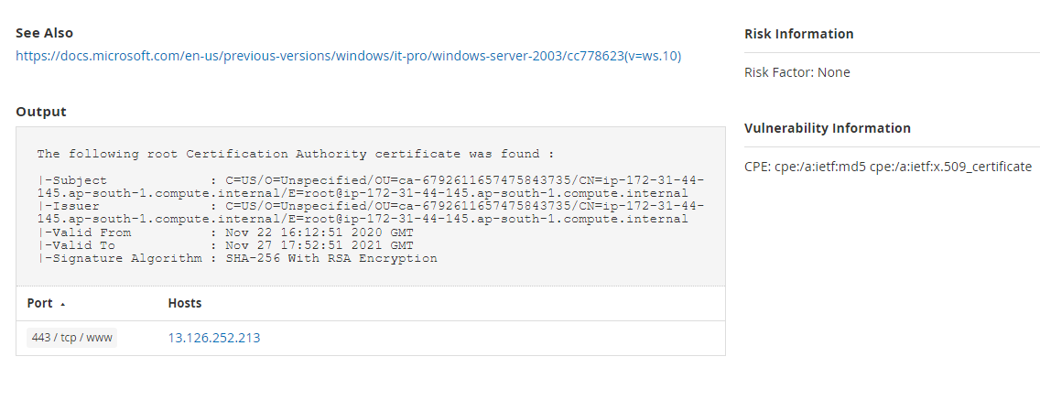
Figure 13: root certification authority for Healios

3.2.4 PHP Version Detection
Nessus was able to determine the version of PHP available on the remote web server.
Output:
Nessus was able to identify the following PHP version information:
Version: 7.2.34
Source: X-Powered-By: PHP/7.2.34
Hosts
443 / tcp / www
13.126.252.213
80 / tcp / www
13.126.252.213
Risk Information
Risk Factor: None
Vulnerability Information
CPE: cpe:/a:php:php
Asset Inventory: True

3.2.5 OpenSSL Version Detection
We were able to obtain the OpenSSL version from the banner of the web server using Nessus. Keep in mind security patches in a lot of scenarios are backported and the patch level is not shown on the display number. The use of this to pick out vulnerable software is might lead to false detection.
Output:
Source: Apache/2.4.46 () OpenSSL/1.0.2k-fips
Reported version: 1.0.2k
Backported version: 1.0.2zzzz
Hosts
443 / tcp / www
13.126.252.213
80 / tcp / www
13.126.252.213
risk Information
Risk Factor: None
Vulnerability Information
CPE: cpe:/a:openssl:openssl
Asset Inventory: True

3.2.6 Nessus SYN scanner
This is a SYN 'half-open ‘plugin port scanner. it's faster even once facing a target with firewall.
Keep in mind that that SYN scans area unit less interrupting than transmission control protocol scans against broken services, however issues might stumble upon for fewer strong firewalls and conjointly leave unclosed connections on the remote target, if the network is loaded.
Solution:
Protect your target with an IP filter.
Output:
Port 80/tcp was found to be open
Hosts
80 / tcp / www
13.126.252.213
Port 443/tcp was found to be open
Hosts
443 / tcp / www
13.126.252.213

3.2.7 Apache HTTP Server Version
Apache HTTP Server running on the host, an open-source web server. The version number could be read from the banner.
Output:
URL: http://ec2-13-126-252-213.ap-south-1.compute.amazonaws.com/
Version: 2.4.46
backported: 1
Hosts
443 and 80 / tcp / www
13.126.252.213
Risk Information
Risk Factor: None
Vulnerability Information
CPE: cpe:/a:apache:http_server
Asset Inventory: True

3.2.8 Service Detection
Nessus could determine the remote service by its banner or by observing the error message it sends once it receives associate degree protocol request
Output
A web server is running on this port.
Hosts
80 / tcp / www
13.126.252.213
A web server is running on this port through TLSv1.2.
Hosts
443 / tcp / www
13.126.252.213
A TLSv1.2 server answered on this port.
Hosts
443 / tcp / www
13.126.252.213

3.2.9 SSL Perfect Forward Secrecy Cipher Suites Supported
The remote host supports the utilization of SSL ciphers that provide perfect Forward Secrecy (PFS) secret writing. These cipher suites make sure that recorded SSL traffic can't be broken at a future date if the server's private key is compromised.
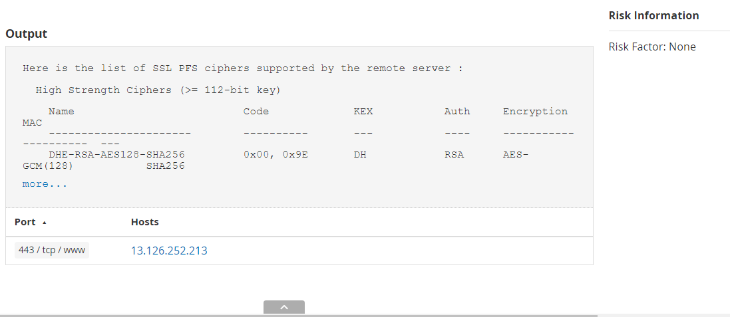
Figure 14: SSL Perfect Forward Secrecy Cipher Suites Supported

3.2.10 SSL Cipher Suites Supported
This plugin tells us which SSL ciphers are supported by the remote service for encrypting communications.
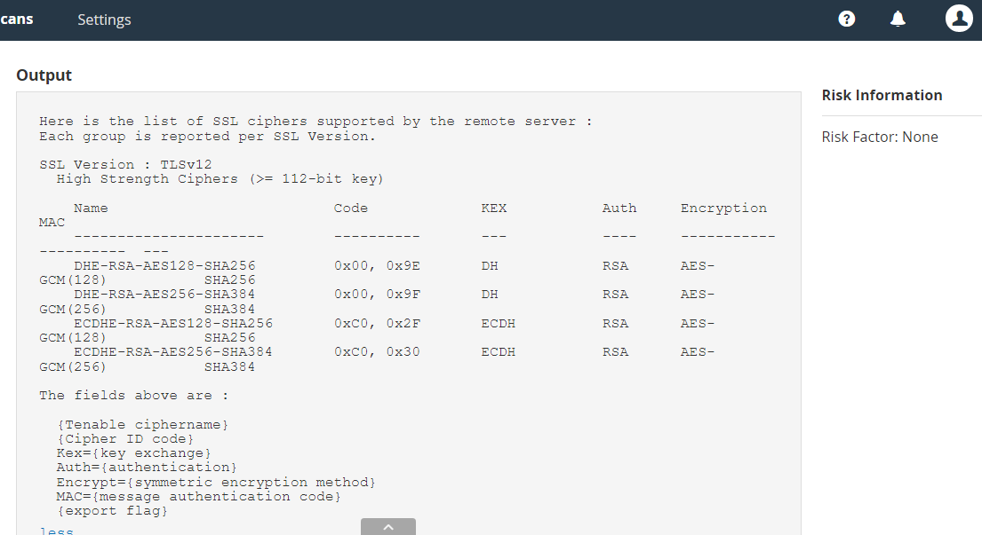
Figure 15: SSL Cipher Suites Supported output

3.2.11 HTTP/2 Cleartext Detection
HTTP server that supports HTTP/2 running over cleartext TCP (h2c) is been ran on the remote host
Solution:
Limit incoming traffic to the present port if desired
Output:
Direct HTTP/2 connections are supported by the server without encryption.
Hosts
80 / tcp / www
13.126.252.213

3.2.12 HSTS Missing from HTTPS Server
The remote hypertext transfer protocol server isn't implementing HTTP Strict Transport Security (HSTS). HSTS is a respond header, which is optional to configure on the server to tell the browser to communicate using only HTTPS. The absence of HSTS permits downgrade attacks, SSL-stripping man-in-the-middle attacks, and weakens cookie-hijacking protections.
Solution:
The remote web server should be configured to use HSTS
Output:
The remote HTTPS server does not send the HTTP “Strict-Transport-Security" header.
Hosts
443 / tcp / www
13.126.252.213

3.2.13 Web mirroring
A mirror of the remote website can be made using this plugin and the CGIs list used by the remote host ca be extracted. It is advisable to change the number of pages that can be mirrored in the client’s option section
.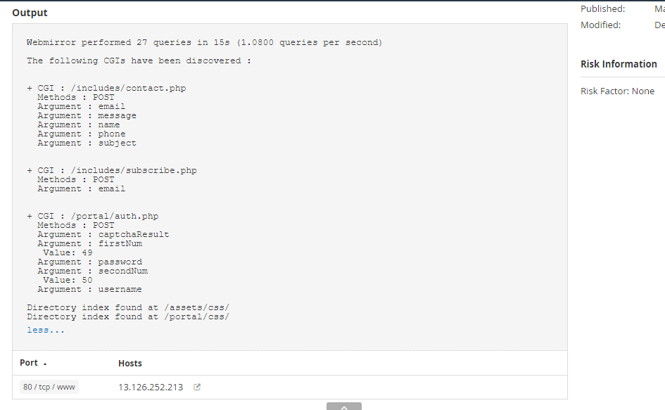
Fig: web mirroring information

3.2.14 Web Application Sitemap
They exist linkable content on the remote web which an attacker can use to gather information about the target
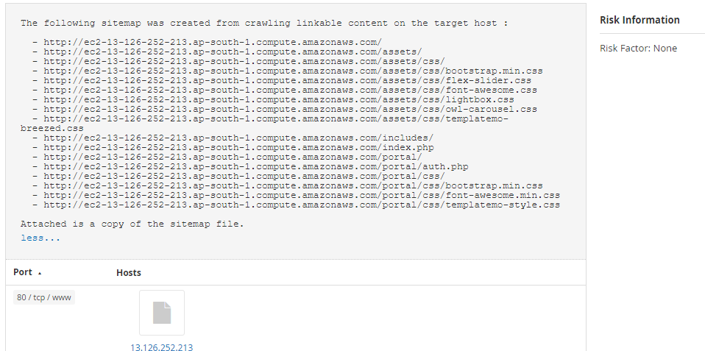
Fig 15: linkable contents

3.2.15 Web Application Potentially Sensitive CGI Parameter Detect

3.3 some vulnerabilities discovered
The following vulnerabilities were captured during the scan and attackers could use these vulnerabilities to exploit the system:

3.3.1 SSL Cipher Suites Supported
This plugin checks expiry dates of certificates associated with SSL- enabled services on the target and reports whether any have already expired. The SSL cipher suites for our target host (healios-pharma.com) was found to be expired meaning attackers can easily exploit through this way. Information about it is given in (figure 16) below
Solution:
Get a new SSL certificate to replace the existing one.

Plugin Details

Severity: Medium
ID:15901
Version:1.50
Type: remote
Family: General
Published: December 3, 2004
Modified: February 3, 2021

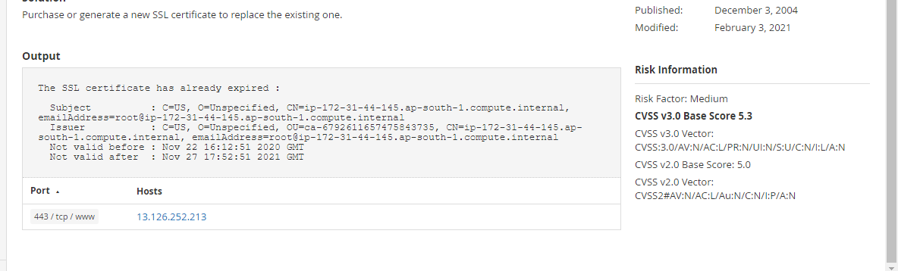
Figure 16: expired SSL Cipher Suites

3.3.2 SSL Self-Signed Certificate
The X.509 certificate chain for this service isn't signed by a recognized certificate authority. If the remote host could be a public host in production, this nullifies the utilization of SSL as anyone may establish a man-in-the-middle attack against the remote host.
Note that this plugin doesn't check for certificate chains that finish during a certificate that's not self-signed, however is signed by Associate in Nursing unrecognized certificate authority [12]
Solution:
buy or produce a correct SSL certificate for this service.
Plugin Details
Severity: Medium
ID:57582
Version:1.5
Type: remote
Family: General
Published: January 17, 2012
Modified: April 27, 2020

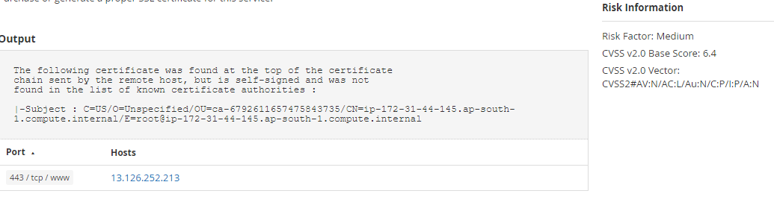
Figure 17: Self-Signed Certificate SSL

3.3.3 SSL Certificate Cannot Be Trusted
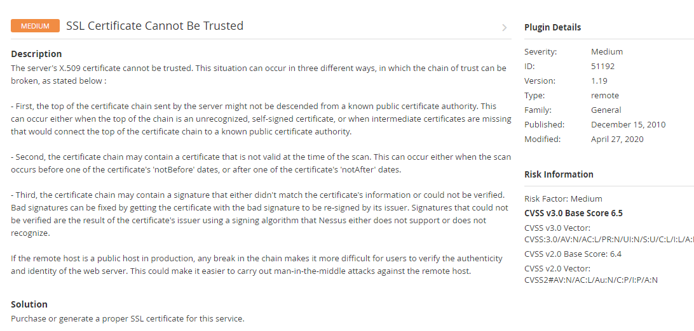
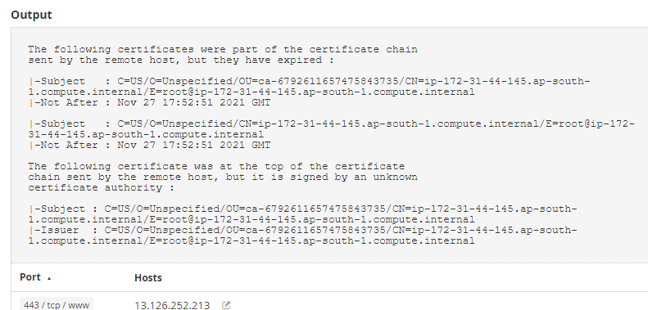
Figure 18: expired ssl certification chain and solution

3.3.4 HTTP TRACE / TRACK Methods Allowed
These are http methods used to troubleshoot connections on web servers. An attacker may be able to abuse the trace and track functionality to obtain important information in http headers when http request is been made [13]
Solution:
These http methods should be disabled. For this method to be disabled, the following line should be added for each virtual host in your config file as shown in (figure 19) for both 443 and 80 / tcp / www on host 13.126.252.213.
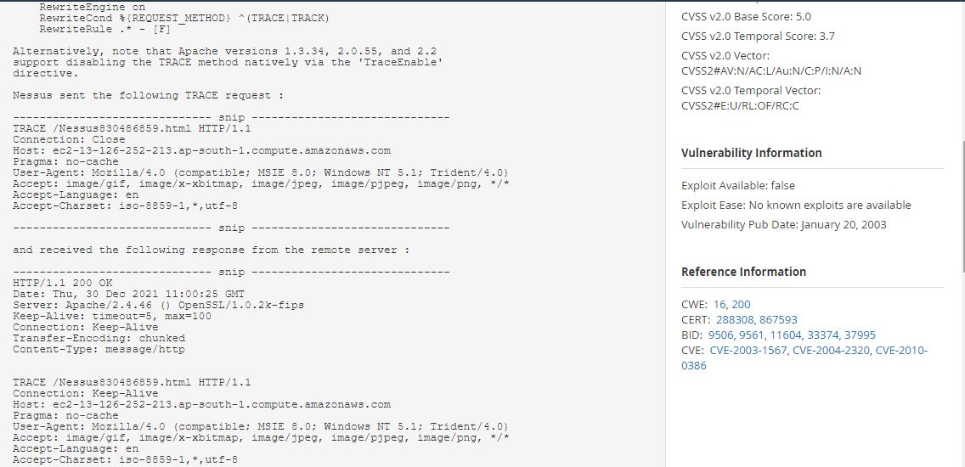
Figure 19: how to disable trace and track method

3.3.5 jQuery 1.2 < 3.5.0 Multiple XSS
In regards to our scan performed on the target host; it was discovered that the host is running an older version of jQuery which makes is vulnerable to multiple cross site scripting.
Solution:
It should be updated to jQuery version 3.5.0 or latest
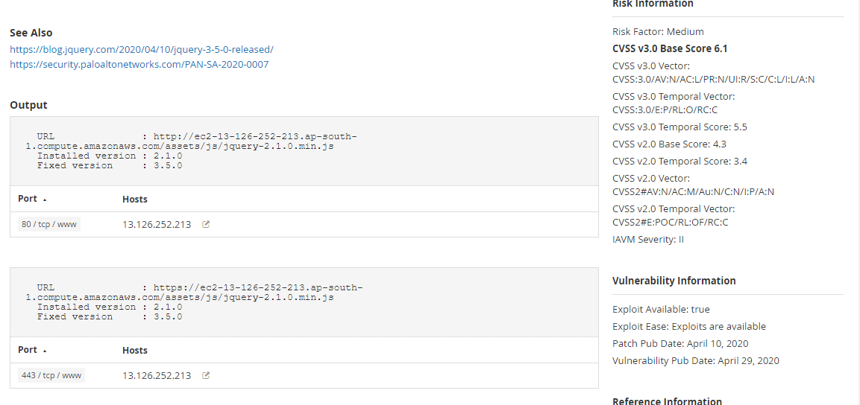
Figure 20: jQuery version installed and its fixed version

3.3.6 PHP < 7.3.28 Email Header Injection
After the scan was completed, it was discovered that the remote host web server was running an older version of php which can be affected by an email header injection vulnerability, in regard to a failure in the handling of the CR-LF sequences in the header fields. Line feed characters can be inserted into the email header by an attacker trying to exploit the system to obtain complete control over the header contents.
Solution:
Install or upgrade to PHP version 7.3.28 or recent php version
Risk factor and severity:
Medium
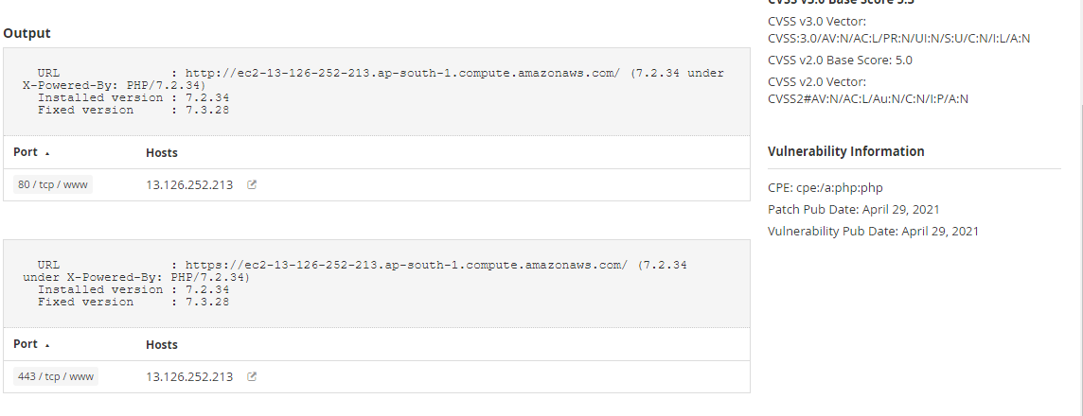
Figure 21: PHP version installed an its fixed

3.3.7 PHP 7.2.x / 7.3.x < 7.3.22 Memory Leak Vulnerability
The remote web server is of the host is running php version 7.2.x which or prior which is the old version. This version is affected by a memory leak vulnerability in the LDAP component which attacks could use to carry out a denial-of-service attack.
Solution:
A latest version of php should be installed or old one upgraded to version 7.3.22 or recent.
Risk severity:
High
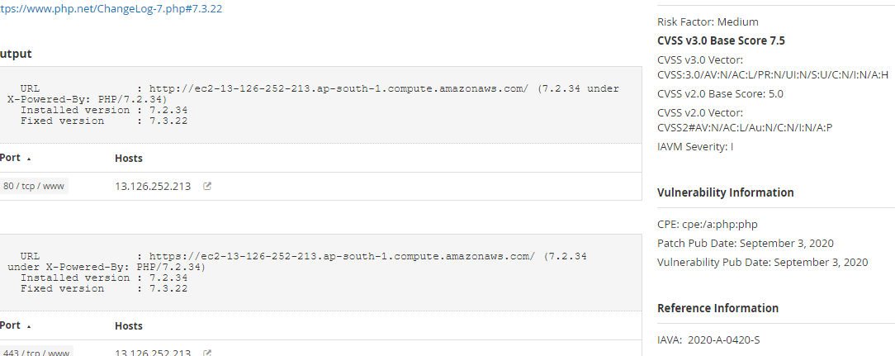
Figure 22: PHP version installed an its fixed for memory vul

3.3.8 PHP < 7.3.24 Multiple Vulnerabilities
The php version running here is an older version which can be affected by multiple vulnerability
Solution:
A recent version should be installed or old one upgraded to 7.3.24
Severity level:
High
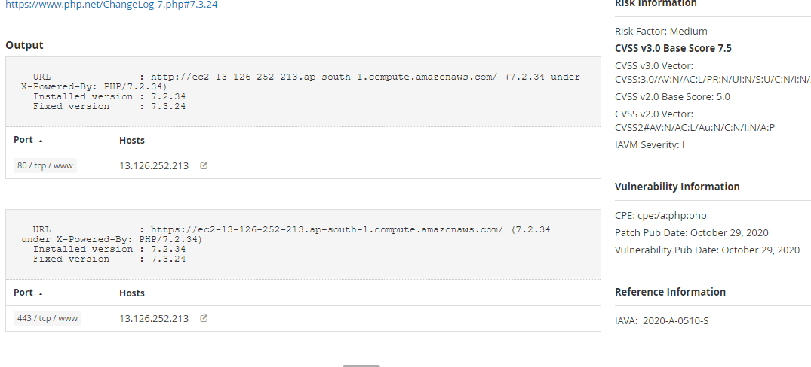
Figure 23 : récent PHP version installed for multiple vulnerability

3.3.9 PHP Unsupported Version Detection
Looking at the version of php running on the remote host, it doesn’t support the installation of php any more so this implies that, they won’t be new security patches which leads to security weaknesses for attackers to exploit.
Solution:
Upgrade or install a php version which is currently supported.
Severity level: critical
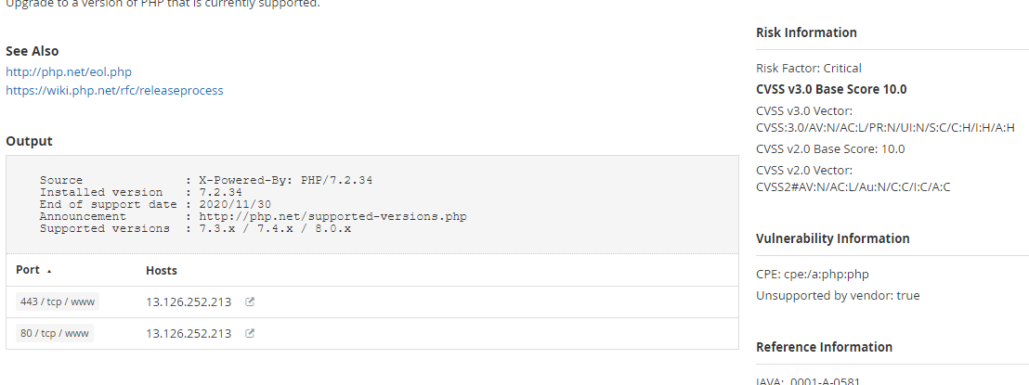
Figure 24: php version supported

3.3.10 Browsable Web Directories
Browsable directories were identified on the web server by multiple Nessus plugins
Solution:
Ensure that this browsable directories do not content important information that attackers can use or give access to exploitable resources. For any containing sensitive information, access restriction should be used and directory indexing should also be disabled.
Severity: medium
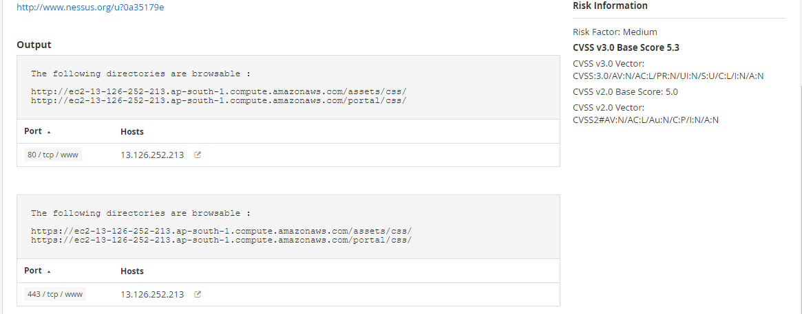
Figure 25: browsable directories on the host

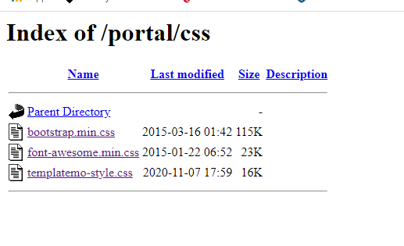
Fig: portal

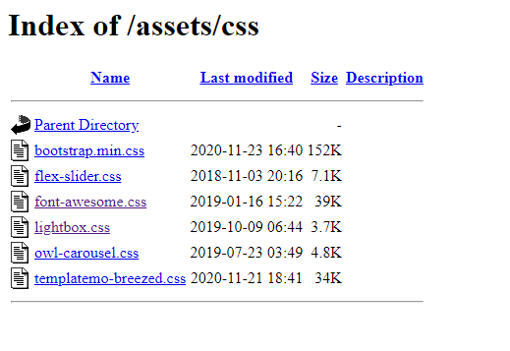
Fig: assets

3.3.11 Web Application Potentially Vulnerable to Clickjacking
Well, I have already explained a lot on click jacking in (2.2) so will just show you a screen shoot of what the Nessus scanning app was able to discover on it.
Severity and risk factor:
Medium
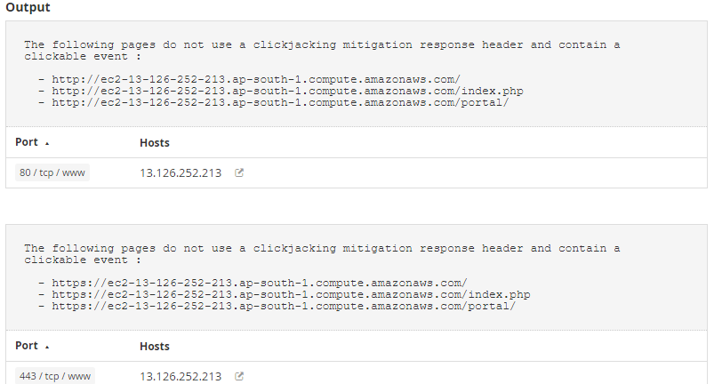
Figure 26: click jacking pages in the host (healios-pharma.com)

3.4 using zenmap to scan the host (healios-pharma.com)
When we talk of zenmap it is similar to Nmap but, it is the graphic user interface of Nmap scanner. Zenmap was created to ease the use of Nmap to perform scan. It is an open source, multi-platform application (i.e., free to download and use). Zenmap makes it easy for beginners to use while still giving us the experience with advanced features. Here we can save frequently used scans as a profile to enable it run repeatedly in an easy way. We can save and view scan results later. We can check the results of saved scan and compare them together to see their difference. Scan results are been kept in a database [14]

3.4.1 advantages of zenmap and why some people will prefer it to Nmap
- It gives us the normal Nmap results and also and show us all ports on a host by arranging its display. It also shows us which particular services hosts are running. Details about a complete scan or single host can easily be summarized in suitable display. A topology map of the networks found can be drawn using Zenmap. Output of different scans can be but together and views as one.
- It has the capability to compare two scans and bring out their differences which makes it easy for admins to track new services or host which pops up on the network.
- It keeps track of all the scan results you have performed till u decide to dump them away
- It commands facilitates the task of repeatedly running exact same scan more than ones
- It has a lot of options which is amazing for beginners. It interface helps show which command will be run making it easy for beginners to learn and understand [14]

3.4.2 scanning our host (healios-pharma.com) using zenmap
An intense scan was carried out on our host (healios-pharma.com) and zenmap was able to provide us with a lot of information about the host which we could use to attack or check for vulnerabilities 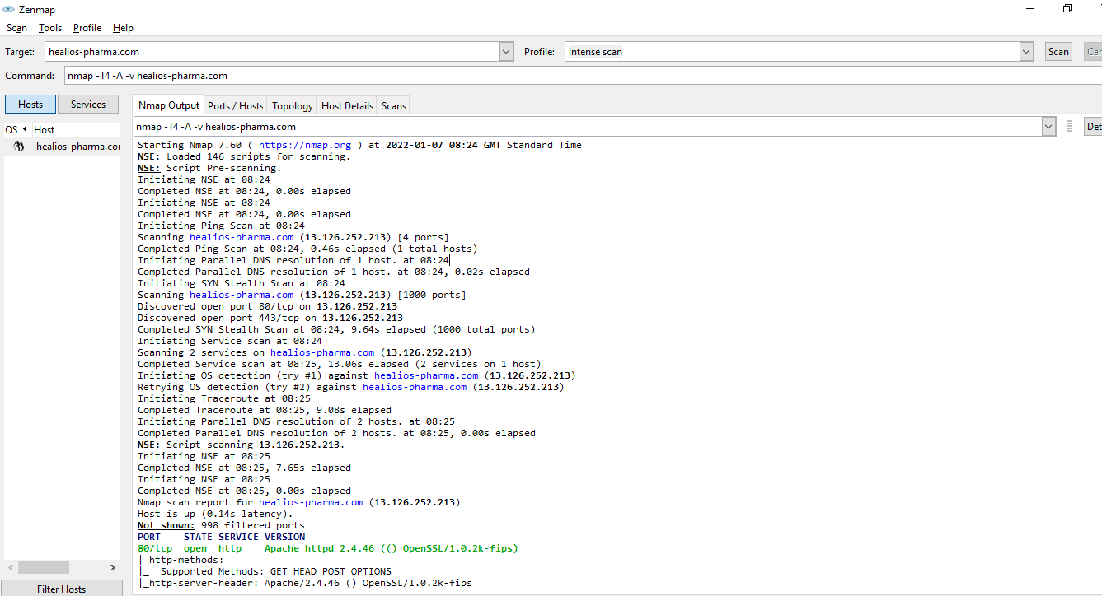
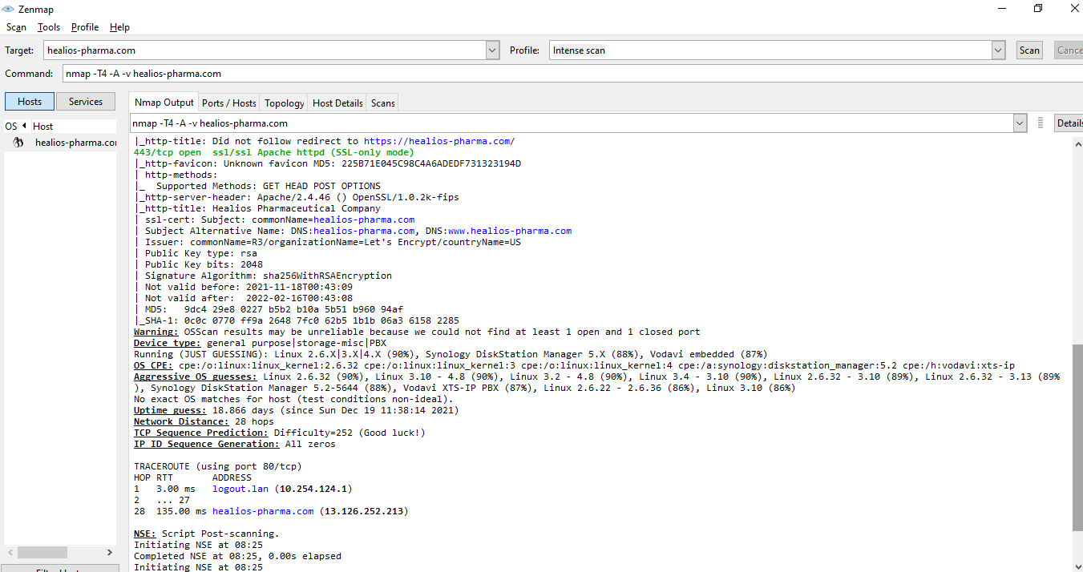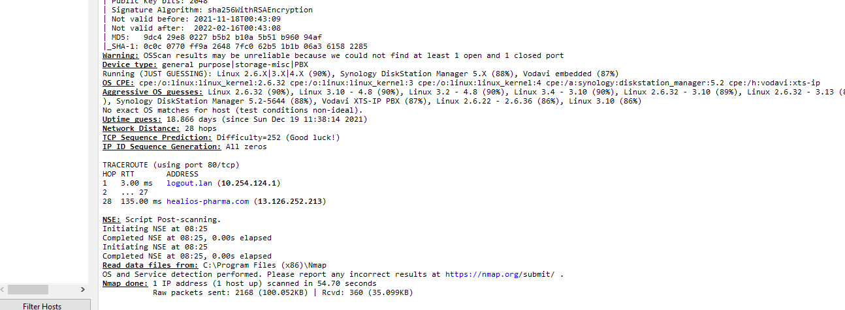
Figure 27: scanning the host using GUI of Nmap

3.5 Using the command uniscan on Linux to detect vulnerabilities on our host.
Uniscan is a web vulnerabilities scanner that is used to look for weaknesses in a host like remote cmd execution, local and remote files etc. this command was used on the targeted host and we were able to obtain some information which is documented and will be attached to this pen test file when submitting name of the file is (uniscan.log). all our finding using uniscan has been documented In this file.

3.5.1 some important findings we discovered using uniscan on the host

- Emails:
E-mail Found: humbedooh@apache.org
E-mail Found: kevinh@kevcom.com
E-mail Found: info@healios-pharma.com
E-mail Found: mike@hyperreal.org
- External hosts:
External Host Found: http://httpd.apache.org

| Directory check:
CODE : 200 URL : http://13.126.252.213/assets/
CODE : 200 URL : http://13.126.252.213/icons/
CODE : 200 URL : http://13.126.252.213/includes/
CODE : 200 URL : http://13.126.252.213/portal/

This directory link (http://13.126.252.213/portal/) which we discovered takes us to the sign in page of the healios-pharma website. This page is hidden from the website no one can find it except pen testers when carrying out test. With is login page been discovered we can now try to gain access to the database i.e., we will try to hack the login page to access the database and later on gain admin privilege.

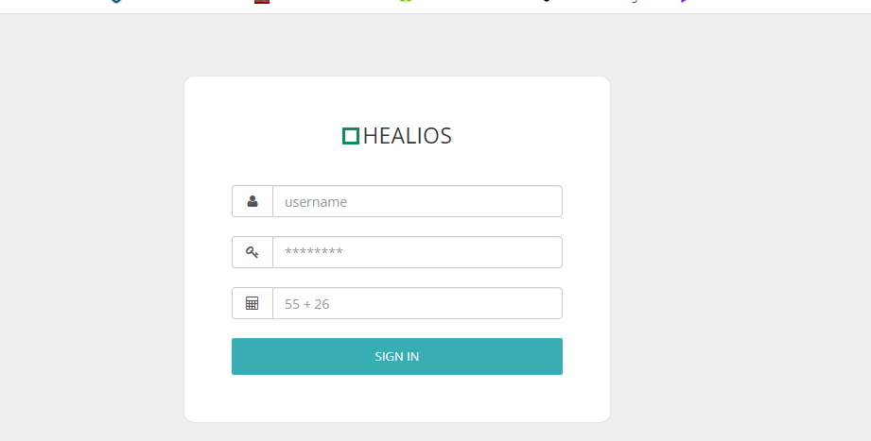
Figure 28: sign in page of host hidden from users

Using the uniscan command on Linux we weren’t able to discover any form of vulnerability as documented in our file. A lot of other useful information was found which is all documented in the (uniscan.log) file please check file.

3.6 finding weaknesses using N-STALKER tool and solution
N-stalker is a web scanner tool which helps assess your network or web applications. It plays an important role when it comes to app security testing. It is well trusted when we talk of browser weaknesses. It makes applications readily connected to it using the configuration section. It still works well with apps which has a lot of codes and complex apps. Data here can be exported in different formats for presentation reasons using the reporting features.

3.6.1 advantages of N-STALKER
- Depending on the area of test it enables us to customize our scan.
- It is used for compliance test making sure dangerous materials are not incorporated in your website.
- It assesses web resources as individual components and examine their relationship. (htt)
- The most complete form of web attack signatures are been used to scan your network system (htt)

3.6.2 screen shots of vulnerabilities discovered using n-stalker
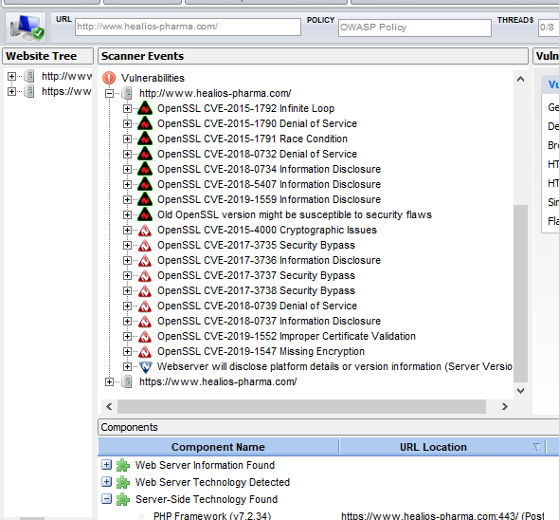
Figure 29: vulnerabilities discovered using N-Stalker scanner

HIGH SEVERITY
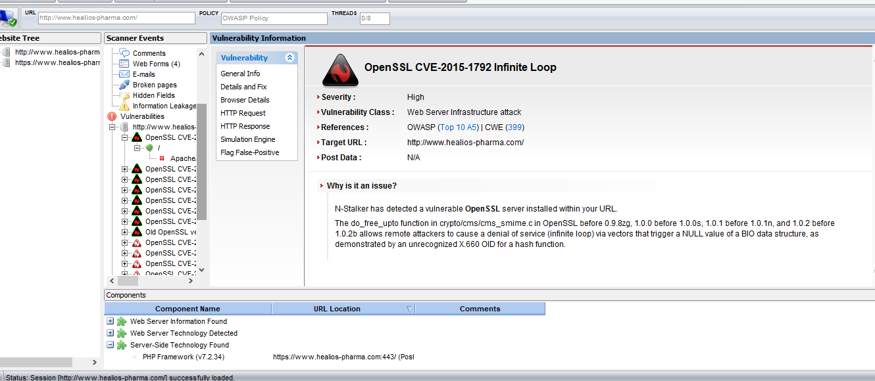

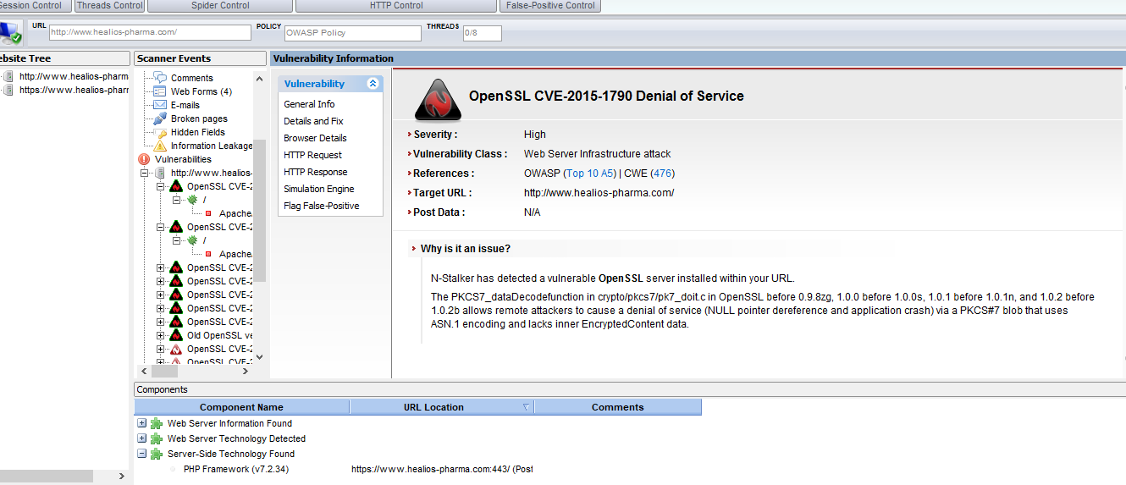

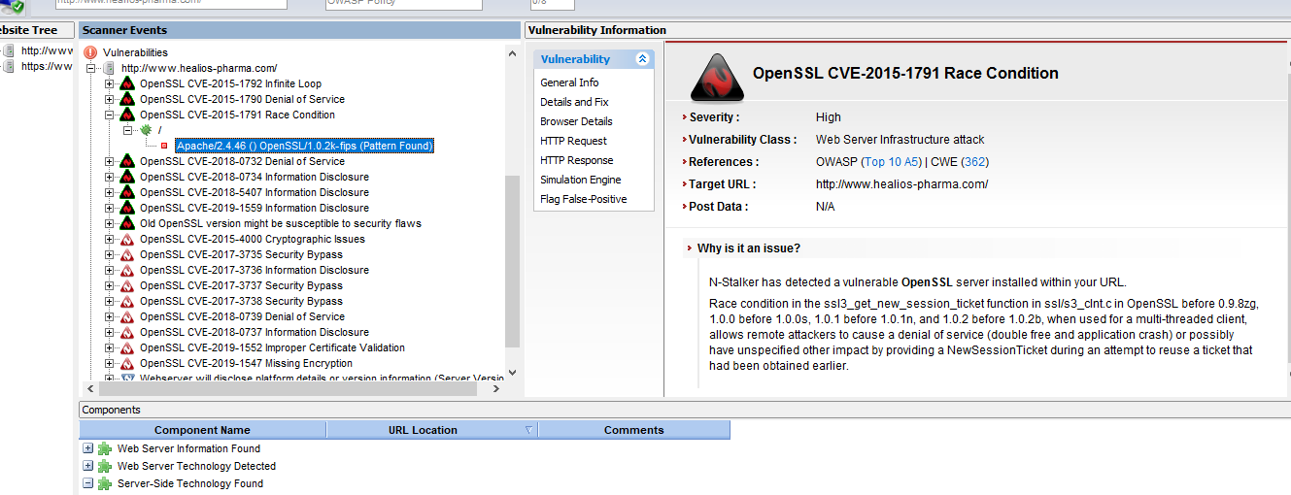
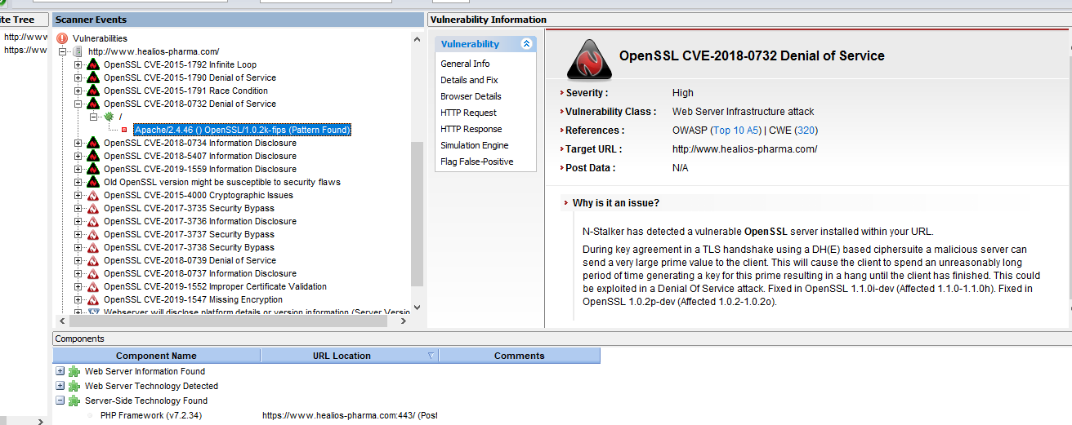

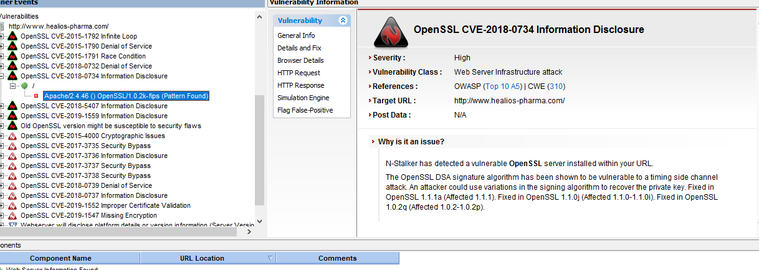

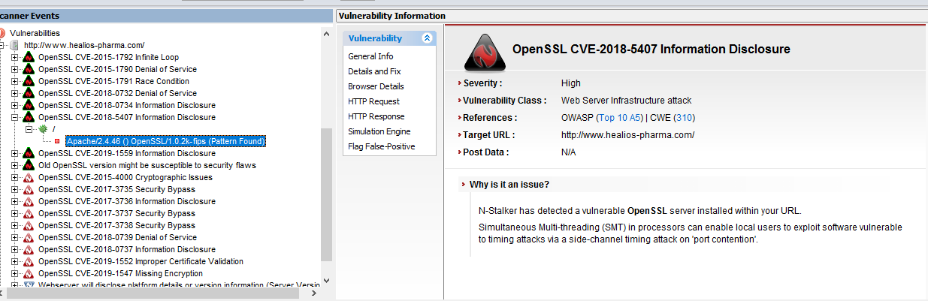

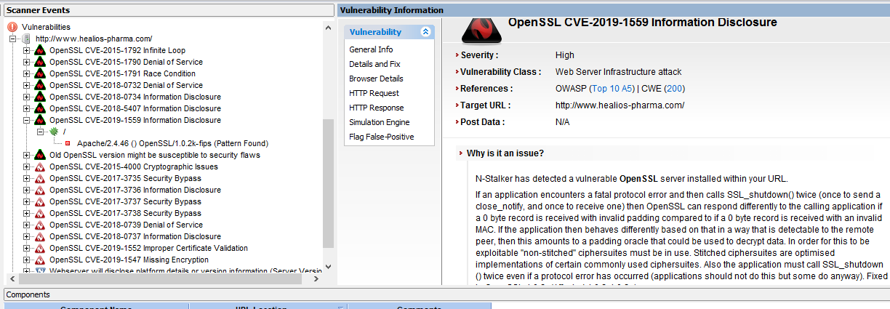

MEDIUM SEVERITY
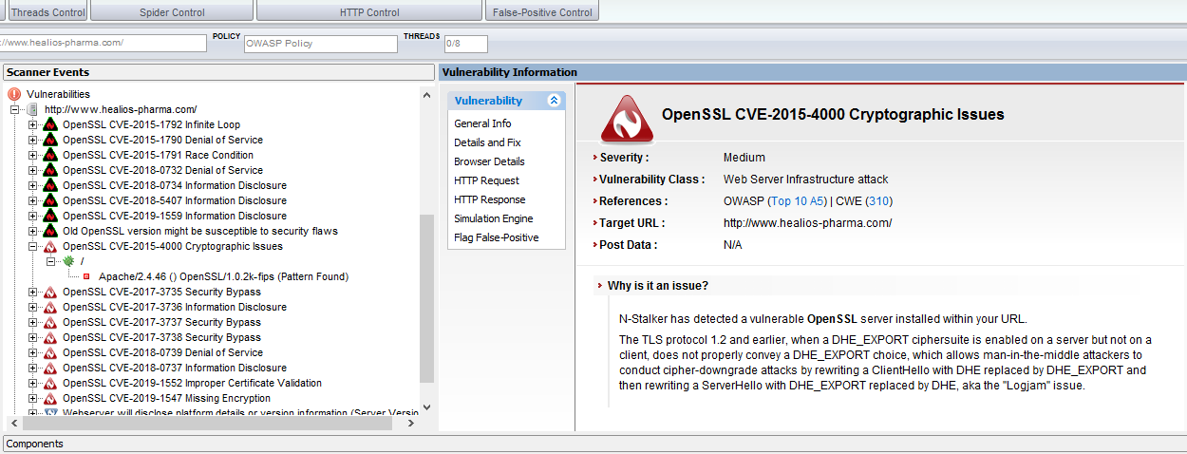

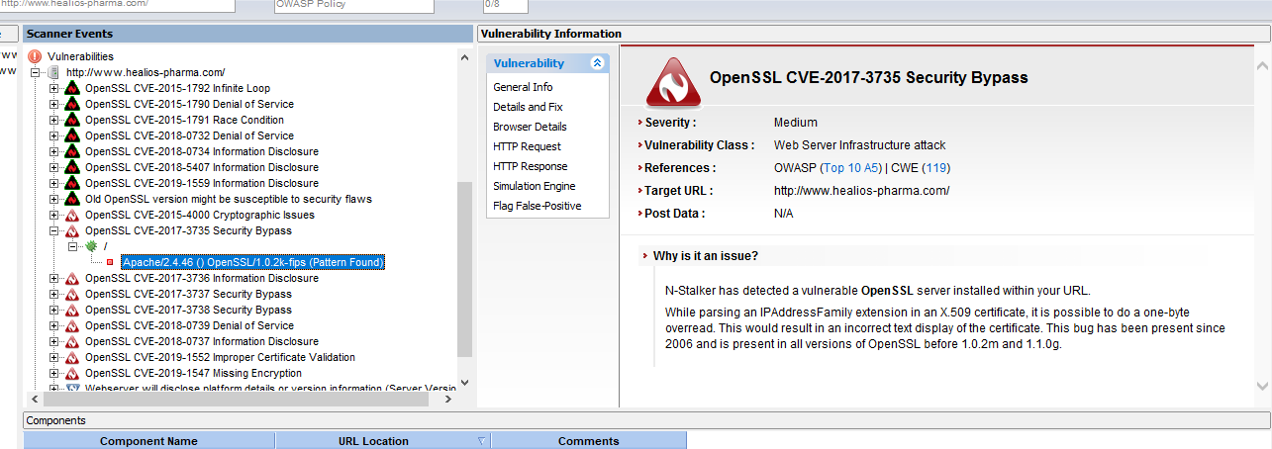

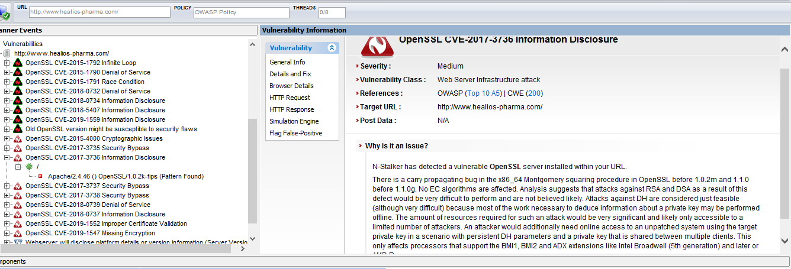

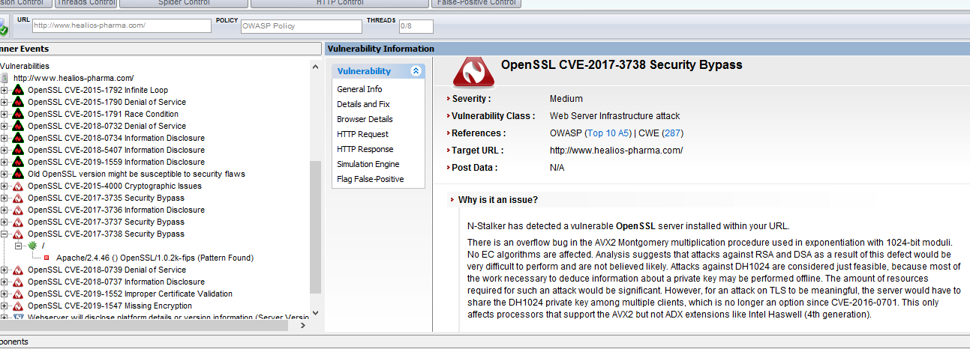

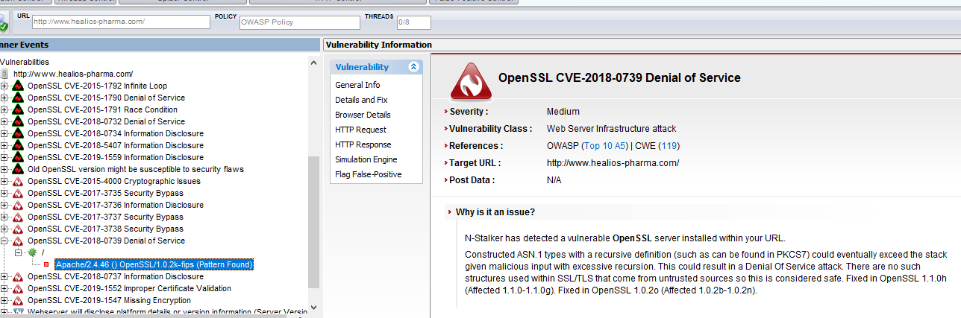

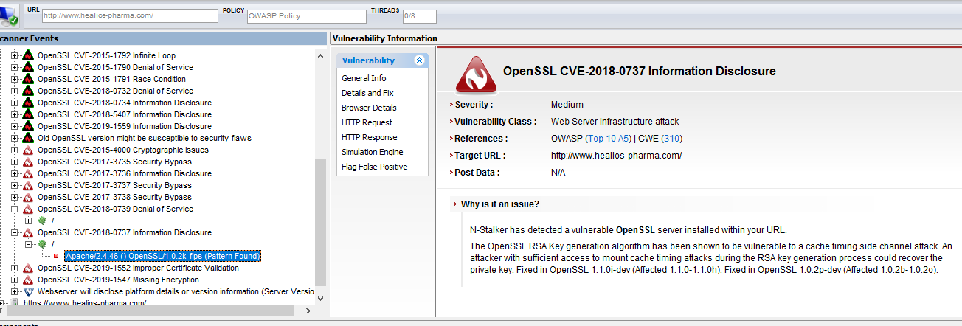

LOW SEVERITY
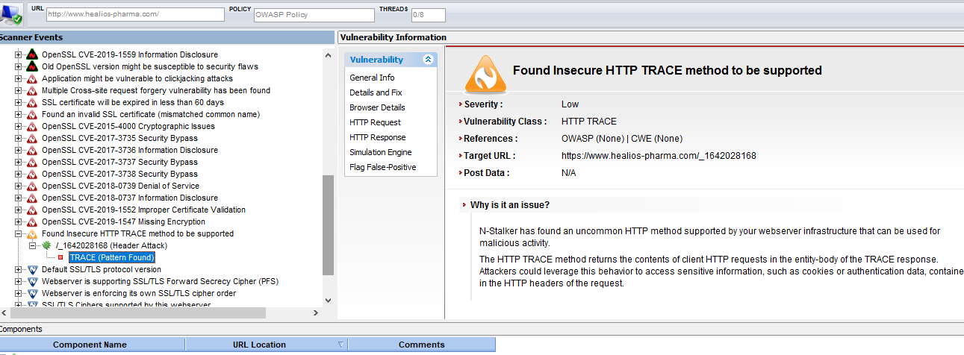

INFORMATION ON SERVER
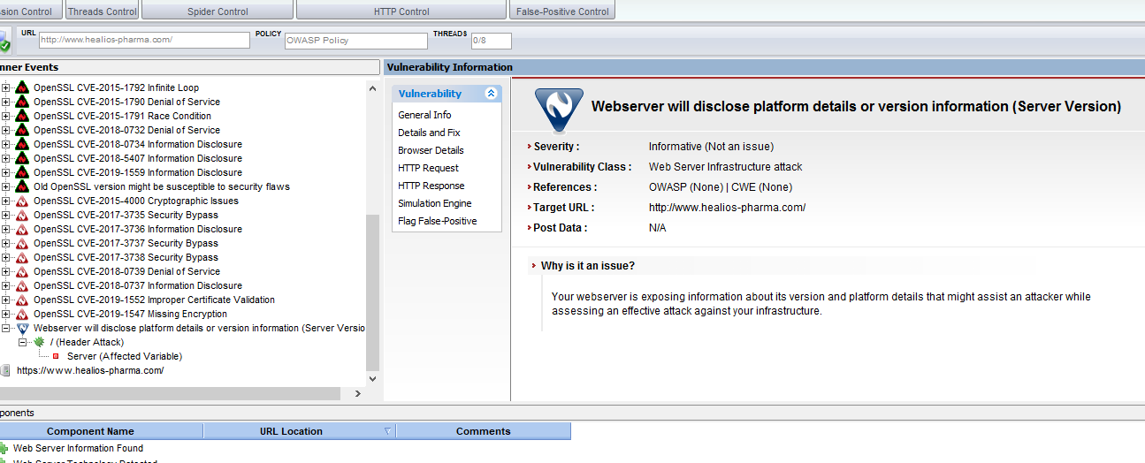
A lot of other weaknesses was discovered how an attacker could hack the host which is too broad and I can’t put all of them here. We discovered all of these vulnerabilities using N-Stalker and some of the vulnerabilities we have already spoken about them previously when discussing about the Nessus scanner.

3.7 scan results found using Nikto scanner

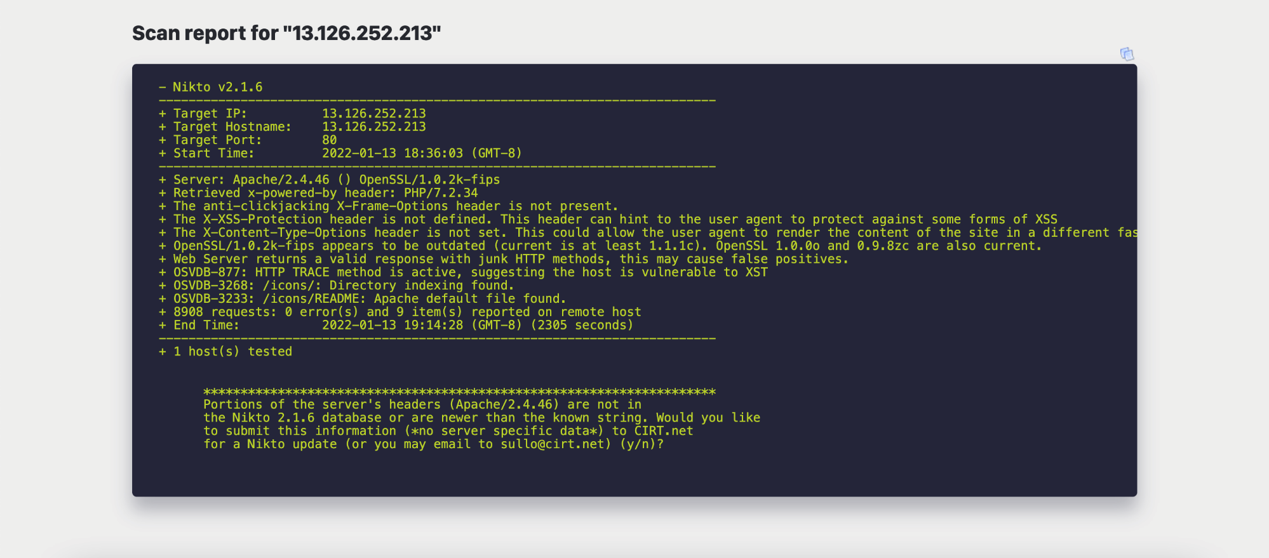
Figure 30: nikto scan result

3.8 budget
The total cost of carrying out this penetration test is almost free kali Linux free to download, VMware work station was used on my windows computer but had to pay for parallels which is a virtual machine for MAC operating system M1 CHIP which do not support VMware which cost around £80 most of the other resources I used have been kind of free. I had a windows 10 OS which I installed on my virtual machine on my windows laptop. I used 2 laptops to carry out this project a MacBook m1 chip and a windows ASUS laptop which made it a little difficult for me my windows laptop lacked space which made the virtual machine and the entire laptop too slow. Some of the resources was been given to us by the lecturer like Nessus, N-stalker etc.

Items | Budget cost
VMware workstation | £0
Parallel | £80
Kali Linux | £0
Windows os | £0
Nessus, N-stalker and all tools | £0
Pen test tool online | £0
Nikto | £0
Figure 31: budget table

3.8.1. cost to fix vulnerabilities discovered and fix
Most of the vulnerabilities discovered just requires us to update the settings and libraries into latest versions like: the JavaScript libraries need update, PHP version update which cost nothing, jQuery updates etc. all the vulnerabilities and their weaknesses have been listed above.
The only thing which will require payment is the purchase of the latest SSL certification which will cost about £50 a year depending on where u purchase it from. And like we can see from the screen shots above most of the vulnerabilities came from the expired SSL certification so purchasing and installing latest one will patch most of the SSL vulnerabilities.
My hourly rate to find out all the possible vulnerabilities in the host and carry out the fix will be £31.25 an hour so depending on how many hours I spent on it we will be looking at the rate.

Name | Planned start date | Planned finish date | Planned duration | Planned cost | Planned resource cost
Evaluation | 15/01/2022 | 17/01/2022 | 3 days | 31.25 per hour | £130
Figure 32: time table for execution

4 Research into cyber security incident and defensive technique case

Study
Due to the fact that Nera was been sideline by the management after working for 6 months on the covid 19 treatment project, she was disappointed that she wasn’t rewarded after all her efforts on this project she was angry and quit the company doing that she also deleted all important information and documents she worked on related to the project. And if healios-pharma company is unbale to retrieve this important document they will lose 3 million USD so the hired m Ceac Cybersecurity and Forensics Ltd (CCFL) to help investigate and recover the important documents which Nera deleted.

4.1 process and procedure to recover deleted files
As a digital forensic you must know how to recover deleted file which is very important. Deleted files stays on the storage medium till it is overwritten. When the file system is overwritten, if a suspect deletes any evidence file, they still remain so it’s still possible to recover them. When your hard disk is been defragmented, that’s when deleted files can be overwritten by your computer. (OTW, 2021)
Firstly, we need to ask those who previously tried recovering the data what the found and if by any chance did, they Take photographs of Nera’s computer and all hardware/software connected to it. Because the first people or person who touched her computer after she left is the first responder and you need to know all what he found immediately when the turned on her computer. They had to document all hardware’s and software connected to it. He needs to protect all evidence found from the crime scene and makes sure no one tempers with them. So, you coming as a second investigator send by the company makes it a little bit difficult because the data had already been tempered with by HPC’s IT department who failed to retrieve it.

4.1.1 procedure to protect and document the evidence
- Tag all evidence found to uniquely identify them
- Use a chain of custody to record every process
- The log book of the process

4.1.2 data analysis
Data analysis technique depends on the scope of the case and requirement of the client which is to recover the files Nera deleted. This data analysis phase includes
- Analysis of the file content
- Date and time when the files were created and modified
- User association with file
- Location and physical storage of files
Forensic tools like Recuva or autopsy which we will use to recover the files aids in the analysis and sorting of huge volume of data.

4.1.3 evidence assessment
A thorough assessment is been conducted reviewing the search warrant, hardware, software etc. installed in Nera’s computer. Be aware of hidden evidence and take precautions to secure it and check if it is necessary to perform other forensic processes on the incident to obtain more digital evidence.
We need to determine what kind of evidence we are searching for which is easy because our client already told us what Nera deleted and what they are searching for.
Determine where to carryout the examination of the evidence after the assessment. Nera’s computer can be taken to a forensic lab with all its peripherals or we secure the area and make sure no one is there apart of the main individuals carrying out the research then start the retrieval.

4.1.4 recovering the deleted files
Here we are going to recover all files deleted by the suspect. We will use the open-source tool the sleuth kit (TSK) which is free to download to carry out the identification and recovering of the files the suspect deleted. TSK is a Linux base software, but a GUI of this software has been developed for windows computer called Autopsy. We will use autopsy in the retrieval process and screenshot will be shown below of what we obtained as evidence.
Since no data has been given, I created a folder but, in some documents, then deleted those documents then used autopsy to retrieve them back. Also, I used an empty 7.19 USB drive which had files I deleted previous years ago to carry out this experiment. Though it was empty I still formatted drive twice to make sure the experiment is effective, installed autopsy on my laptop and started the retrieval process which took several minutes for the process to complete images are shown below

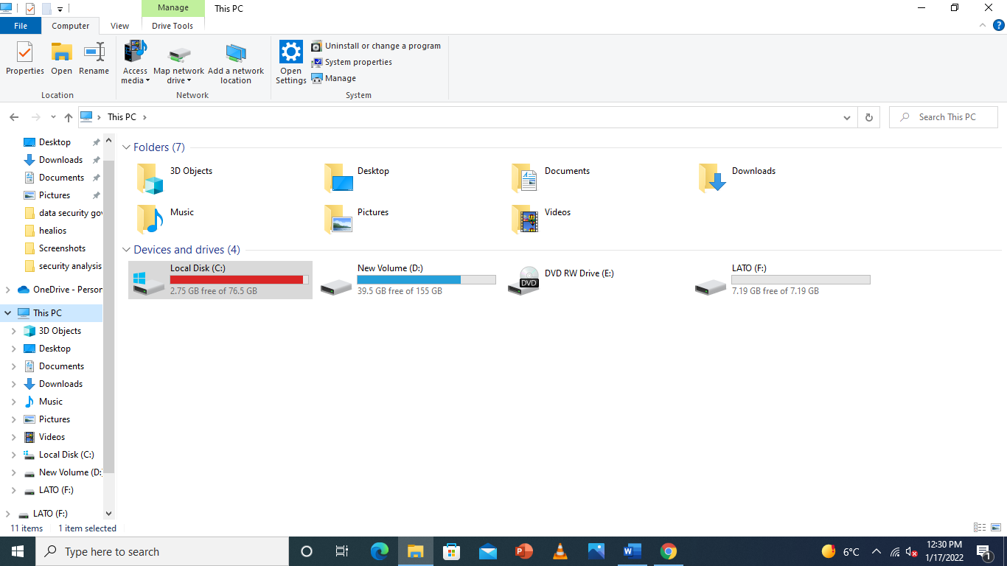
Figure 32: empty USB drive LATO (F:)

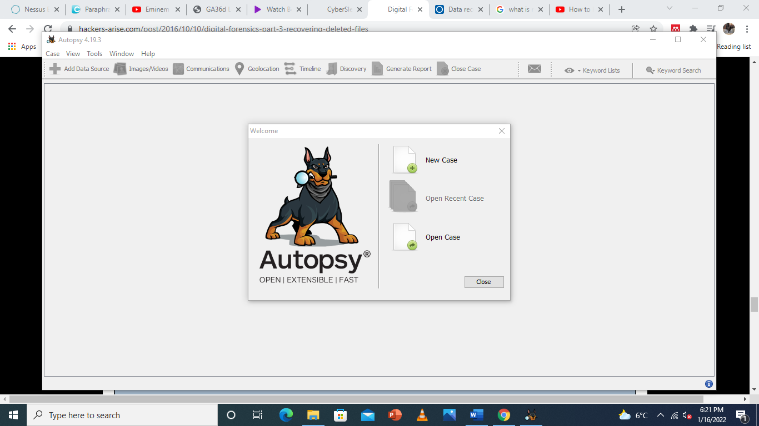

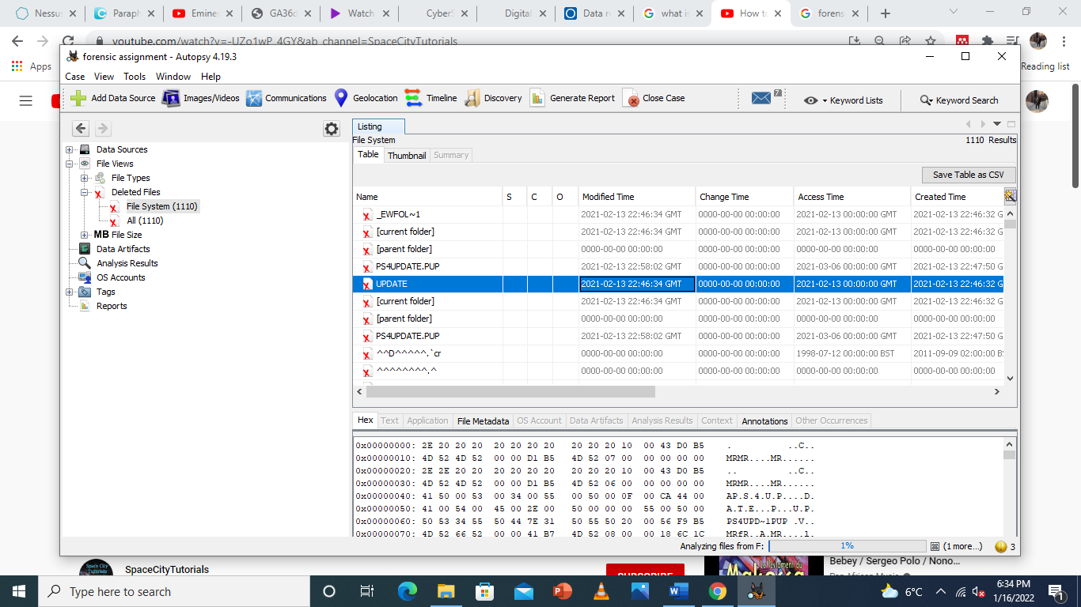del
Figure 33: deleted files from 2021 was discovered

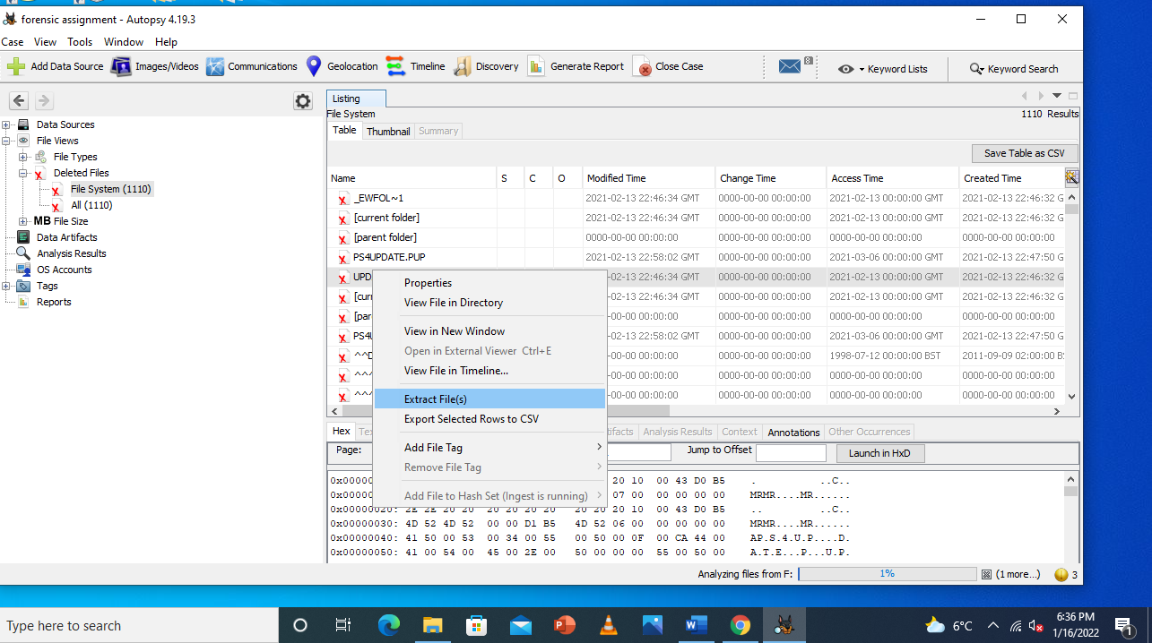
Figure 34: extraction of file to selected folder

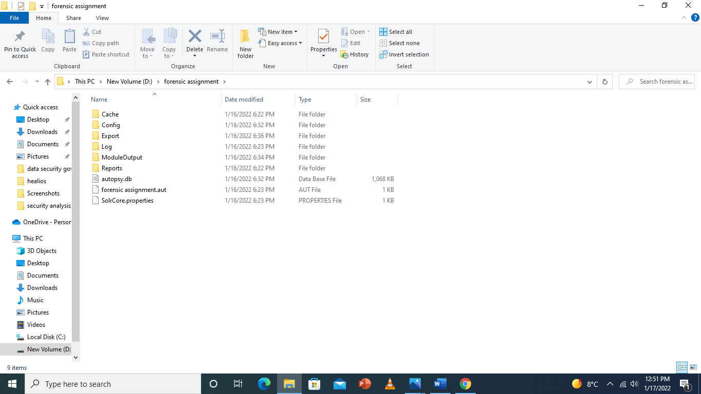
Figure 35: Retrieved files
The professional forensic report and the invoice are found in the report folder uploaded as additional document

5 Conclusion
In part one related to the pen testing several tools were been used to carry out the pen test on our host (Healios Pharmaceutical Company (HPC). With each tool having different functionality we were able to discover some weaknesses which attackers could easily use to exploit the host using some tools like Nessus, n-stalker etc. with other tool, we didn’t get such information they just gave us information about the host but didn’t give its vulnerabilities that’s why several tools were been used to carry out this experiment. For all the vulnerabilities we discovered, their solution was been given on how to fix it and its preventive measures. The total payment of work and cost of software was listed to. In conclusion they were vulnerabilities in the host which attackers could use to exploit the system.
For the second part we were able to carry out the analysis and technique on how to retrieve and restore deleted information (documents, pictures, videos etc.) on a drive. And a report of the steps we used to carry out this restoration was given in our report and an invoice was provided on the total cost of carrying out this process and restoring the deleted files.

marking criteria and Student FEEDBACK

This section details the assessment criteria. The extent to which these are demonstrated by you determines your mark. The marks available for each criterion are shown. Lecturers will use the space provided to comment on the achievement of the task(s), including those areas in which you have performed well and areas that would benefit from development/improvement.

Common Assessment Criteria Applied (Assignment 1) | Marks available | Marks  awarded
1. Engagement with Literature Skills
Extent of research and/or own reading, selection of credible sources, application of appropriate referencing conventions.
You have engaged with the literature using the correct referencing convention but no reference listing provided. (Grade mark: 53.33%) | 15 | 8
2. Knowledge and Understanding Skills
Extent of knowledge and understanding of concepts and underlying principles associated with the discipline.
You have provided the relevant knowledge but went overboard with the research aspect. This demonstrates some lack of understanding. The research focus should be on both tasks and not giving an epistle on the concepts. (Grade mark: 53.33%) | 15 | 8
3. Cognitive and Intellectual Skills
Analysis, evaluation and synthesis; logic, argument and judgement; analytical reflection; organisation of ideas and evidence
You have discussed application of the methods, tools and technique used to carry out all your tests. You have done penetration testing on the live website you have carried out a number of step-by-step tests with a number of penetration testing tools including Nmap, Nessus, etc. Screenshots and explanation of these provided. You have done recommendation for the threats discovered. You had identified to portal and therefore had access to the backend where you could dig for more information. Excellent job.  Part 2 could do with more work and list the methodology steps more clearly. Note the investigation did not start at retrieving the deleted data. The first step should be:  • All the ceased devices carefully placed in anti-static bags and transported them to a forensics laboratory.  The schedule to execute the potential solution done, cost solutions done, recommended solution given and invoice for the forensics investigation portion. No chain of custody document but sample generated report done (Grade mark: 92.50%) | 40 | 37
4. Practical Application Skills
Deployment of methods, materials, tools and techniques; application of concepts; formulation of innovative and creative solutions to solve problems.
Evidence of practical/hands-on penetration testing done. Screenshots provided and the relevant tools used (Grade mark: 96.00%) | 25 | 24
5. Transferable Skills for Life and Professional Practice
Attributes in professional practice: individual and collaborative working; deployment of appropriate media; presentation and organisation.
Your work needs formatting and organisation. Presentation of the overall report need improvement. (Grade mark: 50.00%) | 5 | 2.5

Assignment Mark (Assessment marks are subject to ratification at the Exam Board. These comments and marks are to give feedback on module work and are for guidance only until they are confirmed. ) | Late Submission Penalties (tick if appropriate) |  | 80%
 | Up to four weeks late |  | 80%
 | First Attempt? |  | 80%

