Database Management Systems

APOSTOL GEORGE-ADRIAN

Joy Botu
University of Wales: Trinity Saint David
London
08/05/2020
Contents
Introduction 3
Problems 3
Proposed Solution 4
I) PRGDatabaseAudit Table 4
II) PRGSaleAudit Table 6
I) Trigger_metaData: 7
II) Tr_Sale_InsertTrigger: 9
III) Tr_Sale_DeleteTrigger: 10
IV) Tr_Sale_UpdateTrigger: 11
Results 12
DBMS Advantages 12
1. Concurrency Control: 12
2. Transaction: 13
3. ACID Properties of Transaction: 13
a) Atomicity 13
b) Consistency: 13
c) Isolation: 13
d) Durability: 13
4. Anomalies: 14
A) Lost updates: 14
B) Dirty read: 14
5. Two-Phase Locking: 14
A) Growing Phase: 14
B) Shrinking Phase: 14
References: 15

Introduction
Our goal is to monitor and detect the fraudulent activities taking place within the sales department of ESTATE AGENCY and identify the users responsible for those actions. For any organisation, data is the most critical asset these days and taking appropriate security measures for data protection is necessary for companies. There exist strict laws against the organisations for being responsible for the misuse of data or data breach. This report aims to cover the security approach that we used in our database and to clarify how these functionalities work.

Problems

There were numerous security-related issues in the database. Estate Agency management did not have any mechanism for detection of users creating, deleting, or altering existing tables. Moreover, the administration was not able to audit any information stored in the database. Besides, there was no mechanism for retrieving old data in case of data update or for detecting any DDL or DML transaction or any related information. Moreover, no tool for logging events information or storing information in database existed. Any user could update the data or alter database schema, which might prove to be harmful to the estate agency management.
The management needs to be aware of the security issues and to know when the vulnerabilities apply to their surroundings (Ben-Natan, 2005).

Proposed Solution

I have used various security measures to prevent fraudulent activities. All the methods are implemented using database security standards, keeping in view the issues faced by Estate Agency management and any other possible threats. The proposed solution covers all aspects ranging from auditing to keeping logs of information being modified in the database.

First of all, two new tables are created to store the events, logs and other related information for DDL and DML operations. One of the significant issues for the management was to track the fraudulent activities and the users responsible for those activities. Therefore, the following tables are created:

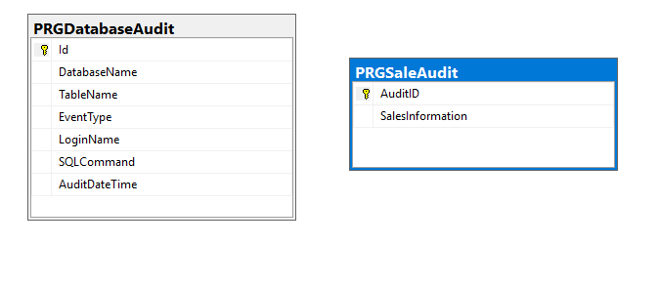

I) PRGDatabaseAudit Table
This table is created to store information related to DDL operations performed on the database schema. A new row is inserted, and each column is updated when any users try to create, alter, or drop table from the database. This information acts as a log for management. This table makes it very easy to identify the user behind any fraudulent activities since it consists of the necessary information regarding any event for being able to catch the guilty person. The datatypes of columns are configured, keeping in view multiple factors.
The table structure is as follows:

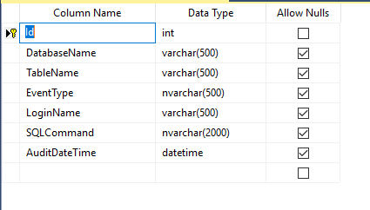

II) PRGSaleAudit Table
This table is created to store information related to DML operations performed by any of the users. When data is updated, inserted, or deleted from the sales table, a trigger is used to store the relevant sales information is PRGSaleAudit table. The PRGSaleAudit table acts as a backup system for management since, in case of any DML operations, information such as property id, date of modification and user responsible for the transaction is inserted in this table. It also proves to be beneficial for keeping track of previous information if it is required anytime in future. Moreover, this table makes it very easy for the management to check the guilty users behind any fraudulent transactions.
The table structure is as follows:
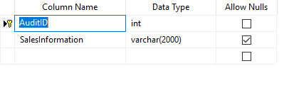

Secondly, I have used triggers for capturing DDL and DML related information automatically. A trigger is a particular stored procedure that executes when certain events perform within a database. These triggers are defined to run when changes are made either in database schema or table's data. We can set triggers to execute after or before DML operations such as INSERT, DELETE and UPDATE. Since, in our case, information was to be stored once any of the DML or DDL operations were performed. I have defined the triggers to execute after any action is performed. The following triggers are created:

Trigger_metaData:

This trigger responds to DDL commands on the database schema. When a user tries to CREATE, ALTER, or DELETE any table from the database, its relevant information is stored in PRGDatabaseAudit table. It helps in identifying the users who are responsible for manipulating the database schema.

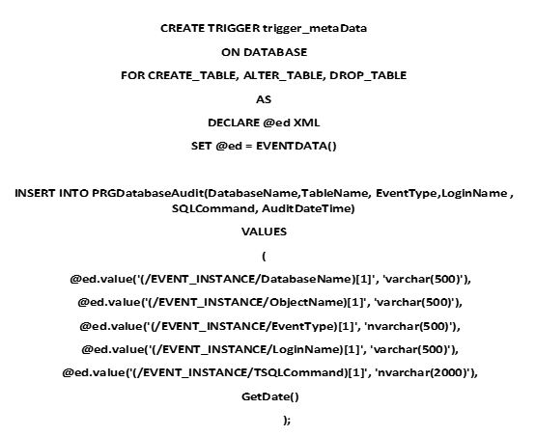
After the PRGDatabaseAudit table is created, and the first trigger runs on the database, with the use of the SELECT statement, it will be displayed the following output with empty columns:
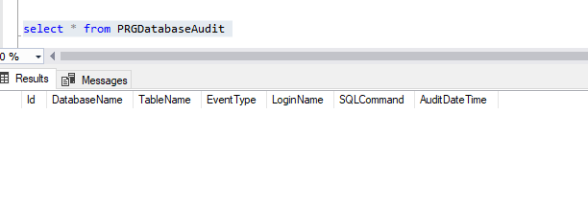
After creating the table PRGSaleAudit, the first output from the DatabaseAudit will be shown below as a CREATE_TABLE event type.
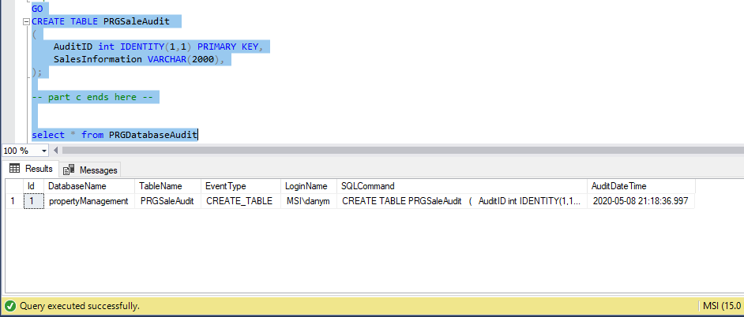
Both tests successfully perform as can be seen in the PRGDatabaseAudit result below.
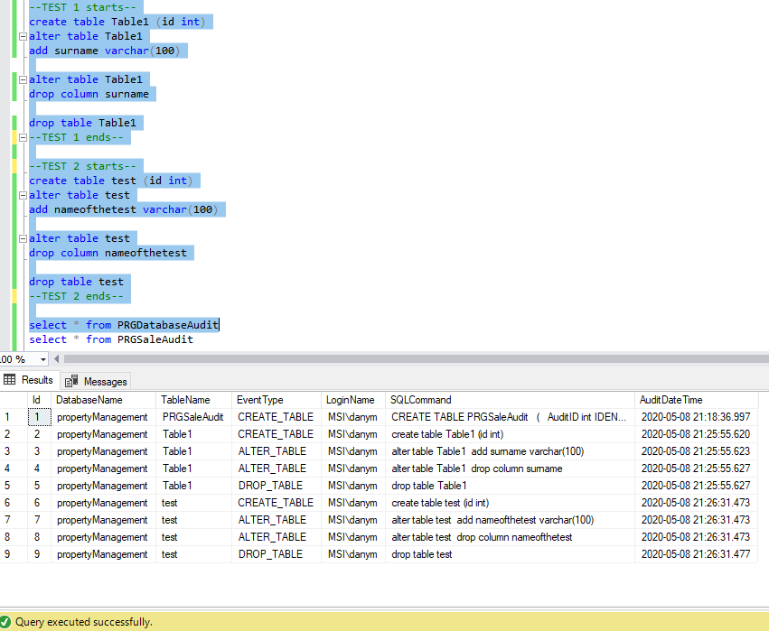

Tr_Sale_InsertTrigger:

This trigger is executed automatically after an Insert statement on the sale table. The property id of the new row is captured and stored in PRGSaleAudit table along with the user information and date of the insert.
When the INSERT statement runs against the sale table, the column "by user" sets the user name who did the change and the column "is added at" sets to the time the change was made. Triggers are automatically executed when an insert, delete, or update statements modify a table, and it can be a valuable tool for auditing data development (Spenik and Sledge, 2003).
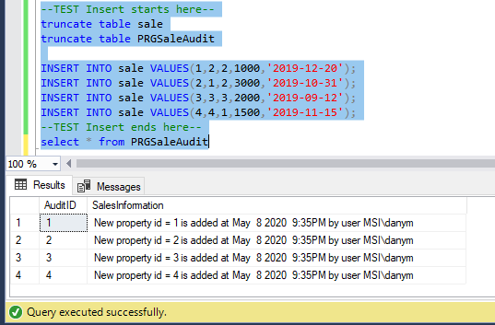

Tr_Sale_DeleteTrigger:

This trigger is executed automatically after a Delete statement on the sale table. The property id of the deleted row is captured and stored in PRGSaleAudit table along with the user information and date of removal.
The following trigger is automatically executed when the delete statement modifies the sale table, and the output will be seen when auditing data changes.
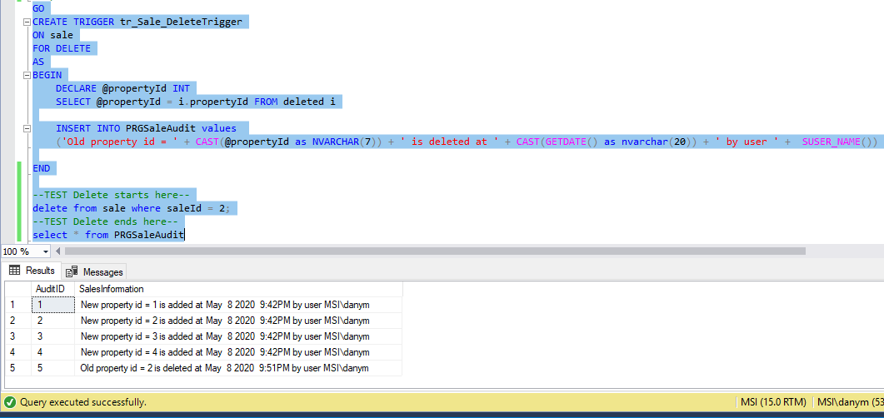
The second sale id has been deleted from the records, as shown below.
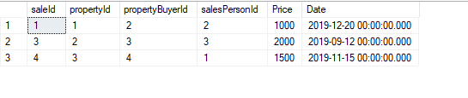

Tr_Sale_UpdateTrigger:

This trigger is executed automatically after an update statement on the sale table. The old and new property ids are captured and stored in PRGSaleAudit table along with the user information and date of removal.
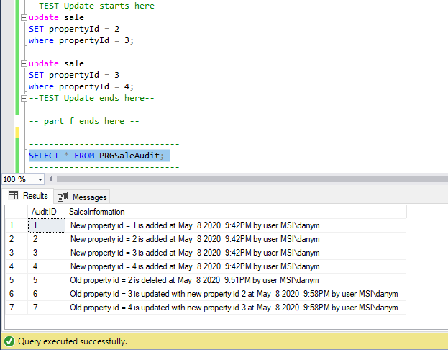

Results
The results of all the DML triggers are verified by performing different DML operations on the sales table. The figure below displays sales information captured by the triggers defined.
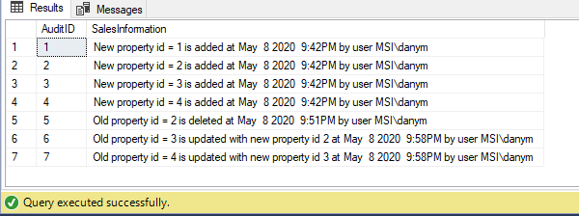

Last but not least, to identify and monitor all the activities performed by the users. I have created different user roles and restricted different users according to different access privileges. Thus, this step will ensure that the information stored in the Audit table is authentic for the user information and cannot be manipulated by anyone.

DBMS Advantages

The DBMS system provides a lot of other advantages as well, to make the database more efficient and secure, explained as follows:
- Concurrency Control:
This procedure is used to manage simultaneous operations in the database without conflicting with each other. When multiple transactions are running simultaneously, conflict may occur, and the database would then be in an inconsistent state (Singh, 2017a). Therefore, the concurrency control mechanism proves to be beneficial for keeping the integrity of the database maintained and prevent any conflicts. For example, if two users try to withdraw money at the same time from the ATM, the database might go into an inconsistent state if concurrency control methods are not used. Therefore, the defined triggers manage concurrency by attaining a lock and preventing any other transaction from occurring until the lock is released.
- Transaction:
A set of logically related operations are termed as a transaction in DBMS. For example, the collection of services for updating a bank account information is known as a transaction (Singh, 2017b). A common problem with the sale is that it can fail in the middle of an operation due to different reasons such as power failure. But the database is left in an inconsistent state due to this. If we are transferring an amount from account A to account B and if the transaction fails after deducting the amount from account A, but before adding it to account B. It might create a lot of issues causing loss to the users. Therefore, Commit and Rollback operations are used to prevent this issue. Commit is used to update the changes in the database if the transaction is successful. Otherwise, Rollback is executed in case of failure. A rollback command reverts all the changes made by any previous operations. I have used these commit and rollback commands to make sure the transactions are performed successfully.
- ACID Properties of Transaction:
ACID properties are used to provide a mechanism for assuring the flexibility and accuracy of a database. It aims to treat a set of operations as a single unit to increase the efficiency and reliability of a DBMS (Sirohi, 2019). ACID properties play a significant role in DBMS. In the database context, ACID is an abbreviation used to refer to the following terms:
a) Atomicity: This term means either a transaction happens immediately or cannot be achieved. There should not be any state in between such as a partial transaction.
b) Consistency: Consistency refers to the idea of keeping the database in a good condition before and after a transaction. According to this term, the integrity constraints must be maintained.
c) Isolation: This property is held responsible for performing multiple transactions simultaneously without any conflict. It ensures that the result of concurrent transactions is equivalent to performing those transactions in serial order (Avneet, n.d.).
d) Durability: The above property insures that after execution of the transaction, the updates in database persist in the disk even if a system failure occurs. It aims to provide that the effects of the transaction are never lost.

These properties are very beneficial for our estate agency database as well.

- Anomalies:
Different type of anomalies can occur in a relational database. Anomalies lead to inconsistency in data. When simultaneous transactions are carried out uncontrollably, various problems can occur. There are different types of anomalies explained as following:
A) Lost updates: This problem occurs when the same database is accessed by two transactions in the wrong order, resulting in an incorrect database item. For example, if two transactions T1 and T2 read a record and update its value. The second update will overwrite the result updated by the first transaction.

B) Dirty read: This problem occurs when a transaction fails after updating a record. But meanwhile, the updated file is read by another transaction. Dirty read leads to incorrect calculation issues. For example, a transaction T1 updates a record and T2 reads the same document at the same time. But T1 aborts, then T2 will have incorrect results.
C) Unrepeatable read: This problem arises when some summary function is calculated across a dataset while the other transactions are updating the data. For example, a transaction T1 reads the record and process is further while a transaction T2 updates it. When T1 rereads it, it is inconsistent with the preceding value.

- Two-Phase Locking:
This method is used to guarantee serializability but does not prevent deadlocks. In all the transactions, the concept of two-phase locking proves to be very beneficial. A transaction may be broken down into two phases, such as:
A) Growing Phase: In the current stage, only new locks can be gained, but any of the gained locks cannot be released.
B) Shrinking Phase: In the current stage, the actual locks are freed, but new locks cannot be gained.
Two transactions cannot have conflicting locks, and no data will change until the locks are obtained.

References:
- Anon, DBMS Concurrency Control. www.javatpoint.com. Available at: https://www.javatpoint.com/dbms-concurrency-control [Accessed 5 May 2020].
- Anon, DBMS States of Transaction. www.javatpoint.com. Available at: https://www.javatpoint.com/dbms-states-of-transaction [Accessed 5 May 2020].
- Avneet, K., n.d. ACID Properties In DBMS. [online] GeeksforGeeks. Available at: <https://www.geeksforgeeks.org/acid-properties-in-dbms> [Accessed 2 May 2020].
- Ben-Natan, R., 2005. Implementing Database Security And Auditing. Burlington, MA: Elsevier Digital Press, p.21.
- Singh, C. (2017a). Concurrency Control in DBMS. [online] beginnersbook.com. Available at: https://beginnersbook.com/2017/09/concurrency-control-in-dbms/ [Accessed 28 April 2020].
- Singh, C. (2017b). Transaction Management in DBMS. [online] beginnersbook.com. Available at: https://beginnersbook.com/2017/09/transaction-management-in-dbms/ [Accessed 3 May 2020].
- Sirohi, K., 2019. Databases: Explaining Data Normalization, Data Anomalies And DBMS Keys. [online] Medium. Available at: <https://towardsdatascience.com/softly-explained-data-normalization-data-anomalies-and-dbms-keys-f8122aefaeb3> [Accessed 8 May 2020].
- Spenik, M. and Sledge, O., 2003. Microsoft SQL Server 2000 DBA Survival Guide. 2nd ed. Indianapolis: Sams, p.233.

