NETWORK PROGRAMMABILITY
ACCB5029
Submission Date: 25/08/2023
Prepared by: Valentin Latinov Miladinov /2024732/ (Report only)
PROJECT WORK
Link for the repository: https://github.com/crist-1/assessment1.git

Stage 1:
Introduction and Team Formation

1.1 Team Name: The Four Musketeers

1.2 Team Member Roles:

 | Name | Skillsets, | Interests
Facilitator | Sigitas Dobrovolskis | Programming, problem-solving | Automotive world and mechanics
Recorder | Christopher Hidalgo | Programming, web applications, designing | Sports
Team Member | Stanimira Staneva | Web design, code debugging | Sports
Team Member | Valentin Miladinov | Programming, website designing | Video Games

1.3 Ice-breaker Questions:

Member Name | Question | Answer
Sigitas Dobrovolskis | What’s your favourite sport? | It is football.
Christopher Hidalgo | What is your favourite cuisine? | It is Bulgarian food.
Stanimira Staneva | What’s your favourite part of this university course? | I loved learning the basics about virtual networks and usage of a Packet tracer.
Valentin Miladinov | Do you like video games? | I totally love video games, anime games and I am eager for VR games.

Stage 2:
Agile Team Formation

2.1 Team Name: The Four Musketeers

2.2 Scrum Leader: Sigitas Dobrovolskis

2.3 How did your team select the scrum leader?
With a good work sense and adult sense of responsibility, Sigitas makes the perfect choice for Scrum Leader. He is dedicated, attentive, fast in decision-making. He is reliable and would answer to any need as fast as possible in a calm tone. Advises well.

2.4 Did you define any other agile team roles? If yes, give details. If no, why? Give reasons.
I personally identified no other agile team roles. In meaning, we all were pretty tight in making the code, we more or less did the whole project together, although we had an apparent line in between what we were doing.

2.5 Which communication tools did your team decide to use and for what purpose?

Tools | Purpose
WhatsApp | Daily updates, messages
Teams | Video calls, more detailed conversations, we could share screens and use each other’s devices

Stage 3:
IMPLEMENTATION

3.1 What were the reasons your team selected this option?
We chose option two because it seemed way more interactive and unique, giving us more opportunities to learn stuff and practice coding, which personally helped me most, since I will be practicing programming more than the others most probably.

3.2 Describe your team's application and its deliverables. What are the specific objectives of this application?
This is for the deployment of a web-based application. It allows a user to look for deals. They can choose to look through different game deals, search up for a specific game by name, by game ID or in a price range. Once the user chooses an option, the application fetches information from the API and presents it in a readable manner to the user to see.

3.3 Record your team member roles and skillsets

Team Member | Role/ Knowledge/ Skillset
Sigitas Dobrovolskis | Began the Python code, includes first option for searching for best deals and connects the code to the API
Christopher Hidalgo | Adds Option 2 which searches for games by name, tests and fixes code
Stanimira Staneva | Adds Option 3 which searches for games by Game ID, tests and fixes code
Valentin Miladinov | Adds Option 4 which searches for games in a given (by user) price range, tests and fixes the code

3.4 Project Plan:
We found four key options out, so afterwards splitting the work was quite easier – everyone would have a job to do and if anything, the jobs are quite similar and when someone is stuck, another would help – we are the Four Musketeers, after all, One for All and All for One.

3.5 Link to GitHub repository?
https://github.com/crist-1/assessment1.git

3.6 Describe how GitHub was used in your project.
Chris created the repository, then got us on board. Then it would be all of us applying our in-class gathered skills on GitHub to finish our assessment work.

3.7 List of future enhancements

1. Less awkward panel.
2. Currency converter.
3. Game price history.
4. More options.
5. Successful connection with the web design.

Stage 4:
Reflection

My contribution is everything around the price-range option. It was the most interesting job, because I got to think of different aspects of the project and how to make it so users could not mistake the whole process of inserting the given information (min and max price). Saying this, I am quite disappointed that I could connect the application to the site I’ve made, but I am still glad about how the project went. Not to mention, my teammates were responsible and ready to converse about this project broadly and long. We were stumbling upon many circumstances, but with good communication and solid cooperation, all problems stood immobilized and solved once we got our minds on them. Everyone would responsibly do their own task, but would always ask about how the others were doing so nobody ever was being behind.

Stage 5:
Codes and Photos with explanations
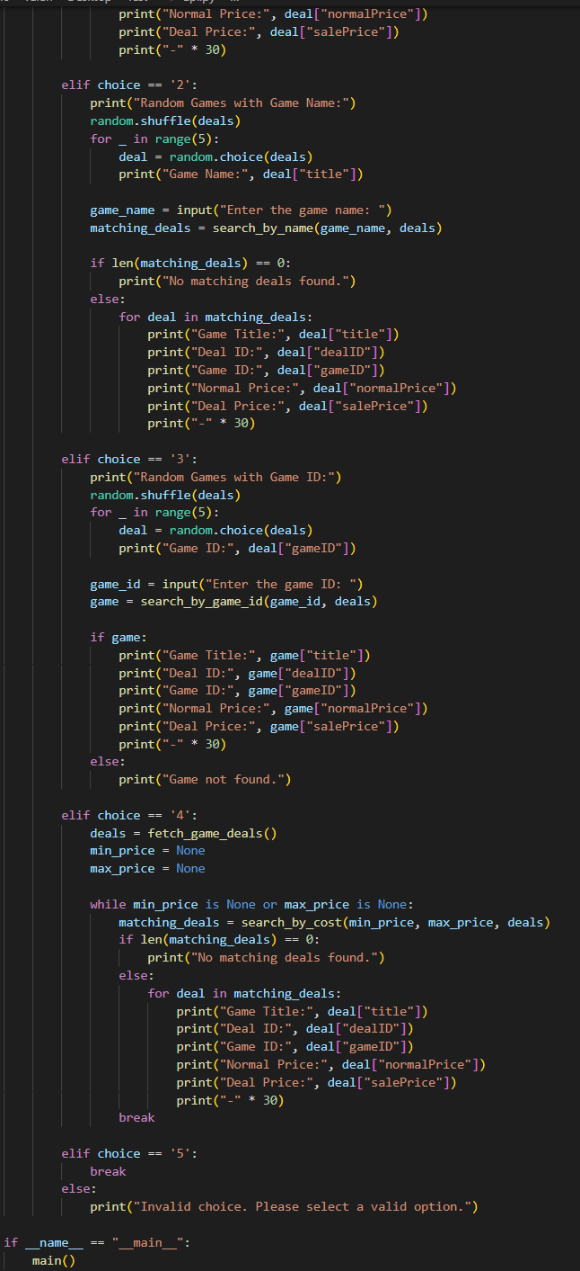
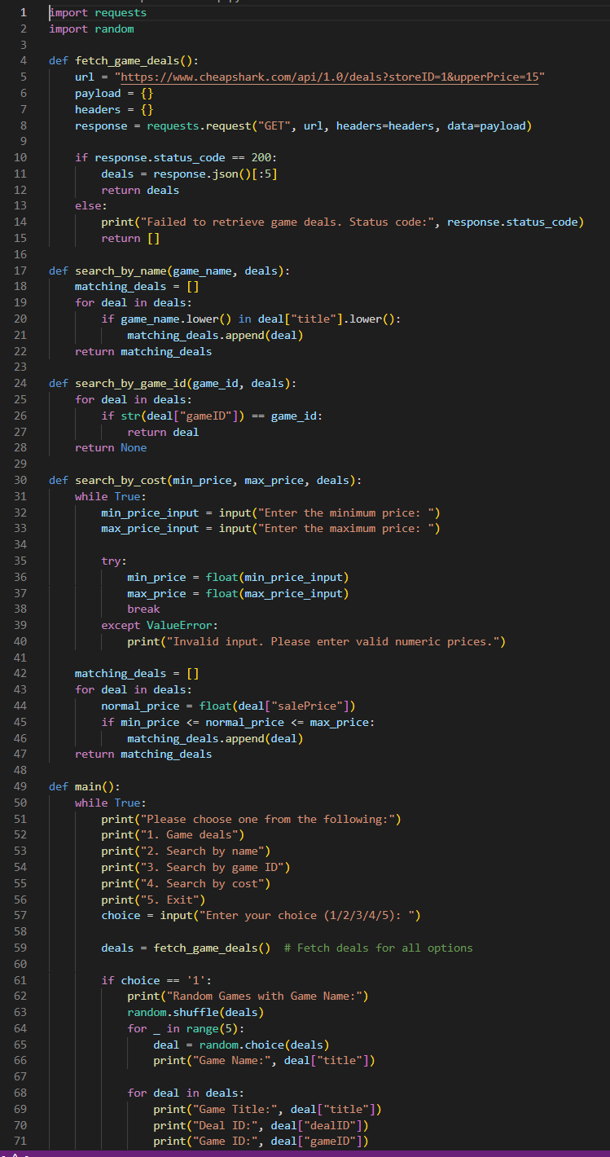
These are the codes for the whole project. There are no in-code explanations, but they are all in the GitHub project.

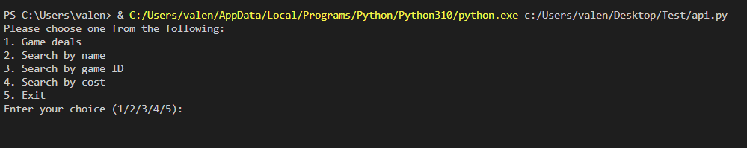
This is the Terminal, when the application is just started.
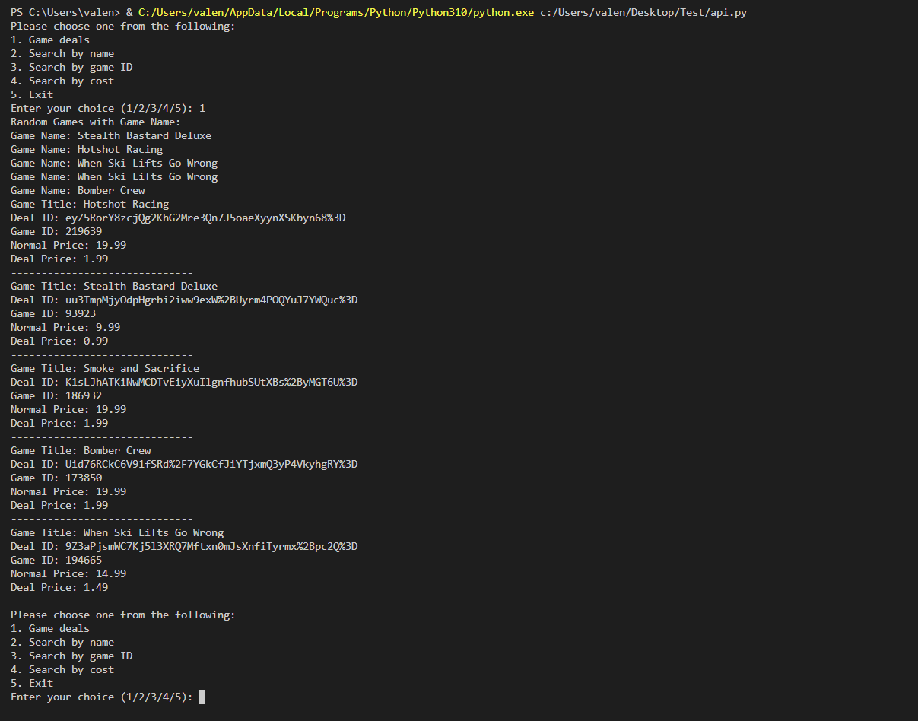
This is the Terminal, when “1” command is put in (Game Deals)
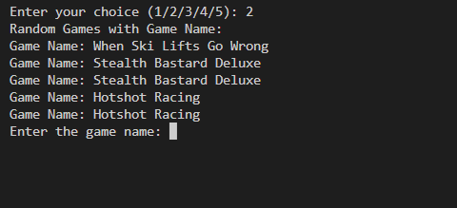
This is the Terminal, when “2” command is put in (Search by Game Name, it offers few names for user’s ease).

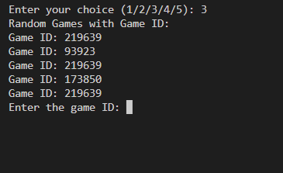
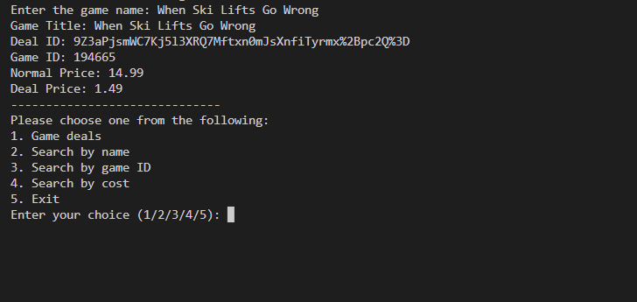
This is the Terminal, when a proper game name is inserted.
This is the Terminal, when “3” command is put in (Search by Game ID, it gives Game ID examples for user’s ease).

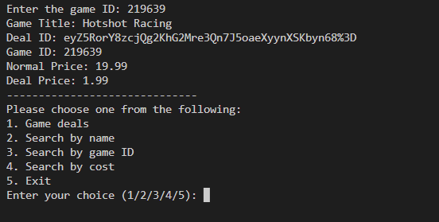
This is the Terminal, when a correct and existing Game ID is inserted.

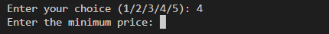
This is the Terminal, when “4” command is put in (Search by Price).
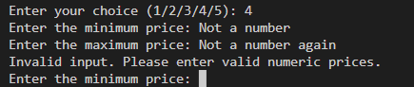
This is the Terminal, when wrong information is put in for price.

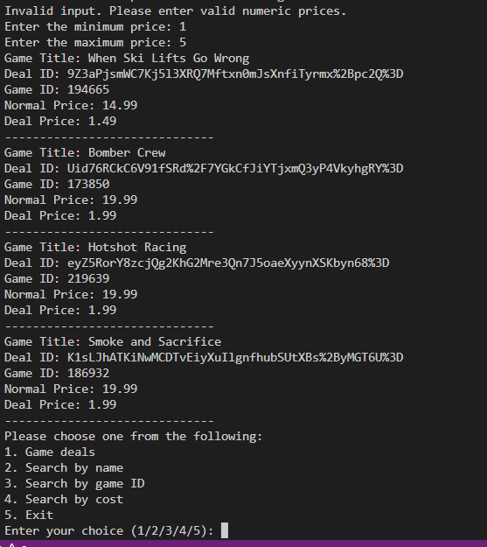
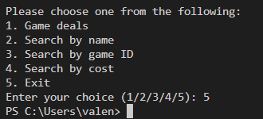
This is the Terminal, when minimum price is 1 and maximum price is 5.
This is the Terminal, when “5” command is put in.

