Effect of Performance Appraisal System on Employee Motivation: A Qualitative Study
Research proposal

Student Name: Khushi Patel
Student ID: 2416327
Table of content
Background 2
Research Problem and question 2
Aim and Objectives of study 4
Preliminary literature review 4
Proposed method 8
Expected contribution 9
Ethical consideration 9
Time plan 10
Reference list 11

Background
In the current competitive era, employee motivation in the workplace helps individuals by inspiring teams and providing necessary support in serving them with personal development. As stated by Jain, Gupta and Bindal (2019), in the organisation employees are provided with extrinsic and intrinsic motivation that have been provided based on employee performance based on their achievement. The below graphs reflect that global employee motivation level is about 71%, in the UK it is about 60% and in the US it is 15% (Statistics, 2025). The impact of high employee motivation enhances productivity in the business that is addressed through performance based review. Thus, the appraisal provided to the employees due to its motivation towards work which showcases development opportunities.
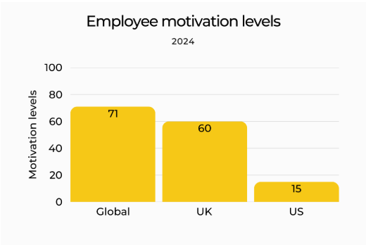
Figure 1: Employee motivation level in different countries
(Source: Statistics, 2025)

Research Problem and question
Research problem
The key research problem is analysing the direct influence of the new appraisal system impact on the motivational aspect among employees. For instance, due to differences in appraisal management systems, job satisfaction level of employees is also found highest in India with 89% followed by Mexico 85% (Flynn, 2024). Overall, promotional issues are also properly recognised as playing a major role with a declination rate -5.2% (Dennis and Ferrer, 2024).
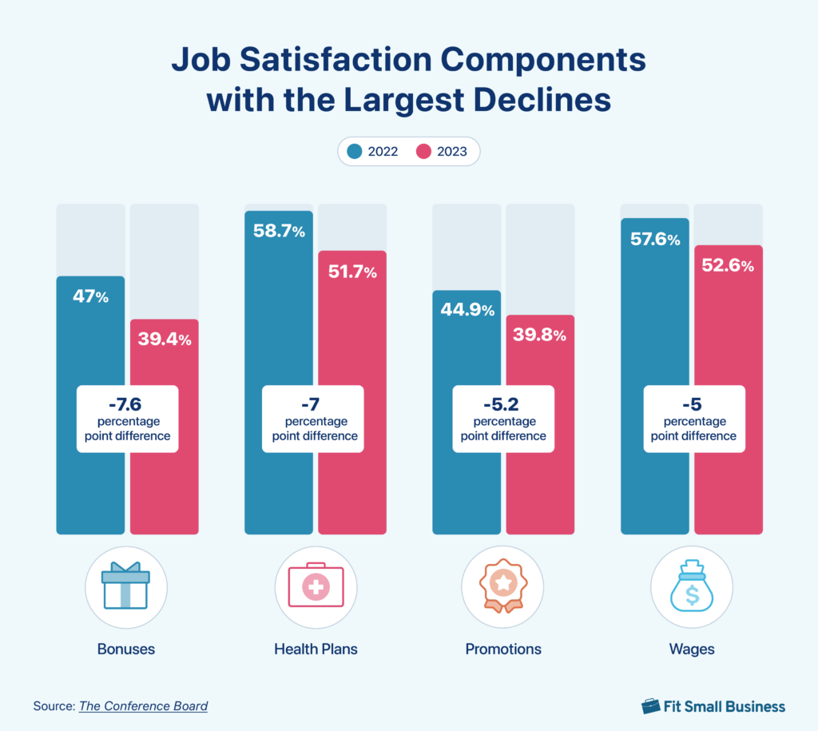
Figure 2: Job satisfaction rate
(Source: Dennis and Ferrer, 2024)
Research question
RQ 1: What is the relationship between performance appraisal practices and employee motivation levels within the organizational context?
RQ 2: Which specific performance appraisal factors most significantly influence employee motivation?
RQ 3: What challenges do employees experience as a result of the current appraisal system in the organization?
RQ 4: What strategies can be implemented to improve the appraisal process and enhance employee motivation?

Aim and Objectives of study
Aim
The aim of the research is to explore the influence of performance appraisal systems in employee motivation with identifying appraisal factors in organizational settings to enhance overall performance.
Objective
- To analyse the key relation between performance appraisal practices and employee motivation levels in organisational context.
- To evaluate the aspect of performance appraisal factors significantly affect motivational activity among employees.
- To explore the key challenges faced by employees due to attribution of the current appraisal system in organisation.
- To recommend strategies to improve the appraisal process for enhancing employee motivation.

Preliminary literature review
Discussion on the relationship between performance appraisal and employee motivation
Performance appraisals have been considered as an important technique that has been adopted by organisations for increasing the engagement level of its workers. For example, Tesco has invested $30m in developing infrastructure such as “Tesco Academy” that has provided digital training to the workers in 2019 (Tesco Plc, 2023a). The availability of a skilled workforce has helped the retail company improve its productivity. Tesco has increased its employee revenue from £8178 in 2019 to £9223 in 2020 (Tesco Plc, 2023). The availability of skill development opportunities has helped Tesco in strengthening its worker relationships.
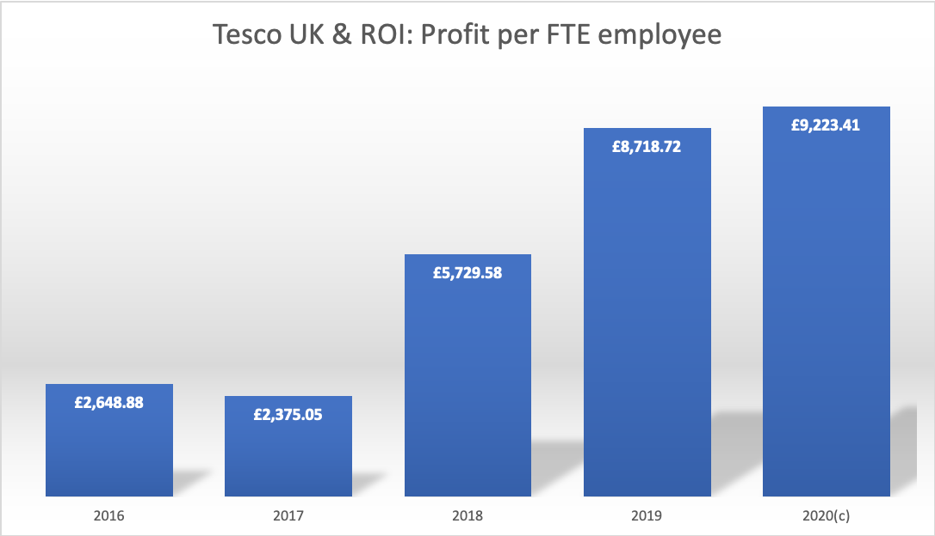
Figure 3: Employee Revenue of Tesco
(Source: Tesco Plc, 2023)
Discussion on the performance appraisal factors influencing employee motivation activities
The adoption of factors such as proper incentives and safety measures has helped organisations in enhancing motivation among its employees. In the UK, the growth in wages has declined from 6.5% in 2021 to 4.6% in 2022 (Brandt, 2022). The reduction in financial income has also lowered the engagement level of the workers. On the other hand, the UK government has provided financial grants worth £1.5m to retail companies for providing health safety equipment such as PPE kits to the workers (Government of UK, 2025). The improvements in occupational safety have improved the brand loyalty of the organisations among its employees
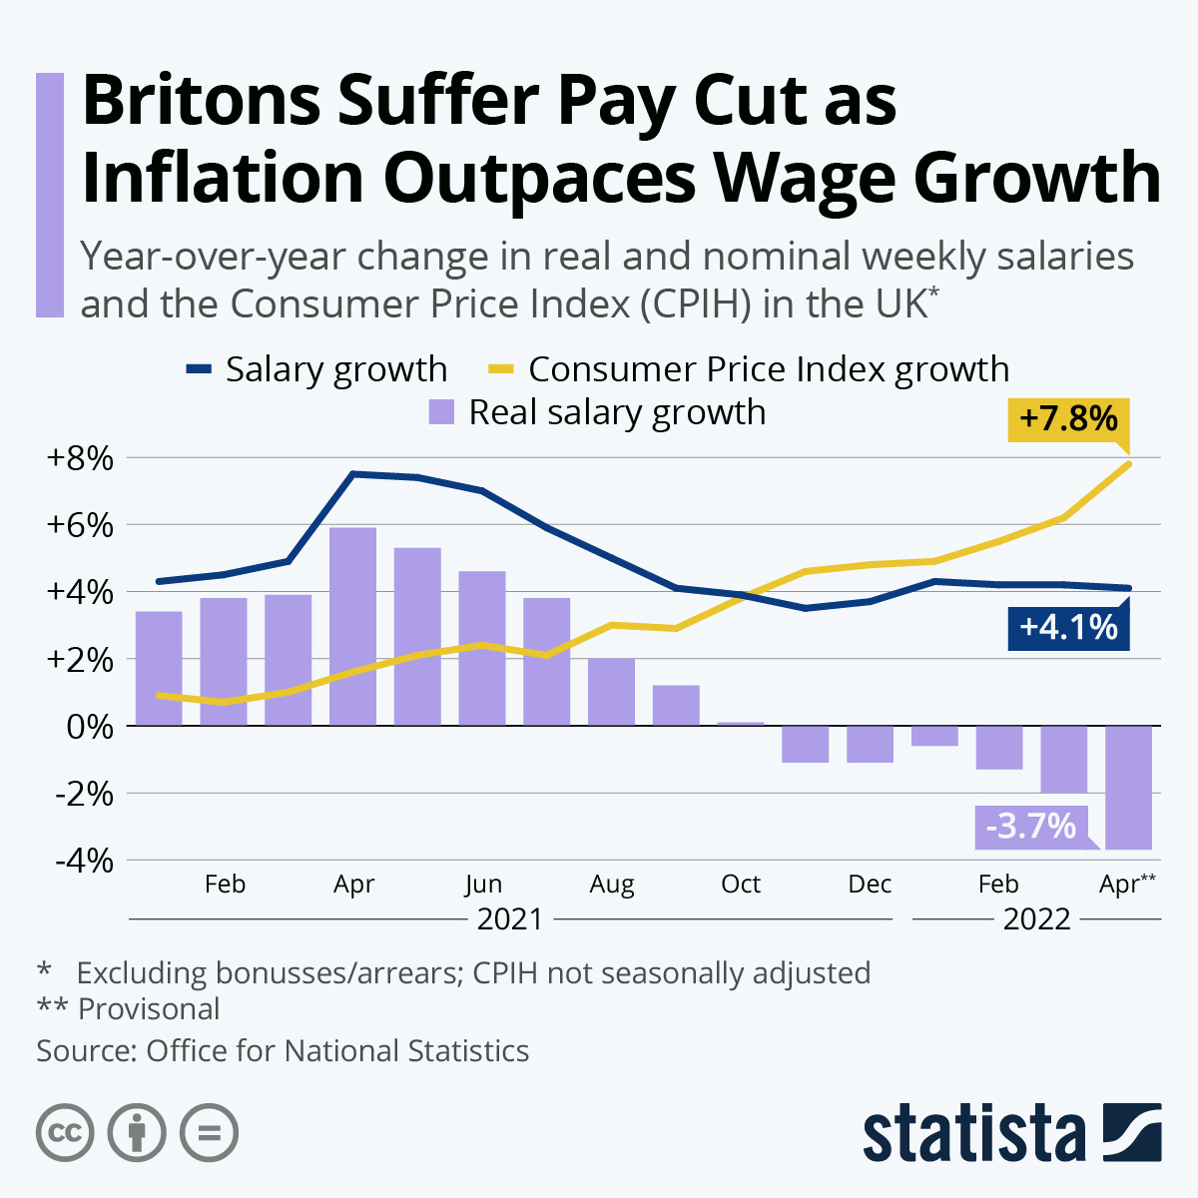
Figure 4: Wage Rate in the UK
(Source: Brandt, 2022)
Challenges faced by employees due to current appraisal system in organisation
As stated by Hamidi (2023), the impact of performance appraisal affects organisational behaviour and job satisfaction by feeling judged due to ulcer criteria at job. The challenges in adoption of the new appraisal system are poor communication, lack of clear goals, biased appraisal and mismatch among biassed outcomes. The below graph reflects that 38% of the millennium and 44% of Gen Z use a feedback system to encounter the performance of employees (Mazur, 2023). The feedback varies based on women and men by highly engaging with the team, feeling valued and through decent performance evaluation. Thus, impact of these challenges in term lowers down the overall productivity by reduction of trust which leads to rising anxiety.
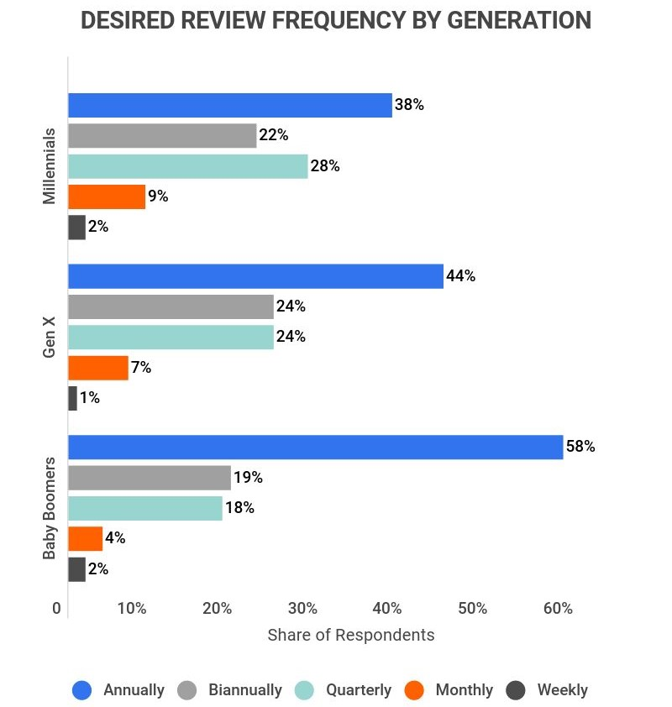
Figure 5: Employee feedback based on demographics
(Source: Mazur, 2023)
Recommend strategies to improve the appraisal process
In the rapidly changing era, the adoption of 360 degree feedback, providing proper compensation, two way conversation and leveraging technology is more reliable to enhance transition. As stated by Dalvi et al. (2023), the 360 degree feedback helps individuals by serving holistic strength which enhances career development and transparency in business. The market size of 360 degree feedback is about USD1, 094099 billion in 2024 tends to rise to USD2,539.99 billion during 2033 (Straits Research, 2024). Thus uses of this tools by different countries foster continuous improvement in business-enhance productivity.
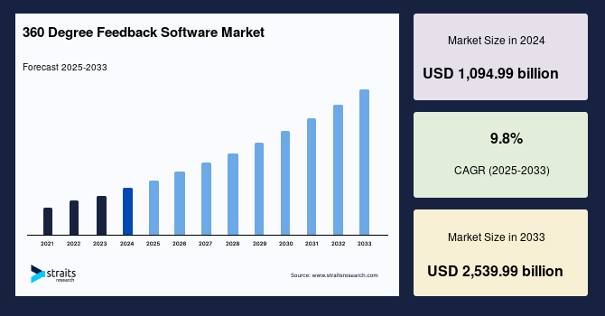
Figure 6: 360 degree feedback market
(Source: Straits Research, 2024)

Proposed method
The Saunders research onion is most significant to follow and identification of key steps associated with completion of research methodology. Thus, in this research interpretivism research philosophy will be useful for analysing the key relation of employee motivation with appraisal systems. As it is generally focused on subjective experiences, understanding employees’ subjective experiences, perceptions, and attitudes. In addition, an inductive approach will be used for determination of collective data potter, for generating themes effectively.
Further, use of secondary qualitative data collection method helpful for attributing different organisational appraisal system influence among employees. As this data is collected from authentic journal bases in "ResearchGate, ScienceDirect, Willie Online library, Sage Journals and others including current newspapers”. Also, the data organising will make proper themes use Braun and Clarke’s (2006) thematic analysis approach (Ahmed et al., 2025). As it is helpful for generating code for making themes with interconnecting variability identified in the employee appraisal system.

Expected contribution
- The study will provide insights including direct influence of employee motivation, strategic alignment with employee performance.
- The key insight purely relies on constructive feedback by addressing primary motivation of employees which showcases potential growth.
- The study showcases linking extrinsic rewards with appraisal that address based on performance and accomplishing value enhance development of career.

Ethical consideration
- Ensure data is used ethically and only for its intended research purpose, maintaining transparency and academic integrity throughout the process.
- The proper acknowledgement of authors are used throughout the research to make research more valid by relying on reliability of research.
- The uses of creditable sources are used throughout the research having proper DOI numbers that have been used throughout the research. .
- Respect intellectual property and confidentiality by adhering to the Copyright, Designs and Patents Act 1988 and safeguarding sensitive data (Government of UK, 2024).

Time plan
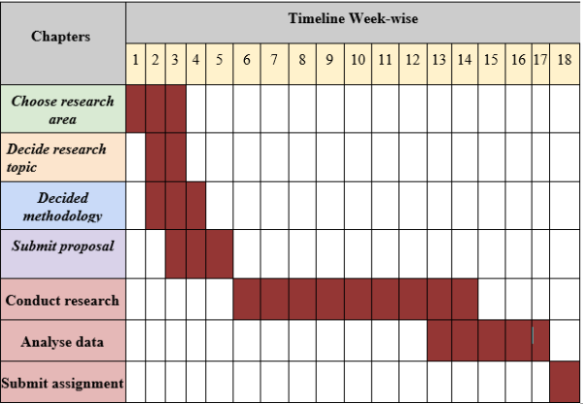
Figure 7: Time plan

Reference list
Ahmed, S.K., Mohammed, R.A., Nashwan, A.J., Ibrahim, R.H., Abdalla, A.Q., Ameen, B.M.M. and Khidhir, R.M. (2025). Using Thematic Analysis in Qualitative Research. Journal of Medicine, Surgery, and Public Health, [online] 6(6), p.100198. doi:https://doi.org/10.1016/j.glmedi.2025.100198.
Brandt, M. (2022). Infographic: Britons Suffer Pay Cut as Inflation Outpaces Wage Growth. [online] Statista Daily Data. Available at: https://www.statista.com/chart/27635/inflation-and-wage-growth-in-the-uk/?srsltid=AfmBOorUXIuooKYIimLcRjpGhxNkgxJZ0tgyf_yn03RZwp-xdcAPpnLZ [Accessed 1 Nov. 2025].
Dalvi, C., Sawant, S.B., Mohite, R.A. and Bajaj, K.K. (2023). 360-Degree Feedback as a Tool for Improving Employee Performance. Tuijin Jishu/Journal of Propulsion Technology, [online] 44(4), pp.1938–1945. Available at: https://www.researchgate.net/publication/374978873_360-Degree_Feedback_as_a_Tool_for_Improving_Employee_Performance.
Dennis, J. and Ferrer, R.A. (2024). 19 Job Satisfaction Statistics 2024: What Employers Should Know. [online] Fit Small Business. Available at: https://fitsmallbusiness.com/job-satisfaction-statistics/.
Flynn, J. (2024). Job Satisfaction Statistics By Country [2023]. [online] Zippia. Available at: https://www.zippia.com/advice/job-satisfaction-statistics-by-country/.
Government of UK (2024). Copyright, Designs and Patents Act 1988. [online] Legislation.gov.uk. Available at: https://www.legislation.gov.uk/ukpga/1988/48/contents.
Government of UK (2025). £1.5 Million investment to improve in-work health services as part of government drive to tackle inactivity. [online] GOV.UK. Available at: https://www.gov.uk/government/news/ai-to-help-keep-people-in-work-through-15-million-investment-in-occupational-health.
Hamidi, A.B. (2023). The Impacts of Performance Appraisal on Employee’s Job Satisfaction and Organizational Behavior. [online] ResearchGate. Available at: https://www.researchgate.net/publication/373328703_The_Impacts_of_Performance_Appraisal_on_Employee.
Jain, Dr.A., Gupta, D.B. and Bindal, Dr.M. (2019). (PDF) A Study of Employee Motivation in Organization. [online] ResearchGate. Available at: https://www.researchgate.net/publication/338506233_A_Study_of_Employee_Motivation_in_Organization.
Mazur, C. (2023). 20 Essential Employee Feedback Statistics [2022] – Zippia. [online] Zippia. Available at: https://www.zippia.com/advice/employee-feedback-statistics/.
Statistics (2025). Employee Motivation Statistics [2025]: What Really Drives Workplace Performance? [online] HIGH5 Strengths Test. Available at: https://high5test.com/employee-motivation-statistics/.
Straits Research (2024). 360 Degree Feedback Software Market Size, Share & Growth Report by 2033. [online] Straitsresearch.com. Available at: https://straitsresearch.com/report/360-degree-feedback-software-market.
Tesco Plc (2023a). New Tesco training Academy in Asia. [online] www.tescoplc.com. Available at: https://www.tescoplc.com/new-tesco-training-academy-in-asia/.
Tesco Plc (2023b). Tesco Workers Together. [online] Tesco Workers Together. Available at: https://tescoworkers.ie/.

