Management Ethics Report
Assignment 2

Naseem Uddin
P150596

Executive Summary
This report will be investigating whether McDonald’s are sustainable or how can they improve to be sustainable. McDonald’s is the world’s leading global food service retailer with over 36,000 locations in over 100 countries. McDonald’s restaurants around the world serve roughly 68 million customers each day. What was found is McDonald’s are trying to become more sustainable but it will take time as they are trying to reach it by the year 2020. The McDonald’s website has information on how they are being more sustainable and how they are improving but the source is biased as it is their own website. Through Carroll’s CSR Pyramid you could see that McDonald’s are only following rules and making profit, they are only following 2 responsibilities which are the legal and economic. McDonald’s are looking to be better but in the end will always look at profits as more important.

Recommendations
Continue making new goals for sustainability to reach by 2020
For McDonald’s to become more transparent with their nutritional information
Allow for more vegetarian or healthy meals and market it like any other menu food

Contents
Executive Summary 2
Table of Figures 4
Introduction 5
Sustainability 5
Main Findings 6
Lawsuits 9
Conclusion 9
References 10

Table of Figures

Fig 1: Stakeholders Page 6

Fig 2: Stakeholder Map Page 7

Fig 3: Carroll’s CSR Pyramid Page 8

Introduction
This report will be explaining how McDonald’s can benefit by adopting sustainability within the organisation, this approach will help long term improvements to the company and keep a competitive advantage. McDonald’s is the world’s leading global food service retailer with over 36,000 locations in over 100 countries. More than 80% of McDonald’s restaurants worldwide are owned and operated by independent local business men and women. McDonald’s was founded in 1940 by Richard and Maurice McDonald, the chain was purchased by businessman Ray Kroc who built up the company to where they are now. McDonald’s restaurants around the world serve roughly 68 million customers each day. The M stands for McDonald’s, but the rounded ‘m’ represents mummy’s mammaries, according to the design consultant and psycologist Louis Cheskin. In 1960’s McDonald’s prepared to abandon this logo, but Cheskin successfully urged the company to maintain this branding with its Freudian symbolism of a pair of nourishing breasts.

Sustainability
Sustainability is as defined by Lexicon as “managing the triple bottom line – a process by which companies manage their financial, social and environmental risks, obligations and opportunities.” These three impacts are usually referred to as profits, people and planet. Sustainable development within a business is explained by John Gardner (2014) as “Sustainable development making sure that people throughout the world can satisfy their basic needs now, while making sure that future generations can also look forward to the same quality of life.” Obesity and the health risks caused by McDonald’s is one of the main reasons they are being targeted by organisations, associations, government agencies, activists and bloggers. McDonald’s currently have meals under 600 or 400 calories but it isn’t being advertised as much as their main items, they need to add more to the healthy menu as well as provide some nutritional education. Another marketing action McDonald’s can take for a healthier menu is to add Happy Meals for adults and instead of a toy they could add a pedometer, this will be healthier and give them a way of exercising when they need to. A collaboration with Scripps Research Institute for fighting childhood obesity and Type 2 diabetes would be a step in the right direction. Scripps Research Institute was founded by Ellen Browning Scripps in 1924 to diagnose, treat, and investigate diabetes and other disorders of metabolism.
McDonald’s are really trying to become more sustainable as they say on their website, their goals for 2020 are to serve 100% more fruit, vegetables, low-fat dairy or whole grains and to reduce salt, sugar, saturated fat or calories across the menu. They have made global guidelines for children’s marketing which is a step in the right direction. The food they promote to children under the age of 12 will fit within a child’s nutritional needs and include a fruit, vegetable and water or juice as beverages, McDonald’s will not be advertising soda to children or feature them on Happy Meal menu boards. They also say on their website 2020 aspirational goals that they have achieved the goal of leading development of global principles and criteria in 2014 as well as begin purchasing verified sustainable beef during 2016. These views are biased as they are from their own website and who knows what the truth is. Gunther (2013) explains that until recently, people had to dig into the company’s website to learn about its environmental performance.

Main Findings
The American economist and statistician widely known for his strong belief in free-market capitalism Milton Friedman (1970) says “There is one and only one social responsibility of business – to use its resources and engage in activities designed to increase its profits so long as it stays within the rules of the game, which is to say, engages in open and free competition without deception or fraud.” What he is saying here is for the business to use its resources to increase profits as long as they do it legally and to engage in open and healthy competition without fraud. Friedman also says that the organisation should only worry about making a return on investments as businesses cannot have the same responsibilities individuals do. Husted and De Jesus Salazar (2006) describe the risks of walking away from the profit maximisation and in the direction of a sustainable campaign by pointing out that it is better for the organisation to concentrate on profits and pleasing their shareholders rather than wasting resources on sustainability. Freeman (2010) explains another approach to business where instead of just concentrating on shareholders there are other bodies involved with a company that can have an incentive on profit and reputation. Freeman describes these bodies of incentives as stakeholders.
Fig 1: Stakeholders
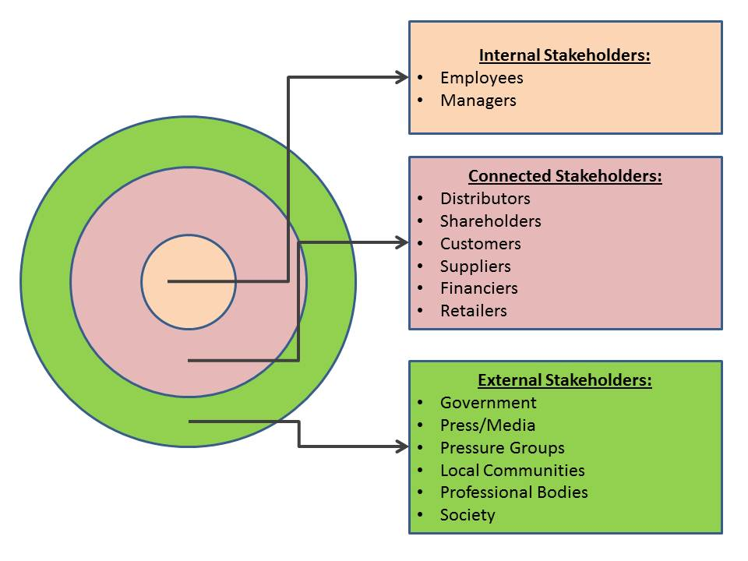
Source: (Professional Academy)
As shown in figure 1 an organisation has many different stakeholders with many different roles. Stakeholder mapping is a business tool created by Freeman (2010) which can be used to find which stakeholders have the most power and must be alleviated.
Figure 2: Stakeholder Map
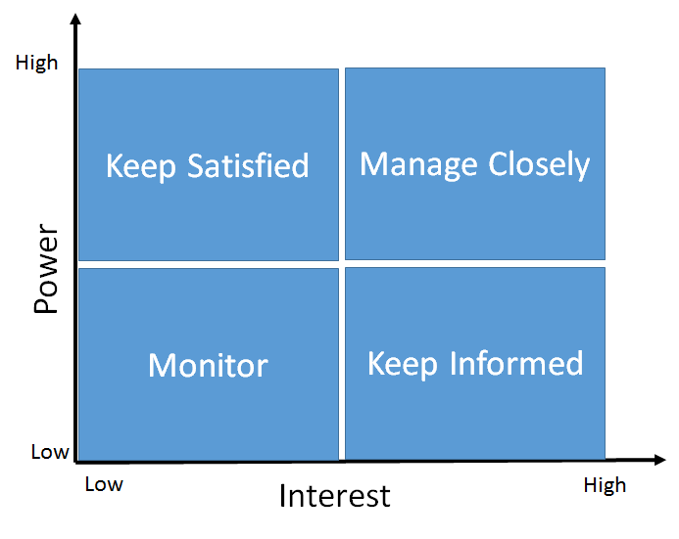
Source: (Freeman, 2010)
Figure 2 shows what each section of stakeholder needs. High power but low interest would be the government and they would need to be kept satisfied with how your organisation is influencing the economy. Managers and shareholders would need to be managed closely as they are the main stakeholders keeping the business going, stakeholders that would need to be monitored are the competitors. Stakeholders to be kept informed are the suppliers, media, pressure groups, employees and the communities.
Looking at both these theories, McDonald’s are keeping their internal and connected stakeholders happy. They need to make sure all stakeholders are happy to ensure a good image for the organisation. Sustainability is one of the main ways to earn a good image and McDonald’s are trying to achieve that by 2020. Currently, 37 percent of McDonald’s coffee comes from certified sustainable sources, Taylor (2016) mentions that McDonald’s are working with Conservation International, a non-profit that has worked with Starbucks to help the chain reach the milestone of using 99 percent ethically sourced coffee.

Figure 3: Carroll’s CSR Pyramid
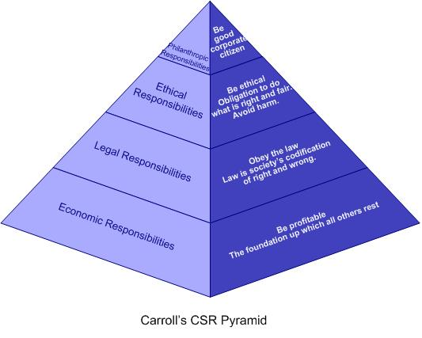
Source: (Carroll, 2016)
Pedersen and Huniche (2014) convey that according to Carroll (1983), corporate social responsibility involves the conduct of a business so that it is economically profitable, law abiding, ethical and socially supportive. To be socially responsible then means that profitability and obedience to the law are foremost conditions when discussing the firm’s ethics and the extent to which it supports the society in which it exists with contributions of money, time and talent. McDonald’s are currently affiliating with two of these responsibilities, which are the economic and legal responsibilities. They are obeying the law and being profitable and there is nothing wrong with it. This model of CSR is showing different ways an organisation could follow a practice, Friedman’s theory would align with legal and economic responsibilities and on the other hand Freeman would align with all four.

Triple Bottom Line
The triple bottom line consists of three P’s which are profit, people and planet. The model looks to measure the financial, social and environmental aspects of the organisation over a period of time. McDonald’s have the people and planet part of the triple bottom line currently on their sustainability section of their website but no sign of the profit. Profit: making a return for the shareholders or furthering the Company’s objectives within its business environment, Planet: making sure that the use of raw materials are sustainable with the organisations output of damage the organisation has on the environment. People: taking into account the workforce and other sociological aspects the company can affect.

Lawsuits
McDonald’s sued two protestors for allegedly libellous statements made in a pamphlet, “What’s Wrong with McDonald’s” This went on from 1994 to 1999 and was a massive PR disaster that made McDonald’s look like a bully, The pamphlet built the media agenda on issues unfavourable to McDonald’s and the court ruled that the defendants were justified in claiming that regular customers of McDonald’s did face a heightened risk of heart trouble, the pamphlet was later remade on the internet to a massive global audience. The court case cost McDonald’s over a million dollars as well as providing material for a full length documentary released in 2005 called McLibel. McDonald’s lost a million dollars on the lawsuit but it would take far less to become more sustainable and healthier and grow the business as a better brand. Another lawsuit McDonald’s were in was the McLawsuit which happened from 2002-2003, where a group of obese teenagers who ate McDonald’s 3-5 times per week sued McDonald;s for causing their weight problems. The alleged that McDonald’s advertising and promotional representations create a false impression that its food products are part of a healthy lifestyle and McDonald’s saying they would provide nutritional information to customers but did not. The court did rule in favour of McDonald’s but the resulting coverage of the press put the issue at the forefront once again, 2002 was also the first time McDonald’s posted a quarter loss in its history.

Conclusion
In conclusion McDonald’s are becoming more sustainable but they will not make it a priority as they will look at profits more. They are one of the biggest brands in the world and it will be hard to change the minds of so many that have witnessed the bad side of McDonald’s. A good thing that McDonald’s have done is set goals as they have hit the goals before deadlines and even not achieving the goals still makes the organisation look good as they are trying to achieve to be better.

References
Carroll, A. B. (2016) Carroll’s Pyramid of CSR. Available at: http://www.csrquest.net/imagefiles/CSR%20Pyramid.jpg. Retrieved January 28, 2018.
Definition of business sustainability - http://lexicon.ft.com/Term?term=business-sustainability
Freeman, E. (2010). Stakeholder Management » R. Edward Freeman. [online] Redwardfreeman.com. Available at: http://redwardfreeman.com/stakeholder-management/ [Accessed 26 Jan. 2018].
Freidman, M. (1970). Strategic Management: A Stakeholder Approach. Cambridge: Cambridge University Press. Retrieved January 26, 2018
Gardner, J. (2014). Sustainability – a local issue for us all | Open Access Government. [online] Open Access Government. Available at: https://www.openaccessgovernment.org/sustainability-a-local-issue-for-us-all/3316/ [Accessed 25 Jan. 2018].
Gunther, M. (2013) Coffee and the consumer: can McDonald's mainstream sustainability? [online]
Available at: https://www.theguardian.com/sustainable-business/mcdonalds-coffee-sustainability
[Accessed 26 Jan. 2018]
Husted, B. and de Jesus Salazar, J. (2006). Taking Friedman Seriously: Maximizing Profits and Social Performance*. Journal of Management Studies, 43(1), pp.75-91.
Pedersen, E. and Huniche, M. (2014). Corporate Citizenship in Developing Countries. 1st ed. Frederiksberg: Copenhagen Business School Press, p.32.
Taylor, K. (2016) McDonald's is making a big change to its coffee [online]
Available at: http://uk.businessinsider.com/mcdonalds-aims-for-sustainable-coffee-2016-10
[Accessed 26 Jan. 2018]

