

Assignment 2

Event Strategic Planning and Delivery Considerations for an International Meeting

THE CARDIFF
Winter Sports and Adventure Expo

- Student ID number: 2133909
- Student name: Roxana Ionica Macarie
- The module title: International Meetings Management for the Hotel Industry
- Module code: BMIH6007
- Module Lead: Kathryn Flynn
- Word count: 2670

I acknowledge the use of Grammarly App and Microsoft Word Editor on 8th November 2024 to check my grammar, syntax and misspellings
I confirm that I have not presented any Al generated text as my own work. I confirm I have copies of my drafts, notes, and other resources I used before, and after the use of Al tools which I may be asked to provide in evidence.

Executive Summary
The Winter Sports and Adventure Expo is a revolutionary event to promote Cardiff as a leading centre for sustainable winter sports tourism. The event integrates winter sports with environmental education, showcasing augmented reality skiing simulations, eco-friendly workshops, and displays from sustainable brands. The Expo, held at the Cardiff International Arena, seeks to improve local economic development and strengthen Cardiff's position in adventure tourism.
The Expo is organised based on the EMBOK (Event Management Body of Knowledge) framework, following a systematic event cycle that includes thorough planning, risk management, and ongoing improvement. The Expo's marketing strategy integrates the 7 Ps of marketing and responds to attendee requirements in accordance with Maslow’s hierarchy. The budget strategy utilises zero-based budgeting to align expenditures with sustainability objectives while optimising revenue through sponsorships and vendor fees.
In light of prevailing industry trends, the Expo integrates hybrid components and sustainable practices to maintain competitiveness. For the event's sustained success, it is essential to implement a post-event feedback mechanism and a membership initiative, thus cultivating attendee loyalty and maintaining Cardiff's prominence in eco-tourism. This event signifies a crucial advancement in Cardiff's goal of becoming a worldwide hub for sustainable adventure tourism.

Table of Contents
- Executive Summary
- Introduction
- EMBOK Event Cycle
- Event Concept
- Aim and Objectives
- Event Management
- Marketing Strategy
- Risk Management
- Event Budget
- Industry Trends / Issues / Impacts
- Situational and Cultural Considerations
- Conclusion
- Recommendation
- References

Introduction
The Winter Sports and Adventure Expo is a pioneering event that integrates the excitement of winter sports, sustainable tourism, and professional advancement. Participants will engage in various interactive activities, including augmented reality (AR) skiing simulations, hands-on workshops conducted by sustainability experts, and exhibitions from environmentally conscious gear companies. This comprehensive strategy honours winter sports and shows Cardiff's dedication to environmental conservation and community enhancement.
The Expo's design fits Cardiff's strategic objective of further strengthening its position as a leader in adventure and eco-tourism, utilising its combination of urban elegance and proximity to natural environments. The Cardiff International Arena was chosen for its established ability to accommodate prominent, interactive events, promoting local economic development and highlighting the city’s potential as a premier event location.
EMBOK Event Cycle
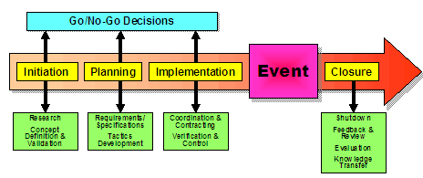
Definition and Overview
The Event Cycle, a fundamental element of the Event Management Body of Knowledge (EMBOK), establishes the entire trajectory of an event from start to finish. It comprises five essential phases: Initiation, Planning, Implementation, Event, and Closure. This systematic method guarantees thorough management, enabling the alignment of strategic objectives with operational implementation (Getz, 2018). The EMBOK model encourages continuous improvement, strategic thinking, and integration throughout its phases, establishing a resilient framework suitable for diverse event types and scales (Makda et al., 2012).
Application to the Expo
Initiation Phase establishes the groundwork by describing the event's purpose and evaluating its feasibility. The Winter Sports and Adventure Expo commences with a comprehensive market analysis to assess interest among winter sports enthusiasts, environmentally aware travellers, and industry experts. This analysis includes stakeholder engagement to refine objectives and establish strategic partnerships, adhering to best practices in feasibility assessment (Arnott, 2020).
Planning Phase: Strategic planning examines logistics, resource distribution, and stakeholder collaboration in greater detail. The focus is on developing a comprehensive plan that incorporates the Cardiff International Arena's acquisition and complex technological innovations such as augmented reality (AR) demonstrations. This phase underscores meticulous scheduling, risk management tactics, and a comprehensive operational plan that adheres to EMBOK's extensive process model for efficient event preparation (Robson, 2008). The strategy comprises schedules for promotional campaigns, guaranteeing a balance between traditional and digital marketing initiatives (Salama, 2021).
Implementation Phase: The implementation phase involves coordinating human and technical resources. During the Expo, this entails mobilising teams to facilitate workshops, supervise safety protocols for climbing walls, and operate AR simulators with assistance from specialised vendors and safety experts (Kariuki et al., 2020). Adequate on-site communication guarantees that personnel and volunteers comprehend their roles and responsibilities.
Event Execution: The live event prioritises the attendee experience by integrating educational and interactive sessions to captivate audiences. Components such as eco-partner exhibitions and live sports demonstrations create a vibrant environment. Immediate modifications are necessary to tackle unexpected challenges, underscoring the necessity for adaptable event management.
Closure Phase: The event's conclusion includes organised debriefing sessions to collect feedback from stakeholders and participants. This phase emphasises data collection for post-event analysis, facilitating continuous improvement and refining future event strategies (Getz, 2018). The study encompasses quantitative aspects—examining attendance metrics—and qualitative elements, evaluating attendee satisfaction and sponsor feedback (Makda et al., 2012).

Event Concept

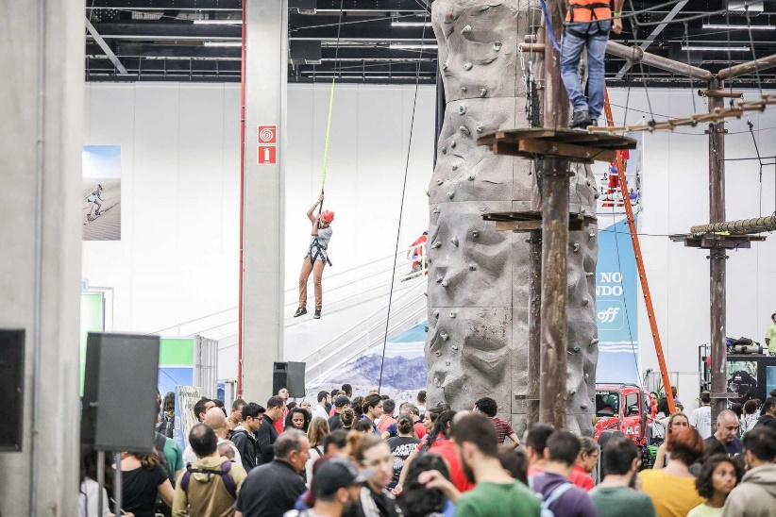
Experience Design
Creating a significant attendee experience for the Winter Sports and Adventure Expo necessitates an advanced understanding of event dynamics that integrate entertainment, education, and environmental involvement.

Participants will be greeted by an engaging entryway enriched with winter-themed decorations and environmentally sustainable installations reflecting the event's sustainability commitment. The event features live demonstrations of winter sports equipment and interactive augmented reality (AR) stations, enabling guests to simulate skiing or snowboarding experiences (Wrathall and Steriopoulos, 2022). These dynamic elements increase visitor engagement, converting passive attendance into active, memorable participation (Berridge, 2007).
Workshops conducted by industry experts offer comprehensive discussions on sustainable adventure tourism, attracting eco-conscious travellers and professionals seeking knowledge on current industry trends. Networking spaces will promote interactions among like-minded participants, sponsors, and experts, thereby strengthening the community essence that is essential to successful events (Orefice, 2018).
Program Outline
The Expo will begin with a keynote session stressing the transformative potential of sustainable tourism, succeeded by a series of workshops centred on eco-friendly practices in winter sports. Midday will include live augmented reality demonstrations and interactive panels with prominent brands such as Arc'teryx and Salomon, highlighting their dedication to sustainable innovation (Latif, Inzaghi, and Mu'asyaroh, 2022). The evening will culminate in a closing address summarising essential insights and celebrating collective accomplishments through an interactive multimedia presentation.
EMBOK Design Domain
The Design domain of the EMBOK framework underlines the significance of creativity and thematic unity in event experiences (Silvers, 2003; AlWaer and Cooper, 2020). The Expo's layout and ambience are designed to reflect the thematic essence of winter sports, incorporating both naturalistic and innovative elements to create a unified narrative. This strategic method guarantees that participants remain engaged and inspired, promoting a smooth transition between different segments of the event (Zomerdijk and Voss, 2010). By synchronising sensory components—auditory landscapes of snow and visual representations of alpine environments—with event goals, the design enhances the event's branding and intent, fostering a significant, impactful experience (Wrathall and Steriopoulos, 2022).

Aim and Objectives
Overarching Aim
The principal objective of the Winter Sports and Adventure Expo is to establish Cardiff as a leader in sustainable winter sports tourism. This event aims to utilise the region's distinctive geographic advantages and growing environmentally aware community to elevate its status as a global hub for sustainable sports initiatives.
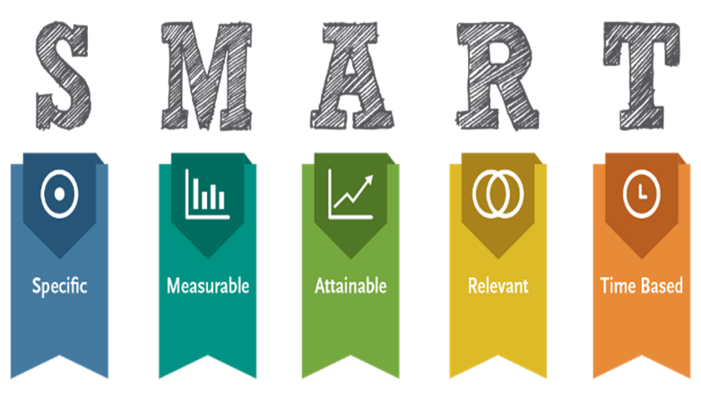
SMART Objectives
1. Increase local attendance by 15% compared to prior similar events: This objective emphasises the significance of measurable growth in participant numbers, utilising historical attendance data from similar sports expos. The event seeks to engage various audiences, from adventure enthusiasts to sustainability advocates, through targeted marketing strategies and collaborations with local influencers (Bjerke and Renger, 2017).
2. Achieve a 90% positive satisfaction rate among attendees as measured by post-event surveys: An extensive assessment strategy, incorporating post-event digital surveys and in-person feedback sessions, will be implemented to measure attendee satisfaction. This objective corresponds with research highlighting customer experience as a fundamental factor in event success (Bustard et al., 2019).
3. Secure partnerships with three sustainable brands for future collaboration: Partnering with environmentally conscious sponsors, including cutting-edge equipment firms and regional sustainability projects, not only supports event legitimacy but also guarantees conformity with international sustainability trends in event organisation (Du and Zhang, 2021). Forming these partnerships strengthens Cardiff's strategic objective to cultivate enduring, value-oriented relationships in the sustainable tourism industry.

Event Management
Skills and Resources Required
The practical implementation of the Winter Sports and Adventure Expo relies on utilising a comprehensive array of skills and resources. Essential competencies encompass project management, guaranteeing systematic planning and supervision of all operational components (Werner et al., 2021). Negotiating with vendors is critical for obtaining advantageous contracts with suppliers while communicating with stakeholders to align expectations and facilitate collaboration, promoting transparency throughout the event cycle (Padron and Stone, 2019). These skills collectively support an event's ability to adjust to changing demands and maintain efficiency under pressure (Junek et al., 2009).
Operational Activities
Operational planning necessitates careful consideration of logistics, covering venue arrangement, safety measures, and technological integration. Configuring the Cardiff International Arena for augmented reality sports simulations and eco-partner exhibits necessitates high-speed internet and specialised audiovisual equipment (Fotiadis, 2020). Safety protocols in interactive sports zones require the implementation of trained personnel and risk mitigation strategies to maintain industry standards (Namratha et al., 2019).
Planning Processes
The comprehensive planning phases of EMBOK—assessment, selection, communication, and documentation—function as a framework for efficient event management (Bladen et al., 2012). Evaluation determines event viability through environmental analysis and stakeholder assessment. The selection phase involves identifying partners and technological solutions that correspond with sustainability objectives, illustrating the EMBOK focus on informed decision-making (Werner, Junek, and Wang, 2021). Communication involves coordinating among teams and external stakeholders and employing cloud-based tools for efficient updates. Documentation formalises plans and preserves records, which is essential for regulatory compliance and continuous learning (Chirieleison and Montrone, 2013).

Marketing Strategy
An innovative marketing strategy using the EMBOK marketing domain provides effective audience targeting. In conjunction with partnerships with notable influencers like adventure photographer Chris Burkard and sustainable travel proponent Céline Cousteau, utilising prominent social media platforms such as Instagram, Twitter, and Facebook can elicit local and global engagement. By tailoring content that highlights environmentally conscious adventure alternatives and attracts nature lovers and sustainability advocates, the Expo can strengthen Cardiff's position as a frontrunner in sustainable tourism (Namratha et al., 2019). Event organisers can utilise advanced analytics tools such as Google Analytics and Sprout Social to monitor audience engagement and reach, enabling real-time modifications to enhance engagement and maximise outreach (Kovač, 2020).
Maslow’s Hierarchy of Needs and Attendee Satisfaction at the Expo
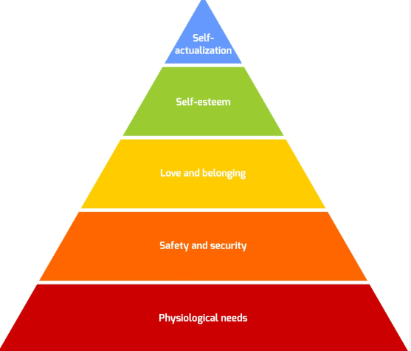
Maslow's hierarchy of needs offers a framework for fulfilling attendee demands across all levels. The Expo provides sustainable food and beverages and comfortable facilities for physiological needs. Safety requirements are met through explicit emergency protocols and competent staff for augmented reality simulations and climbing zones. Social needs are fulfilled through networking zones, enabling attendees to engage based on common interests. Esteem needs are satisfied through exclusive VIP workshops, where participants acquire sustainable tourism practices from industry experts, increasing their sense of achievement. The Expo facilitates Self-Actualization by allowing participants to pursue personal interests in environmentally sustainable winter sports. This stratified method guarantees that participants feel safe, appreciated, and motivated, cultivating a constructive and engaging experience consistent with Cardiff's principles.

Risk Management
Risk management is essential, addressing alternatives for possible disruptions such as severe weather, technical failures, and crowd surges. The EMBOK framework's risk management domain promotes proactive strategies, such as auxiliary power sources and organised crowd control measures, to ensure safety and facilitate event progression (Werner et al., 2021). Training volunteers and staff in emergency protocols guarantees preparedness, a practice essential to event resilience (Leigh et al., 2020).

Event Budget
Income and Funding Sources
Generating revenue for the Winter Sports and Adventure Expo requires a diversified strategy to ensure financial sustainability. Primary revenue streams will consist of ticket sales, including tiered pricing models that provide both general and premium access, allowing diverse financial capacities. Sponsorship packages will constitute a substantial revenue stream aimed at environmentally conscious and outdoor sports brands that can gain exposure at this prestigious event. These collaborations will correspond with the event's sustainability theme, augmenting shared brand equity (Janjusevic and Mathur, 2021). Vendor fees for exhibition space will boost revenue by attracting companies eager to display environmentally sustainable products and technologies (Wrathall and Steriopoulos, 2022).
Expenditure Breakdown
Effective cost management is crucial for sustaining fiscal health. Significant expenditure categories encompass venue rental for the Cardiff International Arena, an essential investment for utilising a space that facilitates substantial foot traffic and interactive installations (Mysyk, 2023). Staffing expenses include remuneration for technical staff, security, and event coordinators, enabling the seamless execution of the event. Marketing costs will combine digital advertising and influencer partnerships to optimise outreach (Liu et al., 2017). A significant portion of the budget will be designated for specialised technology. Augmented reality (AR) displays improve the attendee experience (Galić et al., 2019).
Budget Analysis
The financial strategy for the Expo adheres to zero-based budgeting (ZBB) principles, which prioritise resource allocation according to present requirements instead of past expenditures (Chirieleison and Montrone, 2013). This method fosters financial discipline and flexibility, enabling reallocation if specific event elements require adjustment based on evolving priorities or feedback. The Expo's budget will incorporate a cost-benefit analysis to guarantee that expenditures directly facilitate the attainment of strategic objectives, including attendee engagement and sponsor satisfaction. Furthermore, cash flow management will be consistently overseen to reduce potential deficits, integrating reserve funds for unforeseen expenditures such as last-minute logistical modifications (Janjusevic and Mathur, 2021).
The Expo's financial plan seeks to optimise profitability by carefully aligning projected income with expected expenses while complying with sustainability standards and broader strategic objectives (Mysyk, 2023).

Industry Trends / Issues / Impacts
Current Trends
The event industry is experiencing a notable transition towards hybrid formats, integrating in-person and digital experiences to improve reach and inclusivity. The trend, intensified by the pandemic, increases accessibility and corresponds with contemporary inclinations for flexibility and digital interaction (Ibrahim et al., 2023). A significant trend is the focus on sustainability—events are progressively integrating eco-friendly practices like waste reduction and carbon offsetting, driven by increased environmental consciousness (Salama, 2021). Furthermore, incorporating augmented and virtual reality (AR/VR) revolutionises audience engagement by providing immersive experiences that effortlessly merge physical and digital realms (Mehrotra and Lobo, 2020).
Technological Impacts
Innovative technologies are transforming event management, improving logistical efficiency and attendee interaction. Blockchain technology is increasingly recognised for its secure and transparent ticketing and data management capabilities, effectively mitigating fraud and ensuring irreversible transaction records (Ragab and Salama, 2021). The implementation of cloud computing facilitates real-time updates and collaboration, optimising event operations and participant management (Ozpinar and Ozpinar, 2018). These innovations assist event planners in facilitating seamless operations while improving the overall experience, conforming to contemporary expectations of advanced interactivity.
Post-Pandemic Considerations
The pandemic's enduring impacts have established hybrid formats as standard, integrating online and offline components to sustain engagement despite restrictive circumstances (Werner et al., 2020). Events now focus on health protocols, contactless interactions, and flexible strategies to reduce disruptions from potential outbreaks (Pennington-Gray and Lee, 2024). The strategic integration of digital platforms for sessions and networking has not only eased previous disruptions but also redefined the industry's framework for ensuring the resilience of future events.
In summary, these trends highlight event managers' need to innovate perpetually, balancing sustainability, technological integration, and resilience to maintain competitiveness in a swiftly changing environment.
Situational and Cultural Considerations
Cultural Sensitivity and Inclusion
The diverse demographic landscape of Cardiff requires a culturally sensitive approach to event planning, particularly for the Winter Sports and Adventure Expo. The city's multicultural composition impacts event marketing and program design, necessitating strategies that appeal to diverse cultural groups. Events that integrate cultural sensitivity promote inclusivity, which results in better community engagement and expanding audience reach (Mallen, Adams, 2024). Implementing multilingual promotional materials and accommodating dietary preferences demonstrates respect for cultural differences, increasing participation and satisfaction (Mallena and Adams, 2024).
Business Analysis Tools: SWOT Analysis
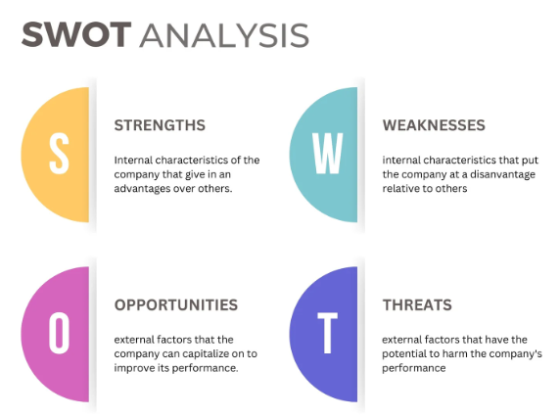
Strengths: Cardiff's strong community involvement and well-established reputation in eco-tourism provide a solid basis for the Expo. The municipal government endorses sustainable tourism initiatives, which align seamlessly with the Expo's environmentally conscious agenda (Salama, 2021).
Weaknesses: Substantial initial expenses for venue preparation, interactive augmented reality technology, and extensive marketing initiatives need to be addressed (Corallo et al., 2018). Maintaining a balance between these investments and anticipated revenue is essential for the event's success.
Opportunities: The increasing global interest in sustainable tourism presents an advantageous context. This trend allows the Expo to establish itself as a pioneering platform advocating sustainable sports practices (Mehrotra and Lobo, 2020). Partnerships with global brands may boost Cardiff's prominence as a leader in sustainable tourism.
Threats: The Expo faces competition from larger, established events in cities with superior tourism infrastructure. Moreover, economic instability may influence sponsor commitments and attendance figures (Andersson et al., 2020). Facilitating strategic adaptability and effective risk management may reduce these challenges.

Conclusion
The Winter Sports and Adventure Expo exemplifies Cardiff's aspiration to be a centre for sustainable tourism and experiential events. With careful strategic planning and a focus on cultural inclusivity and technological integration, the Expo is set to strengthen the city's reputation nationally and internationally. This event guarantees a valuable experience for participants while highlighting Cardiff's leadership in promoting sustainable initiatives and stimulating economic growth through innovative event management. This Expo demonstrates a proactive strategy by anticipating challenges and capitalising on opportunities in the dynamic field of event management. This guarantees its success and establishes a standard for future events.

Recommendation
To secure sustained success, the management has to begin a post-event feedback mechanism to collect attendee insights regarding satisfaction and engagement, facilitating continual improvement (Bustard et al., 2019). Furthermore, provide early-bird discounts for upcoming events to guarantee prompt revenue and build loyalty. A membership program featuring exclusive benefits might boost repeat attendance, reinforcing Cardiff's leadership in sustainable tourism.

References
- AlWaer, H., and Cooper, I., 2020. Changing the Focus: Viewing Design-Led Events within Collaborative Planning. Sustainability. https://doi.org/10.3390/su12083365.
- Arnott, I., 2020. Risk Management in Events Management. pp. 1-20. https://doi.org/10.4018/978-1-7998-3230-0.CH001.
- Berridge, G., 2007. Events design and experience (1st ed.). Butterworth-Heinemann. https://librarysearch.uwtsd.ac.uk/permalink/44WHELF_UWTSD/upgrip/alma99100107556302421
- Bjerke, M., and Renger, R., 2017. Being smart about writing SMART objectives.. Evaluation and program planning, 61, pp. 125-127 . https://doi.org/10.1016/j.evalprogplan.2016.12.009.
- Pennington-Gray, L. and Lee, S., 2024. The demand for safety measures in the hospitality industry: Changes over three phases of a pandemic. International Journal of Hospitality Management, 122, p.103873. https://doi.org/10.1016/j.ijhm.2024.103873
- ANDERSSON, T.D., GETZ, D. and JUTBRING, H., 2020. Balancing value and risk within a city's event portfolio: an explorative study of DMO professionals' assessments. International Journal of Event and Festival Management, 11(4), pp. 413-432. https://www.proquest.com/scholarly-journals/balancing-value-risk-within-citys-event-portfolio/docview/2444525392/se-2?accountid=130472
- BUSTARD, J.R.T., BOLAN, P., DEVINE, A. and HUTCHINSON, K., 2019. The emerging smart event experience: an interpretative phenomenological analysis. Tourism Review of AIEST - International Association of Scientific Experts in Tourism, 74(1), pp. 116-128. https://www.proquest.com/scholarly-journals/emerging-smart-event-experience-interpretative/docview/2173563678/se-2?accountid=130472
- Mallen, C., and Adams, L.J., 2024. Event Management in Sport, Recreation, and Tourism: Theoretical and Practical Dimensions (4th ed.). Routledge. https://doi.org/10.4324/9781003391098
- Chirieleison, C., and Montrone, A., 2013. Evaluating local government costs and revenues: The case of an Italian privately owned for-profit event. Tourism Management Perspectives, 8, pp. 90-97. https://doi.org/10.1016/J.TMP.2013.08.001.
- CORALLO, A., TRONO, A., FORTUNATO, L., PETTINATO, F. and SCHINA, L., 2018. Cultural Event Management and Urban e-Planning Through Bottom-Up User Participation. International Journal of E-Planning Research, 7(1), pp. 15-33. https://www.proquest.com/scholarly-journals/cultural-event-management-urban-e-planning/docview/2931916335/se-2?accountid=130472
- Du, J., and Zhang, J., 2021. Construction of Smart Management System for Large-Scale Sports Event: A Case Study of Hangzhou Asian Games. Proceedings of the 2021 6th International Conference on Social Sciences and Economic Development (ICSSED 2021). https://doi.org/10.2991/ASSEHR.K.210407.059.
- Fotiadis, A., Vassiliadis, C., 2020. Principles and Practices of Small-Scale Sport Event Management. https://librarysearch.uwtsd.ac.uk/permalink/44WHELF_UWTSD/igoone/cdi_igi_books_10_4018_978-1-7998-4757-1_ch001
- Galić, T., Tolušić, Z. and Bulat, M.B., 2019. Financial management as a tool for sustainable development of non-profit sports organizations–analysis of futsal competitions in Eastern Croatia. Ekonomski vjesnik/Econviews-Review of Contemporary Business, Entrepreneurship and Economic Issues, 32(1), pp.55-67. https://hrcak.srce.hr/ojs/index.php/ekonomski-vjesnik/article/download/8150/5134/
- Getz, D 2018, Event Evaluation: : Theory and Methods for Event Management and Tourism, Goodfellow Publishers, Limited, Oxford. https://ebookcentral.proquest.com/lib/trinity/reader.action?docID=29281298&ppg=1
- Hefnawy, A., Bouras, A. and Cherifi, C., 2016. Integration of Smart City and Lifecycle Concepts for Enhanced Large-Scale Event Management. https://www.academia.edu/download/91931668/978-3-319-33111-9_62.pdf
- Ibrahim, I., Sa'aid, H., and Yuliawan, R., 2023. Major Trends in Festivals Events Research: A Bibliometric Study. International Journal of Academic Research in Business and Social Sciences. https://doi.org/10.6007/ijarbss/v13-i5/16674.
- Janjusevic, J., and Mathur, S., 2021. Financial Planning and Budgeting of Events. . https://doi.org/10.23912/9781911635734-4769.
- Junek, O., Lockstone, L., and Mair, J., 2009. Two Perspectives on Event Management Employment: Student and Employer Insights into the Skills Required to Get the Job Done!. Journal of Hospitality and Tourism Management, 16, pp. 120-129. https://doi.org/10.1375/JHTM.16.1.120.
- Kariuki, K., Kimanga, E., and Wanjiku, J., 2020. Performance of Events Management Service Providers within the Weddings Subsector, in Nairobi County, Kenya. International Journal of Innovative Research and Development. https://doi.org/10.24940/IJIRD/2020/V9/I12/DEC20033.
- Kovac, T., 2020. New perspectives and evaluation of training for Event Management. Technium Soc. Sci. J., 8, p.8. https://techniumscience.com/index.php/socialsciences/article/download/544/251
- LEIGH, J., CAIRNCROSS, G. and LAMONT, M., 2021. Training for event volunteers: factors influencing event managers' resource allocation decision-making. International Journal of Event and Festival Management, 12(1), pp. 16-35. https://www.proquest.com/scholarly-journals/training-event-volunteers-factors-influencing/docview/2534249414/se-2?accountid=130472
- Liu, L., Zhang, J., and Keh, H. T. (2017). Event-Marketing And Advertising Expenditures. Link
- Makda, T., Bayat, M.S. and Ukpere, W.I., 2012. Risk management within the events industry in Cape Town, South Africa. African Journal of Business Management, 6(20), p.6243. https://citeseerx.ist.psu.edu/document?repid=rep1&type=pdf&doi=6142b1bcb5ddd3d385d42f3f08f38ae9545479c0
- Mehrotra, A. and Lobo, J., 2020, June. Technology Driving Event Management Industry to the Next Level. In 2020 8th International Conference on Reliability, Infocom Technologies and Optimization (Trends and Future Directions)(ICRITO) (pp. 436-441). IEEE. https://doi.org/10.1109/ICRITO48877.2020.9198025
- Mysyk, V.M., 2023. METHOD OF EVALUATING AND DIAGNOSING COSTS FOR EVENT MANAGEMENT. https://science.lpnu.ua/sites/default/files/journal-paper/2023/sep/31258/menedzhment-73-80.pdf
- Namratha, J., Thiruchelvi, A. and Natasha, J., 2019. Event management and social media marketing. International Journal of Advance Research, Ideas and Innovations in Technology, 5(2). https://www.academia.edu/download/59152847/V5I2-164120190507-35001-dmmrd8.pdf
- OREFICE, C., 2018. Designing for events – a new perspective on event design. International Journal of Event and Festival Management, 9(1), pp. 20-33. https://www.proquest.com/scholarly-journals/designing-events-new-perspective-on-event-design/docview/2014248674/se-2?accountid=130472
- Ozpinar, S.B. and Ozpinar, A., 2018. INTEGRATING CLOUD ENABLED SMART TECHNOLOGIES INTO EVENT MANAGEMENT. ERAZ 2018, p.889. https://www.researchgate.net/profile/Anita-Ilak-Persuric/publication/328505025_EXAMPLES_OF_EUROPEAN_TOURISM_DESTINATIONS_AND_IMPORTANCE_OF_AGRICULTURAL_LANDSCAPES/links/5c7fabb9299bf1268d3d4cb2/EXAMPLES-OF-EUROPEAN-TOURISM-DESTINATIONS-AND-IMPORTANCE-OF-AGRICULTURAL-LANDSCAPES.pdf#page=912
- Padron, T., and Stone, M., 2019. Leadership Skills in Event Management Courses. Event Management, 23, pp. 927-937. https://doi.org/10.3727/152599518X15403853721321.
- Ragab, H., and Salama, M., 2021. Advanced Technology for Event Management. . https://doi.org/10.23912/9781911635734-4774.
- ROBSON, L.M., 2008. Event Management Body Of Knowledge (EMBOK): The Future of Event Industry Research. Event Management, 12(1), pp. 19-25. https://www.proquest.com/scholarly-journals/event-management-body-knowledge-embok-future/docview/2779475550/se-2?accountid=130472
- Salama, M., 2021. Traditional Event Project Management. Event Project Management. https://doi.org/10.23912/9781911635734-4773.
- Latif, N., Inzaghi, F. and Mu'asyaroh, H.A., 2022. Thematic Event Relation to Consumer Experience in Custom Cultural Events as a Differentiation Strategy. Jurnal Manajemen Bisnis, Akuntansi dan Keuangan, 1(2), pp.79-90. https://doi.org/10.55927/jambak.v1i2.1883.
- Werner, K., Junek, O., and Wang, C., 2021. Event Management Skills in the post COVID-19 World: Insights from China, Germany and Australia. Event Management. https://doi.org/10.3727/152599521x16288665119558.
- Wrathall, J., and Steriopoulos, E., 2022. Event and experience design. Reimagining and Reshaping Events. https://doi.org/10.23912/9781911635871-4928.
- Wrathall, J., and Steriopoulos, E., 2022. Event budgeting and financial health. Reimagining and Reshaping Events. https://doi.org/10.23912/9781911635871-4963.
- Mallen, C., and Adams, L.J., 2024. Event Management in Sport, Recreation, and Tourism. https://doi.org/10.4324/9781003391098
- Zomerdijk, L., and Voss, C., 2010. Service Design for Experience-Centric Services. Journal of Service Research, 13, pp. 67 - 82. https://doi.org/10.1177/1094670509351960.

