Wenshuo Zhang 1805199
1805199@student.uwtsd.ac.uk
Planning EUC systems
M6X01097 & Beverley Holland

Abstract
In order to help the dental hospital to computerise its operations carried out, this report design a management information system using end user development tools which is Microsoft Excel. In the design, appointment system helps the employees quickly check available rooms and timeslots and conveniently make appointment card for patients. Then, invoice system offers a read-made template for employees to fill the detailed form and easily print it for patients. Also, relevant information can be extracted from the on-screen invoice to patient details database. Finally, features of Excel and changes of information technology system have been discussed and suggestions for improvement have been offered.

Table of Contents
1. Introduction 1
2. Development Tools and Environment 1
3. Design of the System 1
3.1. System Planning 1
3.2. System Design Method 2
3.3. System Implementation Process 3
3.3.1 Main menu 3
3.3.2 Appointment System 3
3.3.3 Invoice System 7
4. Analysis of Information System 10
4.1. Abilities of Information System 10
4.2. Suggestions for Improvement 11
5. Conclusion 11
Reference 12

Introduction
End-user computing (EUC) ^{[1]} helps people with no programming knowledge to create working computer applications in systems or platforms. It involves end users and non-programmer into computing system development and integrates them as a compilation of methods. The main target for End-user computing is to help end users and non-programmers better control their events with computing environment even though they do not have the aid from real programmers or developers and Microsoft Excel is a useful tool to help their tasks.
Management Information System (MIS)^{[2]} is a system oriented by human to do operations on information such as collecting, transmitting, processing, storing, updating, expanding and maintaining. The necessary office equipment includes hardware and software of computer, network communication and other office tools. The collection, transmission, storage, processing, maintenance and use of information are six perspectives of management information system. A significant symbol of the maturity of management information system is the database with unified planning.
Aim of this report is to help the dental hospital computerised using Microsoft Excel and VBA. Under this circumstance, booking appointment system will be provided to help the hospital manage the use of limited rooms and available time slot. Then, invoice system will give the users convenience to view and print with designed templates. In addition, invoice details database places all the relevant information and humanized clearance operations are offered to help improve work efficiency. Finally, integrated software packages will be analysed, and some suggestion will be given.

Development Tools and Environment
Microsoft office offers a spreadsheet software in Windows and Apple Mac operating systems which is named Microsoft Excel. These years, Excel has become the most popular personal computer software for data processing with its intuitive interface, various calculating functions and graphic tools.
Visual Basic for Application(VBA)^{[3][4]} was designed primarily to help the extension of the functions of Windows application which is a macro language of the Visual Basic. VBA can build user-defined functions which is known as UDFs and access Windows Application Programming Interface or other low-level functions through dynamic-link libraries which is known as DLLs. And Word's Word BASIC has been the earliest application-specific macro programming languages which is expanded on its abilities. Further, VBA can be used to manipulate user interface features such as toolbars and different user forms or dialog boxes which are included in the aspect of the host application.

Design of the System
This system is designed to help the dental hospital computerise some of its business and work in order to improve its working efficiency and bring convenience to customers and employees. To some extent, fast information retrieval and processing has become the trend for most of the business including government department and hospitals. Those who do not conform to the trend are doomed to be eliminated

System Planning

In order to design a Management Information System with Microsoft Excel, functions and requirements below need to be considered.
1. Appointment system or booking system has become the first aspect of the whole system which could be the core of the system. For appointment system, a clear show of available rooms and times is the most important function. In addition, a detail card could help either the employees or the patients remember the appointment details.
2. Invoice system has an important role in the financial part of the whole system which can either printing the receipts to the patients quickly or helping employees keep accounts. Electronic invoice system and establishment of invoice record database can help hospital to manage financial information effectively.
3. Friendly system interface design and clear function button management make the system easy to operate and reduce the cost of enterprise human training.
4. Microsoft Office Excel and Visual Basic Application would be a great tool to establish a management information system and offers various functions such as toolbars and different user forms or dialog boxes.

System Design Method
End-user development (EUD)^{[5][6]} gives people who without professional programming knowledge methods to create, modify or extend program computers. To this extent, useful end user development tools and technologies are necessary to help normal people with complex data objects.
Spreadsheet^{[7]} has become the most popular end user development tool especially Microsoft excel because of its unrestricted nature, friendly operation and existing tools. This also gives people who are in the lower level of programming languages chances to manage information well.
In the development, structured systems analysis and design method offers a great way to analyse and design information system. Figure 1 shows the waterfall method^{[8]} for analysing and designing information system. After understanding the needs of the dental hospital, the design of the information management system has been planned. Next, the process of implementation will be explained.
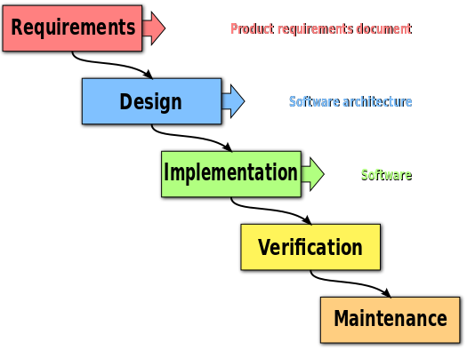
Figure 1: waterfall method process

System Implementation Process

3.3.1 Main menu
A good design of welcome page which is the main menu has a significant role in the whole system. When you first open the spreadsheet, a good main menu can tell you what you can do in this system. Figure 2 show the main menu^{[9]} of the Dental Hospital Management System, it clearly shows two subsystems of the system which are appointment system and invoice system.
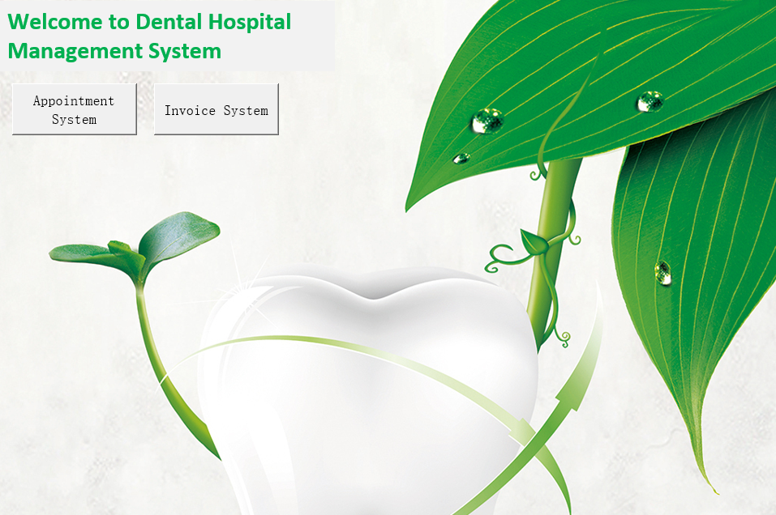
Figure 2: main menu of the system
When you enter into the appointment system or invoice system, you can see a navigation bar on the top of the page. Figure 3 shows the different functions in the navigation bar such as setup page where you can set initial data of the system, booking page where you input booking information into the system, availability page where you can check the room surplus condition, summary page where you can check all the booking information, main menu where you can go back to the initial menu of the system.
Figure 3: navigation bar of the system

3.3.2 Appointment System
For this system, employees or other users should be offered convenience to view vacant rooms and time slots for appointment. Also, a quick and simple operation of generating patient card with appointment time and personal details should be provided. However, initial data of the system should be set up before using. Figure 4 shows different data that need to be set up including calendar start period which can be set up manually or automatically by Excel’s function. Then, the situation of rooms for usage should be set up. Total number of the rooms are 15 which will be explained in the next pat. In addition, you can set different status of rooms such as booked, stayed, cancelled, booked buy moved and under reservation. Also, the limit number of rooms and different colour such as red, yellow, light green and green are used to show different condition of rooms availability. Here, red represents fully booked, yellow represents available rooms are less than three, light green represents available rooms are less than eight and green represents all rooms are available. Finally, peak and low season information and holiday information could be set to limit the time of scheduled rooms.^{[10][11]}
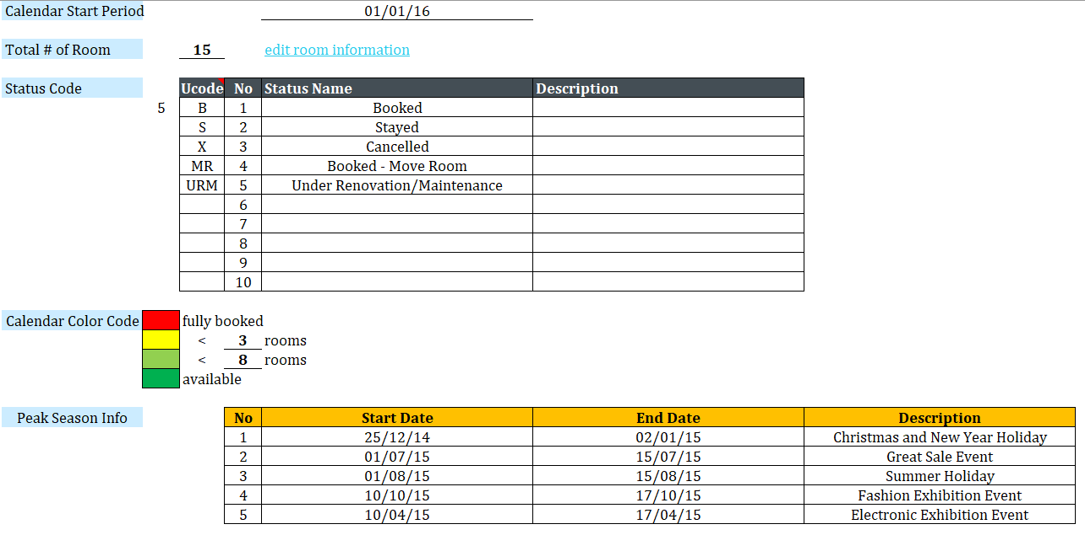
Figure 4: setup page of the system
In the room information page, Figure 5 shows different room types and amount of rooms, also, facility of the rooms has also been explained. Figure 6 shows the room number for different rooms.
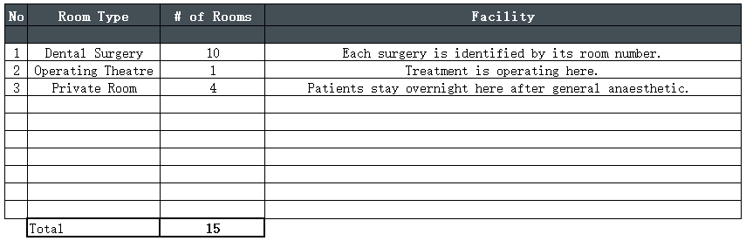
Figure 5: room type setting

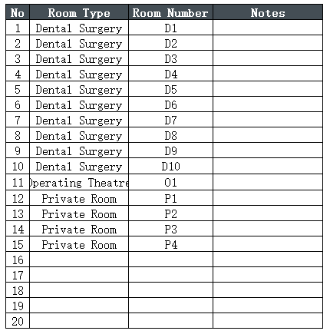
Figure 6: room number setting
Figure 7 shows the booking page of the system. On the top of the page you could check the number of the available rooms, and you could find the number of different types. How this part can show the real situation of available rooms lies on the bottom part of booking information. When employees input the appointment information of the patient, the occupation information will show in the table top. Also, different colours represent different condition of room availability. In the booking guest’s information table, you should type booking status of the guest’s reservation, length of stay, check in date and expected check out date. The information cell with a blue arrow must be filled to make appointment but the cell with a red arrow should not be filled because they will be generated automatically. On the right part of the page, you could find a drop-menu and button for generating appointment card. When you choose the specific booking code and click on the button, it will lead you to appointment card page.
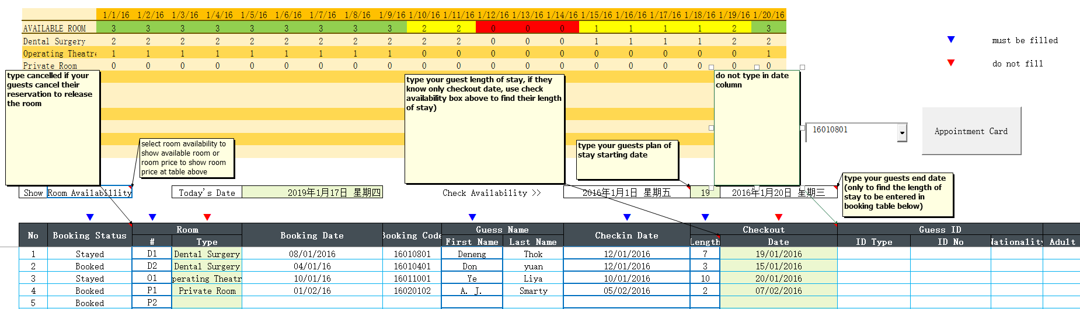
Figure 7: booking information page
Figure 8 shows the appointment card page of the system. In the page, patients’ details are all in the card as well as appointment details. Below the card are two optional buttons to operate the card generation system. Print button can help you print the detail card with the printer and clear button can help you clear the card with wrong or useless information and generate a new card.
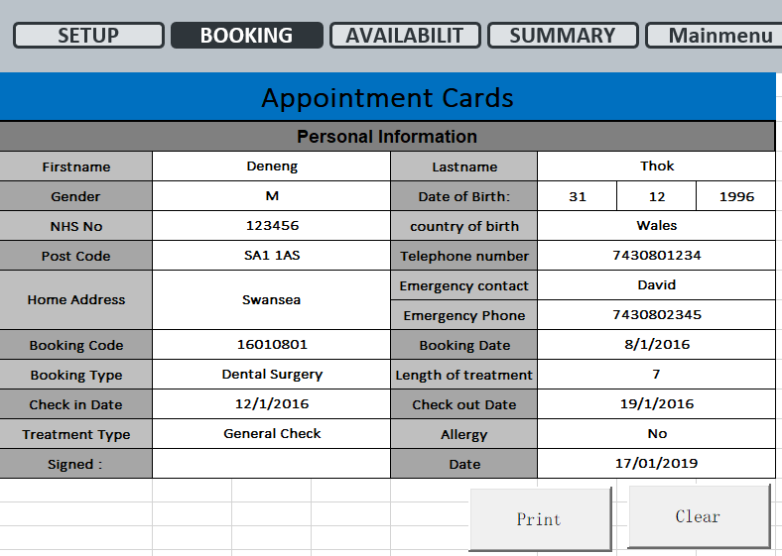
Figure 8: appointment card page
Figure 9 shows the room type availability page. From the page, you could check vacant room types for one month. For example, in the 15th of January, there are four rooms left in total including three dental surgeries and one private room. As a result, the colour for this day becomes yellow which means room crowding at the time. However, in other days you could find green and light green of the date which means there are ample rooms for usage.
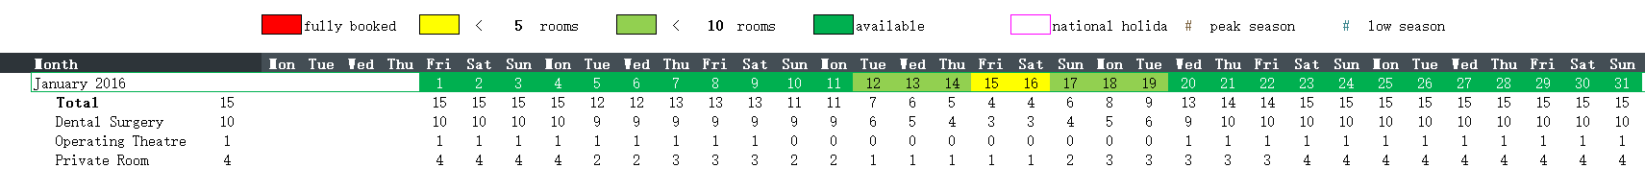
Figure 9: room type availability page
Figure 10 shows the room number availability page. From the page, you could see clearly whether this room is reserved in specific date and the name of patients is shown on the table too. Also, different colours are shown on the dates to represent congestion of appointment directly.
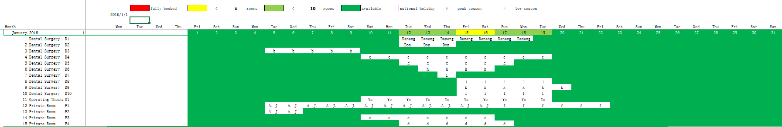
Figure 10: room number availability page
Figure 11 shows the all the patients information including booking relevant information, check in and out date and patients name, ID and contact details. On the table there is a drop-down menu, you can choose different month to see the patient’s information of that time.
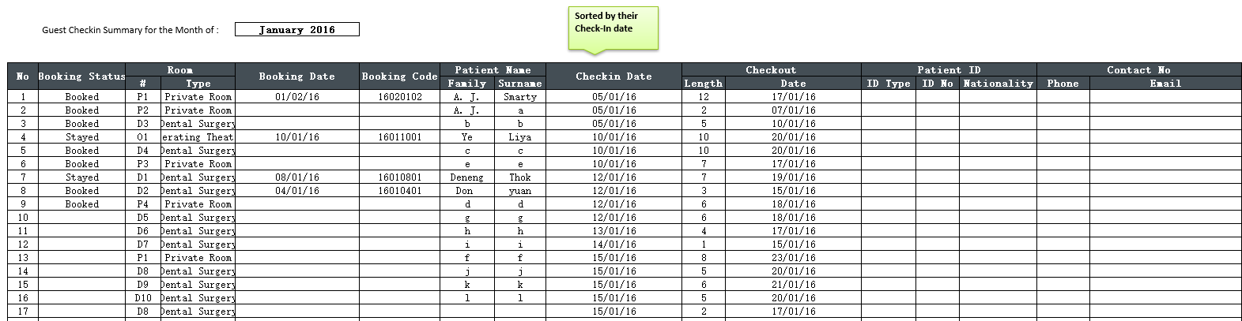
Figure 11: patients information page
In conclusion, appointment system includes basic functions and extended functions. Employees can simply set up initial data of the system and view available rooms and time slots. After typing in the detail of the patients, the table of available rooms will immediately show the decrease in the number of rooms. Also, you could check the availability of different rooms from two perspectives such as room types and room numbers. Finally, there is a table for recording all the details of appointment and patients which can be called a database of the patient information.

3.3.3 Invoice System
For invoice system^{[12]}, a designed invoice temple should be offered to help employees print out the invoices conveniently and quickly for patients and invoice details database should be set up to hold all the information of the patients. After extracting the information details of invoices, the invoice template should be cleared for next time usage which can improve work efficiency greatly.
Figure 12 shows the invoice template of the system. The invoice template clearly shows the patient details including name, address, telephone number and E-mail address. Figure 13 shows the drop-down menu which helps employees choose the right patient and it links to the database of patients, so that you do not have to type in the name of the patient, and you can get the rest information automatically. On the right, there are invoice date which has the function to show today’s date to reduce the type in work. Also, the invoice number should generate automatically to identify each invoice with unique number.
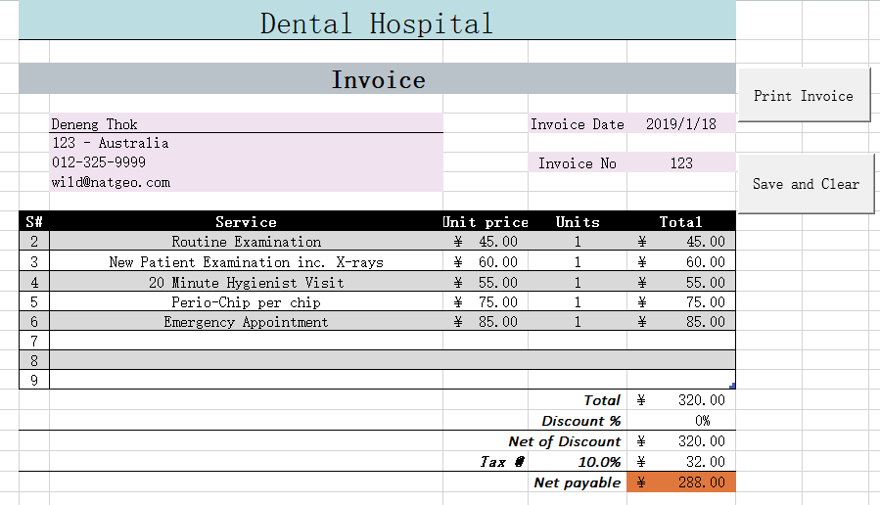
Figure 12: invoice system page
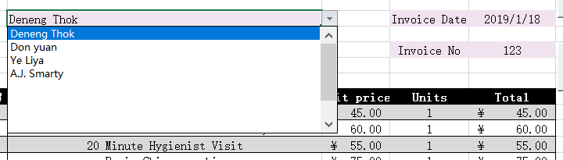
Figure 13: drop-down menu for choosing patients
On the below of the page is service details table with price, number and total amount. Figure 14 shows the drop-down menu which helps employees choose different services easily and the price can generate automatically, the employees just need to type in the units of service which may relate to the number of teeth need to be treated.
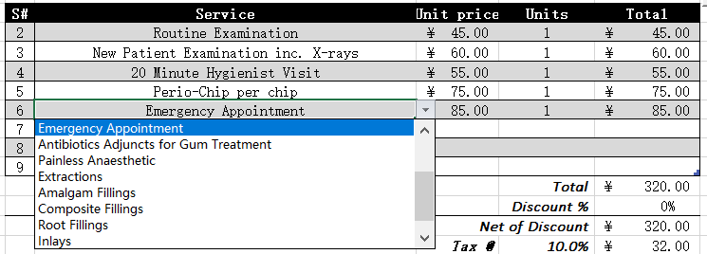
Figure 14: drop-down menu for choosing services
Figure 15 shows the services and price list page of dental hospital, and the page also gets a button to get back to invoice template. The treatment service usually decided by dentist, so the description of each service does not offer on the list for a clear view of corresponding relationship.
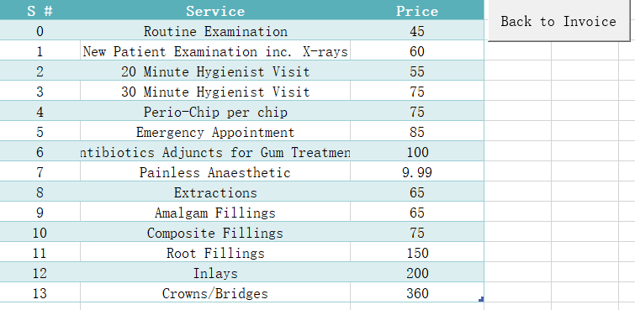
Figure 15: dental hospital services list
After filling in the contents and units of service, total amount of money will be calculated automatically. In addition, you can set different discount rate and tax rate to be calculated. In this example there is no discount but there is tax for 10%, the amount of tax can be calculated automatically, and net payable amount will show for patients’ reference. On the left of the template, there are two buttons. When click on the print invoice button, it will print the invoice automatically with your chosen printer. Figure 16 shows the printing process box. Figure 17 shows the printing setup page, it will only print selected area. Figure 18 shows the printing taskbar, you can check or cancel the printing task here.
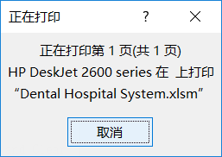
Figure 16: printing process box
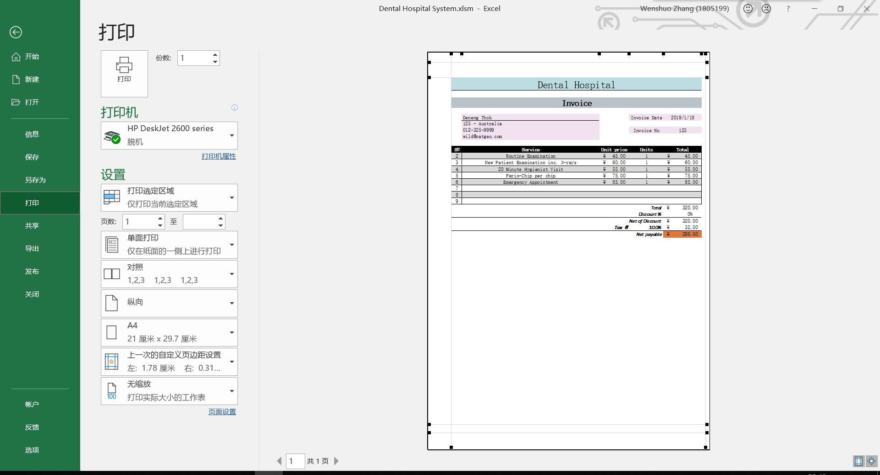
Figure 17: printing setup page
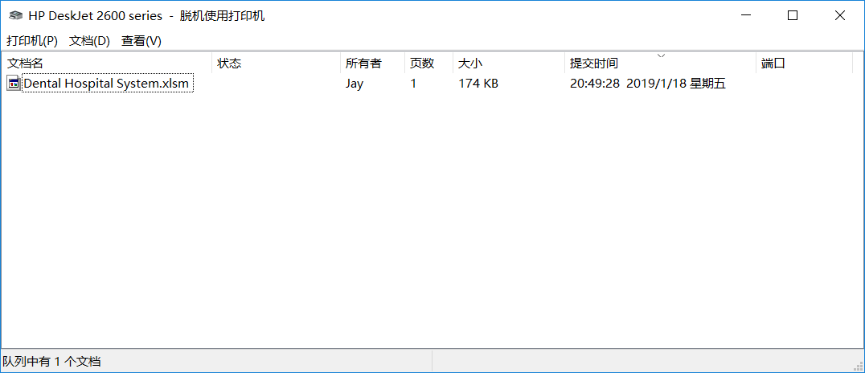
Figure 18: print task bar
After clicking on the save and clear button, the invoice details will directly save in the patients details database in the patient information page which hold the corresponding relationship between patient information, appointment information and invoice information.^{[13]} Figure 19 shows the database of patient details and employees could check all the information by month using the drop-down menu to choose different month.
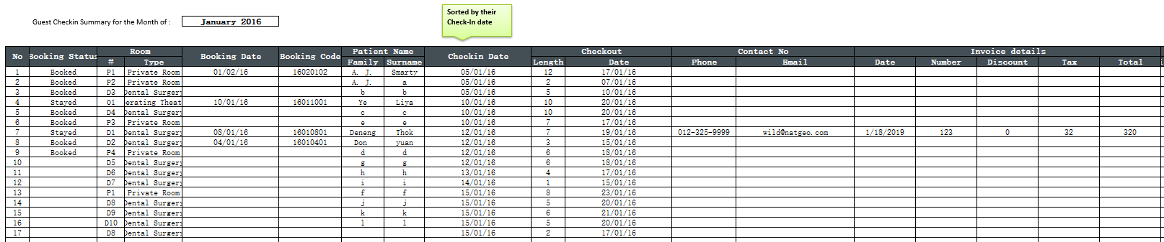
Figure 19: patients details database
After saving the invoice information into the details database, the invoice template will turn to blank like Figure 20 shows below. The employees can choose a new patient and his or her service to get a new invoice.
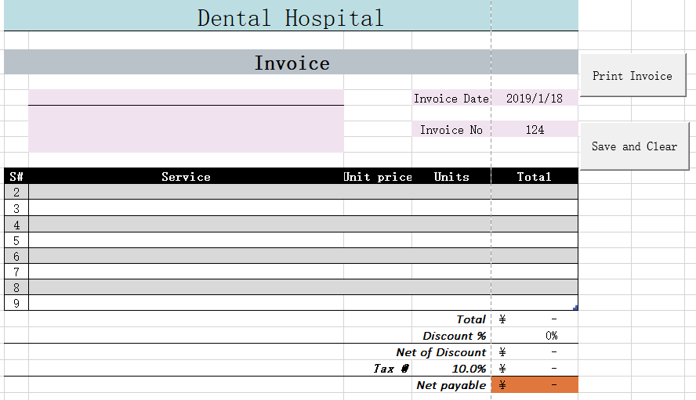
Figure 20: blank invoice template
In conclusion, invoice system includes basic functions and extended functions. Employees can simply print out invoices with designed template, many drop-down menus and automated computation functions are offered to bring convenience for users. After extracting and saving the invoice information to patient information database, the template will be cleared and ready for next set of information.

Analysis of Information System

Abilities of Information System
Information system^{[14][15]} has three main abilities including memory or information storage, thinking or information processing, communication or information communication. It is a summary and characterization of the generality of information system.
1. Information storage capability is one of the three basic capabilities of information system and the prerequisite of the other two capabilities. The memory of Excel system is divided into internal memory and external memory. Excel's system program is stored on the computer's hard disk which is external memory after running and installing to ensure that the system can run at any time. The data will not be lost after the computer shuts down or the Excel system shuts down. While in the internal memory of a computer, when the system is shut down or the computer is restarted, the corresponding data in the memory will be completely emptied.
2. The thinking ability of information system is the ability to process information, and it is the key to realize the system function. It is mainly embodied in the process of arithmetic operation, logic operation and flow control for the information input from outside or other modules, and gets certain results, and then derives the results in a certain form. Excel's data statistics and printing functions reflect this point.
3. There are some links between the operation of each sub-module in Excel system, and information is transmitted among the sub-modules through these links. The process of information exchange within the system is not only the process of information storage, but also the process of information processing. Exchange between Excel system and outside is mainly reflected in data import and export.

Suggestions for Improvement
Due to operating system errors, hardware failures, power outages and other unexpected reasons, such as Excel on the ongoing data operations did not save in time, will cause the loss of operational data and must be re-operated. In this case, Excel's memory ability can be improved to ensure the integrity of the operated data. A backup temporary data storage function sub-module can be set up in Excel system to temporarily store the operation data and update the data at any time according to the operation.
Statistical data need to see its trend of change, and the corresponding information processing module can be invoked to convert the data into specific charts according to the law of change of numbers. This is a fast way to highlight data trends (such as rising or declining in time) so that users can intuitively understand the changes in data.
In conclusion, Microsoft Excel gives business and people chances to experience convenience of information system. Before, people in enterprises need to be trained for a long time to get familiar with the information software and still need to spend a long time get used to it. Microsoft Excel does change the way that people deal with problem of information system.^{[16]} They do not need professional programming knowledge and skills to operate with Excel and they at least know some about Microsoft Office. After setting up in Excel, you can easily check statistics, calculate data, print invoice table and so on. With many features integrated in the software packages of Microsoft Office, different software has better connectivity and compatibility. Also, these information technology systems integrated with tools becomes more and more friendly to users and provide more solutions for users.

Conclusion
In conclusion, end user development offers great and useful tools and solutions for users without professional programming knowledge. According to the dental hospital system, both patients and employees can get simple operation for appointment and generate appointment cards. Then, employees can get full view of available rooms and timeslots from different perspectives. Also, patients’ personal information, appointment information and invoice information will all be recorded in to information database. Next, invoice system helps employees generate invoice with temple quickly and print out for patients. In the future, information system can offer more tools and solutions for users and will be improved by offering backup temporary data storage and statistical charts.

Reference
[1] Techopedia.com. (2019). What is End-User Computing (EUC)? - Definition from Techopedia. [online] Available at: https://www.techopedia.com/definition/11493/end-user-computing-euc [Accessed 14 Jan. 2019].
[2] University, M. (2019). What is Management Information Systems? | Mays Business School | Texas A&M University. [online] Web.archive.org. Available at: https://web.archive.org/web/20150509003228/http://mays.tamu.edu/info/what-is-mis/ [Accessed 14 Jan. 2019].
[3] Walkenbach J. Excel VBA programming for dummies[M]. John Wiley & Sons, 2013.
[4] Web.archive.org. (2019). ACC: Visual/Access Basic Is Both a Compiler and an Interpreter. [online] Available at: https://web.archive.org/web/20121021000129/http://support.microsoft.com/kb/109382#appliesto [Accessed 14 Jan. 2019].
[5] Fabio Paternò, “End User Development: Survey of an Emerging Field for Empowering People,” ISRN Software Engineering, vol. 2013, Article ID 532659, 11 pages, 2013. Available at: https://doi.org/10.1155/2013/532659.
[6] Sarkar A, Blackwell A F, Jamnik M, et al. Teach and try: A simple interaction technique for exploratory data modelling by end users[C]//Visual Languages and Human-Centric Computing (VL/HCC), 2014 IEEE Symposium on. IEEE, 2014: 53-56.
[7] Definitions, S. and Hope, C. (2019). What is a Spreadsheet?. [online] Computerhope.com. Available at: https://www.computerhope.com/jargon/s/spreadsheet.htm [Accessed 21 Jan. 2019].
[8] Idinews.com. (2019). Waterfall Methodology: There's no such thing!. [online] Available at: http://www.idinews.com/waterfall.html [Accessed 21 Jan. 2019].
[9] Airweb.org. (2019). Creating an Excel Menu Worksheet. [online] Available at: https://www.airweb.org/eAIR/techtips/Pages/Excel-Menu-Worksheet.aspx [Accessed 21 Jan. 2019].
[10] Cayirli T, Veral E, Rosen H. Assessment of patient classification in appointment system design[J]. Production and Operations Management, 2008, 17(3): 338-353.
[11] Wiki.openmrs.org. (2019). Appointment Scheduling Module - Documentation - OpenMRS Wiki. [online] Available at: https://wiki.openmrs.org/display/docs/Appointment+Scheduling+Module [Accessed 21 Jan. 2019].
[12] Hill, J. (2019). Disruptive Innovation Part 2: Invoice Processing Software. [online] UFC, Inc. Document Scanning and Forms Processing Software. Available at: https://www.ufcinc.com/BLOG/Document-capture/Disruptive-innovation-part-2-invoice-processing-software [Accessed 21 Jan. 2019].
[13] Learnline.cdu.edu.au. (2019). The INVOICE Database. [online] Available at: http://learnline.cdu.edu.au/units/databaseconcepts/module1/popups/invoicedb.html [Accessed 21 Jan. 2019].
[14] Laudon K C, Laudon J P. Management information systems[M]. Prentice Hall, 2015.
[15] Beaven D F. Processing management information: U.S. Patent 8,095,413[P]. 2012-1-10.
[16] Management Information Systems. (2019). What is MIS?. [online] Available at: https://mis.eller.arizona.edu/what-is-mis [Accessed 21 Jan. 2019].

