

BMIH6007
International Meetings Management
for
the Hotel Industry

LEVEL 6

Student Name: Elena Coanca
Student Id:2026753
Slide 1
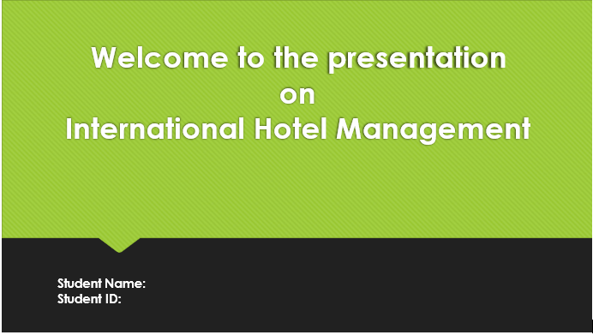

Slide 2
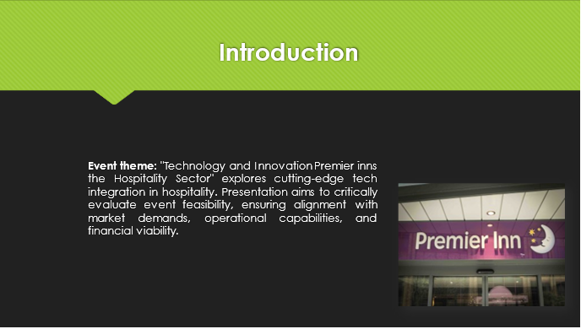
"Technology and Innovation Premier inns the Hospitality Sector" looks at the hotel industry's most cutting-edge innovations in technology. This event looks closely at how modern technology can be seamlessly incorporated to improve the experiences of guests, optimize processes, and spur new ideas in service delivery. It is the main goal of the show to carefully think about the possibility that this event is possible, making sure that it works with the evolving requirements of the market, and the practical and financial success of the planned venture. By looking closely at these important parts, we hope to find out how successful the event might be and how much value it can bring to everyone involved. We look at market trends, practical needs, and economic projections in tremendous detail to find ways to lower risks, take advantage of opportunities, and ultimately produce an epic event experience. Our devotion to strategy planning and thorough feasibility studies shows that we want to provide outstanding event management and promote new ideas in the hospitality sector.

Slide 3
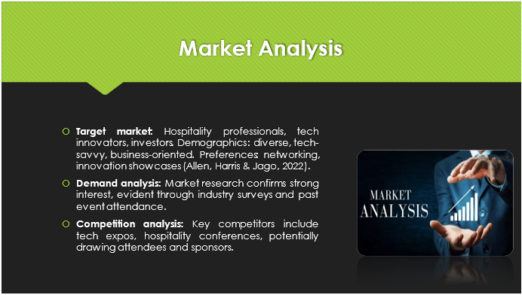
"Technology and Innovation Premier inns the Hospitality Sector" is aimed at people who work in the hospitality industry and want to remain up to date on new developments, tech entrepreneurs who want to demonstrate their newest goods, and investors who want to find profit possibilities within the sector. People in our group come from a wide range of backgrounds and are tech-savvy with a strong focus on business growth (Allen, Harris & Jago, 2022). They like imaginative shows and networking events where they can make useful links while discovering new ways to solve problems.
Based on market research results and attendance data from similar events in the past, demand analysis indicates there is plenty of interest in our event. Industry studies have shown that there is a growing desire to employ technology in the hotel industry. This has made people in the industry extremely enthusiastic about our event.
There are already tech expos and hotel conventions that compete with our event. These events attract similar types of individuals and give similar material. But by providing a special mix of technological advances and novel concepts designed just for the hospitality industry, we hope to stand out and get the interest of both guests and possible sponsors (Fox et al., 2014).

Slide 4
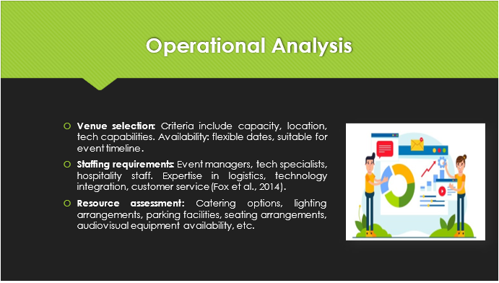
"Technology and Innovation Premier inns the Hospitality Sector" venue decision depends on several significant variables that must be met for the event to go well. First, the place needs to be sufficient to fit all the hotel workers, tech creators, and investors we expect to arrive shortly. Location is also very important, with central places that are easy for commuters to get to and have transportation links given favour. The venue's technological amenities are also very important because we want to show off the latest developments in a good setting (Getz & Page, 2019).
Availability is also very important, so being able to change the dates is very important so that everything works out with our event schedule and logistics. This makes sure that the preparations and carrying out of the event go effectively, without reducing its quality or importance.
Staffing needs include a wide range of skills for effectively managing different parts of the event. This includes organizers who are good at organizing planning, tech experts who are good at putting technology solutions together and solving problems, and hotel staff who are dedicated to giving great customer service (Madray, 2020).
Resource evaluation includes looking at different food options to accommodate different dietary needs, making sure there is enough lighting for everyone to see, making sure there are plenty of places to park for attendees, setting up chairs so they are comfortable and easy to get to, as well as making sure there is videoconferencing equipment available for presentations and examples. All of these factors work together to make our event a good place for social media, learning, and coming up with new ideas.
Slide 5
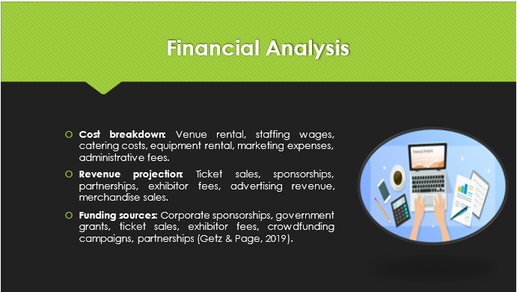
"Technology and Innovation Premier inns the Hospitality Sector" costs are broken down into several distinct categories. The venue rental costs a lot, and then there is the pay of the staff who are going to make sure all that runs smoothly during the event. The cost of catering includes food and drinks for all guests, and the cost of renting equipment contains the gadgets and multimedia tools required for talks and demos. Marketing costs are essential to encourage people to come to the event, and administrative costs include a variety of costs related to planning and running the event (Meredith, 2022).
The event's revenue calculation includes a variety of sources of income to make sure it can be paid for. People who buy tickets and sign up for the festivities should bring in money, and companies that desire to show off their products and services to our target group will also sponsor the event. Along with booth costs and advertising income, partnerships with appropriate organizations can bring in extra money. You can make money through branding goods and promotional items sold at merchandise sales.
For the event's funds, we plan to get funding from companies, apply for government grants, and make funds through selling tickets, charging exhibitors fees, and crowdsourcing efforts. Partnerships with people in the business sector can also help with money, making sure that there is enough to pay for the event and give guests a unique experience (O'Toole, 2011).
Slide 6
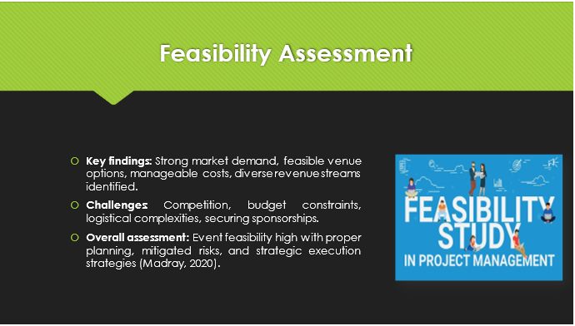
Key results from the feasibility study for "Technology and Innovation Premier Inns the Hospitality Sector" show signs that the event will be a success. Based on market study and industry trends, it's clear that there is a lot to explore in the event's theme. Feasible site options give organizers options for how to accommodate guests, and reasonable prices make sure the celebration can be paid for. Ticket sales, donations, and relationships are just a few of the different ways that you can make money over time.
But some problems need to be fixed before the event can go off without a hitch. Problems like competing with other similar events, financial constraints, tricky logistics, and getting support are significant issues requiring careful thought and planning (Rogers & Wynn-Moylan, 2022).
Even with these problems, the general opinion on the event's viability is still good. The event is set up to succeed with meticulous preparation, risk-reduction tactics, and smart execution. We are sure of our ability to provide a high-quality event journey that fulfils the wants and demands of our intended demographic by facing major challenges head-on and taking full advantage of established chances (Thommandru et al., 2023).
Slide 7
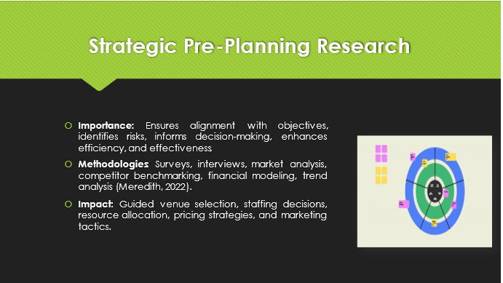
A strategic pre-planning study is very important to the achievement of "Technology and Innovation Premier Inns the Hospitality Sector" because it makes sure that event goals are met, uncovers potential hazards, helps with decision-making, and improves general efficiency and effectiveness. Utilizing a range of methods including polls, interviews, market analysis, rival benchmarking, financial modelling, and trend analysis gives an in-depth understanding of how the marketplace works and what attendees want.
Guided site selection is an excellent instance of how this study has helped people find good places for events that fit the theme as well as meet their practical needs (Rogers & Wynn-Moylan, 2022). It also makes it easier to hire the right people by showing what skills and knowledge are needed for the smooth management of events. The best use of resources is made to ensure, making certain that the food, lights, parking, chairs, and multimedia tools meet the needs of the attendees. Also, study results are used to improve price and advertising techniques, which increases the event's reach and success potential.
Slide 8
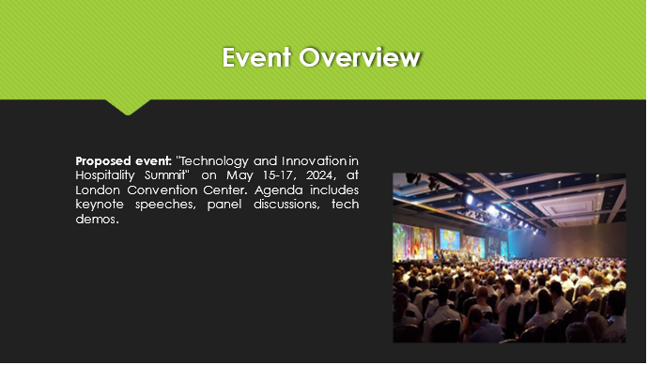
"Technology and Innovation in Hospitality Summit," an event that is planned for May 15–17, 2024, at the prestigious London Convention Center, aims to bring together leaders in the hospitality sector, tech innovators, and hospitality pros for three days of thought-provoking lectures and demonstrations. The schedule includes major talks from key figures, exciting group discussions about new issues and trends, and hands-on tech demos showing off the latest developments that are changing the hotel industry (Smith, 2012). People who go can look toward networking, sharing information, and working together in manners that have never been seen before. This will help drive innovation and bring the industry forward. With a focus on using technology to enhance the surroundings for guests, ease processes, and boost the growth of the company, this conference appears that it will be an unforgettable experience for everyone involved.
Slide 9
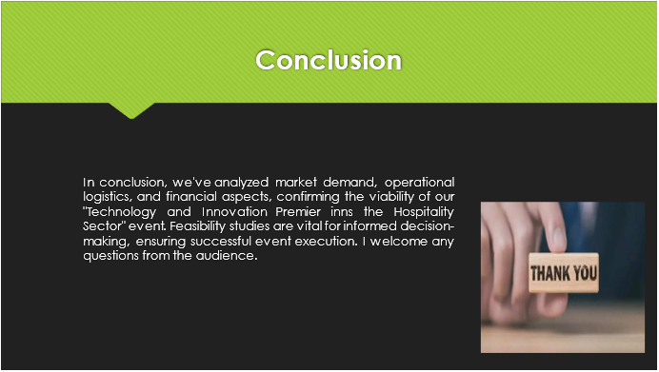
In conclusion, the in-depth study of market demand, practical duties, and financial factors shows that the "Technology and Innovation Premier inns the Hospitality Sector" event may occur. It is very important to do feasibility studies so that you can make smart decisions, lower risks, and make sure the event goes well. We've found that the event will be successful if there is strong business interest, workable operating plans, and a variety of ways to generate money. As the planning process goes on, we are still dedicated to organizing a top-notch event that meets the requirements and desires of every guest and partner. Thank you for listening. Now I'm ready to take any questions from the crowd.

Slide 10
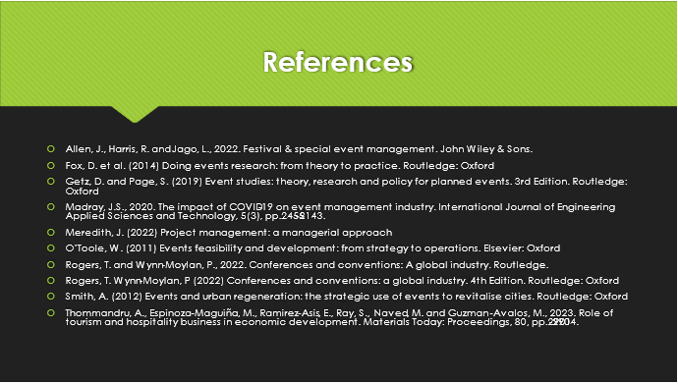Allen, J., Harris, R. and Jago, L., 2022. Festival & special event management. John Wiley & Sons.
Fox, D. et al. (2014) Doing events research: from theory to practice. Routledge: Oxford
Getz, D. and Page, S. (2019) Event studies: theory, research and policy for planned events. 3rd Edition. Routledge: Oxford
Madray, J.S., 2020. The impact of COVID-19 on event management industry. International Journal of Engineering Applied Sciences and Technology, 5(3), pp.2455-2143.
Meredith, J. (2022) Project management: a managerial approach
O’Toole, W. (2011) Events feasibility and development: from strategy to operations. Elsevier: Oxford
Rogers, T. and Wynn-Moylan, P., 2022. Conferences and conventions: A global industry. Routledge.
Rogers, T. Wynn-Moylan, P (2022) Conferences and conventions: a global industry. 4th Edition. Routledge: Oxford
Smith, A. (2012) Events and urban regeneration: the strategic use of events to revitalise cities. Routledge: Oxford
Thommandru, A., Espinoza-Maguiña, M., Ramirez-Asis, E., Ray, S., Naved, M. and Guzman-Avalos, M., 2023. Role of tourism and hospitality business in economic development. Materials Today: Proceedings, 80, pp.2901-2904.

