

Module Code: LCMB7023
Module Name: Human Capital Management
Title: The Influence of National and International Labour Markets on HRM and IHRM Strategies

Student Name: Md Alamin
Student ID:2434280
Lecturer: Gladius Kulothungan

Word Count: 2737
Date of Submission: 14th November, 2025

Executive Summary
This report discusses the impact of global technological and demographic trends that are changing labour markets and altering the Human Resource Management (HRM) approaches. It points to the fact that automation and Artificial Intelligence (AI) are replacing and generating jobs at the same time, and digital platforms are fueling flexible gig-based employment. Consequently, HRM is transforming through AI-driven recruitment, lifelong reskilling, and hybrid working setups. Demographic and geopolitical changes that necessitate HR professionals to address compliance, diversity and mobility issues are ageing, migrations, and political unrest. Also, the report discusses how strategic HRM applications of the build, buy and borrow/bind strategies have been used to close the endemic skills shortages in the technology, healthcare and hospitality sectors. Finally, the reflective section shows how the most significant adaptive skills are to be honed, i.e. digital literacy, cross-cultural collaborative work and self-directed learning, to emerge a successful employee in a dynamic, globalised workplace environment. The general conclusions are that agile, inclusive, and technology-driven strategies should be used by HR and business leaders in the future to stay competitive.
Table of Contents
Introduction 4
Analysis of Technology and Labour Market for HRM and IHRM Strategies 5
Technology and Labour Markets 5
Implications for HRM and IHRM Strategies 7
The key Demographic and Geopolitical Factors Influencing Employment Markets 8
Major Demographic Factors 8
Major Geopolitical Drivers 9
Challenges Facing HR Professionals 10
Addressing Persistent Skills Gap and Talent Shortages 11
Root Causes of Skills Deficits 11
Strategic HRM Solutions 11
Sector-Specific Illustrations 12
Reflective Report on Capabilities in International Context 13
Conclusion 17
References 18
Appendix – SWOT Analysis 21

1.0 Introduction
The labour markets and Human Resource Management (HRM) is being redefined as never before by the digital transformation and globalisation (Hegedűs, 2020). The nature of the jobs, and the skills required are not only changing due to related new technologies such as automation, artificial intelligence and data analytics. Meanwhile, the demographic shifts, immigrant trends, and political instability on a global scale are influencing the global workforce dynamics. All these make organisations reconsider their HRM and International HRM (IHRM) approaches to guarantee workforce flexibility, competitiveness, and inclusivity. This report discusses the effects of technological, demographic and geopolitical forces on labour markets and looks at the HR response required to ensure that such forces are effectively handled in both the domestic and international labour markets.

2.0 Analysis of Technology and Labour Market for HRM and IHRM Strategies
The section addresses how labour markets are being transformed due to the development of technologies like the AI, automation, and online platforms, and how these strategies are shifting HRM and IHRM approaches to managing talent, skills, and workforce planning.

2.1 Technology and Labour Markets
Automation & AI: Job Loss vs. Job Creation: Robotic process automation (RPA) and artificial intelligence, as well as machine learning, are making routine and repetitive work less frequent. Statista (2017) estimated that 73 million jobs will be eliminated to automation, mostly in administrative, manufacturing, and financial-processing sectors. More than 40 per cent of businesses are creating jobs that have never existed within the past five years because of automation. StellarTech Ltd. is faced with high turnover because the company does not develop leadership, and, therefore, automation may assist in lowering the administrative workload and enabling HR to work on staff engagement and career paths.
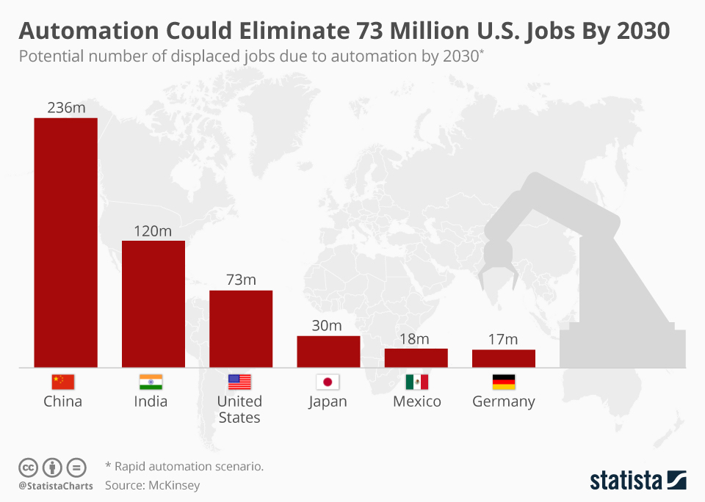
Figure 1: Estimated Job Elimination by Automation and AI
Source: (Statista, 2017).
Skills Churn & Declining Half-life of Skills: The World Economic Forum (2022) claims that half of the existing job competencies will be outdated by 2027. Traditional competencies that are task-based are being substituted by digital literacy, AI proficiency, and data interpretation. Various technology firms like Amazon launched an initiative to invest 1.2 billion in training 300,000 workers in cloud and automation by 2025.
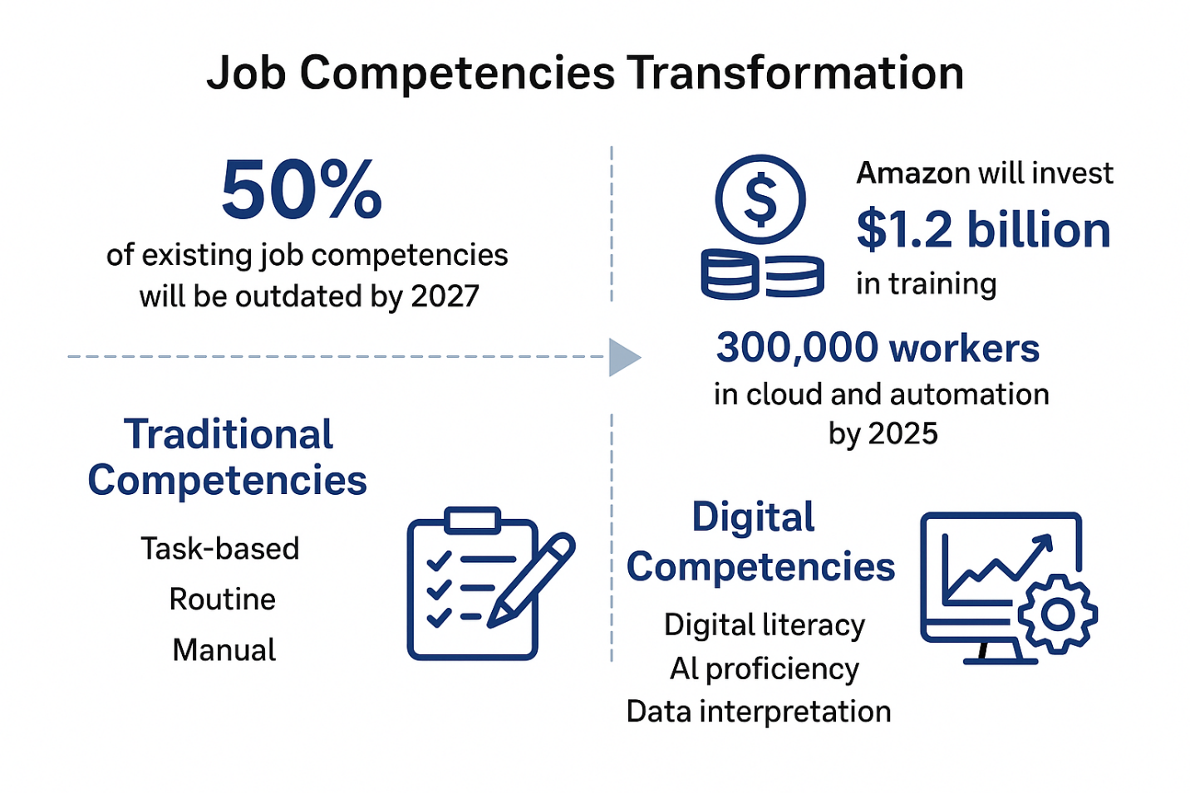
Figure 2: Job Competencies Transformation
Source: (The World Economic Forum, 2022)
Digital Platforms & Gig Economy: Flexible work arrangements have been enabled by technology via Uber, Fiverr, and Upwork. In 2023 alone, gig workers in the UK had grown to 4.4 million, which is a 41% growth since 2016 (CIPD, 2023). This change puts a strain on traditional employment, lowering organisational commitment but improving access to global talent. In FinServe Bank (case study), the investigation of outsourcing and AI-driven HR systems was conducted in order to save on costs, which demonstrates how organisations can use technology to tap into global labour at a lower cost of operation.
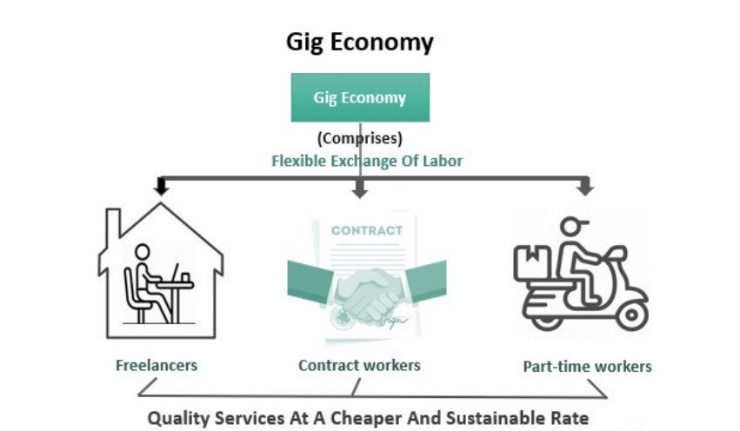
Figure 3: Gig Economy
Source: (Peak Frameworks Team, 2023)

2.2 Implications for HRM and IHRM Strategies
Talent Acquisition (AI-enabled hiring): Recruiting tools like HireVue and LinkedIn Talent Insights are AI-based recruitment tools that will screen and match job applicants to job profiles based on predictive analytics. Brynjolfsson (2014) discovered that companies that recruit with the help of AI save up to 35% on the time spent on hiring. In the case of TechNova Solutions (case), the application of AI-based recruitment may help to decrease 30 per cent of turnover in R&D by making skills and jobs more aligned.
Learning & Development (Continuous Reskilling): The HR departments should focus on micro-learning, digital badges, and individual learning journeys. IBM applies AI-driven personalised training with Your Learning Platform that leads to a 60 per cent faster rate of skills acquisition. Moreover, GreenHarvest Ltd., which shifted its personnel management to HRM, would be able to implement digital upskilling to increase employee engagement and decrease dissatisfaction.
Strategic HR Planning & Workforce Blending: Organisations are now adopting hybrid staffing (full-time + gig + remote). According Graham and Hjorth (2023), 58 per cent of organisations employ gig workers to undertake specialised digital projects. HRM and IHRM should thus anticipate new skills and overcome global labour laws like GDPR in handling offshore gig workers.

3.0 The key Demographic and Geopolitical Factors Influencing Employment Markets
This section critically analyses the major demographic and geopolitical dynamics influencing the labour markets across the world and discusses the subsequent implications of the same on the HR professionals, both in the domestic and international environments.

3.1 Major Demographic Factors
Ageing Populations: The issue of the ageing workforce is a menace that is haunting most developed economies such as Japan and some of the European Union countries. The numbers of Japanese above the 65 years are 28 per cent and the labour force is fading with the dependency ratios rising (PwC, 2023). For example, the phased retirement and reverse mentoring programme of the Siemens AG in Germany to retain the knowledge of the older generation and not lose it to the younger generation who are transferring the same knowledge to them.

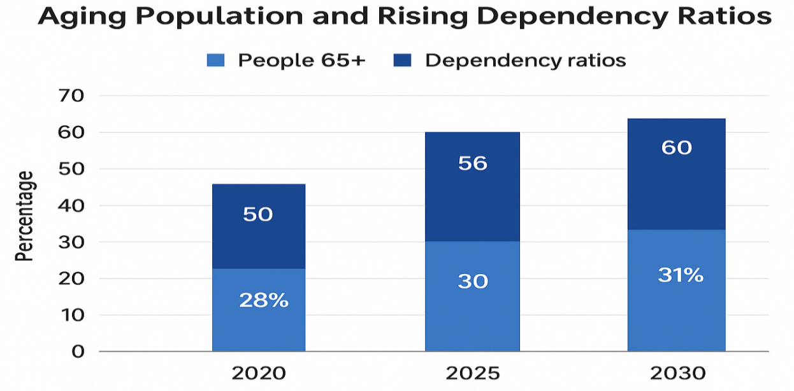

Figure 4: Ageing Populations and Rising Dependency Ratios
Source: (PwC, 2023)
Shifting Migration Trends: The world migration trends are still restructuring the labour market. According to the OECD (2024), in 2022, the UK's net migration was 745,000, with demand in the human resource sector and technology. This inflow solves the problem of skill deficits but raises HR complexity in onboarding and cross-border compliance. In the case of home countries, like India and the Philippines, brain drain has become a problem since the skilled professionals have moved to countries with high income.
Growing Workforce Diversity: The increase in cultural and ethnic diversity requires hiring practices that are inclusive (Pless and Maak, 2024). Organisations that hire a diverse team of leaders are 39 per cent more likely to succeed financially. On the one hand, Unilever created its Unstereotype programme to enhance inclusion and fair access to opportunities in its 150 markets worldwide. Furthermore, StellarTech Ltd. would consider implementing inclusion training and cross-cultural communication initiatives to increase cohesion between its multinational teams.

3.2 Major Geopolitical Drivers
Trade Wars and Protectionism: The global supply chains have been disrupted by trade disputes, especially between the US and China, which have made firms reconsider recruitment hubs. An example is Apple Inc., which transferred part of its production to Vietnam and India, which affected the HR's role in the workforce relocation, local hiring, and compliance.
Political Instability and Sanctions: Expats are made difficult by political instability and sanctions. The conflict between Ukraine and Russia made a lot of European companies close down, send back workers and shift their functions to areas that were not unstable (Prohorovs, 2022). HR departments like those of BP and Shell needed to deal with the emergency evacuations and reemployment assistance to displaced employees.
Pandemics and Global Health Crises: COVID-19 increased the pace of digital transformation and the acceptance of remote work. Gartner (2022) discovered that 80% of the companies launched hybrid models after the pandemic. In the case of StellarTech Ltd., the flexibility and resilience of a company require the use of digital collaboration tools to ensure that productivity is not affected.
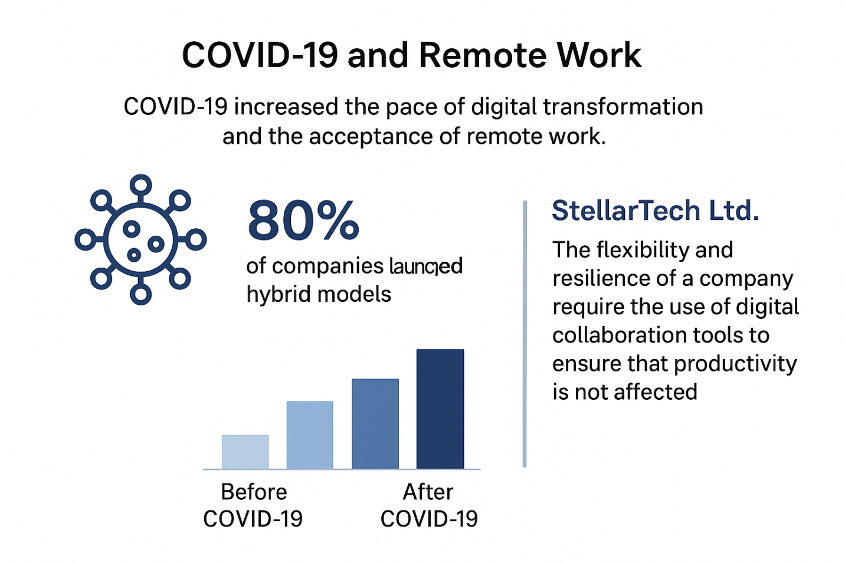
Figure 5: Covid-19 and Remote Work
Source (Gartner, 2022)

3.3 Challenges Facing HR Professionals
There are various challenges that are facing by HR professionals in the work place which are following:

Figure 6: Challenges Facing by HR Professionals
Source: (Self-Made)
Talent Mobility: The mobility of talent across the world is limited by the changing visa and immigration policies. HR managers should make sure that they do not violate the local labour laws and that they support the cross-border employees.
Risk Management: HR departments are becoming more involved in risk management and the safety of employees (Becker and Smidt, 2023). Companies such as IBM have devised global duty-of-care systems, which can respond quickly in case of geopolitical instability or a pandemic.
Compliance and Cultural Integration: The fact that it is an organisation that operates in various jurisdictions necessitates that HR maintains awareness of diverse employment legislation (Shen and Chanda, 2024). Besides, cultural integration in dispersed teams, such as in the case of StellarTech Ltd., can only be managed by specific communication strategies and leaders' development to create a common organisational identity.

3.4 Addressing Persistent Skills Gap and Talent Shortages
This section focuses at the issue of the long-standing skills gaps in key areas and how strategic HRM can utilise strategies of build, buy, borrow/bind to eliminate such gaps using actual organisational examples.

Root Causes of Skills Deficits
The main cause of skills shortages is the increasing rate of technological change. IBM reports that the half-life of technical skills is reducing to approximately 2.5years, which results in an increasingly large discrepancy. The misalignment of educational industries adds to the problem: in the US, one out of every three workers does not have basic digital skills, although 92% of all jobs demand such skills (Cappelli, 2008). It is also caused by low investment in learning and development: approximately 69 per cent of employers confirm that skills gaps have detrimental effects on productivity.

Strategic HRM Solutions
Build Strategy (Develop internally): Organisations may invest in internal learning ecosystems, for example, the AI startup StellarTech Ltd. may roll out an in-house AI bootcamp and corporate academy to reskill the current staff in machine learning and data engineering. This type of build strategy lowers the rate of external recruitment and aligns the skills with the strategic objectives. In technology, research indicates that 79 per cent of organisations have focused on skill gap efforts.
Buy Strategy (Recruit externally): Strategic purchasing of talent can be done by businesses when they have no internal capacity to fill desperate vacancies. For example, technology firms are in a cutthroat competition: 7 out of 10 technical employees have received numerous jobs offers in the recent past. Cross-border recruitment of nurses and other allied health professionals is a usual practice in the healthcare field that there will be 100,000 US healthcare workers short by 2028 (Mercer, 2024).
Borrow / Bind Strategy (Leverage and retain): Borrow strategies involve the external talent (like freelancers, consultants or gigworkers) to fill temporary vacancies like StellarTech might engage specialist AI consultants on projects whilst developing internal talent. The strategies of bind are aimed at retention: mentorship, job rotation, career path, and learning culture all contribute to retaining the talent that you invested in.

Sector-Specific Illustrations
Technology Sector: According to an EU study, the gap in tech talent will be between 1.4 to 3.9 million in 2027, and a dual workforce approach is a pressing necessity (Shen and Chanda, 2024). Companies are moving towards a build and borrow strategy- investing in the skills development of local talent through the use of coding bootcamps, but hiring specialised AI develops to fill immediate skill gaps and ensure a continuous flow of innovation.
Healthcare Sector: The global shortage of healthcare workers by 2030 will be at least ten million (Bruckner and Scheffler, 2024). To respond to this, health systems are putting emphasis on buy strategies by recruiting internationally and bind strategies that are more retention-oriented. These involve enhancing the working environment, provision of clear career development and emotional and professional support to enhance workforce sustainability.
Hospitality Sector: Hotel groups are also focusing on build strategies such as management development programmes to produce future leaders within the company in the face of long-term labour shortages. In parallel, the high level of employer branding and competitive incentives are the elements of buy strategies that attract the rare talent and strengthen the long-term loyalty to the organisation.

4.0 Reflective Report on Capabilities in International Context
Technological flexibility, inter-cultural communication, teamwork, leadership, and sustained learning are needed in the international tourism labour market to provide employees with exceptional service delivery in the rapidly evolving global settings. Through the Reflective Model of Gibbs, I will be able to reflect on the progression of these skills and my ability to perform well in tourism positions worldwide.
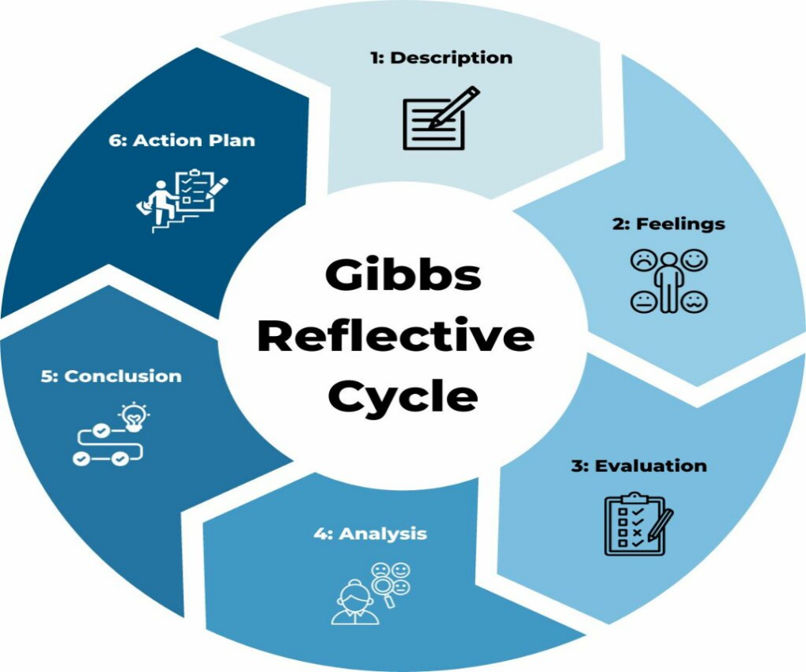
Figure 7: Gibbs Reflective Cycle
Source: (Channell, 2023)
1. Description
In this MBA module, I was engaged in a project that examined the issue of labour market in international tourism organisations. The assignment involved cooperation with teammates of other nationalities, which was coordinated by MS Teams, analysing tourism employment statistics by using Excel, and assistant AI applications like ChatGPT to help the research. My task was to put together the final report and present the trends in tourism workforce, such as global shortage of staff and the growing popularity of HR technology in the hiring process.
2. Feelings
I was also initially confident due to the experience that I had in the tourism sector, especially in terms of handling multi-national travellers. Nevertheless, I was also unsure of my skills in using advanced data analysis tools and becoming a leader of a diverse academic environment. I feared that the cultural differences in communication would cause misunderstanding when working in teams.
3. Evaluation
This experience in the tourism sector helped me to feel relaxed when I dealt with other multicultural colleagues just like tourism employees engage with tourists who may be of different cultural backgrounds. Scheduling meetings with MS Teams and labour data analysis with Excel helped us to become efficient. Nonetheless, I did identify a weakness such as I was not outspoken when it came to exercising leadership, especially when confronting conflict situations, a situation that would at times slow down the making of decisions. Timely decision-making is paramount in international tourism working capacities particularly in responding to time sensitive customer demands.
4. Analysis
In the international tourism labour market, this project showed that employers place importance on digital fluency, cross-cultural confidence, and online and cross-time-zone collaboration. The World Tourism Organisation (UNWTO) reports that organisations in the tourism sector are favouring employees who have technology competency and self-directed learning skills. This requirement is in line with my strengths such as good communication, flexibility and autonomous learning. I personally investigated such trends as AI-based booking systems and online interactions with customers, which complemented our project. Nonetheless, leadership is one of the areas to be developed. Tourism environments tend to demand hasty and aggressive decision-making particularly in unforeseen circumstances such as customer complaints or travel policy changes. My reluctance to be a leader can potentially restrict my capability to lead in an international team.
5. Conclusion
I possess great potentials in communication, technology application, and self-directed learning that meets the changing needs of tourism across the world. However, to excel in the leadership positions in multinational tourism organisations, I need to enhance my confidence in decision making.
6. Action Plan
Area | Strength | Weakness | Evidence | Improvement Plan
Technology | Proficient in using MS Teams, Excel, and AI tools for research and collaboration | Need to improve advanced data analytics and visualization for interpreting global tourism trends | Tourism labour market project and final report analytics | Enrol in a certified course on data analytics and visualization such as Power BI or Tableau by March 2026
Communication | Strong cross-cultural communication and empathy developed through interaction with international teammates | Occasionally face difficulty in maintaining clarity and assertiveness during online discussions | Peer and tutor feedback during group project meetings | Practice structured and concise communication through weekly reflections and professional writing workshops
Teamwork | Cooperative and adaptable when working with diverse groups | Hesitant to address disagreements or conflicts directly | Reflective log on project teamwork experience | Attend workshops on conflict resolution and negotiation skills to handle multicultural team challenges confidently
Leadership | Supportive and empathetic when guiding teammates | Lack of confidence in leading decision-making during high-pressure situations | Group project experience with delayed decision outcomes | Join a mentorship or leadership development program and apply RACI chart and prioritisation tools in next MBA group project
Self-Directed Learning | Self-motivated learner and adaptable to new technologies | Struggle with managing time effectively under tight academic and project deadlines | Learning diary and project submission feedback | Implement SMART goal-setting and use digital planning tools such as Trello, Notion to improve time and task management

This action plan will assist me in my transition towards becoming a leader in international tourism labour market.

Conclusion
The global labour markets are all being redefined by technological advancement, demographic change and geopolitical changes. To survive in the future, the HRM strategies should be transformed to accommodate AI-based recruiting, life-long learning, and the hybrid workforce. The HRM strategic approaches entail build, buy, and borrow/bind approaches that are very crucial in addressing skills deficits which is rampant in most industries. In addition, HR professionals should ensure that they strike a balance between global mobility, compliance and diversity priorities in order to ensure organisational agility.

References
Becker, K. and Smidt, M. (2023). A risk perspective on human resource management: A review and directions for future research. Human Resource Management Review, 26(2), pp.149–165. doi:https://doi.org/10.1016/j.hrmr.2015.12.001.
Bruckner, T. and Scheffler, R. (2024). Global Health Workforce Labor Market Projections for 2030. Human Resources for Health, 15(1). doi:https://doi.org/10.1186/s12960-017-0187-2.
Brynjolfsson, E., (2014). The second machine age: Work, progress, and prosperity in a time of brilliant technologies (Vol. 236). WW Norton Company.
Cappelli, P. H. (2008). Talent on Demand: Managing Talent in an Age of Uncertainty. Harvard Business Press.
Channell, M. (2023). Gibbs Reflective Cycle – How to Learn from Experience and Become a Better Leader. [online] TSW Training. Available at: https://www.tsw.co.uk/blog/leadership-and-management/gibbs-reflective-cycle/ [Accessed 1 Nov. 2025].
CIPD (2023). The True Story of the UK Gig Economy. [online] CIPD. Available at: https://www.cipd.org/uk/views-and-insights/thought-leadership/cipd-voice/uk-gig-economy/ [Accessed 31 Oct. 2025].
Graham, M. and Hjorth, I. (2023). Digital labour and development: impacts of global digital labour platforms and the gig economy on worker livelihoods. Transfer: European Review of Labour and Research, 23(2), pp.135–162.
Hegedűs, H. (2020). The Impact of Digital Transformation on the World of Work and on Human Resource Management. Hadtudomány, 30(E-szám), pp.146–153. doi:https://doi.org/10.17047/hadtud.2020.30.e.146.
Hospitality Insights (2024). Is an aging society a threat or an opportunity for hospitality? [online] hospitalityinsights.ehl.edu. Available at: https://hospitalityinsights.ehl.edu/an-aging-society-threat-or-opportunity [Accessed 31 Oct. 2025].
Lamhan, G. (2025). AI and Automation. [online] gradmalaysia. Available at: https://gradmalaysia.com/graduate-careers-advice/sector-areas-of-work/ai-and-automation [Accessed 31 Oct. 2025].
Mercer (2024). Mercer projects a deficit of over 100,000 healthcare workers in the US by 2028, worsening health disparities and impacting patient care. [online] Mercer.com. Available at: https://www.mercer.com/en-us/about/newsroom/future-of-the-us-healthcare-industry-labor-market-projections-by-2028/ [Accessed 31 Oct. 2025].
OECD (2024). International Migration Outlook 2024: United Kingdom. [online] OECD. Available at: https://www.oecd.org/en/publications/2024/11/international-migration-outlook-2024_c6f3e803/full-report/united-kingdom_7b8a1eb9.html [Accessed 31 Oct. 2025].
Peak Frameworks Team (2023). What Is the Gig Economy? [online] Peak Frameworks. Available at: https://www.peakframeworks.com/post/gig-economy [Accessed 31 Oct. 2025].
Pless, N. and Maak, T. (2024). Building an Inclusive Diversity Culture: Principles, Processes and Practice. Journal of Business Ethics, [online] 54(2), pp.129–147. doi:https://doi.org/10.1007/s10551-004-9465-8.
Prohorovs, A. (2022). Russia’s War in Ukraine: Consequences for European Countries’ Businesses and Economies. Journal of Risk and Financial Management, [online] 15(7), p.295. Available at: https://www.mdpi.com/1911-8074/15/7/295.
PwC (2023). Japan defies demographic destiny by boosting workforce. [online] PwC. Available at: https://www.pwc.com/gx/en/news-room/press-releases/2019/japan-defies-demographic-destiny-by-boosting-workforce.html [Accessed 31 Oct. 2025].
Shen, J. and Chanda, A. (2024). Managing diversity through human resource management: an international perspective and conceptual framework. The International Journal of Human Resource Management, 20(2), pp.235–251. doi: https://doi.org/10.1080/09585190802670516.
Statista. (2017). Automation could eliminate 73 million U.S. jobs by 2030 [Chart]. Statista. https://www.statista.com/chart/12082/automation-could-eliminate-73-million-us-jobs-by-2030/?srsltid=AfmBOor_NB2epSLZWsZoOIQx_eOQkn_BCquol9uVXfWJEGFXdf6Uh05N [Accessed 1 November. 2025]
World Economic Forum (2022). The robots are coming – for as many as 800 million jobs. [online] World Economic Forum. Available at: https://www.weforum.org/stories/2017/12/robots-coming-for-800-million-jobs/ [Accessed 31 Oct. 2025].

Appendix – SWOT Analysis
Strengths | Weaknesses | Opportunities | Threats
Highly motivated and capable of independent research and continuous self-improvement. | Occasionally struggles to delegate tasks effectively within group settings. | Expanding global tourism markets offering diverse career growth prospects. | Rapid digital transformation demanding constant learning and adaptation.
Strong collaboration skills with individuals from various cultural and professional backgrounds. | Difficulty managing multiple priorities during peak academic or work periods. | Access to international exchange programs and professional networks. | Heightened global competition reducing job security in tourism and hospitality.
Proficient in using digital platforms and emerging technologies to enhance productivity. | Limited exposure to managing complex, multi-departmental projects. | Opportunities to gain certifications in HR analytics and sustainable tourism. | Economic instability and global crises potentially reducing employment rates.

