

Evaluating the impact that frequent exposure to trauma has on a Police Officers mental health and wellbeing.

Robert Wayne Morgan
(Student ID: 2016387)
BSc (Hons) Professional Policing Practice
Due Date: 8th July 2024

Declaration
This work has not previously been accepted in substance for any degree and is not being concurrently submitted in candidature for any degree.
Signed: Morgan, R
Date: 07/07/2024

STATEMENT 1
This dissertation is being submitted in partial fulfilment of the requirements for the degree of BA.
Signed: Morgan, R
Date: 07/07/2024

STATEMENT 2
This dissertation is the result of my own independent work/investigation, except where otherwise stated.
Other sources are acknowledged by footnotes giving explicit references. A bibliography is appended.
Signed: Morgan, R
Date: 07/07/2024

STATEMENT 3
I hereby give consent for my dissertation, if accepted, to be available for photocopying and for interlibrary loan, and for the title and summary to be made available to outside organisations.
Signed: Morgan, R
Date: 07/07/2024

STATEMENT 4
I hereby give consent for my dissertation, if accepted, to be available on the university’s IT system to those who have consent to use the system.
Signed: Morgan, R
Date: 07/07/2024

Acknowledgements: -
I would like to give my thanks to the support and direction I have received from the University of Wales Trinity Saint David, which has enabled me to complete the undergraduate degree, but a special thanks to my supervisor Vivienne Harpwood.
I would like to thank many of my work colleagues but especially Laura Davies and Tyler Daniels, who themselves had faced and completed the same challenges as myself but made time to provide me with some much-needed work-based support on numerous occasions.
I would also like to thank all of my work supervisors for their assistance, but particularly Sergeant Craig Evans who was gracious enough to provide me with sympathetic encouragement, along with agile working conditions when it was required.
Lastly, I would like to thank my wife Bethan for supporting my career change into the Police service which necessitated these studies, and for putting up with my absences from numerous family occasions of which I will now look to make up for.

Abstract

This dissertation investigates and examines research that has been available to the researcher, this was conducted by the researcher to identify the impact that exposure to traumatic incidents have on a police officer, who as an emergency responder will on many occasions be the first person at such an event.

The research will aim to explain what a traumatic incident is, and how these incidents affect police officers, it will also describe the more serious effects such as post-traumatic stress disorder, and identify if any, and what support was offered, if support was offered rather than being requested, and if when support was taken, was it of a satisfactory standard.

The dissertation utilises a questionnaire completed by various Police Officers and Police Staff who all provide their opinions and views of their experiences of traumatic incidents, their effects and views on any support provided.

Contents Table
Declaration – Page 2
Acknowledgements – Page 3
Abstract Page - 3
Contents Table – Page 4,5
Chapter 1: - Introduction
Introduction 1.1 – Page 6
Background 1.2 – Page 6
Aims and Objectives 1.3 – Page 6
Chapter 2: - Literature Review
Introduction 2.1 – Page 7
A Definition of Trauma 2.2 – Page 7
Post Traumatic Stress Disorder 2.3 – Page 8
PTSD in Police Officers 2.4 – Page 9
Mental Health Problems Amongst Front Line Emergency Workers Following the COVID Pandemic 2.5 – Page 10
A Solution 2.6 – Page 10
PTSD Amongst Police Officers 2.7 – Page 10
Conclusion 2.8 – Page 11
Chapter 3: - Methodology
Introduction 3.1 – Page 11
Research 3.2 – Page 12
Data Collection and analysis 3.3 – Page 13
Conclusion 3.4 – Page 13
Chapter 4: - Analysis of Results
Introduction 4.1 – Page 13
Results of Questionnaire 4.2 – Page 13
Conclusion 4.3 – Page 20
Chapter 5: - Conclusion and Recommendations
Introduction 5.1 – Page 21
Objective Achievement 5.2 – Page 21
Main Findings 5.3 – Page 22
Recommendations 5.4 – Page 22
Limitations 5.5 – Page 23
Conclusion 5.6 – Page 23
Bibliography – Page 24,25
Appendix One – Questionnaire Page 26
Appendix Two – Questionnaire Results – Page 29
Appendix Three – Ethics/Proposal Form – Page 36

INTRODUCTION 1.1
Emergency first responders such as Police Officers are exposed to trauma on a recurring basis, so it a topic that many emergency workers will relate to, but on many occasions it the police service that attends the traumatic incidents first and who are then subjected to the many varied and upsetting situations.
For many years the Police service would be the secondary agency at the majority of medical incidents or would not attend when not required but has the NHS has been suffering with its own difficulties which have affected their ability to attend such calls, the onus has fallen to the Police service to attend and take primary of the situation.
As the NHS struggles, front line Police officers during their day-to-day roles are becoming more likely to attend medical emergencies where the types of incidents are going to provide an increased probability of facing traumatic incidents, thus increasing the probability that the attending Police officers will suffer with their mental health, general wellbeing and bringing a higher risk of developing Post Traumatic Stress Disorder (PTSD).
Background 1.2
The Centre for addiction and Mental Health (CAMH) stated in 2023 “Trauma is the lasting emotional response that often results from living through a distressed event. Experiencing a traumatic event can harm a person’s sense of safety, sense of self, and ability to regulate emotions and navigate relationships. Long after the traumatic event occurs, people with trauma can fell shame, helplessness, powerlessness and intense fear”, (Centre for Addiction and Mental Health, 2023). The article highlights that some people may not see an incident as traumatic and it will have little to effect on that person, whilst other person may see the same incident as traumatic who may struggle to deal with it post incident.
As the name ‘First Responder’ suggests, they are the people who attend incidents initially, and at times it will be with a limited amount of information on what the incident involves, or what they are going to be exposed to. Police officers are on many occasions the person(s) who are the first responders to such incidents and will inevitably be subjected to traumatic events that will require resilience to cope with when dealing, but at times the appropriate post incident aftercare officer will be required to avoid post-traumatic stress disorder (PTSD).
The National Health Service (NHS) in May 2022 described PTSD as the following, “post-traumatic stress disorder (PTSD) is an anxiety disorder caused by stressful, frightening or distressing events”, (National Health Service, 2022).
The NHS highlights that the causes of PTSD include road traffic collisions, violent assaults, sexual assaults and any more types of situations and incidents. The NHS explains that one in every three people who are subjects to a traumatic experience will be affected by PTSD. This emphasizes the need for police officers to be carted for post-incident to prevent PTSD.
Aims and Objectives 1.3
The aims and objectives I have set out for this project is to find out if how frequent exposure to trauma affects a police officer, the objectives consist of: -
- Firstly, is to analyse statistics on how frequent exposure trauma affects Police Officers as front-line emergency workers, along with the real risk of developing PTSD and recognising the symptoms.
- The second will be looking how police officers and staff deal with mental health difficulties in the workplace, including whether support is readily available, is of an adequate standard and if the support is accepted.
- Lastly is to examine police officers' own perspective on how their supervisors treat them when they are suffering after dealing with a traumatic incident, and what they believe is the organisation's attitude towards such officers who require support and take time off work.

Chapter 2: - Literature Review
Introduction 2.1
The literature review will be a survey of sources on this particular subject that will provide a summary of what is known currently. Due to the large volume of research on exposure to trauma that has been conducted over the years, I will specifically look for relevant material to support my objectives.
Exposure to trauma is an event that all emergency workers will be subjected to throughout their careers, and although any person can be exposed to it, it is more likely that emergency workers will attend a much higher number of incident where trauma is present.
A definition of Trauma 2.2
Trauma is a pervasive problem. It results from exposure to an incident or series of events that are emotionally disturbing or life-threatening with lasting adverse effects on the individual’s functioning and mental, physical, social, emotional, and/or spiritual well-being. (Trauma-Informed Care, 2021)
(Trauma-Informed Care, 2021) Goes on to explain how serious the effects that a traumatic experience can have on a person’s health, which at times could lead to death, and the younger the person is at the time of exposure, the more likely the effects will be long-term. Health issues can be directly linked to how the person copes in the aftermath, such examples are a person exposed to trauma is more likely to take up smoking cigarettes, drink more alcohol and is much more likely to attempt suicide.
(Boldan, 2023) explains that people will react differently to traumatic incidents, some will show no visible signs of being affected whatsoever, whilst others will show emotional expressions immediately. The most common reactions are denial and shock, this is specifically more prevalent when the traumatic incident has any sort of personal connection. Both denial and shock are a natural self-defence mechanism, they act as a way to safeguard the person affected in the short-term. The person affected will go through two stages, firstly an ‘acute stress reaction’ this is usually at the four-week stage, but it is not until around the six-week post-incident that the person will experience the post-traumatic reaction.

(Boldan, 2023) state that after the initial shock of a traumatic event a person behavioural reaction could be one or more of the following: -

- repeated memories of the event or flashbacks.
- nightmares
- intense fear that the traumatic event will recur, particularly around anniversaries of the event (or when going back to the scene of the original event).
- withdrawal and isolation from day-to-day activities.
- continued avoidance of reminders of the event
- shifts in mood or changes in thought patterns.
- irritability
- sudden, dramatic mood shifts
- anxiety and nervousness.
- anger
- denial
- depression that can commonly occur along with traumatic stress.
- difficulty concentrating
- altered sleeping or insomnia.
- physical symptoms of stress, such as headaches and nausea.
- worsening of an existing medical condition.

Post Traumatic Stress Disorder 2.3
When a person is subjected to a traumatic event, and particular ones that may involve death or life-threatening events, it will depend on the individual’s disposition as how susceptible the person may be to developing a condition known as Post-Traumatic Stress Disorder (PTSD). PTSD is widely known to many as a condition that affects soldiers on their return from combat, it was also known as shell shock or combat stress. (Robinson, et al., 2023) of Help Guide Online explain that during a traumatic event our nervous system has two responses, the first being mobilization and the second being immobilization. Mobilization is also known as fight-or-flight, during which your heart rate increases, blood pressure rises and muscles tense in readiness to defend yourself and or make good your escape. Immobilization happens when the stress is too much, and you find yourself ‘stuck’ or frozen, your nervous system cannot reset and return to a normal setting, even after the danger has passed, this is PTSD.
Experts in the field of PTSD are still not sure why some people will develop PTSD and others who are subjected to similar traumatic experiences do not. (Lautieri, 2023) article stated that a study conducted by World Mental Health survey showed that of the 83% military soldiers who responders to their survey, a little over 8% were diagnosed with lifetime PTSD. It maintains that reasons as to why a soldier will develop PTSD can be attributed to their own past experiences along with their physical, genetical, psychological and their social factors. After facing a traumatic experience, a person’s avoidance, self-blame or shame for their own role in the event are additional factors that can also contribute to a person suffering with PTSD.
To treat PTSD, it first needs to be recognized and diagnosed, (DerSarkissian, 2021) explains that PTSD is difficult to recognise, especially when it is occurring in the sufferers own mind, and whilst PTSD can appear to someone as depression or anger, PTSD is not the same and can have a much greater detrimental effect on a person life, negatively affecting every part of it. The article goes on to explain that memories of an incident make the victim feel that they are reliving the trauma over and over, and each time it plays out as a memory it will feel to the person as though the incident is happening for the first time. To combat this a sufferer will actively avoid any of the people who may have been involved in the incident or they may also avoid anything including places that may jog the memory and trigger the incident to play over again. At times the victim will cut contact with all persons in their life, but by doing this this they are furthering their deterioration as they lose the support of family and friends who may not be aware of the condition.
(DerSarkissian, 2021) states that not all cases of PTSD have symptoms such as dreams or flashbacks, at times the victim may begin to suffer mood swings which may not be related whatsoever to the original incident. The victim will feel negative, numb and suicidal thoughts may come and go, but guilt and shame are very common. Certain activities that may have been a regular activity pre-incident will may also become something that they lose interest in and avoid, this may include relationships with your close friends and family.
PTSD in Police Officers 2.4
(University of Cambridge, N.D.) article state that Police Care UK Conducted the largest (at the time) force wide survey in 2018 that was published in 2023 in which 16,857 serving officers and police staff from England, Wales, Scotland and Ireland took part. The results showed that 90% of the participants were exposed to trauma and of the 90% one in five had experienced PTSD or complex Post Traumatic Stress Disorder (CPTSD) post incident. The report explains that the World Health Organisation (WHO) describes CPTSD as a more severe form of PTSD, and that it is chronic condition of emotional numbness and disconnection. The condition happens when a person through repeated traumatic exposure becomes ‘hardened’, and those suffering CPTSD will struggle to regulate their own emotions, 12% of the trauma-exposed participants showed clear signs of this condition.
A concerning statistic from the survey revealed that 93% of officers and police staff suffering with mental health problems such as PTSD would attend work in their usual role as normal, even though they were feeling stressed and depressed. In the responses to the survey officers claimed that they would not have had the down time required post traumatic incident to process and digest what they had been exposed to, before being deployed to another emergency. Officers were unaware that their post-incident symptoms such as sleep disorder, sweats and in some cases irregular heartbeat were in fact signs that they were suffering with PTSD, but instead chose to self-medicate with drugs and or alcohol rather than seek the correct assessment and suitable treatment.
Dr Jess Miller, the director of Police Care UK describes that for the first time in the UK it could be seen that police officers are ‘burnt-out’, and officers are not receiving the aftercare and treatment that is required to deal with the traumatic incidents they attend. Dr Miller acknowledges that police officers will always have to attend and deal with these types of incidents as it is an integral part of their role, but more is needed to be done in the aftermath of a traumatic incident as a way to preserve the officers wellbeing, and prevent a strain on resources with officers off work sick, as this leads to police staff shortages which then have a knock on affect to the public’s safety, so the present ‘stiff upper lip attitude’ will not work in modern policing (Police Care UK, 2023).
Mental Health Problems Amongst Front Line Emergency Workers Following the COVID Pandemic 2.5
Mental health problems are a growing concern among all front-line emergency workers, (Chorley, 2023), the article state that the COVID-19 pandemic put a huge strain on the mental health of emergency workers, and that the situation has not recovered since the end of the pandemic. Joint research by Kings College London, Open University and the Royal Foundation revealed that UK emergency responders were more likely to suffer with poor mental health, such as anxiety, depression and PTSD, compared to other professions within the United Kingdom. Chorley, 2023 goes to explain that another joint study by Ryerson and Toronto University found that call handlers relaying the upsetting details of each incident from the public to the responding officers were experiencing a very similar rate of trauma and mental health problems as the officers who physically attended. It was established that the call handler may experience more trauma at times than the attending officers, and this this was due their remoteness from the incident itself, and from rarely having any closure at the end of the incident.
A Solution 2.6
A solution suggested was to use artificial intelligence (A.I.) technology to collate data and analyse it to monitor staff workloads, but also to recognize traumatic identified jobs. Supervisors using the reports and data are then able to identify the staff members who have been subjected to more frequent or higher levels of trauma and take action such as respite or changing their working environment for a period of time, when acted upon effectively the aim is to prevent an escalation in a person MH thus preventing PTSD.
PTSD amongst Police Officers 2.7
To identify PTSD among policer officers and staff, many police forces use a focused peer support system called Trauma Risk Management (TRIM). (March on Stress, N.D.) explain that TRIM originated from the British Army and is based on an ‘active monitoring’ system. The objective of TRIM is to train staff from within its own organisation who are then able to identify any incidents that could have an adverse effect on the attending police officers or staff and the n reach out to provide the correct level of support. The said staff are equipped with the knowledge identify the individual needs and provide the correct support until deemed it is no longer required. The TRIM staff member will also have the ability to restrict the person’s duties or sign them off work completely to assist with alleviating stress, or if the needs are more sever then to refer the person to outside support facility such as, medical doctors or psychiatrists.
Another form of PTSD treatment has been in development by Police Care UK, they are running a new Intensive Trauma Service pilot that will uniquely treat the more severe cases such as CPTSD. The treatment has been adapted from a method being used in the Netherlands but has been altered and adapted to suit the needs of the UK police forces. (Police Care UK, 2023) explain this treatment is a residential facility for serving police officers that with an initial assessment for suitability the successful applicant(s) will be put into a facility for two weeks for an intense treatment with no outside distractions, thus allowing the candidates to fully immerse themselves in their treatment and wellbeing. The program is still int infancy but has taken huge strides to help provide a powerful and effective treatment for CPTSD.
Conclusion 2.8
Exposure to trauma and the risk of developing PTSD or CPTSD is unavoidable for all emergency workers including the associated back-room staff. When exposed not every person subjected to trauma is affected the same, some will need a lot of support, others will not require any support whatsoever. Untreated PTSD can be a devastating disorder than can lead to a personality change, breakdown of relationships, poor general health and even death. From the surveys conducted and the subsequent reports, they have identified that emergency workers for the most part are not able to identifying their own potential mental health issues such as PTSD. Or at times when officers have recognised it themselves, they are choosing to ignore the symptoms and instead attempting to self-medication, turn to alcohol or do nothing at all. The impact on the emergency workers not being treated can have a huge impact on the public’s safety if a higher number of police officers and staff are on restricted duty or off work altogether.
Whilst new and innovative ways are being developed to address PTSD and CPTSD, more needs to be done to spot the signs that a colleague may need help early on. More widespread staff training is required for all police officers and staff so every person can identify an incident a colleague has been involved with is a traumatic one and have the ability to implement actions that will assist the affected person post incident and prevent a decline in the persons wellbeing.

Chapter 3: – Methodology
Introduction 3.1
This chapter is going to focus on the research surrounding the statistics and the understanding of the correlation between a police offices frequent exposure to trauma and the officer’s mental health resilience.
Research on the mental health issue currently plaguing the police forces in England and Wales is currently ongoing because of the types of calls in which medical practitioner would be more appropriate, but due to high demand and shortages within the ambulance service police officers attend on their behalf, who are then forced to take primacy of medical emergencies and suicide attempts. The Mental Health Act 1989 and Mental Capacity Act 2005 demonstrated that more needs to be done to update the legislation governing the powers and policies that the police and mental health teams have to assist those who come to them seeking help.
Since the global pandemic there has been a 30% rise in under eighteens seeking mental health treatment and many people will be not able to access mental health care (Devlin, 2022). As of December 2022, there were 1.8 million people on a waiting list for mental health support and a further 8 million unable to access any form of treatment whatsoever.
Research 3.2
A researcher can choose from many different research methodologies, and the benefits and drawbacks of each have been taken into account throughout the dissertation. Numerous research projects have benefited from research support, including those for educational reasons, current government concerns, and health and social care policies. Western Sydney define research as “Research is defined as the creation of new knowledge and/or the use of existing knowledge in a new and creative way so as to generate new concepts, methodologies and understandings. This could include synthesis and analysis of previous research to the extent that it leads to new and creative outcomes”. (Western Sydney University, 2023).
Due to the time constraints associated with a dissertation a practical research method is required, a simple questionnaire with relevant research questions that can be accessed by a wide suitable audience would suit the short time frame. Other research methods have been considered such as interviews, or focus groups which would provide research needs, but would be time consuming and answers may lead to open ended rather that closed and direct.
Advantages to participants completing a pre-scripted questionnaire style is that the questions and answer choices will be relevant to the topics in-hand and gives the participant little room to roam off topic. Once complied the questionnaire can be sent electronically (email) to upwards of thousands of people within a few seconds will little to no cost.
An article by Cvent (2019) state there are further advantages to questionnaires such as being convenient for the responder to answer the questions when they have the time and pause if necessary (Asiedu, 2019). The article continues with listing disadvantages such as, missing out on views from a wider audience, lack of participation and the without a trained interviewer the survey will not be in a position to probe or clarify the answers, which may lead to data received being less reliable.
The questionnaire will be produced with relevant questions to current servicing front-line police officers in south Wales Police; it will be shared with locale response offices and other suitable specialised officers who may also be frequently subjected to the burden of trauma.
The target audience will be notified about the survey via email which will be sent directly to the officers, as well as via the internal social media platform. The target aim is to have a response from between 50 and 100 officers, which will provide a representative reflection from South Wales Police, and the greater the response should assist with improved data accuracy.
The questionnaire will be formatted for ease of use and with a simple approach, by making the process simple the user will be provided with instructions explaining how to answer and consider their answers before completion. The participants will be directed to answer from their own experiences but will have the option to tick a box (N/A) should a specific question not be applicable to themselves, thus preventing the user guessing and providing data that would reduce the overall accuracy.
The questionnaire will have a predentary yes/no answer selection, several questions will have a ‘explain your answer’ box. These explanations will provide further data in the hope of gathering of the current issues and Improvements that can be made.
Data Collection and analysis 3.3
Once the questionnaire responses are received the answers will be complied and formatted into graphs and tables to assist with understanding and interpreting the answers. The aim of formatting the data in this way is to allow the readers to view and understand the information with ease. Along with the graphs and table there will be written explanations of the data.
Conclusion 3.4
This method of research has been undertaken after considering the time constraints and the ease of completion by the responding participants. The limitations of this type of research have been considered, but by targeting the specific audience will limit the impact on the data quality. Due to the nature and sensitivity of the subject being around trauma, participants will be reminded that they are under no obligation to contribute, and that they should withdraw at any time if they feel the questions, or their own answers trigger any negative reactions to their well-being such as post-traumatic stress disorder (PTSD).

Chapter 4 – Analysis of Results
Introduction 4.1
This section of the dissertation is to review the results which have been gathered from the questionnaire that was sent out to South Wales Police officers and other non-police staff members who participated in the survey. The questionnaire was constructed with simplicity and ease of use to encourage more participants to take part, it would take each contributor less than 3 or 4 minutes to complete.
The questionnaire was created using Google Forms, after some research it was decided as the best tool as it was user friendly, automatically saved the results and was free to use for the developer and the participants. To reach a higher number of responses the questionnaire was shared through internal emails to local response teams along with posting a link on the South Wales Police social media site named BOB. The target was for between 50 and 100 participants, and the goal was reached with 62 responses. At the end of the questionnaire there was an open text box giving the participants an opportunity to add anything else that was not covered by the questions.
Results to Questionnaire 4.2
Q1 – Currently serving or previously served as a front-line police officer/staff.
This question was to determine if the the participants were or are poicle officers/staff. There were 62 response with as expected all confiming that they had experienced front line policing as a police officers, or as police staff.
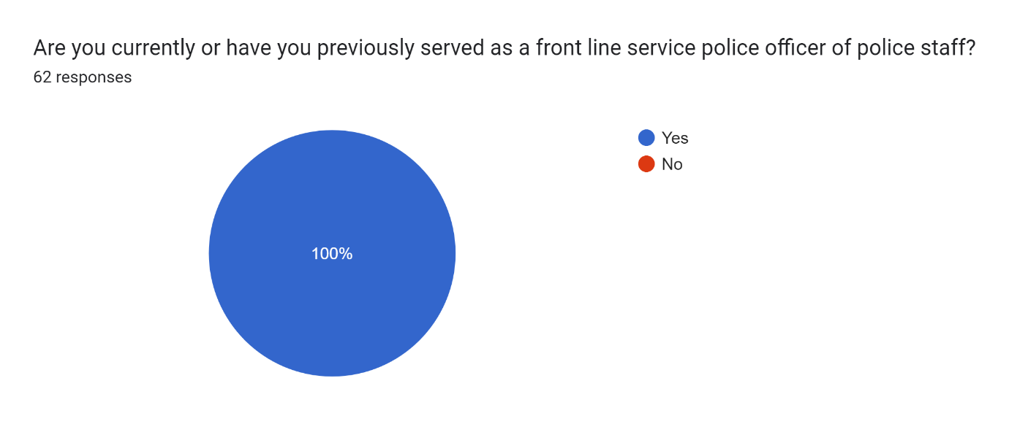

Q2 – Length of time in service.
This question was to gauge the participants length of service. 62 responses revealed that the highest number of participants had served 2-5 years at 30.6%, followed closely by 5-10 years at 16.1%. The survey showed that 40.3% of participants had served over 10 years.
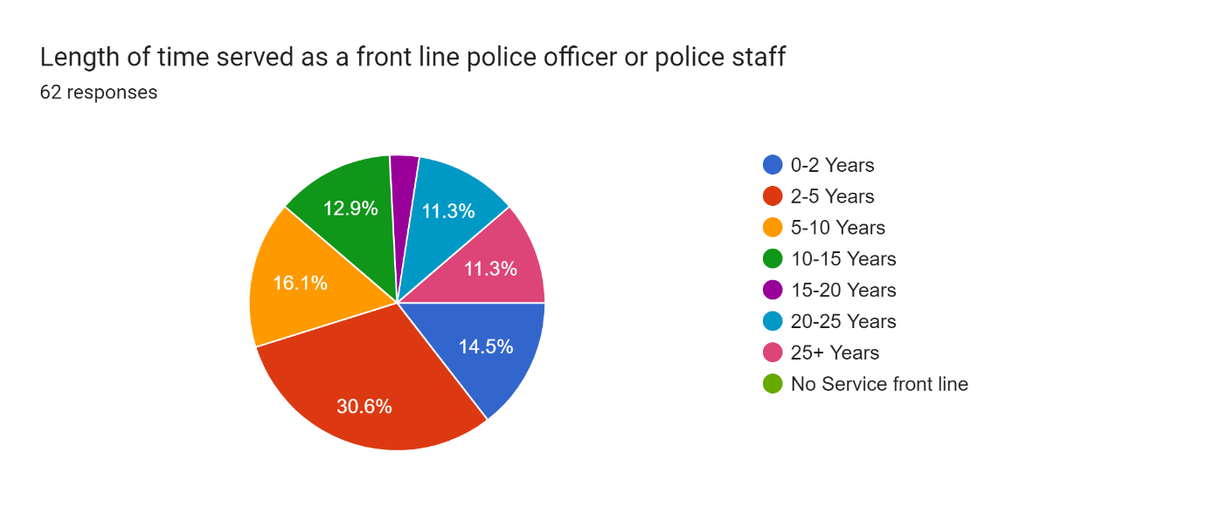
Q3 – Age
This question was to gauge the participants age, The 62 responses revealed the age of the participants were closely matched in each category except for 40-45, which was around half of each of the other age groups.
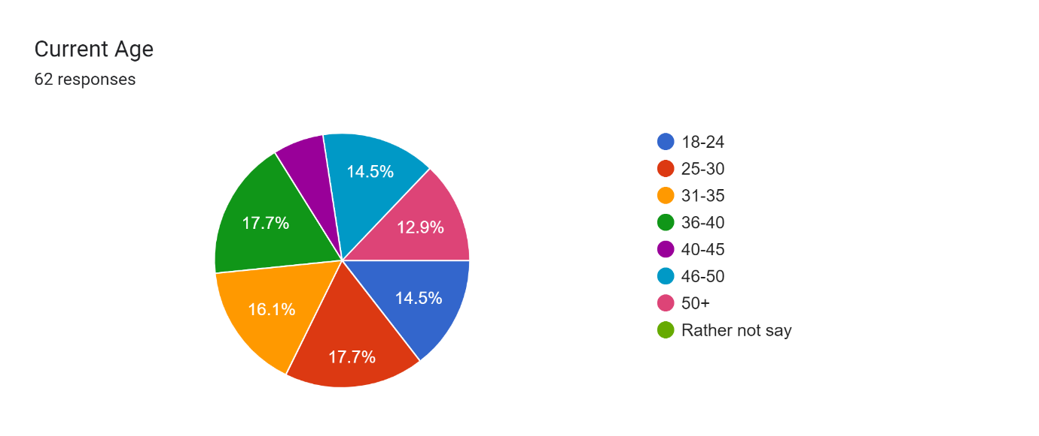
Q4 – Current Rank
This question was to determine the participants rank, as expected the majority of the 61 participants were constables at 67.2%, followed by sergeants at 18%. The survey also received a small participation from inspectors and chief inspectors.
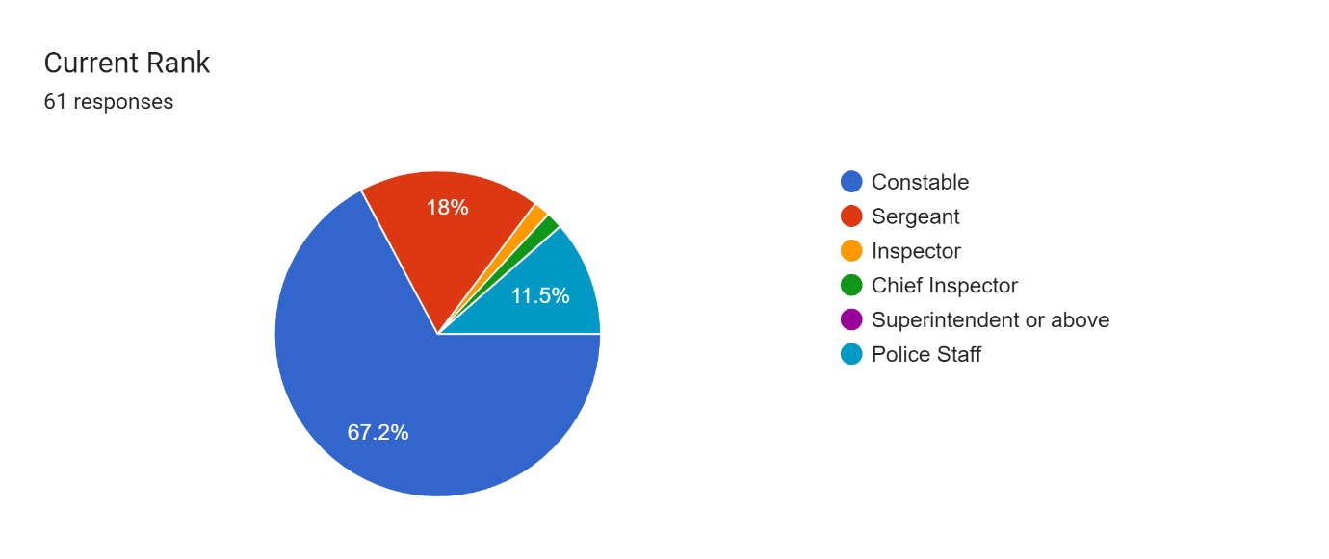

Q5 – Gender
This question was to gauge the participants gender with a ‘Prefer not to say’ option, although none of the 62 participants utilised this choice. 61.3% of the participants were male with 38.7% being female.
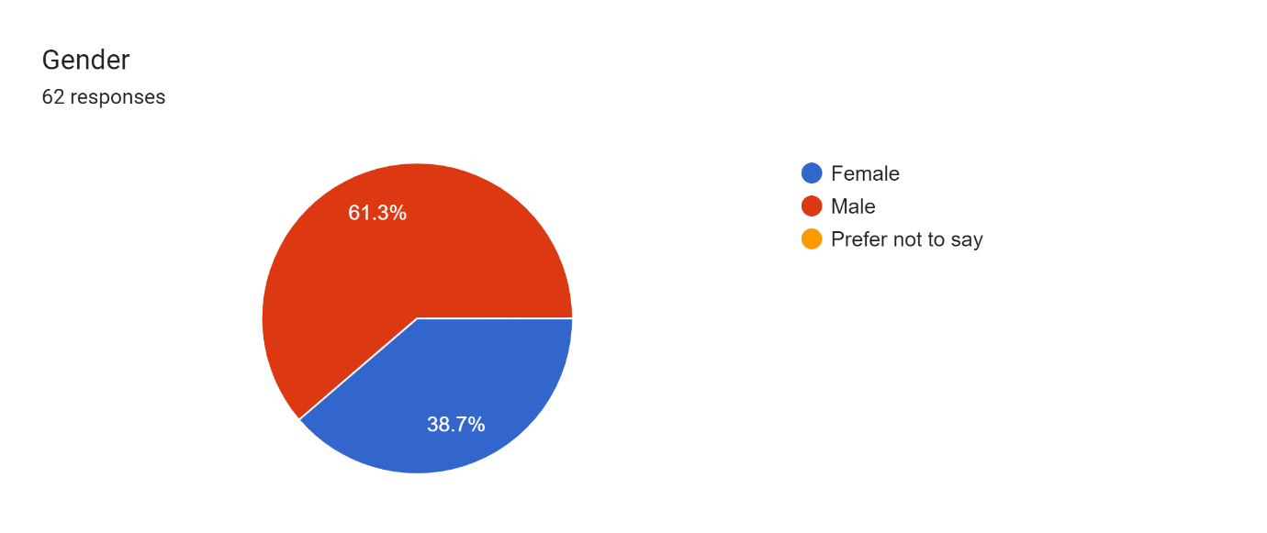
Q6 – Has the participants mental health or wellbeing been negatively affected post dealing with a traumatic incident.
This question was to ascertain if the participants had been subjected to a traumatic incident which had had a negative effect on their mental health and wellbeing, there was also a ‘Prefer not to say’ although this was not utilised. Ther were 62 replies with 90.3% answering yes to the question.
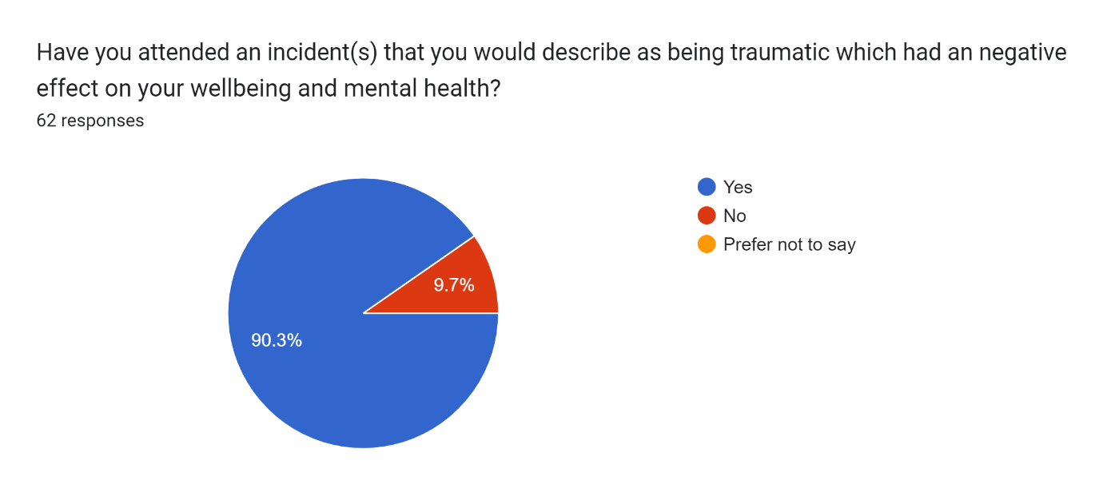
Q7 – Adequate training
This question was to gauge if the participant felt that they had the right training to deal with the traumatic incidents. 61 people responded to this question with 50.8% saying they did not, and 34.4% saying the training was somewhat adequate and 14.8% saying the training was adequate.
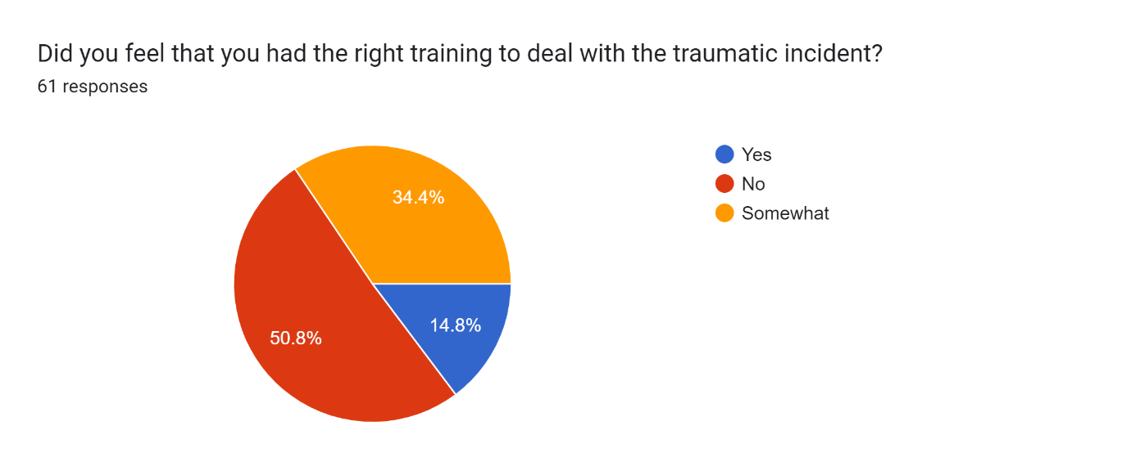
Q8 – Support post traumatic incident
This question was to ascertain whether or not the participant was offered support post traumatic incident. 61 participants of which 47.5% answered that they were offered support, 18% answering they were not, and 29.5% answering they had had sometimes been offered support.
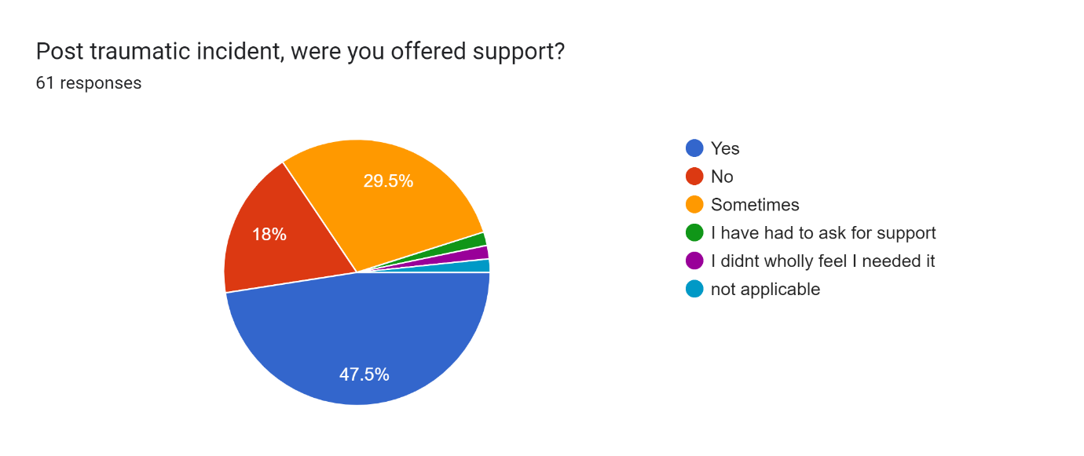
Q9 – Accepting the support when offered.
This question was to ascertain if the participant accepted the support offered post traumatic incident. 59 participants answered the question, over 64% of them stated they did not accept the support offered and only 30.5% answering yes to accepting the support.
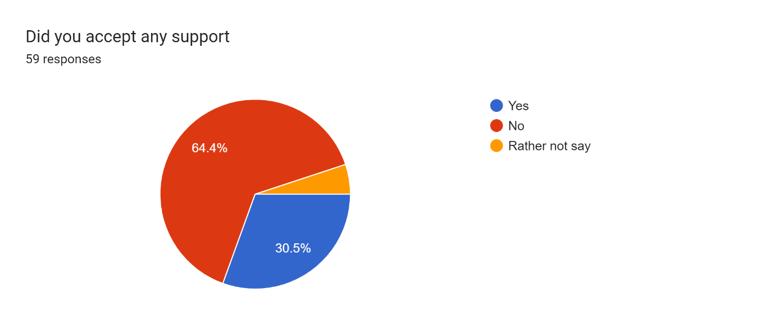
Q10 – Was the support provided adequate.
This question was to gauge if the participants felt the support that they had received was adequate. 53 participants responded and 29.6% answered that the support was adequate, the majority at 46.3% answered that the support was not adequate, and 24.1% answering that the support was somewhat adequate.
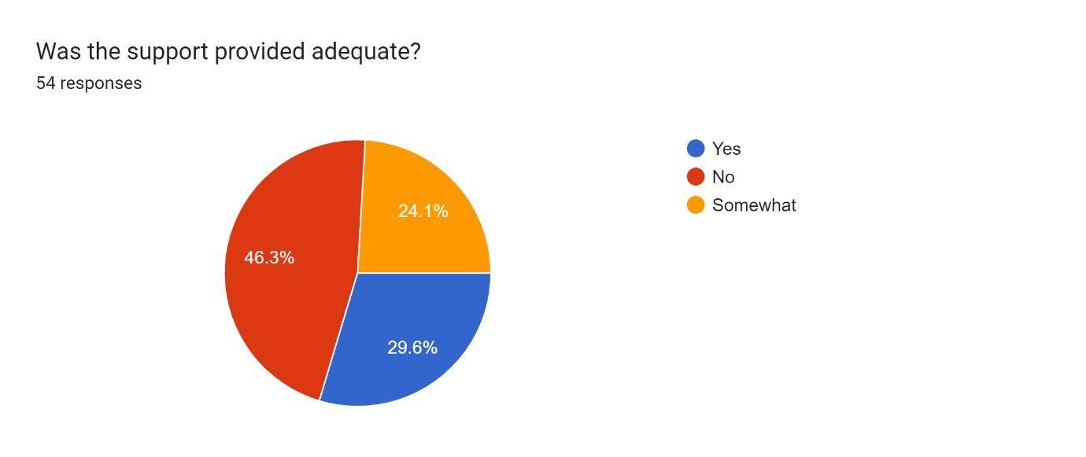
Q11 – Seeking your own external medical care post traumatic incident.
This question was to ascertain if any of the participants have sought out external medical treatment post dealing with a traumatic incident, there was also a ‘Prefer not to say’ option which was utilised, 59 responses of which the large majority at 69.5% answering no and 25.4% answering yes, a small percentage at 5.1% preferred not to answer the question.
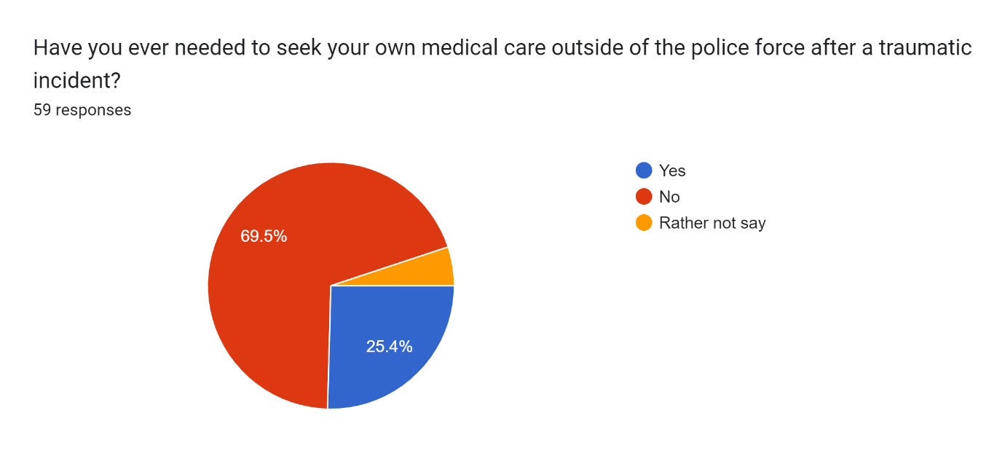
Q12 – Diagnosed with post-traumatic stress disorder (PTSD).
This question was to ascertain if the participant had been diagnosed with PTSD post traumatic incidents, this question had a ‘Prefer not to say’ option included. 62 responses of which the majority at 82.3% answered no and 16.1% answered yes.
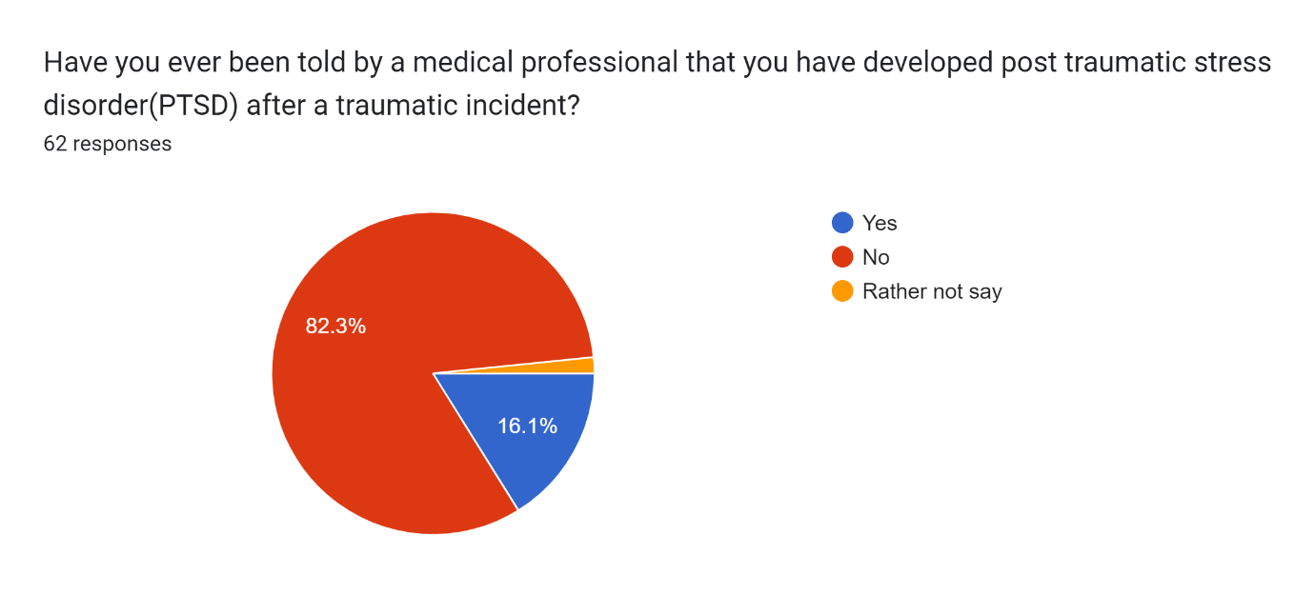
Q13 – Time off work post traumatic incident.
This question was to ascertain is the participant had ever needed to take time of work post traumatic incident. 60 responses were the majority at 78.3% had not taken time off, and 21.7% had taken time off.
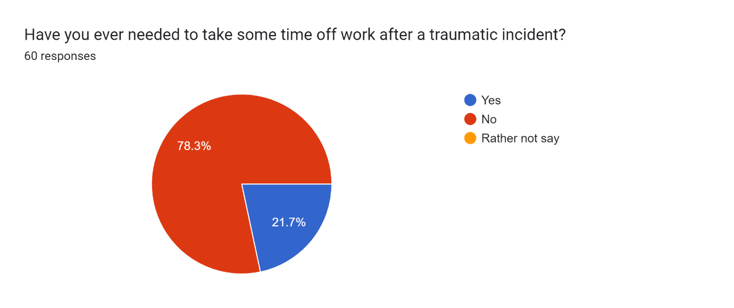
Q14 – Support from supervisor whilst off work due to a traumatic incident.
This question was to gauge If the participant felt they were positively supported by their supervisor whilst off work due to the effects of dealing with a traumatic incident, there was a ‘Rather not say option’ which was not utilised. 62 responses of which 50% were not applicable, the majority at 21% answering they were not supported, 19.4 % answering yes and 9.7% answering they were somewhat supported.
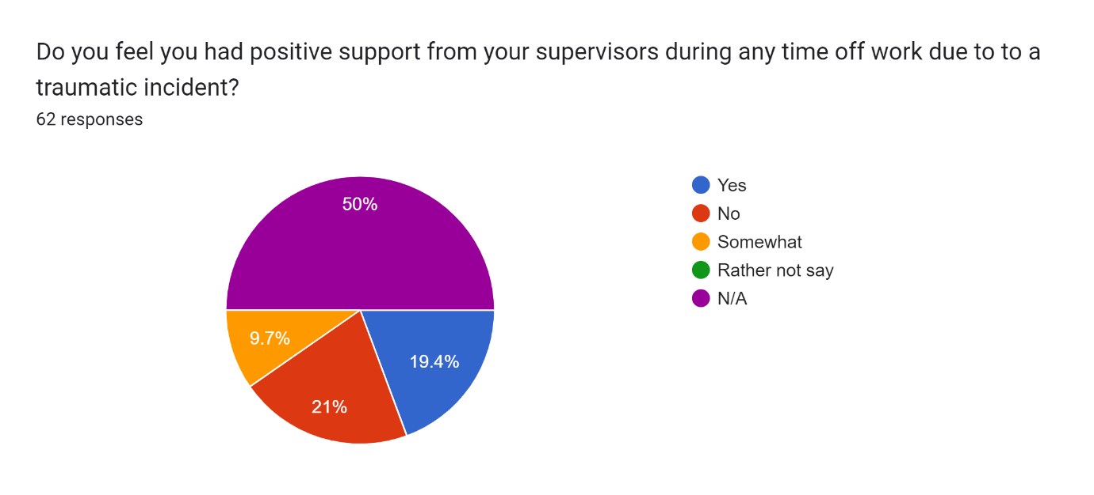
Q15 – Support from supervisor on your return to work after a traumatic incident.
This question is a follow-up to Q14 and is to gauge if the participant felt that they were positively supported by their supervisor on their return to work, there was a ‘Rather not say’ option which was not utilised. 62 responses of which 51.6% were not applicable, the majority at 22.6% answered that they were supported, 17.7% answered they were not, and 8.1% answered that they were somewhat supported.
Conclusion 4.3
In conclusion, the results achieved from the questionnaire were of approx. 60 responses per question, excluding the free text at the end which achieved 16 responses with additional relevant information. The evidence from the questionnaire indicated that 1 in 10 participants (90.3%) have been exposure to trauma, of which 50.8% felt they were not fully trained to deal with the incident along with an addition 34.4% who believed they were only somewhat trained.
Whilst there is post traumatic incident support available from the police service to police officers and staff, the results indicate that the support is not always presented to the affected person(s) and when it is offered a large number are not accepting. The vast majority claim that the support provided is not adequate and a small number have pursued their own support from outside of the police service, whilst stating that unless you ask for support your issues can be overlooked or ignored.
The results indicated that only (21.7%) of the participants have taken time off due to the effects of a traumatic incident, this information coincides with the additional comments section in which participants mention the constant shortages on police response teams which are having an effect on a persevered lack of support from supervisors, who themselves have to manage high call demands and resourcing to the live incidents.
The comments section also mention the ‘old school’ mentality was that you did not show weakness, you dealt with issues yourself and got on with the job without obtaining support, but this mindset appears to have positively changed somewhat over the years.
The results of this questionnaire may possibly have been affected by a number of factors, such as respondents applying misinformation due to their own interpretation of the questions, or time restraints as most of the participants would be completing it whilst on-duty. A more beneficial approach would been to have disseminated the questionnaire to all of the individual police forces in England and Wales to improve the accuracy of the answers.

Chapter 5: – Conclusion and recommendations
Introduction 5.1
For this dissertation I have detailed the introduction, I have completed literature reviews along with research methodology and the outcome from a questionnaire that was shared and completed by various respondents. For this closing chapter I will look at the overall dissertation and document recommendations that I have discovered during my research.
Objective Achievement 5.2
To complete the objectives stated at the start of this dissertation, I wanted to find out from police officers of all ranks along with police staff about their own views and experiences of being exposure to trauma.
- Explore statistics surrounding the effects of frequent exposure to trauma has on an emergency worker such as Police officer e.g., developing PTSD and the identifying symptoms.
- Discuss key points from police officers and staff on how any of their mental health issues are addressed in the workplace such as, is the support is readily available and of an adequate standard.
- To investigate police officers’ views on how their supervisors treat them when they are suffering with their mental health, and what they think the organisations attitude is towards officers who require support and time off work.
I have completed these objectives throughout the dissertation where I have researched the available literature that has already been published. The literature that was available revealed that exposure to trauma can have serious adverse effects on a person mental health and wellbeing. Identifying the symptoms of Post Traumatic Stress Disorder (PTSD) and applying the correct treatment can save a person from despair or in the more dire cases the treatment could save them from death.
Main Findings 5.3
Police officers along with other front-line staff will always be exposed to trauma as it is an integrated part of their role and that will not change. The research shows that every person that is exposed to trauma deals with it differently, and whilst some people are more susceptible to the adverse effects and cannot hide the symptoms, so support is offered and accepted. Worryingly there are those who are able to bury these traumatic moments and hide their despair from others and refuse to reach out for support, and there are those who have little to no adverse effects whatsoever.
From the research carried out in the questionnaire, which was disseminated to serving police officers and staff within South Wales Police there was a good understanding of what trauma is and what effect it has had on the participant. Of the 62 participants 90.3% stated that had been subjected to trauma within their role which indicates that this is the correct target audience for the survey. 85.2% felt that they were not trained adequately to deal with the traumatic incidents that they had attended, and that the support offered post traumatic incident was not always offered, but when it was and accepted 70.3% claim the standard of support was not fully adequate.
Participants of the survey reported over 50% stated that support from their supervisors was not always forthcoming when the person required extraction from their role or on their return to work after the absence which along with the free text comments section revealed that officers were at times reluctant to push the agenda. A cultural attitude of the past such as the term ‘man up’ and ‘stiff upper lip’ still exists within the service, making it difficult at times for an officer to admit they are suffering and receive support.
Recommendations 5.4
- Develop a computer program that can be integrated into a police control rooms computer system, the program will be able to automatically identify and flag up incidents where it is likely that the attending officers or staff members have been subjected to trauma. This system would be to be designed to assist supervisors so that action is taken and help reduce the number of sufferers slipping through the net.

- Trained trauma officers or staff who will assist in contacting officers or staff who have been identified as requiring an initial assessment to establish if support is needed. This assessment would be peer-to-peer based to enable the person to be relaxed and not feel pressured into refusing help or time off work which they may reject when speaking with supervisors.

- A multi-agency approach to be implemented for trauma exposed officers and staff. This would be a similar approach taken by police officers themselves when they attend such calls, where they identify members of the public who require support. This approach would be that affected police officers and staff obtain treatment and support not only in the workplace, but also from appropriate agencies outside the workplace such as doctors or from the school of any children of to the affected person. This approach will assist with maintain a cohesive family relationship, along with providing support to the other family members who may be affected by their spouses’ troubles at work.

- Compulsory supervisor training to enhance the support they can provide to officers who are suffering after dealing with a traumatic incident. The supervisors will have the ability to be sensitive to the officers’ individual needs and assist with monitoring their progress as they return to work.

- Cultural attitude changes in the organisation so that mental health and PTSD are not taboo subjects, by doing this it will allow officers or staff who may otherwise be suffering in silence to accept support without being scorned at or feel they are letting their team down. A positive cultural attitude change toward this subject, should assist with the reduction of the number of staff off work and shorten their treatment time.
Limitations 5.5
As with the majority of studies, there will be the limitations that can be altered by the researcher. The most significant drawback is time constraints; the dissertation was completed in 9 months, which is not an ideal timeframe to deliver and apply all of the material provided. Along with the time restraint, there is also a word count limit, therefore the content must be brief in order to fit within the word limits. The questionnaire responses are not conclusive as each respondent has a different experience of trauma and how they perceive it. An interview-style question would be more beneficial, but time constraints would hinder this.
Conclusion 5.6
Exposure to trauma can have a negative long-term effect for anyone’s mental health, but for front-line Police Officers who are subjected to it much more frequently makes them highly susceptible to suffering with their mental health and wellbeing along with the possibility of developing Post Traumatic Stress Disorder (PTSD). The effects of reoccurring exposure to trauma cannot be underestimated, it can be hugely traumatic and at times deadly for the sufferer, unfortunately there is no indication that the frequency in which police officers are subjected to trauma will reduce and time soon.
The research showed that the attitude within the police service towards mental health has improved over the years from the ‘old school’ mentality but is still not in a position where all sufferers are freely coming forward for help and support. It was discovered that 93% of police officers were attending work as normal whilst feeling stressed and anxious rather than seek help and support. Possible solutions to the concerns have been identified which may assist in highlighting any officers or staff who require an assessment post incident, in the hope of recognising when treatment is required.

Bibliography
Asiedu, F., 2019. Advantages and Disadvantages of Online Surveys. [Online]
Available at: https://www.cvent.com/uk/blog/events/advantages-disadvantages-online-surveys
[Accessed 17 February 2024].
Boldan, M. M., 2023. Traumatic Events. [Online]
Available at: https://www.healthline.com/health/traumatic-events
[Accessed 16 January 2024].
Centre for Addiction and Mental Health, 2023. TRAUMA. [Online]
Available at: https://www.camh.ca/en/health-info/mental-illness-and-addiction-index/trauma
[Accessed 20 November 2023].
Chorley, N., 2023. Addressing the mental health crisis amongst emergency response workers. [Online]
Available at: https://www.openaccessgovernment.org/addressing-mental-health-crisis-emergency-response-workers/153772/
[Accessed 16 January 2024].
DerSarkissian, C. M., 2021. What are the Symptoms of PTSD?. [Online]
Available at: https://www.webmd.com/mental-health/what-are-symptoms-ptsd
[Accessed 16 January 2024].
Devlin, H., 2022. More people face being shut out of NHS mental health services, experts warn. [Online]
Available at: https://www.theguardian.com/society/2022/dec/27/more-people-shut-out-nhs-england-mental-health-service-mind-charity
[Accessed 14 February 2024].
Lautieri, A., 2023. Why Do Some Individuals Get PTSD While Others Do Not?. [Online]
Available at: https://deserthopetreatment.com/co-occurring-disorders/ptsd/why-some-get-it-and-some-do-not/
[Accessed 16 January 2024].
March on Stress, N.D.. Trauma Risk Management (TRiM). [Online]
Available at: https://www.marchonstress.com/page/p/trim
[Accessed 16 January 2024].
National Health Service, 2022. Overview - Post-traumatic stress disorder. [Online]
Available at: https://www.nhs.uk/mental-health/conditions/post-traumatic-stress-disorder-ptsd/overview/
[Accessed 20 November 2023].
Police Care UK, 2023. Intensive Trauma Service. [Online]
Available at: https://www.policecare.org.uk/help/intensive-trauma-service/
[Accessed 16 January 2024].
Police Care UK, 2023. The Job The Life. [Online]
Available at: https://www.policecare.org.uk/research-article/the-job-the-life/
[Accessed 16 January 2024].
Robinson, L., Segal, J. P. & Smith, M. M., 2023. Understanding PTSD in veterans. [Online]
Available at: https://www.helpguide.org/articles/ptsd-trauma/ptsd-in-military-veterans.htm
[Accessed 16 January 2024].
Trauma-Informed Care, 2021. What is Trauma?. [Online]
Available at: https://www.traumainformedcare.chcs.org/what-is-trauma/
[Accessed 16 January 2024].
University of Cambridge, N.D.. POLICE WORKFORCE:. [Online]
Available at: https://www.cam.ac.uk/policeptsd
[Accessed 16 January 2024].
Western Sydney University, 2023. Definition of Research. [Online]
Available at: https://www.westernsydney.edu.au/research/researchers/preparing_a_grant_application/dest_definition_of_research
[Accessed 14 February 2024].

Appendix One – Questionnaire
I have a number of questions that would provide me with invaluable information of the effects from exposure to trauma has on a police officer of police staff attending such incidents.

I appreciate that some of the questions may cause distress to the user, I advise that if that is the case the user should not compete the questions, Thank You

NOTE! - The questionnaire is completely anonymous

Are you currently or have you previously served as a front-line service police officer of police staff?
  - ( ) Yes
  - ( ) No

Length of time served as a front-line police officer or police staff
  - ( ) 0-2 Years
  - ( ) 2-5 Years
  - ( ) 5-10 Years
  - ( ) 10-15 Years
  - ( ) 15-20 Years
  - ( ) 20-25 Years
  - ( ) 25+ Years
  - ( ) No Service front line

Current Age
  - ( ) 18-24
  - ( ) 25-30
  - ( ) 31-35
  - ( ) 36-40
  - ( ) 40-45
  - ( ) 46-50
  - ( ) 50+
  - ( ) Rather not say

Current Rank
  - ( ) Constable
  - ( ) Sergeant
  - ( ) Inspector
  - ( ) Chief Inspector
  - ( ) Superintendent or above
  - ( ) Police Staff

Gender
  - ( ) Female
  - ( ) Male
  - ( ) Prefer not to say

Have you attended an incident(s) that you would describe as being traumatic which had a negative effect on your wellbeing and mental health?
  - ( ) Yes
  - ( ) No
  - ( ) Prefer not to say
Did you feel that you had the right training to deal with the traumatic incident?
  - ( ) Yes
  - ( ) No
  - ( ) Somewhat

Post traumatic incident, were you offered support?
  - ( ) Yes
  - ( ) No
  - ( ) Sometimes
  - ( ) I have had to ask for support
  - ( ) Other:

Did you accept any support
  - ( ) Yes
  - ( ) No
  - ( ) Rather not say

Was the support provided adequate?
  - ( ) Yes
  - ( ) No
  - ( ) Somewhat

Have you ever needed to seek your own medical care outside of the police force after a traumatic incident?
  - ( ) Yes
  - ( ) No
  - ( ) Rather not say

Have you ever been told by a medical professional that you have developed post traumatic stress disorder (PTSD) after a traumatic incident?
  - ( ) Yes
  - ( ) No
  - ( ) Rather not say

Have you ever needed to take some time off work after a traumatic incident?
  - ( ) Yes
  - ( ) No
  - ( ) Rather not say

Do you feel you had positive support from your supervisors during any time off work due to a traumatic incident?
  - ( ) Yes
  - ( ) No
  - ( ) Somewhat
  - ( ) Rather not say
  - ( ) N/A

Did you feel that you had positive support from your supervisor on your return to work after a traumatic incident?
  - ( ) Yes
  - ( ) No
  - ( ) Somewhat
  - ( ) Rather not say
  - ( ) N/A

If there anything you would like to add, please write below.
[Submit]

Appendix Two – Questionnaire Results

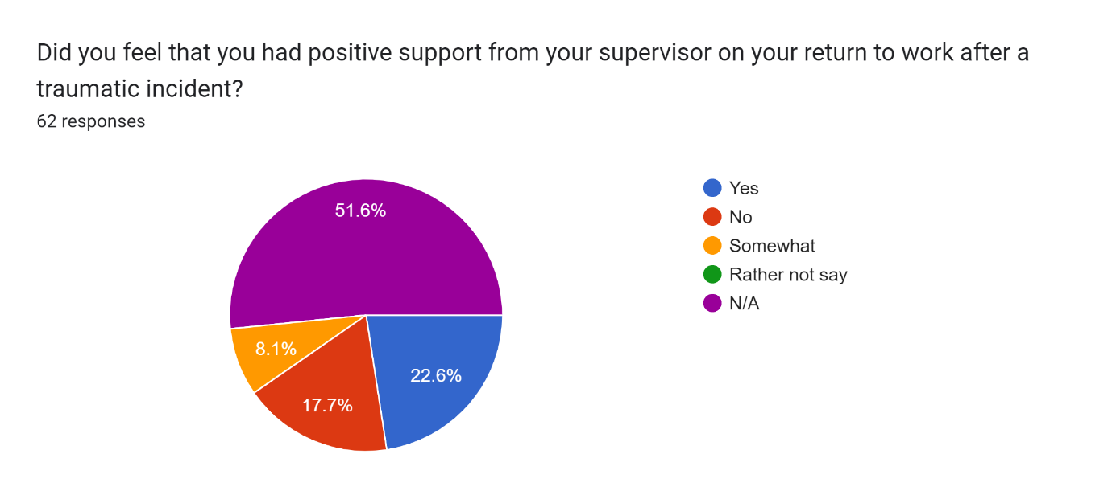

If there anything you would like to add, please write below.
18 responses
My incident happened over 20 yrs ago, there have been huge improvements made and the understanding, both of the force as a whole and of individuals, has increased immensely.
I don't think you can be trained to deal with traumatic incidents, you can be given coping mechanisms and support but no training can prepare for the sights we see
no
I think even though referrals are made for officers following attendance at traumatic incidents , there should be a system as is on NICHE whereby people can be flagged similar to the way we flag repeat victims , in those cases a face to face session should be mandatory as there is still a reluctance wo accept help and we should be more proactive in identifying those who are vulnerable to PTSD / trauma
More initial training needed on how to cope mentally with highly stress situation, occurrences, after using force I was torn as to whether I APLLIED IT CORRECTLY, AND WHETHER IT WAS appropriate, it was upsetting to do so
Particularly on response, we are regularly exposed to traumatic incidents - sometimes multiple times a shift. Whilst I have found that support from supervisors in these situations is always good, there is a unwritten expectation that you just crack on and get to the next call and more often than not, you haven't even had time to process the previous call.
My line manager was somewhat blind to the fact I had been told I had complex PTSD and did not make any decisions around that to take me away from front line duties - from a welfare aspect. At the time I was in a role where I was repeatedly exposed to traumatic incidents (fatal RTC's). Due to my own mindset at the time I felt I was unable to make the decision myself, never took time off work and on reflection wished my supervisor made the call to pull me away from front line duties. It was over a year later, when I was still in the same role, doing the same job, that my Chief Inspector reviewed my annual Perform, where I made mention of my cPTSD, and she made the call to remove me from front line duties - which is what I needed. I think my Sergeant was more concerned about balancing the on call cover as we were a small team, rather than pulling me away from it.
Generational expectation when I joined induced a psychology around coping internally and not identifying as affected - I recall comments re, ''toughening up and, 'you will see much worse' and similar. Thankfully times have changed and the provision of support and openness about wellbeing appears much greater. Having not accessed such services I cannot comment on the quality - although that concerns me as to how consistent quality of service is especially when provided internally by 'trained' employees. There is also a balance to be achieved between support and the fact that the job has to be done and all are likely to experience some trauma during a long career - hence there needs to be reality in expectation or some form of robust psychological suitability assessment when joining the service to further protect individuals and the organisation from future harm.
I assume your dissertation is around trauma within 'frontline' policing, hence the wording of your questions. It has been my experience that I have seen and witnessed far more traumatic events since leaving 'frontline' policing and going into specialist departments. I will say that the aftercare is better within specialist departments.
N/A
My role meant I had annual 1-2-1 in person check in with counselling services. They stopped this during covid and started doing it online and only if you request it. I believe people who genuinely need help will go under the radar. I feel SWP is saving money at the expense of peoples welfare.
diagnosed with complex PTSD after 18years front line service , which turned my life upside down both at home and in work , after short sessions in force of counselling in house, I had specialist treatment from police care uk in 2021 which helped , however in a restricted role and will probably remain
As police officers we attend the worst incidents that you could possibly imagine. See people at their worst and see things that normal people couldn't dream of. The force will send a token email days after the incident. If you take time off it will go against you (Bradford score) and there is no support from the top. You can have a great supervisor who understands but ultimately due to low numbers and demands there is no time to sit still, and take time off. After nearly a decade of service I only now realise that you are just a number.
During the early 2000's, after a traumatic incident you were just left to deal with it yourself. This is where team comradery came into it's own. Everyone dealt with it together. No support was marketed as being available or ever offered.
majority of answers not applicable as not faced a traumatic incident
The support is there but staff still need to be made aware what it is and that they will not be judged if they accept it or seek it out. Onus is on supervisors to spot any change in behaviours and support staff
If there is insufficient capacity for the supervisor or the welfare department to properly manage the member of staff who has reported sick/unable to attend work, this can have a further negative impact on the member of staff's wellbeing/mental health.
I had much better support from my direct Sgt in comparison to my Bronze Ins. who pulled the team in less than 24 hrs later to "debrief" where we were criticised for our actions (albeit we were only following his instructions). This was found by SMT to contradict the feedback he had given them and only aggravated our distress. We were also asked to conduct scene guard at the address during the following shift, where we had seen 2 people (1 child aged 3 and 1 adult) die which wasn't so great for emotional/mental wellbeing.

Appendix Three – Proposal Form
APPLICATION FOR ETHICAL APPROVAL

RESEARCH STUDENTS
This form is to be completed by the student within SIX months for full-time students and TWELVE months for part time students, after the commencement of the research degree or following progression to Part Two of your course.

Once complete, submit this form via the MyTSD Doctoral College Portal at (https://mytsd.uwtsd.ac.uk).

This document is also available in Welsh.

RESEARCH STAFF ONLY
All communications relating to this application during its processing must be in writing and emailed to pgresearch@uwtsd.ac.uk , with the title ‘Ethical Approval’ followed by your name.

STUDENTS ON UNDERGRADUATE OR TAUGHT MASTERS PROGRAMMES should submit this form (and receive the outcome) via systems explained to you by the supervisor/module leader.

In order for research to result in benefit and minimise risk of harm, it must be conducted ethically. A researcher may not be covered by the University’s insurance if ethical approval has not been obtained prior to commencement.

The University follows the OECD Frascati manual definition of research activity: “creative work undertaken on a systematic basis in order to increase the stock of knowledge, including knowledge of man, culture and society, and the use of this stock of knowledge to devise new applications”. As such this covers activities undertaken by members of staff, postgraduate research students, and both taught postgraduate and undergraduate students working on dissertations/projects.

The individual undertaking the research activity is known as the “principal researcher”.

Ethical approval is not required for routine audits, performance reviews, quality assurance studies, testing within normal educational requirements, and literary or artistic criticism.

Please read the notes for guidance before completing ALL sections of the form.

This form must be completed and approved prior to undertaking any research activity. Please see Checklist for details of process for different categories of application.

SECTION A: About You (Principal Researcher)
1 | Full Name: |  | Robert Morgan
2 | Tick all boxes that apply: |  | Member of staff: | ☐ | Honorary research fellow: | ☐
 | Undergraduate Student | ☒ | Taught Postgraduate Student | ☐ | Postgraduate Research Student | ☐

3 | Institute/Academic Discipline/Centre: | IMH
4 | Campus: | Swansea
5 | E-mail address: | 2016387@student.uwtsd.ac.uk
6 | Contact Telephone Number: | N/A
 | For students:
7 | Student Number: | 2016387
8 | Programme of Study: | BSc (Hons) Professional Policing Practice
9 | Director of Studies/Supervisor: | Vivienne Harpwood

SECTION B: Approval for Research Activity
1 | Has the research activity received approval in principle?  (please check the Guidance Notes as to the appropriate approval process for different levels of research by different categories of individual) |  | YES | ☒ | NO | ☐
 |  |  |  |  | Date
2 | If Yes, please indicate source of approval (and date where known): Approval in principle must be obtained from the relevant source prior to seeking ethical approval | Research Degrees Committee |  | ☐
2 |  | Institute Research Committee |  | ☐
2 |  | Other (write in) |  | ☒ | Vivienne Harpwood

SECTION C: Internal and External Ethical Guidance Materials
 | Please list the core ethical guidance documents that have been referred to during the completion of this form (including any discipline-specific codes of research ethics, location-specific codes of research ethics, and also any specific ethical guidance relating to the proposed methodology). Please tick to confirm that your research proposal adheres to these codes and guidelines. You may add rows to this table if needed.
1 | UWTSD Research Ethics & Integrity Code of Practice | ☒
2 | UWTSD Research Data Management Policy | ☒
3 | [List any other relevant documents here] | ☐

SECTION D: External Collaborative Research Activity
If there are external collaborators then you should gain consent from the contact persons to share their personal data with the university. If there are no external collaborators then leave this section blank and continue to section E.
1 | Institution
2 | Contact person name
3 | Contact person e-mail address
4 | Is your research externally funded? |  | YES | ☐ | NO |  | ☐
5 | Are you in receipt of a KESS scholarship? |  | YES | ☐ | NO |  | ☐
6 | Are you specifically employed to undertake this research in either a paid or voluntary capacity? | Voluntary | YES | ☐ | NO | ☐
7 |  | Employed | YES | ☐ | NO | ☐
8 | Is the research being undertaken within an existing UWTSD Athrofa Professional Learning Partnership (APLP)? | If YES then the permission question below does not need to be answered. | YES | ☐ | NO |  | ☐
9 | Has permission to undertake the research has been provided by the partner organisation? | (If YES attach copy)  If NO the application cannot continue | YES | ☐ | NO |  | ☐

Where research activity is carried out in collaboration with an external organisation
10 | Does this organisation have its own ethics approval system? | YES | ☐ | NO | ☐
 | If Yes, please attach a copy of any final approval (or interim approval) from the organisation (this may be a copy of an email if appropriate).

SECTION E: Details of Research Activity
1 | Indicative title: | Evaluating the impact that frequent exposure to trauma has on a first responders mental health, resilience and wellbeing. The focus will be on police officers as first responders and preventing post-traumatic stress disorder (PTSD).
2 | Proposed start date: | 2nd October 2023 | Proposed end date: | 8th July 2024
Introduction to the Research (maximum 300 words per section)
Ensure that you write for a Non-Specialist Audience when outlining your response to the points below:
- Purpose of Research Activity
- Proposed Research Question
- Aims of Research Activity
- Objectives of Research Activity
Demonstrate, briefly, how Existing Research has informed the proposed activity and explain
- What the research activity will add to the body of knowledge
- How it addresses an area of importance.
3 | Purpose of Research Activity  The research addresses the impact of exposure to trauma has on a police officer.  (this box should expand as you type)
4 | Research Questions  - How impactive traumatic incidents are on police officers as first responders.  - Examine how individual police officers determine what is and what is not a traumatic incident.  - Explore Police officers’ perspective on traumatic incident they have been exposed to.  - How effective and readily available the aftercare is in the police service in preventing PTSD.  (this box should expand as you type)
5 | Aims of Research Activity  The research aims to collect data from serving police officers regarding their attendance at traumatic incident.  In order to satisfy the aim for which this research is being undertaken, the following objectives need to be accomplished which will provide us the clear view of the current opinion form officers: -  - Collect data from serving police officers.  - Evaluate how different officer determine what is or is not a traumatic incident.  - To critically evaluate the information provided by Police officers and asses whether or not the aftercare is effective.  (this box should expand as you type)
6 | Objectives of Research Activity  - Gain firsthand accounts from police officers on how trauma has affected them.  - Gain an understanding and opinion from serving police officers on the effectiveness of post-incident treatment.  (this box should expand as you type)
Proposed methods (maximum 600 words)
Provide a brief summary of all the methods that may be used in the research activity, making it clear what specific techniques may be used. If methods other than those listed in this section are deemed appropriate later, additional ethical approval for those methods will be needed. You do not need to justify the methods here but should instead describe how you intend to collect the data necessary for you to complete your project.
7 | For me to achieve my objectives, I will research the topic using sources available to myself such as the internet, and any related journals and articles.  I will also develop an electronic internet-based survey which will consist of approximately 15 questions. I will distribute the survey to a large number of serving police officers within South Wales Police respectfully requesting they participate and complete this survey. The answers provided will be from the officers’ knowledge and personnel experiences of the subject. The date provided will have a contribute to assisting me in answering the research question.  I will disseminate the survey through web links within emails, I will also utilise the police services own social media platform by posting a link for the survey and explaining the objectives. I will ensure the questions are short, clear and to the point as to avoid a lack of participation of the survey.  I will then be accessing the already published articles and comparing the information in them to the data generated from my survey.  (this box should expand as you type)
Location of research activity
Identify all locations where research activity will take place.
8 | Swansea
Research activity outside of the UK
If research activity will take place overseas, you are responsible for ensuring that local ethical considerations are complied with and that the relevant permissions are sought. Specify any local guidelines (e.g. from local professional associations/learned societies/universities) that exist and whether these involve any ethical stipulations beyond those usual in the UK (provide details of any licenses or permissions required). Also specify whether there are any specific ethical issues raised by the local context in which the research activity is taking place, for example, particular cultural and/or legal sensitivities or vulnerabilities of participants. If you live in the country where you will do the research then please state this.
9 | N/a  (this box should expand as you type)

10 | Use of documentation not in the public domain: Are any documents NOT publicly available? | NO | ☒
10 |  | YES | ☐
11 | If Yes, please provide details here of how you will gain access to specific documentation that is not in the public domain and that this is in accordance with the current data protection law of the country in question and that of England and Wales.  (this box should expand as you type)

 | Does your research relate to one or more of the seven aims of the Well-being of Future Generations (Wales) Act 2015? | YES | NO
12 | A prosperous Wales | ☐ | ☒
13 | A resilient Wales | ☒ | ☐
14 | A healthier Wales | ☒ | ☐
15 | A more equal Wales | ☐ | ☒
16 | A Wales of cohesive communities | ☐ | ☒
17 | A Wales of vibrant culture and thriving Welsh language | ☐ | ☒
18 | A globally responsible Wales | ☐ | ☒
19 | If YES to any of the above, please give details:
Provide details of how to prevent or assist with PTSD

(this box should expand as you type)

SECTION F: Scope of Research Activity
 | Will the research activity include: | YES | NO
1 | Use of a questionnaire or similar research instrument? | ☒ | ☐
2 | Use of interviews? | ☐ | ☒
3 | Use of focus groups? | ☐ | ☒
4 | Use of participant diaries? | ☐ | ☒
5 | Use of video or audio recording? | ☐ | ☒
6 | Use of computer-generated log files? | ☐ | ☒
7 | Participant observation with their knowledge? | ☐ | ☒
8 | Participant observation without their knowledge? | ☐ | ☒
9 | Access to personal or confidential information without the participants’ specific consent? | ☐ | ☒
10 | Administration of any questions, test stimuli, presentation that may be experienced as physically, mentally or emotionally harmful / offensive? | ☐ | ☒
11 | Performance of any acts which may cause embarrassment or affect self-esteem? | ☐ | ☒
12 | Investigation of participants involved in illegal activities? | ☐ | ☒
13 | Use of procedures that involve deception? | ☐ | ☒
14 | Administration of any substance, agent or placebo? | ☐ | ☒
15 | Working with live vertebrate animals? | ☐ | ☒
16 | Procedures that may have a negative impact on the environment? | ☐ | ☐
17 | Other primary data collection methods. Please indicate the type of data collection method(s) below. | ☐ | ☒
 | Details of any other primary data collection method:  (this box should expand as you type) | ☐ | ☒
If NO to every question, then the research activity is (ethically) low risk and may be exempt from some of the following sections (please refer to Guidance Notes).

If YES to any question, then no research activity should be undertaken until full ethical approval has been obtained.

SECTION G: Intended Participants
If there are no participants then do not complete this section, but go directly to section H.

 | Who are the intended participants: | YES | NO
1 | Students or staff at the University? | ☒ | ☒
2 | Adults (over the age of 18 and competent to give consent)? | ☒ | ☐
3 | Vulnerable adults? | ☐ | ☒
4 | Children and Young People under the age of 18? (Consent from Parent, Carer or Guardian will be required) | ☐ | ☒
5 | Prisoners? | ☐ | ☒
6 | Young offenders? | ☐ | ☒
7 | Those who could be considered to have a particularly dependent relationship with the investigator or a gatekeeper? | ☐ | ☒
8 | People engaged in illegal activities? | ☐ | ☒
9 | Others. Please indicate the participants below, and specifically any group who may be unable to give consent. | ☐ | ☒
 | Details of any other participant groups:  (this box should expand as you type) | ☐ | ☒

Participant numbers and source
Provide an estimate of the expected number of participants. How will you identify participants and how will they be recruited?
10 | How many participants are expected? | 20-30  (this box should expand as you type)
11 | Who will the participants be? | Serving police officers  (this box should expand as you type)
12 | How will you identify the participants? | Utilising police email database and police only social media  (this box should expand as you type)

 | Information for participants: | YES | NO | N/A
13 | Will you describe the main research procedures to participants in advance, so that they are informed about what to expect? | ☒ | ☐ | ☐
14 | Will you tell participants that their participation is voluntary? | ☒ | ☐ | ☐
15 | Will you obtain written consent for participation? | ☒ | ☒ | ☐
16 | Will you explain to participants that refusal to participate in the research will not affect their treatment or education (if relevant)? | ☒ | ☐ | ☐
17 | If the research is observational, will you ask participants for their consent to being observed? | ☒ | ☐ | ☐
18 | Will you tell participants that they may withdraw from the research at any time and for any reason? | ☒ | ☐ | ☐
19 | With questionnaires, will you give participants the option of omitting questions they do not want to answer? | ☒ | ☐ | ☐
20 | Will you tell participants that their data will be treated with full confidentiality and that, if published, it will not be identifiable as theirs? | ☒ | ☐ | ☐
21 | Will you debrief participants at the end of their participation, in a way appropriate to the type of research undertaken? | ☒ | ☐ | ☐
22 | If NO to any of above questions, please give an explanation
 | (this box should expand as you type)

 | Information for participants: | YES | NO | N/A
24 | Will participants be paid? | ☐ | ☒ | ☐
25 | Is specialist electrical or other equipment to be used with participants? | ☐ | ☒ | ☐
26 | Are there any financial or other interests to the investigator or University arising from this study? | ☐ | ☒ | ☐
27 | Will the research activity involve deliberately misleading participants in any way, or the partial or full concealment of the specific study aims? | ☐ | ☒ | ☐
28 | If YES to any question, please provide full details
 | (this box should expand as you type)

SECTION H: Anticipated Risks

Outline any anticipated risks that may adversely affect any of the participants, the researchers and/or the University, and the steps that will be taken to address them.

If you have completed a full risk assessment (for example as required by a laboratory, or external research collaborator) you may append that to this form.
1 | Full risk assessment completed and appended? |  | Yes | ☐
1 |  |  | No | ☒
2 | Risks to participants  For example: sector-specific health & safety, emotional distress, financial disclosure, physical harm, transfer of personal data, sensitive organisational information
 | Risk to participants: none  (this box should expand as you type) | How you will mitigate the risk to participants:  n/a  (this box should expand as you type)
3 | If research activity may include sensitive, embarrassing or upsetting topics (e.g. sexual activity, drug use) or issues likely to disclose information requiring further action (e.g. criminal activity), give details of the procedures to deal with these issues, including any support/advice (e.g. helpline numbers) to be offered to participants. Note that where applicable, consent procedures should make it clear that if something potentially or actually illegal is discovered in the course of a project, it may need to be disclosed to the proper authorities
 | (this box should expand as you type)
4 | Risks to the investigator  For example: personal health & safety, physical harm, emotional distress, risk of accusation of harm/impropriety, conflict of interest
 | Risk to the investigator:  None  (this box should expand as you type) | How you will mitigate the risk to the investigator:  n/a  (this box should expand as you type)
5 | University/institutional risks  For example: adverse publicity, financial loss, data protection
 | Risk to the University: none  (this box should expand as you type) | How you will mitigate the risk to the University:  n/a  (this box should expand as you type)
6 | Environmental risks  For example: accidental spillage of pollutants, damage to local ecosystems
 | Risk to the environment: none  (this box should expand as you type) | How you will mitigate the risk to environment:  n/a  (this box should expand as you type)

 | Disclosure and Barring Service
 | If the research activity involves children or vulnerable adults, a Disclosure and Barring Service (DBS) certificate must be obtained before any contact with such participants. | YES | NO | N/A
7 | Does your research require you to hold a current DBS Certificate? | ☐ | ☐ | ☒
8 | If YES, please give the certificate number. If the certificate number is not available please write “Pending”; in this case any ethical approval will be subject to providing the appropriate certificate number.

SECTION I: Feedback, Consent and Confidentiality

1 | Feedback  What de-briefing and feedback will be provided to participants, how will this be done and when?
At the end of the survey participants will be provided with a copy should it be requested

(this box should expand as you type)
2 | Informed consent  Describe the arrangements to inform potential participants, before providing consent, of what is involved in participating. Describe the arrangements for participants to provide full consent before data collection begins. If gaining consent in this way is inappropriate, explain how consent will be obtained and recorded in accordance with prevailing data protection legislation.
All participants are over 18 and starting my questionnaire is consenting.

(this box should expand as you type)
3 | Confidentiality / Anonymity  Set out how anonymity of participants and confidentiality will be ensured in any outputs. If anonymity is not being offered, explain why this is the case.
Surveys will be confidential and any personal information will be not be posted, and deleted once objectives achieved.

(this box should expand as you type)

SECTION J: Data Protection and Storage

 | Does the research activity involve personal data (as defined by the General Data Protection Regulation 2016 “GDPR” and the Data Protection Act 2018 “DPA”)? | YES | NO
1 | “Personal data” means any information relating to an identified or identifiable natural person (‘data subject’). An identifiable natural person is one who can be identified, directly or indirectly, in particular by reference to an identifier such as a name, an identification number, location data, an online identifier or to one or more factors specific to the physical, physiological, genetic, mental, economic, cultural or social identity of that natural person. Any video or audio recordings of participants is considered to be personal data. | ☐ | n
 | If YES, provide a description of the data and explain why this data needs to be collected:
2 | (this box should expand as you type)
 | Does it involve special category data (as defined by the GDPR)? | YES | NO
3 | “Special category data” means sensitive personal data consisting of information as to the data subjects’ –  (a) racial or ethnic origin,  (b) political opinions,  (c ) religious beliefs or other beliefs of a similar nature,  (d) membership of a trade union (within the meaning of the Trade Union and Labour Relations (Consolidation) Act 1992),  (e) physical or mental health or condition,  (f) sexual life,  (g) genetics,  (h) biometric data (as used for ID purposes), | ☐ | n
 | If YES, provide a description of the special category data and explain why this data needs to be collected:
4 | (this box should expand as you type)

 | Will data from the research activity (collected data, drafts of the thesis, or materials for publication) be stored in any of the following ways? | YES | NO
5 | Manual files (i.e. in paper form)? | ☐ | ☒
6 | University computers? | ☐ | ☒
7 | Private company computers? | ☐ | ☒
8 | Home or other personal computers? | ☒ | ☐
9 | Laptop computers/ CDs/ Portable disk-drives/ memory sticks? | ☐ | ☒
10 | “Cloud” storage or websites? | ☐ | ☒
11 | Other – specify: | ☐ | ☒
12 | For all stored data, explain the measures in place to ensure the security of the data collected, data confidentiality, including details of backup procedures, password protection, encryption, anonymisation and pseudonymisation:
Date will be stored on an encrypted laptop, and backed up via a secure external hard drive that is only accessible to the relevant person.
(this box should expand as you type)

 | Data Protection
 | Will the research activity involve any of the following activities: | YES | NO
13 | Electronic transfer of data in any form? | ☒ | ☐
14 | Sharing of data with others at the University outside of the immediate research team? | ☐ | ☒
15 | Sharing of data with other organisations? | ☐ | ☒
16 | Export of data outside the UK or importing of data from outside the UK? | ☐ | ☒
17 | Use of personal addresses, postcodes, faxes, emails or telephone numbers? | ☐ | ☒
18 | Publication of data that might allow identification of individuals? | ☐ | ☒
19 | Use of data management system? | ☐ | ☒
20 | Data archiving? | ☐ | ☒
21 | If YES to any question, please provide full details, explaining how this will be conducted in accordance with the GDPR and Data Protection Act (2018) (and any international equivalents, where appropriate):
Information will be transferred by a secure link to myself, and also via secure email to myself.

(this box should expand as you type)
22 | List all who will have access to the data generated by the research activity:
Only myself

(this box should expand as you type)
23 | List who will have control of, and act as custodian(s) for, data generated by the research activity:
Only myself

(this box should expand as you type)
24 | Give details of data storage arrangements, including security measures in place to protect the data, where data will be stored, how long for, and in what form. Will data be archived – if so how and if not why not.
Storage will be in a secure drive accessible only via an encrypted laptop. It will be stored until the end of my dissertation and then deleted.

(this box should expand as you type)
25 | Please indicate if your data will be stored in the UWTSD Research Data Repository (see https://researchdata.uwtsd.ac.uk/ ). If so please explain. (Most relevant to academic staff)
n/a

(this box should expand as you type)
26 | Confirm that you have read the UWTSD guidance on data management (see https://www.uwtsd.ac.uk/library/research-data-management/) | YES | ☒
27 | Confirm that you are aware that you need to keep all data until after your research has completed or the end of your funding | YES | ☒

SECTION K: Declaration
The information which I have provided is correct and complete to the best of my knowledge. I have attempted to identify any risks and issues related to the research activity and acknowledge my obligations and the rights of the participants.

In submitting this application I hereby confirm that I undertake to ensure that the above named research activity will meet the University’s Research Ethics and Integrity Code of Practice which is published on the website: https://www.uwtsd.ac.uk/research/research-ethics/
1 | Signature of applicant: | R Morgan | Date:  26th November 2023

For STUDENT Submissions:
2 | Director of Studies/Supervisor: |  | Date:
3 | Signature: |  | Date:

For STAFF Submissions:
4 | Academic Director/ Assistant Dean: |  | Date:
5 | Signature: |  | Date:

Checklist: Please complete the checklist below to ensure that you have completed the form according to the guidelines and attached any required documentation:
☒ | I have read the guidance notes supplied before completing the form.
☒ | I have completed ALL RELEVANT sections of the form in full.
☒ | I confirm that the research activity has received approval in principle
☒ | I have attached a copy of final/interim approval from external organisation (where appropriate)
☐ | I have attached a full risk assessment (where appropriate) ONLY TICK IF YOU HAVE ATTACHED A FULL RISK ASSESSMENT
☒ | I understand that it is my responsibility to ensure that the above named research activity will meet the University’s Research Ethics and Integrity Code of Practice.
☒ | I understand that before commencing data collection all documents aimed at respondents (including information sheets, consent forms, questionnaires, interview schedules etc.) must be confirmed by the DoS/Supervisor, module tutor or Academic Director.

RESEARCH STUDENTS ONLY
Once complete, submit this form via the MyTSD Doctoral College Portal at (https://mytsd.uwtsd.ac.uk).

RESEARCH STAFF ONLY
All communications relating to this application during its processing must be in writing and emailed to pgresearch@uwtsd.ac.uk , with the title ‘Ethical Approval’ followed by your name.

STUDENTS ON UNDERGRADUATE OR TAUGHT MASTERS PROGRAMMES should submit this form (and receive the outcome) via systems explained to you by the supervisor/module leader.

