Written Report
Hilton Hotel Group

Sheron Ahmed 2117695
Management and Organisational Behaviour BMIH5004 Lola Villard Coles

Executive Summary
In light of the implications for the hospitality industry regarding organisational procedures and principles, the way an organisation is organised and cultured create a direct effect on its efficiency and effectiveness. Assessing the way an organisation works and its culture presents an understanding of how well it performs in comparison to its competitors. This research examines the Hilton Hotel Group's organisational structure and culture and goals in order to better understand how it operates. The assessment also investigates the performance of Hilton Hotels Group's business approach and the challenges that encountered in the hospitality industry. The hotel group's fiscal health had significant effects for hospitality businesses looking to enter the international marketplace. The assessment comprises suggestions towards the Hilton Hotel Group concerning tactics for improving the hospitality industry operational issues.

Contents
Executive Summary 1
Introduction 3
Hilton’s organisational structure, culture and goals 3
Hilton’s recent change initiatives, their impacts and how well these were managed within their organisations 5
Hilton’s organisation’s strategic direction and current business performance 6
Recommendations 7
Conclusion 8
References 9
Appendices 12

Introduction
The Hilton Hotel Group is one of the world's largest hospitality organisations, with various brand names providing guests who are seeking services related to hospitality. Hilton Hotel Group, as one of the world's leading hotel brands, implemented an interesting organisational structure organised into different departments allowing the effective management of the hotel's multiple divisions (Organimi, 2023). Due to the hotel's huge measurement, the management at Hilton Hotel Group has been investing mainly to hire a proficient and experienced staff which delivers outstanding customer service to Hilton Hotel guests (Reidhead, 2020, p.433). The organisational culture at Hiton Hotel focuses towards supporting and encouraging employees while simultaneously offering an economic benefit to the hotel's management division via exceptional services in hospitality. which allows a hotel business to contend in the hospitality industry (Ma, 2021, p.2). When compared with other hospitality businesses that handle fewer hotel brands, the Hilton Hotel Group's broad portfolio of hotel brands captures more and serves the demands and expectations of hotel guests (Brand Hopper, 2023). Furthermore, continual upgrades in the management and operation of the company contribute to a sustainable return on equity for Hiton Hotel group partners.

Hilton’s organisational structure, culture and goals
The Hiton Hotel Group's organisational structure is divisional, and this is influenced by divisions of operations categorised into various geographical areas of business. The Hilton Hotel Group is led by Chief Executive Officer Christopher Nasseta, who is supported through additional managerial executives in charge of various functions within the company such as Human Resources, branding, finance, and commercial purposes (Organimi, 2023). Some managerial executives lead the Hilton Hotel Group's region-specific divisions, ensuring the hotel organisation is managed efficiently despite the geographical location of its hospitality assets. The Hilton Hotel Group's organisational division across various hotel brands is an example of decentralised management, which has significant advantages for operational effectiveness (Eze et al. 2017, p.50). The various hotel brands led by the Hilton Hotel Group have independent management frameworks which means that management in the individual brands is not linked to the general management of the Hilton Hotel Group. In exchange for franchising fees, hotels enter into a contract with Hilton Hotel Group to take advantage of the credibility of the company and wealth of assets to lure hospitality clientele. Through economies of scale, the franchising model enables the Hilton Hotel Group to successfully branch out into various global markets and withstand strong rivalry in the market (Zeng, 2021, p.22). The substantial amount of investments functioning based on the Hilton Hotel company name and branding assures that the main business brand efficiently dominates the marketplace share among the hospitality industry at an affordable expense because each of the hotels are organised and managed by the respective hotel proprietors (Zeng, 2021, p.22). The main advantage of Hilton Hotel Group's management structure is that it is adaptable for the current business regulations, policies, and local circumstances in the intended marketplace. Through the global epidemic, when several hospitality businesses were having to shut down, the Hilton Hotel Group managed to boost its ownership position of hotel brands, demonstrating the positive effects of the franchising business approach.
The Hilton Hotel Group's organisational culture relies on the company's vision and principles assertions, which promote for delivering outstanding hospitality for every guest via collaborative efforts, management, and authenticity. The hospitality company uses a code of ethical conduct for regulating behaviours of every employee, includes managers, and establish positive working conditions (Lamo, 2019, p.16). Its organisational culture is additionally oriented around creating competent managers who empower employees achieve their goals and objectives. Leadership is expected to set a good example for each member of the workforce by upholding rigorous principles of ethics (Mathur and Nair, 2016, p.350). Managers upkeep ongoing communication among their employees to motivate them in their efforts while get involved where required for encouraging employee progression (Lamo, 2019, p.16). For employees, the Hilton Hotel Group's organisational culture begins with the process of hiring, as the company is particular in hiring competent workers who's objectives and purposes coordinate with the needs of the company as a whole. The hospitality organisation hires through company referrals, campus employment, and via internet applicant screening (Ma, 2021, p.2). Hilton Hotel Group also offers educational and career development initiatives to its employees, ensuring ongoing advancement. Hilton University, a hotel company's e-learning platform, has been designed whereby its employees can acquire multiple competencies for advancement in their careers (Reidhead, 2020, p.434). Evidently are additional awarding and recognition for the most deserving employees, which maintains team members inspired and helps hospitality organisation prosper.

Hilton’s recent change initiatives, their impacts and how well these were managed within their organisations.
Recent global threats, such as the pandemic in 2020, have had a substantial effect on hospitality organisations. In response, the Hilton Hotel Group has launched a variety of corporate plans aimed at minimising the pandemic's effect for accessibility to services related to hospitality. In particular, the hotel organisation has implemented computerised the user experience which enable guests to make reservations for hotel accommodations through the convenience of their homes, allowing the accessibility required by the majority of guests throughout the lockdown phase (Mixson, 2021). The adoption of digitisation operations additionally allows openings towards tailored interpersonal experiences, which are made possible by using details about customers from prior service bookings to create customised recommendations (Dudovskiy, 2016). Taking advantage consumer information has helped the Hilton Hotel Group sustain guests via incentive schemes relating to subsequent bookings for services via online platforms. To remain competitive in the hospitality industry, Hilton Hotel Group continues to invest in robust relationships with its consumers. Utilising the influence of modern technology to grow consumer interest in hotel amenities and profitability from a loyal customer base proved essential for Hilton Hotel's performance (Hilton, 2023).
The Hilton ecommerce division operates websites that operate effectively for the company and the brands it owns, driving traffic to them via successful advertising tactics. There also seems to be an emphasis on customer loyalty programmes, which help the Hilton Hotel Group resist expanding rivalry by travel booking firms, that are renowned for undercutting hotel sales whenever customers make a reservation service via independent intermediaries (Hilton, 2023). Hilton Hotel's loyalty programmes have increased the customer base by up to 60%, which results in the hotel business's return on equity (Sanchez, 2019). Increasing hospitality organisations are looking to collaborate alongside the Hilton Hotel Group on capitalising the prospective markets. The Hilton Hotel Group made investments in branding diversification of its established assets, allowing for more effective targeted marketing of customers with diverse requirements. The Hilton hospitality the business's varied portfolio includes luxurious hotels, inexpensive hotels, and hotels that offer customers with unique holiday trips while providing impeccable guest service. Furthermore, the Hilton Hotel Group's various brands attract particular demographics that range from millennial and Gen-Z to the baby boomers. With exceptional customer care, market division maximises the hospitality organization's profit return on investment as well as encourages significant brand loyalty (Dudovskiy, 2016). As a result of market segmentation, the Hilton Hotel Group's portfolio is constantly growing as additional hotels joins the company's portfolio as a franchising business. The franchising model of operation helps save the hotel organisation's money on building infrastructure whilst collecting the company franchise profits on recent acquired assets, making the organisation exceptionally profitable for the Hilton Hotel Group (Cvrtak et al. 2022, p.175). Since implementing the franchise business model, the hotel group's income stream has increased.

Hilton’s organisation’s strategic direction and current business performance
Hilton is among the global leading and largest hospitality organisations, comprising 22 brands in 124 countries and territories. 7,399 properties globally (Hilton, 2023a). Although challenges in its operations have arisen as an outcome of the COVID-19 pandemic, resulting in a decline in revenues and shareholder revenues (Lin Xi, 2021, p.319). The implementation of travel restrictions beginning in March 2020 resulted in a decrease in hotel occupancy for Hilton Hotel brands, as well as the suspension of hotel operations. According to Hilton's 2020 quarterly financial report, Revenue per Available Room (RevPAR) decreased by 59.2 and 56.7% in the months following the imposition of travel restrictions. (Hilton, 2020). Hilton's revenues were reduced by 50 and 51% due to a temporary shutdown of hotel business before travel restrictions were lifted. Considering the setbacks caused by the pandemic, the Hilton Hotel Group succeeded to operate a total of 414 hotels in 2020, attaining an increase of 47,400 rooms while broadening its hotel chain. (Hiton, 2020). System-wide comparable RevPAR increased 14.9 percent in comparison to the same period in 2022, owing to growth for both occupancy and ADR, along with management and franchise fee revenues increased 18.4 percent compared to the same period in 2022. In comparison to pre-pandemic results, system-wide comparable RevPAR increased 9.7 percent for the nine months ended September 2023 compared to the same period in 2019, and management and franchise fee revenues increased 31.3 percent from the same period in 2019 (Hilton, 2023b).
Hilton's competitors include Hyatt, Marriott, IHG. Hilton distinguishes itself from competitors through its adoption of technological advances as a link between concept and unparalleled technology. They provide everything from central booking and ownership management platforms to high-speed internet, privacy of data, and in-room entertainment through their unrivalled standard of inclusion, supplies, and alliances (Hilton, 2023c). The digitisation of operations during COVID-19 massively assisted the Hilton Hotel Group in attracting clients of hospitality services. Technological innovation has additionally been incorporated into the Hilton Hotel Group personnel for development and training purposes. The hospitality organisation has developed an educational platform with hospitality training programmes that encourages personnel's ongoing development, enhancing the abilities and competency of every employee, and avoiding the added expense of employing and onboarding new hires (Ma, 2021, p.2). The use of digital technology in the hospitality industry also has the advantage of optimising the efficiency of operations and procedures throughout the organisation ensuring there are fewer congestion as customers reserve services and are checked in and out. When customers enter in a hotel company, they are made aware of the offerings that are available, thereby minimising the period of time required to determine what kind of assistance they prefer (Pizam, 2020, p.434).
The Hilton Hotel Group continues to maintain its franchise model of operation, in which it collaborates with prospective hospitality businesses that seek to have their hotels administered by the Hilton Hotel Group. The rise in the number of franchise assets boosts the hotel collective's development across global markets in addition to providing customer segmentation, which is important for profitability (Krupskyi et al. 2017). Aside from alliances with hospitality organisations, the Hilton Hotel Group has collaborated with additional companies that add value to their brands service offerings. Amazon's Alexa integration provides comfort to guest rooms, Live Nation Entertainment is a promotional agency that provides entertainment experiences for hotel guests, and United Airlines offers hotel guests with the optimal travelling experience (Brand Hopper, 2023). These collaborations with value-added brands help to increase the appealing qualities of the Hilton Hotel Group brand.

Recommendations
The global pandemic of 2020 presented the Hilton Hotel Group's shortcomings, which has been attributed to their excessive reliance on its domestic economy. With the majority of its ventures and organisational functioning based in the USA, the hotel chain faced business threats as an outcome of the uncertainty, which additionally affect the resilience of its competitive position in territories beyond the USA. A more diverse market selection safeguards the hotel group from shifts in the market (Rutherford, 2021). An additional problem is the organisation's operational approach lack of flexibility across each of its operating divisions. All Hilton Hotel Group brands use a standardised organisation structure, therefore restricts branding personalisation based on regional and demographic variables. Due to the inflexibility of the organisational structure and system, having a lack of a distinctive corporate identity for the brands under franchising management has rendered it challenging for a few of the brands to carry out effective profiling (Sztorc, 2017, p.273). The Hilton Hotel Group could provide a degree of adaptability in the operational concepts implemented by franchising to enable them to effectively reach customers across the global sector. Addressing hiring and retention, the Hilton Hotel Group could make investments in employee development while maintaining the organisation's demands in consideration (Testa and Sipe, 2011, p.8). Furthermore, the Hilton hotel group's staff training culture could be applied to all franchise businesses in order to guarantee that the customer experience in all brands surpasses customer standard (Seidu et al. 2022, p.535).

Conclusion
The Hilton Hotel Group is one of the biggest rivals in the hospitality industry and has expanded its hotel holdings to include greater corporate brands. The hotel organisation has a divisional management organisational structure that decentralises making decisions among its several business divisions. The hotel chain uses an enjoyable work environment to encourage its employees with abilities and expertise to provide outstanding service to customers. The inclusion of technological advances into its business operations enables the Hilton Hotel Group to efficiently categorise its intended customer base and broaden its offerings for both the domestic and global markets. Nonetheless, organisational adaptability is crucial for allowing Hilton Hotel Group brands adjust to market trends in the markets they seek to penetrate. Harnessing the efficacy that technology offers additionally offers greater possibilities for providing customers with unique hospitality experiences.

References
Brand Hopper. (2023). “Breaking down marketing strategies of Hilton Hotels.” Brand Hopper. Available at: https://thebrandhopper.com/2023/09/24/breaking-down-hilton-marketing-strategy/#google_vignette (Accessed: 10 November 2023).
Cvrtak, K.R., et al. (2021). Franchising as a Strategy of Entering Foreign Markets in the Hotel Industry. International Journal of Hospitality Management, 27, p.325.
Dudovskiy, J. (2016). “Hilton’s Hotels Business Strategy and Competitive Advantage,” Business Research Methodology. Available at:https://research-methodology.net/hilton-hotels-business-strategy-and-competitive-advantage/ (Accessed: 11 November 2023).
Eze, S.C., et al. (2017). The effects of organizational structure on the performance of organizations. European Journal of Business and Innovation Research, 5(6), pp.46-62.
Hilton, (2020). Hilton Reports Fourth Quarter and Full Year Results. Hilton. Available at: https://ir.hilton.com/~/media/Files/H/Hilton-Worldwide-IR-V3/quarterly-results/2020/q4-2020-earnings-release.pdf (Accessed: 12 November 2023).
Hilton, (2023). Hilton Performance Advantage. Hilton. Available at: https://www.hilton.com/en/corporate/development/hilton-performance-advantage/#:~:text=Through%20advanced%20technologies%2C%20global%20scale,entire%20portfolio%20of%20Hilton%20brands. (Accessed: 12 November 2023).
Hilton, (2023a) Welcome to Hilton. Available at: https://www.hilton.com/en/corporate/ (Accessed: 13 November 2023).
Hilton, (2023b) Hilton reports third quarter results. Available at: https://ir.hilton.com/~/media/Files/H/Hilton-Worldwide-IR-V3/quarterly-results/2023/q3-2023-earnings-release.pdf (Accessed: 13 November 2023).
Hilton, (2023c) Information Technology. Available at: https://www.hilton.com/en/corporate/development/hilton-performance-advantage/#:~:text=At%20Hilton%2C%20we%20see%20Information,%2C%20and%20in%2Droom%20entertainment. (Accessed: 13 November 2023).
Krupskyi, O.P., et al. (2017). Franchising model for the expansion of the international travel business. Problems and Perspectives in Management, 15(4).
Lamo, E.G., (2019). The Center of Success: A Case Study on Hilton's Company Culture.
Lin xi, X., (2021), September. The Digital Transformation Strategy of Hilton During COVID-19. In 2021 International Conference on Financial Management and Economic Transition (FMET 2021) (pp. 317-321). Atlantis Press.
Ma, R., (2021). Human resource management in multinational companies——from the perspective of Hilton Hotels. In E3S Web of Conferences (Vol. 235, p. 02058). EDP Sciences.
Mathur, P. and Nair, M., (2016). Organizational structure is a key driver of competitive advantage. International Journal of Management and Commerce Innovations, 3(2), pp.348-356.
Mixson, E. (2021). “Inside Hilton Hotels Post-Pandemic Digital Reinvention.” Intelligent Automation Network. Available at: https://www.intelligentautomation.network/transformation/articles/inside-hilton-hotels-post-pandemic-digital-reinvention (Accessed: 11 November 2023).
Organimi. (2023). “Hilton’s Organizational Structure.” Organimi. Available at: https://www.organimi.com/organizational-structures/hilton/ (Accessed: 10 November 2023).
Pizam, A., (2020). Hospitality as an organizational culture. Journal of Hospitality & Tourism Research, 44(3), pp.431-438.
Reidhead, C., (2020). Impact of organizational culture on employee satisfaction: A case of Hilton hotel, United Kingdom. Journal of Economics and Business, 3(1).
Rutherford, D.G., (2021). Hotel management and operations.
Sanchez, L. (2019). “How Hilton’s growth strategy is delivering strong results.” The Motley Fool. Available at: https://www.fool.com/investing/2019/11/29/how-hiltons-growth-strategy-deliver-strong-results.aspx#:~:text=The%20core%20of%20Hilton's%20growth,went%20to%20Park%20Hotels%20%26%20Resorts. (Accessed: 11 November 2023).
Seidu, S., et al. (2022). Does organisational culture determine performance differentials in the hospitality industry? Evidence from the hotel industry. Journal of Hospitality and Tourism Insights, 5(3), pp.535-552.
Sztorc, M., (2017). Franchising as a Model of Business and Hotel Development in the Process of Market Globalization. BUSINESS AND NON-PROFIT ORGANIZATIONS FACING INCREASED COMPETITION AND GROWING CUSTOMERS’DEMANDS.
Testa, M.R. and Sipe, L.J., (2011). The organizational culture audit: A model for hospitality executives.
Zeng, L., (2021). Analysis of Hilton Worldwide Hotel Group’s Transnational Operation Strategy. Academic Journal of Business & Management, 3(11), pp.20-27.

Appendices
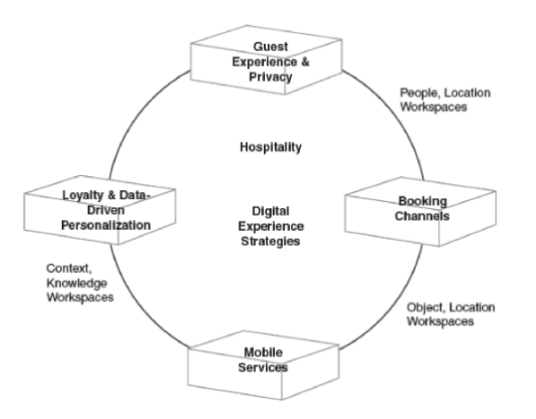
The Digitisation of Activities at the Hilton Hotel Groups
Source: (Dudovskiy, 2016).

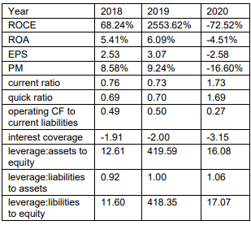
The performance of the Hilton Hotel Group before and during the pandemic
Source: (Lin Xi, 2021).

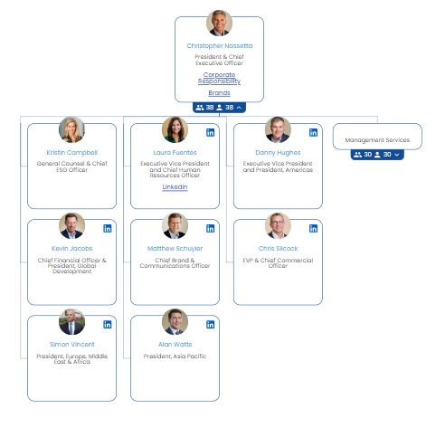
The Hilton Hotel Group Organisational Structure
Source: (Organimi, 2023)

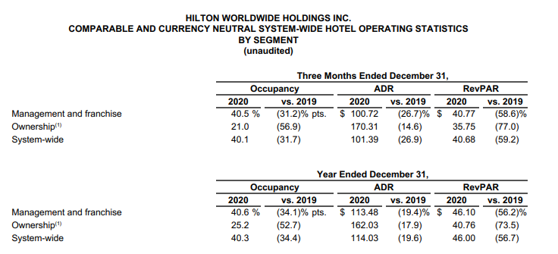
Fourth quarterly results of Hilton Hotel Group during the pandemic
Source: (Hilton, 2020)

