2018

Digital skills and research methods

AYSHA BEGUM ALI
STUDENT ID: 1710487
LECTURER: RENUGA JAYAKUMAR

Table of Contents
What is modern technology? 3
Differences in modern technology 4
G-MAIL 4
OUTLOOK 4
Modern Technology: Facebook page 6
Conclusion 6
REFERENCING………………………………………………………………………………………………………………………………..9

What is modern technology?

Modern technology is systems, equipment and methods used in the scientific view being used practically in businesses (Collinsdictionary.com, 2018).

All businesses use technology for an effective and productive service. Technology allows for the business to run smoothly, allowing good communication between the partners and clients. There are many types of technology available, some of the popular technologies used in businesses on a day to day basis includes;

A Computer is an equipment which is used in nearly all businesses and it is the most used technology and the most convenient. Business meetings, financial information, emails and presentations are all run through computers (Smallbusiness.chron.com, 2018).

Software is a system which is installed onto computers to provide all the functions e.g. Microsoft word and Microsoft excel; for containing financial information and writing reports. The software is required on computers for all businesses to perform their daily tasks.

Networking is done through technologies such as computers. Networking allows for individuals to access and share information within the company and it provides a source which allows for all computers and data within the computers to be linked to one source (Smallbusiness.chron.com, 2018).

All businesses have a telephone line which is connected through all the handsets. These types of systems consist of both hardware and software’s which connects all the handsets together, and they share one phone number which is the company’s contact number. Accounting systems is the financial margin of the business. The accounting system is a software which records the organization’s expenditure as well as their budgets and funds.

Inventory control systems, this is when there are systems within a workplace where it keeps the stock levels in control, this can ensure the stock levels are in balance and this can help save time and effort ordering stock which may already be in stock. The system is frequently updated so the right figures are on the system and the results are true.

Differences in modern technology

Below, there are examples of modern technology and the differences between the differences between the two.

DIFFERENCES
 | G-MAIL | OUTLOOK
INTERFACE | Clean, email only interface, generic ads | Ribbons, file tab that opens backstage views.
Spam control | Can hit the junk button then will automatically Go to junk. | Outlook automatically labels these messages and adds an unsubscribe button to it.
Email Storage Space | 10GB | No cap on email storage.
JUNK MAIL CONTROL | Not so good at filtering | Solid spam filters.
Send attachments | 25MB or less | Large as 100MB.

Gmail allows you to store only 10BG storage on your email and this is limited to 25MB for attachments sent via email, if the files are larger than this, the attachment will not process and it will fail (Sartain, 2018).

On the other hand, outlook allows for you to have unlimited storage space with no limitations. Sending attachments can go up to 100MB of images and videos. The benefits are that it this allows to send large files and it is beneficial for business professions as the work files can be saved within outlook or One drive, this guarantees the safety of the attachments being saved and they will not go missing. In addition; this can be beneficial for businesses as presentations and files can be backed up and saved on outlook, One drive.
Gmail is better at managing and filtering junk mail and outlook has its own ways of disappearing. Outlook automatically unsubscribes certain junk mails advertisements without having to filter it to do so.
Outlook’s spam control is filtered and this routinely changes the emails and filters them according to their type which includes spam messages and junk messages. The emails may come through but the messages and emails do not come constantly (Comparison, 2018). This is beneficial for businesses and for use of work because this is easy, accessible and it is automatic.
Gmail also has its filtered settings where spam is not a problem with the emails. It does not have the same system as the outlook procedure however, it is accessible and easy to set up manually, this includes to opting out of the spam emails and unsubscribing. This is more beneficial for personal use than businesses as time is money therefore spending time manually changing something where there’s another available option, it is not necessary to stay.

Modern Technology:

Facebook business page Heavenlyhandmade
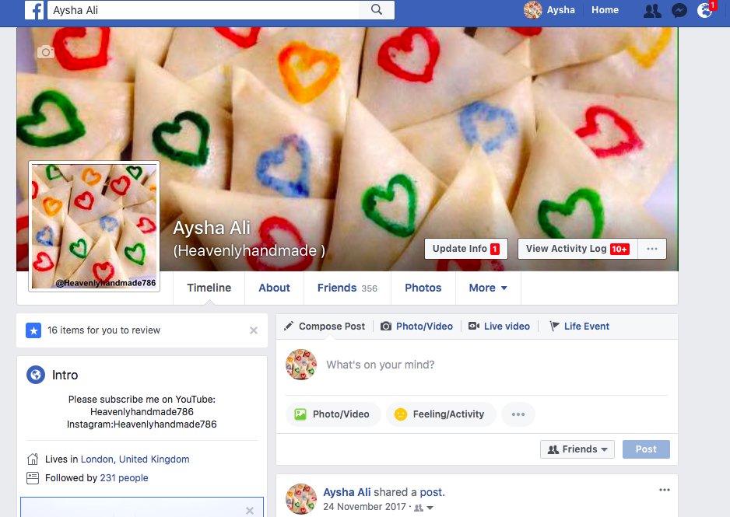

This above Facebook screenshot is my business page that I have created,
Running a business page can be challenging with some benefits too, because it’s a worldwide social media you can go private or be open to all so there is no restrictions on the page therefore everyone can view the business page.

Facebook is one of the leading social media in the world.
You can be connected to some business associations were they may be potential customers.
Posting online eye catching, colorful media will help you to rise online visits.

One advantages allows Facebook advertising is specifying all age group e.g
Age, genders, interests, area, and many more.

To boost up your online Facebook Business you can give out special offers,
Your own delivery and charge a small amount of charge or even add few pounds on the item & give free delivery to satisfy a customer. A good customer feedback is a must.
A negative feedback can slowly ruin the business reputation. We therefore need to be more alert and improve on these areas need to handle these customers in a very wise way due to their messages being public.
It will be a good idea not to delete genuine comments.

Emails used in business is so important sending customer messages also receiving
Orders.

Another way to connect with customers is by MESSENGER this is another app that keeps us close with our customers, take orders and also sharing messages,

Running a business requires your maximum time and commitment.
It will be a good idea if you can divide the work load into groups so you can manage your time more effectively.

Some of the staff may need training for few weeks just to be more focused and that they will be more aware of the work station they are placed in.
Sometimes it’s a good idea to investing on the social media by paying for the advertisements, this budget will also come out our own pocket,
Facebook is a social media website that shows no sign of slowing down,
As long as you use the Facebook creatively, and successful advertising has been done
Customers will respond to the business.

Conclusion

I have a lot experience during this term, some skills like computing,
There are different experiences gained in making a social media business page,
Dealing with many different people online can be challenging at the same time enjoyable getting to communicate with people from all over the world.
Being your boss of your own business makes individual feel proud.

Reference

- Collinsdictionary.com. (2018). Technology definition and meaning | Collins English Dictionary. [Online] Available at: https://www.collinsdictionary.com/dictionary/english/technology [Accessed 19 Apr. 2018].
- Smallbusiness.chron.com. (2018). What Are the Types of Business Technology? [Online] Available at: http://smallbusiness.chron.com/types-business-technology-167.html [Accessed 19 Apr. 2018].
- Sartain, J. (2018). 5 ways to manage emails and control spam in Outlook. [online] PC World. Available at: https://www.pcworld.com/article/2886662/software-productivity/5-ways-to-manage-emails-and-control-spam-in-outlook.html [Accessed 26 Apr. 2018].
- Comparison, O. (2018). Outlook vs. Gmail: A Feature-by-Feature Comparison. [online] Mohsinister.blogspot.co.uk. Available at: http://mohsinister.blogspot.co.uk/2012/08/outlook-vs-gmail-feature-by-feature.html [Accessed 25 Apr. 2018].
- https://www.nibusinessinfo.co.uk/content/advantages-and- disadvantages-Facebook-business
- https://www.inc.com/logan-chierotti/7-reasons-facebook-is-the-place-to-grow-your-business-in-2017.html

