Introduction
The roles that I was assigned based on the Belbin table that was created were Plant and Monitor evaluator. I decided to research my roles a bit deeper to try and get a better understanding of them and to help decide what tasks I could do to help the group achieve an innovative product that was sustainable. Here are my findings:
Plants are innovative members of the team. They come up with original approaches and ideas that help the team in solving problems or overcoming challenges. Plants are introverts in nature and possess poor communication skills. Plants prefer to work alone. They react well to praise but are greatly affected by negative criticism. Monitor evaluators are the critical thinkers in a team. They're serious minded and cautious in nature. Rather than rush into decision making, they prefer to critically analyse information before making any conclusions. Monitor-evaluators lack the energy to motivate other team members and are deemed to be slow in decision making (What Are the Nine Types of Team Roles?, 2020).
With a better understanding of my role, the tasks I suggested to the others that I would complete were to find ideas and evaluate them and make a final selection.
Ideas
To begin my task, I had to think of ideas. This meant I had to brainstorm. I decided to try and come up with ideas of my own and if I was struggling to come up with them then I would go to the team for ideas. I went into the brainstorming stage with the premise of no idea is a bad idea. While group brainstorming is often more effective at generating ideas than normal group problem solving, several studies have shown that individual brainstorming produces more – and often better – ideas than group brainstorming. This can occur because groups aren't always strict in following the rules of brainstorming, and bad behaviours creep in. Mostly, though, this happens because people pay so much attention to other people that they don't generate ideas of their own – or they forget these ideas while they wait for their turn to speak. This is called "blocking." When you brainstorm on your own, you don't have to worry about other people's egos or opinions, and you can be freer and more creative. For example, you might find that an idea you'd hesitate to bring up in a group develops into something special when you explore it on your own (Brainstorming: Generating Many Radical, Creative Ideas, 2020).
As the product would have to be sustainable I decided to put a few constraints on the brainstorming stage. The first is that it would be made of plastic. Plastic is the 4th most recycled material on the planet after concrete, steel and aluminium (Top 10 Most Recycled Materials: Lists and Examples, 2020). Plastic is also a much cheaper and lighter alternative to the other materials above it on the list. The second constraint was that it should be able to be 3D printed. This meant that any big projects wouldn’t be able to be considered as size would be an issue and the time taken to print bigger objects wouldn’t make it cost effective. The last constraint I decided to use was to ensure that the product would be used regularly. By thinking of a product that you would use weekly/daily I could ensure that I wasn’t manufacturing something that was only going to be used a handful of times then be discarded of.

Plastic amplifier for mobile phone – 3D printing an amplifier for a mobile phone out of plastic. This could be achieved by designing a base with a slot for the phone to sit in. The slot would then have two chambers run off either speaker at the bottom of the phone which would amplify the volume played through the speakers. The design would have to be drawn up on 3D CAD modelling software. The amplifier could be personalised using different colour and patterns. Speaker systems can be rather expensive and can be considered a luxury item. This idea gives a much cheaper alternative to the pricey options on the market. Size is another factor when it comes to reasons why someone wouldn’t purchase a speaker system. The design would be small enough and light enough to transport, maybe not pocket sized but certainly in a bag. With this idea there is no need for electricity to play the sound and you wouldn’t be restricted to a battery life like you would for the portable speaker systems. If the product did break then the material could be recycled. The quality of sound wouldn’t be as good as a speaker system, but I think it’s a good cheap alternative.
Cable holder – 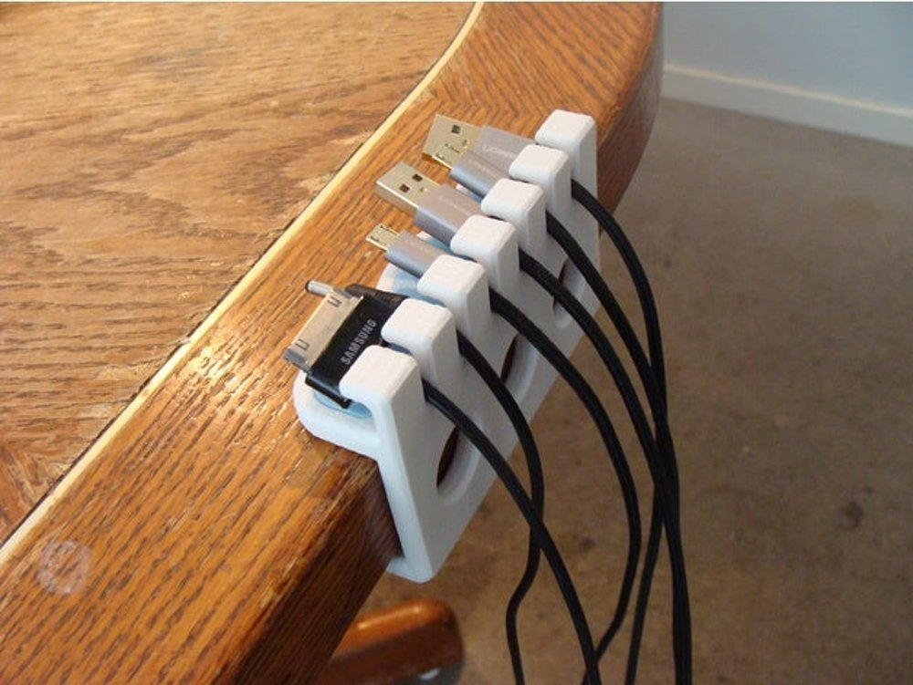
Fridge drawer – A drawer that is 3D printed with plastic to hold fruit, vegetables or any other products in your fridge. The design would have a topless box shape with a slot either side so that it would mimic a drawer. This would then be able to slide on and off the shelf that would be placed above it. This design makes use of space that is usually wasted in most people’s fridges. The main advantage of this design is you could have multiple drawers along the shelf for different fruit and vegetables. The user could then avoid single use packaging from supermarkets by taking their own reusable bags shopping and picking loose fruit and vegetables and brining them home to put in the drawers. The downsides to this idea are that some types of plastic can become brittle over time when exposed to cold temperatures. Also, the drawers would have to be washed every so often. This could cause more problems as some plastics would likely deteriorate over time when exposed to water and chemicals from cleaning products. The choice of plastic could negate these issues, but the choice may also incur higher costs due to the favourable properties.
Cutlery – 3D printed plastic cutlery for events and festivals. A simple design could be produced on software and batch printed in minutes to produce recyclable cutlery. An estimated 23,500 tonnes of waste are produced by music festivals in the UK each year – about the same as weight as 78 fully loaded Boeing 747 Jumbo Jets. Drinks and food are sold in disposable plastic cups, bottles and food containers, along with enormous amounts of plastic cutlery (Gray, 2020). This idea gives us a service to offer as well as a product. The success of a service like this would rely on the end users

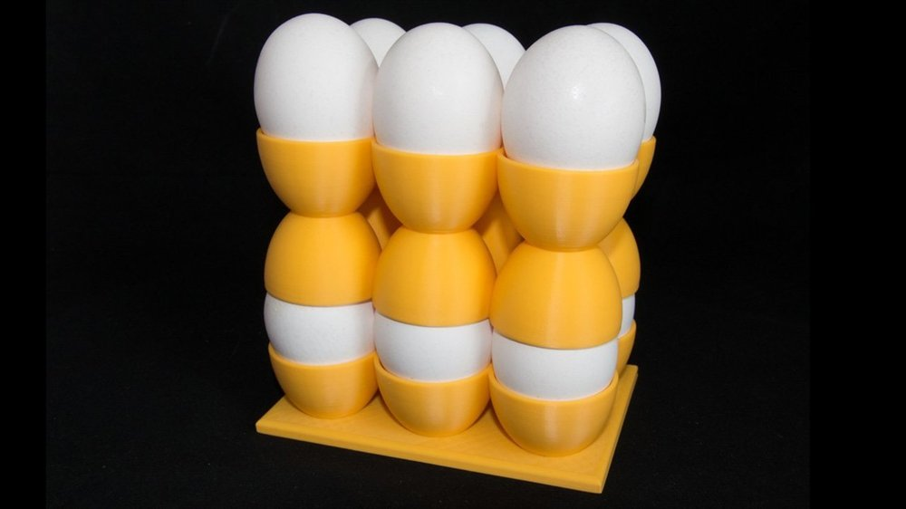

Bibliography
Small Business - Chron.com. 2020. What Are The Nine Types Of Team Roles?. [online] Available at: <https://smallbusiness.chron.com/nine-types-team-roles-15566.html> [Accessed 24 June 2020].
Mindtools.com. 2020. Brainstorming: Generating Many Radical, Creative Ideas. [online] Available at: <https://www.mindtools.com/brainstm.html> [Accessed 24 June 2020].
TurboFuture. 2020. Top 10 Most Recycled Materials: Lists And Examples. [online] Available at: <https://turbofuture.com/misc/recycled-materials-list-examples> [Accessed 24 June 2020].
Gray, R., 2020. The People Fighting The War On Waste At Music Festivals. [online] Bbc.com. Available at: <https://www.bbc.com/culture/article/20190627-the-people-fighting-the-war-on-waste-at-music-festivals> [Accessed 25 June 2020].

