Student-teacher: | Jayne Morgan | Class / Group: | Y1/2
AoLE or Subject: | Languages, Literacy and Communication | Date (please note that this may be a continuous session): | Monday, 12th October 2026
Meaningful links to Curriculum (What Matters Statements, Descriptions of learning, ‘previous’ curriculum...) | WMS3 - Expressing ourselves through language is key to communication  - I can contribute to shared writing for different audiences and purposes.  - I can organise my writing into a logical sequence.
Meaningful links across the curriculum  Links to other AoLEs or the Cross-curricular skills frameworks) | - I am beginning to write using familiar words and phrases. (LNF)  - I can write words and phrases by using knowledge of letters and the sounds they represent. (LNF)  This writing lesson is part of a cross-curricular theme about Pirates. The children listened to a story, “Sunk”, on the previous day. This lesson builds on that session.
Personal Targets (targets and consequent impact on learning - refer to any targets that have been identified in learning journal or weekly reflection meeting and describe the desired impact on learning)
- N/A

Learning Intention
‘This should focus on the pupils’ learning during the lesson, rather than what they will be doing, and should be short, achievable and measurable.’ (Crichton, H., and Mcdaid, A. 2016 p. 196)
- I can contribute to shared writing for different audiences and purposes. (PS1)
- I can organise my writing into a logical sequence. (PS2)
- I can write words and phrases by using knowledge of letters and the sounds they represent. (LNF)

Success Criteria
What the pupils need to demonstrate to successfully meet the Learning Intention.
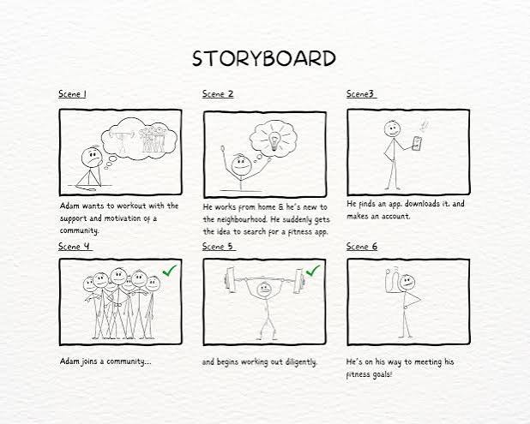
- Will demonstrate participation in shared writing process by using whiteboard
- Will begin to formulate ideas in a logical sequence using a story board
- Will write ideas underneath the pictures of the story board.
- Will write words and phrases by using knowledge of letters and the sounds they represent
Planning for misconceptions:
Use this section to anticipate pupil errors and misunderstandings and your planned responses to them.
Do the children understand that the story has a sequence ? What happens next? Can they transfer that onto their story board?
Can the children use the magpie words?

Strategies to support learners’ Welsh language development
Key vocabulary:​

- môr-leidr – pirate
- môr-ladron - pirates
- llong - ship
- het - hat
- cleddyf - sword
- hwylio - sailing
​
Language focus:​
​New vocabulary
​
Language teaching and learning activities:
Simple repetition of new vocabualry

SEQUENCE OF TEACHING & LEARNING
(Add or remove rows below as appropriate)

Timing:  Break down timings into groups if appropriate. ensure pupils are ‘doing’ quickly and that transitions are taken into account | Role of the teacher & support staff:  e.g., key questions, retrieval of prior learning, modelling and explanations, checking understanding, planned use of additional adults.  Choice of pedagogical model or of the 12 pedagogical principles | Pupils’ learning and activities:  What will the pupils be learning to do and what activities / resources will facilitate this?  Please refer to Foundation Learning planning document for details of continuous provision. | Inclusive Strategies (including differentiation):  Reasons for and details of scaffolding.  Types of representation in tasks. | Check what pupils know, understand, and can do:  Key questions, types of retrieval practices, self and peer assessment opportunities, purposeful AfL strategies, live marking opportunities, planned feedback.
10m  Carpet | Introduction  Recap of the theme (Pirates) and reminder that they did listen to the story on the previous day.  Have the book on your lap.  Show each page to the children  Explain to the children what they will be learning. | Children to retell the story to a partner. | Have children who will need support close by so they can be supported. | Who remembers what we have been learning about?  Can you tell me the title of the story you listened to yesterday?  Who were the characters?  What happened in the story?
5m  Carpet | Sequencing the story:  Draw 3 / boxes on chart paper.  Guide the children as they identify the different parts of the story.  Write key vocabulary  Model how to write simple sentences.  Point out when and how we use full-stops. | Children to draw on white boards what they think happens in answer to each question. | Some children can write what happens instead of drawing. | What happened first?  What happened next?  What happened at the end?
15m | Children to use the template to draw and write.  Move around the class and engage with individual children and groups. | Children to use the template provided to draw the story in sequence. | All / some pupils will be encouraged to write what happened too. | Ask children to tell you what they have drawn as you move around the class.  Can they tell you?  Have some of them written? If so, which strategies have they used to spell words?
5m  Carpet | Plenary  Ask children to show each other their story boards. | Children show another child their storyboard. |  | Did Child A do a good job of the story? Was it in the right order? Did they write the words correctly?

