

BMSW5102: Leadership & Management Skills for Workplace
Developing Relationship and workplace achievem

Critically evaluate development vehicles
Student ID:1916729
Student name: Galina Cavcaliuc

1.1 Introduction
This report focuses on the needs and expectations of the employees from Unilever with reference to their personal development in order to play a fundamental role in the growth and expansion of the business. This report will also include the discussion about the fact that how a developing employee is a beneficial asset for the organization ad plays a key role for the organization in gaining substantial market advantage over the market competitors. Development vehicles that are being available in the workplace environment of Unilever will also be highlighted in order to cater the individual need of its employees. In the end a detailed plan will be included focusing on the fulfilment of the identified individual needs and performance of the management within the workplace premises of Unilever UK.

1.2 Developing Employees and beneficial impacts in the Organization:
The accomplishments, performance and market reputation of every organization is directly proportional and linked with the related workforce/ employee development (Jehanzeb, Nadeem and Bashir, 2013). Developing Employee / or colloquially known as employee development is a method of partnering with workers to strengthen, expand, refine and cultivate existing capabilities, and to also create newer ones, in pursuit of the organization’s vision and objectives. It is basically of collaborating strategy with workers to strengthen, reinforce, refine and hone existing talents, and to also create newer ones, in pursuit of the organization’s mission and objectives (Jacobs and Washington, 2003).
Employee development is associated with the organizational development (OD). Therefore it is a practise of planned organisational transformation in employee beliefs, behaviours and values for personal and enterprise development. It is linked with the provision of the required help to assist and support a business to adjust faster and respond to changes in industry/the market and technical advancements.
Employee development has many beneficial impacts over the organizational growth and development. Few of them are
- The expensive (and often lengthy) method of recruiting an outgoing employee has been stopped due to the developing employee strategies and methods.
- Developing employees has been proven to be substantial in preserving the organizational investment that can be explained by the business term of “sunk capital” in order to improve the expertise and experience of the currently hired/existing workforce.
- Employee development is important in encouraging and pushing the HR management for building upon the existing organisational culture that has already been incorporated and has been displayed by the employee via his performance rather than creating and inculcating organizational culture from the scratch (Mustapha et al., 2004).

1.3 Managing Individual Needs and Expectations w.r.t Personal Development
The organization's achievement and loss specifically involves the efficiency of the employee. So businesses spend large amounts of money in the growth of workers (Shraddha Awasthi and Kumar, 2016). Similarly Unilever has allocated a significant percentage from its HR budget in order to fulfil the needs and requirements of its employees with respect to personal and professional development. Administrations and managements across different market sectors are mindful that training and employee development is crucial to team achievement. Yet many do not take the time to consider the individual/customised interests/needs/requirements of the individuals from the team members although they accept the fact that it is the best way to guarantee their employees have the expertise and experience to achieve their goals (McNamara, 2019).
Unilever UK, however is very focused and determined to fulfil and manage the individual needs by the following ways
- Ensuring a support for the employee’s Physical and Mental well-being
It is the basic/primary requirement that workforce of the organization should be made sure that their management/administration care about them. They understand the physical, emotional, health and nutritional needs that are necessary for the optimum employee performance at the organization. HR department and Unilever management make sure that they provide the necessary support and cooperation from their end by providing peaceful and cooperative workplace environment as well as providing a space to all employees at individual and group levels to perform their tasks by managing a balance between their mental and physical health (Sutherland, 2019).

- Provision of a healthy and positive workplace environment with a positive employee relations
The employee performance is directly proportional to the level of availability of the positive energy from the workplace environment and its coherence to fulfil the the social and emotional needs of the employees (Satterfield and Hughes, 2007). Therefore Unilever management encourages and cultivates appositive work environment employee relations, discouraging conflicts and support collaborative team work approaches for achieving organizational goals and objectives which strengthen the bond between organizational workforce (Hameed and Waheed, 2011).

- Provision of ample professional challenges for Mental Simulation
The professional challenges in relation with the self-growth and emotional relaxation meet mental needs of the employee o individual basis. Employees require continued intellectual and cognitive growth. If these desires are not fulfilled, workers are typically stagnant, bored and ultimately unhappy. Unilever management manages the behavioural needs by supplying staff on individual basis with intellectual challenges and opportunities to move forward, to broaden existing awareness and thinking; strengthen their capacity to function creatively and independently; and strive to create opportunities to learn new talents (GetSmarter, 2019).

1.4 Development Vehicles available in Unilever UK appropriate to the development needs of the individual

Development needs:
These are the needs that the employee requires to understand their role more clearly by the help of the employer. Strengthening the strengths of the employees rather than always focusing on the weaknesses of employees as well as helping them to polish or bring up the skills, behaviour and knowledge to perform the assigned tasks more efficiently. This starts by asking the employee what he/she thinks about his/her skills and expertise regarding the fulfilment of the tasks. Asking them what they think are the needs that are required to be developed or what the gaps are according to their personal observations (Sands, 2020).

Development Vehicles
Unilever is utilising different development vehicles to address the development needs of its employees. The developmental vehicles utilised by Unilever are as follows:

- Skill based trainings
Unilever UK, launches quart monthly skill based trainings according to the needs of the individuals within the premises of its workplace by understanding and evaluating their performance via different performance monitoring evaluating strategies and tools. These skill based trainings are designed keeping in mind the individual needs, expertise and performance level of the employees in relevance to the suggestions added by their higher authorities. However employees can themselves also write to the HR department for including them in any ongoing/upcoming training program that they feel will increase their professional capabilities and lead to their personal development. Employees are encouraged to participate in different trainings and development programs to increase their professional expertise and strengthen the position of the organization by delivering optimum performance (Wang, 2019; (Chen and Klimoski, 2007)).
Appropriateness for meeting the development needs
This is effective and appropriate in manging the development needs of the individuals as they directly emphasize/work on the individuals lacking with respect to their professional assignments. These skill based trainings play a fundamental role in fulfilling the skills and technical expertise of the individual in order to address and fulfil the development needs of the employee on the customised basis.

- Monitoring Performance/Motivation rewards and appraisals
Individual professional skills and expertise of the employees at the Unilever are monitored by different performance monitoring tools which highlights the loopholes/contradictions with respect to the expected level of performance of the employees. Management works on the obvious reasons to cater those loopholes in order to manage and cater the employee needs for improving his/her performance. One of the development vehicle used for such purposes is creating motivation via rewards and appraisals and sometimes punishments. This development vehicles catalyses the employees to give their optimum this helps in managing their development needs (Dachner et al., 2019).
Appropriateness for meeting the development needs
Appraisals, rewards and punishment have been proven to be very effective in cases where employees lack motivation or inspiration for working on their personal development. These development vehicles act as a catalyst to perform according to the performance standards of the organization in order to prove their worth. This also help them in growing their professional and personal capabilities.

- Feedback and evaluations systems
One of the most effective development vehicles utilised regularly by the Unilever management is the implication of the feedback and evaluation systems. This helps the organization to understand the expectations and needs (personal/professional) of the employees that they are expecting from Unilever to address on immediate basis. This helps in gaining and strengthening employee satisfaction and loyalty with the organization by being ensured that Unilever care about them and is focused to fulfil their needs and requirements.
Appropriateness for meeting the development needs
This development vehicles used by Unilever UK is effective in for employees as well for the management in understanding the basic reasons or factors that has created any obstruction towards fulfilment of the development needs of the individuals or expectations of the organization from the individual employees. Thus after mutual discussions between employee and management about the feedback and evaluation forms, one can proceed directly in the right direction without wasting further time.

- Analysis and development of individual development plans
Unilever UK uses different analysis tools and mechanisms to research about the employee needs and requirements and on the basis of these analysis develop customised developmental plans in order to cater the professional and personal employee development.
Appropriateness for meeting the development needs
The development plans have been proven to be the most effective and significant development vehicles used by the organization that not only manages and addresses the development needs of the employees but also increases the employee satisfaction and contentment.

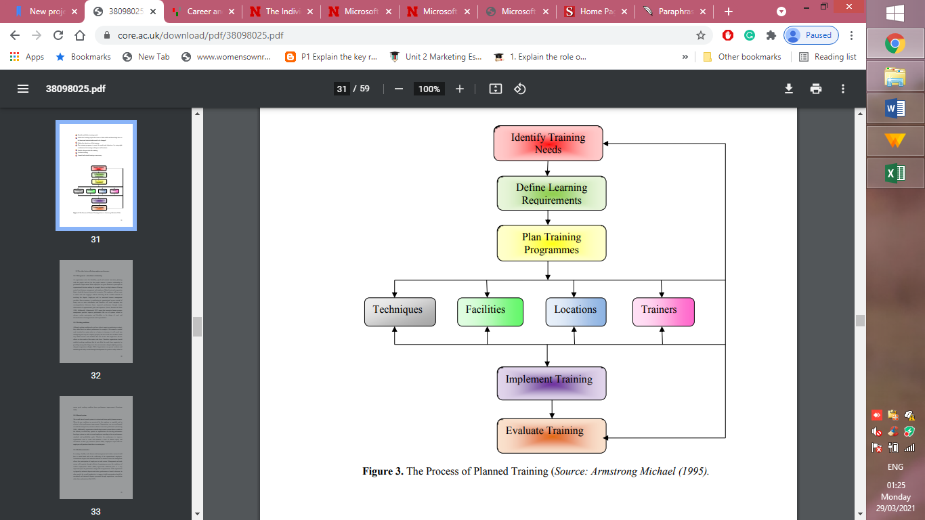

1.5 Detailed Plan to meet the identified development needs of an individual in the workplace and the management of performance.
Individual Development needs and Expectation meeting Plan

Name : Mark Ethans

Date: March 2021

Assessment of Development needs
STRENGTHS |  | INTERESTS
- Statistical and data analysis |  | - Research and development
- Communication skills |  | - Analyzing key market trends and existing Enhances the customer satisfaction and trust
- Expertise in experimental designs |  | - Preparation of project reports and proposals
- Innovation and Creativity |  | - Implementation of sustainable development strategies in operational activities.
- Data management and interpretation
GOALS
Long term career goals and strategies to achieve them
Being an employee at Unilever, what you are curious about? | What are the skills/needs that are required to meet by the development vehicles utilized by Unilever UK | What are the future progressive steps/activities that you will be needing to get involved into in order to fulfill your development needs? | Expected Goal Completion Date | Completion Date (Act.)
Understanding how Covid-19 will affect the business activities of Unilever across the world especially with respect to employees forced terminations | - Analysis of the project reports, business activities and future business investment plans of Unilever.  - Training in the research and development in order to understand the basics of organizational R&D departments and its requirements.  - Individual research and project proposal writing trainings for developing organizational plans and projects for future investments and projects. | - As a senior employee in the operational department of Unilever, I expect that I should be allowed to review, assess and manage the work plans related to the tasks that are assigned to me in order to asses my capabilities and skills to fulfill those targets and goals associated with my performance.  - Involvement in a Project proposal writing under the supervision of the research and development teams,  - Planning and implementation of the yearly research projects at Unilever for managing and meeting the needs of employees Plan identification of the problems that are related to sustainable development activities w.r.t to operational activities of Unilever. | APR2022  Feb 2023  June  2024
SHORT-TERM NEEDS FOR DEVELOPING SKILLS AND INTERESTS
Prioritize the skills you need to develop. What can you accomplish first, or what is absolutely necessary? | Specifically, how are you going to acquire these skills? (training, courses, teaching, job shadow, informational interview) | Where can you develop these skills? Are there multiple places? | Goal Completion  Date | Completion Date (Act.)
Writing of the budgets, as well as of the Business planning with respect to the ongoing and future investments  Developing skills with respect to writing plans for increasing investment opportunities and shareholder interests. | -On project training with budget preparing and planning teams of the Unilever  - Being provided with the opportunity to enhance my proposal and investment plans writing skills  -Informational interviews and trainings under the supervision of managers who have been successful in developing successful grant proposals for the past and current organizational investment projects. | By working with the research and development department in my extra hours with the fulfillment of my tasks at the operational department.  -Through skill based customized training and development programs that are being launched on quarterly basis by the Unilever UK.  -Communication and discussion with the investment project developers from other organizations in order to bring innovation and creativity in the investment plans. | Oct 2022  Dec  2022  Jan  2023  May 2023
Effective and significant Evaluation of the feedbacks and evaluation forms |  |  | August 2024

OTHER FACTORS TO CONSIDER
What are the career pressures that being an employee at Unilever you are facing? | What is your ideal working environment in order to fulfill your development needs? | What are the questions that are linked with your expected professional growth/career target? | Enlist three Organizations that you can contact in order to fulfill your development needs in future?
Market competition and new emerging and more experienced candidates | A cooperative and healthy workplace that encourages field work as well as office work to make me a competitive and skilled candidate. | Will Unilever allow me to pursue my Doctorate in Business research and development?  Will they allow me to take part in trainings that are not linked with operational department (my current job)? | Nestle UK  Arnold Clark UK
Have to improve and enhance my professional skills on regular basis in order to remain technically up-to-date with changing technology | I want to get involved in an organization that let me continue my professional studies in order to grab more career opportunities that I am sacrificing due to inflexible work hours at Unilever UK |  | Home Bargains Research and development department UK
 | I am looking forward for career opportunities that do provide financial id to candidates for pursuing higher studies in relevance to their profession.

Employee signature and date:

Advisor’s signature and date:

References
- Mel Kleiman (2000). What happens if you don’t train them and they stay? Occupational Health and Safety, 69 (1), pp. 18, 70.
- Bashir, Nadeem & Jehanzeb, Khawaja. (2013). Training and Development Program and Its Benefits to Employee and Organization: An Conceptual Study. European Journal of Business and Management. 5. 243-252.
- Chen, G. and Klimoski, R.J. (2007). Training and development of human resources at work: Is the state of our science strong? Human Resource Management Review, 17(2), pp.180–190.
- Dachner, A., Ellingson, J., Noe, R. and Saxton, B. (2019). The future of employee development The future of employee development The future of employee development. [online] . Available at: https://core.ac.uk/download/pdf/289197727.pdf.
- GetSmarter (2019). Employee Training and Development: the Benefits and Why it’s Important. [online] GetSmarter Blog. Available at: https://www.getsmarter.com/blog/employee-development/employee-training-and-development-the-benefits-and-why-its-important/.
- Hameed, A. and Waheed, A. (2011). Employee Development and Its Affect on Employee Performance A Conceptual Framework. International Journal of Business and Social Science, [online] 2(13). Available at: http://www.ijbssnet.com/journals/Vol._2_No._13_Special_Issue_July_2011/26.pdf.
- Jacobs, R.L. and Washington, C. (2003). Employee Development and Organizational Performance: A Review of Literature and Directions for Future Research. [online] ResearchGate. Available at: https://www.researchgate.net/publication/233706115_Employee_Development_and_Organizational_Performance_A_Review_of_Literature_and_Directions_for_Future_Research.
- Jehanzeb, K., Nadeem, A. and Bashir (2013). Training and Development Program and its Benefits to Employee and Organization: A Conceptual Study. [online] . Available at: https://www.dcvmn.org/IMG/pdf/3947-5999-1-pb.pdf [Accessed 28 Mar. 2021].

McNamara, C. (2019). Employee Training and Development: Reasons and Benefits. [online] Managementhelp.org. Available at: https://managementhelp.org/training/basics/reasons-for-training.htm.
- Mustapha, R., Yasin, R.M., Ishak, N. and Abdullah, A. (2004). Workplace Literacy: Employers’ Perspectives. The International Journal of Learning: Annual Review, 8(1).
- Sands, L. (2020). How to identify employee training and development needs. [online] www.breathehr.com. Available at: https://www.breathehr.com/en-gb/blog/topic/company-culture/how-to-identify-employee-training-and-development-needs.
- Satterfield, J.M. and Hughes, E. (2007). Emotion skills training for medical students: a systematic review. Medical Education, [online] 41(10), pp.935–941. Available at: https://onlinelibrary.wiley.com/doi/abs/10.1111/j.1365-2923.2007.02835.x [Accessed 28 Mar. 2021].
- Shraddha Awasthi, S. and Kumar, S. (2016). (PDF) Need for Employee Development in Employee Performance: A Present Scenario. [online] ResearchGate. Available at: https://www.researchgate.net/publication/316664674_Need_for_Employee_Development_in_Employee_Performance_A_Present_Scenario [Accessed 28 Mar. 2021].
- Sutherland, C. (2019). 5 Key Benefits of Organizational Development and How to Achieve Them. [online] Explorance. Available at: https://explorance.com/blog/5-key-benefits-organizational-development/.
- Wang, T. (2019). Career and Personal Developmental Needs: Developing Employees to Maximize Performance. [online] Mindtools.com. Available at: https://www.mindtools.com/pages/article/newLDR_06.htm.

