

University of Wales Trinity Saint David (UWTSD)
Module Name: Employability and Career Development
Module code: LCLM 4005
Assessment Title:
[ Assessment title e.g. Component 1 CV ]

CertHE Business Skills for the Workplace
Submitted by:
Sunnah Syed
Student ID: 2420729
Lecturer: Ibrahim
Submission Date:

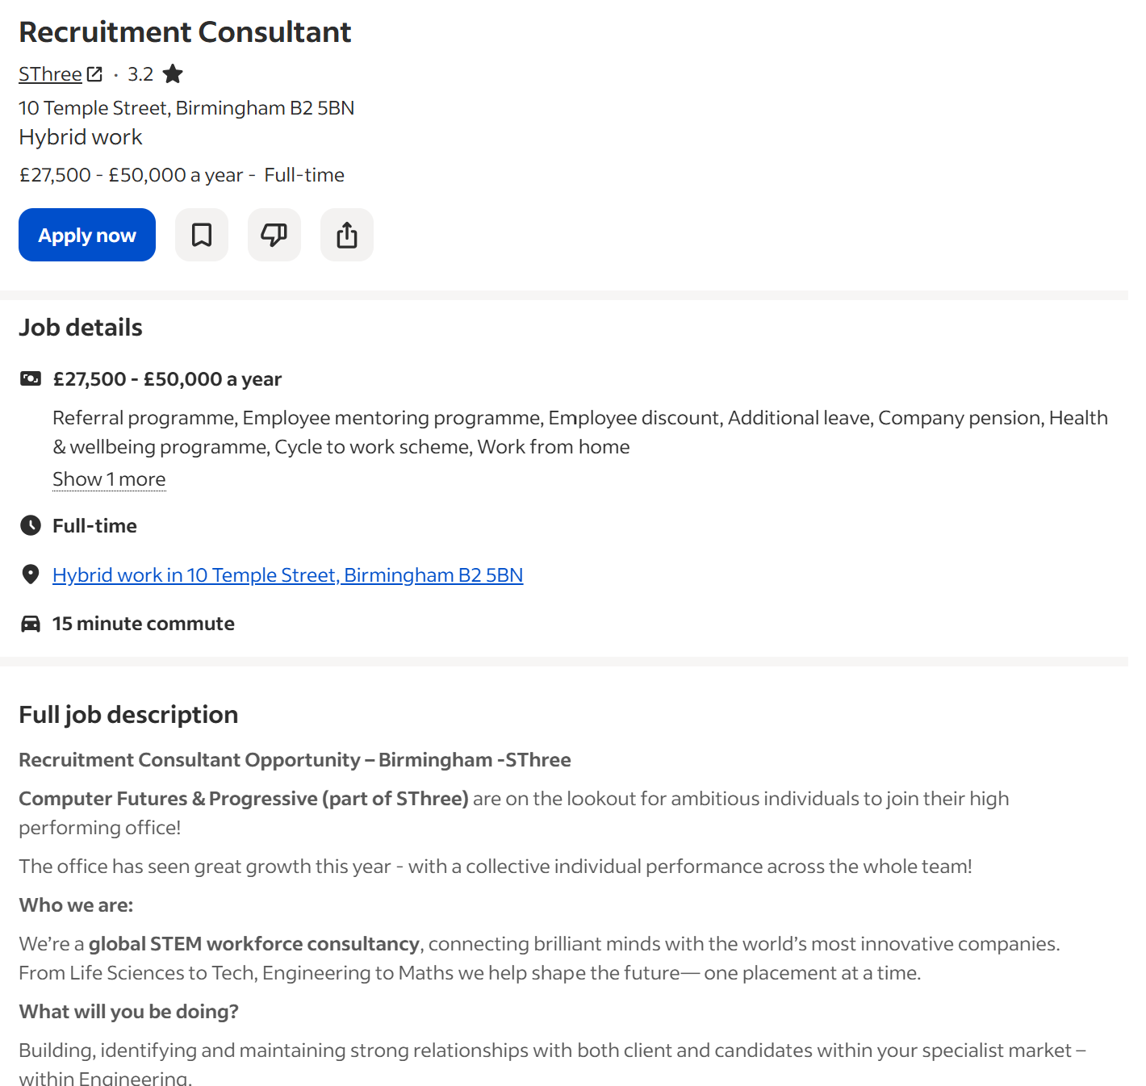
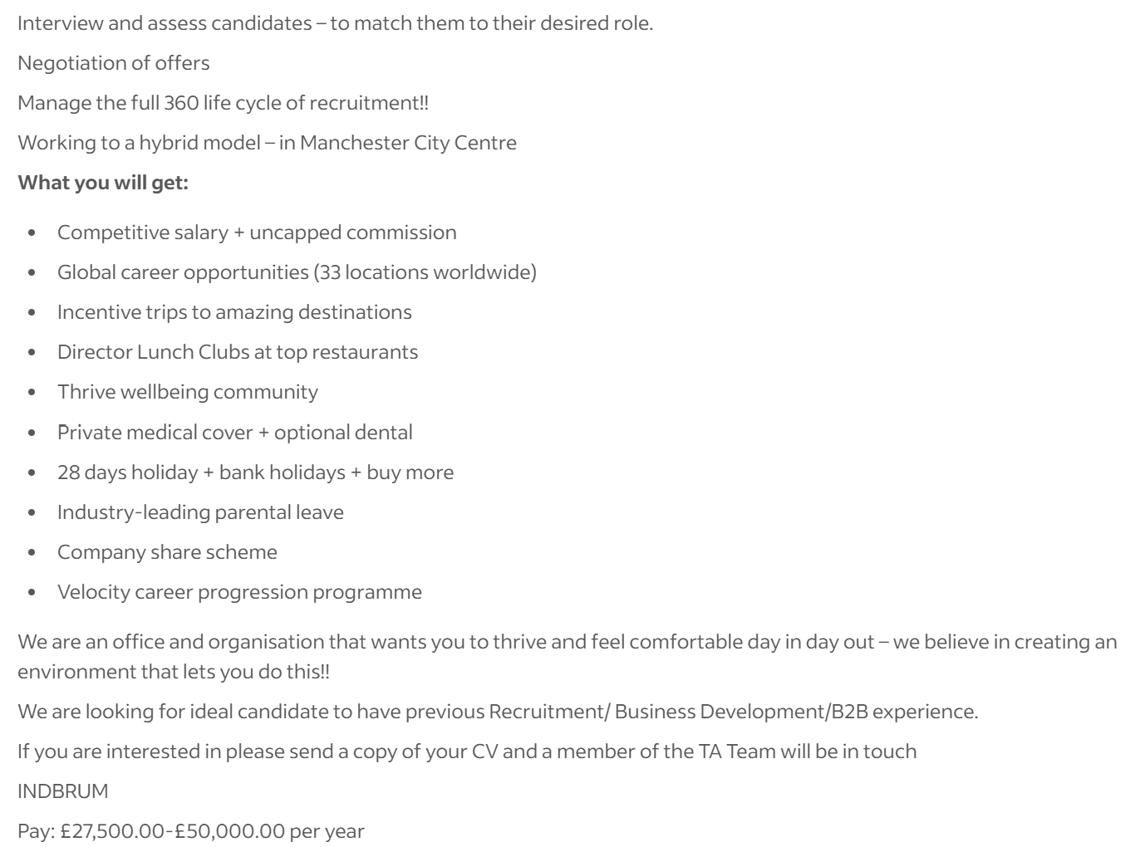

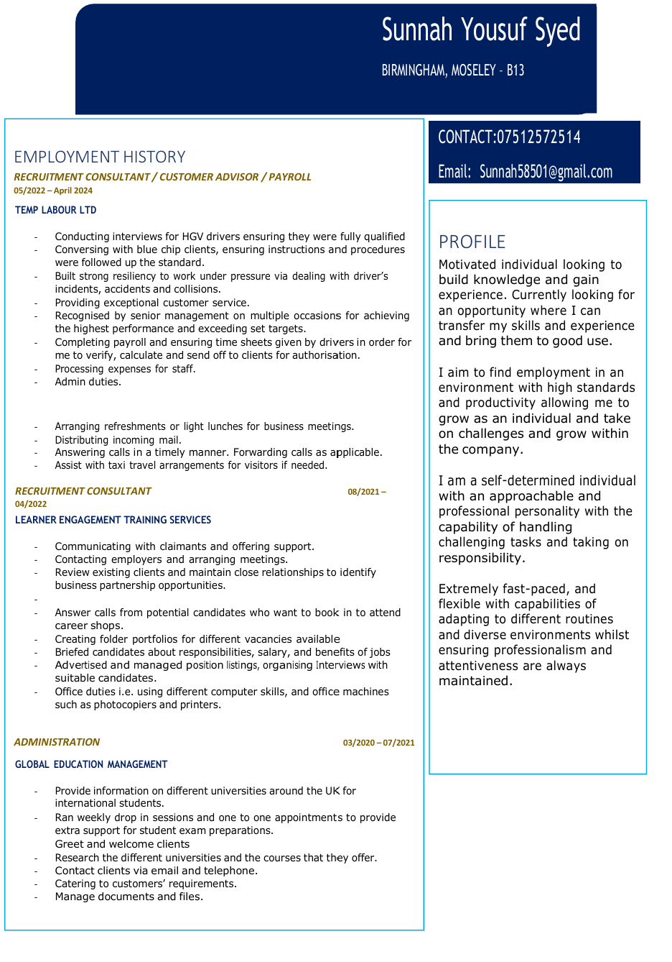
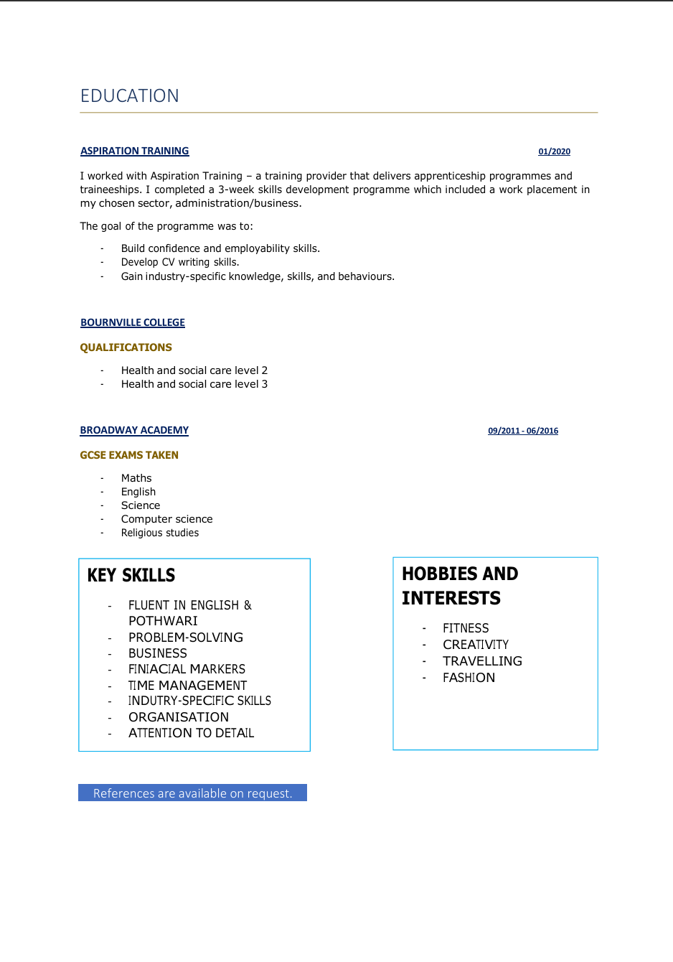
Cover letter for job role:
Sunnah
Birmingham, West Midlands
Dear Hiring Manager,
Re: Recruitment Consultant Position – SThree
I am writing to apply for the Recruitment Consultant position at SThree. Having previously worked as a Recruitment Consultant for a temporary labour company, I have gained valuable experience in the recruitment industry and feel that this role would be a great opportunity for me to build on the skills I already have while taking the next step in my career.
Working in recruitment has taught me a lot, particularly when it comes to dealing with different people, staying organised and working in a busy environment. Temporary recruitment can be quite demanding, as staffing requirements can change at short notice and employers often need people quickly. Through this experience, I have learnt the importance of being adaptable, thinking on my feet and remaining professional even when things become stressful.
One of my biggest strengths is my ability to communicate with people and build good working relationships. I enjoy speaking to different individuals, understanding what they are looking for and helping them find suitable opportunities. I also understand how important it is to maintain a good relationship with clients, as recruitment is not just about filling vacancies but also about building trust and providing a reliable service.
I would describe myself as hardworking, approachable and determined. I am someone who enjoys having responsibilities and takes pride in getting things done properly. I am also confident working independently, but equally enjoy being part of a team where everyone is working towards a common goal. My previous experience has helped me develop patience, good time management and the ability to prioritise tasks when dealing with several things at once.
What particularly interests me about SThree is the opportunity to work within a specialist recruitment market, especially engineering. I like the idea of developing my knowledge of a particular industry and building long-term relationships with both candidates and businesses. I am also attracted to the opportunities for career progression, as I want to work somewhere I can continue learning, challenge myself and grow professionally.
I understand that this position involves more than simply matching candidates to vacancies. It requires confidence, resilience, negotiation skills and the motivation to achieve targets. These are qualities I have developed through my previous recruitment experience, and I would welcome the chance to strengthen them further in a more specialised environment.
I feel I would be a good addition to SThree because I already understand the demands of recruitment, enjoy working with people and am willing to put in the effort needed to achieve results. Most importantly, I am genuinely motivated to progress in this industry and make a positive contribution to the team.
Thank you for taking the time to consider my application. I would welcome the opportunity to discuss my experience further and explain how I could contribute to SThree.
Yours sincerely,
Sunnah Syed

