Word Count: 2455- Amberlea Knowles – 2116495
(Part two of the Assignment in link Page 15)

The Role of Line Manager in Driving Performance:
Line managers play a crucial role in shaping the performance of their teams and employees within an organisation. Their influence extends to various aspects of performance, including individual productivity, team dynamics, employee engagement, and overall organisational success (Cunningham, 1995; Dany, 2008). Line managers are responsible for guiding employees in understanding organisational and individual objectives and ensuring that employees are managed in accordance with HR policies (Gifford, 2022). Additionally, they possess the ability to inspire, influence, and guide their teams (Armstrong, 2016:78).
Differentiating Between Managers and Leaders:
Leadership and management are often considered distinct yet interconnected concepts. Leadership involves creating a vision, motivating individuals, and ensuring employee engagement to inspire their best performance (Armstrong, 2016:4). In contrast, management is typically associated with resource allocation, planning, efficiency, and meeting deadlines (Armstrong, 2016:28). However, it is essential to recognise that effective people management necessitates both leadership and management skills (Birkinshaw, 2010:23). Armstrong (2016:34) emphasises that leadership and management are mutually dependent, with each requiring element of the other.
Leadership Styles and Models:
There is no single leadership style that universally dominates all situations. The effectiveness of a leadership style depends on various factors, including the organisational context, task characteristics, follower attributes, and leader goals (Bass, 1990). Different leadership styles may be more suitable and effective in different circumstances, and leaders must adapt their approach accordingly.
6 Leadership Styles
Goleman (2000) Identified 6 Leadership Styles to improve employee performance based on the situation and how the employee responds best:

- Coercive Style: This style can be effective in emergencies or when immediate action is needed, but it can create a hostile work environment, low morale, and hinder long-term employee development and creativity. (Bass & Riggio,2006)

- Authoritative Style: This style focuses on setting a clear vision but may leave little room for collaboration, creating a dependency on the leader and inhibiting independent decision-making. (Northouse, 2018)

- Affiliative Style: prioritises maintaining harmony but may hinder growth and innovation by avoiding challenging the status quo. (Dumdum, Lowe, & Avolio, 2002)

- Democratic Style: This involves involving team members in decision-making, but it can lead to slower decision-making processes and diffused accountability. (Vecchio, 2000)

- Coaching Style: This style focuses on employee growth but may require significant time and resources, potentially limiting its applicability in fast-paced environments. (Losoncz & Gabor,2014)

- Pacesetting Style: This style can drive short-term results but may create pressure, burnout and hinder creativity and collaboration. (Almatrooshi, 2019)

The Importance of Trust and Psychological Safety in Leadership:

Creating trust and psychological safety in the workplace requires leaders to lead by example, encourage open communication, value diverse perspectives, and provide support and feedback. When leaders prioritise these elements, they cultivate an environment that unlocks employees' full potential, promotes innovation, and fosters a culture of continuous learning and growth. (Edmondson, 1999: 354)

Reflective Activity: - Think of the worst boss in your career; what was it that you didn’t like, what characteristics did they have, and how did they make you feel?


The Importance of Effective Teams:
What is a team?
As defined by Young and Gifford (2023:3)
“It’s a group of people working together to achieve a goal. But it is not simply a group; a team is a collection of interdependent individuals who share responsibility for outcomes and fit into a larger social system, such as a business”.
- Common Goals
- Shared objectives
- Aligned attitudes and values.

What constitutes an effective team?
Team effectiveness and performance are often synonymous and encompass the effectiveness of the team’s core responsibilities, the ability to exceed responsibilities collectively and its’s adaptiveness to innovation and change. (Young &Gifford, 2023:3)
WHSmith measures effective teams and management through operational metrics such as (Scollen, 2023).
- Sales Performance and profit contribution
- Store standards and operational compliance.
- Labour Turnover and absence data.
- Employee Engagement scores
The assumption in WHST is that the better the contribution % of the metric, the more engaged the team and leadership are, thus, the more successful.
The Impact on Organisational Performance:
An effective team plays a crucial role in organisational success, impacting various aspects of an organisation's performance and functioning. (Armstrong, 2016: 324) Research has shown the importance of effective teams in the following areas:
Enhanced Productivity and Performance: Effective teams are likelier to achieve higher productivity and performance than individual contributors. (Mathieu et al., 2008).
Increased Innovation and Creativity: Teams that foster collaboration and a climate of trust and psychological safety are more likely to generate innovative ideas and creative solutions to problems (Anderson & West, 1998). Better communication and coordination facilitate efficient workflow. (Jehn et al., 1999).
Improved Employee Satisfaction and Engagement: Effective teams create a sense of belonging and fulfilment, leading to higher levels of motivation and commitment (Salanova et al., 2005).
Team Management Theory:
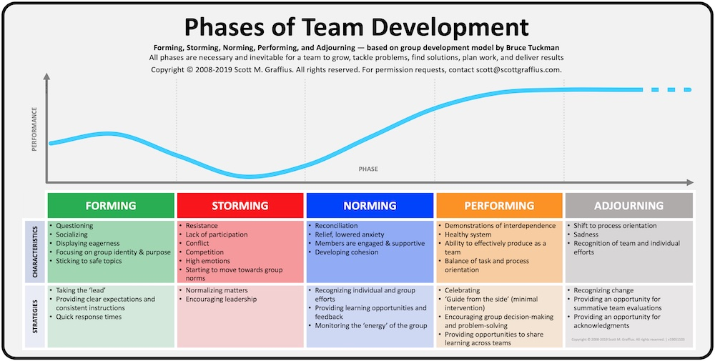
Effective team management requires flexibility, adaptability, and ongoing effort. Tailoring management styles to the needs and dynamics of the team while maintaining a focus on achieving shared goals and fostering a positive work environment. (Avoli & Gardner, 2005: 320) Leadership is crucial in managing and engaging effective teams. (Armstrong, 2016:324) There are Team building models such as Tuckman’s (1965) Stages of Group Development, Comprised of five stages:( Below)

Limitations of Tuckman’s Theory:
- Limited Consideration of External Context: The Model focuses on a team's internal dynamics and processes but does not explicitly consider the external factors or context that can influence team development and performance. Factors such as organisational culture, leadership style, and external pressures can significantly impact team dynamics and may need to be considered alongside Tuckman's stages. (Hackman, 2002) In addition, the model emphasises team members as homogenous and does not consider different levels of motivation and expertise. (Grant & Berry, 2011).
- Overemphasis on Linear Progression and lack of inference on team nuances: The model suggests a linear progression through stages, starting from forming and ending in adjourning. However, teams may not always follow a linear path, and the progression through stages can be non-linear or cyclical. Team dynamics can fluctuate, and teams may revisit earlier stages or experience regression, especially during conflict or change. (Bouchikhi & Kimberly, 2003; De Drue & Weingart, (2003).
- Insufficient Guidance for Team Leadership: While Tuckman's model provides a framework for understanding team development, it offers limited guidance for leaders regarding specific strategies or interventions to support team progress or overcome challenges. Other theories and approaches may be needed to complement Tuckman's stages and provide practical insights for team leadership. (Yuki, 2010)
Summary:
Tuckman's Stages of Group Development remain a valuable framework for understanding team dynamics and can provide a general roadmap. However, it should be used with other theories and approaches to ensure a comprehensive understanding of team functioning and guide effective team management practices.
Reflective Activity: Think about your team – What segment is your team in according to Tuckman’s Theory, and what actions are required to move to the next phase?

Retention:
Did You Know……?
- WHS LTO is 63% per annum; for every 10 employees we recruit, we lose six within their first year
- 74% of new employees leave within the first three months at WHS? (Scollen, 2023)
- 50% of those are within the first month………

Why is Retention so important?
Employee turnover can harm an organisation’s performance (CIPD,2021). Retaining employees Is fundamental to organisational success. The average cost of replacing employees is £3000 (CIPD,2021)

- High Cost: The process of recruiting, hiring, and training new employees requires significant time, effort, and resources. (Allen & Bryant, 2012).

- Loss of Knowledge and Expertise: Long-term employees often need to gain more valuable knowledge and skills. This maintains productivity, saving money (Eisenberger et al., 2002).

- Organisational Culture and Stability: High turnover can disrupt the organisational culture and create instability. The well-being impact on other employees that workload increases in the absence of resources also creates turnover issues. (Cable & Judge, 1996).

- Organisations' reputation: A high employee turnover rate can negatively impact an organisation's reputation, negatively affecting talent attraction and Organisational branding (Harter et al., 2002).

Push Factors: Within Manager's control…
- Job Dissatisfaction: Low job satisfaction, limited growth opportunities, and poor work-life balance can lead to employee dissatisfaction and increase the likelihood of turnover (Wasti, 2005).
- Unhealthy Work Environment: Toxic work cultures, conflicts with colleagues or supervisors, and high-stress levels can push employees away from an organisation (Saks, 2006).
- Limited Career Advancement: A lack of clear career paths, limited opportunities for skill development, and perceived stagnation can push employees to seek better prospects elsewhere (Elnaga & Imran, 2013).
Pull Factors:
- Career Development and Growth Opportunities: Providing opportunities for skill enhancement, training, and a clear path for career advancement can pull employees towards staying and growing within the organisation (Elnaga & Imran, 2013).
- Positive Work Environment: A supportive work culture, positive relationships with colleagues and supervisors, and a healthy work-life balance can create a pull factor that fosters employee loyalty and engagement (Saks, 2006).
- Recognition and Rewards: Regular recognition, rewards, and opportunities for employee appreciation can pull employees towards staying with an organisation, reinforcing their value and contribution (Allen & Bryant, 2012).
How do managers foster employee Relationships? (Taylor, 2019)

- Balance praise and constructive feedback whilst displaying gratitude.
- Ensure all the team are treated equally and that there is no favouritism.
- Regular communication
- Show integrity and investigate potential problems within a team dynamic
- Provide Autonomy whilst ensuring objectives are met.
- Involve the team in decision-making and value their contribution.

Reflection Activity: What changes could you make to your leadership to improve retention in your store?

Managing Absence:
Statistics (Scollen, 2023)
- Last year 67,000 hours were attributed to Absence in WHSmith Travel.
- One hundred three employees have had 5 absences or more in 12 months.
- There are 88 Long-term sick cases, 20 over 26 weeks.
- The estimated cost of Absence in the last year was 6 million
- Main Reasons for absence, Stress, cold and flu and back pain.

Managing absence:
The role of the line manager is vital in absence management and ensuring that monitoring and addressing causes of absence are identified to ensure the well-being of the employee and the organisation's productivity. (Harvey, 2019) Absence is a considerable cost for the organisation and can have legal ramifications if not dealt with lawfully. (Acas, 2021)
How to manage absence lawfully and effectively in Line with WHST Policy:
- Managers should understand the sickness and absence policy
- Track and monitor absences ensuring that the employee knows the absence policy. (Dunn, 2020)
- Return to work meetings must be completed as soon as practicable (ACAS, 2021)
- The employee must be given access to support functions such as OH/ EAP. (CIPD, 2016)
- Trigger points in absence must be made clear to the employee, and the consequences, and reasonable adjustments, where possible, must be made throughout.
- Effective collaboration with HR is essential to ensure legal compliance and disability accommodations. (CIPD, 2016)
Absence Reintegration:
Return-to-Work Support: Employee well-being initiatives also play a vital role in facilitating the return-to-work process after an absence. Providing support, accommodations, and gradual reintegration plans can help employees transition back into work smoothly, reducing the likelihood of extended absences (Munn-Giddings & Winter, 2013).
- Phased return
- Flexible working
- Reasonable adjustments to working environments
- Reasonable adjustment to working practices. (ACAS,2021)

Managing Capability: Performance Management
There is no universal definition for performance management. Gifford (2023) outlines as below:
- Establish objectives for individuals in line with organisational goals
- Improve performance among employees
- Accountability for the employee to maintain performance through linking of career development, financial reward, or contract termination.
Define Capability:
Encompassing skill, aptitude, or health. It is potentially fair to dismiss an employee on the grounds of incapability as long as correct and fair procedures are followed (Taylor, 2019)
The importance of managing capability for the Employee:
Effective capability management is essential as this enhances employee performance through additional support and training. This enables the employee to meet the requirements of their job role and increases productivity and individual well-being. (Noe, Clarke, and Klein, 2014)
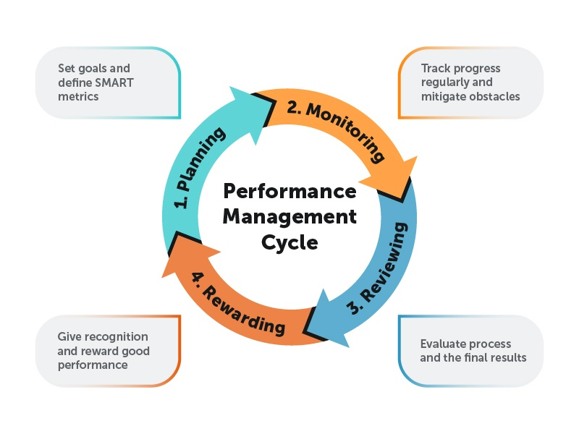
The importance of managing capability for the organisation:
Managing employee capability is essential for organisations to enhance performance, adapt to change, retain talent, foster innovation, and attract top talent whilst maintaining organisational agility. Performance management enables organisations to build a capable workforce that drives their competitiveness and achieves sustainable growth. (Noe, Clarke, and Klein, 2014)

Coaching and Mentoring, the Influence on organisational performance:
The role of line managers in coaching involves building trust and rapport, providing feedback and guidance, and supporting the learning and development of their team members. (Berg, 2014; Clutterbuck & Megginson, 2011).
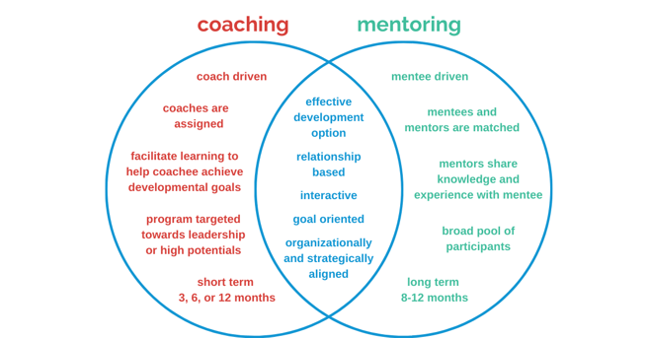
Coaching and mentoring are two distinct but related practices:

Coaching:
A structured and goal-oriented process where a coach helps the coachee gain self-awareness, develop specific skills, and achieve their desired outcomes. It empowers individuals to find solutions and make informed decisions (Grant, 2012).
Mentoring:
More informal and relationship-based approach, where a mentor with relevant experience and expertise provides guidance and support to a mentee. It involves sharing knowledge, providing career guidance, and fostering personal and professional development (Eby et al., 2008).
Both coaching and mentoring have proven to be valuable approaches for individual development, performance improvement, and career advancement. They enhance self-confidence, promote learning, and facilitate goal attainment (Clutterbuck, 2013; Eby et al., 2008).
Coaching Model: GROW (Whitmore, 2009)
Four stages:
Goal Setting, Reality Assessment, Options Exploration, Way Forward.

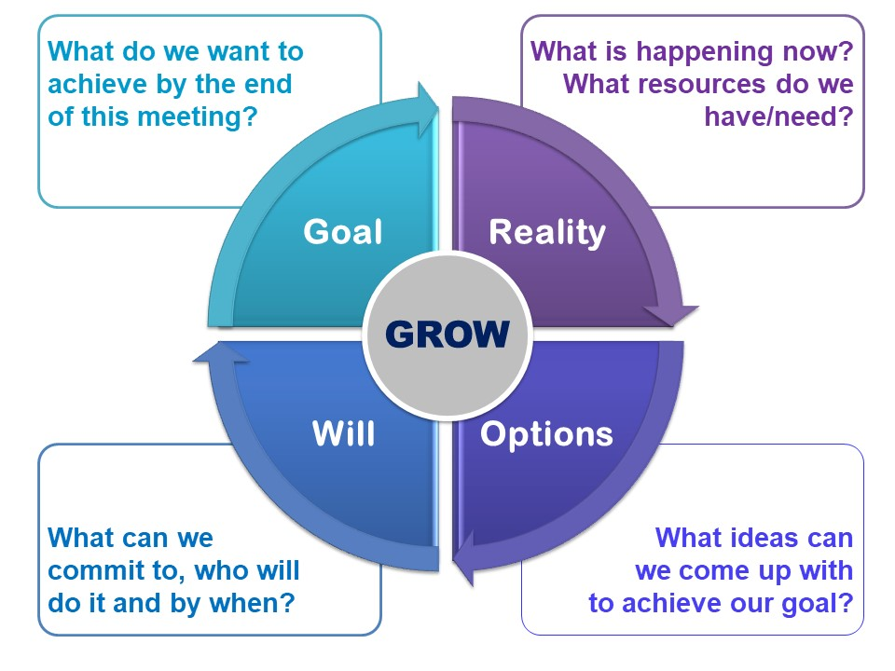
Define. Examine Explore Solution
Critique of Coaching Model:
Limitations: Coaches should be aware and flexible, and diverse in their approach.
- a potential lack of emphasis on emotions, (Grant, 2011)
- an overemphasis on goal setting, which may lead to disenfranchisement. (Grant, 2006 & Winkler, 2010)
- a linear process that may not capture the dynamic nature of coaching (Cavanagh & Grant, 2006)
- potential cultural insensitivity (Winkler, 2010)
Benefits: (Whitmore, 2017)
- Structured and effective framework with a holistic approach for goal setting and problem-solving. (Grant, 2011)
- Provides participants with a contribution towards personal and professional growth.
- SMART Actions that provide Clarity to work towards desired outcomes.
- Empowers individuals by involving them in the goal-setting and problem-solving process and promotes a sense of ownership, accountability, and self-direction.
- Enhances communication, reflective techniques, and the adoption of open-ended questioning techniques. Enabling deeper understanding and insights (Grant, 2011)
Overall, the GROW model offers a structured and effective approach to coaching, supporting individuals in clarifying goals, overcoming obstacles, and achieving desired outcomes.

Benefits of GROW Model to the Organisation:
- Enhancing employee performance
- Increasing employee engagement and motivation
- Improving retention
- Supporting succession planning
- Fostering effective communication and collaboration
- Cultivating a Learning culture

(Clutterbuck & Megginson, 2011; Kampa-Kokesch & Anderson, 2001)

Thank you for participating in today’s session:
Any Follow-up questions can be sent to: HRStores@Whsmith.co.uk
Further information can be found following the below link:
https://whsmith.rms-metro.com/Communication/Do/32874?hierarchyId=1732&RepeatDate=0

PowerPoint: Lunchtime Learning Session Part Two
https://1drv.ms/p/s!AmuJs91iMTL9ikqMKJ22SeWz5eyo

Reference list:
- Acas (2021) ‘Absence Trigger Points’. Available at URL: https://www.acas.org.uk/absence-trigger-points (Accessed: 7th June 2023)
- Allen, D. G., & Bryant, P. C. (2012). ‘Retaining Talent: Replacing Misconceptions with Evidence-based Strategies’. The Academy of Management Perspectives, 26(2), 7-18.Available at DOI:10.5465/AMP.2010.51827775 (Accessed 6th June 2023)

- Almatrooshi, A., & Ahmed, M. I. (2019). ‘Leadership Styles and Job Performance: A literature review’. Journal of Business and Management, 21(7), 18-29. Available at DOI: 10.18775/jibrm.1849-8558.2015.33.3004 (Accessed:31st May 2023)
- Armstrong, M (2016) ‘Armstrong’s Handbook of Management and Leadership for HR’. London. Kogan Page.
- Avolio, B. J., & Gardner, W. L. (2005). ‘Authentic Leadership Development: Getting to the Root of Positive Forms of Leadership’. Leadership Quarterly, 16(3), 315-338. Available at DOI: https://psycnet.apa.org/doi/10.1016/j.leaqua.2005.03.001 (Accessed 31st May 2023)
- Bass, B. M., & Stogdill, R. M. (1990). Handbook of leadership: Theory, research, and managerial applications (3rd ed.). California. Free Press.
- Bass, B. M., & Riggio, R. E. (2006). ‘Transformational Leadership’ (2nd ed.). Psychology Press.
- Berg, I. K. (2014). ‘Coaching for Leadership: Writings on Leadership from the World's Greatest Coaches. New York. Crown House Publishing.
- Birkinshaw, J. (2010) ‘An Experiment in Reinvention’. People Management Magazine 15 July pp 22-24 Available online at URL: https://iveybusinessjournal.com/publication/reinventing-management/ (Accessed: 3rd June 2023)
- Bouchikhi, H., & Kimberly, J. R. (2003). ‘Escaping the Identity Trap’. MIT Sloan Management Review, 44(3), 20-27. Available at URL: https://www.researchgate.net/publication/39318947_Escaping_the_Identity_Trap (Accessed: 7th June 2023)
- Cable, D. M., & Judge, T. A. (1996). ‘Person-Organization Fit, Job Choice Decisions, and Organisational Entry’. Organisational Behaviour and Human Decision Processes, 67(3), 294-311. Available at: https://doi.org/10.1006/obhd.1996.0081 (Accessed: 3rd June 2023)

- Cunningham, I.,Hyman, J. (1995), ‘Transforming the HRM vision into reality: The Role of Line Managers and Supervisors in Implementing Change’, Employee Relations Vol. 17 No. 8, pp. 5-20. Available at DOI: https://doi.org/10.1108/01425459510103451 (Accessed: 3rd June 2023)
- Cavanagh, M. J., & Grant, A. M. (2006). ‘The Coaching Relationship in Practice: An Observational Study. Coaching: An International Journal of Theory, Research and Practice, 1(2), 135-154. Available at DOI:10.1093/acprof:oso/9780195373585.003.0019 (Accessed 9th June 2023)

- Chartered Institute of Personnel and Development (CIPD). (2021) ‘Employee Turnover and Retention Factsheet’ Available at URL: https://www.cipd.org/en/knowledge/factsheets/turnover-retention-factsheet/ (Accessed: 7th June 2023)
- Chartered Institute of Personnel and Development (CIPD). (2016). ‘Managing Absence Factsheet’. Available at URL: https://www.cipd.co.uk/knowledge/fundamentals/relations/absence/factsheet (Accessed: 3rd June 2023)

- Clutterbuck, D., & Megginson, D. (2011). ‘Coaching in Organisations: A Team Coaching Framework’. In E. Cox, T. Bachkirova, & D. Clutterbuck (Eds.), The Complete Handbook of Coaching (2nd ed., pp. 167-184). New York. Sage.

- Clutterbuck, D. (2013). ‘Coaching and Mentoring: Practical Techniques for Developing Learning and Performance. London. Kogan Page.

- Dunn, L. (2020). ‘Managing Employee Absenteeism: Strategies for Success’. Business Horizons, 63(2), 145-153. Available at DOI: https://10.1016/j.bushor.2019.11.001 (Accessed: 3rd June 2023)

- Dumdum, U. R., Lowe, K. B., & Avolio, B. J. (2002). ‘A Meta-analysis of Transformational and Transactional Leadership Correlates of Effectiveness and Satisfaction: An Update and Extension’. In B. J. Avolio & F. J. Yammarino Transformational and Charismatic Leadership: The Road Ahead’ pp. 35-66. Emerald Group Publishing Limited. Available at DOI:10.13140/RG.2.1.3549.1681 (Accessed” 3rd June 2023)
- De Dreu, C. K., & Weingart, L. R. (2003). ‘Task Versus Relationship Conflict, Team Performance, and Team Member Satisfaction: A Meta-analysis’. Journal of Applied Psychology, 88(4), 741-749. Available at: http://dx.doi.org/10.1037/0021-9010.88.4.741 (Accessed: 3rd June 2023)
- Eby, L. T., Allen, T. D., Evans, S. C., Ng, T., & DuBois, D. L. (2008). ‘Does Mentoring Matter? A Multidisciplinary Meta-analysis Comparing Mentored and Non-mentored Individuals’. Journal of Vocational Behaviour, 72(2), 254-267. Available at: DOI:10.1016/j.jvb.2007.04.005 (Accessed: 9th June 2023)

- Edmondson, A. (1999). ‘Psychological Safety and Learning Behaviour in Work Teams’. Administrative Science Quarterly, 44(2), 350-383. Available at DOI: https://doi.org/10.2307/2666999 (Accessed: 31st May 2023)
- Eisenberger, R., Huntington, R., Hutchison, S., & Sowa, D. (2002). ‘Perceived Organisational Support’. Journal of Applied Psychology, 87(4), 698-714. Available at: https://psycnet.apa.org/doi/10.1037/0021-9010.87.4.698 (Accessed 3rd June 2023)

- Elnaga, A., & Imran, A. (2013). ‘The Effect of Training on Employee Performance’. European Journal of Business and Management, 5(4), 137-147. Available at URL: https://www.researchgate.net/publication/325420167_Effects_of_Training_on_Employee_Performance (Accessed 4th June 2023)

- Françoise, D. Zied, G. & Florian, H. (2008) ‘New Insights into the Link Between HRM Integration and Organisational Performance: the Moderating Role of Influence Distribution Between HRM Specialists and Line Managers’, The International Journal of Human Resource Management, 19:11, 2095-2112 Available at:, DOI: 10.1080/09585190802404320 (Accessed 1st June 2023)
- Gifford, J. (2022) ‘Performance Management Factsheet’. Chartered Institute of Personnel and Development. Available at URL: https://www.cipd.org/uk/knowledge/factsheets/performance-factsheet/#six (Accessed: 31st May 2023)
- Goleman, D. (2000) ‘Leadership that gets Results’ Harvard Business Review. March- April. Available at URL: https://hbr.org/2000/03/leadership-that-gets-results (Accessed: 31st May 2023)
- Grant, A. M., & Berry, J. W. (2011). ‘The Necessity of Others is the Mother of Invention: Intrinsic and Prosocial Motivations, Perspective-taking, and Creativity’. Academy of Management Journal, 54(1), 73-96. Available at: https://doi.org/10.5465/amj.2011.59215085 (Accessed: 7th June 2023)
- Grant, A. M. (2012). ‘An integrated model of goal-focused coaching: An evidence-based framework for teaching and practice’. International Coaching Psychology Review, 7(2), 146-165. Available at DOI:10.1002/9781119656913.ch7 (Accessed: 9th June 2023)

- Grant, A. M. (2012). ‘An Integrated Model of Goal-Focused Coaching: An Evidence-based Framework for Teaching and Practice. International Coaching Psychology Review, 7(2), 146-165. Available at: DOI:10.1002/9781119656913.ch7 (Accessed: 9th June 2023)

- Hackman, J. R. (2002). ‘Leading teams: Setting the stage for great Performances’. Harvard Business Review, 80(11), 110-117. Available at URL: https://hbswk.hbs.edu/archive/leading-teams-setting-the-stage-for-great-performances-the-five-keys-to-successful-teams (Accessed: 3rd June 2023)
- Harter, J. K., Schmidt, F. L., & Hayes, T. L. (2002). Business-Unit-Level Relationship Between Employee Satisfaction, Employee Engagement, and Business Outcomes: A Meta-Analysis. Journal of Applied Psychology, 87(2), 268-279. Available at: DOI:10.1037//0021-9010.87.2.268 (Accessed 3rd June 2023)

- Harvey, J. (2019). ‘Managing Attendance and Employee Turnover. Journal of Leadership, Accountability, and Ethics, 16(3), 9-17 Available at: https://doi.org/10.33423/jlae.v16i2 (Accessed 3rd June 2023)

- Kampa-Kokesch, S., & Anderson, M. Z. (2001). ‘Executive coaching: A comprehensive review of the literature’. Consulting Psychology Journal: Practice and Research, 53(4), 205-228. Available at DOI: https://psycnet.apa.org/doi/10.1037/1061-4087.53.4.205 (Accessed: 9th June 2023)

- Losoncz, I., & Gabor, K. (2014).’ Does leadership matter? Examining the Relationship between Leadership Styles and Organisational Performance in Hungarian SMEs’. Journal of East European Management Studies, 19(1), 102-123. Available at DOI: https://doi.org/10.4236/ojl.2019.81001 (Accessed: 3rd June 2023)
- Munn-Giddings, C., & Winter, R. (2013). ‘A Handbook for Action Research in Health and Social Care’. London. Routledge.
- Northouse, P. G. (2018). ‘Leadership: Theory and Practice’ (8th ed.). New York. Sage Publications.
- Noe, R. A., Clarke, A. D., & Klein, H. J. (2014). ‘Employee Training and Development’ (7th ed.). New York. McGraw-Hill Education.

- Saks, A. M. (2006). ‘Antecedents and Consequences of Employee Engagement’. Journal of Managerial Psychology, 21(7), 600-619. Available at: https://doi.org/10.1108/02683940610690169 (Accessed 7th June 2023)

- Scollen, V. (2023) Email to Amberlea Knowles 2nd February 2023 Unpublished
- Scollen, V (2023) Email to Amberlea Knowles 20th March 2023 Unpublished
- Taylor, S. (2019) Resourcing and Talent Management. (7th Edn) Kogan Page. London.

- Tuckman, B. W. (1965). ‘Developmental Sequence in Small Groups’. Psychological Bulletin, 63(6), 384–399. Available at DOI: https://doi.org/10.1037/h0022100 (Accessed: 3rd June 2023)
- Vecchio, R. P. (2000). ‘Negative Emotion in the Workplace: Employee Jealousy and Envy’. International Journal of Stress Management, 7(3), 161-179. Available at DOI: https://doi.org/10.1023/A:1009592430712 (Accessed: 3rd June 2023)
- Wasti, S. A. (2005). Commitment Profiles: Combinations of Organisational Commitment Forms and Job Outcomes. Journal of Vocational Behaviour, 67(2), 290-308. Available at: DOI:10.1016/j.jvb.2004.07.002 (Accessed 7th June 2023)
- Whitmore, J. (2009). Coaching for Performance: GROWing Human Potential and Purpose. London. Nicholas Brealey Publishing.
- Winkler, A. (2010). Cultural issues in executive coaching: A critical analysis. In E. Cox, T. Bachkirova, & D. Clutterbuck (Eds.), The Complete Handbook of Coaching (pp. 220-236). Sage. Available at: DOI:10.4102/sajip.v49i0.2034 (Accessed 9th June 2023)
- Young, J. and Gifford, J. (2023) ‘High-performing teams: An Evidence Review. Practice summary and guidance.’ Chartered Institute of Personnel and Development. Available online URL: https://www.cipd.org/globalassets/media/knowledge/knowledge-hub/evidence-reviews/2023-pdfs/8388-high-performing-teams-practice-summary.pdf (Accessed: 31st May 2023)
- Yukl, G. (2010). Leadership in Organisations (7th ed.). New York. Pearson, Prentice Hall.

