Case Study 2: Respiratory Health and Asthma Management in Adolescents
Student Name: [ANISA KARIM]
Student Number: 2407467

Table of Contents
1. Introduction 3
2. Structure of the Respiratory System and Mechanical Respiration 4
3. Gas Exchange and Cellular Metabolism 5
4. Impact of Irritants and Airway Pathophysiology 6
5. Recording and Tracking: The Role of Peak Flow Monitoring 7
6. Evidence-Based Lifestyle Recommendations 8
7. Conclusion 9
8. Reference List 10

1. Introduction
Asthma is a heterogeneous chronic inflammatory disease of the conducting airways that is mainly typified by the hyper-responsiveness of the bronchial vascular system, reversible airflow hampering and inflammation of the airways. In the United Kingdom, asthma has a huge impact on the overall population, especially regarding the young group. According to the statistics provided by Asthma + Lung UK (2023), it turns out that nowadays, the number of children and adolescents who are being treated because of the condition is estimated to be 1.1 million. This translates to an average one in every eleven persons in this age group. In the case of adolescents, the shift towards the independence of managing their lives according to the adulthood and the disorganised care that childhood brings elicit a multifaceted set of physiological, psychological and social issues that often result in inappropriate health outcomes and higher hospitalisation rates.
The clinical team, as a practice nurse working in a local GP surgery, detected the following disturbing trend: adolescents initially diagnosed in childhood are coming with an increasingly severe exacerbation. This aggressive increase is very often accompanied by substantial changes in lifestyle because of becoming adult. It is not a secret that there is an adolescent gap in health care provision; with individuals in that age group desiring autonomy, they might lose the parental control over their medical procedures and thus resort to them less optimally (National Institute for Health and Care Excellence [NICE], 2021).
Additionally, the multifactorial nature of the risk factors of asthma in this group manifests itself. Heredity is one of the building blocks as atopy which consists of the genetic inclination of creating IgE antibodies to usual allergens such as pollen or dust mites (Global Initiative for Asthma [GINA], 2023). Yet the frequency of attacks is determined mostly by environmental stimuli and behavioural decisions like adopting smoking or vaping habits and exposing themselves to more people in social places. In its turn, this report gives a close analysis of the physiology of the respiratory system, the pathological effects of contemporary irritants, and the evidence-based approaches to management options that would suit the specific requirements of the adolescent patient.
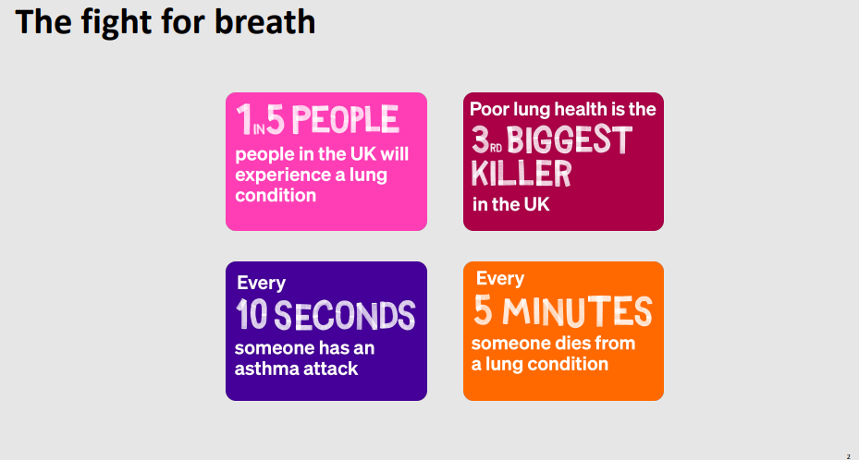
Figure 1: Asthma Figures
Source: https://www.england.nhs.uk/london/wp-content/uploads/sites/8/2025/10/04-Preventing-asthma-deaths-in-children.pdf

2. Structure of the Respiratory System and Mechanical Respiration
Human respiratory machinery is a complex structural masterpiece that facilitates the exchange of carbon dioxide and oxygen very fast. It is anatomically subdivided into the upper respiratory system (nose, pharynx and larynx) and the lower respiratory system (trachea, bronchi, bronchioles and alveoli). The main activity of the upper tract is the warming and humidifying of the atmospheric air; the ciliated mucous membranes also trap the particles (Johnstone, 2018). The clinical manifestations of asthma are located in the lower tract and specifically in the so-called bronchial tree. The trachea splits into the main bronchi, which further subdivide into smaller ones second and third branch that, finally, turn into terminal and respiratory bronchioles lacking cartilage and being highly packed with smooth muscle (Johnstone, 2018).
The body has a cyclical internal system that pumps clogged air in and out of the lungs and this is known as mechanical respiration or pulmonary ventilation. The laws of fluid dynamics and pressure-volume relationships determine this process; in particular, there is the Boyle Law according to which the pressure of a gas in a closed vessel is directly proportional to the volume (Bozzone and Whittemore, 2021). The respiratory centers in the medulla oblongata and pons are the source of inspiration process. This is transmitted through nerve impulses through the phrenic nerve and the intercostal nerve to the diaphragm, flattening and contracting it at the same time the external intercostal muscles raise the ribcage. Such enlargement enlarges the thoracic cavity. The lungs expand following the widening of the chest wall as surface tension in the visceral and parietal pleura hold the latter together. The resulting decrease in the intrapulmonary pressure (compared to the atmospheric pressure) produces a vacuum that pulls air into the alveoli.
The whole process of expiration at rest in a normal person is rather passive, depending on the elastic recoil of the lung tissue and relaxing of the inspiratory muscles. In a patient with an asthma exacerbation who is an adolescent, however, this mechanism is grossly impaired. Airway resistance is greatly affected by the constricted airways due to their inflammation. The change in the radius of an airway by a small margin increases the amount of force needed to expel air by many copies, the Law of Poiseuille (Dutton and Finch, 2018). As a result, the teenager is compelled to use accessory muscles: the scalene, pectoralis minor, and sternocleidomastoid to push the air out of the lungs causing very quick exhaustion and the frequently presented respiratory distress in the GP surgery.
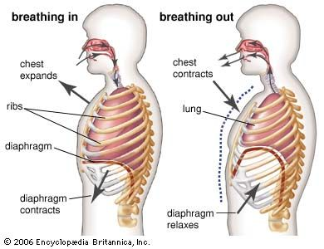
Figure 2: Human Respiratory System
Source: https://www.britannica.com/science/human-respiratory-system/The-mechanics-of-breathing

3. Gas Exchange and Cellular Metabolism
The alveolus is the functional unit of the respiratory system, as here external respiration, which is the exchange of gases between the blood and air, occurs. Human lungs have about 300 million alveoli, which offers it an enormous surface area to diffusion (Marieb and Hoehn, 2007). The alveolar wall and capillary endothelium form the respiratory membrane that is only 0.5 micrometers thick, and this is where gases are easily passed across nearly at the instant.
The impetus of this exchange is the partial pressure gradient of each gas. Deoxygenated blood enters the pulmonary capillaries with a partial pressure of oxygen (O₂) of approximately 40 mmHg and a CO₂ of 46 mmHg. In the alveoli, the O₂ is typically 104 mmHg. Oxygen molecules are transported along this steep gradient, where they dissolve into the blood plasma and bind to the heme groups of hemoglobin to create oxyhemoglobin (Rolfe and Paul, 2018). At the same time, the blood transfers carbon dioxide into the alveoli where it is exhaled into the atmosphere.
This oxygen is crucial to the inner breathing and to restore cell metabolism. In the mitochondria of the cells of the adolescent, oxygen is the ultimate electron acceptor in an electron transport chain that is referred to as aerobic respiration. The cells use glucose to generate Adenosine Triphosphate (ATP), the universal energy currency needed to achieve growth, tissue repair, and body activity (Blanco and Blanco, 2017). When airways block in an asthma patient, ventilation is hampered resulting in reduced supply of oxygen to the tissues (hypoxia). This causes the cells to turn towards the anaerobic metabolism which is much less efficient and results in an accumulation of lactic acid which causes fatigue to the muscles and system wide malaise experienced by patients during a flare-up.
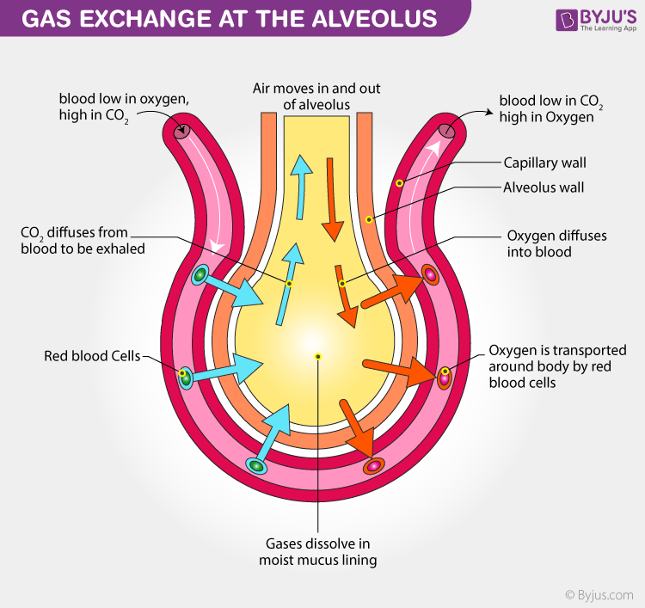
Figure 3: Cellular Respiration
Source: https://byjus.com/biology/respiration-gas-exchange/

4. Impact of Irritants and Airway Pathophysiology
The adolescent age involves stronger exploration of the social world, and they tend to be exposed to the irritants that are even more harmful to the asthmatic lungs. The most common chemical irritants experienced in our GP clinic are tobacco smoke and e-cigarette vapor (vaping). When they are inhaled, the substances circumvent the first lines of defense, which are located at the upper respiratory tract and are deposited in the bronchioles. This causes acute innate immune reaction. The epithelial cells of the airways release Type 2 lymphocytes and innate lymphoid cells Th2 generate alarmins (cytotokines such as TSLP and IL-33), thereby triggering them (Chung et al., 2022).
The end product of this inflammatory cascade is three pathological changes that are hallmark:
- Bronchoconstriction: The smooth muscles surrounding the airways are suddenly and forcefully contracted in response to the action of such inflammatory mediators as histamine and cysteinyl leukotrienes (BTS, 2019).
- Mucosal Edema: Capillary permeability increases; thus, fluid will leak into the airway walls leading to their swelling and subsequent lumenal narrowing.
- Goblet Cell Hyperplasia: A trigger causes an excess in the production of thick and tenacious mucus that may develop mucus plugs, which fully block smaller airways (Yokoyama and Yokoyama, 2019).
In an adolescent who often goes to bars or clubs with a large crowd of people, the danger is doubled. These environments are not only exposed to second hand smoke or vapor, the environments are also habitats to rhinovirus and influenza. The most common trigger of status asthmaticus which is a long-lasting and life threatening asthma attack is caused by viral infections and is not treated by the normal asthma medications. The irreversible remodeling of airways can also be caused by chronic contact with these irritants, but there the thickening of the basement membrane and an increase in the mass of smooth muscle employees can take place as the permanent loss of lung function (Wang et al., 2023).

5. Recording and Tracking: The Role of Peak Flow Monitoring
Objective monitoring of the condition is a key element in the adolescent asthma clinic, involving teaching the patient to use a Peak Expiratory Flow (PEF) meter to monitor their condition. Although subjective symptoms such as tightness matter, they might not be accurate in adolescents, who might under-report and get used to having obstruction due to chronic symptoms (NICE, 2021).
PEF meter is used to affect the maximum speed of a breath of the individual after complete inhalation of the breath. The patient by documenting these numbers twice per day makes their personal best. This information is normally graphically described, and a visual image of their breathing state is created. PEF tracking is necessary because of several reasons:
- Early Warning: A drop in PEF often precedes physical symptoms by hours or even days, allowing for early intervention.
- Trigger Identification: It helps adolescents correlate specific activities (e.g., going to a specific club or exercising in cold air) with a decline in lung function (Levy et al., 2025).
- Adherence Verification: For the practice nurse, the peak flow diary serves as a tool to discuss medication adherence without being confrontational.
The British Thoracic Society (2019) also insists that, according to the readings of peak flows, all teenagers are to possess a Personalised Asthma Action Plan (PAAP). In this plan, a traffic light method is employed (Green (80-100% of personal best) - good control; Amber (50-80%) - flare-up and the necessity of more preventer medication; Red (below 50) - medical emergency and the need to visit a hospital).

6. Evidence-Based Lifestyle Recommendations
In order to enhance (better) results, the practice nurse ought to go beyond pharmacology and intervene with the lifestyle issues (that contribute to a worse outcome in asthma amongst adolescents).
Smoking and Vaping Cessation: No smoking vaping amount could be safe to an asthmatic. Said to be a healthier option, vaping was proved to cause the cilia in the airways to go paralyzed and provide the lung tissue with oxidative stress (Lempert et al., 2021). Clinical education should aim at harm reduction and provide nicotine replacement therapy should the need arise, but the patient should be educated on the direct counteraction effects of these irritants on the effects of their costly preventer inhalers.
Social Triggers Management: Teenagers should not be informed not to have a social life, but to learn how to do so safely. This involves making sure that they will always have their inhaler of short-acting asthma drug salbutamol with them (in their bags, etc.) and being aware of the effect of emotion-induced asthma; a high rate of excitement or stress in socially oriented settings can trigger a bronchospasm (GINA, 2023).
Nutritional and Physical Support: Overweight condition is one of the major asthma co-morbidities. Pro-inflammatory cytokines (adipokines) are released in adipose tissue, which aggravates inflammation in the airways (Aron and Akbari, 2017). Diets rich in antioxidants (Vitamin C and E) can also have some protective response to the oxidative stress in lungs. Moreover, exercise may be one of the triggers, although, active physical activity is advised to make the respiratory muscles work better and enhance the effectiveness of oxygen consumption in the periphery.
The Transition to Self-Care: The clinical team needs to assist the adolescent to assume ownership of his/her inhaler technique. According to the research, 90 percent of patients are using inhalers improperly (McCorry et al., 2021). Evidence-based "gold standard" applies to the use of spacers in conjunction with pressurised metered-dose inhalers (pMDIs) to make sure that the medication damages lower lungs as opposed to striking the back of the throat.

7. Conclusion
The adolescent asthma is complex disease which is on the border of social transition and biological vulnerability. The physiological needs of mechanical breath and gas exchange are left to be easily disturbed by the inflammation and bronchospasm caused by modern irritants such as those produced by vaping and tobacco smoke as this report has explored. In the case of the practice nurse, the difficulty is how to bridge the gap between the clinical guidelines and the adolescent life. Endorsing the youthful patients with objective measures such as peak flow and offer them non-judgmental, evidence-based lifestyle interventions are effective in enhancing compliance with care plans. The ultimate idea is to change a passive recipient of care to an active manager of their own respiratory condition and make them less prone to the life-threatening exacerbations to lead a healthier adult life.

8. Reference List
Aron, J.L. and Akbari, O., 2017. Regulatory T cells and type 2 innate lymphoid cell‐dependent asthma. Allergy, 72(8), pp.1148-1155.
Asthma + Lung UK (2023) Asthma facts and statistics. Available at: https://www.asthmaandlung.org.uk/about-us/our-latest-work/our-asthma-reports
Blanco, A. and Blanco, G., 2017. Medical biochemistry. Academic Press.
Bozzone, D. and Whittemore, S., 2021. The Respiratory System. Infobase Holdings, Inc.
British Thoracic Society (BTS) and Scottish Intercollegiate Guidelines Network (SIGN) (2019) British guideline on the management of asthma. London: BTS/SIGN. Available at: https://www.brit-thoracic.org.uk/quality-improvement/guidelines/asthma
Chung, K.F., Dixey, P., Abubakar-Waziri, H., Bhavsar, P., Patel, P.H., Guo, S. and Ji, Y., 2022. Characteristics, phenotypes, mechanisms and management of severe asthma. Chinese medical journal, 135(10), pp.1141-1155.
Dutton, H. and Finch, J. eds., 2018. Acute and critical care nursing at a glance. John Wiley & Sons.
Global Initiative for Asthma (GINA) (2023) Global Strategy for Asthma Management and Prevention. Available at: https://ginasthma.org
Johnstone, C., 2018. Pathophysiology and nursing management of acute pancreatitis. Nursing Standard, 33(4).
Lempert, L.K. and Halpern-Felsher, B., 2021. The E-cigarette phenomenon: What it is, why it is happening, and what you should know about it. In Electronic Cigarettes and Vape Devices: A Comprehensive Guide for Clinicians and Health Professionals (pp. 17-36). Cham: Springer International Publishing.
Levy, M.L., Bourdin, A., Stoianova, S. and Sleap, V., 2025. Learnings from asthma fatalities. In Asthma (pp. 180-195). European Respiratory Society.
Marieb, E.N. and Hoehn, K., 2007. Human anatomy & physiology. Pearson education.
McCorry, L.K., Zdanowicz, M.M. and Gonnella, C.Y., 2021. Essentials of Human Physiology and Pathophysiology for Pharmacy and Allied Health. Routledge.
National Institute for Health and Care Excellence (NICE) (2021) Asthma: diagnosis, monitoring and chronic asthma management (NG80). London: NICE. Available at: https://www.nice.org.uk/guidance/ng80
Rolfe, S. and Paul, F., 2018. Oxygen therapy in adult patients. Part 1: understanding the relevant physiology and pathophysiology. British Journal of Nursing, 27(14), pp.798-804.
Wang, L., Zhou, L., Zheng, P., Mao, Z. and Liu, H., 2023. Mild asthma is not mild: risk factors and predictive biomarkers for severe acute exacerbations and progression in mild asthma. Expert Review of Respiratory Medicine, 17(12), pp.1261-1271.
Yokoyama, A. and Yokoyama, A., 2019. Advances in Asthma. Springer Singapore.

