Certificate of Higher Education in Employability Skills
Level 4
Module: Digital Skills for Personal and Professional Growth
Module code: BMSW4011
Assignment Name: Evidence of Learning
(E-Portfolio)
TASK 1 AND 2
Student Name: Zamfir Cristina
Student Id: 2020466
2024-2025

Task1: Questionnaire Analysis and design of Website and Marketing Materials

Introduction
The beauty industry is one of the fastest-growing sectors, and customer satisfaction plays a very important role in its success (Statista, 2024). This project focuses on exploring what customers expect from beauty salon and how digital tools can help improve communication, visibility, and service quality. The study was designed around a short online questionnaire to understand clients 'preferences, their main motivations when choosing a salon, and their opinions about digital presence. The information gathered helped shape ideas for creating a modern website and suitable marketing materials for my business idea-a small beauty salon offering hair, nail, and skincare services.

Methodology
The research was carried out through a ten- question survey created with Google Forms. The link was shared with friends, family and social media contacts on Instagram and Facebook. In total fifty people complected the questionnaire. The questions were simple and clear, including both multiple-choice and one open-ended question to collect more personal opinions.
The purpose was to find out how often people visit salons, which services they prefer, what makes them loyal to a salon, and how they discover new ones. This method was chosen because it its quick, inexpensive, and allows honest feedback from people of different ages and background (Bryman, 2021). The answer was then reviewed and summarised to identify the most common patters and expectations.

Findings
The results showed that most respondents were between 25 and 34 years old. This suggest that the younger generation is more engaged with beauty services and self-care routine (Mintel, 2023). Around 44% said they visit a beauty salon once a month, while 20% go every week. This means that there is a consistent level of demand throughout the year.
When asked what services they use most often 40% said hairdressing,34% manicure or pedicure, and 14% facial treatments. Massage and body care were less common, with around 12% choosing them. These results show that focus for most clients remains on hair and nails. Quality of services was chosen as the most important factor when selecting salon (50%), followed by staff professionalism (30%). Only a small number mentioned price or location as a main reason. This proves that people prefer paying a bit more if the service is professional and the staff are skilled (Kotler et al., 2022).
Social media was the most popular wat to discover new salons (59%), follows by recommendations from friends or family (37%). This means that having a strong online presence is essential for promoting the business (Digital Marketing Institute,2023). In terms of satisfaction, most participants said they were either satisfied or very satisfied with their current salon, which shows that the market already has good standards, but there is still room for improvement.
An interesting result was that 80% of people said it is ‘’very important’’ for salons to use high-quality, eco-friendly products. This reflects modern awareness about sustainability and healthy living (Euromonitor, 2023). In the open-ended question, several people mentioned they would like salons to offer easier online booking and loyalty discounts for regular customers.

Analysis and Discussion
The survey made it clear customers value professionalism, hygiene, and trust above everything else. Many respondents also said they look for friendly staff and a relaxing atmosphere. These insights show that a beauty salon should focus on building strong customer relationships, not just providing treatments (Kotler et al., 2022).
Another key finding was the role of digital platforms. Since most clients find salons on Instagram or Facebook, social media must be treated as part of the business strategy.
Consistent posts, high-quality photos, and good reviews can make a big difference in attracting new customers.
The interest in natural and eco-friendly products is also important. Promoting organic, cruelty-free, and sustainable brands can help create a modern image and attract clients who care about the environment (Euromonitor, 2023). Based on the results, the target market for this salon will mainly be women aged 18-35 who are active online and care about both quality and image.

Audience Segmentation
Based on the survey results, the main customers for Glow & Grace Beauty are women aged 25–34. They visit salons regularly, use social media often, and care about both style and eco-friendly products. These clients are interested in modern, high-quality services and prefer convenience, like online booking.
A smaller group includes women and men aged 35–50, who want reliable, professional treatments and appreciate loyalty programs. By understanding these two groups, the salon can make sure its messages and promotions reach the right people. For example, Instagram and TikTok posts will mainly target younger clients with trends and tips, while Facebook and email offers will focus on older customers who value loyalty rewards and easy scheduling.

Website Design
The website will be designed to look elegant, simple and easy to use. The colour palette will include soft pink, beige, and gold to create a feminine and luxurious atmosphere. The name of the salon will be ‘’Glow & Grace Beauty’ ’representing both inner and outer beauty.
The homepage will include a large image of the salon with a short welcome message such as ‘’Enhance your beauty, embrace your confidence. ’A clear Book Now button will allow visitors to schedule an appointment directly. The About Us section will describe the salon’s story, the experience of the staff, and the use of safe, eco-friendly products. The Services Page will list treatments with prices and short descriptions, divided into categorised such as Hair, Nails, Skin and Massage. Each section will have a photo and an option to book instantly. A Gallery Page will show before-and-after images and short videos, while the Contact Page will include phone number, email, address, and links to social media accounts.
The website will also include a customer review section to build trust and transparency (Forsey, 2023). Finally, a responsive mobile version will ensure that clients can access it easily on their phones.
SEO Strategy
To increase visibility, the website will follow a focused SEO plan. Keywords such as “beauty salon near me,” “eco-friendly salon,” and “hair and nail care” will be used throughout the content. Each page will include meta titles, meta descriptions, and image alt text. Blog articles about skincare and seasonal beauty trends will be published monthly to keep the website updated and relevant (Forsey, 2023). Internal links between pages and consistent social media sharing will help generate organic traffic and improve ranking on search engines (Google Search Central, 2024).

Marketing Materials and Social Media
The marketing part of the business will focus mainly on social media, because the questionnaire showed that most people discover new salons online. The salon will be active on Instagram, Facebook, and TikTok.
- Instagram will be used for daily photos, short videos, and simple beauty tips.
- Facebook will be used for special offers, competitions, and for talking directly with clients.
- TikTok will show short, fun videos with makeovers or daily moments from the salon.
All designs will use the same colours—soft pink and beige, —so people can easily recognise the brand. The marketing materials will be created with Canva, including posters, flyers, and online posts.
Example Poster:
A light pink background with the text:
“Grand Opening! 70% off our services this month at Glow & Grace Beauty Salon. Book your appointment today!”
Below this, the salon’s website and social media icons will be shown to help people find the salon online.
The salon will also have loyalty cards that give a free treatment after ten visits, and referral discounts for clients who bring friends. It will also work with local influencers, and happy customers will be encouraged to post reviews or photos on social media (Hootsuite, 2024).
In addition to online promotion, some flyers will be placed in local cafés or gyms to attract people who live nearby. All materials will follow the same simple and elegant style as the website to create a clear and friendly image of the brand.

Conclusion
The questionnaire and analysis provided a clear understanding of what customers expect from a modern beauty salon. The research showed that quality, professionalism, and a strong online presence are key to success. Clients care about how they are treated and want convivence through digital booking and online communication.
The website and marketing design were built around these findings. By creating a clean, elegant and easy- to-navigate website and by staying active on social media, the salon can build a professional image and reach its ideal audience. Using eco-friendly products and focusing on client satisfaction will help the business stand out from competitors. Overall, this project demonstrates hoe digital skills, marketing, and customer research can work together to support the growth of a small business in the beauty industry (Mintel, 2023).

Appendix-Questionnaire
(This questionnaire was used to collect data for the project’’ Customer Preferences and Satisfaction in a Beauty Salon.’’)

- What is your age group?

- How often do you visit a beauty salon?

- What services do you usually use?

- What is most important when choosing a salon?

- How do you usually find a new beauty?

- How satisfied are you with your current salon?
7.How important is it that the salon uses high-quality, eco-friendly products?
8.Would you be interested in online booking or social media promotions?
9. How likely are you to recommend your beauty salon to others?
10. What improvements would you like to see in a beauty salon?
Note:
The questionnaire was completed by 50 respondents. The full form can be accessed via the link above for verification purposes.
Questionnaire: Customer Preferences and Satisfaction in a Beauty Salon – Fill in form

Appendix – Questionnaire Results
Figure 1: Age distribution of respondents
(Most respondents were aged 25–34 years).
Figure 2: Most used beauty services
(40% hairdressing, 34% manicure/pedicure, 14% facial treatments).
Figure 3: Key factors when choosing a salon
(Quality and professionalism were top priorities).
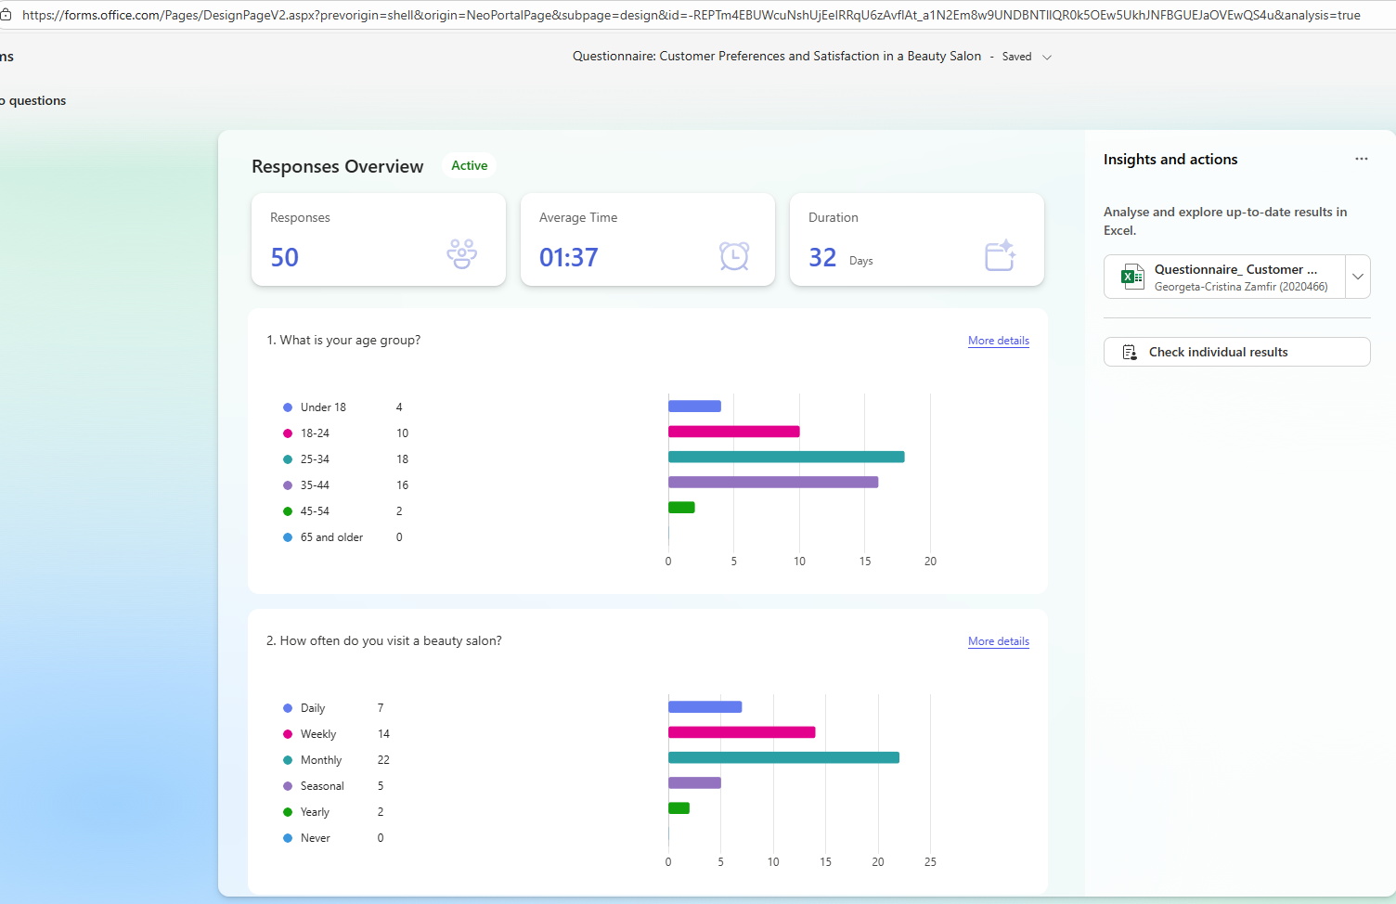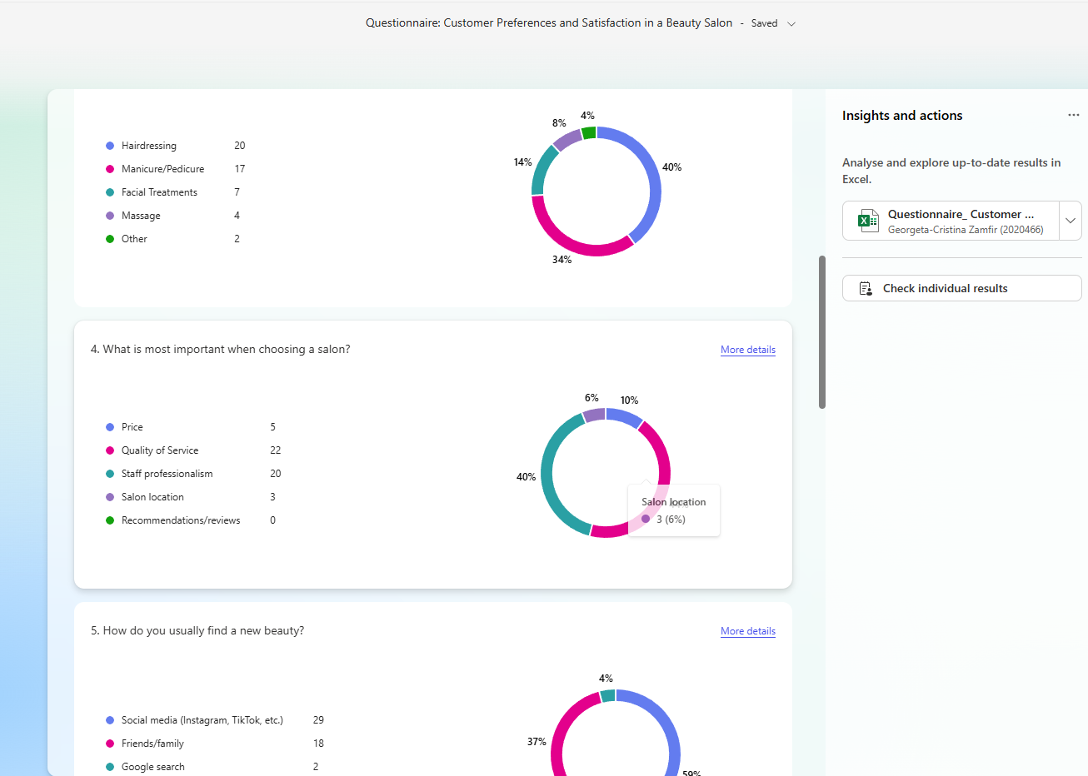
(FIGURE1, Website Home Page, + link)
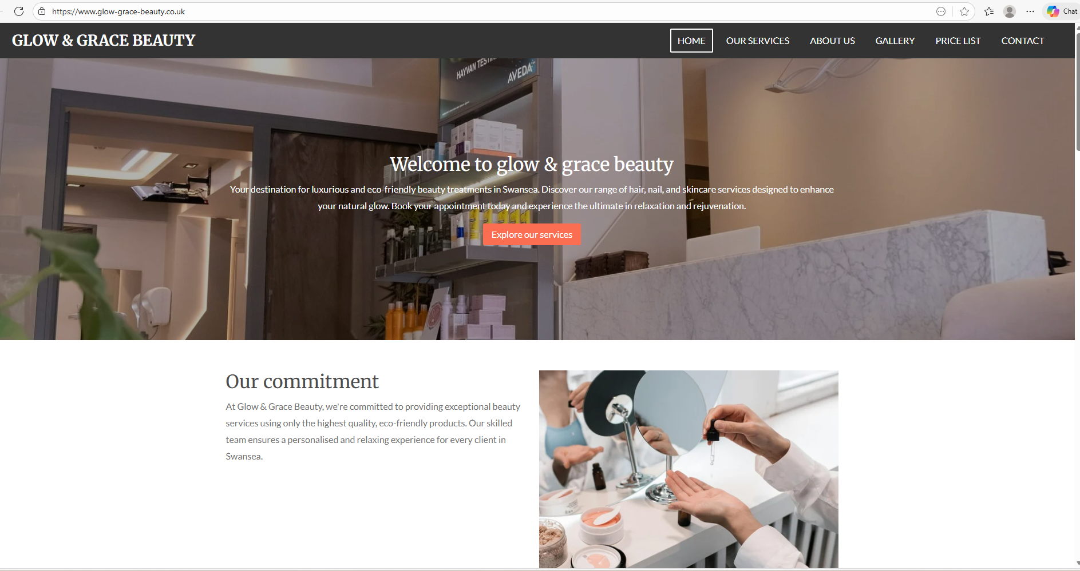
(Figure 2, Website- Our Services)

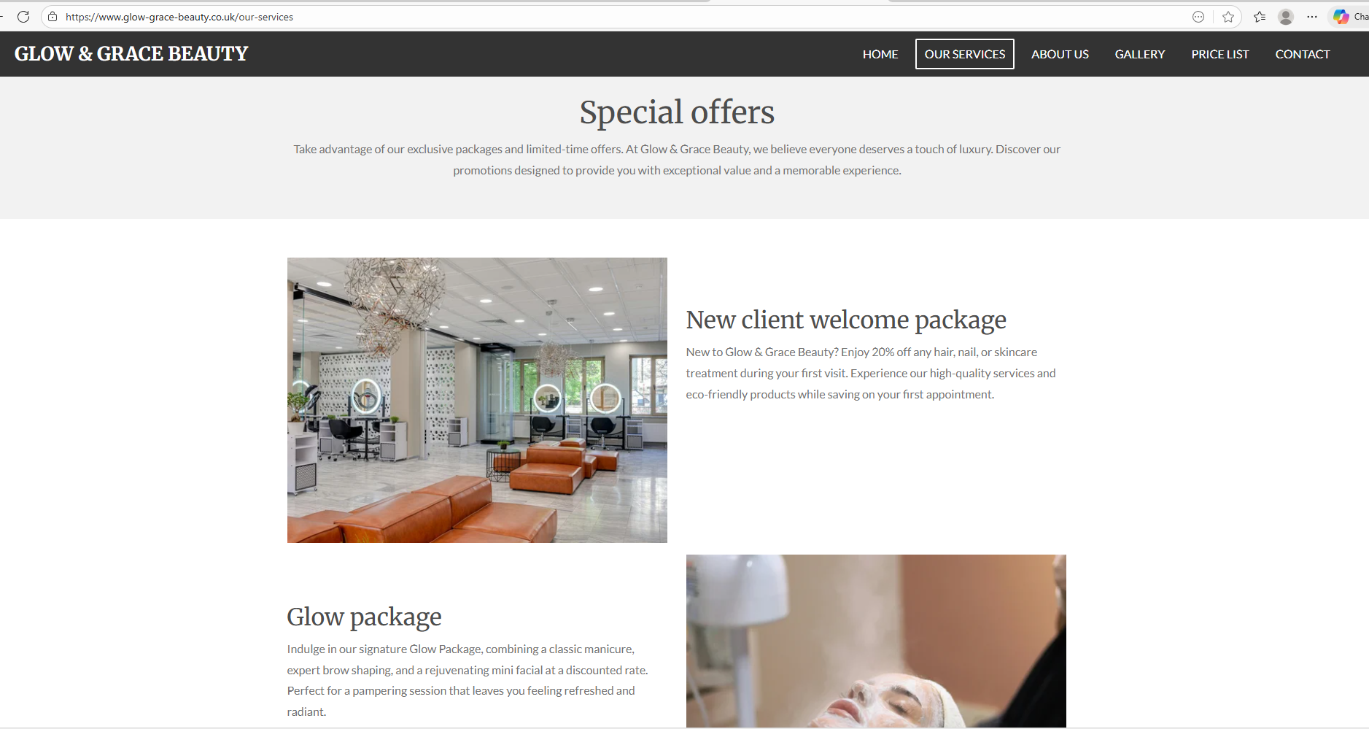

(Figure 3 Poster Canva)

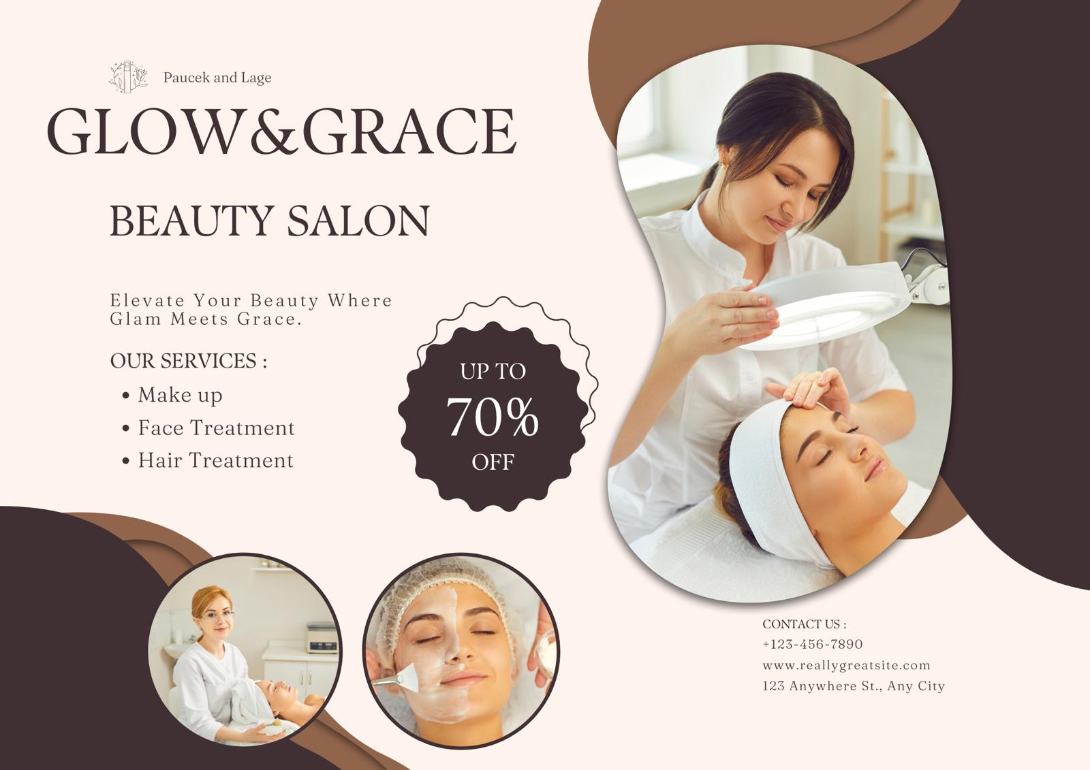
References

- Bryman, A. (2021) Social Research Methods. 6th ed. Oxford: Oxford University Press.
- Digital Marketing Institute (2023) The Importance of Social Media in Modern Marketing. Available at: https://digitalmarketinginstitute.com/ (Accessed: 3 November 2025).
- Euromonitor (2023) Sustainability and Beauty: Global Consumer Trends 2023. Available at: https://www.euromonitor.com/ (Accessed: 3 November 2025).
- Forsey, C. (2023) Website Design Principles for Small Businesses. HubSpot Blog. Available at: https://blog.hubspot.com/ (Accessed: 3 November 2025).
- Hootsuite (2024) Social Media Marketing Trends 2024. Available at: https://www.hootsuite.com/ (Accessed: 3 November 2025).
- Kotler, P., Kartajaya, H. and Setiawan, I. (2022) Marketing 5.0: Technology for Humanity. New York: Wiley.
- Mintel (2023) Beauty and Personal Care Industry Report: UK Market Overview 2023. Available at: https://www.mintel.com/ (Accessed: 3 November 2025).
- Social Media Examiner (2023) TikTok and Instagram Strategies for Small Businesses. Available at: https://www.socialmediaexaminer.com/ (Accessed: 3 November 2025).
- Statista (2024) Global Beauty and Personal Care Market – Growth Outlook 2024. Available at: https://www.statista.com/ (Accessed: 3 November 2025).
Google Search Central. (2024). SEO Starter Guide: The Basics. Available at: https://developers.google.com/search/docs/fundamentals/seo-starter-guide
(Accessed at: 3 November 2025)

Task 2
The Importance of Microsoft Excel in the Digital Era

In today’s world, being able to handle and understand data is more important than ever.
Microsoft Excel is a tool that many people use to make sense of numbers and information.
Even though there are many programs out there, Excel stands out because it is simple to use, yet very powerful (Dziak, 2024). People use it in business, schools, and even at home to keep track of information, make calculations, and create charts. For a small business like a beauty salon, Excel can help manage monthly income, expenses, and profits easily (Rebman et al., 2023). In the Excel spreadsheet created for Glow & Grace Beauty Salon, I used a bar chart to compare monthly income and expenses, and formulas like =SUM () to calculate totals and profit/loss. By using basic formulas, owners can quickly see how the business is performing without needing complex software.
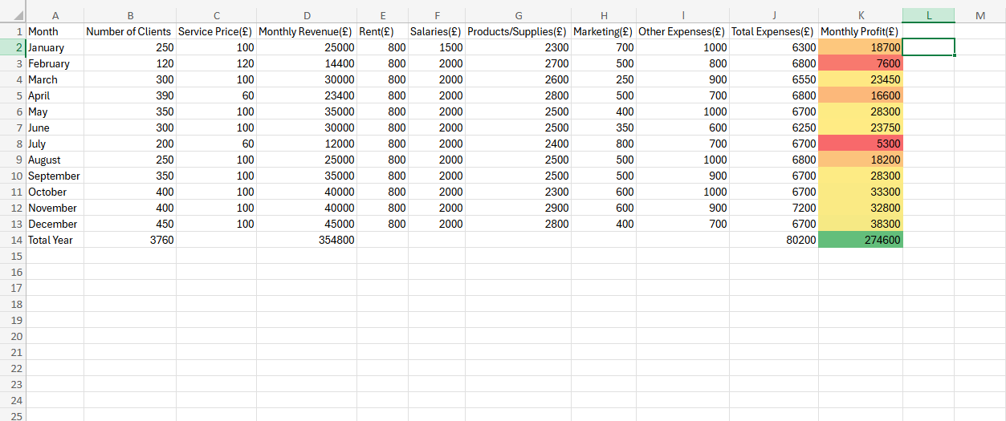
Figure 1: Financial projection for Glow & Grace Beauty - created in Microsoft Excel (original work)
The full spreadsheet can be accessed using the link below:
Book 1.xlsx

Excel also helps people see their data clearly. Charts and graphs allow someone to understand trends over time. For example, a salon manager can look at a line chart to see which months are busier or more profitable. This visual representation is very helpful for making decisions (Kelly, Hall & Connolly, 2023). Instead of just looking at numbers, owners can see patterns and plan, such as offering promotions during slow months.

Another great feature of Excel is automation. Simple formulas can calculate totals automatically, which saves time and reduces mistakes (Samar & Patni, 2008). This makes managing a business much easier, especially for someone who has many responsibilities. Automation in Excel helps people focus on planning and improving the business rather than spending hours on manual calculations.

Excel works well with other tools too. It can be used alongside Word, PowerPoint, or cloud services, which make it easier to share and present information(Birch, Lyford-Smith & Guo, 2018).For example, a manager can make a chart in Excel and then include it in a presentation to show performance to staff or investors. This flexibility makes Excel useful in many situations beyond just calculations.

Many students and researchers also use Excel. It helps them organize data from surveys, experiments, or projects. With simple formulas, it is possible to analyse results and make graphs that explain findings clearly. Learning Excel is useful not only for school but also for future jobs, because many employers expect people to have basic data skills (Kelly, Hall &Connolly, 2023; Hurst, 2021).

Even with new tools like Python or Power BI, Excel remains important because it is easy to use and widely available. Microsoft keeps updating it, adding features like real-time collaboration and cloud access (Dziak,2024). This means that people can work together on the same document from different places, which is essential in today’s world.

In conclusion, Excel is more than just a spreadsheet. It helps people understand and manage information, make better decisions, save time, and share data easily. For business, schools, and daily life, Excel is a tool that improves productivity and makes working with numbers simpler. For small businesses like Glow & Grace Beauty Salon, Excel is essential for tracking income and expenses, calculating profit or loss, and visualizing trends through charts. This task also links directly to the Managing Enterprise module, showing how practical digital skills can support decision-making and business planning in real-life scenarios. Learning how to use Excel is valuable and will continue to be important as technology and data play a bigger role in our lives (Hurst,2021).

References

*Birch, D., Lyford-Smith, D. & Guo, Y. (2018) The future of Spreadsheets in the Big Data Era. arXiv. Available at: https://arxiv.org/abs/1901.10231 (Accessed: 30 October 2025).
*Dziak, M. (2024) Microsoft Excel. Research Starters, EBSCO. Available at: https://www.ebsco.com/research-starters/computer-science/microsoft-excel
(Accessed: 30 October 2025).
*Hurst, S. (2021) Why the lack of Excel skills could threaten the economic recovery from the pandemic.
*ICAEW Excel Community. Available at: https://www.icaew.com/technology/excel-community/excel-community-articles/2021/lack-of-excel-skills-could-threaten-recovery-from-covid
(Accessed: 30 October 2025).
*Kelly, O., Hall, T. & Connoly, C. (2023) Digital Workplace Skills: Designing the Integrated Learning of Accounting and Microsoft Excel. Accounting, Finance & Governance Review, 30. Available at: https://afgr.scholasticahq.com/article/77593-digital-workplace-skills (Accessed: 30 October 2025).

*Rebman, C.M., Booker, Q.E., Wimmer, H., Levkoff, S. &McMurtrey, M (2023) An Industry Survey of Analytics Spreadsheet Tools Adoption: Microsoft Excel vs Google Sheets. Information Systems Education Journal, 21(5). Available at: https://files.eric.ed.gov/fulltext/EJ1409034.
(Accessed:30 October 2025).
*Samar, V. & Patni, S. (2008) Controlling the information Flow in Spreadsheets. arXiv.
Available at: https://arxiv.org/abs/0803.2527
(Accessed: 30 October 2025).

