Alexandru Carp

Lecture Name: Dr Nouh Elmitwally
Student Id:2317094
Data Warehousing & Data Mining
Data Mining

Contents
Task1 2
Task 1.1 Purpose and Practice of Data Mining 2
Task 1.2 Dataset Description and Exploration 2
Attributes and data types 2
Number of instances 4
Missing value 4
Summary statistics and distributions 5
1.3: Data Pre-processing and Post-processing 9
Handling missing values 9
Encoding categorical variables 10
Balancing the dataset 11
12
Feature selection or engineering 12
1.4: Sample Runs and Analysis Methods 14
J48: Classify 14
RandomForest: Classify 15
Logistic Regression Classify 16
Conclusion 17
1.5: Business Recommendations 17
1.6: Reflective Commentary 18

Task1

Task 1.1 Purpose and Practice of Data Mining

Data mining is frequently used in commercial settings to segment markets, identify fraud, forecast client behaviour, and enhance operational effectiveness. Because medical datasets frequently include substantial volumes of clinical, demographic, and behavioural data that may be examined for risk prediction and decision assistance, it is particularly useful in the healthcare industry.
Predictive analytics is one of the main goals of data mining. This entails creating models that can calculate the probability of future events using previous data, this can assist public health groups in creating preventative or awareness efforts that are more focused.
All things considered, data mining helps business and healthcare by enhancing decision-making, lowering uncertainty, and enabling companies to act on facts rather than conjecture. [1]

Task 1.2 Dataset Description and Exploration
The structure, quality, and usefulness of the Stroke Prediction Dataset for data mining were investigated. Prior to preprocessing and modelling, this step is crucial because it defines the kinds of variables that are accessible, draws attention to missing data, and shows early trends in the distribution of the characteristics. [2]

Attributes and data types
The dataset includes 12 attributes that include lifestyle, medical, and demographic data, as seen in Figure 1. These attributes comprise a combination of binary, category, and numerical variables.

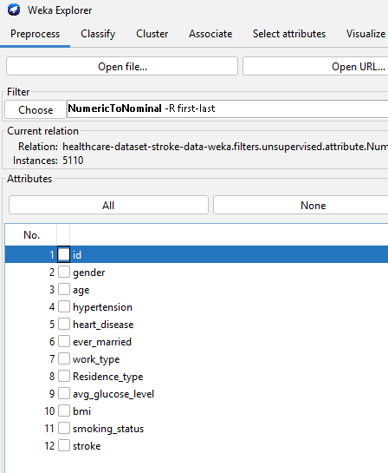

Numeric attributes | id | age | Avg glucose level | bmi
Binary attributes | hypertension | heart disease | stroke
Categorical | Gender | ever married | Residence type | Smoking status | Work type

Number of instances
There are 5,110 instances, or 5,110 distinct records in the dataset, this offers a moderately big dataset appropriate for classification models and exploratory research.

Missing value
Many characteristics were complete, according to an analysis of missing values. Nevertheless, there were 201 missing values in the bmi property, although there were no missing values in the other variables. This is crucial because improper handling of missing values during preprocessing might lower data quality and impact classification model accuracy.
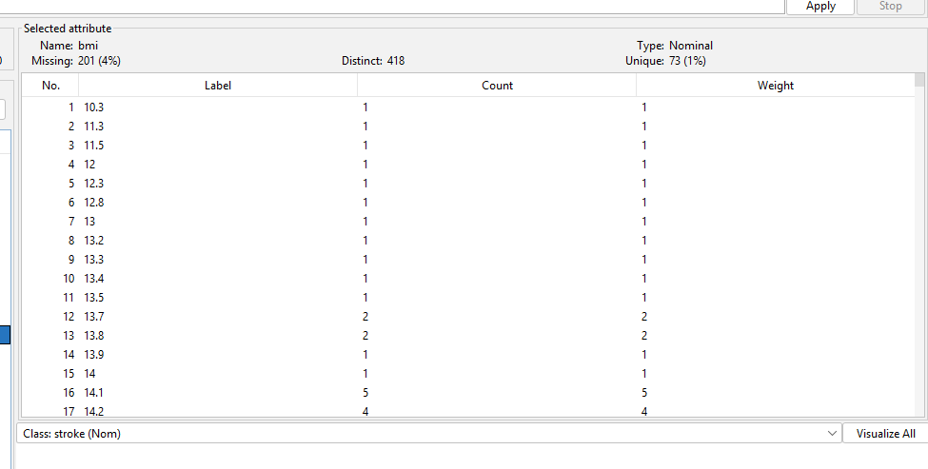

Summary statistics and distributions
An overview of the distribution of the key variables in the Stroke Prediction Dataset is given by the visualisations in this section. These charts show the frequency patterns of categorical variables like gender, smoking status, work type, residence type, hypertension, heart disease, and stroke outcome, as well as the distribution of values across numerical attributes like age, BMI, and average glucose level. Before additional preprocessing and modelling are carried out, these figures generally aid in identifying key patterns, variability, class imbalance, and the overall structure of the dataset. [3]
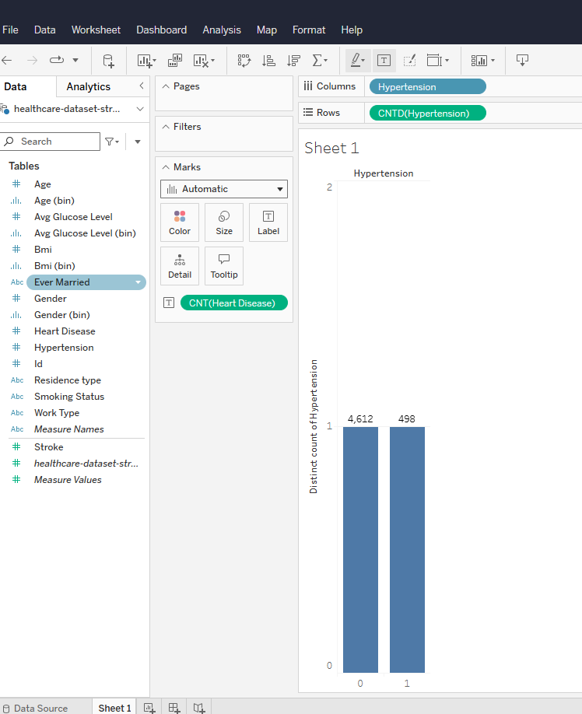

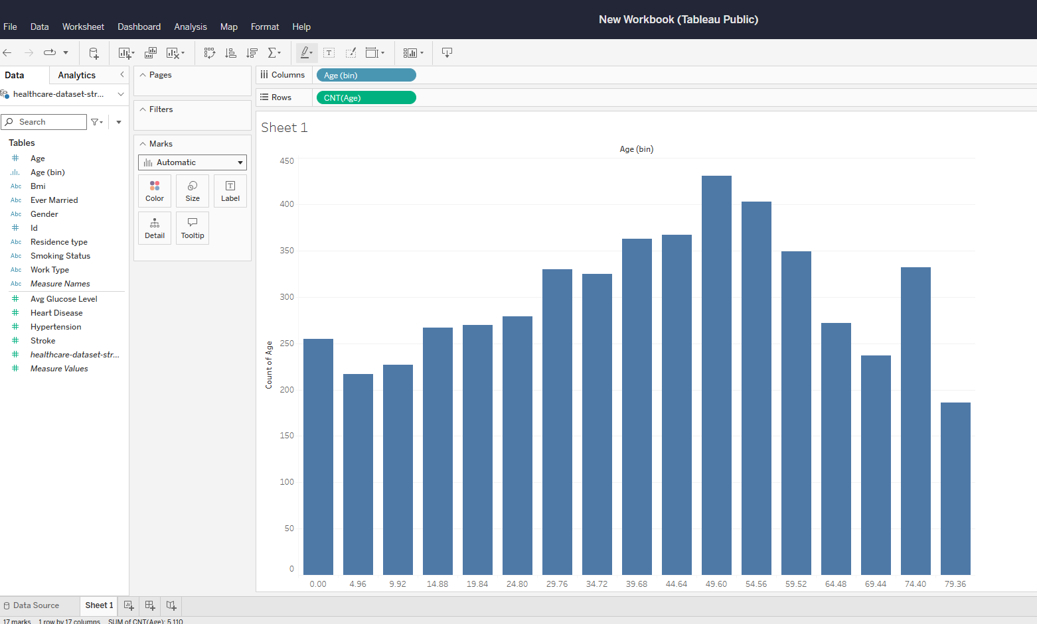

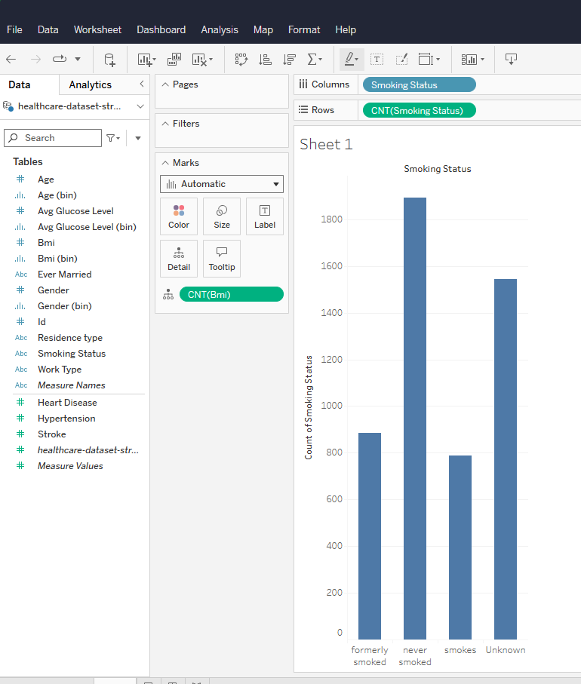

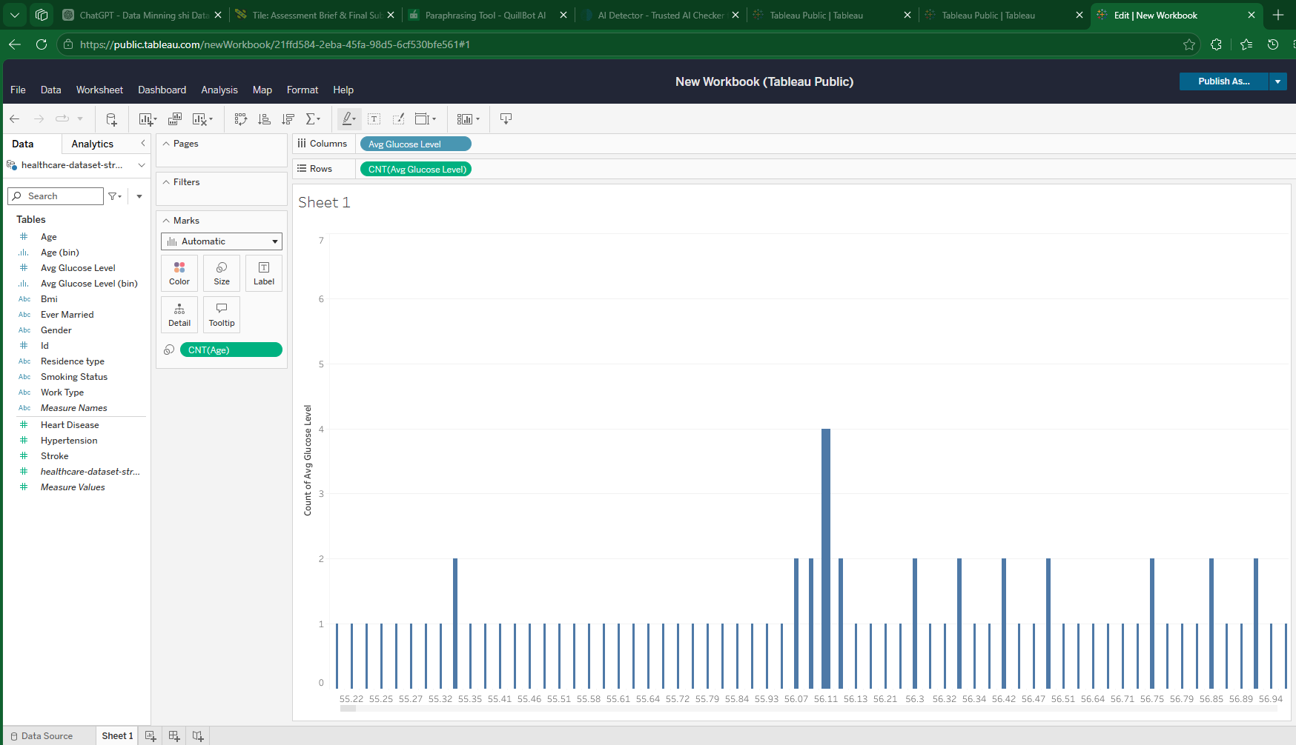
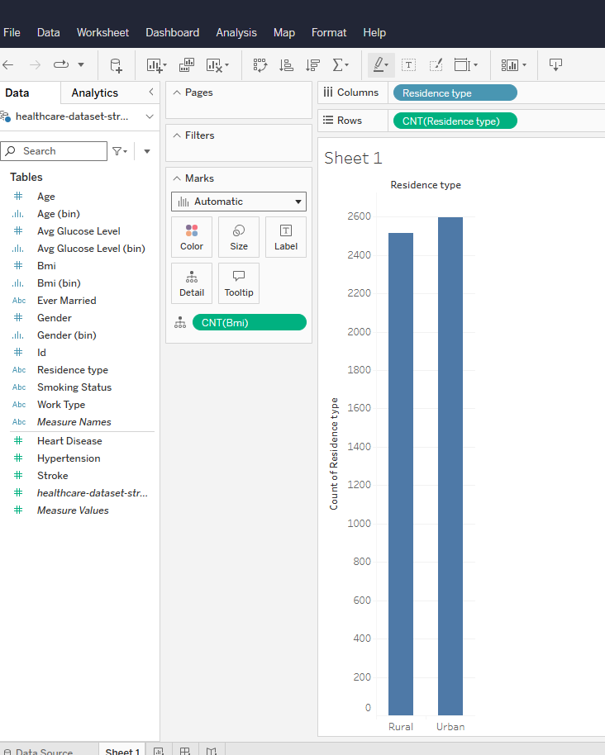

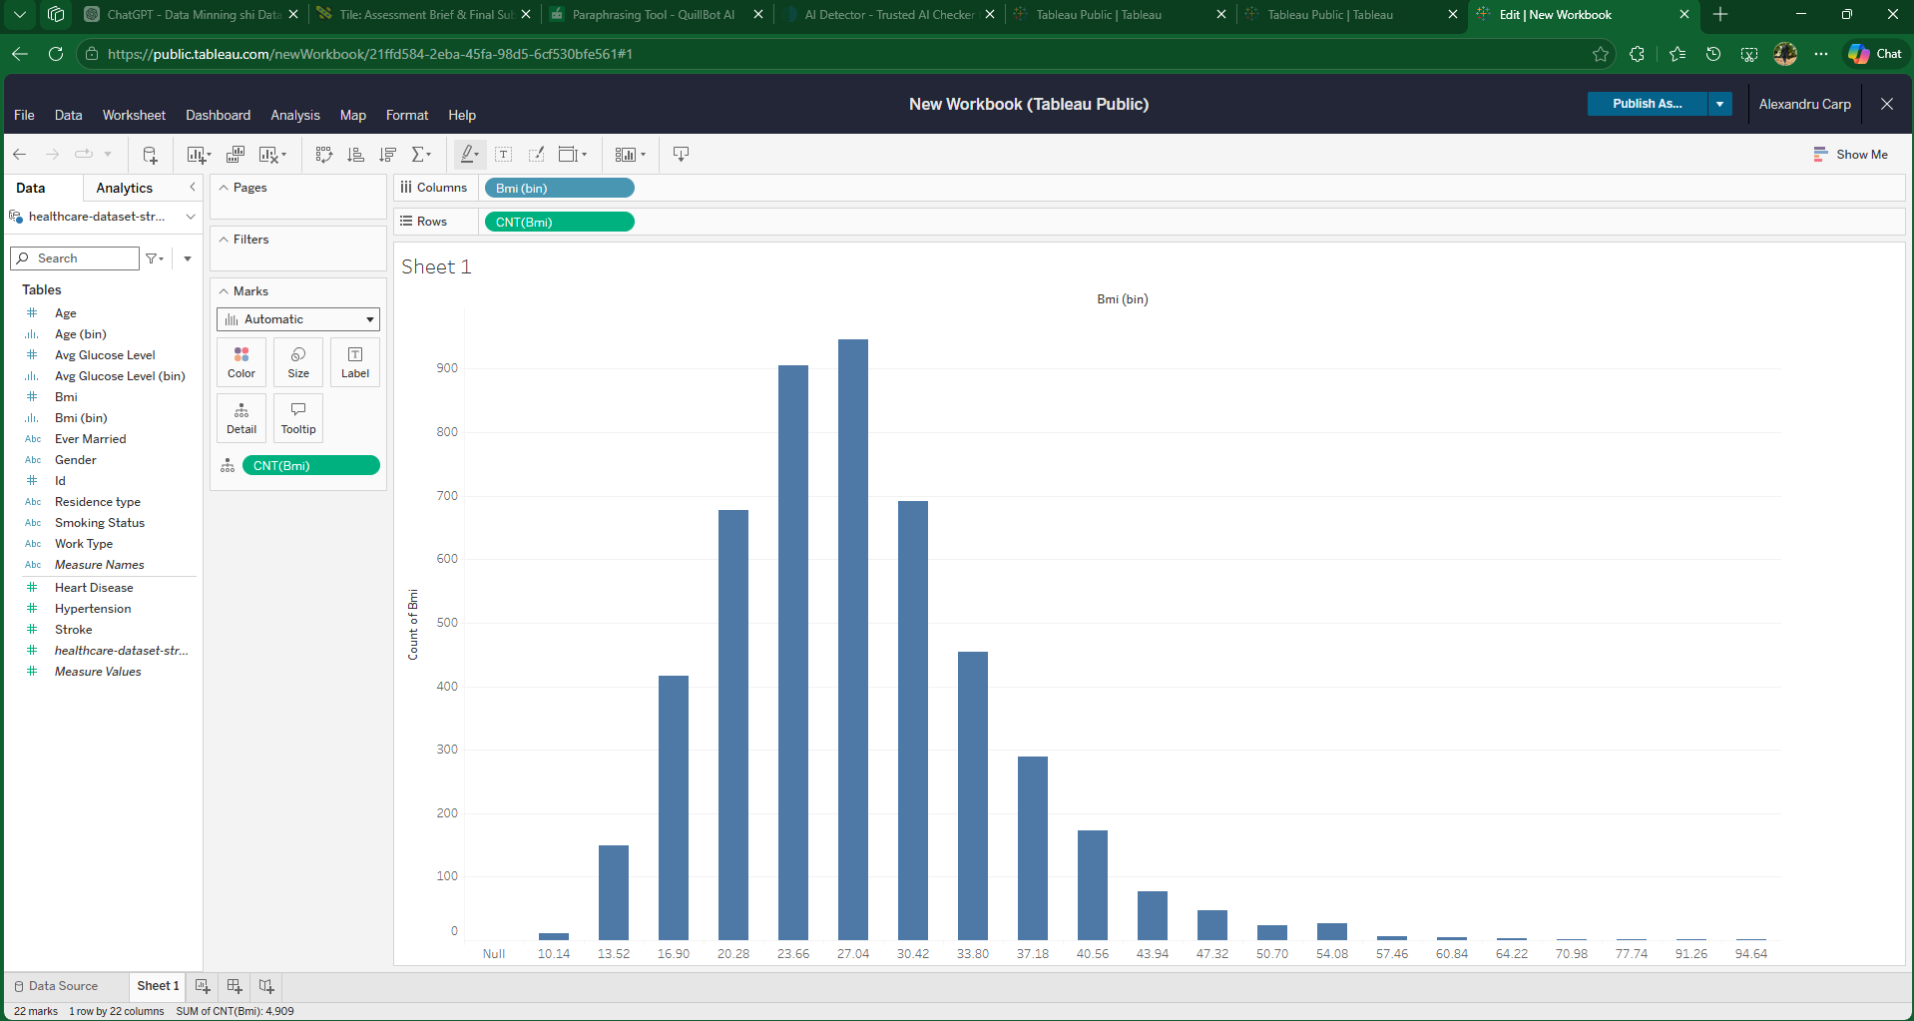
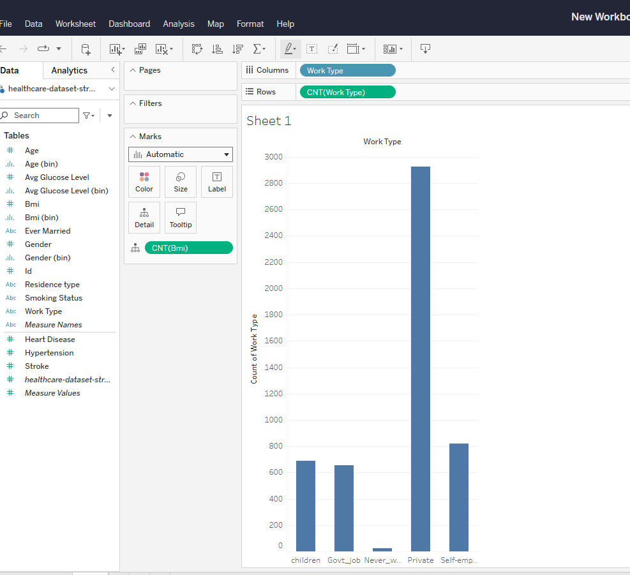

1.3: Data Pre-processing and Post-processing

Handling missing values
To enhance the quality of the dataset prior to analysis, missing values were found during the preprocessing phase. Only the BMI characteristic had missing data, with 201 records (4%) lacking, according to the findings; all other variables were full. Weka's ReplaceMissingValues filter was used to solve this problem. The whole dataset of 5,110 cases was preserved thanks to this preprocessing procedure, which automatically filled in the missing BMI values. This was crucial since removing records could have decreased the quantity of valuable data that could have been used for modelling. Therefore, addressing missing values enhanced data completeness and enabled more trustworthy classification outcomes.
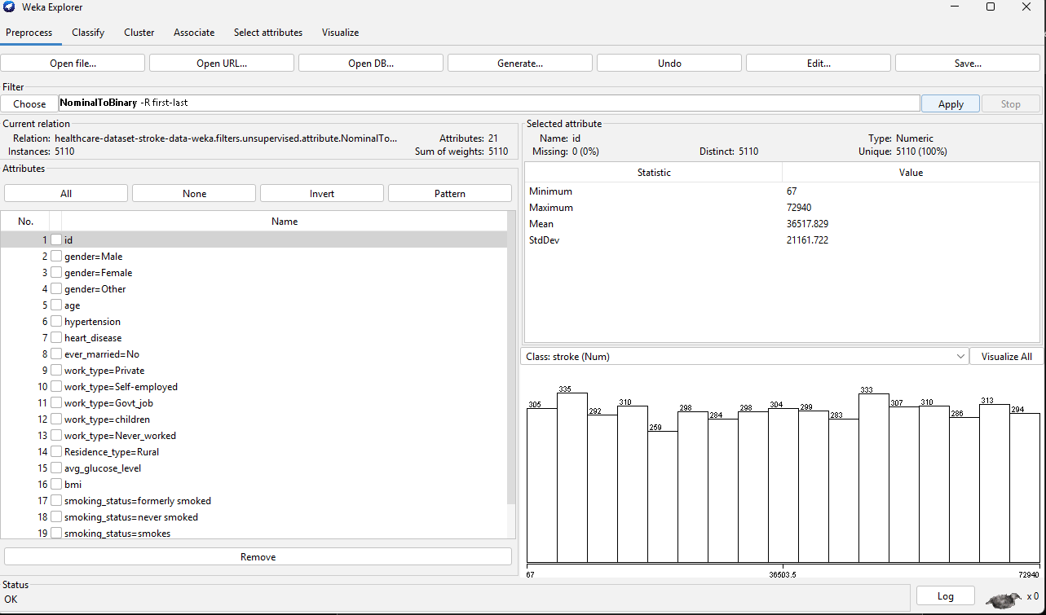
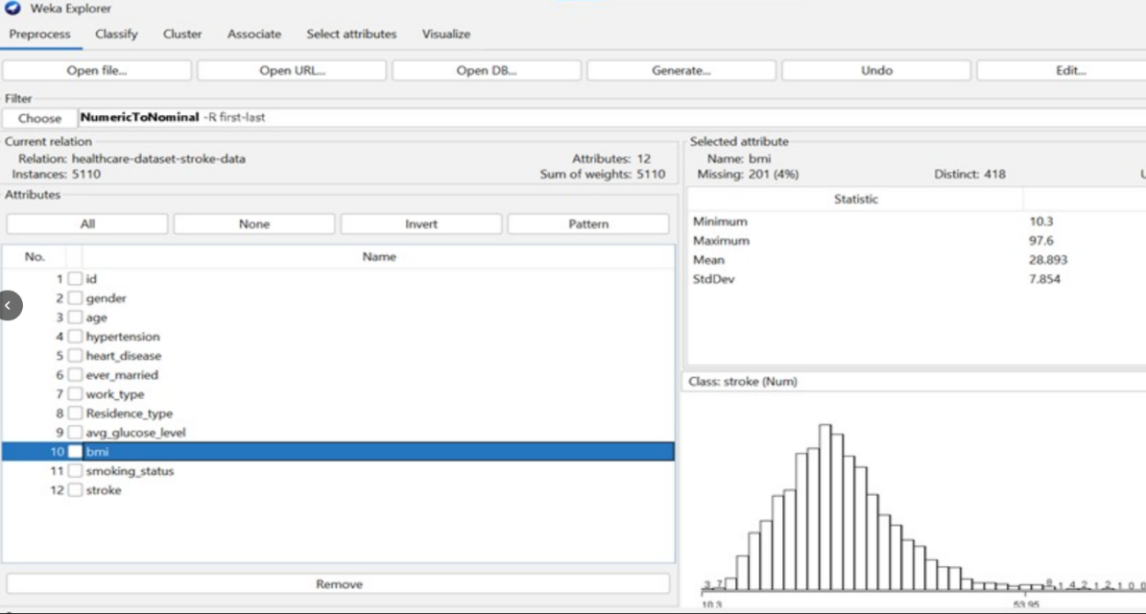

Encoding categorical variables
Gender, ever-married, employment type, residence type, and smoking status were among the categorical characteristics in the dataset. Many machine learning algorithms were unable to directly use these variables in their original nominal form. To transform categorical variables into binary indicators, Weka’s NominalToBinary filter was used during preprocessing. As an example, the gender attribute was selected to demonstrate this process. In the original dataset, gender appeared as a single nominal variable with categories such as male, female, and other. After applying the filter, it was converted into separate binary attributes. This transformation improved the dataset’s suitability for classification modelling by converting text-based categories into a numerical representation. The before and after screenshots illustrate how the categorical variables, using gender as an example, were transformed and prepared for further analysis.

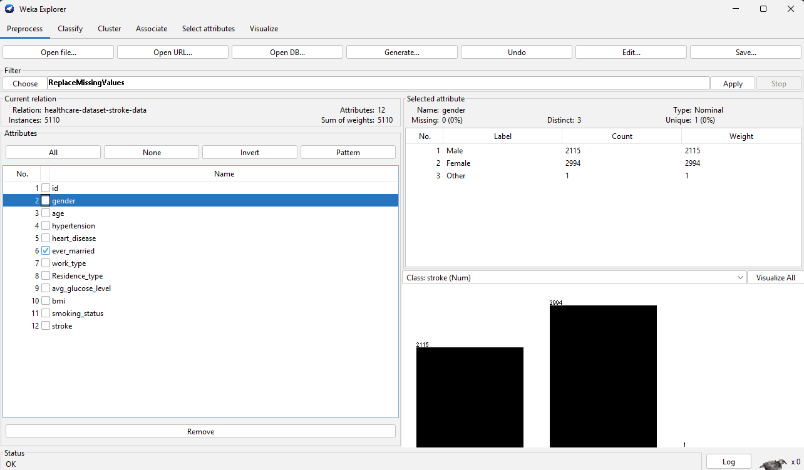

Balancing the dataset
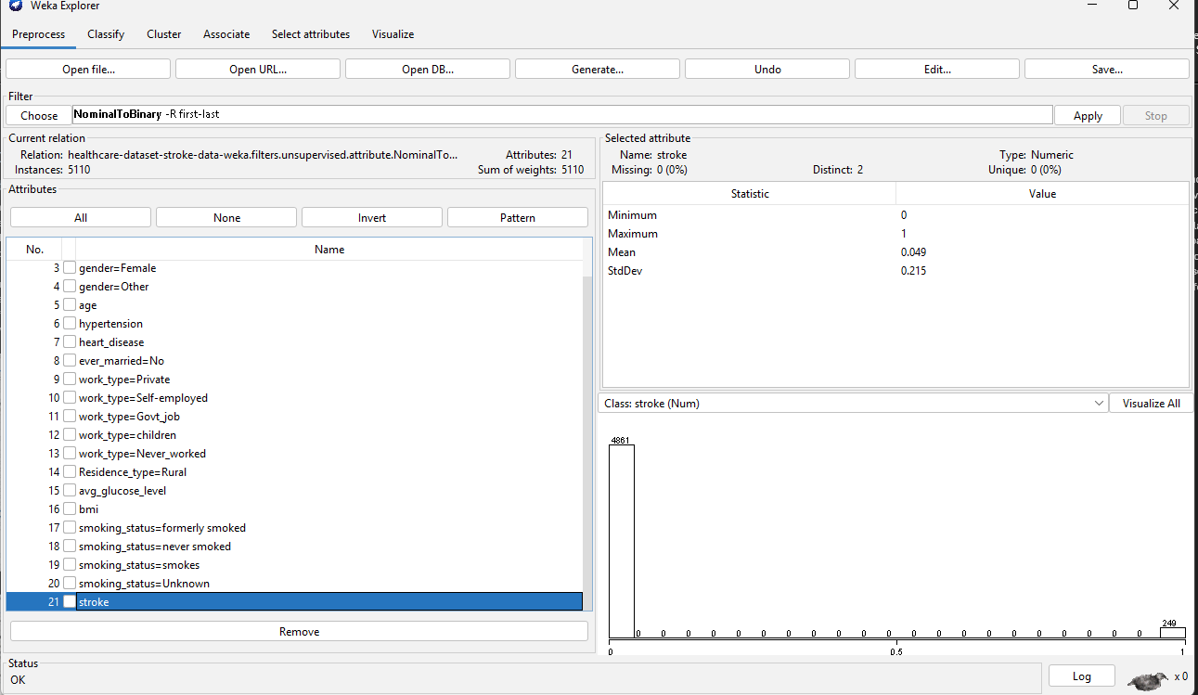
To determine whether balancing was required, the target variable's class distribution was examined. It was discovered that the dataset was unbalanced since only a tiny percentage of the occurrences represented stroke cases, with the remainder falling into the non-stroke class. No balancing technique was used at this point, even though this imbalance may have an impact on categorisation performance. This choice was taken since the present stage concentrated on data transformation, cleansing, and comprehension of the dataset's structure. To ensure that the preprocessing step accurately represented the features of the data prior to model training, the original distribution was kept. [4]

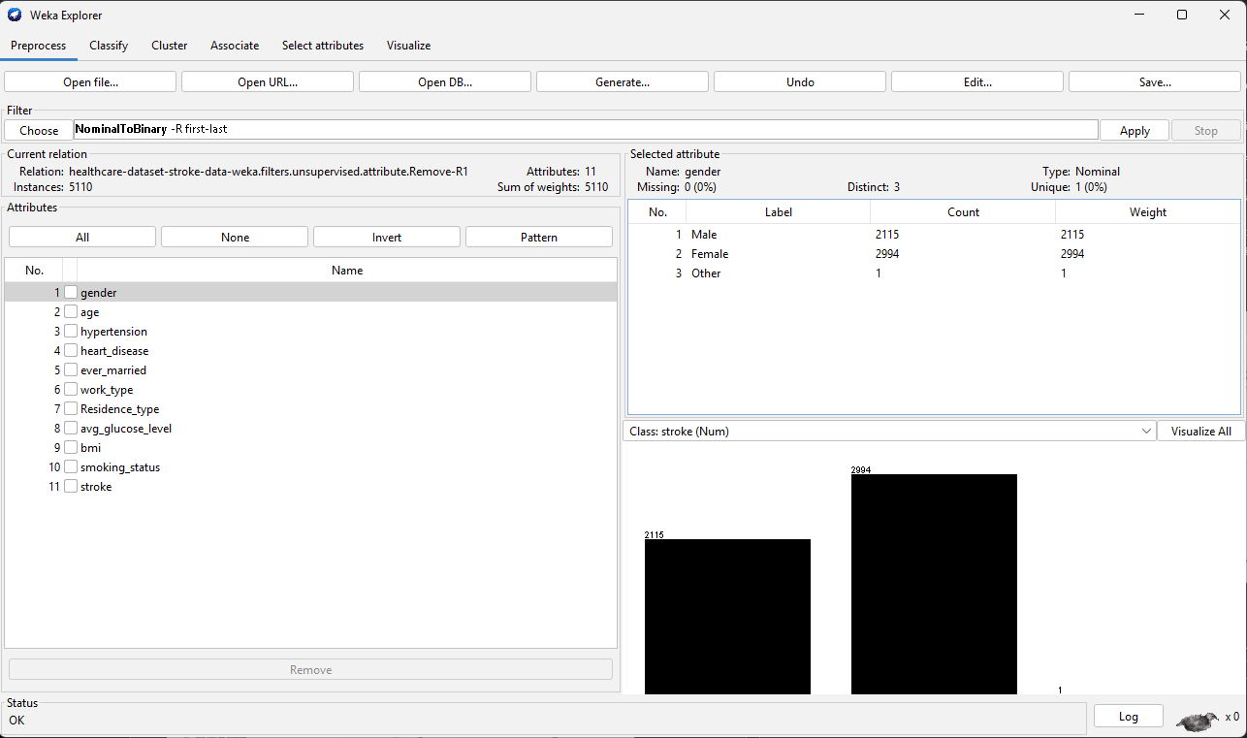

Feature selection or engineering
The id property was eliminated during feature selection as it provided no useful predictive information and served solely as a unique identifier for every patient. Keeping it might add needless noise to the dataset because it has no analytical use for stroke prediction. As a result, it was left out of additional modelling and analysis.

1.4: Sample Runs and Analysis Methods

J48: Classify
Since the original goal was to assess how conventional classifiers performed on the original dataset, balancing was not used during the preparation step. This allowed for the firsthand observation of how class imbalance affects model behaviour, namely the propensity to support the majority class. Despite the imbalance being discovered earlier in the preprocessing phase, no balancing method was used at that time. Its effects were evident during classification, as the J48 model failed to identify any stroke patients while achieving high overall accuracy. Balancing was not employed during the preparation phase because the initial objective was to evaluate how traditional classifiers performed on the original dataset. This made it possible to observe directly how class disparity influences model behaviour, namely the inclination to support the majority class. Even though the imbalance was found earlier in the preprocessing stage, no balancing technique was applied at the time. The J48 model had great overall accuracy during classification, however it was unable to identify any stroke victims.

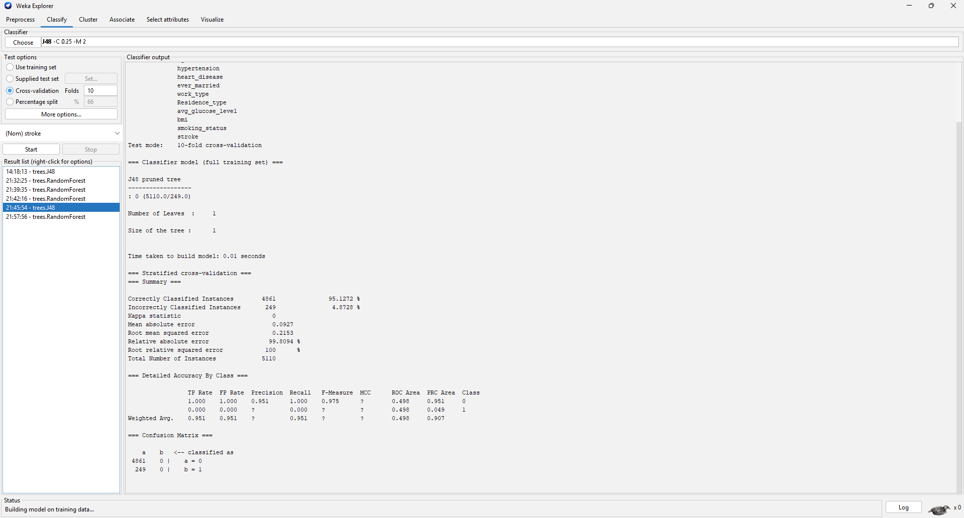

RandomForest: Classify
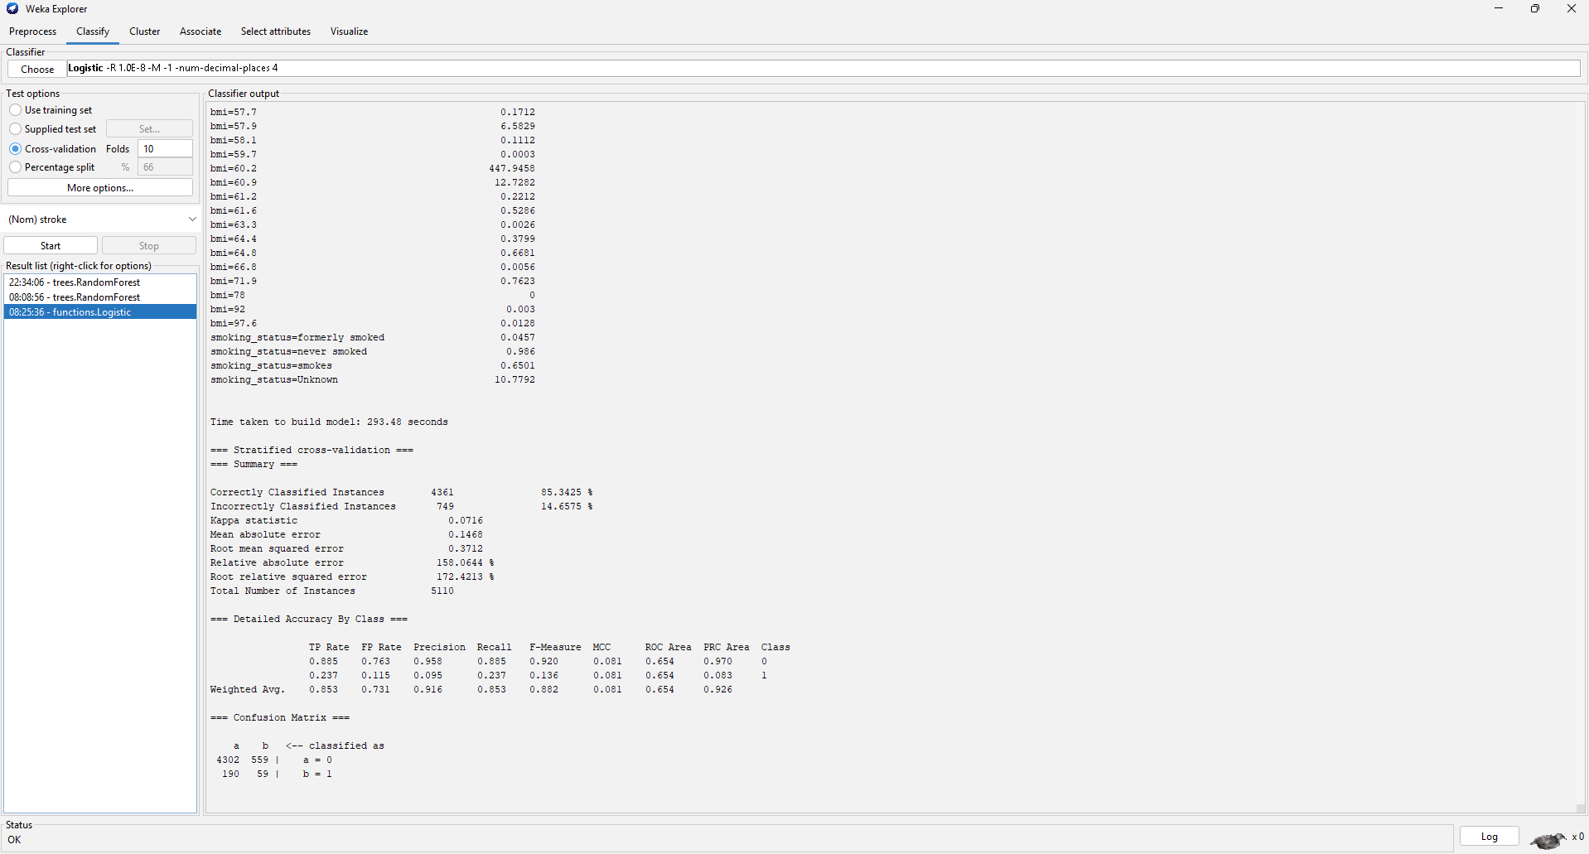
A deeper look at the confusion matrix showed that despite the model's high overall
accuracy of almost 95%, it was unable to accurately categorise any stroke instances. The majority class (non-stroke) was predicted for every occasion, suggesting a significant bias brought on by class imbalance.
this experiment demonstrates the necessity for methods like oversampling, under sampling, or SMOTE in future work and proves that class imbalance has a major detrimental effect on model performance.

Logistic Regression Classify

To compare its effectiveness with tree-based models, logistic regression was used as a linear classification technique. A fraction of the minority class was detected by the logistic model, in contrast to J48 and Random Forest, which were unable to find any stroke instances.
The confusion matrix revealed that the model accurately detected certain stroke events, despite the overall accuracy dropping to about 85%. In contrast to earlier models that were strongly biased toward the majority class, this shows a more balanced prediction behaviour.
But the model still had trouble achieving high recall for stroke cases, suggesting that performance was still impacted by class imbalance. This implies that other methods, such dataset balance, would be needed to further enhance the detection of the minority class, even though logistic regression can partially address the problem.

Conclusion
Several classification algorithms, such as J48, Random Forest, and Logistic Regression, were used in this job to forecast the incidence of stroke. The findings demonstrated a considerable bias toward the majority class, with tree-based models achieving excellent overall accuracy but failing to properly identify any stroke instances. On the other hand, Logistic Regression demonstrated a more balanced prediction by detecting some cases of the minority class while producing lower accuracy.
These results demonstrate that when assessing models on unbalanced datasets, great accuracy is insufficient on its own. The class imbalance, which caused most models to favour the majority class, was the primary factor influencing performance. To enhance the identification of stroke patients and create a more trustworthy prediction model, the results indicate that future research should concentrate on using data balancing approaches like oversampling or SMOTE. [5]

1.5: Business Recommendations
Numerous suggestions for public health groups and healthcare professionals might be made considering the analysis's conclusions.
First, when identifying high-risk patients, predictive models shouldn't depend only on overall accuracy. As shown, even very accurate models may be unable to identify crucial situations like strokes. To prevent at-risk patients from being overlooked, healthcare systems should give assessment measures like recall and sensitivity top priority.

Second, it is necessary to improve the balance and quality of the data. The findings demonstrated that class imbalance had a substantial impact on model performance, resulting in inadequate stroke case identification. To increase model dependability, healthcare institutions could invest in gathering more balanced datasets or use strategies like oversampling or SMOTE.
Third, rather than being stand-alone systems, predictive models ought to be employed as instruments for decision-making. Even Logistic Regression, the model that performed better, was not accurate enough to be utilised on its own. When evaluating patient risk, clinicians should integrate model projections with medical knowledge.
Lastly, it is crucial to continuously assess and update the model. Models should be retrained when additional data becomes available to enhance their capacity to identify uncommon but serious illnesses like stroke.
All things considered, early detection can be improved, and better healthcare decision-making may be supported by the incorporation of enhanced data practices and thorough model evaluation. [6]

1.6: Reflective Commentary
The analysis's use of several methods, which made it possible to compare various modelling techniques clearly, was one of its key advantages. This made it easier to determine that the dataset's structure rather than the model selection was the problem. The absence of data balancing methods during preprocessing, however, was a major drawback that had a big impact on the outcomes.
If this research were to be redone, I would train the models using balancing techniques like SMOTE or oversampling. Furthermore, rather than concentrating only on accuracy, I would pay more attention to assessment criteria like recall and precision. My comprehension of machine learning assessment and the significance of data quality in creating trustworthy prediction models has generally increased because of this job.

Bibliography

[1] | M. L. Kolling, “https://pmc.ncbi.nlm.nih.gov,” Int J Environ Res Public Health, 1 03 2021. [Online]. Available: https://pmc.ncbi.nlm.nih.gov/articles/PMC8002654/. [Accessed 22 04 2026].
[2] | AWS, “https://aws.amazon.com/,” AWS, 1 02 2025. [Online]. Available: https://aws.amazon.com/what-is/data-mining/?trk=cd123851-b4fc-4bc3-83eb-12424869c512&sc_channel=ps&ef_id=CjwKCAjwqazPBhALEiwAOuXqdOLa4my1L8jo_7T1CKJNe5RisyPgibsfAC71XAm407HWNPqCM9zjJhoCtFkQAvD_BwE:G:s&s_kwcid=AL!4422!3!795811957842!p!!g!!data%20mining%20t. [Accessed 22 04 2026].
[3] | https://public.tableau.com/, “https://public.tableau.com/,” https://public.tableau.com/, 1 02 2026. [Online]. Available: https://public.tableau.com/. [Accessed 23 04 2026].
[4] | softguide, “https://www.softguide.com,” SoftGuide, 03 04 2026. [Online]. Available: https://www.softguide.com/function/pre-and-post-processing. [Accessed 23 04 2026].
[5] | J. Brabec, “https://pmc.ncbi.nlm.nih.gov,” Computational Science, 1 03 2020. [Online]. Available: https://pmc.ncbi.nlm.nih.gov/articles/PMC7303692/. [Accessed 23 04 2026].
[6] | B. Larijani, “https://pmc.ncbi.nlm.nih.gov,” Arch Acad Emerg Med., 7 03 2024. [Online]. Available: https://pmc.ncbi.nlm.nih.gov/articles/PMC11635538/. [Accessed 23 04 2026].

