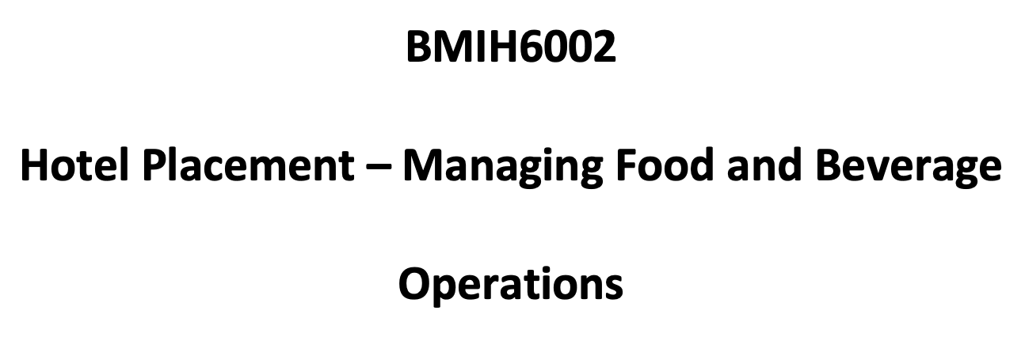Submitted By
Yanka Stancheva
Student number:2210661

I confirm that I have not used any AI tools in the research and creation of this assignment.
I confirm that I have not presented any AI generated materials as my own work.
I confirm I have copies of my drafts, notes and other resources I used, which I may be asked to provide in evidence.

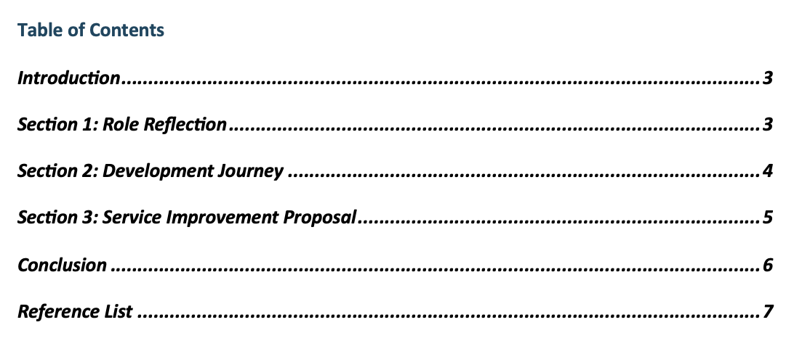

Introduction
My placement hotel was the DoubleTree by Hilton Dartford Bridge, a famous 4-star hotel in Kent welcoming people on business trips as well as holidays. F&B offers a restaurant, a lounge bar, banquet areas and room service. My main responsibility during my placement was in the restaurant, where I helped serve snacks, pick up after meals and do the dinner arrangements, both for regular guests and football teams.
I entered the placement with three primary learning objectives:
- Enhance communication and leadership skills in a high-pressure F&B environment.
- Develop practical competence in service setup, guest handling, and post-service clearing.
- Understand how supervisory roles manage team dynamics and quality assurance.
I am using the Learning Cycle identified by Kolb (1984) to look at my learning experience in more detail.

Section 1: Role Reflection
Concrete Experience
My basic tasks were to set up the snack section, handle beverage delivery quickly, take charge of dish clean up and help with food preparations mainly for the football players. A high level of pressure was experienced at a weekend sports event when 40 players arrived at once. Since many tourists came unexpectedly, it took fast decisions to keep guests happy and prevent any delays. I took charge of organising people waiting to eat, delivered notes about diet requests to the kitchen and kept an eye on the buffet to be sure it was always filled.
Though I did not directly supervise anyone, I was able to watch how the restaurant supervisor divided responsibilities, resolved staff questions and helped guests who felt anxious. Because of this experience, I realised that being a supervisor means being flexible and emotionally intelligent at the same time.
Reflective Observation
One of the things I did best was to keep everyone informed and clear during the busy times. People I work with noted that staying calm during the service rush was really helpful. However, I realised that I did not always help out when my staff members appeared confused.
I didn’t start solving the problem by myself when buffet service was delayed; I simply waited for directions. After that, the supervisor explained that being self-assured at the start is a major factor in the team’s progress. This made it clear that a leader’s style and employees’ initiative play a key role in achieving successful operations (Johnston et al., 2012).
Abstract Conceptualisation
When I thought about the scenario using Kolb’s approach, I realised that doing real service work helped me learn new things I couldn’t get from theory alone. The Tuckman model gave me an explanation of how teams work in the most demanding situations (Cousins & Weekes, 2020). As people understood their roles and started supporting each other, the team moved from being confused to being well coordinated.
I realised how important SOPs were for maintaining the same level of order even during times of chaos. Following Hilton’s brand service standards was made easier because the supervisor led by example (Walker, 2021).
Active Experimentation
Moving forward, I aim to:
- Join F&B leadership workshops to develop decision-making under pressure.
- Shadow supervisors more formally to understand task prioritisation.
- Build confidence through mock team briefings to enhance communication under pressure.
These actions will enable me to transition from task-doer to proactive team contributor—essential for future supervisory roles (Fallon & Rutherford, 2010).

Section 2: Development Journey
Comparing Level 4 and Level 6 Placements
My position at Level 4 was at a Premier Inn hotel which saw few guests at any given time. The service was informal and tasks were highly guided. At the other end, Double Tree Dartford Bridge was bigger, created time pressure, handled much larger slots and had several activities operating at once.
This let me go from sticking to routines to choosing actions related to service. I also had to endure a wide range of emotions and think quickly in response.
Academic Module Learning
The menu planning and table arrangements that I learned in Level 4 were fine for a small restaurant, but at Double Tree, things needed to be changed quickly for big groups. I started with the theoretical knowledge, but I changed my approach when dealing with actual guests and the demands of the team (Vallen & Vallen, 2014).
In the Level 5 Sustainable Hospitality & Tourism Management module, we talked about corporate social responsibility and specifically about food waste. I found that DoubleTree used a waste system, but having big groups in once meant they made too much food. Because of my similar bookings, I advised using portion control and was positively acknowledged by a staff member. I realised that it is important to make sustainability work in real-life situations (Martin, 2020).

Section 3: Service Improvement Proposal
Identified Issue: Slow Guest Turnaround Time for Large Groups
I noticed again and again during our group breakfast that the food took a long time to be delivered. They took a long time to clear the plates, set up the tables again and bring out new food items from the buffet. This led to guest dissatisfaction and visible team stress.
Observations and Conversations
Apparently, the inconsistency in briefings and the absence of marked seating for each table caused the delays. Staff often didn’t know which tables to prioritise. A chef indicated that, sometimes, refills were delayed because of last-minute messages.
Proposed Three-Step Plan:
- Structured Pre-Service Briefing: Before any large meal, meet with the team for 10 minutes to decide who does each job, how the service will go and what is included in the menu.
- Zoning System for Servers: Divide restaurant into zones. Every server is responsible for one zone to keep things organised and the same for all guests.
- Set Up Digital Refill Reminders: Start a group chat on WhatsApp or Slack so staff members can alert the kitchens when something is low.
Crask (2024) believes that structured communication greatly enhances the process of service recovery and how guests view a business. Using real-time technology, Steen et al. (2024) argue that restaurants can overcome operational delays when the dining areas are very busy.
Impact on Performance Standards
If hotels improve communication and take responsibility, guests’ stay will be shorter and the service will be improved (Johnston et al., 2012).

Conclusion
Working at DoubleTree by Hilton Dartford Bridge helped me advance greatly in the F&B industry. It made me combine both technical knowledge and interpersonal skills in various real-life scenarios. I noticed that keeping calm as a leader, working well as a group and being adaptable is very important, especially in big group situations like football team lunches.
Although my skills in communication and organisation have grown, I should continue to boost my confidence and make more positive decisions. Going through Kolb’s Learning Cycle has allowed me to transform what I learn from experience into things I can use.
I achieved my learning goals and feel confident to accept greater responsibilities in the F&B field.

Reference List
Cousins, J. & Weekes, S. (2020). Food and Beverage Service. 10th ed. London: Hodder Education.
Crask, J. (2024). Business continuity management: A practical guide to organization resilience and ISO 22301. Kogan Page Publishers.
Fallon, M. & Rutherford, D. (2010). Hotel Management and Operations. London: Wiley.
Johnston, R., Clark, G. & Shulver, M. (2012). Service Operations Management. 5th ed. London: Pearson.
Kolb, D. (1984). Experiential Learning: Experience as the Source of Learning and Development. Englewood Cliffs: Prentice-Hall.
Martin, A. (2020). The Practical Guide to Understanding and Raising Hotel Profitability. Abingdon: Routledge.
Steen, R., Haug, O.J. & Patriarca, R. (2024). Business continuity and resilience management. Journal of Contingencies and Crisis Management, 32(1), e12501.
Vallen, G. & Vallen, J.J. (2014). Check-In Check-Out: Managing Hotel Operations. 9th ed. Harlow: Pearson.
Van den Bossche, P. & Baktiran, T. (2021). Experience and Reflection: Donald Schön and David Kolb. In Theories of Workplace Learning in Changing Times. Routledge.
Walker, J.C. (2021). Introduction to Hospitality. 8th ed. Harlow: Pearson.

