Academic Scrapbook.

Michelle Thomas
1602397
SJIE4006

With reference to classroom observation and practice, demonstrate an understanding of the effective application of three educational theories.

Contents:

- Introduction- What is learning?

- Theorist John Dewey

- Theorist B, F Skinner

- Theorist Lev Vygotsky

- Conclusion

- Reference List

This academic scrapbook will look at three educational theorists and how their theories are used within the classroom setting. As a learning support assistant in a classroom I will reflect on observations and practice used.

What is learning? We begin to learn as soon as we are born and continue to do so until we die. From birth we need to learn to eat, to walk and to interact with others to allow our bodies to become functional. Learning is a continuous process throughout our daily life, it is how we use experiences to gain information. Learning can occur randomly during day to day activities
Learning is natural, we all have a desire to see, touch or hear new things. Learning in the classroom environment can take shape in many different ways. We are all individual and how we learn to retain information varies greatly. Over time a variety of theories have been tried and tested, on a personal level I favour ‘learn by doing’. By actively taking part in a task reinforces what is being taught. Personal experience in a Special Educational Needs (SEN) setting sees teachers plan their success criteria and learning outcomes, then adapt or differentiate activities to suit individuals. (Skills You Need, 2011).

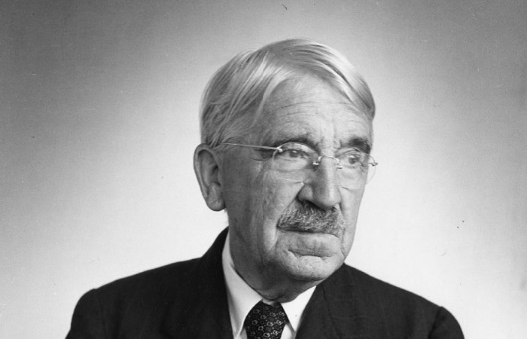 John Dewey (1859-1952)
became Professor of Philosophy and along with his wife Alice, they explored ways of improving education.
Dewey theory states that
‘Children learn by doing.
Education should be based on real-life situations.
Experimentation and independent thinking should be fostered. He saw children as being characterised by curiosity’ (Pound, 2005, p. 21).

Dewey believed that children benefited from taking an ‘active part in the process of their own learning’ (Wheeler, no date, p.1). Children would benefit from activities linked to ‘real-life’ situations. Dewey favoured teachers and their pupils having an equal importance in learning and a more balanced approach to learning instead of emphasising too much on abilities (Pound, 2005; Wheeler, nd).
As a SEN setting we strive to create a happy, safe, supportive, and stimulating learning environment. School uses a thematic approach to learning based on skills curriculum appropriate to the children’s needs. With an emphasis on building relationships and independent learning. Children take responsibility for accessing appropriate equipment and resources to develop and promote independence (Portfield, 2016).
Foundation Phase is favoured in many early years settings, as we do at our setting. A child’s early years are a time when they are particularly receptive to learning, are active and curious about their surroundings. Children need space to move and explore, keeping them stimulated and motivated is also important. Children will still need to be challenged at an appropriate level. Part of Foundation Phase is for children to ‘Plan Do Review’. This encourages them to plan their own activity, do the activity then return to the group and review what they have done. In favour with Dewey this encourages children to take ownership of their learning and to evaluate their findings (Pound, 2015; Portfield, 2016).

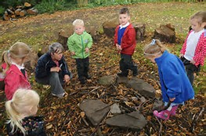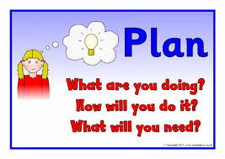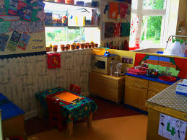

Working day to day in a class of six pupils aged 12-18 with Profound and Multiple Difficulties (PMLD) promoting independence is important. Class teachers work within the curriculum as required though many aspects are adapted to suit a wide range of Additional Learning Needs (ALN). Many of our daily activities are centred around being independent and life skills, such as shopping, cooking, hoovering and tidying up. One task that is reinforced daily is for pupils to make their own breakfast and then clear away after. Pupils are supported by staff, they are encouraged to gather their resources make their cereal or toast and clear away after. Pupils are challenged to problem solve by items not being in usual place or possibly an electrical item being unplugged. Tasks are linked to tasks that may be carried out at home.
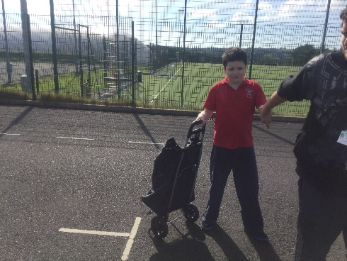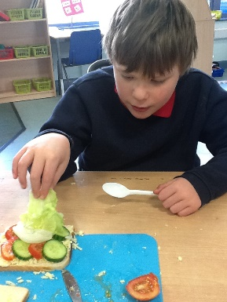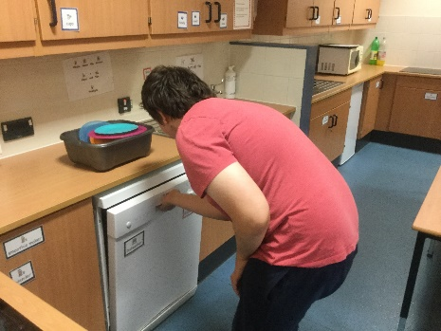

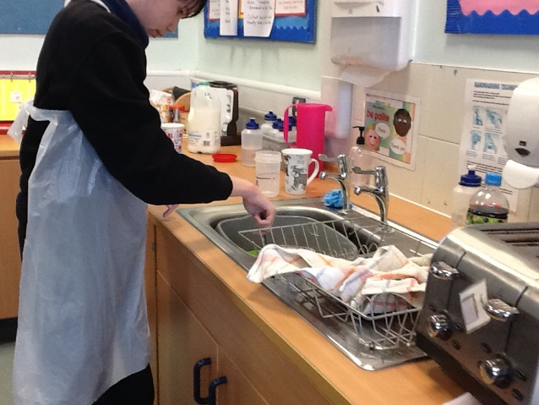
Pupils are carrying out daily activities promoting life skills and independence.

B F Skinner. (1904-1990)

 Skinner is a well-known behaviourist theorist. It is my opinion that Skinners experiments were unorthodox as he experimented on rats and pigeons, though most of his written work was about children.
Results of Skinners experiments showed that if previous behaviours are rewarded then they are likely to be repeated. As a reward is given children happily believe they are doing ‘what they want’. Children then believe they are in control.
Skinner believed that most behaviour is learnt, and children behave in any manner they choose (Pound, 2015).
Behaviourism is quite often seen in the teaching of pupils with SEN and in behaviour management.
Within our setting we use various rewards systems usually tailored to pupil’s individual needs. All pupils have varying Additional Learning Needs (ALN) and are motivated by individual preferences. One severely Autistic pupil is highly motivated by free time on the computer and will usually complete all work tasks in order to gain this reward.
Now and Next, is a visual timetable to break down tasks. Pupils feel they are in control as they are having a reward, when really it is the teacher who is in control. Pupils understand that they need to complete the ‘Now’ which is usually a work task to receive the ‘Next’.
I am working towards…… pupils choose their own reward and place a picture on a visual chart. Between three and five tasks are set by the teacher to be completed. After each task a token is given and placed on chart. When all tasks are completed the tokens are given in exchange for the chosen reward. As with Now and Next this strategy works well in our SEN setting especially with pupils presenting with high levels of Autism Spectrum Condition (ASC). Pupils who are able to work to a higher level these systems are adapted, especially if pupils are capable of being challenged a little further. By providing rewards it will promote continuous behaviour and is an incentive for others.
‘Today, many parents (and even school systems and other childhood authorities) are inclined to provide positive reinforcement to encourage good behaviour, reserving negative reinforcement techniques only as a last resort’ (Grace, 2017, p.1).

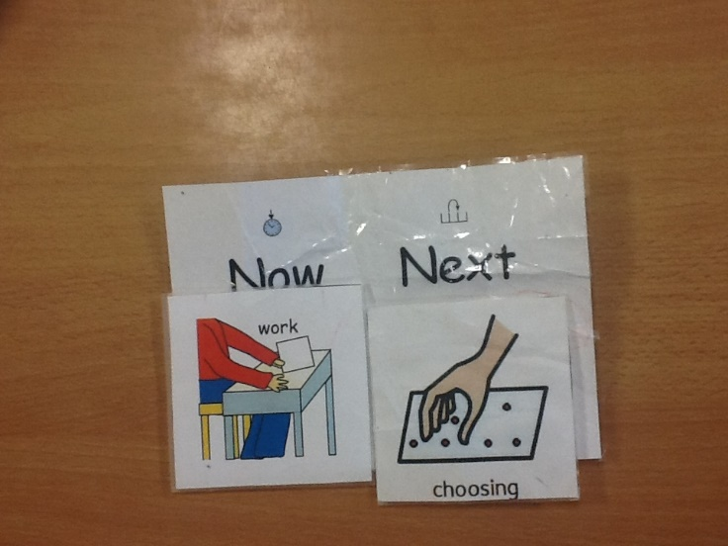
Example of a pupils Now and Next chart. Picture symbols are used, pupil can refer to this during task for reassurance.

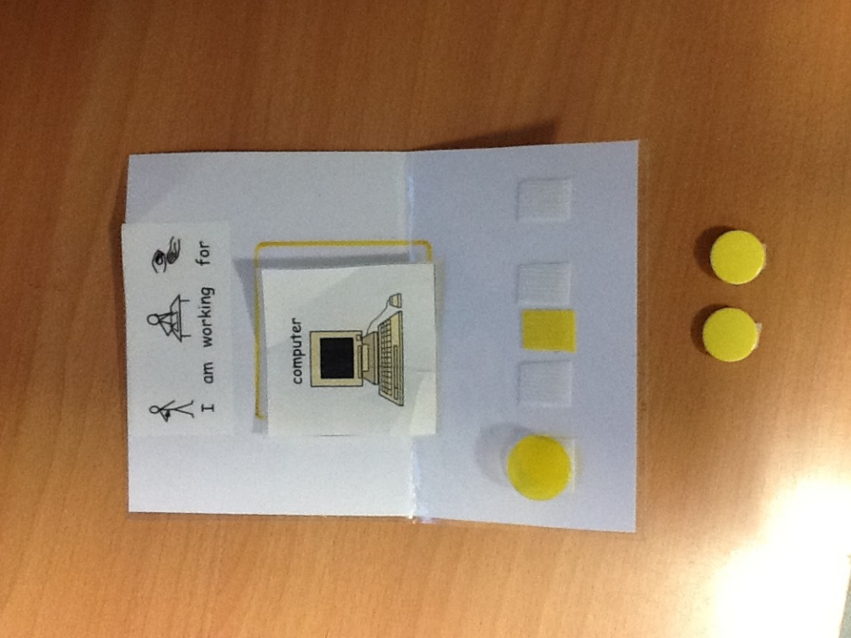
An example of a rewards chart used in class. Pupils choose a reward such as computer then need to earn reward by completing five tasks.

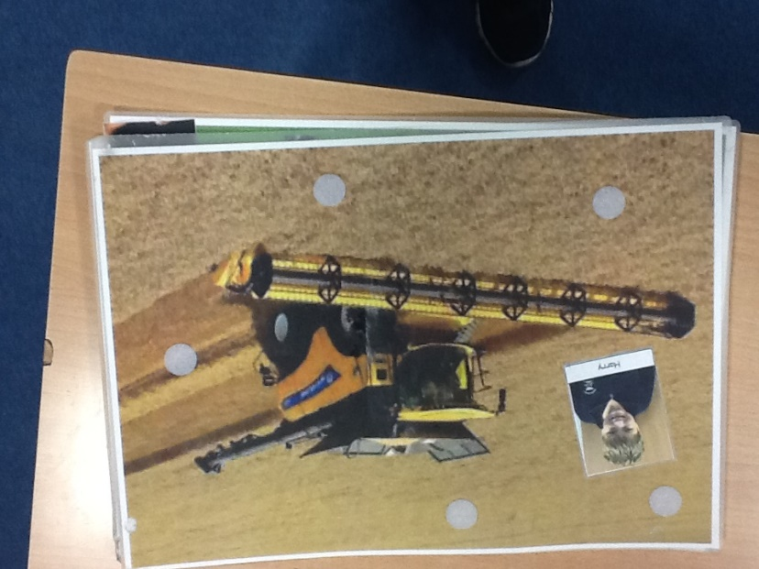

An example of a personalised rewards chart. Pupils personalise their charts to help keep them motivated and have ownership.
Lev Vygotsky 1896 - 1934
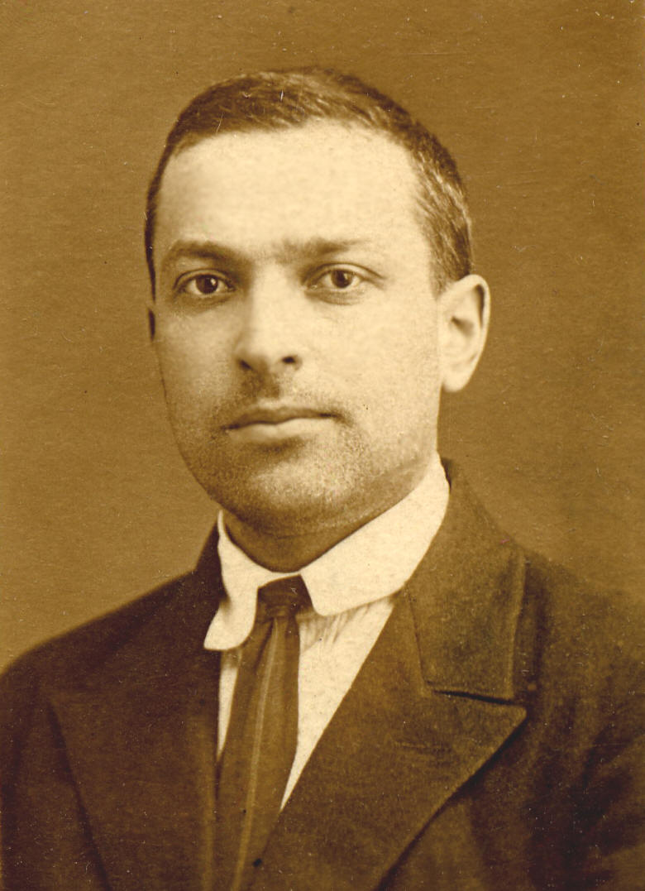 A particular cultural and social background can have an impact on a child’s development. Theorist Vygotsky’s work focuses mainly on this. He believed children’s language began socially when they interacted with others. Vygotsky believed everyday experiences should be shared with adults to help build knowledge of language. Speech, hands and eyes are also a means of support when undertaking practical tasks for children. Vygotsky also thought that children do not just react to words but also body language to help understand.
A concept that Vygotsky began to develop for his death was the Zone of Proximal development (ZPD). Known as ‘the place where the adult and child meet’ (Dolya & Palmer, 2017, p.1). Vygotsky believed the teachers role is vital within education. Teachers can set tasks to challenge children beyond their current ability. With support and guidance children will perform.
‘Vygotsky defined these limits as ZPD which he describes as difference between level of solved tasks that can be performed with adult guidance and help and the level of independently solved tasks. The most effective teaching is aimed at the higher level of the child’s ZPD, the edge of challenge’ (Dolya & Palmer, 2017, p.1).
Not all of our pupils are verbal but we all deserve a voice to be able to communicate with others, ask questions or label items. Staff always use appropriate language when talking to pupils whether it’s to give instructions to tasks or describing something. Pupils in class communicate in several different ways. Staff support their spoken words with sign language resulting in pupils being able to understand signs and use signs themselves. Sign language is a constant throughout the whole school. Other pupils use iPads or Picture Exchange Communication System (PECS) to communicate.

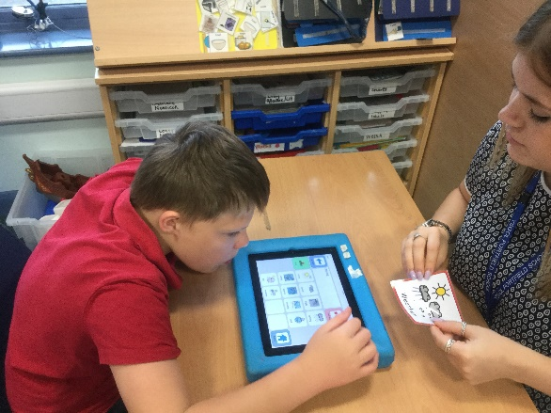
Pupil using his iPad to communicate and comment on the weather with adult.

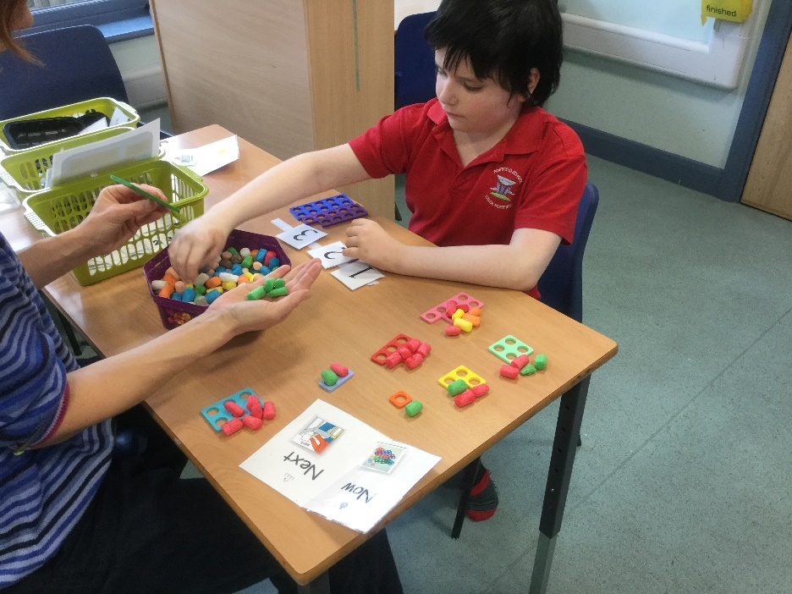
Pupils is being supported by adult to complete a challenging number activity. Pupil is familiar with the Numicon tiles, with the support of the adult he is being challenged to find and match each number. Pupil is also supported by a Now and Next.

To conclude, as part of a SEN school these theories, whilst are practical, they have to be adapted for our school/children, as they are not theories specialised for SEN children. Reward charts are widely used within the school, however it does not allow the pupils the ability to develop understanding and deep meaning. In regards to Vygotsky, he believed that children’s language began when they socially interact with those around them. For example parents talking to them, perhaps as they are undertaking a household job, however not all parents are able to communicate correctly in order for their children to learn off of it. As an SEN school, we favour Dewey’s theory as it is more practical for SEN children as the majority are incapable of learning through sitting at a desk and learning from books.
Reference List

Doyla, G and Palmer, S. (2017) Viva Vygotsky! Freedom of Thought. http://www.keytolearning.com/viva-vygotsky-freedom-of-thought/ (Accessed: 31st October 2017).
Grace, E. (2017) B.F Skinner’s Behavioural Theory. http://www.kidsdevelopment.co.uk/bfskinnersbehaviouraltheory.html (Accessed: 31st October 2017).
Portfield School (2016) Policy Document for Teaching and Learning. https://www.j2e.com/portfield-special-school/JanO/Website+Documents/PDF/Curriculum+Polices.Curriculum+No15++TEACHING+AND+LEARNING+%28Feb+16%29.pdf (Accessed: 31st October 2017).
Pound, L. (2005) How Children Learn. Leamington Spa: Step Forward Publishing.
Skills you Need (2011) What is Learning? https://www.skillsyouneed.com/learn/learning.html (Accessed: 31st October 2017).
Wheeler, S. (no date) The Pedagogy of John Dewey: A Summary. https://www.teachthought.com/learning/pedagogy-john-dewey-summary/ (Accessed: 31st October 2017).

