Module Code: LCBB5004
Module name: Managing People
Student Name: Felix Lucian Fistoleanu
Student ID: 2115327

Table of Contents
Part 1 1
CIPD Profession Map 1
Importance of compliance to CIPD Map’s advised behaviours for effective HR professionals in the UK 2
The extent of CIPD Map’s applicability for global HR professionals 3
Part 2 5
Introduction 5
The main causes of skill shortages in the UK public sector 5
Long-term labour market developments for addressing skills shortages in the UK healthcare sector 6
Conclusion 7
References 8

Table of Figures
Figure 1: CIPD Profession Map 1
Figure 2: Main uses of CIPD map 3

Part 1

CIPD Profession Map
It is an interactive tool that helps individuals practise human resources (HR) appropriately and with the highest efficiency. It is built on the research of people professionals and it provides the knowledge, skills and behaviours that one needs to cause a positive impact on their career.
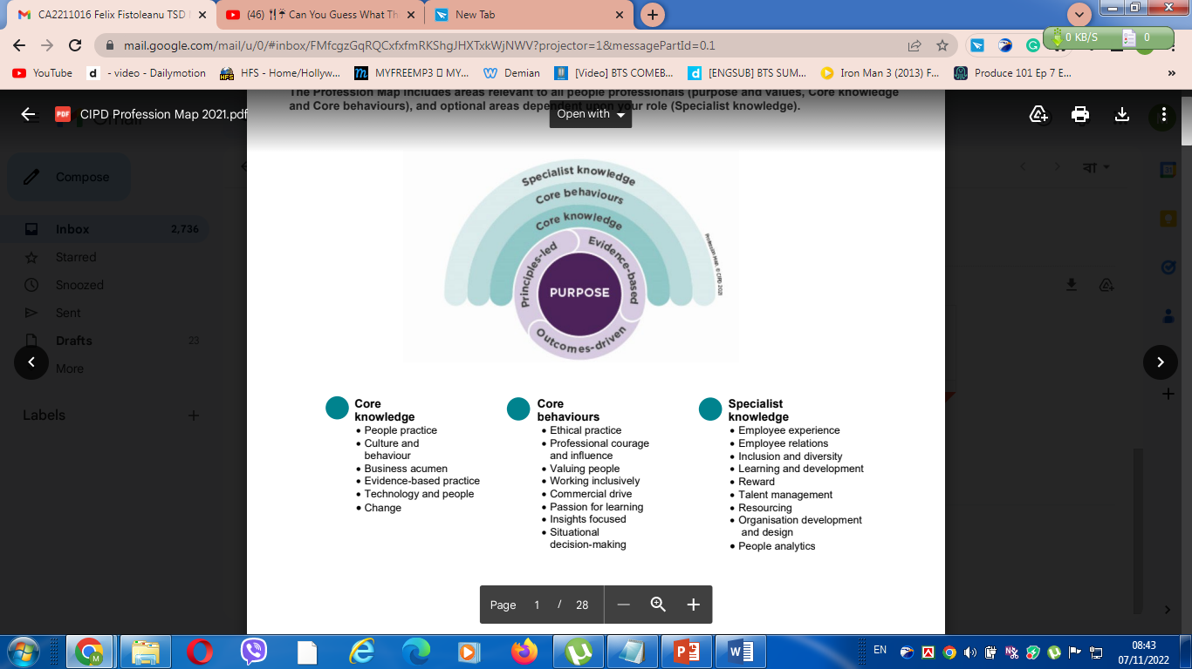
Figure 1: CIPD Profession Map
Source: (Ulrich, 2020).
The map is centred on the purpose and is then closely wrapped by three principles to be led by principles, make decisions based on pieces of evidence and be outcome-driven. Above that, there are three layers such as core knowledge, core behaviours and specialist knowledge. All of these are extremely important for professionals, even those not belonging to HR (Lester, 2021). The core knowledge and behaviour are pretty similar for all professions, while the specialist knowledge generally differs based on the chosen profession of the individual.

Importance of compliance to CIPD Map’s advised behaviours for effective HR professionals in the UK
Some core behaviours are pieces of advice for HR professionals according to the CIPD Map, and the application and compliance of these behaviours are very important. The core behaviours can affect how a professional will be perceived from the view of his/her colleagues, seniors, juniors, clients and even third parties (Parkes and Davis, 2019). The various core behaviours described along with how they are important for HR professionals will be explained below:
Ethical behaviour
The British are very strict about being ethical, and so as an individual working mostly with people from the UK, HR professionals must adhere to this recommended behaviour.
Professional courage and influence
An HR professional plays the role of a manager and sometimes leader very often, and they need to be able to make decisions and guide the subordinates towards the determined goals or objectives.
Working inclusively
Inclusion is one of the major indicators and influencers of employee satisfaction and organisational success, as well as brand image in the UK (Jades, 2022). In this state, an HR professional must be able to work inclusively with people from various backgrounds harmoniously.
Valuing people
In a profession where the main subject to work with are people, HR professionals cannot get away with treating people poorly. The disobedience of this behaviour will lead directly to complaints and even punishment in cases.
Commercial Drive
All of the people working for organisations are somehow responsible for the success of that organisation, and so every employee must keep in mind that they should grab every opportunity and maximise the commercialisation of everything they can manage.

The extent of CIPD Map’s applicability for global HR professionals
The CIPD map is a universal procedure that can be applied in any organisation in any part of the world. For HR professionals working on a global scale, it can be even more helpful due to its generalised principles that don't depend on a certain country or geographical boundary (Pickett, 2020).
The professional map is designed for the career development of an individual, not of a company, so it is completely dependent on the willingness, skillset, skill gaps and resources available for them to develop themselves with the help of this.
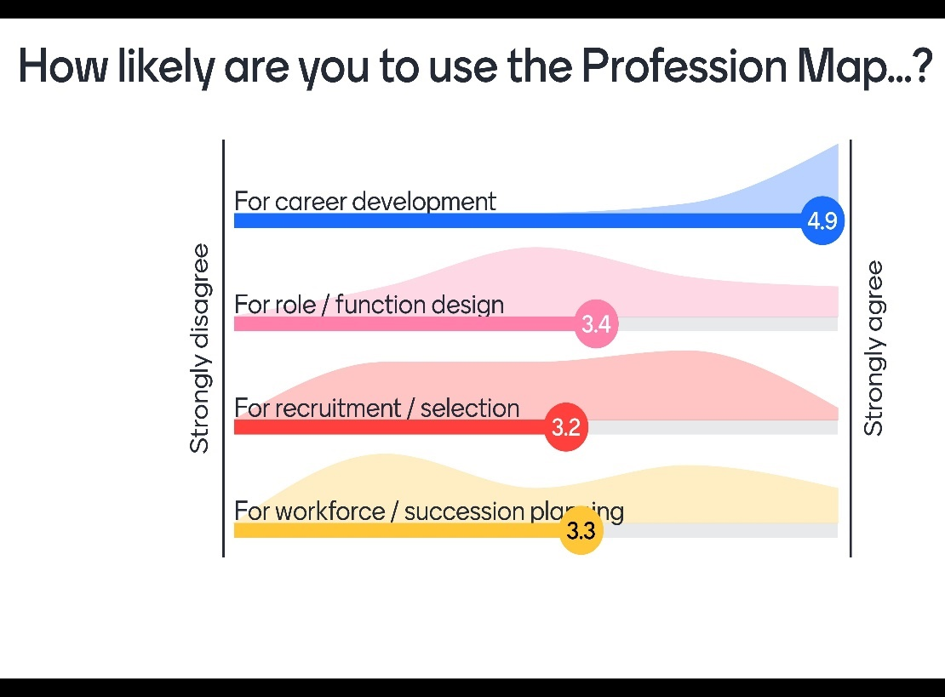
Figure 2: Main uses of the CIPD map
Source: (Coates and Dutson, 2021).
As the image shows, there are some aspects in which people tend to use the map most, such as career development, role and function design, recruitment and selection as well as workforce or succession planning.
Career development
The professionals can develop their careers by identifying their skill gaps, formulating strategies for improvement and then implementing those. This development in their skills will lead to a development in their career as well, regardless of the global scale or size of the organisation.
Role or function design
The map can also be implemented in designing a function of an organisation or the role of an employee. In this case, the core principles must be adhered to and only the specialized knowledge is needed to be designed based on the job position of an employee or the certain function people are expected to fulfil.
Recruitment/selection
CIPD map can be the most useful for recruitment and selection because the core behaviours and knowledge can be kept in mind while designing the steps of the recruitment process and while hiring the employees (McGregor, 2020). The size of the organisation or its possible global status wouldn't matter here because though the number of resources and various basis of recruitment will be based on the national culture or country of operation, in the end, adherence to the principles will surely lead to positive results.
Workforce/succession planning
In the case of workforce planning, the employees should be chosen not only based on their skills and experience, but also on their attributes. They should be courageous and be able to make situational decisions and influence their subordinates successfully while also being ethical. So it shows how the map is applicable in this aspect as well, regardless of other variables.

Part 2

Introduction
This part of the study will be based on the labour market of the UK in the year 2021/22 and it will be focused on the skills shortages. The possible reasons for skill shortages in the UK in recent years despite the high unemployment rate will be identified and described. The long-term labour market developments for addressing this skills shortage in the healthcare sector of the UK will also be explained in the end.

The main causes of skill shortages in the UK public sector
The public sector of the UK consists of various kinds of institutions such as the central government work, local government and public corporations to get a job. There are also various agencies and national health services, academy schools etc. all of these organisations employ a huge number of people, and also provide great benefits after the retirement of the employees by the government (Coyle‐Shapiro and Kessler, 2021). The UK public sector has had a high rate of unemployment in recent years, but it is also seeing a skill shortage in this sector. This is caused by the mismatch of demand and supply in the labour market and even though there is enough supply for potential employees, the quality is not up to par. There are some main causes behind this such as:
Low wage rate
The public sector, unlike the private sector, doesn't offer much in terms of present benefits and the employees often struggle to get by with their current wage rates. This is a big reason that candidates are preferring the private sector instead and the public sector is having an increasingly higher number of hard-to-fill vacancies (Prowse and Fells, 2019).
Lack of flexible jobs
The difference between the private and public sectors becomes even more apparent in terms of flexible working opportunities. After the pandemic, more than 50% of employees now prefer flexible working because it helps females in handling their families and males in being more present in family life (Giesecke and Schindler, 2018). So while many private companies are offering partial forms for various flexible working opportunities, the public sector is lagging, becoming another cause of skill shortage.

Unsatisfactory job quality
When the employees are unsatisfied and demotivated, they fail to perform their best naturally, and that causes their skills to drop even more. In public sectors, there are many complaints of unpleasant job environments, lack of employee safety and well-being, long work hours and many other issues (Harris, 2021). This poor quality of work often causes employees to opt out of public sector jobs despite possessing the required quality, further adding to the issue.
Little to no use for automation
The use of automation has become not a privilege, but an essentiality in recent years, something that public sector companies often fail to provide employees with. The lack of automation also hampers employee skill development, which with time leaves them unable to comply with the skill demand (Dickinson and Yates, 2021). So this is another reason for the identified skill shortage in the public sector.

Long-term labour market developments for addressing skills shortages in the UK healthcare sector
The healthcare sector has one of the highest percentages of hard-to-fill vacancies because the employees are required to be certified and well aware of their work process in this sector. So, there should be some changes to be made in the UK healthcare sector for labour market development and getting over the crisis of skill shortages.
Youth employment opportunities
If the students are offered opportunities for training and internship in healthcare sectors to learn various tasks, it can be helpful for both parties in future (Baum, 2019). The sector will not suffer from skill shortage and the individuals will be ready for this sector and will not suffer from unemployment.
Raising awareness about ensuring a steady supply of workers
Society as a whole can be conscious of this skill gap because healthcare is an essential sector with a demand for certain skill levels. In this state, organisations can work together to introduce advanced training and development courses for the skill improvement of the present employees.

Identifying more sources of employees
The UK market alone is not always sufficient to fill up these hard-to-fill vacancies. In this state, the optimum way is to make sure that there are other sources of talent available for the industry as well. The sources can be outsourcing, the availability of past employees in this sector, UK nationals who fit the criteria etc. If these sources are taken into consideration and then cultivated appropriately then there can be a high chance that the healthcare sector in the UK will not see this shortage of skills shortly.
Encouraging a profession in the healthcare sector
After making the necessary changes in various policies and strategies, the companies in the healthcare industry can then focus on appealing to future employees. There should be awareness among people to know that they will be highly valued and rewarded if they contribute to the great cause of ensuring people’s well-being (Coyle, 2020). This can be done through campaigns, attractive advertising and word-of-mouth policy.
Increasing the budget for the healthcare sector
There is a limitation to how much the organisations can offer to their potential employees, and in this state, the government needs to take control. The UK government needs to increase the budget for this sector so that employee skills can be developed up to the desired level with various training and development opportunities.

Conclusion
This study has shown the current scenario of the labour market that has been struggling due to a skill shortage n more than one sector in the UK. The possible causes for this skills shortage, especially in the public sector have been identified and described. How long-term plans can be made to close this skill gap in the healthcare sector of the UK has also been explained. Lastly, it can be concluded that the UK is in great need of skills development in most of the sectors and actions must be taken as soon as possible.

References
Baum, T. (2019). Skills, training and development within an insular labour market: The changing role of catering managers in the healthcare environment. Journal of Management Development, 78(1), pp. 13-14.
Coates, N. and Dutson, R. (2021). The HR consultant–an experiential learning approach: A case study approach of HR students working on live client projects. In Organisation Studies and Human Resource Management (pp. 150-165). Routledge.
Coyle, A. (2020). Changing times: flexibilization and the re-organization of work in feminized labour markets. The Sociological Review, 53(2_suppl), pp.73-88.
Coyle‐Shapiro, J.A.M. and Kessler, I. (2021). The employment relationship in the UK public sector: A psychological contract perspective. Journal of Public Administration Research and Theory, 13(2), pp.213-230.
Dickinson, H. and Yates, S. (2021). From external provision to technological outsourcing: lessons for public sector automation from the outsourcing literature. Public Management Review, pp.1-19.
Giesecke, J. and Schindler, S. (2018). Field of study and flexible work: A comparison between Germany and the UK. International Journal of Comparative Sociology, 49(4-5), pp.283-304.
Harris, L. (2021). UK public sector reform and the “performance agenda” in UK local government: HRM challenges and dilemmas. Personnel Review, 21(6), pp. 213-215.
Jades, S. (2022). Professional competence standards and frameworks in the United Kingdom. Assessment & Evaluation in Higher Education, 39(1), pp.38-52.
Lester, S. (2021). Professional versus occupational models of work competence. Research in Post-Compulsory Education, 19(3), pp.276-286.
McGregor, F.L. (2020). The next step: We help you to help your career. People Management, p.49.
Parkes, C. and Davis, A.J. (2019). Ethics and social responsibility–do HR professionals have the ‘courage to challenge or are they set to be permanent ‘bystanders?’. The International Journal of Human Resource Management, 24(12), pp.2411-2434.
Pickett, L. (2020). Optimising human capital: Strategies for success. Training & Development, 40(1), pp.12-13.
Prowse, P. and Fells, R. (2019). The living wage in the UK–an analysis of the GMB campaign in local government. Labour & Industry: a journal of the social and economic relations of work, 26(1), pp.58-73.
Ulrich, D., Younger, J., Brockbank, W. and Ulrich, M.D. (2020). The state of the HR profession. Human Resource Management, 52(3), pp.457-471.

