

MODULE CODE: Digital Skills for Personal Development and Business Growth BMSW4008

ASSESSMENT COMPONENT: PORTFOLIO

STUDENT NAME: SAMSON SALVI

STUDENT NUMBER: 2530269

LECTURER: MANJIT BIANT

DATE: 16/03/2026 at 09:00 AM

Contents
AI acknowledgement…………………………………………………………………………………………3
Task 1 3
Assessment of Digital Skills 3
References 3
Task 2 4
LinkedIn Learning Certificates for Office 365 4
Task 3 5
Essay on Relevance of Excel in professional and personal life. 5
References 5
Task 4 6
7 Minute Reflective Presentation 6
References 6

AI Acknowledgement
I acknowledge that on 02/03/2026, I used Microsoft Copilot, Google Scholar, UWTSD Hub Library resources, and Library AI support tools to gather information and develop my understanding for research purposes. All materials were used responsibly to support critical thinking, academic integrity, and evidence-based study.

Task 1

JISC Report

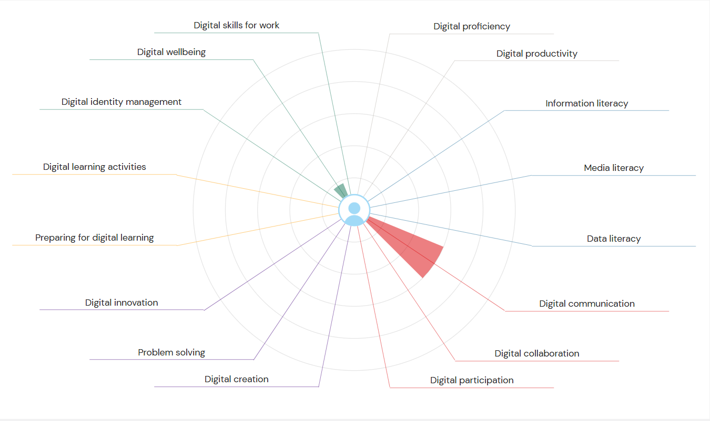

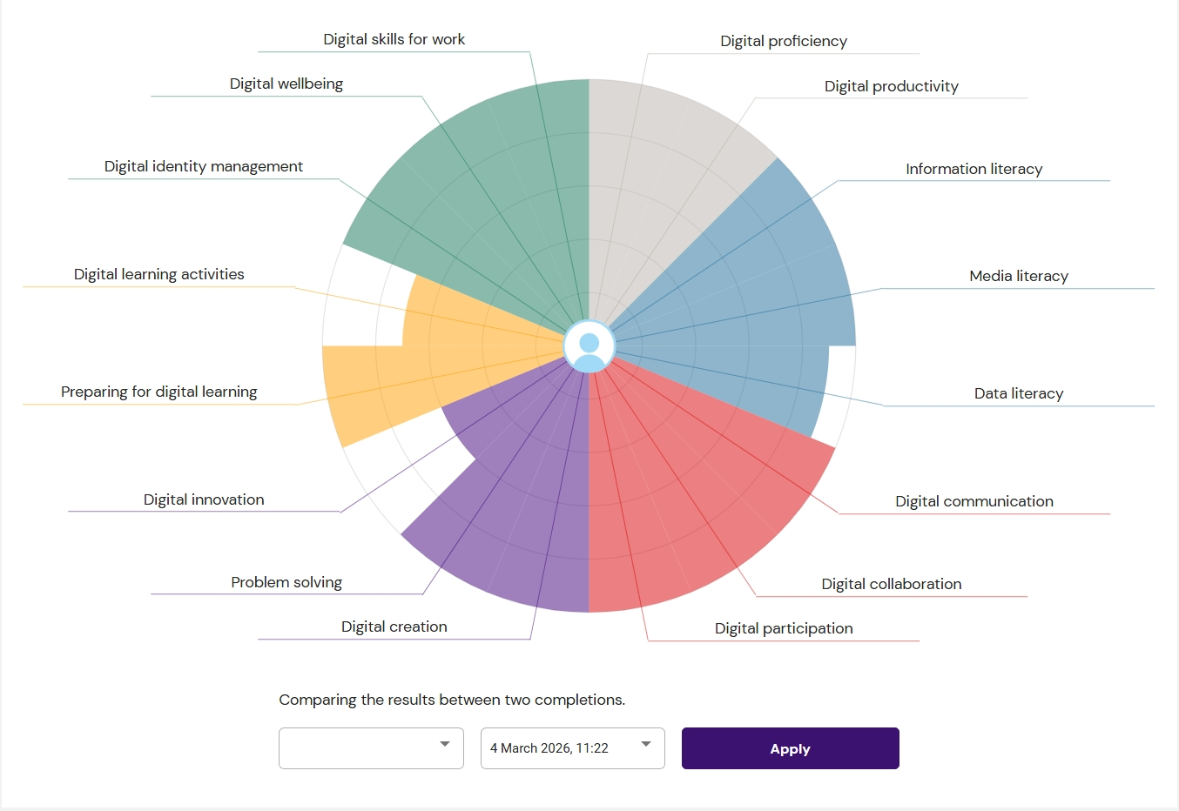

Reflective Essay

Introduction.
Nowadays, digital expertise plays an imperative role in learning. Learning activities involve using computers, online platforms, and digital tools. Academic students need to know how to use digital technology collaboratively in an effective way. Digital skills not only include searching for information online, but also communicating through digital platforms, creating documents, and working with others using technology. Reviewing digital skills in contemporary life helps people to understand what they can achieve and where they still need improvement. Developing these abilities allows students to study more effectively these days and prepares them for modern workplaces where technology is widely used.
In order to understand my current level of digital ability, I have completed the self-assessment tool provided by Jisc at the UWTSD, which measures different sections of digital competence. This assessment helped me with an insite to which digital skills I already possess well and which ones I still need to enhance. This reflection explains the importance of digital skills, summarises my assessment results, discusses two strengths and two areas that need improvement, and outlines a simple action plan using a SMART goal. Finally, it explains how improving my digital skills will support my studies and future career.
The importance of digital skills in academia.
Scholars believe that digital skills are essential for university students because universities rely heavily on digital systems. For instance, learning materials, lecture slides, and assignments are often shared through online learning platforms. Although students must not only search for reliable academic sources but also evaluate information, they must also present their work using digital tools such as Microsoft Word processing or using innovative presentation software like PowerPoint and Canva, for example.
Moreover, understanding powerful digital skills helps students work more efficiently and produce better academic work, which further leads to positive outcomes and results. In addition, it also helps them communicate clearly with others and manage their time effectively. To illustrate, employers nowadays expect graduates to have proficient digital capabilities because technology is used in almost every job sector. Therefore, improving digital skills is important not only for academic success but also for future career opportunities.
Summary of my JISC Digital Capability Results.
I had completed the JISC digital skills self-assessment online. After completing this profound assessment, I had an absolute insight into my digital capabilities, and I received feedback about my abilities across several digital skill areas. The results showed that I am comfortable using basic digital tools, especially when communicating or finding information online. For example, I regularly use Outlook email, online learning platforms like LinkedIn Learning, and digital library databases for my studies. This indicates that I have a good foundation in some digital areas.
However, the results also showed that there are areas where my confidence is lower. In particular, I need to improve my ability to create digital innovation using advanced tools and develop stronger problem-solving skills when dealing with technology. These results helped me understand that digital skills go beyond basic computer use and include many different abilities that support learning and professional work.
My Strengths.
One of my strengths is digital communication. I feel confident when using online platforms to communicate with lecturers and classmates. To illustrate, I regularly check my university email on Outlook, read announcements, and submit assignments through the Turnitin Link. I believe these practices help me stay organised and manage time effectively, bearing in mind that I do not skip essential facts about my studies.
Another strength is finding information online via the UWTSD library tile. I can search for academic articles, books, and other useful resources through digital libraries and academic databases. When completing assignments, I try to choose reliable sources rather than random websites. This skill helped me to improve the quality of my work because academic research is based on trustworthy information.
Areas That I Need to Progress
One area that needs improvement is producing digital content using advanced digital tools. I can create basic documents using Word and simple PPT presentations, but I am not very confident using advanced features such as data charts, spreadsheet formulas, or visual design tools. These skills are useful when presenting information at an advanced stage.
Another area where I think I need improvement is solving technical problems independently. When I face difficulties with digital platforms or software, I sometimes rely on help from others instead of trying to solve the issue myself. Developing better problem-solving skills would make me more confident when using digital systems.
Action Plan Using SMART Goals
In order to help me improve my weaker areas and project optimised outcomes, I have created a simple action plan using a SMART goal.
Goal: Develop confidence in digital design.
- Specific: I will learn to use Canva for designing posters and Excel for creating charts and graphs.
- Measurable: I will complete one LinkedIn Learning course for each tool and create one piece of work using each platform.
- Achievable: These tools are free to access on an online learning platform, and the courses are suitable for beginners to advanced-level creators.
- Relevant: These skills will help me produce better academic posters, presentations, and assignments in the future.
- Time-bound: I will complete both courses and create two digital pieces within four weeks.
Conclusion
In summary, digital skills are an important part of university education and modern workplaces. Without a shadow of doubt, the JISC digital competence evaluation helped me reflect on my existing abilities and identify sections where I need to improve in the future. My strengths include digital communication and searching for information, while my weaker areas involve advanced digital content creation and technical problem-solving. By following my SMART action plan and practising regularly, I can improve these skills over time. Strengthening my digital abilities will help me complete my university work more effectively and will also prepare me for future professional roles where digital competence is essential.

References
Beetham, H. and Sharpe, R. (2019) Rethinking Pedagogy for a Digital Age. 3rd edn. London: Routledge.
Bawden, D. and Robinson, L. (2022). Introduction to Information Science. London: Facet Publishing.
European Commission (2022) Digital Education Action Plan 2021–2027. Brussels: European Commission.
Fry, H., Kitteridge, S. and Marshall, S. (2015) A Handbook for Teaching and Learning in Higher Education. 4th edn. London: Routledge.
Littlejohn, A., Beetham, H. and McGill, L. (2012) ‘Learning at the digital frontier’, Studies in Higher Education, 37(5), pp. 547–562.
Ng, W. (2012) ‘Can we teach digital natives digital literacy?’, Computers and Education, 59(3), pp. 1065–1078.
Selwyn, N. (2016). Education and Technology: Key Issues and Debates. London: Bloomsbury.
Spante, M., Hashemi, S., Lundin, M. and Algers, A. (2018) ‘Digital competence and digital literacy in higher education’, Cogent Education, 5(1), pp. 1–20.
van Laar, E., van Deursen, A., van Dijk, J. and de Haan, J. (2017) ‘The relation between 21st-century skills and digital skills’, Computers in Human Behavior, 72, pp. 577–588.

Task 2

LinkedIn Learning Certificates for Office 365

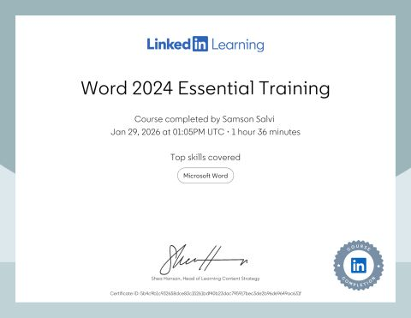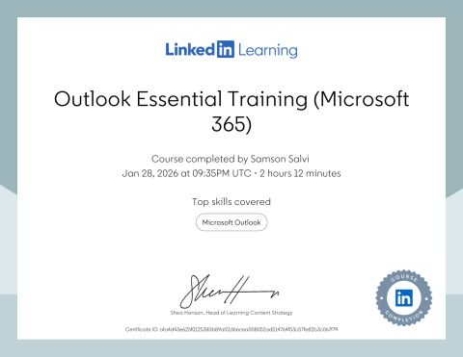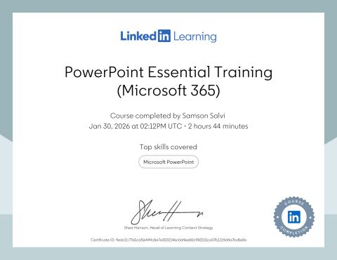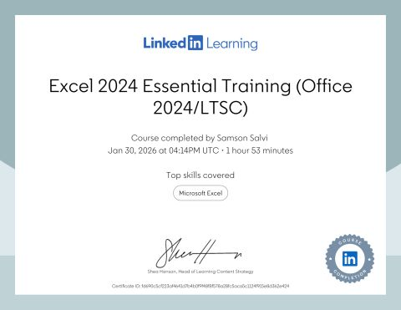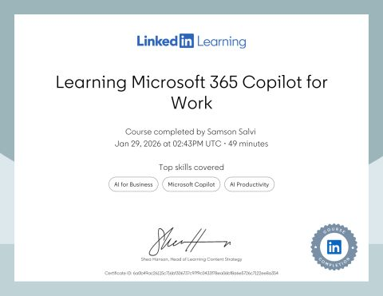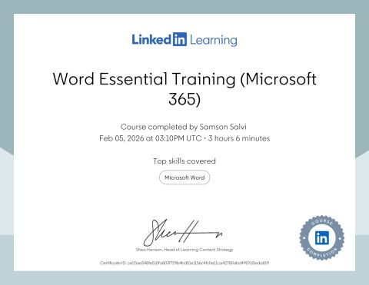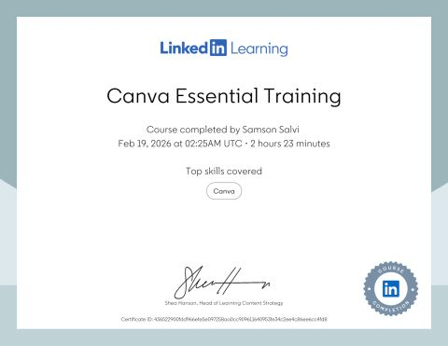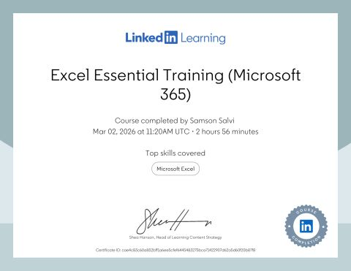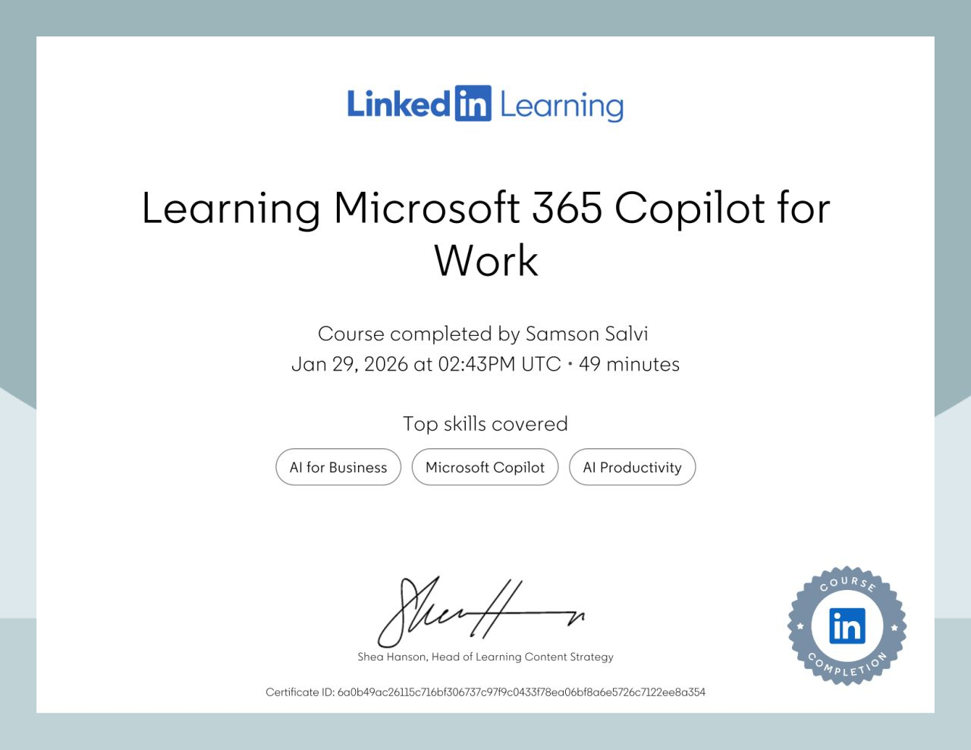

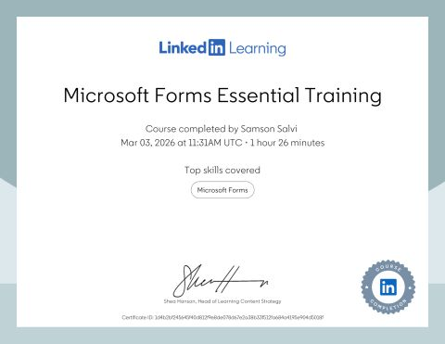

Task 3

Essay on the significance of Excel in a qualified and individual life, 1000 words.

In today's modern society, people deal with enormous amounts of information every day. Whether it is in an office, a classroom, or at home, human beings often need to organise numbers, track records, and study data. One of the most popular tools used for these tasks is Microsoft Excel. This is a renowned program that primarily focuses on the spreadsheet application, which allows users to store data in tables, perform calculations, and create charts to present information clearly. Because of these abilities, Excel has become an important digital skill in both professional and personal life.
Many organisations around the globe today widely use Excel to handle business activities such as finance, business projection, and data reporting. At the same time, people use it at home to manage their daily accounts, manage their timetable, and track personal objectives. This essay explains why Excel is important in professional environments and also describes how it helps people manage their personal lives more effectively.
Importance of Excel in Professional Life
To begin with, scholars assert that Excel plays a major role in many workplaces because it helps employees organise information in a simple and clear format. Companies often deal with a large number of records, such as customer information, sales figures, employee data, and financial reports. A spreadsheet makes it easier to keep all this information in one place, for instance. Instead of writing numbers on paper or searching through many documents, workers can quickly find the information they need in an Excel sheet.
Secondly, Excel is valuable at work as it allows users to execute calculations automatically. In many workplaces, employees must add totals, compare values, or calculate percentages. Excel includes built-in formulas that complete these tasks instantly. For example, the SUM function can add a list of numbers in seconds. This saves time and reduces mistakes that may occur when calculations are done manually.
Moreover, Excel is also very useful for presenting information in a way that others can understand. Digits alone can sometimes be confusing, especially when there are many rows of data. These visual displays make it easier to explain trends and patterns. To illustrate, managers and team leaders often use charts to review business performance and to help make better decisions.
In addition, Excel supports planning and organisation within companies. Many professionals nowadays use spreadsheets to schedule tasks, track progress, and manage projects. For example, a project manager may create a spreadsheet that lists activities, deadlines, and responsibilities for each team member. This helps everyone understand their duties and keeps the project moving forward; as a result, it helps to optimise the outcome.
Thirdly, Excel is also helpful when analysing content online. Companies collect information about customers, sales, and operations. Excel tools such as sorting and filtering allow workers to examine this information in different ways. By studying the data carefully, organisations can discover useful insights. These insights may help them not only to improve services and reduce costs, but also to increase the company's gross earnings.
Besides this, another benefit to consider is that Excel can be used in professional life for teamwork. Through cloud services such as Microsoft 365, employees can share worksheets and work on them together. Several people can update the same file while working from different locations. This is particularly useful in modern workplaces where remote work and digital communication are common, for example.
Importance of Excel in Personal Life
However, Excel is widely known as a business tool; it is also extremely helpful in everyday personal activities. Many individuals these days use Excel to organise different aspects of their daily lives. The program can act as a personal planner, financial tracker, or record-keeping system.
First, one of the most common uses of Excel at home is household budgeting. Managing money is an important responsibility for individuals and families. By creating a simple spreadsheet, people can record their income, expenses, and savings. This allows them to see exactly where their money is going. When spending is recorded regularly, it becomes easier to control unnecessary expenses and plan for future needs.
The second reason people widely prefer to use Excel is that it also helps with planning and organisation. People often have many responsibilities, such as work tasks, family commitments, appointments, and personal goals. A spreadsheet can be used to create lists, schedules, or reminders. For example, someone planning a holiday might use Excel to record travel details, expenses, and activities for each day.
Furthermore, students can also benefit from using Excel. It can help them track assignments, manage study time, and organise research data. When working on academic projects, students may collect data that needs to be analysed. Excel makes it easier to organise this data and create graphs that explain the results.
Finally, a useful personal application of Excel is tracking patterns and making progress. Some people use spreadsheets to monitor exercise routines, diet plans, or daily activities. By recording information over time, individuals can see improvements and stay motivated to achieve their goals.
As a result, Excel also encourages better problem-solving skills. When users create formulas or organise information, they must think logically about how data should be arranged. This process helps improve numerical knowledge. In a world where technology is becoming part of almost every activity, digital literacy is an important skill for everyone.
Conclusion
To conclude, Excel is one of the most powerful tools that offers many benefits in both professional and personal life. In the workplace, it helps organisations save information, perform estimates, evaluate data, and present results clearly. Employees use it for tasks such as budgeting, reporting, project planning, and decision-making. At the same time, Excel can also improve everyday life outside the workplace. Individuals can use it to manage finances, organise schedules, track goals, and monitor personal progress.
Because Excel is flexible and easy to learn, it is suitable for people with different levels of experience. Whether someone is working in a large organisation or managing their own household tasks, the program provides practical solutions for handling information efficiently. As digital technology continues to grow, the ability to use tools like Excel will remain a valuable skill.

Embed your Excel here

References
Boateng, R., 2016. Effectively using spreadsheet tools for data analysis. International Journal of Information Technology, 12(2), pp.45–52.
Duffy, J., 2020. The growing importance of spreadsheet skills in modern workplaces. Journal of Digital Literacy, 9(1), pp.15–22.
McFedries, P., 2019. Microsoft Excel 2019 formulas and functions. Indianapolis: Microsoft Press.
Microsoft, 2023. Excel help and learning resources. Available at: https://support.microsoft.com (Accessed: 8 March 2026).
O’Day, V., 2017. Spreadsheet use and business decision-making. Business Information Review, 34(3), pp.150–158.
Panko, R., 2015. What we know about spreadsheet errors. Journal of End User Computing, 10(2), pp.15–21.
Walkenbach, J., 2015. Excel 2016 Bible. Indianapolis: Wiley.
Creswell, J., 2018. Research design: Qualitative, quantitative and mixed methods approach. London: Sage.

Task 4

7 Minute Reflective Presentation

Embed PowerPoint here

References
Beetham, H. and Sharpe, R. (2019). Rethinking pedagogy for a digital age: Designing for 21st century learning. 3rd edn. London: Routledge.
Bawden, D. and Robinson, L. (2022). Introduction to information science. 2nd edn. London: Facet Publishing.
Fry, H., Kitteridge, S. and Marshall, S. (2015) A handbook for teaching and learning in higher education: Enhancing academic practice. 4th edn. London: Routledge.
Jisc (2022) Building digital capability framework. Available at: https://www.jisc.ac.uk (Accessed: 9 March 2026).
Littlejohn, A., Beetham, H. and McGill, L. (2012) ‘Learning at the digital frontier: A review of digital literacies in theory and practice’, Journal of Computer Assisted Learning, 28(6), pp. 547–556.
Ng, W. (2012) ‘Can we teach digital natives digital literacy?’, Computers & Education, 59(3), pp. 1065–1078.
Selwyn, N. (2016) Education and technology: Key issues and debates. 2nd edn. London: Bloomsbury Academic.

