Professional Practice - ADAD5002
BA (hons) Music Technology and Performance
Simon Kilshaw & Johnathan Pugh
Bailey Heredge – 1802246

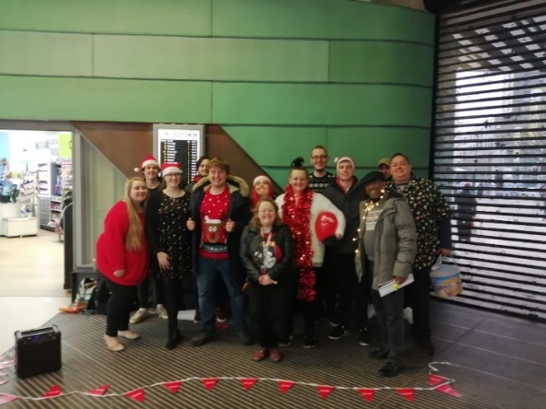
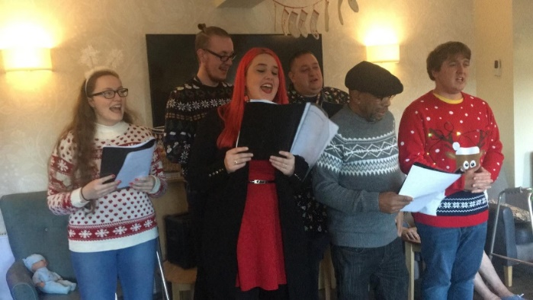
During the course of the Professional Practice module, I have been engaged and present during the majority of meetings, rehearsals and performances arranged by ourselves and Johnathan. During the preparation stages of the carol organisations, I was eager to express my opinion on job allocations and the importance of each task to create these carol performances; including advertisement, backing track creators, communicator with venue owners and council officials. I also aided in providing input towards what areas we would be performing in; being the Swansea float parade, the Dynevor building, Swansea train station and other public access areas. I also expressed my enthusiasm for having most of these performances be towards the Shelter Cymru charity organisation, which I held a charity donation bucket for nearby the performance in the Dynevor building. It was up to us also to organise which dates these performances were going to take place and so suggesting weekends and evenings due to our own and the publics availability. Once these factors were finalised, we had to decide which Christmas carols the performers were going to sing; thus suggesting Silent Night, White Christmas and Jingle Bells due to their popularity and upbeat, positive meanings behind them. I decided, due to my music technology background, to be in charge of recording every carol rehearsal session and also every performance I attended. This involved sessions in the BBC hall, including Wednesday the 23rd of October and Wednesday the 11th of November, and final events such as the performance in the Dynevor building. This audio I created was then sent to Johnathan to be used towards the advertisement of the carol events to build interest and engagement with the public through social media; most of which seen via our course’s university twitter account. During the performance at the Dynevor building, I also video recorded and photographed the carollers for future advertisement of these events to be put on to social media for engagement. During the preparations and planning of these performances, I provided communication to other music technology students when any last-minute arrangements had taken place due to my presence in the BBC building and activity on our group chat via WhatsApp. This included guiding students to our rehearsal sessions, providing access into buildings for the team and communicating any last-minute changes to the rest of the group. I also addressed any concerns on behalf of absent students within my music technology group when rehearsals and performances couldn’t be attended due to lessons taking place and providing input to when our class could attend to help during these rehearsals and performances.

