Analysis of results
This section will provide an insight into the information that has been collected via a Google Forms questionnaire from serving police officers and staff regarding substance abuse and mental health contributing towards increased pressure on policing.
The questionnaire approach was chosen to make it quicker and easier to share the survey and to read the results. Making it both modern and cost-effective.
The objective of the survey is to analyse its results compared to current research on the effects of alcohol and drugs in policing. Comparing the finished survey to earlier projections of the survey's outcomes, as described in the ethics form, will be another intention.

Data Collection
This section involves tasks such as data cleaning which helps resolve problems such as inconsistencies, and data transformation. This means that the owner of the survey must review all answers to ensure there are clean and comprehensive results to allow an accurate reading. The 17 questioned survey was fully completed by 22 people, therefore there aren’t any inconsistencies regarding numbers until the final question. This open question was intended to have opinions regarding the Mental Health Act (2005) and whether the reader felt it was up to date with modern day society, however there was only 17 responses to this, and some responses provided were given as “Not Applicable”. Because of this, the question has been removed completely from the analysis to allow an accurate reading of the results.

Data Analysis
The questionnaire is completed by answering quantitative and multiple-choice questions. This way the quantitative questions minimise researcher bias (Creswell and Creswell, 2018) and the multiple-choice questions allow efficient and completed responses as they are quick to answer (Sue and Ritter, 2012). The desired achievement for the questionnaire is to analyse its results compared to current research on the effects of alcohol and drugs on policing.

Results
Figure 1 - A graphical representation of the different roles within policing who responded to the questionnaire.
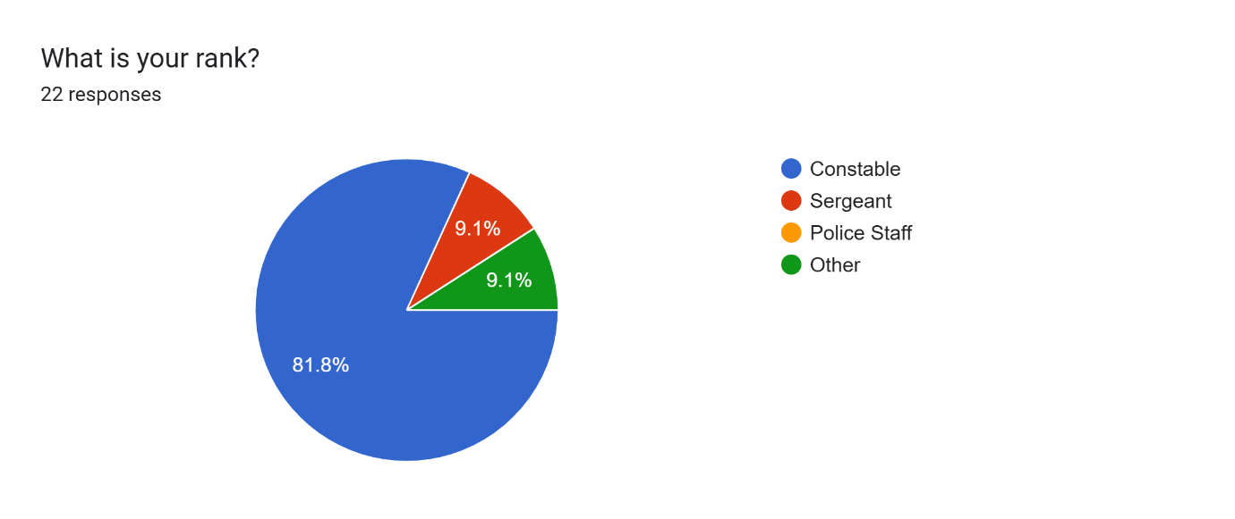

Figure 2 - A graphical representation of experience of officers that answered the questionnaire.
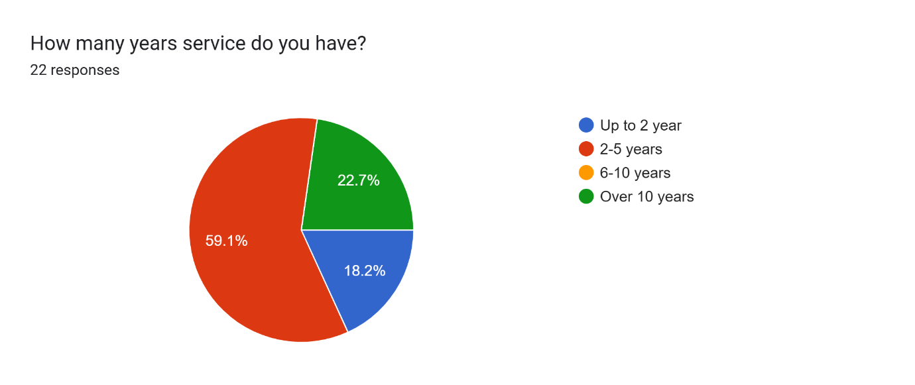

Figure 3 - A graphical representation of experience of officers that answered the questionnaire.
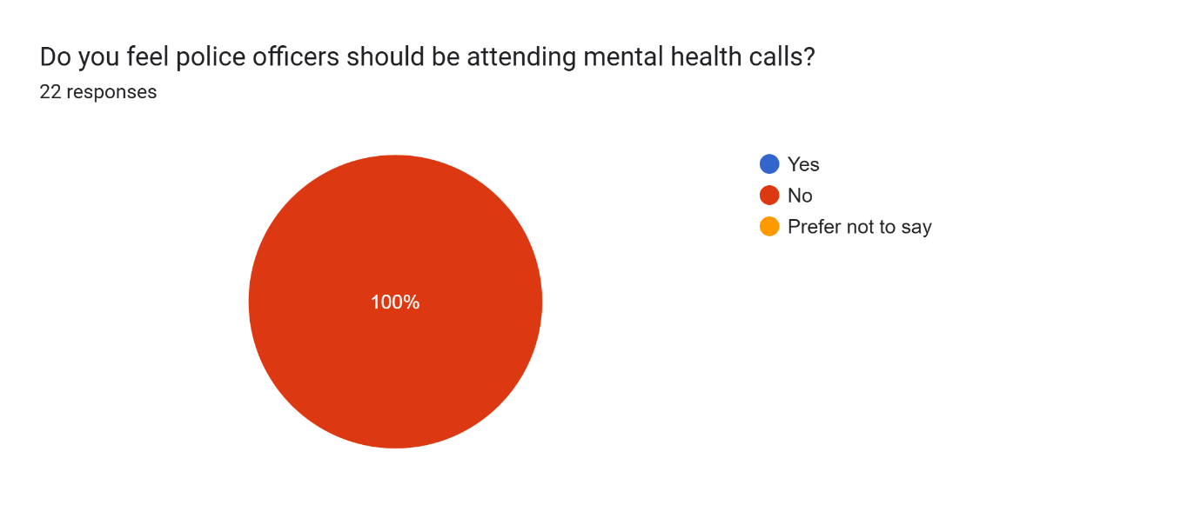
Figure 4 – A graphical representation of officer’s opinions regarding mental health calls being triggered by alcohol.
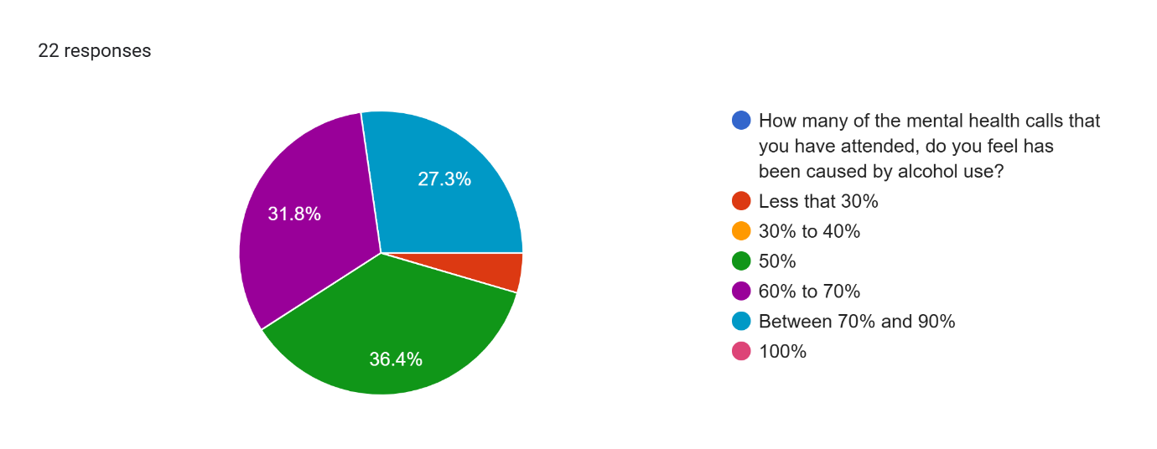
Figure 5 – A graphical representation of officer’s opinions regarding mental health calls 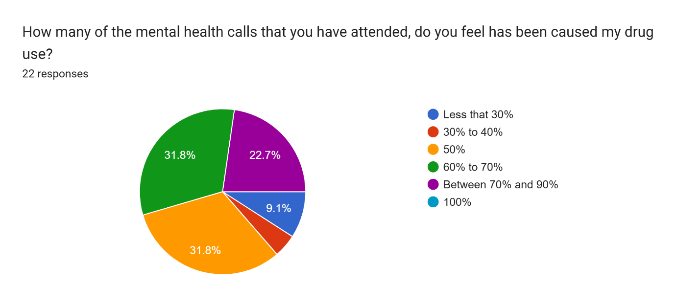being triggered by drug use. Figure 6 – A graphical representation of officers opinion regarding addiction as a brain illness.
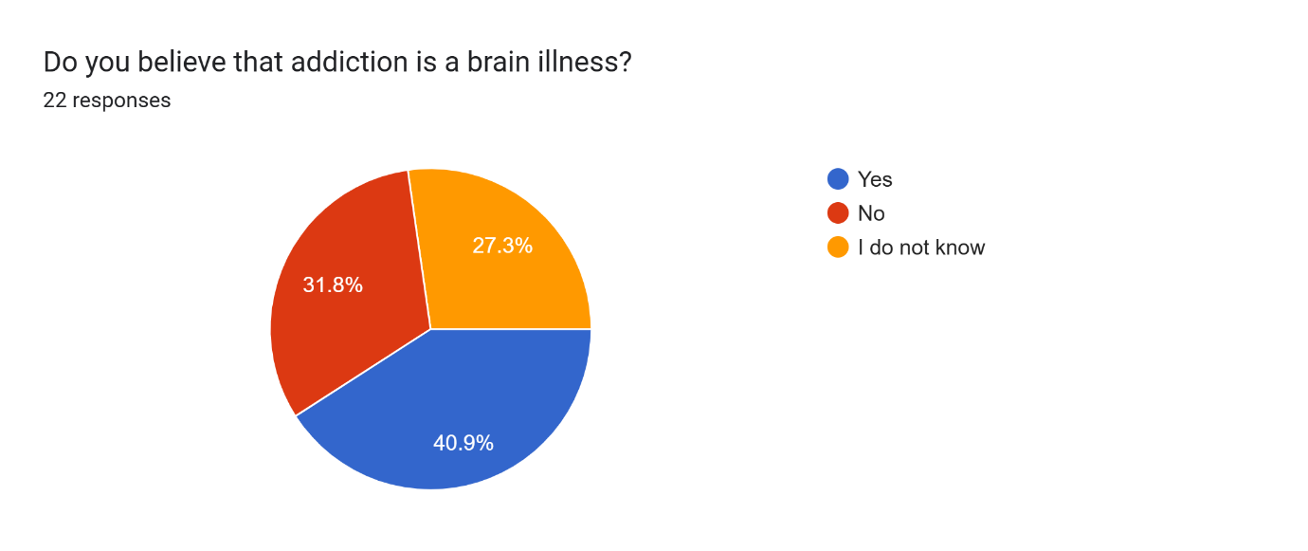Figure 7 – A graphical representation demonstrating how often hospital watches are tiggered by alcohol and drug abuse.
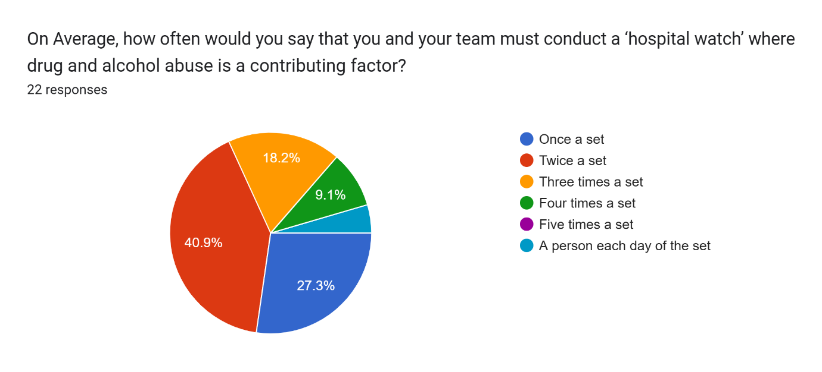

Figure 8 – A graphical representation demonstrating how often people disclose trauma to police officers.
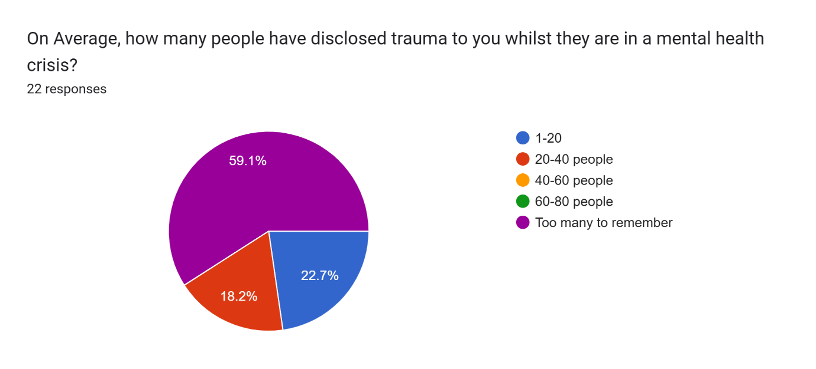
Figure 9 – A graphical representation demonstrating the impact someone else’s trauma has on an officer.
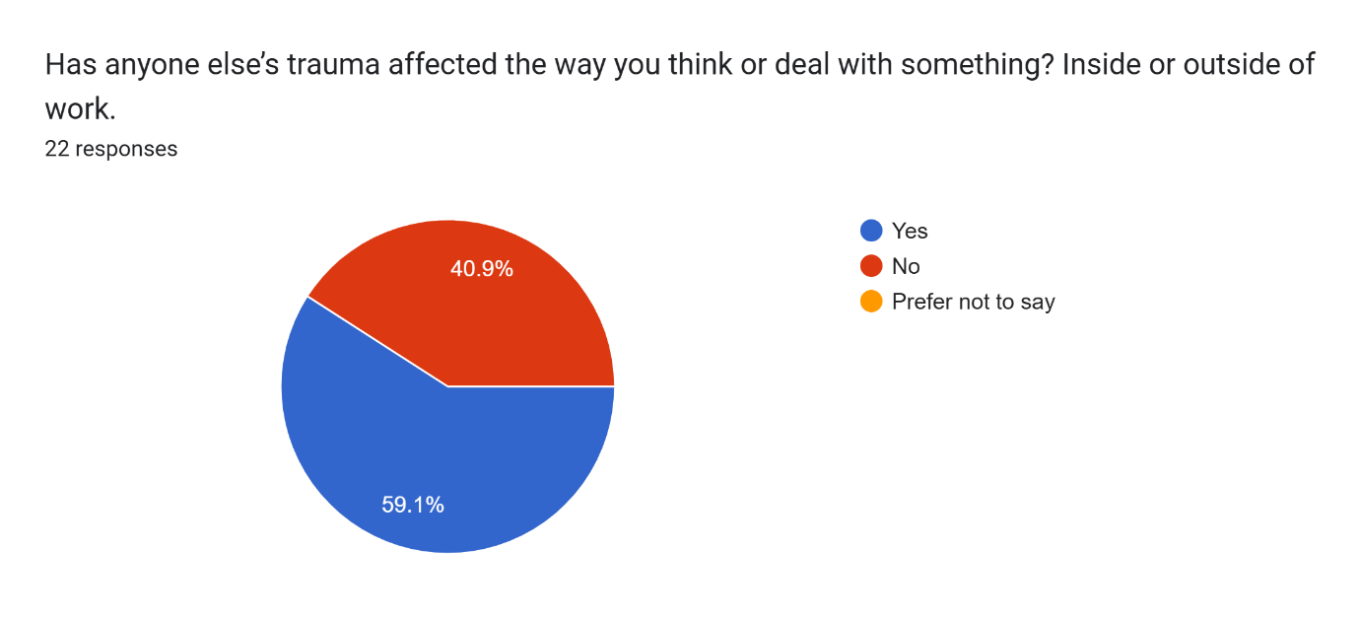
Figure 10 – A graphical representation showing officers opinion on whether alcohol increases the danger of injury to both the drinker and those around them or not.
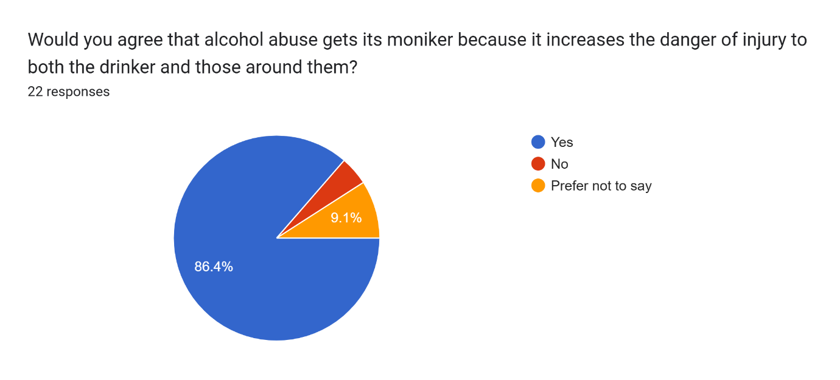

Figure 11 – A graphical representation demonstrating officers opinion on addiction.
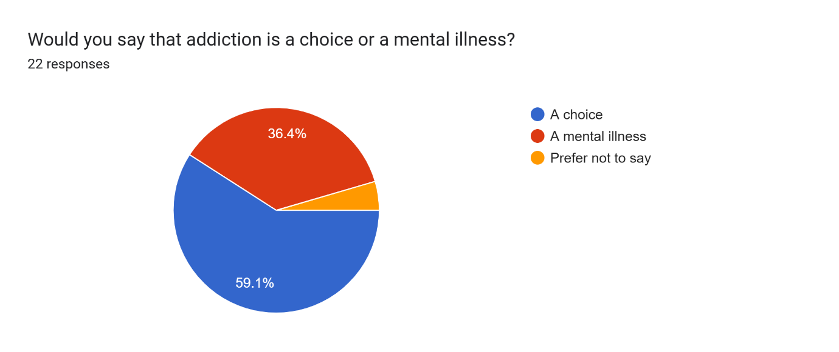
Figure 12 - A graphical representation demonstrating officers opinion on demand in the role.
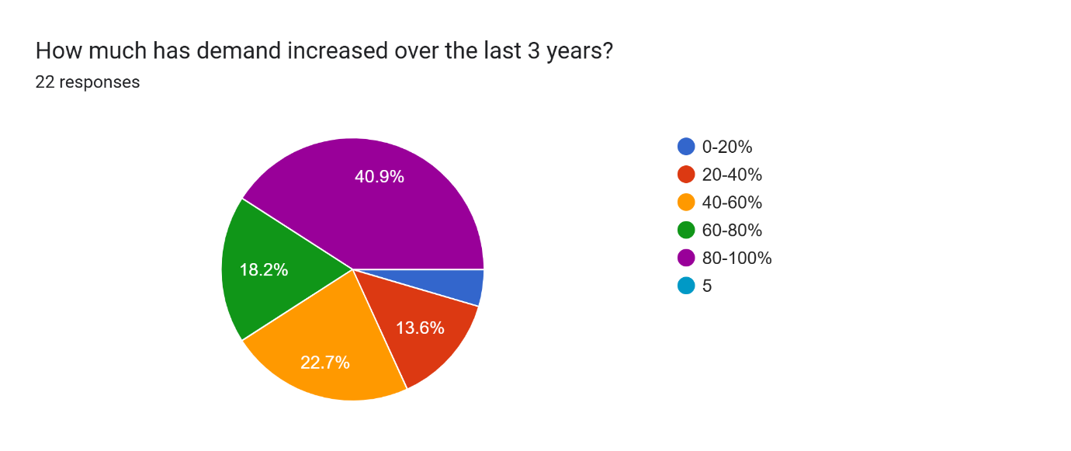
Figure 13 – A graphical representation demonstrating the effects of drug and alcohol related calls on personal mental health.
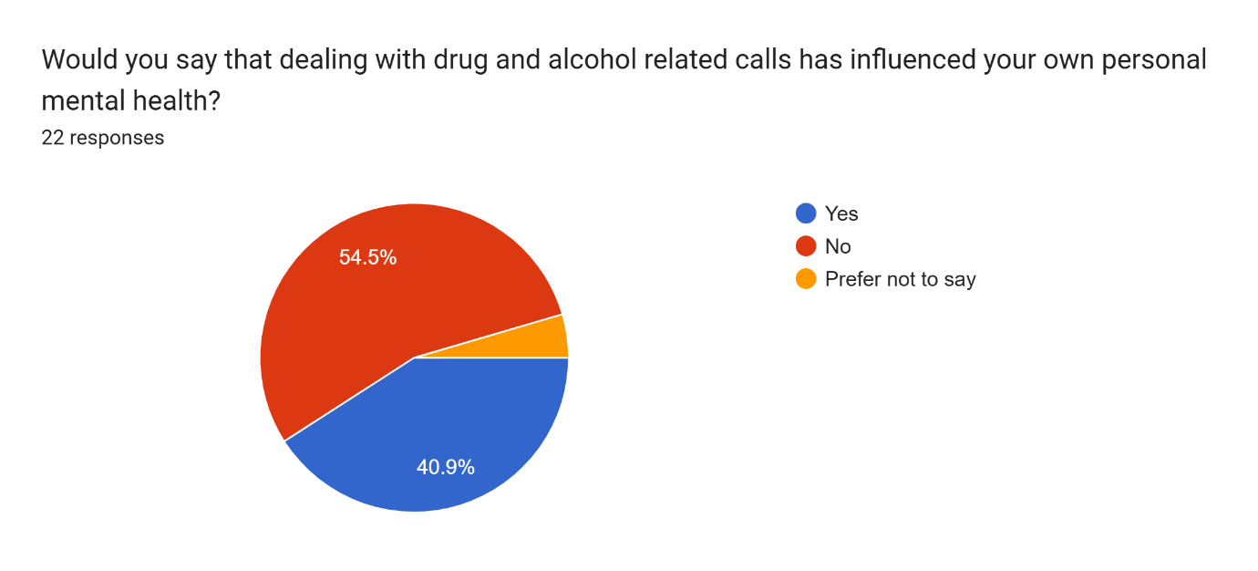

Figure 14 - A graphical representation demonstrating officers mental health.
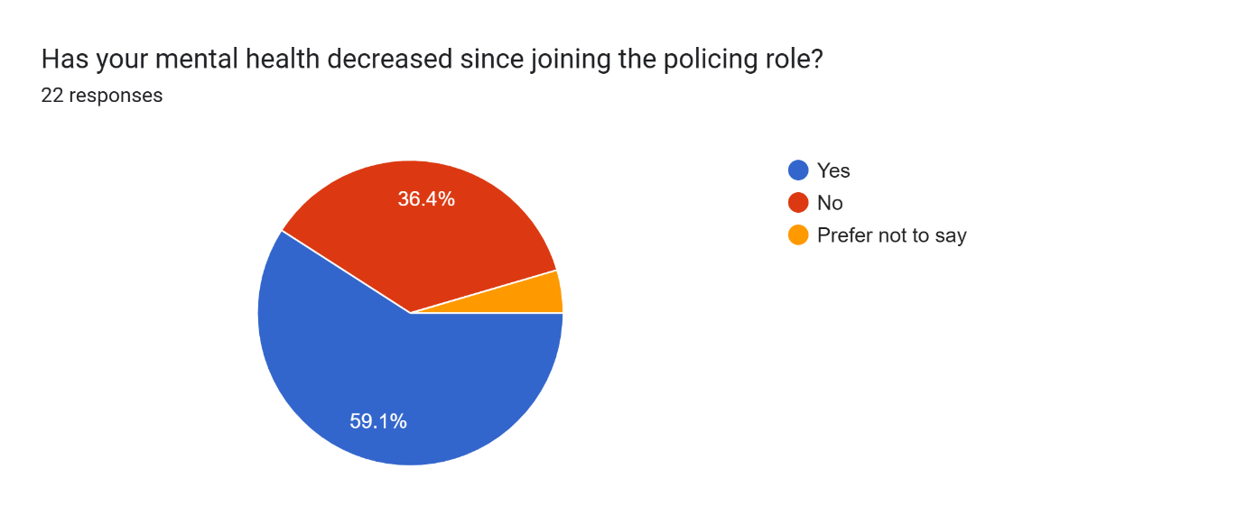
Figure 15 – A graphical representation demonstrating that officers are aware they can seek support from Trim.
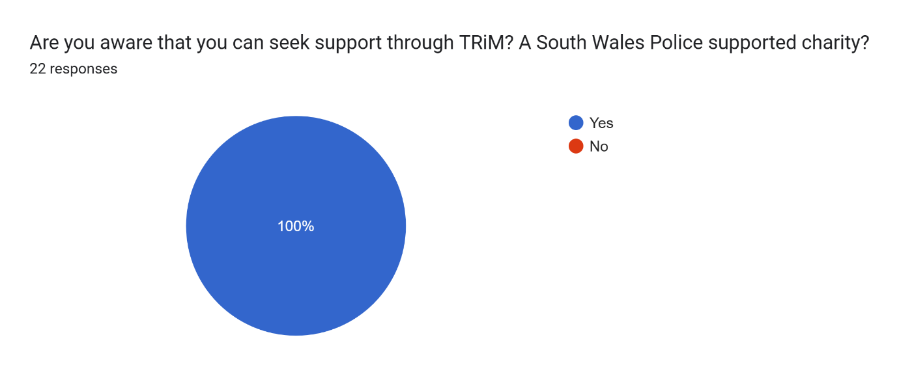
Figure 16 – A graphical representation demonstrating whether increased demand has caused them to take time from work.
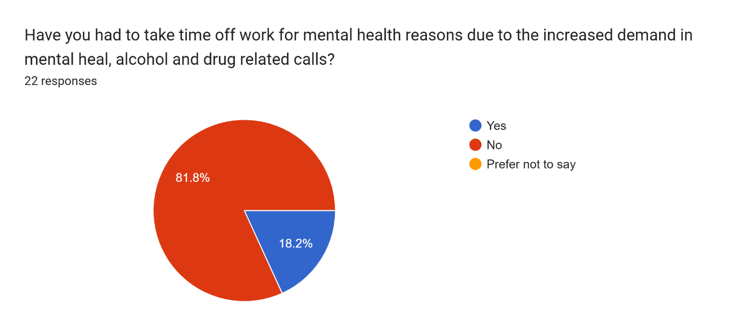

Discussion of the findings
Of the 22 respondents, 18 of those were PC’s, 2 were sergeants and 2 were ‘other’. 4 of the respondents are less than two years into their career, thirteen of the respondents were between two and five years into their career and five respondents had over ten years’ experience. This corroborates with the recent His Majesties Inspectorate of Constabulary and Fire, report that explains the rise of new officers has contributed to delays in investigations (Dodd, 2024).
Unsurprisingly, all participants agreed in question three that police officers should not be attending mental health calls. His Majesties Inspectorate of Constabulary and Fire (2018) stated six years ago that police officers are being used as a service of default however the survey evidence’s that this is still an ongoing issue.
The remaining results will be discussed and analysed in a power presentation.

Word Count: 451

Reference List
Creswell, J. W., and Creswell, J. D. (2018) Research Design: Qualitative, Quantitative, and Mixed Methods Approaches (5th edn.). SAGE Publications.
Dodd, V. (2024) Inspection finds Met police failing or inadequate in key crime fighting areas. Available at: Inspection finds Met police failing or inadequate in key crime fighting areas | Metropolitan police | The Guardian (Accessed: 04 August 2025)
His Majesties Inspectorate of Constabulary and Fire (2018) ‘Police cannot fix a broken mental health system’. Available at: https://hmicfrs.justiceinspectorates.gov.uk/news/news-feed/police-cannot-fix-a-broken-mental-health-system/?utm_source=chatgpt.com (Accessed: 04 August 2025)
Sue, V. M. and Ritter, L. A . (2012). Conducting Online Surveys. SAGE Publications.

