
Marketing Fundamentals

Student ID:2114145
Student Name: Corina Cosma

Contents
Introduction 2
Definition of marketing 3
Marketing process 3
PESTLE analysis 4
Porters five forces model 6
SWOT analysis 7
Relation of two models from the major environment 8
Advantages and disadvantages of macro forces 9
Segmentation, targeting and positioning 10
Marketing mix elements 10
Recommendation 11
Conclusion 12
Referecnes 13

Introduction
Marketing is considered a classic business practice that has universal appeal. With the change of time, new concepts are coming but marketing implication is being deeper and deeper. With the rise of technology now the business managers prefer to focus on digital marketing. Marketing is not only confined to promotional activities where it starts with the identification of the needs and wants of the customers and runs still the post-purchase service delivery (Kumar, 2020). Covid-19 is the major threat in recent that has changed the world a lot. This has a major impact on the life of the common people like many lost jobs, people need to adjust with the new lifestyle, manage communication by meaning safe distancing. These have an impact on the businesses as well as it can be seen that there’s been a reduction of income by the companies (Kumar, 2020). Ralph Lauren Corporation is a USA based fashionable clothes service provider that started operation in 1967. This was started by Ralph Lauren a famous fashion designer. Being a marketing manager here the assignment shows the marketing approaches of the corporation.
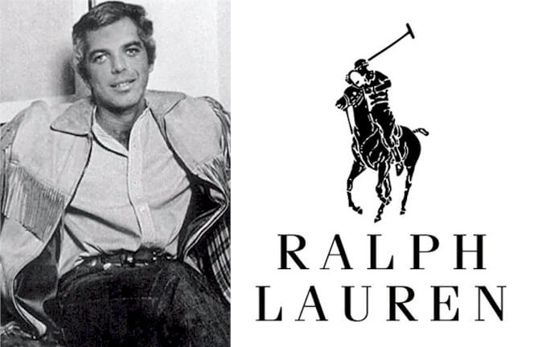
Figure: Founder and logo of Ralph Lauren (Kumar, 2020)

Definition of marketing
Marketing is like a process that has multiple stages. Ralph Lauren or other companies take it seriously as it has a relationship with so many internal and external factors that help to make the business successful in the crucial market situation (Brunswick, 2014). Marketing can be considered as the combination of some essential business functions such as product, price, promotion and place. This starts with the identification of the needs and wants of the customers such as Ralph Lauren customers want to have quality fashionable clothes that will make them attractive

Marketing process
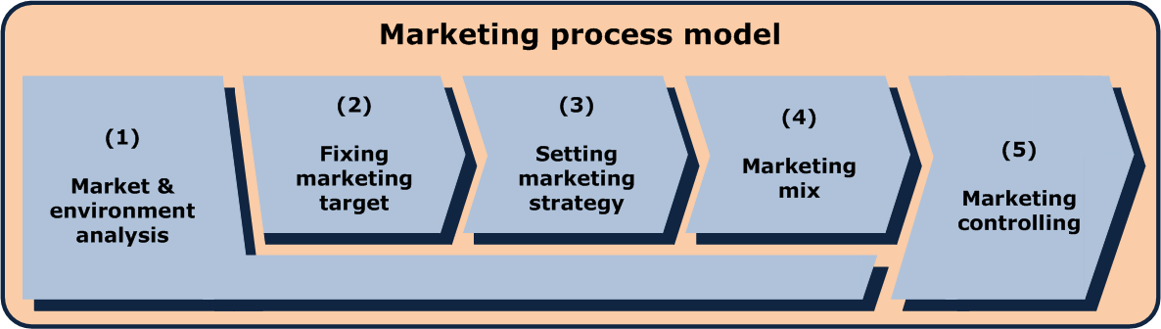
Figure: Marketing process (Brunswick, 2014)
Situational analysis: Situational analysis is the next stage that helps to understand the internal situation like the business approach, policy, thinking by the management. Ralph Lauren management wan to ensure that customers are happy with the fashionable clothes they provide. Thereby they prepare employees, provide them with a good working environment, remain beside them and help them do their part of the duties. This is how situational analysis issues include external forces as well like the market situation, demand pattern, current trend and others (Brunswick, 2014). Based on the external issues that affect Ralph Lauren the management decide and develop a business strategy.
Purpose, mission, the vision of Ralph Lauren: The marketing process start with the analysis of the mission, vision of the company that helps to understand why the business is in the market. By defining the goals and objectives the management can develop the business strategies (Deepak and Jeyakumar, 2019). With the use of this, the employees get the idea when they are working and help the management to imply the business decisions.
Strategy: based on the objectives set by Ralph Lauren management now it is important to know how to develop the business strategy well to achieve the goals. For example, they may need to have employees who have sound knowledge in this sector and produce quality fashionable clothes (Deepak and Jeyakumar, 2019). Besides Ralph Lauran management may feel that they need to invest more in bringing the innovation and support the customers at their best. This is how the business strategy includes developing a production strategy like Ralph Lauren top management decide which product to produce, set the pricing model like following the differential pricing policy, the distribution policy like providing product both on the online and offline channel.
Implantation and control: Implementation of the business planning largely depends on the ability of the top management who can understand the background situation and develop the right decision in the right situation. This is a vital one that helps to assess the situation at the market and imply the business decisions (Deepak and Jeyakumar, 2019). When necessary top management needs to change the plan at Ralph Lauren and need to adjust to the situation. Besides Ralph Lauren employees get feedback from the top management as they compare the planned performance and the actual performance.

PESTLE analysis
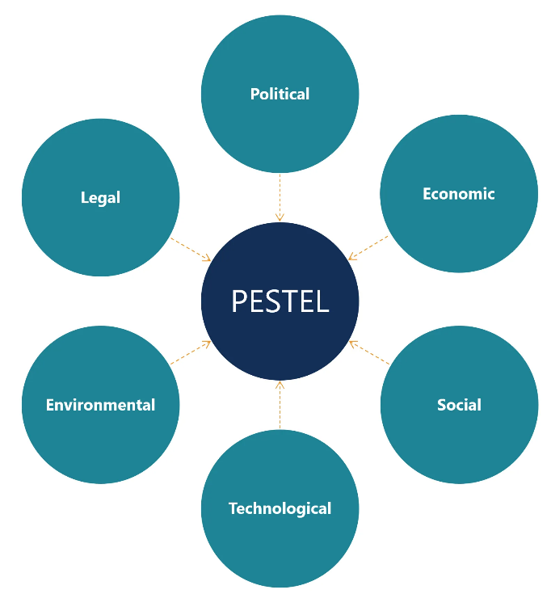
Figure: External forces (Domański, 2021)
Political factors: For Ralph Lauren and other businesses that are running in USA or UK or other areas they need to understand the local government policy, how is the local situation. The decision by the local government is important here like different governments allow business easily and help them increase the investment. In these areas, Ralph Lauren management can feel it easy to invest in the market (Domański, 2021). But there may have restrictions for them and this creates a blockage in starting the operation. Besides, politely instability is a major issue. Brexit decision is a major decision in the UK where the Ralph Lauren management needs to abide by rules and regulations in the UK if they want to run operation. Previously it was all about EU rules and regulations.
Economic factors: Economic situation is very much important for Ralph Lauren to decide whether to invest in a certain market or not. For example, in different developing countries like India, Sri Lanka, Myanmar and other areas the income level is being increased (Domański, 2021). Thus, there is a good future for Ralph Lauren and other businesses. In the USA current unemployment rate is 4.6% which has increased by. 6% in this pandemic situation. This also shows the pressure on the economy where more than 40% of the people find themselves less wage or the majority of them are out of the job. But the good news for Ralph Lauren is that the market is being in a normal situation but this is a new normal situation because new variants of Covid-19 is coming (Domański, 2021).
Social factors: For Ralph Lauren, this is a vital one as the demand by the customer is the vital one. Customers when to feel that Ralph Lauren provide a quality product for them, they feel motivated to purchase the product. Thus, it is a good option for Ralph Lauren to invest more in research as the demand in this industry change very quickly (Edward, 2010). Ralph Lauren takes feedback from customers careful land belief on bringing innovation. Thu8s innovation and development are the two important issues that work for Ralph Lauren. Still, now Ralph Lauren is a popular brand not only in the USA but also outside of the USA but they need to keep eye on changing areas.
Technological factors: Technology determine how will be liked by the customers and now modern customers are largely influenced by technology. For Ralph Lauren this major one as they need to adjust to the quickly changing market. From this point of view, Ralph Lauren management need to understand the tools of technology that help them promote the business. For example, social media, company websites online blogs and other sources are used to promote the information (Domański, 2021). This also reduced the promotional cost of the business as well. Still, Ralph Lauren management need to invest more in finding new tools of technology that help to support the customers well.
Legal factors: There are local rules and regulations such as the minimum wage act, anti-discrimination act, contract act, environmental act and others. Ralph Lauren must need to abide by the law while running the operation. If they violate the law in the country this will not give good results for them. So, while running a global operation Ralph Lauren management must need to remember this as they need to adjust to the global situation by assessing the rules and regulations there (Edward, 2010). Before making any major decision, the company management needs to develop an idea about the local policy.
Environmental factors: the USA is liable for the production of 16% of the carbon emission that is a massive one and has a major impact on modern business. From this point of view, this is essential to focus on how to minimise the pollution level in the environment. Ralph Lauren and other companies’ management work well by following sustainable development policy (Edward, 2010). Ralph Lauren management also need to be committed to reducing the pollution level in the environment.

Porters five forces model
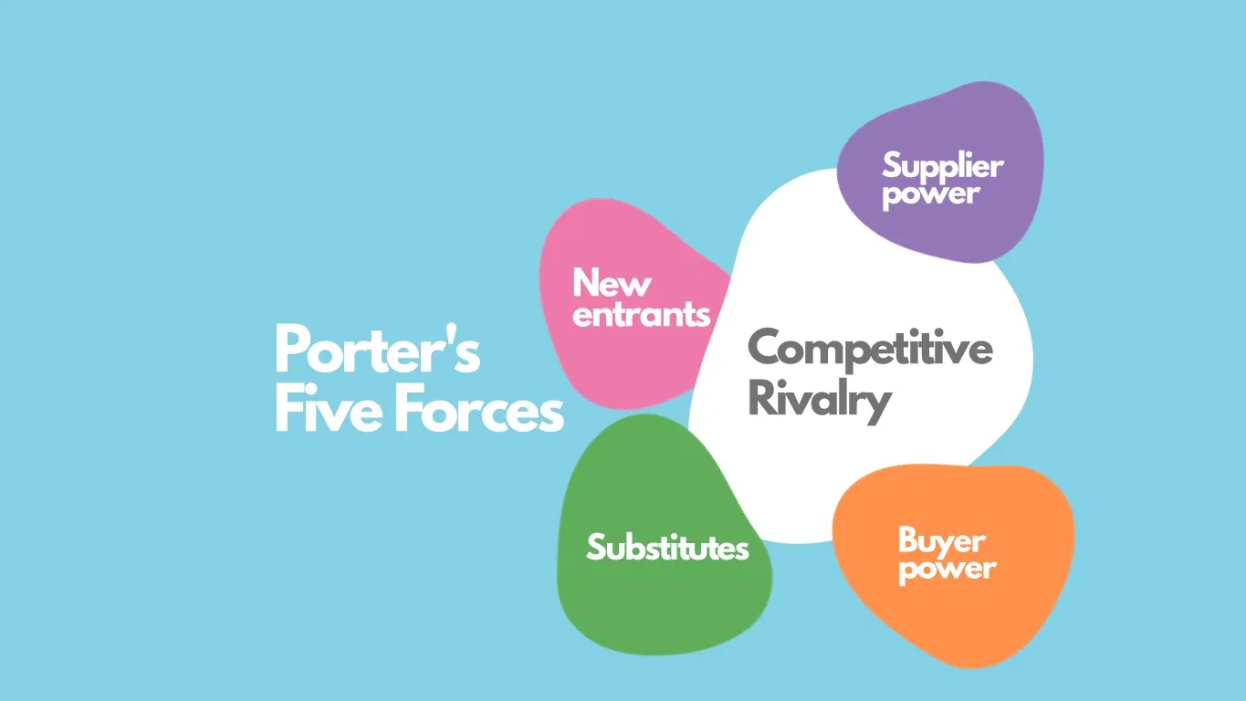
Figure: Five forces model (Elshiewy et al., 2017)
Threats from new entry: This has a higher impact on Ralph Lauren because they need to have a strong position in the market. Customers want to have a quality product for them but the matter is that when demand increase business gets more profit and others feel the motivation to come into the sector. Thus, the market becomes competitive which is not good for the business (Elshiewy et al., 2017). Thus, Ralph Lauren management here retaliates in such a way where new companies find it difficult to capture the market there.
Bargaining power of the buyers: Customers when having options in hand then they will have more power. There branding is the only solution for companies that facing major challenges. Ralph Lauren is in the market for so mays years and customers like the products by them and they provide a good rating of them online (Elshiewy et al., 2017). Thus, more customers believe in the business and this helps them get a good return from the investment. Thus, a high switching cost could have been imposed by Ralph Lauran that help to minimise the power of buyers.
Bargaining power by the suppliers: Suppliers do have a major impact on the business areas that include suppliers creating problems in supplying the product. Ralph Lauren also has suppliers and is a successful business, this company has a good relationship with them. This realty is old enough still their suppliers may increase the problem. For Ralph Lauren, this has a lower impact but still, they should have an alternative in hand and minimise the level of problems (Groucutt and Hopkins, 2015).
Threats from substitutes: Day by day new companies come and capture the market. It is all about adjustment for Ralph Lauren if they want to be in the market in the long run. But this is not the only solution to this problem where Ralph Lauren management should think about more market, develop more business portfolio, product portfolio, work to bring innovation (Groucutt and Hopkins, 2015). Ralph Lauren can be a successful business in the long run if it can move with the flow in the market.
Rivalry among the competitors: When there is a large number of suppliers the market becomes smaller and businesses face major problems especially for those that have more investment. Ralph Lauren is such a kind of organising that has huge investment on the market. In this situation, all the companies get small a share of profit for the market (Hillesland et al., 2013). Here a successful brand like Ralph Lauren can exist but still, they end to work exploring new market areas and start to invest in the areas.

SWOT analysis
Strengths  Ralph Lauren is the key successful business in the USA, UK, Dubai and other areas (Hillesland et al., 2013). This has high cash flow from the market, reliable suppliers of quality products and services. Customers have the belief in the business that helps them get enough return from investment. Ralph Lauren has automated business activities that help to minimise the cost level for them. Customer review is also positive for them that help to give a good message to the new customers. | Weakness  A higher employee attrition rate is not good for the company that is limiting the growth level of the business. Another major issue is that the company has not been able to tackle the challenges of the new entries as so many new entries are coming at the market getting scarce. The business model develops by ralph Lauren’s is suitable for the current situation only (Hillesland et al., 2013). This is not compatible in the long run. Besides the customer's complaints is being increased that must be minimised.
Opportunities  Ralph Lauren is having a good move in the market and this seems to increase in the upcoming days. Some markets are creating major opportunities for them (Kotler, 2012). They can start to invest in the market areas and this likely to give good return form investment for them. Another vital issue there is a wide opportunity for them to add product and business portfolio as they have enough money in hand (Kreutzer, 2010). This will minimise the level of threats on the business as well. | Threats  Covid-19 is the major threats for Ralph Lauren in the current market. There is no doubt that the company is having a major crucial time as the demand level reduced with the increasing threats from the pandemic. Besides the political situation in different countries are not stable (Pride and Ferrell, 2021). The quick-changing market is affecting them as lo because the sector is a challenging one. Thus, Ralph Lauren management need to focus on the market carefully to find ideas where to invest.

Relation of two models from the major environment
Porter five forces model and SWOT analysis
Ralph Lauren business reputation helps in combating the new entries: This is a notable issue for Ralph Lauren as the new entries find it difficult to follow the business model that has been developed by the management. From this point of view, the management is the gainer here. this is rights for them is helping them to retain at the market position (Pride and Ferrell, 2021). Still, there are some areas where the management needs to focus on to avoid the problem.
Rising customer complaints may invite new entries: This is a weakness so Ralph Lauren where they need to work to minimise the customer's complaints to retain the market in the long run. Here they need to work by assessing the market situation well to have a good return from the investment. Thus, more research is helpful to find the root causes of the problem (Pride and Ferrell, 2021).
Brand identity and reputation help to minimise bargaining power by the customers: Ralph Lauren has a good brand image in the market that is helping them to keep the customers at the business. Current customers surely feel that the company supply them a good product. Thus, the customers feel the motivation to purchase the product from them. This helps them win the current position in the market (Masterson and Pickton, 2010).
But more options for customers cause the problem: For customers, there are some options as there are so many companies that are providing cheaper products claiming good quality. They are finding the gap in the market where this is also an opportunity for Ralph Lauren to explore why things are happening and start to solve the problem. this is how it can give a better solution to the problem (Masterson and Pickton, 2010).
A good business policy helps to satisfy the suppliers: One of the strengths of Ralph Lauren is that the business has a quality leader who can explore the opportunities in the market. The management feels that the suppliers are part of the business can develop a good relationship with them (Peter and Donnelly, 2010). Thus, suppliers do believe in the company and can see a good future for them which is a good issue for the business.
Research and development to avoid substitutes: This is the demand of time and happens with the change of time. But the Ralph Lauren has a strengths zone that the company has created some fan zone around the world. Besides this has opportunities like more market is being regarded where they can invest (Pride and Ferrell, 2021). Thus, in these areas, Ralph Lauren can invest more and support the customers well. thus, research and development are helping them minimise the threats for the business as well.
Adding business and product portfolio to minimise threats from competitive rivalry: Polo, Chaps, RLX and others brands are there under the Ralph Lauran business (Peter and Donnelly, 2010). The management is planning to bring more brands that help to minimise the threat for the business as well. thus, Ralph Lauren is having more investment in different market areas that also help to have the proper solution to the problem (Pride and Ferrell, 2021). This includes exploring more opportunities in the market and thinking about how to bring innovation.

Advantages and disadvantages of macro forces
Advantages | Disadvantages
Macro forces mean the force that has no control of the management at Ralph Lauren. These are the areas like the laws, rules, regulations, local policy, the demand of the customers, changing trends and other areas. These are the areas where Ralph Lauren can find that there are good opportunities for them (Pride and Ferrell, 2021). By analysing the forces, they can find that different countries allow them to invest in the areas where Ralph Lauren can invest. Besides, there may have tax concessions, a booming economy and other facilities. In these areas, the management can invest more and more and support the customers at their best. | But if the management at Ralph Lauren fails to trace the market, they will be looser in the market (Savina, 2021). The macro forces are out of the control where the success of the business depends largely on the ability of the management to identify the factors that are positive for the business. Thus, here the management needs to think about the situation well to avoid the level so problem. For example, the local government may change their decision suddenly which may not be good for the business (Savina, 2021). An increase in minimum salary, tax rate, excise duty and others can create a threat for the business.

Segmentation, targeting and positioning
Ralph Lauren management believe the geographic segmentation that helps to target the customers in different areas like the UK, EU countries, UAE, Singapore and other areas. By analysing the demand of the customers in the areas they can support them at their best like they have a different product for the young customers, for older as well (Strauss et al., 2014). Thus, they target especially the young generation who like to have a quality product from them.

Marketing mix elements
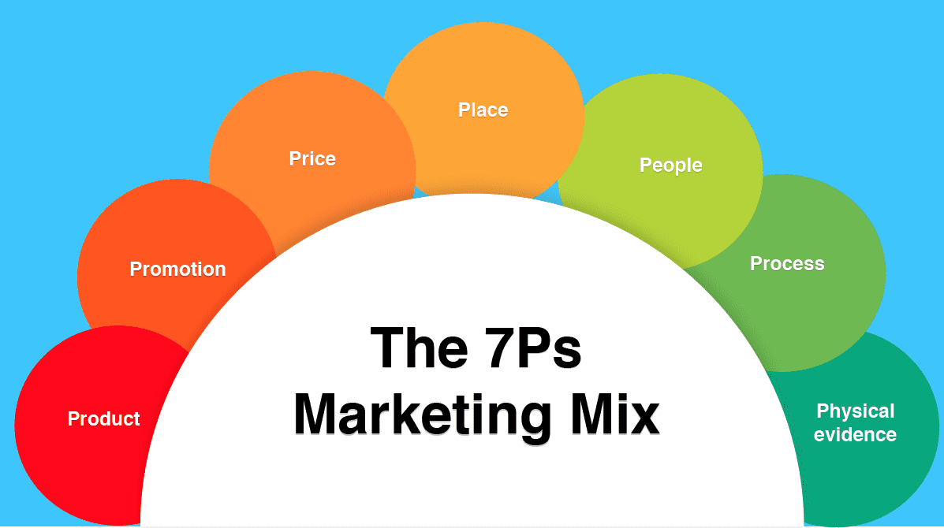
Figure: Elements of market mix (Strauss et al., 2014)
Marketing mix has different elements that start with the feeling the needs the company management set the production process and determine the price following different pricing model. Then comes the distribution policy that helps to understand how Ralph Lauren management will reach the customers well (Strauss et al., 2014). then come the promotional issues where with the use of different tools like social media, company website they can promote the business. There have additional three forces that are also related to the marketing mix such as people, process and physical evidence. People means bringing the capable employees at Ralph Lauren who can work well (Domański, 2021). process means designing the overall system that will work for the business. By following good promotional strategies company management can promote the appeal of the product at Ralph Lauren.

Recommendation
This is also possible for Ralph Lauren management to find the gap in the market by analysing the market situation well. This is helpful for them to develop ideas about the gap in the market and start to invest here. Thus, for Ralph Lauren, it is essential to look at the changing situation in the market. Thus, it helps in finding the solution to the problem and minimise the level of threats on the business (Domański, 2021). A curious mindset from the management is helpful here for Ralph Lauren

Conclusion
So, the above analysis shows that marketing has greater implications in the business. This has a relationship with the macro forces. Business managers need to face a challenging situation in the market while dealing with the macro forces new concepts are coming in the market arena that shows how effectively the business managers can support the customers at their best. This assignment showed the approaches by Ralph Lauren in managing their operation in the global market (Edward, 2010). This company has bene expectations one that could minimise the threats from the external force and work well.

Referecnes
Brunswick, G.J., 2014. A chronology of the definition of marketing. Journal of Business & Economics Research (JBER), 12(2), pp.105-114.
Deepak, R.K.A. and Jeyakumar, S., 2019. Marketing management. Educreation Publishing.
Domański, R., 2021. How to measure omnichannel? Marketing indicatorbased approach-theory fundamentals. LogForum, 17(3).
Edward, R., 2010. The fundamentals of Marketing. AVA Publishing.
Elshiewy, O., Guhl, D. and Boztuğ, Y., 2017. Multinomial logit models in marketing–from fundamentals to state-of-the-art. Marketing: ZFP–Journal of Research and Management, 39(3), pp.32-49.
Groucutt, J. and Hopkins, C., 2015. Marketing. Macmillan International Higher Education.
Hillesland, J., Rudolph, T., Meise, N., Gisholt, O., Bendixen, A., Fjeldstad, T., Nordfält, J. and Clement, J., 2013. Fundamentals of Retailing & Shopper Marketing (Vol. 1, p. 340). Pearson Educated Limited.
Kotler, P., 2012. Kotler on marketing. Simon and Schuster.
Kreutzer, R.T., 2010. Praxisorientiertes Marketing. Gabler.
Kumar, P., 2020. A Review of Relationship Marketing Fundamentals. Journal of Talent Development and Excellence, 12(2s), pp.3915-3921.
Masterson, R. and Pickton, D., 2010. Marketing: an introduction. Sage Publications.
Peter, J.P. and Donnelly, J.H., 2010. Marketing management. McGraw-Hill Higher Education.
Pride, W.M. and Ferrell, O.C., 2021. Foundations of marketing. Cengage Learning.
Savina, S.S., 2021. Theoretical fundamentals of competitiveness management of enterprise products on the basis of marketing. Magyar Tudományos Journal. 2021.№ 50. Р. 24-33.
Strauss, J., Frost, R. and Sinha, N., 2014. E-marketing (p. 496). Upper Saddle River, NJ: Pearson.

