TITLE PAGE

Title: The Discerning Eye Author : Janet Allen p143157

Submitted in partial fulfilment of the requirements for the degree of
BA (Hons) University of Wales Trinity Saint David , Swansea.

12/12/2018

TABLE OF CONTENTS
1. PAGES 2- 5 History , and the Development of Reportage Drawing.
2. PAGES 5-15 Camera versus Pencil (A look at photography and its possible limitations)
3. PAGES 16-21 Current Practice
4. PAGES 22- 23 Future Developments
5. PAGE 24- 25 Conclusion

LIST OF ILLUSRATIONS
Figure1 Unknown artist(1879 Wood Engraving The Tay Bridge Disaster Available at:https//www.alamy.com/stockphoto Accessed3/11/2018

Figure 2. William Simpson : Windsor Castle Kitchen at Christmas 1894 GicleePrint for London Evening News: Embury/Minichiello P4

Figure 3 Francisco Goya Plate23 The Disasters of War Series Aquatint Engraving Available at https:www.google.co.uk Accessed3/11/18

Figure 4.News film coverage of Kennedy’s last moments Available at://www.itvnews/2013-11-johnfkennedyAccessed4/11/2018 Figure 5
Veronica Lawler : Line and Watercolour Drawing of a Vintage train (2013)Available at:https://www.veronicalawler.com/?p=608 Accessed 20/11/2018

Figure 6. Analogue photograph by Anna Linke Available at:https://medium.com@annalinke/Accessed 13/11/2018

Figure7.Award winning news photograph in the category of photo essay Bruce Adams, (2009)dailymail.com Accessed 15/11/2018
Figure 8 Court Room sketch of Karen Matthews and partner, (2008)Pastel pencil Available @www.mirror.co.uk/newsAccessed19/11/2018

Figure 10 Illustration of Soldier by Hans Liska who served in the German ArmedforcesWW2:Availableatwww.virtualpilots/fi/feature/articlesjpegAccess:30/11/2018
Figure 11Illustration of “Bakery Road” drawn from life in Syria Availableat: https;www.georgebutler.comAccessed25/11/2018

Figure12 Olivier Kugler illustration Olivier Kugler Available at:https :www.oliverkugler.com Accessed 26/11/2018

Figure 13.Anne Howeson Remember Me Project Available at:https www.bing.com/images accessed13.11.2018

Figure 14 Mary Poppins Available at: www.Amazon.com

Figure 15 Tim Vyner Mount Athos Project 2013(Animated film project) Available At :https//reportager.uwe.ac.uk Accessed2/12/2018

Figure 16 Gareth Proskourine Barnett Distorted picture of a Bangkok Street
Digital .Available at:https//reportage.uwe.ac.uk Accessed 3/12/2018

Page 1

Title: THE DISCERNING EYE : Introduction
The subject I have selected for my dissertation is that of Reportage Illustration.
I intend to explore the role of this type of drawing in a world of photography
In order to explain why this technique can be used to communicate a
valid picture of an event. I became interested in reportage illustration having
attended a lecture given by Oliver Kugler the successful producer of reportage
narratives dealing with subjects such as the refugee crisis. His work is based
on personal interviews of people caught up in world events. We also did a
university module consisting of on the spot drawings of people in an urban
setting. My aim in this dissertation will be to look at the subject of reportage
illustration in more depth in order to decide if there is a real resurgence in its
popularity and the reasons for this, including an assessment of the extra
impact that a drawing made at the time may have when compared to a
photograph.
I intend to use a variety of resources, including books , websites and articles.

Page2
Chapter1 . History

The dissertation begins with a section on the history of Illustrative reportage
in
order to give a background view of the current situation.
. Although “the years
between 1839/1900 saw the beginnings of
photography” as noted by Collins
(2015), visual images in the form of
drawings from news reporting remained important forms of communication
for many people. Thompson (2008 4th edition p 23) recalls the extent to which
people valued newspaper illustrations. She remembers pictures being pasted
upon the whitewashed walls of the outside privy, including a picture of the Tay
Bridge disaster depicting a major accident when the Tay Bridge collapsed in a
storm.
“It was before the days of press photography and the artists were able to give
their imagination full play” she says. After the wall had been re-whitewashed
again a spread depicting “Our Political Leaders” appeared and she particularly
loved the picture of Sir Randolf Churchill as she thought him to be “the most
handsome man in the world.” During this era in the later part of the 19th
century many less well- off people did not receive a proper education and
were unable to read and write therefore the pictures in newspapers must have
provided information.They were not able to travel away for holidays, and
may have lived their entire lives within a very small radius ,so this was their
only opportunity to view places farther afield.

Page3
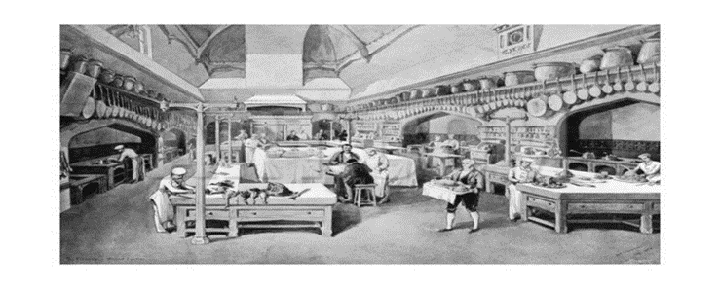
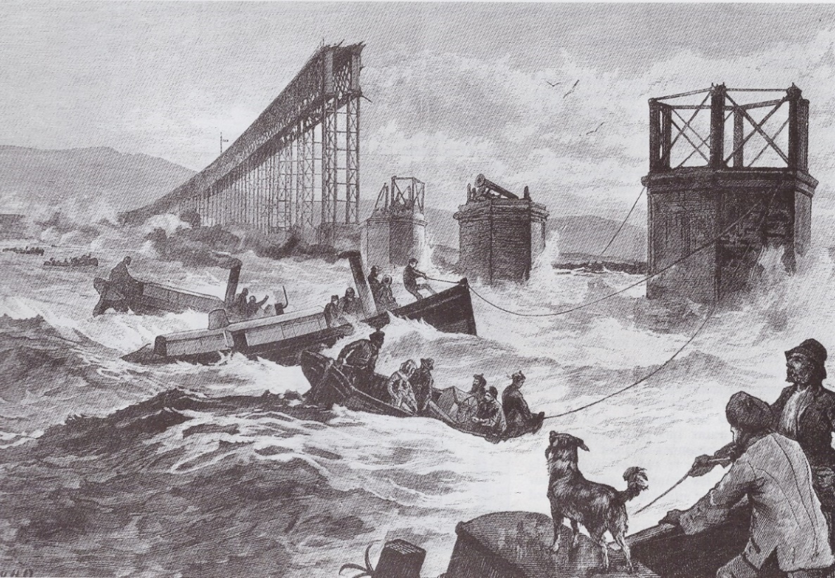
Fig 1 The Tay Bridge Disaster

Fig 2. Windsor Castle Kitchen at Christmas Page4

During the late Victorian era there were many talented illustrators at work
such as William Simpson who produced beautiful detailed illustrations for the
London Evening News and also worked as a war reporter for the same
publication.
Francisco Goya y Lucientes was an artist with a different agenda. Waring and
Fee (2006 p51-52) explain that he already had a history of making artwork
which mocked religious and political hypocrisy when he started to record a
series of images about Napoleon’s invasion and occupation of Spain. Despite
instructions received from Napoleon’s Minister of Arts he drew no scenes of
heroic battle, as expected, but instead concentrated on recording the
truth as he saw it. Waring and Fee (2006, p 51 to 52) describe it as a vision of
“war without the consolation of chivalry, religion without mercy and despair
without redemption”. Despite the horror of the subject matter, in this way
Goya adhered to high moral principals in attempting to show his audience the
truth about this conflict. The aim of reportage journalism today has also to be
the recording of events as faithfully as possible.
The series “The Disasters of War” consisted of 80 etchings and aquatints which
covered a period of 10 years meticulous work. Reportage artists over the years
have used a variety of techniques both traditional and contemporary to
enhance their work.
Sadly none of ‘The Disasters of War’ series was published in Goya’s lifetime
and he died in exile (according to Waring and Fee)

Page 5
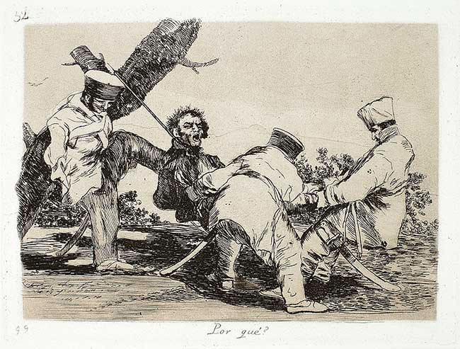

Fig 3 Plate 32 The Disasters of War

. However Goya was not alone in his passion for recording events using art.
Later (in the early 20th century) the Polish born artist Feliks Topolski published
many sketches and was also a painter. He travelled abroad extensively, for
example sketching on the Russian front and attending the Nuremberg trials.He
worked all over the world at the heart of important events. Martin (2004 p
7=8) describes his principles when he states “Topolski believed art could tackle
important issues of the day and the artists ability to express human emotion
would eventually triumph over the camera.” Unfortunately photography was
developing quickly, and Martin has to record that “his work is now largely
forgotten”. Hopefully it mayre emerge for future generations to appreciate.
There are so many examples of early artists working in the field of Reportage
Page 6
Illustration that it has not been practical to mention more than a few before
moving on to the next chapter.

Chapter 2.
Camera Versus Pencil.
(A look at photography and its possible limitations)
Nowadays photographs are available all around us. It can be said that
photography stops time, which Lange (American Masters)enlarged
upon when she said
“photography takes an instant out of time, altering life by holding it still”.
Certainly photography can provide an accurate visual picture of an unexpected
or shocking event. An example of this may be the assassination of President
Kennedy in 1963 ,when camera cover of Kennedy’s last moments was seen by
the public all over the world. In fact as a moment passes so quickly a
photograph adds to the details of a recollection.
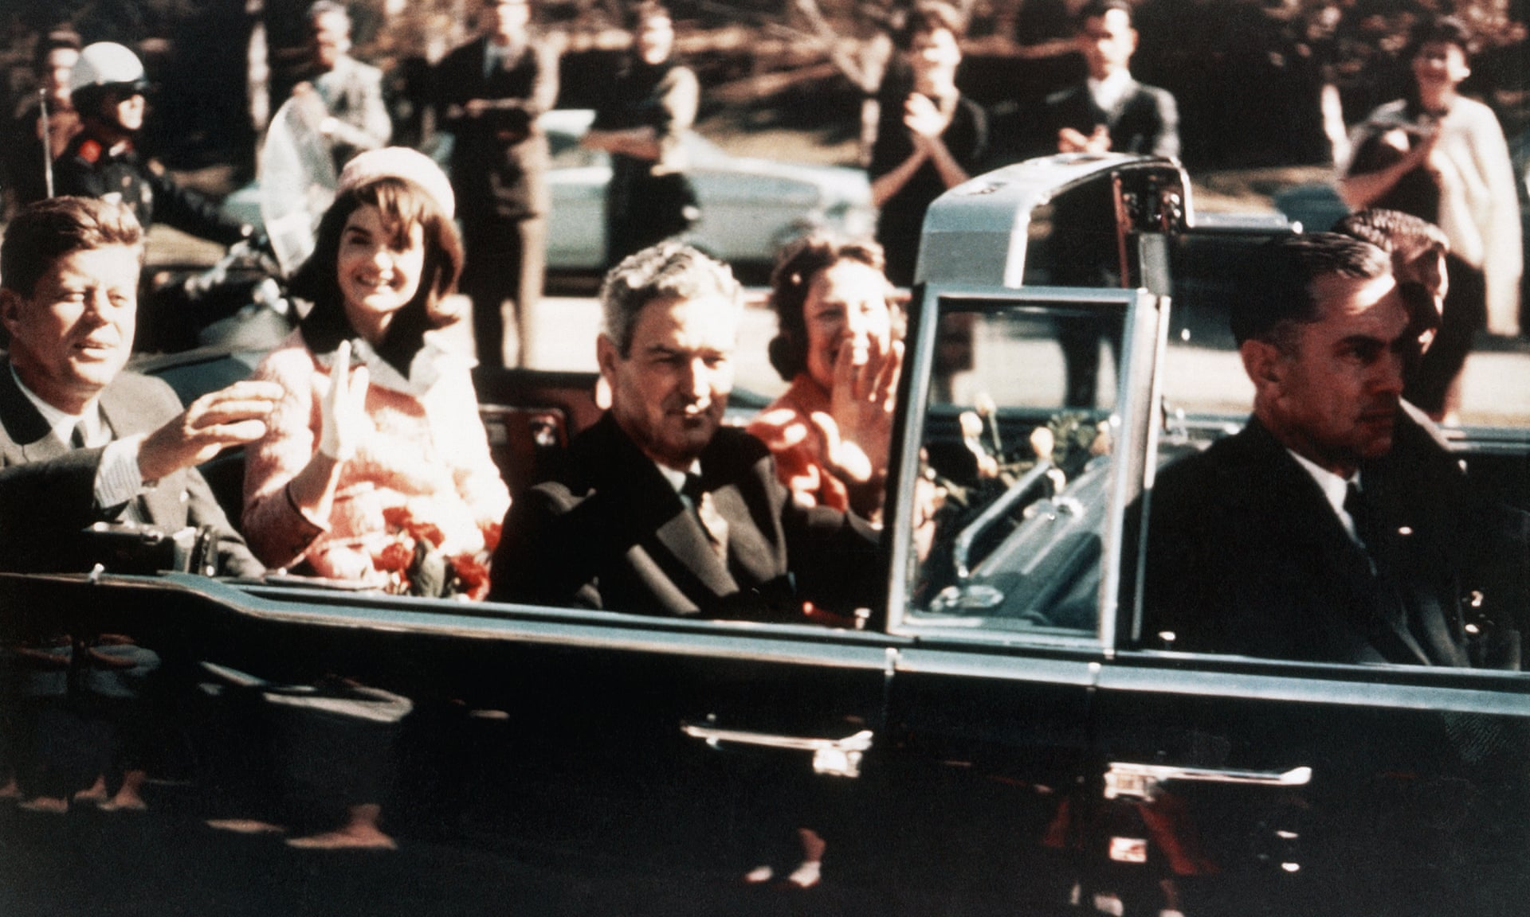
Fig 4 Media Coverage of Kennedy’s last moments
Page 7
In the same way as the camera “stops” time , so a hand drawn image may be
described as “capturing” time. This describes the essence of reportage
illustration, and how it differs from photography .As a drawing progresses the
artist has time to carefully consider the subject and to decide which aspects of
a particular scene he may include. Embury (2018) describes the process as
having the effect of “steering the viewer’s attention to the essential crux of
the story.” In this way the viewer may be drawn in to a memorable
image.
In order to make a successful drawing an artist must first “learn to see”
(Simpson 1992, p 11 ) By this he means that through sight “the visual world
can be analysed and translated ….as drawing.” This involves being able to
perform a kind of “optical illusion” when an artist depicts a 3 dimensional
image onto a 2 dimensional sheet of paper. This is a skilful process involving
the sometimes difficult techniques such as perspective drawing, the
assessment of proportion and learning about composition. However, Speed
(1972p18) points out that these practical skills though very important are not
The most essential components of a successful drawing, in fact these
techniques are just “a means of conveying to others in adequate form the
things he (the artist) may wish to express.”
Butler (Embury 2018 p13) is able to quote from a letter he once received from
Ronald Searle which said : “A pen and pencil and paper is nothing if you have
nothing to say. Otherwise do pretty watercolours and forget it.” This seems to
sum up the situation. Reportage illustrators often use a rapid line drawing
technique to describe a quickly changing situation. Human vision does not
perceive objects in the form of outlines but in a drawing the brain seems to
Page 8
readily accept an image which is represented by a series of lines. Speed (1972
p 50) explains that our instinctive acceptance of line drawing is derived from
the sense of touch. “When an object is felt there is no merging in the
surrounding mass,but a firm definition of its boundary, which the mind
instinctively conceives as a line.”
This is not the whole story because as in any successful piece of art the skilful
use of technique means that the artist can convey energy and meaning in his
work. Speed refers to this as “a music of line.” Some shading is often added to
give an impression of depth.
Closer objects appear larger than those further away for the same reason.

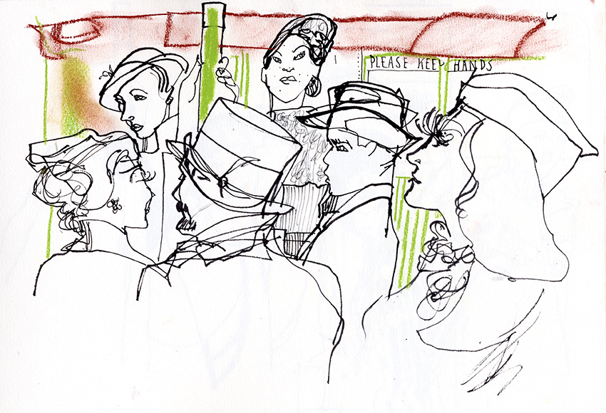

Fig 5 A Vintage Train

Page 9
Nowadays we all live in a highly digitalised world surrounded by innumerable
images but even today there are photographers who prefer the traditional
advantages of analogue photography which is felt to be a specialised art ,
requiring expertise and equipment not readily available to the public at home,
in the form of specialised cameras, dark rooms and chemicals which are used
in the developing process . Alternatively the film has to be developed by a
retailer or chemist.
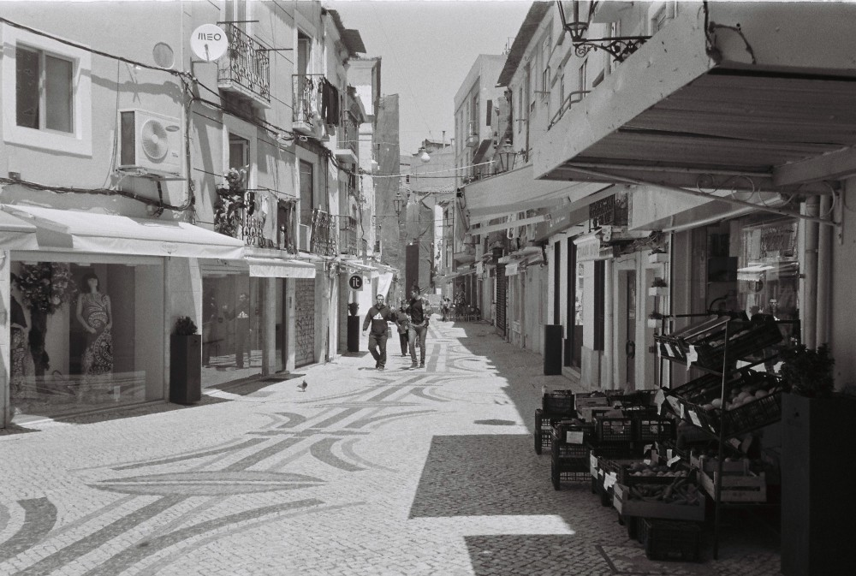

Fig 6 Photograph taken with an analogue camera

Anna Linke (2017) is an experienced photographer who went
back to analogue “finding to her surprise that she preferred the quality of the
prints, and the fact that she enjoyed composing pictures through a
viewfinder.” I stopped taking snapshots most of the time. Instead I focus on
taking photographs” she says. Colours appear richer and the photographs
often seem to have an extra quality of depth and clarity.
Page 10
Digital photography by contrast, may be easily produced, by the use of a
camera phone and the results quickly available, and ready to be shared,
frequently on social media sites.
Some of these images are quite transient, perhaps immediately deleted if the
quality is not felt to be as expected, or after a short period after publication
onto social media sites. For example, “Snapchat” is a social media site, popular
with teenagers, where images taken will disappear after an hour, unless the
user of the site decides to keep a particular image for longer ..It allows very
little time for planning or careful consideration of the composition .Bennet
(2007p 9-11) has investigated how photographers are coping with changing
marketing conditions and finds that “commissioned works from publishers,
design and advertising firms have slowed down for photo journalists/
reportage photographers and commercial photographers due to competition
from digital photography archives and the emergence of affordable digital
cameras.” With such a visual overload of images today it is
questionable whether the majority of photographs are merely glanced at, or
maybe passed over completely, certainly not carefully considered.
An anonymous comment left on the Reportager website may also help to
indicate why illustrative reportage seems to have gone out of fashion.
“Perhaps its down to the celebrity sensationalism we all love”
It is interesting to compare a photographic image which deals with an
unfolding news story with a hand drawn illustration in order to look at the
different features of both. In order to provide an example the press coverage
of a well known news story from 2008 was selected. The photograph appears
really well thought out and skilfully taken. In fact it won a Press Photographers
Year Award for 2009 in the category of ‘Photo Essay’. Page 11
The photograph shown below was taken when mother Karen Mathews and
Step father Craig Meehan had just been informed that their missing daughter
Shannon, then aged 9 had just been found alive nearby , having been cruelly
Confined in the drawer of a divan bed base. The case later went to court.
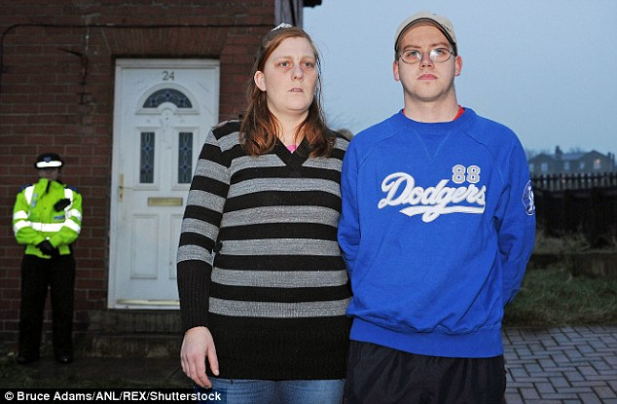
Fig 7 Karen Matthews with partner
Courtroom drawings are made quickly from notes and
memory because drawing is not allowed in court. They are able to give a
picture of the defendant and their attitude and appearance during the trial. At
first glance this illustration may appear less detailed than the photograph, but
comments from the artist Julia Quenzler(2013) on her perception of the
subject highlight how her observations have informed her work, and can be
seen by the viewer. “her whole demeanor was very resentful” says Quenzler.

My overwhelming feeling feeling out Matthews was that she was a very tough
Page 12
character. Her co-defendant appeared terrified, but stocky Karen looked
almost defiant”. These type of observations make a drawing intriguing and
lead us on to become interested in the characters involved in a news story
in a way which a photograph may not do.
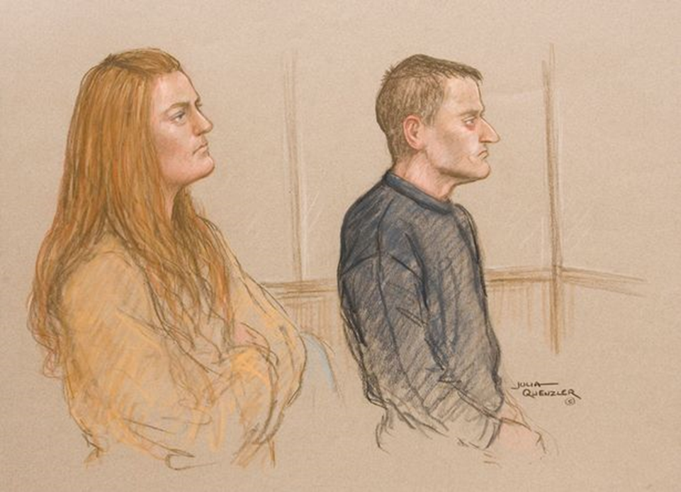

Fig 8 Courtroom Sketch

Nowadays, especially as cameras have been recently allowed into court rooms
in America, for example in the trial of O.J. Simpson, and as technological
advances increase, the role of the courtroom artist may feel under threat, but
Gottschalk (2017) is able to encapsulate their value when she observes “they
possess an untouchable ability to edit and distil the days drama and emotion
into a single frame”. For this reason they remain popular.
Another situation where reportage illustration may be used is to document
social events or concerts. This is often very much the realm of the camera
where photographs and videos abound in newspapers , magazines and social
Page 13
media. The camera provides an instant image, but hand drawn imagery, or
perhaps a mix of digital and traditional drawing can give a vibrant picture
reminiscent of the movement and atmosphere at the event in a similar
way in which the Courtroom artist is able to sum up the drama of the day.
The camera is frequently used to provide visual information for news stories,
Including war Reportage. Even in World War 1 photographers were present,
and some of their footage brought up to date with the addition of subtle
colours and the speed of the film altered to appear normal was recently shown
on television as part of the Armistice Day Remembrance. This seemed very
effective, and provided a valuable insight into history.

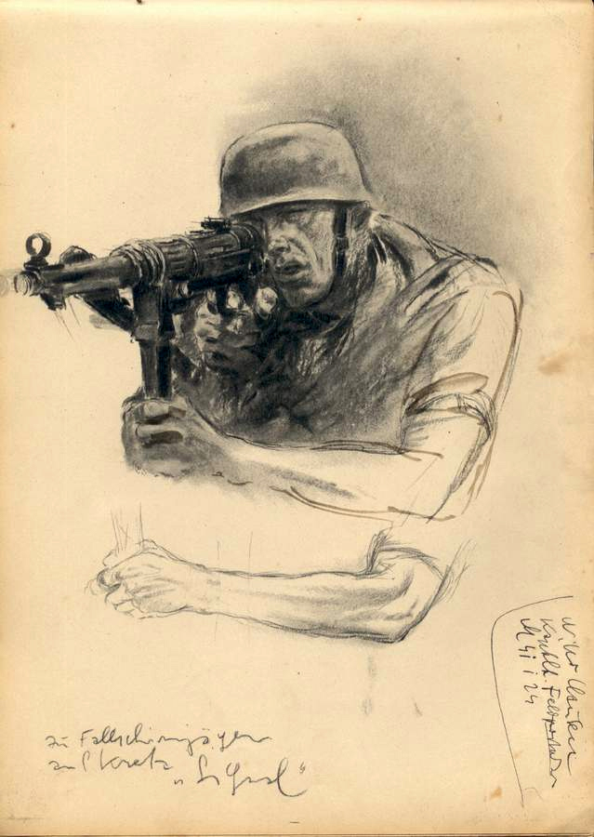

Fig 9 German soldier from World War 11
Page 14
War Artists remain popular as they provide an immediate response to the
situation, and also a picture free from possible propaganda to give people at
home a clearer idea of events. In the second World War artists such as Otto
Dix and George Gross showed horrific pictures of “bodies blown to pieces in a
landscape ruined by conflict, this was known as Degenerate art” (Embury,
2018)
In the present day notable Reportage artists such as George Butler specialise in
Current Affairs. This work has lead him to many dangerous and war torn areas
around the world. His many watercolour , pen and ink drawings often depict
the aftermath of recent conflict where people are rebuilding their lives(not
the war itself). They are full of human interest. In his recent series about Syria
he describes life in some of the recently liberated areas showing some of the
“abhorrent “conditions which he encountered.(Butler,2018}.
Here people are attempting to rebuild their lives. These pictures were
published in many newspapers including The Times and The Guardian.
Using modern technology artists such as Butler are often able to transmit their
work almost instantaneously to a publisher at home. Once a drawing has
been completed it is ready for viewing as quickly as a photograph would be. It
is also notable that according to his website (2018)George Butler instigated the
“Hands Up” foundation which was able to raise over 3.5 million pounds of aid
for the people of Syria to support the salaries of professionals working within
Syria. Such is the power of Reportage Illustration.

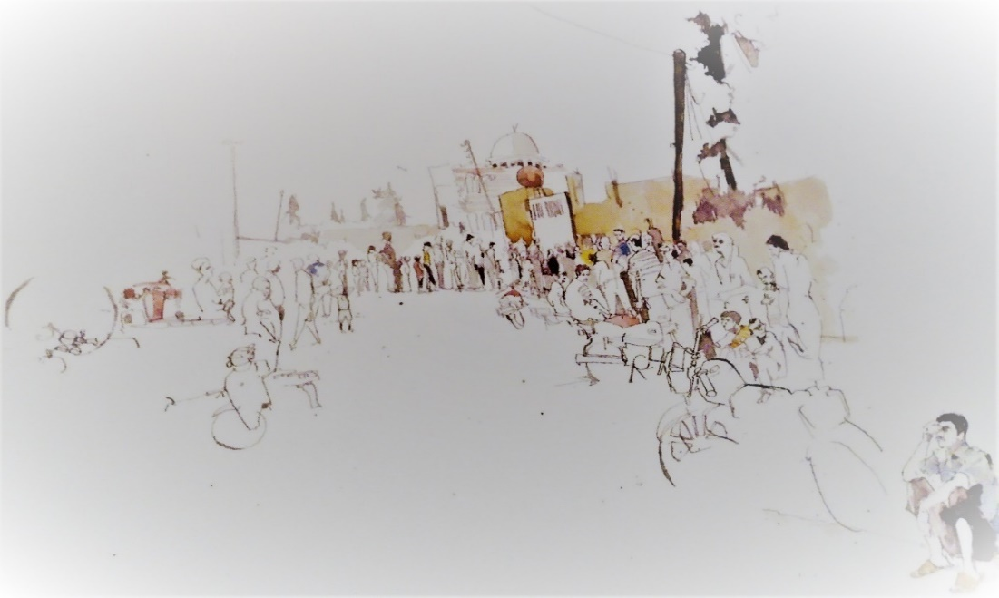
Page 15

Fig 10 Bakery Road, Syria illustration 2012
One final reportage artist to mention in the chapter “Camera
versus pencil” is the well known illustrator Olivier Kugler. Kugler specialises
in visual essays in which he explains he draws from his own high definition
photography , in this way combining the skills of photography and hand drawn
imagery .(Kugler, 2018) The characters he describes in this way are made to
appear totally realistic. He is able to give an impression of hand and arm
movement by merging several different images into his illustration. He makes
full use of technology by also colouring the images digitally. Reportage
illustration is an art which does not preclude the use of technology, his images
can be improved and enhanced in this way but in a truthful manner. Olivier
Kugler writes both descriptions and speech into his image. He can in this way
tell the story of the person he is portraying. In his illustrations the image and
the text intermingle to become part of the whole. Kugler(2018) only reports
On situations that he has seen for himself. He says “I stick quite faithfully
to the sequence as it happens”( Kugler,2018 p63)
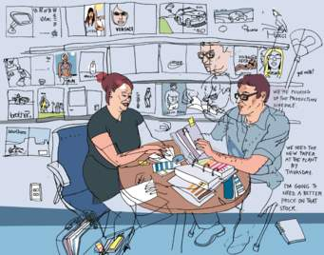
Page 16
Fig 11 Illustration by Olivier Kugler

CHAPTER 3 Current Practice

I had hoped to send out a brief questionnaire email with questions for
businesses, which I thought may help to assess the current situation for
Reportage artists but unfortunately did not receive enough responses to make
Up a meaningful sample.so the idea had to be scrapped. The present era is
exciting and challenging for illustrators .Although there is no professional body
which exclusively supports and protects standards for reportage illustrators
an important website has been set up by Gary Embury, Senior Lecturer in
Illustration at the University of the West of England, Bristol .Gary Embury also
Page 17
acts as the Editor of the Website.
According to Heller (2012) :
Reportager exists in order to support, initiate and showcase projects
involving drawing as reportage, visual journalism, documentary drawing
and illlustration as visual essay. The website works as an editorial space
for the dissemination of good practice in this area.
Work submitted via “Reportager” is therefore expected to be of a good
professional standard, otherwise it will fail to be accepted. Many reportage
drawings have to be made very quickly in fast moving situations which mean
that it would be impossible for the artist to be other than truthful as he
records what he sees . A reportage artist must try to aim for accuracy and
draw as truthfully as possible, however each artist is an individual with his or
her unique personality, set of values and beliefs. The work produced will
inevitably to some extent reflect this if it is to be drawn from the heart,
otherwise it will be of lesser value. Outside influences and concerns can also
impact on the work. Some of these circumstances may be quite mundane as
Embury (2018) points out with the question of how much will a drawing be
governed by “for example fitting into a school day routine”- a situation very
familiar to working parents! Other external influences may affect the
reportage artist to a greater or lesser extent depending on individual
susceptibility. For example lack of sunlight in winter may make some people
feel depressed . Commenting on this Gallagher (1994) states that “seasonal
shifts in energy are a general human tendency”. There are many
examples of the effect of external factors and following a discussion on the
probable effects of electro magnetic fields upon us and Gallagher also
Page 18
comments that “our everyday perceptions also spring from a collaboration
between our brains and environments”.
A discussion with a group of illustrators and designers known as the ‘First Hand
Reportage Artists Collective’ ( Embury and Minichiello, 2018 p 56-57) goes
further as they state “For accuracy in terms of pixel perfect detail then you
should be using a photograph.” However it is more important to “honestly
communicate the story that is happening around you from a human
perspective”. In this way a picture drawn by hand can describe what it was like
to be a person witnessing a particular event. A drawing may convey urgency,
excitement or any human feeling by the quality of line and mark making ,and
this is an important and valuable way of describing an event. At the launch of
the planned Reportage Newspaper(Heller 2012) a brief to submit work was
sent out . The work created was to be “without correction , ,mediation or
beautification” .A reportage artist concerned with news reportage should then
be able to produce an instinctive work based on real experience.
Reportage drawing is extremely diverse. As mentioned earlier in this chapter a
group of enthusiastic illustrators and designers has been set up with the aim
of working together in order to “champion reportage drawing, using their
draughtsmanship to visually record events with a journalistic
approach.”Embury/ Minichiello, 2018. The results can be posted
on social media. Working together seems an excellent idea, as the group can
use each others skills, and should be able to produce powerful work together
as they further develop their personal practice. The group has been entitled
“First Hand” and their membership includes Ed Rivers, Tim King, Phoebe
Halstead, Hannah Simpson and Sophia O’ Connor.
Page 19
There is certainly more than one way of becoming a successful Reportage
artist, and interestingly in the course of their reported discussion , although
advocating “on the spot” drawing ‘First Hand’ point out that really there are
two types of reportage illustration. Drawing in the present is one, but “drawing
the past and reflecting on your thoughts” is another. In order to see how this
may be done in practice a project by Anne Howeson was selected. Anne
Howeson has exhibited in the Guardian Newspaper. She works as a tutor at the
Royal College of Art. Her project is about “Drawing and Memory ” and consists
of two collections of works entitled “ Remember Me” and “Present in the Past”
These artworks are about the regeneration of Kings Cross/ St. Pancras in
London .For the first part of theproject, a start was made with sketchbook and
camera which evolved into a series of beautiful drawings. The set of drawings
is without people, and the artist found that the buildings themselves became
the characters in the story. She is interested in the “in between” state when
the buildings are still intact, though soon to disappear. She does not adhere
totally to reality so the work becomes part fact and part fiction as she draws on
to the buildings.(Howeson p104)
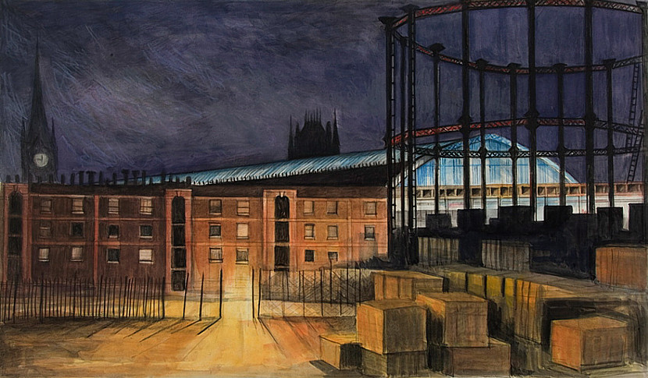
Page20
Fig 12 Culross Buildings (Disappeared)

In the series “Present in the Past” the same artist has made some large digital
prints from early engravings of the Kings Cross area and drawn on to them,
frequently erasing to give an impression of time passing. She has included
figures, some derived from the present.
Anne Howeson has therefore produced a series of artwork which seem a little
outside the mainstream of Reportage Drawing. She herself says: “the use of
imagination and memoryin Reportage Drawing (in addition to observation) is
both radical and highly demanding.” (Howeson 104)
In this case it has produced some lovely drawings which seem to represent a
new strand in the development of Reportage art. Anne Howeson openly
acknowledges the element of fiction which forms part of her work as a whole.
Some commentators worry that subjective elements may creep into
work that is presented as factual reportage illustration. Catrin Morgan(2016)
lecturer at the Royal College of Art has written a paper entitled “The Myth of
Reportage illustration”.
She says that “I’m very interested in the way that fiction infiltrates fact and
the way that this infiltration might be facilitated by images or illustration”.) As
previously discussed this may be to some extent inevitable but this is surely
also the case in written journalism , where the reader has to realise that an
article or editorial may contain the opinion of its author .These days more than
ever before photography may convey an image which is not really accurate at
all. The use of filters is widespread and though they may increase the apparent
beauty of a landscape for example they do not produce an accurate likeness.
Page 21
.The viewer could imagine that purple sunsets are frequent whereas they are
never, or hardly ever seen. As technology improvesthese deceptions become
more realistic as when a green screen has been used or an unusual animal on screen turns out to be an animatronic
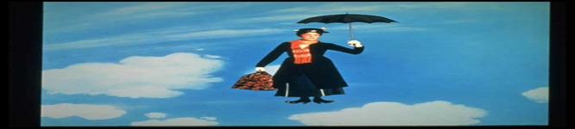

Fig13 Mary Poppins amazon jpeg

Photoshop gives endless opportunities to manipulate a photograph.
All that can be expected from a Reportage artist is that they sincerely try to
convey the event that is being covered as truthfully as possible so that the
viewer can share init and enrich their personal experience.In addition to the
Reportager website’ illustrative journalists are able to join the A. O.I,(the
Association of illustrators.) This will offer practical information, help and
support in dealing with clients and help to negotiate contracts.Reportage Art
is an exciting and skilful way of working, especially as it tells a narrative and
often deals with important issues and events. It is relevant to many situations,
but given the interest and passion that it engenders amongst artists it seems a
little disappointing that it is not an obvious feature in many publications such

Page 22
as magazines and newspapers. Harrison M. 2018), former Senior Art Editor for
the Times makes some relevant comments regarding
budgets for the newspaper. He would consider illustration if he was in the
position of having a higher than normal budget. The number of digital editions
is also an issue to be considered. He feels there is a strong public response to
drawn reportage, and hopes that some technical solutions may be developed
in the future. Obviously the Times is a large and prestigious national
newspaper, but it seems that there may be similar budgetary concerns held by
much smaller businesses.In contrast to the hand drawn image photographs
used in newspapers are often easy to obtain, and comparatively cheap.
I contacted a small local publication the District Diary a local magazine based at
Llanharan, Mid Glamorgan. In response to my survey questions Mark Hyde
the editor has written “we would use a relevant illustration If it was sent to us
with an article, but we’re a small publication run on a tight budget which
doesn’t extend to buying in extras such as illustration”. This primary research only seems to emphasise the fact that Budgetary concerns
are important, especially in view of the politicaL uncertainty in the UK at
present but even allowing for difficulties the future for Reportage illustration
seems good and there are many reasons to look forward to the future.

5. Future Developments.
Since the earliest times reportage illustrators have made full use of all the
different methods available to enhance their practice. The willingness to use
technology as it advances is no exception .For example illustrator Tim Vyner

Page 23
not only uses the most traditional methods of drawing with pen and ink , and
watercolour paint, he has also produced short animated films created on his I
pad. (Reportager 2013) Usually animation as such does not seem compatible
with hand drawn illustration, but in this case as part of a special project at
Mount Athos the “Holy Mountain” in Greece a simple and effective animation
was made and set to suitable music. No characters are present in the film
which begins as a partly drawn sketch of monastery buildings, but as the film
progresses wesee new marks being added, with shading and colour as the final
picture is built up. The hand of the artist is not visible, and the effect is quite
magical, not detracting at all from the hand drawn image.

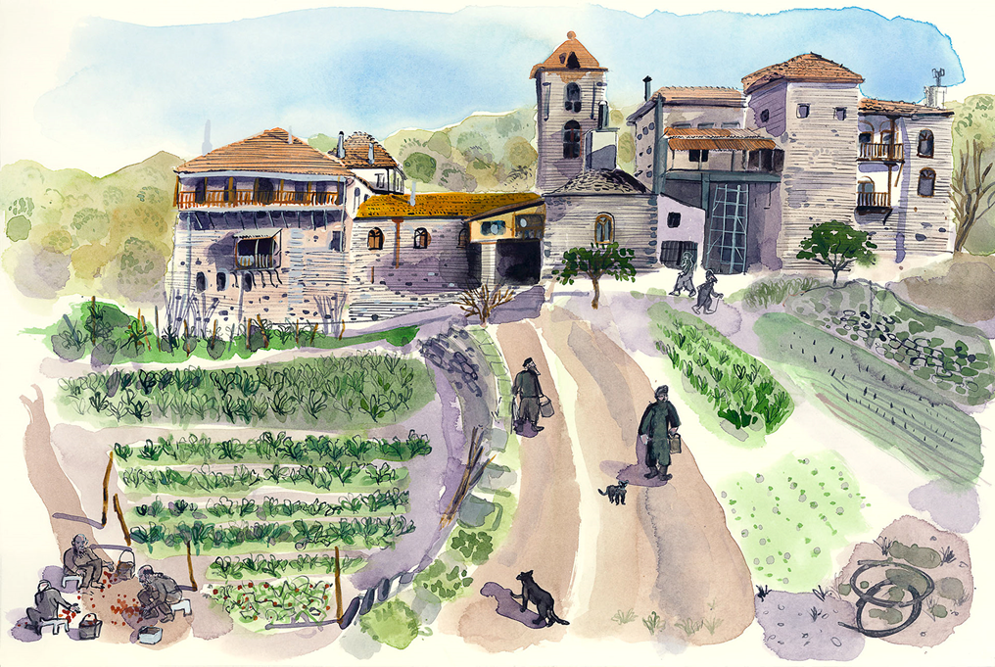

Fig 14 Mount Athos
Page24
such as the use of a GIF. A GIF is a common type of image file found on most
computer systems and websites.(Techwalla.com 2018 ). The initials GIF
stand for Graphics Interchange Format and it is a small repetitive moving
image which may be inserted into a drawing file.
“It is best suited for displaying line drawings, text or relatively simple graphics.
Image distortion or quality loss may occur in more complex images.” Therefore
it is well suited for use in a line drawing produced by a Reportage illustrator.
The sight of maybe a tree moving in the wind, or a bird which pecks at seed
will add depth to the image, and therefore increase the enjoyment of the
viewer.
Although reportage artists (for example George Butler) are now able to
transmit theirwork quickly from far flung locations Harrison (2018 p.156) feels
there is still room for improvement. He urges lecturers and art institutions “to
approach leading companies such as Adobe to develop product improvements
for drawing and filing pictures from difficult or restrictive locations.” Although
technology has come so far there are still improvements and refinements that
could be made. Also “simpler and faster animation packages to aid artwork
conversion for digital editions” would be beneficial says Harrison Nowadays
the variety of Reportage Illustration seems to be increasing and there is a
wealth of talent certainly evident in the leading artists.
Whatever appears next must be due to the talent and imagination of the
creators and the technology now becoming available.
Maybe we may see more of works such as the digitally manipulated postcard
shown below.
More publicity and public familiarity with the hand drawn image may be helpful.
Page 26
Also schools could help to promote reportage imagery in lessons, and
Competitions and public events will hopefully be more frequent in future.
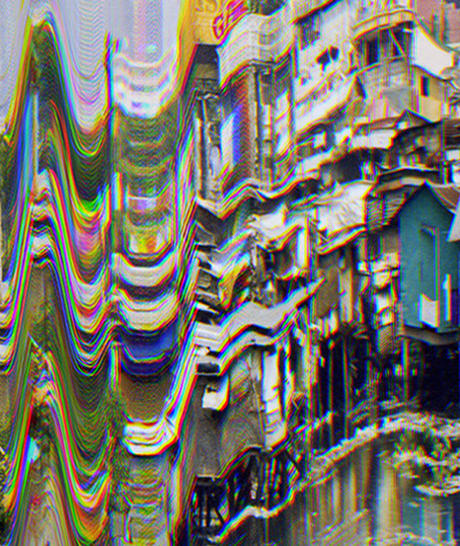

Fig 15 Distorted image of a street in Bangkok

The subject of Reportage Illustration has proved to be very interesting and
inspiring.
In order to appreciate it the dissertation first looked at the historical
background. The research for this showed that reportage was an important
factor in the lives of ordinary people, and the illustrations carefully studied. As
many people could not read or write newspapers were a valuable resource. It
was also surprising to read
Page 27
about the selfless dedication of war artists such as Goya and Topolski as they
depicted the stark horrors of war. The second chapter (Camera versus Pencil)
further helped to clarify the different quality of a drawing versus a photograph,
attempting to explain how a camera can be said to stop time whereas a
drawing captures time, showing the atmosphere and feelings present. I feel
that the comparison of news and courtroom coverage helped this explanation,
as did the examples of Hans Keller and George Butler. Olivier Kugler combines
photography, illustration and text in his powerful Illustrations.
The third chapter contained a discussion about current practice. It was
Important to describe the Reportager website and its aims. Submissions via
the website must be of a high professional standard or they will not be
, accepted.
It seems that modern technology is welcomed, and there is a new much
discussed diversity with a strong bank of talent. Having established the
aesthetic value of reportage illustration, the dissertation attempted
to address the reasons why it is not more widely published. The conclusion was
that this must be due to budgeting concerns, and that it is easy and cheap to
obtain photographs instead. Technology appears to be lagging behind when it
comes to the publication of illustration in digital form. The use of GIFs may be
developed.
. The dissertation however has also highlighted the disappointing scarcity of
these images in our everyday lives, and tried to ascertain the reason for this .If
these concerns could be alleviated. The outlook remains positive because of
the wonderful variety of talent which exists and in our stressful age the quiet

Page 28
contemplation of a hand drawn image is an enriching experience. Hopefully
publishers and editorial producers will utilise and value illustrative reportage
once again.

Reference List
Books:
Embury, G./ Minichiello M (2018) Reportage Illustration London: Bloomsbury Publishing plc
Gallagher W, (1993) The Power of Place New York:Harper Collins Publishers inc

Lawler, V (2016) Reportage and Documentary Drawing ,Quarto Publishing Group USA inc

Simpson. I.(1992) 3rd Edition Drawing, Seeing and Observation London A&C Black Publhers inc

Speed,H.(1972) The Practice and Science of Drawing USA Dover Publications.com
Thompson F.(2008) 4TH edition ,Lark Rise to Candleford London Penguin Books Ltd
Chapter within an edited book
Butler G (2018) George Butler, Syria in Embury G. and Minichiell M.(eds)
Reportage Illustration London, Bloomsbury publishing

Harrison,M.(2018)’Interview with Martin Harrison, Former Senior Director for the Times’, in Embury, G. and Minichiello ,M.(eds) Reportage Illustration London; Bloomsbury publishing

Howeson,A.Case Study(2018)Embury G. and Minichiello M Reportage Illustration London Bloomsbury Publishing

Kugler’ O(2018)’Interview with Olivier Kugler in Embury G and Miniechiello M (eds) Reportage Illustration London, Bloomsbury Publishing

First Hand Reportage Artists Collective(2018) Interview with in Embury G. and MiniechiellO M.Reportage Illustration London Bloomsbury publishing

Whole newspaper
The District Diary, LLANHAREN Editor Mark Hyde

Journal articles

Bennet O (2007)Design Week published by Centaur Communications Vol22 (46)p9-11 Accessed 7October 2018

Martin J(2004)’Brush with the United Nations History Today Vol54p7-8 Accessed 22October2018

Waring, B, Fee E, (2006)’The Disasters of War’ American Journal of Public Health Vol 96 P51-52 Accessed 15October2018

Websites with an organisation as author
American Masters Available at:www,pbs.org/wnet/americanmasters/dorothea-lange-quotesbydorothea accessed 7December2018)

Britannica.com available at https//www.britannica.com/technology/lithography( Accessed1 September2018)

