

Mental Health in Frontline Policing: A critical evaluation into the effects of mental health on the Police and the Public.

Daniel Graham
Student number: 2031308

BSc (Hons) Professional Policing Practice

Acknowledgements

Firstly, I would like to thank my tutor Kate Colclough for their support and guidance throughout this dissertation. I would also like to thank all the staff at UWTSD for their support also and their dedication to educating and providing support to all of those in education. I would also like to thank all my colleagues at Gwent Police, in particular the learning and development department who have offered their support throughout. A special thank you to all my supervisors who have supported me and offered me additional support where necessary.
Finally, I would like to thank my wife Holly, for her amazing support and encouragement offered throughout my studies. For her words of encouragement and comfort. Without everybody’s collective support, this project would have been unequivocally more difficult to complete.

Declaration

This work has not previously been accepted in substance for any degree and is not being concurrently submitted in candidature for any degree.
Signed: D.Graham
Date: 08.04.2024

STATEMENT 1
This dissertation is being submitted in partial fulfilment of the requirements for the degree of BA.
Signed: D.Graham
Date: 08.04.2024

STATEMENT 2
This dissertation is the result of my own independent work/investigation, except where otherwise stated.
Other sources are acknowledged by footnotes giving explicit references. A bibliography is appended.
Signed: D.Graham
Date: 08.04.2024

STATEMENT 3
I hereby give consent for my dissertation, if accepted, to be available for photocopying and for interlibrary loan, and for the title and summary to be made available to outside organisations.
Signed: D.Graham
Date: 08.04.2024

STATEMENT 4
I hereby give consent for my dissertation, if accepted, to be available on the university’s IT system to those who have consent to use the system.
Signed: D.Graham
Date: 08.04.2024

Contents table
Contents
Acknowledgements 2
Declaration 3
Contents table 4
1. Chapter One: Introduction 5
2. Chapter Two: Literature Review 6
2.1 Types of Literature Review 6
2.2 Mental Health In Policing 7
2.3 Types of mental health problems 8
2.4 Causes behind Police Officers suffering with mental health problems 9
2.4 Mental Health and Crime 12
3. Chapter 3. Methodology 13
3.1 Introduction 13
3.2 Research Strategy 14
3.3 Data Collection 15
3.4 Limitations and problems 16
4. Chapter Four: Analysis of results 16
4.1 Introduction 16
4.2 Data Analysis 17
4.3 Advantages of Survey Monkey 17
4.4 Disadvantages of Survey Monkey 17
4.5 Statistics of Frontline officers with mental health issues. 17
4.6 Ability to carry out role of a police officer 18
5. Chapter 5: Findings and Conclusion 19
5.1 Introduction 19
5.2 Objective’s achievements 20
5.3 Findings 20
6. Chapter 6: Recommendations 21
6.1 Partnership working 22
6.2 Self-reflection 22
7. Bibliography 23
8. Appendices 26
8.1 Appendix One: Questionnaire 26
8.2 Appendix Two: Questionnaire Results 31
8.3 Appendix Three: Ethics form 38
8.4 Appendix Four: Research Proposal 54

1. Chapter One: Introduction

This research will look to examine the effect mental health has had on frontline police officers within Gwent Police.
Previous research conducted shows that policing has been proven to be a hazardous and stressful occupation. Now that mental health has become a much more accepted topic and the stigma has lifted for the most part, more and more research is being conducted and more people are talking about their mental health. This is also the case in police officers. The University of Cambridge recently found that one in five police officers struggle with their mental health in some format.
Police officers working on the frontline serving and protecting communities attend a wide variety of incidents, some of which can be traumatic. Police officers are expected to deal with varied and complex crimes which can cause and expose them to trauma and have a tremendous effect on their mental health which can lead to long term and sustained health issues.

Objectives
- Analyse the effect mental health has had on frontline police officers when carrying out their duties.
- Evaluate the causes behind mental health in frontline police officers.
- Discuss what changes have been made to assist the police in dealing with vulnerable people who have mental health issues.

The main focus of the research is to look in depth at whether officers within Gwent Police suffer with their Mental Health and whether the reported mental health issues support previous research done. This will then be compared to the previous literature and if the statistics in the upcoming research will correlate or negate the previous research.
Front line Police officers will have different opportunities which they can use to seek support for their mental health, whether that is within their local constabulary or whether that is externally. Some will decide that they can deal with their issues personally and with no additional support and some will be more open and be willing to discuss this. Like all discussions involving any group of people, there will be a level of predictability and unpredictability with the answers which will be an interesting area to review.

2. Chapter Two: Literature Review

2.1 Types of Literature Review

The University of Cumbria identifies that there are two predominantly used types of literature review. The first of these being the primary research project. This type of literature review utilises the research which has already been completed and is known, it then sets out the context of the research which will be undertaken by the researcher. The type of review also helps to find any gaps in the specific research field and allows there to be an opportunity for this to be developed further.
The second type of literature review is referred to as secondary research which is a ‘stand-alone’ review. This uses research which has already been reviewed and published in order to assist in answering a specific question or to explore that topic in more detail. Whatever type of literature review is chosen the reason is the same, for a select analysis into a chosen area of research. (University of Cumbria, 2023)

2.2 Mental Health In Policing

Mental health can be viewed as how an individual thinks and feels about themselves and their lives, and that mental health can affect how an individual copes and manages in times of adversity (Bhugra et al., 2013). This is a particular poignant definition due to the known links between police officers and adversity in their day-to-day tasks in the 21st century, and more recently the 2020’s. The 2020’s were a time of great changes in the modern world, with the COVID-19 pandemic affecting the world, along with political challenges faced by far-right and far-left protesters in the UK which put a large strain on policing resources in recent years (Miller, 2022).
As of March 2023, 5,113 full-time equivalent police officers were on long-term sickness due to their mental health in England and Wales. This is the equivalent to 3.5% of all officers and is a slight increase on the previous year which was a total of 3.3% in 2022 (Home Office, 2023). Apart from the obvious impact that this number of officers being on leave will cause to department resourcing, it is crucial that the reason for these absences is identified and also what the causes may lead to, including officers leaving their respective police forces permanently.
A recent review of studies (Syed et al., 2020) looked at the most common mental health problems in policing. The studies looked at the mental health categories of depression, anxiety, and post-traumatic stress disorder (PTSD). 14.6% of police were reported to have depression, 9.6% with an anxiety disorder and 14.2% with PTSD.
For this literature review, the researcher has tried to identify completed research using keyword searches including ‘mental health’ and ‘UK police officer’. The reason for specifying this is to identify the correct research relating to mental health within UK police officers and how there may be reasons specific to issues ongoing within the UK. This means that the researcher can narrow the results to the correct group of subjects. The main topics which arose from the research results identified a high number of references to trauma and organisational issues leading to a downfall in mental health. Mental health was frequently referred to with the use of terms such as depression, anxiety, stress, and PTSD. The studies already completed and published used statistics along with interviews and questionnaire responses.
Based on the above, the researcher will look to focus the topic of mental health mainly on the four specific areas of stress, anxiety, depression, and PTSD. This will be used to compare how these factors are attributed to areas in policing which are highlighted as common areas in which officers feel that they are affected and what areas of policing are contributing to their mental health issues.
Alongside this, the researcher will look at common health factors which have been linked to police officers in the UK at the end of their career. There was a trend seen whereby those officers who had been exposed to traumatic incidents or met the criteria for PTSD, had seen an increase in alcohol consumption by 42% to a level which was described as increasing or high risk to their health (Stevelink, S.A.M. et al. 2020).

2.3 Types of mental health problems

National Health Service (2023) describes anxiety as a feeling of fear or unease, and it is something everyone experiences at times. Anxiety is a natural reaction to some situations and can help us focus or take extra care when needed, but if it gets too much or goes on for a while it can affect our daily life. Anxiety becomes a mental health problem if it starts to affect our daily life and the issues are ongoing for a long period of time, or if the person suffering from it starts worrying about small things and relatively harmless or unimportant situations.
Mind (2023) describes depression as a mental health problem that involves having a low mood or losing interest and enjoyment in things. It can also cause a range of other changes in how a person may feel or behave at any point in time. A mental illness which requires long term treatment. Depression can have a number of symptoms which can include, but are not limited to, sadness, emptiness, and hopelessness. This can result in outbursts of anger through irritation and frustration over minor issues. Depression can result in sleep issues such as insomnia or over-sleeping. As a result of a lack of effective sleep, the individual has a lack of energy and may have trouble thinking clearly about their actions or decisions, concentrating, and making day to day decisions. Ultimately, depression can lead to suicidal thoughts and suicide if not dealt with and treated effectively.
A review held in 2020 based on a study of over 40,000 individuals across England and Wales showed that 9.8% of UK police officers and staff reported suffering with probably depression. (Stevelink, S.A.M. et al. (2020)).
Stress is our body’s response to pressure. Many different life events or situations can cause us to feel stressed. This is often triggered when we experience situations which are new or unexpected and these experiences threaten our sense of self or when we feel that we do not have much, or any, control over a situation. We all deal with stress differently. Our ability to cope can depend on our DNA and genetics, early life events and our socio-economic circumstances. When a person feels stressed it triggers an internal response in the body via a flight, flight, freeze or flop method. This assists in the body’s response time to a dangerous situation through one of the four above responses. Too much stress can cause a negative effect of feeling overwhelmed or the inability to cope with a situation. (Mental Health Foundation, 2021).
Post Traumatic Stress Disorder (PTSD) is a psychological order which can be linked to stress. Mind (2021) states that this occurs when a person is exposed to a traumatic incident. A lot of people who go through traumatic incidents can, over time, get better and recover mentally. However, when these negative thoughts don’t go away and lead to have negative effects on an individual’s lifestyle, this can be classified as PTSD. The negative effects may include vivid flashbacks, intrusive thoughts or images and nightmares. The exposure to a traumatic incident does not have to be experienced directly by a person for them to have PTSD. If they were a witness to this, or they are supporting a person who experienced a traumatic event, they may also suffer with a form of PTSD known as secondary trauma.

2.4 Causes behind Police Officers suffering with mental health problems

Recent research conducted by Edwards and Kotera (2021) has noted that policing has been identified as a hazardous and stressful occupation. The consequences of the organisational stressors and the high-risk nature of frontline duties mean officers are at greater risk of developing psychological illnesses. They also mentioned that the cumulative exposure of possibly traumatic situations is an extremely important part of operational policing.
Cartwright and Roach (2020) state that policing is undoubtedly a dangerous occupation where officers are expected to be routinely exposed to dangerous and potentially traumatic incidents, such as attending road traffic collisions, informing people of the death of a loved one and ensuring public safety at football matches/organised events or protests.
Research was conducted by a group of researchers from the University of Cambridge found that one in five police officers in the UK had symptoms which were consistent with post-traumatic stress disorder, or more specifically Complex post-traumatic stress disorder. 16,857 police officers across England, Wales, Scotland, and Northern Ireland participated in a major survey during Autumn of 2014. The results of this research showed that 90% of police personnel involved in the survey had experiences some level of trauma during their duties and that one in five stated they had suffered either post-traumatic stress disorder or Complex post-traumatic stress disorder.
A more recent research study conducted by the University of Cambridge again in 2022 of 12,248 police officers in England and Wales showed that there was a high number of officers who reported complex PTSD symptoms which were exacerbated by environmental factors such as a lack of support or time to effectively complete their duties. During this study, it was discovered that officers who stated that they never had enough time to “get the job done” had nearly double the rates of Complex PTSD to 22% in comparison to the UK wide average of 12% seen in other officers who have not noted this to be an issue that affects them.
Around 15% of the officers who were involved in this study stated that their relationship between work life and home life did not fit well. Of these officers, there was a notable 24% who showed signs of complex PTSD, double the UK-wide average. Research which was undertaken by the Police Federation of England and Wales (PFEW) makes regular reports on the working conditions on officers and in 2020, 39% of the participants in a PFEW survey reported that they were working such extensive hours that they never or were rarely able to take their full rest/break entitlement (Elliott-Davies, 2020). Thus, showing that there is a clear pattern of the effects poor work-life balance has and the lasting effects it can have on the officers long-term mental health.
A report was published in 2019 by the mental health charity, Mind. This report compared two separate research surveys conducted by Mind into police personnel and the specific aspects of the role which cause them to have some form of mental health condition.
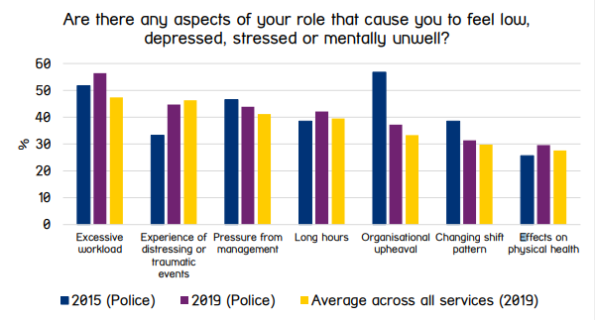
The below is the correlated diagram to the above which evidences the survey findings.
(Mind, 2019)
This survey showed that there was a change in what officers felt contributed mainly to their mental health. The changes included a shift from the highest reported impact on the officer’s mental health in 2015 which was Organisational upheaval which moved to fifth place in 2019. While Excessive workload and long hours were more likely to be cited as a stressor then it was in the 2015 survey.

In the same survey conducted by Mind, the proportion of officers who were aware of the mental health available to them rose from 41.9% in 2015 to 57.7% in 2019. With this, we can gather that there has been a positive increase in the awareness of support, but we could gather from the trend of 15.8% increase over four years that, if the survey followed the same trend, it would take until 2031 for all officers to be aware of organisational support for mental health.
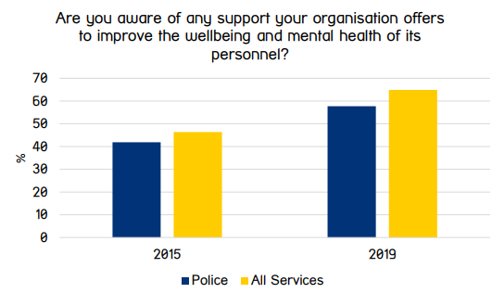
(Mind, 2019)

Foley, Jones, Hassett & Williams (2023) found that in the general population, depression was reportedly found in 3.3% of those who participated whereas research conducted in Stevelink et al. (2020) found higher levels of depression, 9.8%, within their studies of police officers and staff.
Miller, Brewin, Soffia, Elliott-Davies, Burchell, & Peart (2022) stated that, while testing a trauma checklist on UK police officers, trauma is an extremely threatening or horrific event or series of events. Even when you exclude PTSD, they said that trauma can affect the officers health, performance and cognitive function. For police officers in England and Wales, the main traumas that were reported were related to dealing with child abuse, unexpected deaths including murders and suicides and traffic collisions and railway incidents. This is important as previous trauma checklists created did not take specific trauma events into account as they were not designed for UK police forces based on common experiences. An example of this being gun violences which is not as common in the UK compared to countries like the United States. Previous checklists classed trauma as ‘firsts, worst and most’. This meant that previous checklists focused on trauma exposures in an officer’s early part of their career, the most severe trauma exposure and the most frequent trauma exposures.
Foley and Massey (2021) discuss the effects of secondary trauma on the officers who may not necessarily have been exposed to the live primary trauma incident. They describe how secondary trauma occurs when there is an emotional connection to a traumatised individual, and the primary trauma carrier passes their symptoms on to another, in this case that person is the police officer. The impact of secondary trauma has been widely studied for the ‘caring’ professions such as nurses and paramedics, however there is minimal empirical research into the effects of secondary trauma on frontline police officers. This creates limitations into the amount of evidence and research that can be used to inform decision making and draw conclusions from to assist in the development of support systems for those in the police service. Foley and Massey also noted that more research needed to be conducted into the impact of other individual factors, such as having a traumatic history, age, gender and real or perceived social support.
It was particularly challenging for the researched to find any reviews or studies that were looking specifically at Gwent Police exclusively. The research was unable to receive a positive response from the organisation when requesting specific information regarding officers within the force who have mental health issues and those who may be on absence due to this.

2.4 Mental Health and Crime

Research conducted by Halle et al., (2020) showed that there was no defined link between violent crimes and mental health, with individuals diagnosed with a mental health disorder being accountable for only 1% of the makeup of violent offenders and they are only responsible for only 5% of societal violence and criminal behaviour.
Research conducted in the Netherlands by Vinkers, de Beurs, Barendregt, Rinne and Hoek (2011) identified that violent crimes such as arson, assault and homicidal attempts or threats were found to have the strongest relationship to defendants with mental health disorders. Whereas offences such as sexual crimes had the weakest relationship to those same offenders. It was found by the researchers that those sexual offence defendants were more likely to have lower IQ’s but no defined mental health disorder.
Morgan, Scanlon and Van Horn (2020) have conducted research which provides an in-depth review of those people with mental illness and the relationship to the criminal justice system. The research concluded that mental illness was not the driving force behind a person with mental illness’ involvement in the criminal justice system and it was only a risk factor to take into account. The criminogenic risk is likely to be the primary cause of crime which is similar to those individuals in the criminal justice system who do not have any mental health conditions or illnesses.

3. Chapter 3. Methodology

3.1 Introduction

This study is looking to identify the causes of mental health related illnesses within front line officers of Gwent Police and analyse the effect mental health has on frontline officers when attempting to carry out their duties. The study will also evaluate the impact mental health has on member of the public and look specifically at the correlation between mental health and the commission of crime. The focus of this will be crimes which have been caused as a result of the individuals mental health.
There have been a number of studies conducted using questionnaires and interviews to identify the rates and causes along with the link between mental health and crime. However, it was difficult to find specific studies linked to Gwent Police. Finding information and relevant research is important as police forces in the UK are investing a lot of resources into mental health awareness and training.

3.2 Research Strategy

To evaluate the effect mental health has on frontline police officers when carrying out their duties, a survey will be sent to serving Gwent Police Officers to complete. The survey will be emailed with the link to complete the survey attached to this. This link will direct the participant to a website called Survey Monkey to maintain anonymity. The researcher will have no knowledge of who is completing the survey or when it is completed.
This research has the intent of being conducted using the research onion framework. By using this method, the researcher has the ability to work through a number of steps in order to develop the methodology connected to this research. The framework comes from Saunders et al. (2003) and illustrates what stages must be covered when developing a research strategy.
(Saunders et al, 2003)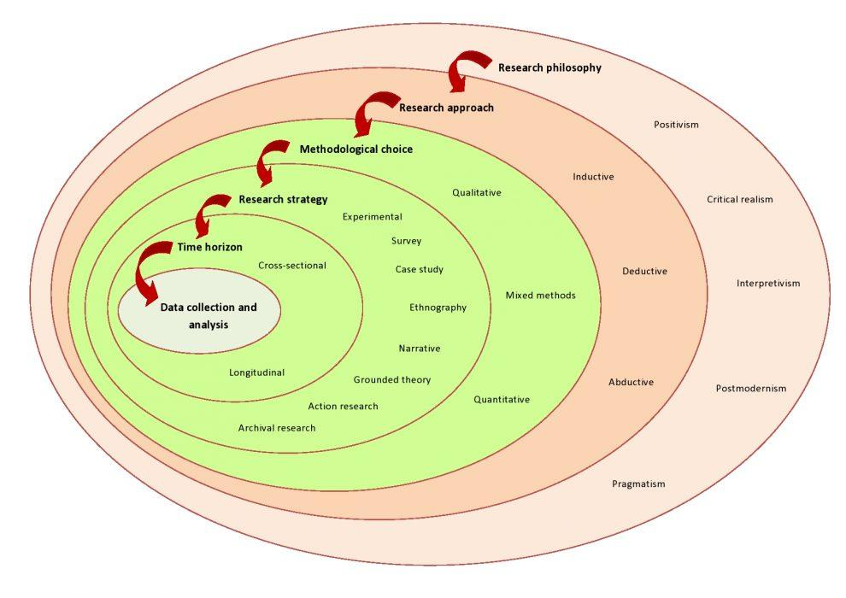

The researcher has chosen to complete a questionnaire as these are faster to complete in comparison to an individual interview of the participants and it will also allow for there to be a larger amount of completed surveys as the participants will be able to complete these anonymously, privately and in their own time which will be more respectful given the nature of the questions being asked being so personal. This will also allow for the participants to note their answers without having to discuss them, which they may not feel comfortable doing. The link for the survey will be sent via email to the selected 100 participants from a range of roles, with the intent of broadening the results to a range of frontline departments in policing.
The aim was initially to complete the questionnaire with the intent of requesting 100 participants and the expectation of receiving 40% of responses, however, due to limitations by the survey website’s free survey, the researcher was only able to collect 25 responses and due to a lack of funding, was unable to collect further results without further spending to gain premium access and collect an unlimited number of responses. As such, only 25% of the original participants who were requested to complete the survey will be necessary in order to ascertain the maximum number of responses. This will have implications on the outcome of the results as there will be a minimum 15% of results which were initially required, that will not be able to be accounted for meaning the sample size may be compromised.
Cited by Baker, Edwards and Doidge (2012) Adler and Adler note that the ideal number of participants in a graduate level suggest a sample of between 12 and 60 participants, with 30 being the mean. Thus meaning that although there is a lower sample than the researcher anticipated, there is still a adequate sample size to obtain the necessary results and outcome required to ensure a fair analysis of the results.

3.3 Data Collection

The responses to the questionnaire have been broken down into ten individual categories in order to analyse and collate information from each individual answer which can then be assessed individually or by looking at a correlation between answers and whether this links to previous research conducted.
The survey will ask for participants to state their age, specific frontline role and length of time in service to see whether this has an impact on their mental health disclosures and what they believe to be the causes behind this. They will then be asked to specify if they have ever suffered with their mental health and whether this has impacted their ability to carry out their role. The participants will then be asked what specific mental health problem they perceived to have suffered with. The participants will have an open comment box to select from, meaning they can answer with anything they wish to, rather than narrowing down the list which could cause some issues in accurately recording the issues.
For those who state they have a mental health problem, they will be asked to select what caused them to suffer from this problem from options of personal issues not relating to work, a specific traumatic event or incident, the typical role of a police officer, other, and not applicable if there is no identified mental health concern from the participant.
The participants will then be asked if this has impacted their ability to perform their role and will be able to answer yes, no or not applicable and the next question will ask how it impacted their role. Again, this will be an open-ended answer to allow for a broad range of answers to be selected from. Finally, the participants will be asked if they have ever experienced an isolated traumatic incident in work and whether they feel they have a healthy work life balance.

3.4 Limitations and problems
When conducting a quantitative analysis where participants volunteer information, there is a risk that this is more than likely going to be completed by those who are willing to discuss the topic, in this case being mental health. As there is already a known stigma around mental health, there is a possibility that those who either dismiss or do not recognise whether they suffer with a mental health condition.
This type of questionnaire relies on participants to self-diagnose their own mental health issues, meaning this could be misguided or possibly incorrectly labelled by themselves. Meaning the results may be slightly inaccurate based on the individuals deeper mental health problems.
The survey will not be sent to any frontline officers who are currently on absent leave due to work related illness, which is likely linked to mental health.

4. Chapter Four: Analysis of results

4.1 Introduction
For this chapter, it is the researchers intention to examine the effect mental health has on frontline police officers when carrying out their duties and also what causes these issues. From the literature review conducted earlier in this paper, it was highlighted that officers can be affected by trauma which may have lasting effects on the officers health, cognitive function and performance. The analysis survey will look to find any correlation between previous research and the results given by the participants in this research. The main objective within this chapter is to analyse and discuss the survey results and discuss the findings of this.

4.2 Data Analysis
Data analysis is the process of looking through information which has been collected in the research in order to look and find any patterns as to the causes of mental health in front line policing and the effects of mental health on those same frontline officers. The survey data was collected through an online website called SurveyMonkey.

4.3 Advantages of Survey Monkey
The advantage of using a website such as Survey Monkey to gather data is that when the survey was created, the researcher was able to send a link to all the selected participant sample group which would take the participant directly to the survey, with no need for any personal data to be required or stored. This meant that the participants were confident from their first interaction, that they were to remain anonymous when completing the survey. This gave the participants the freedom to answer the questions freely with the knowledge that they would be able to remain anonymous and there would be no collateral impact following the completion of the survey. An example of the collateral impact would be a breach of Data Protection where their results and disclosures of mental health may become public knowledge.

4.4 Disadvantages of Survey Monkey
As discussed previously, Survey Monkey had changed their policy to only allow there to be 25 responses on a basic plan without the need to upgrade. The researcher was anticipating receiving 40 participants to be able to be selected however this was not possible to achieve, meaning the sample size was decreased dramatically.

4.5 Statistics of Frontline officers with mental health issues.
Participants of the survey were asked ten questions about their mental health and other related questions to establish if there were any patterns or correlation in answers they gave and whether police officers have mental health and whether this impacted their ability to carry out their role. The survey started with three basic questions about each participant. First their age, then their length of service, and finally their role within frontline policing.
25 police officers completed the survey. Out of those 25 officers, 5 were aged 18-24, which is 20%, 11 were aged between 25 and 34 which is 44%, 7 were aged between 35 and 44 which is 28%, 2 were aged between 45 and 54 which is 8% .No participants stated their age was 55 or over. The majority of participants answered that their length of service was 4-7 years. Both categories of 0-3 years’ service and 8-10 years’ service had 6 answers, so an even split of 24% each. 3 participants stated they had 10 or more years’ experience so a final percentage of 12%.
Participants were then asked to specify their role in frontline policing. The majority of participants answered that their role was Response, with 13 officers stating this, totalling 52%. A further 7 officers stated they worked for either Neighbourhood or Neighbourhood enforcement teams which amounted to 28%. Finally, 5 officers stated they worked as ither a Firearms Unit a Traffic officer or Dog handler which rounds up the final 20%. No officers stated they had other frontline roles.
Participants were then asked whether they had ever suffered with mental health problems. The vast majority, 22 participants, answered yes which amounts to 88% of the total amount of response, while only 3 participants, 12%, said no. The next question allowed participants to answer openly about their mental health problem when they were asked what the mental health issue was. 8 participants answered PTSD totalling 32% of the overall answers. 4 participants answered with either Stress or Stress and Anxiety. This added 16% of the total responses to each of those answers. 3 participants stated they suffered with anxiety, totalling 12%. Only 1 participant stated they had depression, meaning 4% have stated they have depression. 4 participants claimed they had a combination of stress and anxiety, which amounts to 16% of the total and finally 1 participant stated they had depression and Anxiety amounting to 4%. 4 participants responded N/A indicating that this question was not applicable. This amounts to the final 16% of the responses for this question.
Participants were then asked about what caused their mental health. Of the 25 participants, 11 stated the cause behind their mental health was linked to experiencing a traumatic incident in work which was the majority answer of 44%. The next highest answer was that 8 participants felt that dealing with the standard role of a police officer caused their mental health issues and this was 32% of the answers. 4 participants stated that personal issues not related to work were the causes for their mental health which is 16% of the answers. Finally, 2 participants answered that this question was not applicable. So, 8% of participants felt they did not have mental health issues.
The final question on the survey asked whether officers had been exposed to a single traumatic incident whilst at work. Nearly all, 24 participants said they had been exposed. This amounts to 96% of the total answers. Only 1 individual stated they had not been exposed to an incident of this type, amounting to only 4% of the answers.

4.6 Ability to carry out role of a police officer
The next question focussed on if the mental health issues the participants listed had an impact on their ability to carry out their roles. Out of the 25 participants, 19 answered yes indicating a vast majority of 76% of responses. 4 participants said that this did not impact their ability to carry out the role, so 16% of the responses. And finally, 2 participants equalling 8% of the responses said this was not applicable.
For those who answered yes to the previous question, the next question asked how your role was impacted. 11 participants stated that they found it harder to focus on work, so 44% of responses came from this answer. 4 participants said they were absent from work due to their mental health equalling 16% of the responses. Another 4 participants said that they felt added pressure, for a further 16% and 1 participant said that they had flashbacks, indicating PTSD which accounted for only 4% of the responses. 5 participants put Not Applicable totalling 20% of the results.
The next question asked whether the participants felt they had a healthy work life balance. The overwhelming majority, 21 participants said no, a total of 84%. While only 4 participants equalling 16% of the responses said they do have a healthy work life balance.

5. Chapter 5: Findings and Conclusion

5.1 Introduction
This research project started with an introduction which explained what the project was intending to discuss and set out the objectives of the project. The next part of the research project was focused on a literature review which demonstrates the knowledge and understanding of previous research projects and discussions surrounding the targeted area which had been chosen by the researcher to discuss also. The next section of the project looked at the research methodology. In this section, the research strategy was explained. This explained how the researcher was going to conduct the research and this was through the use of a questionnaire hosted on a online website called Survey Monkey. A weblink was sent to the sample group of participants who were then able to directly access the survey which was completed online. This section also looked at the limitations surrounding the research. Following on from the research methodology. Following this chapter, the next section looked to analyse the results of the survey after all the necessary participants had completed their answers. Within this section, the researcher has displayed the results obtained and discussed the advantages and disadvantage of this chosen method. It discussed to mental health issues that the front-line police officers had and what caused these issues.

5.2 Objective’s achievements
The purpose behind this research project was to discuss and explore the chosen research objects which were the following:
- Analyse the effect mental health has had on frontline police officers when carrying out their duties.
- Evaluate the causes behind mental health in frontline police officers.
- Discuss what changes have been made to assist the police in dealing with vulnerable people who have mental health issues.

These objectives were met by the use of quantitative research through the use of the survey and the subsequent analysis of the information and identifying if any of the findings correlated with the information located in the literature review.

5.3 Findings

Analyse the effect mental health has had on frontline police officers when carrying out their duties.
This was the main objective of the research project and looked to identify and explore the impact that mental health has on frontline police officers during their duties. This was found by using the survey results of the 25 participants and more specifically, 76% of the respondents stated that the mental health issues they had impacted their role. Of the respondents who answered yes, 44% of these answered the following question about what stopped them carrying out their role by saying that they found it harder to focus on their work. A further 16% said that they were absent from work due to their mental health showing a clear impact as they were unable to work and carry out their duties.
Participants were also asked whether they had been exposed to a single traumatic incident at work. The overwhelming majority of 96% of respondents answered that they had been exposed to this type of incident.

Evaluate the causes behind mental health in frontline police officers.
Of the 25 participants, the leading response to what caused their mental health was a total of 44% who answered this question and stated they were exposed to a traumatic incident whilst in work. This made up the most selected answer. A further 32% of the participants answered that the standard role of a police officer was the cause of their mental health. The next highest response added from participants was that they had personal issue snot related to work and this contributed to 16% of the answers. 8% of the participants answered that this question was not applicable as they did not feel that they had mental health issues.

Discuss what changes have been made to assist the police in dealing with vulnerable people who have mental health issues.

The researcher was limited by the number of questions were available to ask on the survey and the decision was made to focus mainly on what affected the mental health of police officers and what caused officers to have mental health issues. As such, this aspect of the research has fallen short and has not been able to have been properly assessed and discussed in an effective manner for it to be discussed and used to compare to previous literature. This has been recognised as a miscalculation by the researcher and would look to be rectified given the second chance in order to do so.

6. Chapter 6: Recommendations

Following from this research project there are a number of recommendations which could be made in order to form a more well-rounded and informative response to the objectives Firstly, the survey could have been expanded to more than just 10 questions. With the lack of further questioning it was not possible for the researcher to ask all the questions necessary to allow an informative answer to be discussed and analysed. This meant that there have been blatant flaws in the research which would need to be addressed at a later date if the researcher was to re-visit this topic.
The researcher has also recognised the order of the questions asked were slightly incorrect and could have been ordered better to allow for a better presented survey. The final question regarding whether participants had experienced a single traumatic incident. This could have been placed earlier in the survey which would have allowed participants to have a better experience while completing the survey.

6.1 Partnership working

Another recommendation for further research could be a question relating to whether the participants sought support for their mental health. This could be used to ascertain whether the mental health of the participants was being effectively treated or whether there was a lack of support either being sought or offered for mental health support. If this was questioned, the results could be used to feed back to the respective force, in this case Gwent Police, in order to allow better evidence to support officers. Police forces across England and Wales already have confidential support systems in place, however it is not known whether they are being used effectively and it could be the case that officers are unaware of how to seek support or what support is available.

6.2 Self-reflection
During the course of this research project, an overwhelming issue for the researcher has been time management. The researcher has been working full time in a separate role not related to research and therefore the research has had to have been conducted mainly in the researchers own time, with some allowance given from their full-time role in order to complete the research project. Alongside this, the project has given the researcher a better understanding and knowledge surrounding the topic of mental health in police officers, which could be used in the researcher’s role going forward.
This was the researchers first attempt at conducted self-led research. As such, the researcher also understands the limitations and how to conduct research in a professional format.
As mentioned above, there are gaps in the research which could have been explored further and investigated in order to achieve better results and have a better knowledge of the impact that mental health has on frontline officers and the consequences this may have on the public.
The researcher also has to take into account their own limitations when dealing with a project of this magnitude. The researcher has diagnosed dyslexia and this has put restrictions in how the researcher has been able to fully conduct his research and how to manage their time in order to account for their own neurodivergence. The researcher has had to seek support from outside sources in order to assist in managing with this, however it has not impacted it to the extent that the researcher has been unable to complete the required elements. The researcher still holds themselves to the same expected standard as others in this case and does not see their own learning needs as a barrier, but merely a aspect to take into account along the research strategy.

7. Bibliography

Baker, SE, Edwards, R & Doidge, M 2012 'How many qualitative interviews is enough?: expert voices and early career reflections on sampling and cases in qualitative research' National Centre for Research Methods, Southampton, National Centre for Research Methods, Southampton, UK.
Bhugra, D., Till, A. and Sartorius, N. 2013 ‘What is mental health?’, International Journal of Social Psychiatry, 59(1), pp. 3–4. doi:10.1177/0020764012463315.
Edwards, AM., Kotera, Y. 2021. Mental Health in the UK Police Force: a Qualitative Investigation into the Stigma with Mental Illness. Int J Ment Health Addiction 19, 1116–1134 https://doi.org/10.1007/s11469-019-00214-x
Elliott-Davies, M. (2020). Demand Capacity & Welfare Survey Headline Report, R095. Police Federation of England and Wales. https://www.polfed.org/media/16557/dcw_prrb-report-13-01-2021-v20.pdf
Foley, J., & Massey, K. L. D. (2021). The ‘cost’ of caring in policing: From burnout to PTSD in police officers in England and Wales. The Police Journal, 94(3), 298-315. https://doi.org/10.1177/0032258X20917442
Foley, J., Jones, F., Hassett, A., & Williams, E. (2023). ‘Holding onto trauma?’ The prevalence and predictors of PTSD, anxiety and depression in police officers working with child abuse, rape and sexual exploitation victims. The Police Journal, 0(0). https://doi-org.ezproxy.uwtsd.ac.uk/10.1177/0032258X231183638
Halle, C. et al. (2020) The link between Mental Health, crime and violence, New Ideas in Psychology. Available at: https://www.sciencedirect.com/science/article/abs/pii/S0732118X18302551 (Accessed: 22 February 2024).
Home Office (2023) Police Workforce, England and Wales: 31 March 2023, GOV.UK. Available at: https://www.gov.uk/government/statistics/police-workforce-england-and-wales-31-march-2023/police-workforce-england-and-wales-31-march-2023#officer-wellbeing (Accessed: 15 November 2023).
Mental Health Foundation (2021) Stress, Mental Health Foundation. Available at: https://www.mentalhealth.org.uk/explore-mental-health/a-z-topics/stress (Accessed: 13 March 2024).
Miller, J., Brewin, C., Soffia, M., Elliott-Davies, M., Burchell, B., & Peart, A. (2022). The development of a UK police traumatic events checklist. The Police Journal, 95(1), 207-223. https://doi.org/10.1177/0032258X211002597
Miller, J.K. (2022) 1: Why the need to be resilient? how it feels to be a police officer in the UK and why, Bristol University Press. Available at: https://bristoluniversitypressdigital.com/configurable/content/book$002f9781447361923$002fch001.xml?t%3Aac=book%24002f9781447361923%24002fch001.xml (Accessed: 25 February 2024).
Mind (2019) Mental health in the emergency services, Mental Health in the Emergency Services. Available at: https://www.mind.org.uk/media-a/4849/2019-survey-police-service-summary.pdf (Accessed: 13 March 2024).
Mind (2021) What is PTSD?, Mind. Available at: https://www.mind.org.uk/information-support/types-of-mental-health-problems/post-traumatic-stress-disorder-ptsd-and-complex-ptsd/about-ptsd/ (Accessed: 20 February 2024).
Mind (2023) Depression, Mind. Available at: https://www.mind.org.uk/information-support/types-of-mental-health-problems/depression/about-depression/ (Accessed: 08 January 2024).
Morgan, R.D., Scanlon, F. and Van Horn, S.A. (2020) ‘Criminogenic risk and mental health: a complicated relationship’, CNS Spectrums, 25(2), pp. 237–244. doi:10.1017/S109285291900141X.
NHS (2023) Anxiety - Every Mind Matters, NHS wellbeing. Available at: https://www.nhs.uk/every-mind-matters/mental-health-issues/anxiety/#what-is-anxiety (Accessed: 01 March 2024).
Stevelink, S.A.M. et al. (2020) ‘Probable PTSD, depression and anxiety in 40,299 UK police officers and staff: Prevalence, risk factors and associations

Syed, S. et al. (2020) Global prevalence and risk factors for mental health problems in Police Personnel: A systematic review and meta-analysis, Occupational & Environmental Medicine. Available at: https://oem.bmj.com/content/77/11/737.abstract (Accessed: 04 February 2024).
University of Cumbria (2023) Types of Literature review, Literature Review | MyCumbria. Available at: https://my.cumbria.ac.uk/Student-Life/Learning/Skills-Cumbria/Dissertations/Literature-Review/ (Accessed: 15 November 2023).

8. Appendices

8.1 Appendix One: Questionnaire







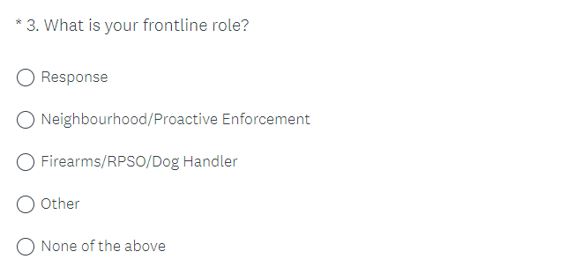

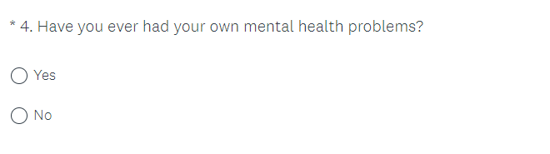

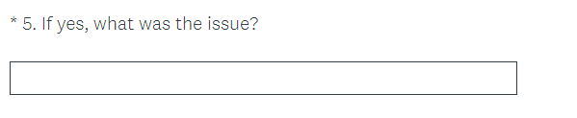

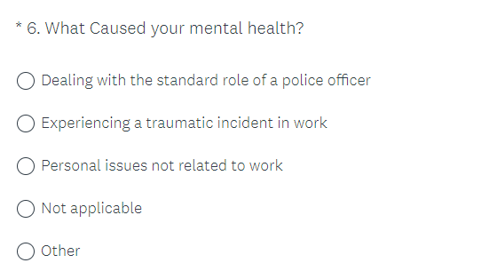

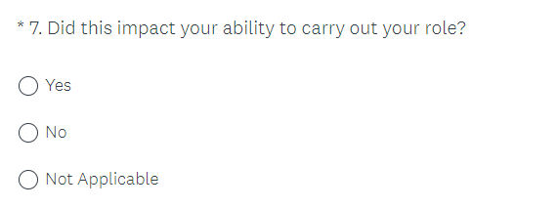

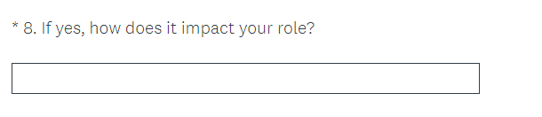

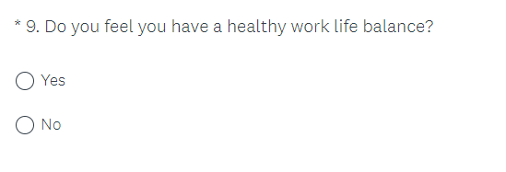

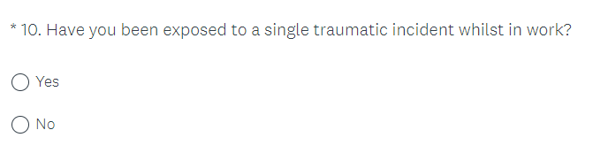

8.2 Appendix Two: Questionnaire Results

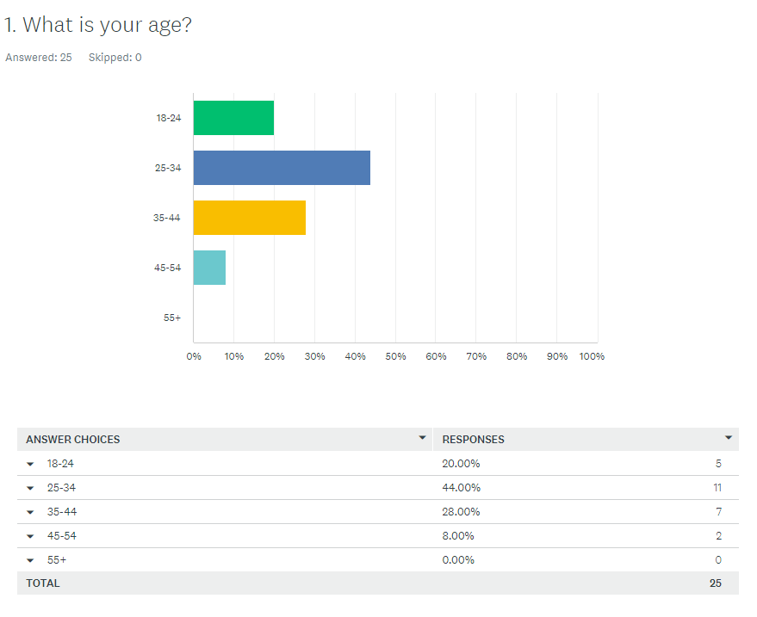

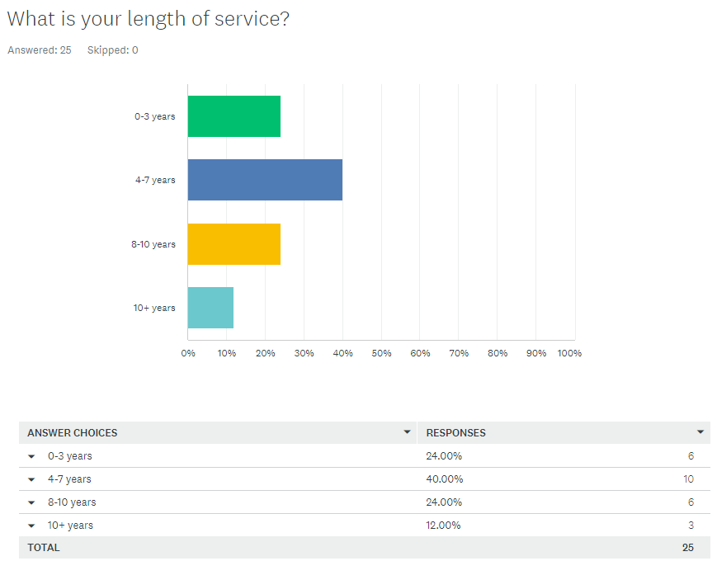

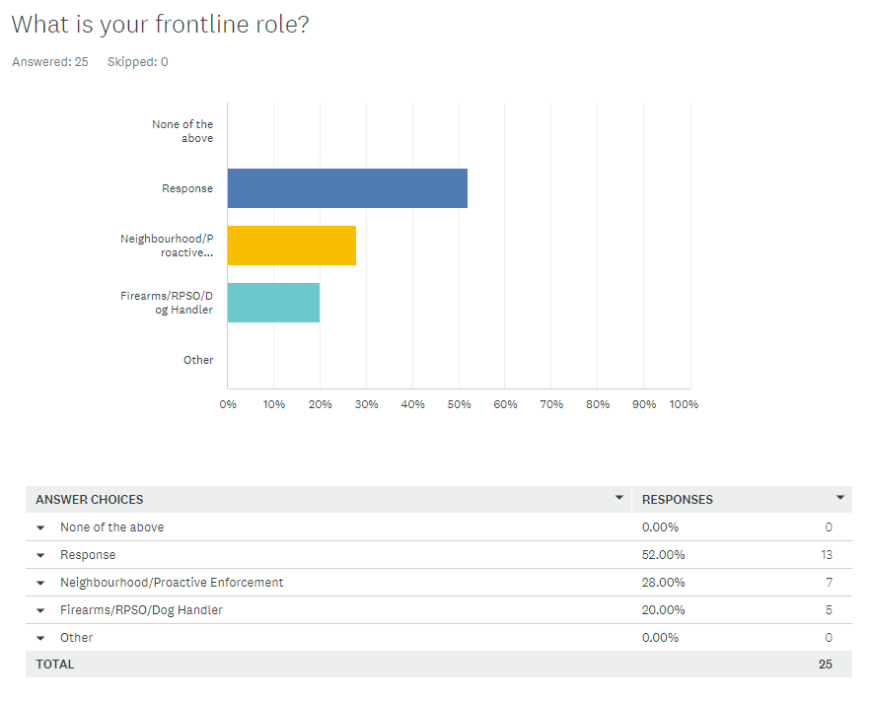

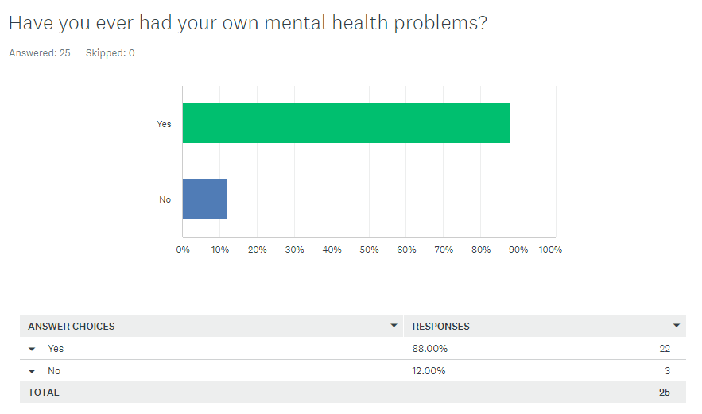
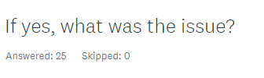
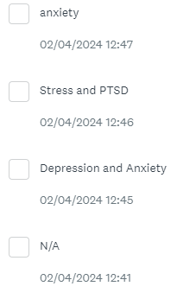
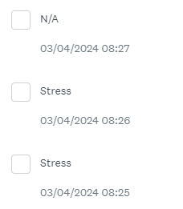
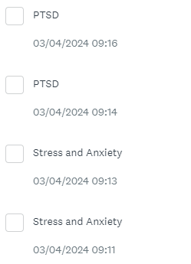



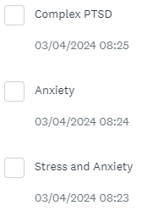

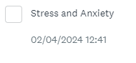

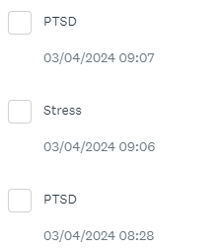

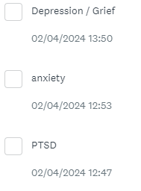

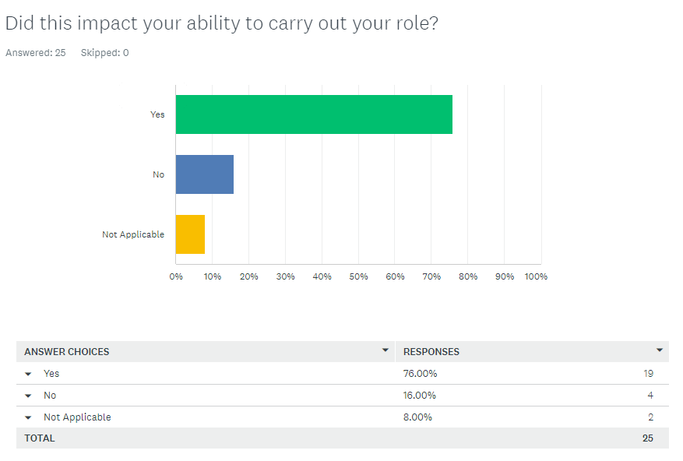
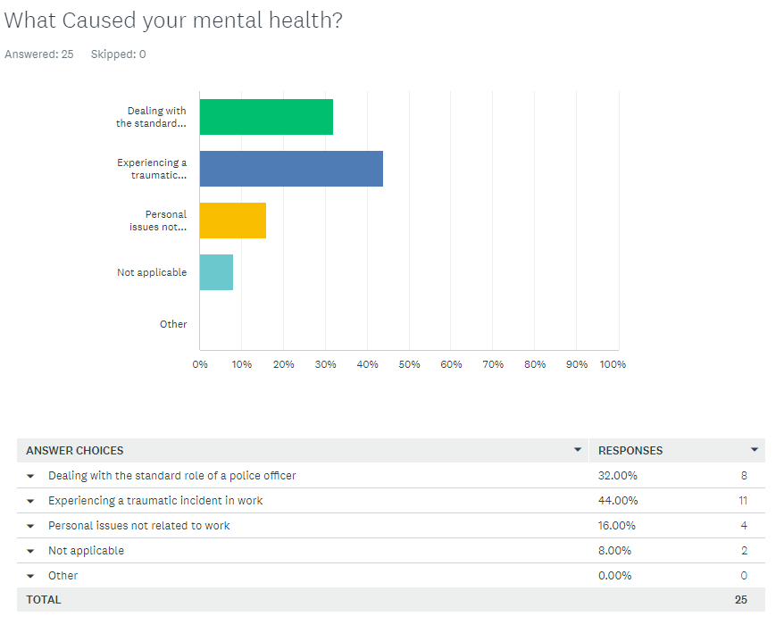


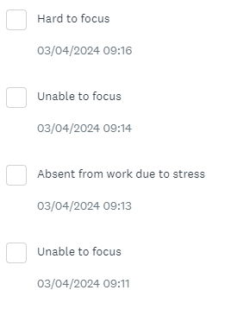

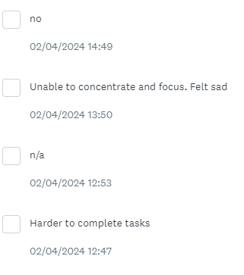
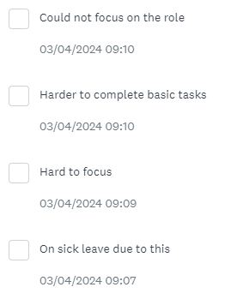

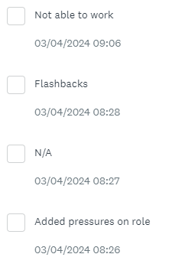
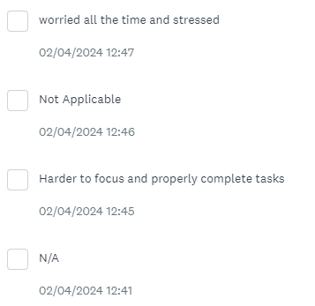



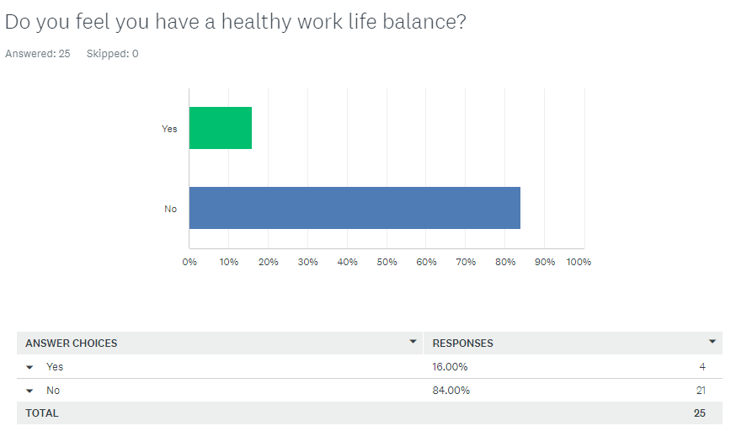
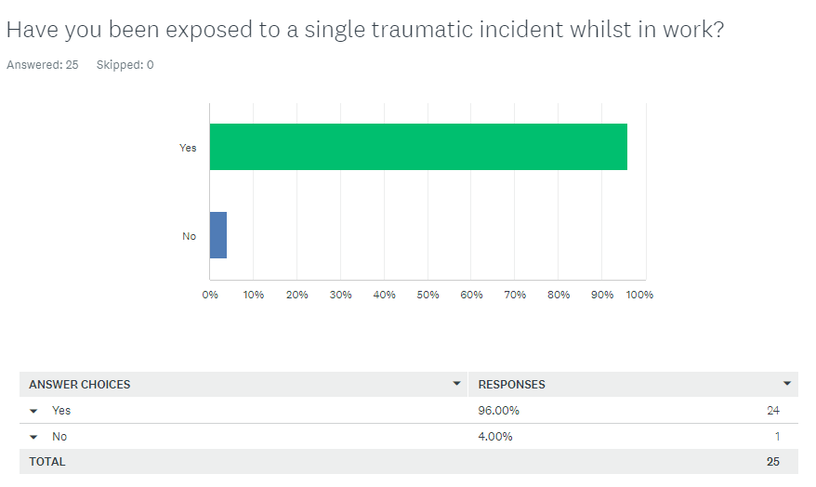

8.3 Appendix Three: Ethics form

1 | Full Name: |  | Daniel Joseph Graham
2 | Tick all boxes that apply: |  | Member of staff: | ☐ | Honorary research fellow: | ☐
 | Undergraduate Student | ☒ | Taught Postgraduate Student | ☐ | Postgraduate Research Student | ☐
SECTION A: About You (Principal Researcher)
3 | Institute/Academic Discipline/Centre: | Blue Light Academy
4 | Campus:
5 | E-mail address: | 2031308@student.uwtsd.ac.uk
6 | Contact Telephone Number: | 07713806390
 | For students:
7 | Student Number: | 2031308
8 | Programme of Study: | Professional Police Practice
9 | Director of Studies/Supervisor: | Rhiannon Sandy

SECTION B: Approval for Research Activity
1 | Has the research activity received approval in principle?  (please check the Guidance Notes as to the appropriate approval process for different levels of research by different categories of individual) |  | YES | ☐ | NO | ☒
 |  |  |  |  | Date
2 | If Yes, please indicate source of approval (and date where known): Approval in principle must be obtained from the relevant source prior to seeking ethical approval | Research Degrees Committee |  | ☐
2 |  | Institute Research Committee |  | ☐
2 |  | Other (write in) |  | ☐

SECTION C: Internal and External Ethical Guidance Materials
 | Please list the core ethical guidance documents that have been referred to during the completion of this form (including any discipline-specific codes of research ethics, location-specific codes of research ethics, and also any specific ethical guidance relating to the proposed methodology). Please tick to confirm that your research proposal adheres to these codes and guidelines. You may add rows to this table if needed.
1 | UWTSD Research Ethics & Integrity Code of Practice | ☒
2 | UWTSD Research Data Management Policy | ☒
3 | [List any other relevant documents here] | ☐

SECTION D: External Collaborative Research Activity
If there are external collaborators then you should gain consent from the contact persons to share their personal data with the university. If there are no external collaborators then leave this section blank and continue to section E.
1 | Institution
2 | Contact person name
3 | Contact person e-mail address
4 | Is your research externally funded? |  | YES | ☐ | NO |  | ☐
5 | Are you in receipt of a KESS scholarship? |  | YES | ☐ | NO |  | ☐
6 | Are you specifically employed to undertake this research in either a paid or voluntary capacity? | Voluntary | YES | ☐ | NO | ☐
7 |  | Employed | YES | ☐ | NO | ☐
8 | Is the research being undertaken within an existing UWTSD Athrofa Professional Learning Partnership (APLP)? | If YES then the permission question below does not need to be answered. | YES | ☐ | NO |  | ☐
9 | Has permission to undertake the research has been provided by the partner organisation? | (If YES attach copy)  If NO the application cannot continue | YES | ☐ | NO |  | ☐

Where research activity is carried out in collaboration with an external organisation
10 | Does this organisation have its own ethics approval system? | YES | ☐ | NO | ☐
 | If Yes, please attach a copy of any final approval (or interim approval) from the organisation (this may be a copy of an email if appropriate).

SECTION E: Details of Research Activity
1 | Indicative title: | Mental Health in Frontline Policing: A critical evaluation into the effects of mental health on the Police and the Public.
2 | Proposed start date: | 04/07/2023 | Proposed end date: | 08/04/2023
Introduction to the Research (maximum 300 words per section)
Ensure that you write for a Non-Specialist Audience when outlining your response to the points below:
- Purpose of Research Activity
- Proposed Research Question
- Aims of Research Activity
- Objectives of Research Activity
Demonstrate, briefly, how Existing Research has informed the proposed activity and explain
- What the research activity will add to the body of knowledge
- How it addresses an area of importance.
3 | Purpose of Research Activity  The purpose of my research is to establish and evaluate what, if any, links there are between mental health and police officers also, how this link may impact members of the public.  (this box should expand as you type)
4 | Research Question  Mental Health in Frontline Policing: A critical evaluation into the effects of mental health on the Police and the Public.  (this box should expand as you type)
5 | Aims of Research Activity  To evaluate the current understanding around mental health in policing and how that impacts both police officers and the general public.  The research will look at evidence to support or oppose this claim and I will look to analyse both sides with an unbiased viewpoint.  (this box should expand as you type)
6 | Objectives of Research Activity  To evaluate the current understanding around mental health in policing and how that impacts both police officers and the general public.  The research will look at evidence to support or oppose this claim and I will look to analyse both sides with an unbiased viewpoint.  (this box should expand as you type)
Proposed methods (maximum 600 words)
Provide a brief summary of all the methods that may be used in the research activity, making it clear what specific techniques may be used. If methods other than those listed in this section are deemed appropriate later, additional ethical approval for those methods will be needed. You do not need to justify the methods here, but should instead describe how you intend to collect the data necessary for you to complete your project.
7 | My research will look at using surveys which will be completed by a range of frontline police officers, meaning those officers whose roles are directly correlated to dealing with members of the public. The surveys will be conducted in the officers own time, and will look to encompass all areas of my research and give me the information necessary to evaluate the response, to my hypothesis and other findings in other sources of research.  (this box should expand as you type)
Location of research activity
Identify all locations where research activity will take place.
8 | Gwent  (this box should expand as you type)
Research activity outside of the UK
If research activity will take place overseas, you are responsible for ensuring that local ethical considerations are complied with and that the relevant permissions are sought. Specify any local guidelines (e.g. from local professional associations/learned societies/universities) that exist and whether these involve any ethical stipulations beyond those usual in the UK (provide details of any licenses or permissions required). Also specify whether there are any specific ethical issues raised by the local context in which the research activity is taking place, for example, particular cultural and/or legal sensitivities or vulnerabilities of participants. If you live in the country where you will do the research then please state this.
9 | N/A  (this box should expand as you type)
10 | Use of documentation not in the public domain: Are any documents NOT publicly available? | NO | ☒
10 |  | YES | ☐
11 | If Yes, please provide details here of how you will gain access to specific documentation that is not in the public domain and that this is in accordance with the current data protection law of the country in question and that of England and Wales.  (this box should expand as you type)

 | Does your research relate to one or more of the seven aims of the Well-being of Future Generations (Wales) Act 2015? | YES | NO
12 | A prosperous Wales | ☐ | ☒
13 | A resilient Wales | ☐ | ☒
14 | A healthier Wales | ☐ | ☒
15 | A more equal Wales | ☐ | ☒
16 | A Wales of cohesive communities | ☐ | ☒
17 | A Wales of vibrant culture and thriving Welsh language | ☐ | ☒
18 | A globally responsible Wales | ☐ | ☒
19 | If YES to any of the above, please give details:
 | (this box should expand as you type)

SECTION F: Scope of Research Activity
 | Will the research activity include: | YES | NO
1 | Use of a questionnaire or similar research instrument? | ☒ | ☐
2 | Use of interviews? | ☐ | ☒
3 | Use of focus groups? | ☐ | ☒
4 | Use of participant diaries? | ☐ | ☒
5 | Use of video or audio recording? | ☐ | ☒
6 | Use of computer-generated log files? | ☐ | ☒
7 | Participant observation with their knowledge? | ☐ | ☒
8 | Participant observation without their knowledge? | ☐ | ☒
9 | Access to personal or confidential information without the participants’ specific consent? | ☐ | ☒
10 | Administration of any questions, test stimuli, presentation that may be experienced as physically, mentally or emotionally harmful / offensive? | ☐ | ☒
11 | Performance of any acts which may cause embarrassment or affect self-esteem? | ☐ | ☒
12 | Investigation of participants involved in illegal activities? | ☐ | ☒
13 | Use of procedures that involve deception? | ☐ | ☒
14 | Administration of any substance, agent or placebo? | ☐ | ☒
15 | Working with live vertebrate animals? | ☐ | ☒
16 | Procedures that may have a negative impact on the environment? | ☐ | ☒
17 | Other primary data collection methods. Please indicate the type of data collection method(s) below. | ☐ | ☒
 | Details of any other primary data collection method:  (this box should expand as you type) | ☐ | ☒

SECTION G: Intended Participants
If there are no participants then do not complete this section, but go directly to section H.
 | Who are the intended participants: | YES | NO
1 | Students or staff at the University? | ☐ | ☒
2 | Adults (over the age of 18 and competent to give consent)? | ☒ | ☐
3 | Vulnerable adults? | ☐ | ☒
4 | Children and Young People under the age of 18? (Consent from Parent, Carer or Guardian will be required) | ☐ | ☒
5 | Prisoners? | ☐ | ☒
6 | Young offenders? | ☐ | ☒
7 | Those who could be considered to have a particularly dependent relationship with the investigator or a gatekeeper? | ☐ | ☒
8 | People engaged in illegal activities? | ☐ | ☒
9 | Others. Please indicate the participants below, and specifically any group who may be unable to give consent. | ☒ | ☒
 | Details of any other participant groups:  (this box should expand as you type) | ☒ | ☒

Participant numbers and source
Provide an estimate of the expected number of participants. How will you identify participants and how will they be recruited?
How many participants are expected? | 25 to 50  (this box should expand as you type)
Who will the participants be? | Serving frontline Gwent Police officers  (this box should expand as you type)
How will you identify the participants? | Email sent to random officers with no identification from themselves when completing the survey  (this box should expand as you type)

 | Information for participants: | YES | NO | N/A
13 | Will you describe the main research procedures to participants in advance, so that they are informed about what to expect? | ☒ | ☐ | ☐
14 | Will you tell participants that their participation is voluntary? | ☒ | ☐ | ☐
15 | Will you obtain written consent for participation? | ☒ | ☐ | ☐
16 | Will you explain to participants that refusal to participate in the research will not affect their treatment or education (if relevant)? | ☐ | ☐ | ☒
17 | If the research is observational, will you ask participants for their consent to being observed? | ☐ | ☐ | ☒
18 | Will you tell participants that they may withdraw from the research at any time and for any reason? | ☒ | ☐ | ☐
19 | With questionnaires, will you give participants the option of omitting questions they do not want to answer? | ☒ | ☐ | ☐
20 | Will you tell participants that their data will be treated with full confidentiality and that, if published, it will not be identifiable as theirs? | ☒ | ☐ | ☐
21 | Will you debrief participants at the end of their participation, in a way appropriate to the type of research undertaken? | ☒ | ☐ | ☐
22 | If NO to any of above questions, please give an explanation
 | (this box should expand as you type)

 | Information for participants: | YES | NO | N/A
24 | Will participants be paid? | ☐ | ☒ | ☐
25 | Is specialist electrical or other equipment to be used with participants? | ☐ | ☒ | ☐
26 | Are there any financial or other interests to the investigator or University arising from this study? | ☐ | ☒ | ☐
27 | Will the research activity involve deliberately misleading participants in any way, or the partial or full concealment of the specific study aims? | ☐ | ☒ | ☐
28 | If YES to any question, please provide full details
 | (this box should expand as you type)

SECTION H: Anticipated Risks

Outline any anticipated risks that may adversely affect any of the participants, the researchers and/or the University, and the steps that will be taken to address them.

If you have completed a full risk assessment (for example as required by a laboratory, or external research collaborator) you may append that to this form.
1 | Full risk assessment completed and appended? |  | Yes | ☐
1 |  |  | No | ☐
2 | Risks to participants  For example: sector-specific health & safety, emotional distress, financial disclosure, physical harm, transfer of personal data, sensitive organisational information
 | Risk to participants:  - Emotional triggers based on past experiences  (this box should expand as you type) | How you will mitigate the risk to participants:  - As mentioned, there will be information to signpost the participants to the relevant mental health treatment/support if they deem this necessary for themselves.. I will also ensure that the survey is noted as voluntary and those completing it can withdraw at any time.  (this box should expand as you type)
3 | If research activity may include sensitive, embarrassing or upsetting topics (e.g. sexual activity, drug use) or issues likely to disclose information requiring further action (e.g. criminal activity), give details of the procedures to deal with these issues, including any support/advice (e.g. helpline numbers) to be offered to participants. Note that where applicable, consent procedures should make it clear that if something potentially or actually illegal is discovered in the course of a project, it may need to be disclosed to the proper authorities
N/A

(this box should expand as you type)
4 | Risks to the investigator  For example: personal health & safety, physical harm, emotional distress, risk of accusation of harm/impropriety, conflict of interest
 | Risk to the investigator:  None  (this box should expand as you type) | How you will mitigate the risk to the investigator:  (this box should expand as you type)
5 | University/institutional risks  For example: adverse publicity, financial loss, data protection
 | Risk to the University:  None  (this box should expand as you type) | How you will mitigate the risk to the University:  (this box should expand as you type)
6 | Environmental risks  For example: accidental spillage of pollutants, damage to local ecosystems
 | Risk to the environment:  This is not applicable to my research.  (this box should expand as you type) | How you will mitigate the risk to environment:  (this box should expand as you type)

 | Disclosure and Barring Service
 | If the research activity involves children or vulnerable adults, a Disclosure and Barring Service (DBS) certificate must be obtained before any contact with such participants. | YES | NO | N/A
7 | Does your research require you to hold a current DBS Certificate? | ☐ | ☒ | ☐
8 | If YES, please give the certificate number. If the certificate number is not available please write “Pending”; in this case any ethical approval will be subject to providing the appropriate certificate number.

SECTION I: Feedback, Consent and Confidentiality
1 | Feedback  What de-briefing and feedback will be provided to participants, how will this be done and when?
Not required

(this box should expand as you type)
2 | Informed consent  Describe the arrangements to inform potential participants, before providing consent, of what is involved in participating. Describe the arrangements for participants to provide full consent before data collection begins. If gaining consent in this way is inappropriate, explain how consent will be obtained and recorded in accordance with prevailing data protection legislation.
Participants are not obliged to complete the survey. Any questions within the survey that they do not feel comfortable answering, can be skipped.

(this box should expand as you type)
3 | Confidentiality / Anonymity  Set out how anonymity of participants and confidentiality will be ensured in any outputs. If anonymity is not being offered, explain why this is the case.
Anonymity is being offered to participants of my survey. There will be no option provide personal data

(this box should expand as you type)

SECTION J: Data Protection and Storage
 | Does the research activity involve personal data (as defined by the General Data Protection Regulation 2016 “GDPR” and the Data Protection Act 2018 “DPA”)? | YES | NO
1 | “Personal data” means any information relating to an identified or identifiable natural person (‘data subject’). An identifiable natural person is one who can be identified, directly or indirectly, in particular by reference to an identifier such as a name, an identification number, location data, an online identifier or to one or more factors specific to the physical, physiological, genetic, mental, economic, cultural or social identity of that natural person. Any video or audio recordings of participants is considered to be personal data. | ☐ | X
 | If YES, provide a description of the data and explain why this data needs to be collected:
2 | (this box should expand as you type)
 | Does it involve special category data (as defined by the GDPR)? | YES | NO
3 | “Special category data” means sensitive personal data consisting of information as to the data subjects’ –  (a) racial or ethnic origin,  (b) political opinions,  (c ) religious beliefs or other beliefs of a similar nature,  (d) membership of a trade union (within the meaning of the Trade Union and Labour Relations (Consolidation) Act 1992),  (e) physical or mental health or condition,  (f) sexual life,  (g) genetics,  (h) biometric data (as used for ID purposes), | ☐ | X
 | If YES, provide a description of the special category data and explain why this data needs to be collected:
4 | (this box should expand as you type)

 | Will data from the research activity (collected data, drafts of the thesis, or materials for publication) be stored in any of the following ways? | YES | NO
5 | Manual files (i.e. in paper form)? | ☐ | ☒
6 | University computers? | ☐ | ☒
7 | Private company computers? | ☐ | ☒
8 | Home or other personal computers? | ☐ | ☒
9 | Laptop computers/ CDs/ Portable disk-drives/ memory sticks? | ☐ | ☒
10 | “Cloud” storage or websites? | ☐ | ☒
11 | Other – specify: | ☐ | ☒
12 | For all stored data, explain the measures in place to ensure the security of the data collected, data confidentiality, including details of backup procedures, password protection, encryption, anonymisation and pseudonymisation:
 | (this box should expand as you type)

 | Data Protection
 | Will the research activity involve any of the following activities: | YES | NO
13 | Electronic transfer of data in any form? | ☐ | ☒
14 | Sharing of data with others at the University outside of the immediate research team? | ☐ | ☒
15 | Sharing of data with other organisations? | ☐ | ☒
16 | Export of data outside the UK or importing of data from outside the UK? | ☐ | ☒
17 | Use of personal addresses, postcodes, faxes, emails or telephone numbers? | ☐ | ☒
18 | Publication of data that might allow identification of individuals? | ☐ | ☒
19 | Use of data management system? | ☐ | ☒
20 | Data archiving? | ☐ | ☒
21 | If YES to any question, please provide full details, explaining how this will be conducted in accordance with the GDPR and Data Protection Act (2018) (and any international equivalents, where appropriate):
N/A

(this box should expand as you type)
22 | List all who will have access to the data generated by the research activity:
 | (this box should expand as you type)
23 | List who will have control of, and act as custodian(s) for, data generated by the research activity:
Myself

(this box should expand as you type)
24 | Give details of data storage arrangements, including security measures in place to protect the data, where data will be stored, how long for, and in what form. Will data be archived – if so how and if not why not.
Data obtained is anonymous and will only be available to view by myself and subsequently presented to UWTSD.

(this box should expand as you type)
25 | Please indicate if your data will be stored in the UWTSD Research Data Repository (see https://researchdata.uwtsd.ac.uk/ ). If so please explain. (Most relevant to academic staff)
 | (this box should expand as you type)
26 | Confirm that you have read the UWTSD guidance on data management (see https://www.uwtsd.ac.uk/library/research-data-management/) | YES | ☒
27 | Confirm that you are aware that you need to keep all data until after your research has completed or the end of your funding | YES | ☒

SECTION K: Declaration
The information which I have provided is correct and complete to the best of my knowledge. I have attempted to identify any risks and issues related to the research activity and acknowledge my obligations and the rights of the participants.

In submitting this application I hereby confirm that I undertake to ensure that the above named research activity will meet the University’s Research Ethics and Integrity Code of Practice which is published on the website: https://www.uwtsd.ac.uk/research/research-ethics/
1 | Signature of applicant: | D.GRAHAM | Date:  17/10/2023
2 | Director of Studies/Supervisor: |  | Date:
3 | Signature:

Checklist: Please complete the checklist below to ensure that you have completed the form according to the guidelines and attached any required documentation
☒ | I have read the guidance notes supplied before completing the form.
☒ | I have completed ALL RELEVANT sections of the form in full.
☐ | I confirm that the research activity has received approval in principle
☐ | I have attached a copy of final/interim approval from external organisation (where appropriate)
☐ | I have attached a full risk assessment (where appropriate) ONLY TICK IF YOU HAVE ATTACHED A FULL RISK ASSESSMENT
☒ | I understand that it is my responsibility to ensure that the above named research activity will meet the University’s Research Ethics and Integrity Code of Practice.
☒ | I understand that before commencing data collection all documents aimed at respondents (including information sheets, consent forms, questionnaires, interview schedules etc.) must be confirmed by the DoS/Supervisor, module tutor or Academic Director.

8.4 Appendix Four: Research Proposal



UNDERGRADUATE DISSERTATION
RESEARCH PROPOSAL FORM

Please complete the following research proposal and submit it to Turnitin.

Which project option are you taking? Please tick:

8,000 word project:

NAME: Daniel Joseph Graham | STUDENT ID No.: 2031308
DRAFT RESEARCH TITLE QUESTION:
Mental Health in Frontline Policing: A critical evaluation into the effects of mental health on the Police and the Public.

INTRODUCTION:
This topic is something which I feel is at the forefront of society currently and is something which has been analysed and evaluated to a point which I consider it to be one of the main topics which affects the vast majority of the population in some facet. Policing and Mental Health is something which is symbiotic in a number of different ways, whether that be police officers dealing with members of the public with a variety of mental health issues or maybe police officers struggling with their mental health personally following on from the challenges of frontline policing in this day and age.
This topic is worthy of consideration for an undergraduate dissertation as there are a number of studies surrounding this topic which can be explored, for example Williams (2023) elaborates on how police officers deal with vulnerable people in society and how critical it is that there is a multi-agency approach to deal with this group of people. Policing can, in some respect be simplified when looking at an individual incident, however when dealing with the bigger picture, it is important that this is thoroughly evaluated, and the best practices are carried out nationally to ensure safeguarding and support for those individuals affected by different vulnerabilities.
There is no specific subject to my research, however I will be looking to use surveys completed by police officers anonymously to answer questions surrounding their experiences as frontline police officers and the impact of mental health on their roles. These police officers will be able to answer honestly and anonymously and have their answers evaluated qualitatively by myself. There will also be a chance to answer some quantitative questions in a separate part of the survey, this will allow me to explore a different aspect of the answers I receive.
I will also be looking at research already conducted and evaluate whether this is in line with information which has been gathered already by the regional police force mental health lead. This will be discussed and included in my dissertation and used to evaluate how the geographical area of Gwent compares to national statistics.

SUMMARY OF RESEARCH OBJECTIVES:

- Analyse the effect mental health has had on frontline police officers when carrying out their duties.
- Evaluate the causes behind mental health in frontline police officers.
- Discuss what changes have been made to assist the police in dealing with vulnerable people who have mental health issues.

LITERATURE REVIEW:

When looking at the literature surrounding this topic. It is interesting to note that a lot of the peer-reviewed published documents including articles, journals and books all tend to generally focus on how police officers deal with members of the public facing mental health issues and illnesses. When researching whether there were any publications directly connected to my proposed research title, I found only one source similar to my title, Mclean and Marshall (2010). Even this does not necessarily focus entirely on the issues the front line police officers have in this country with their own personal mental health.

As such, I feel that my research is important to highlight the issues that are faced by police officers and how this then impacts the police force as a whole.

As part of my research, I will be looking to implement the use of statistics from my local police organisation as well as national statistics provided by the UK government. This will help me compare how my local policing area deals with mental health in their own officers in comparison to the rest of the UK.

SUMMARY OF RESEARCH –SURVEY METHOD:
When it comes to research, I will be looking to implement a well-rounded, unintrusive survey which allows the police officers who are involved to provide honest and informative answers without the need for excessive questioning and probing too far. The intent by making it a simple survey will hopefully allow a more engaged subject and more responsive answers. This will allow me to analyse the results when compared to literature which will have been submitted by other published authors.
I will not be looking to seek specific primary research from specific experts; however, I will be using secondary research from other sources to assist in my findings and my analysis of the topic.

SUMMARY OF SAMPLING FRAMEWORK:

The aim is to get around 40 answers on this questionnaire as the survey website allows a maximum of 40 responses for free before it charges for use.

My target sample is a range of people with different experiences. Both in policing and in the general public. In policing, I will be asking for officers to be involved who have a range of experience of frontline policing, from six months to twenty years. This will give me a range of different viewpoints and examples of different officer experiences and opinions on the matter.
As the involvement of the participants will be anonymous, this rules out most ethical problems and also may reduce the concerns of those officers sharing their experiences with mental health.

ETHICAL ISSUES:

There will not be any ethical issues that may arise during the course of my research due to the lack of personal information that I will be using for this research.

TIME SCALE:
The time scale for obtaining this research will be between 04/07/2023 and 08/04/2024.
.
REFERENCE LIST:
- Mclean, N. and Marshall, L.A. (2010) ‘A front line police perspective of mental health issues and services’, Criminal behaviour and mental health, 20(1), pp. 62–71. Available at: https://doi.org/10.1002/cbm.756.
- Williams, B. (2023) Policing Mental Health, Vulnerability and Risk. First edition. Edited by T. Blockley. St Albans, England: Critical Publishing Ltd.

