Georgina Payne
P135325
Principles of teaching, Learning and Emergent Technologies
Reflection of 30 Minute Micro-Teach

This paper will explore a thirty minute micro-teach and will evaluate my first teaching experience which was focused on using emergent technologies.
Using Johns (2004) model for structured reflection I will answer the questions that are set out to be able to reflect on my performance and how I can improve on them in the future. Using the model for structured reflection there are five main points that will be answered throughout. These are:
- Description of my experience – what were the significant factors?
- Reflection – what was I trying to achieve and what were the consequences?
- Influencing Factors - What things like internal/external/knowledge affected my decision making?
- Could I have dealt with it better – What other choices did I have?
- Learning - What will change because of this experience and how did I feel about the experience? (Skills for Learning, 2018).
I was given the task to plan and deliver a 30 minute micro-teach lesson to my peers, whilst having to follow my own lesson plan. This meant including relevant learning objectives, different teaching and learning strategies, assessment methods and to be able to use a wide range of relevant technologies that are used in modern day teaching environments.
To say that I was nervous to start was an understatement as I am going to be ‘essential skills’ which is mainly Maths and English. Therefore, I had to be able to narrow it down to something more specific as it would not be suitable for my audience to be taught Maths or English. After days of being stressed about what to do and conducting a small amount of research, I finally decided to go with a lesson on ‘Dyslexia’ as it integrates with reading and writing which is my subject focus, but it is also something that all my peers will have come across or are going to come across during their own teaching experiences.
Using background knowledge following my previous degree in ‘Education Studies’ I felt like it would be a great subject to focus on as I considered the fact that I already knew a little bit about the subject itself and it is a subject that I would be able to talk confidently about, which is I feel is one of the most important qualities of teaching.
Lesson planning gives teachers a chance to create lesson objectives, think about activities that they could use to meet those lesson objectives, what materials they may use and plan how they can deliver their lesson in the set time that they are usually given. The teacher is then clear on what needs to be done and because all information is gathered and set out the teacher will become more relaxed and confident with their teaching they will not be wondering what to do next (Kingsley, 2016).
The planning of my micro-teach was to be able to have a structure of what the aim of the lesson is and how it was going to be assessed and that alone. By planning my lesson, I could decide exactly what I was going to do and how long I was going to do it for. At first, I took the lesson planning in the wrong direction in some respects and planned my lesson in regards for what I was going to do, however it should have been what my students were going to do. I feel like from this feedback that I received regarding my lesson planning I can now learn from this mistake and it has put me in the right direction for my next lesson plan.
Although my lesson planning did not go as well as I wanted, I do not feel that it affected the delivery of the lesson. The delivery of the lesson run as smoothly as expected (or hoped!) and the professional standards for Further Education (FE) were aligned as I planned and delivered effective learning, teaching and assessment (7) and throughout the lesson my learners shared responsibility for the learning and assessment (9) by engaging in discussion and communicating with their peers for the activity that was set out.
To meet standard (9) I created an activity where students had to work in groups and discuss ‘ways in which you think Dyslexia is identified’. I created this activity to encourage ‘Flip Learning’. Flip learning is where students have their own responsibility for their learning and discuss their own ideas and opinions which could then be shared and communicated with the rest of the class where usually creates discussion.
Flip learning can provide deeper learning and develops higher-level cognitive skills. It moves students away passive learning and aims towards active learning where students are more engaged with peer learning. The responsibility of the teacher is a now a coach and should now encourage students to take control of their own learning. The use of technology further enhances the procedure of flipped learning and promotes skills that are essential for 21st Century learning (Heacademy, 2017).
The objective of the lesson was ‘to identify what Dyslexia is and how it affects students in education’. Lesson objectives designate the skills or learning that a learner should obtain while contributing in learning. No matter what the age or the level of the learner, it is important that they get given a clear understanding of what is going to happen and what is expected of the learner. Lesson Objectives are a good way to point learners in the right direction into what they need to do to succeed and to be provided a stimulus for the preparation of learning (Ubi, 2014).
I kept the lesson objective to just one objective as given the time frame for the lesson was only thirty minutes I felt like I would not be able to teach much more than one objective in a short space of time. It was realised that was a good idea as the timing of the lesson was respectable finishing at twenty-eight minutes. I decided on the objective to keep the lesson as simple as I could but also to give my audience an insight into what they may come across when dealing with dyslexia in the classroom themselves.
Maybe I could have dealt with the Lesson Objectives my narrowing it down again as it could have been seen as too broad as ‘education’ is a wide subject as there are many different forms of education or different levels, therefore I should have narrowed it down to certain educational setting as when conducting research I found that Dyslexia could be identified in different ways depending on the educational setting or age group of learners. From this I have now learned to keep my objectives to the point as much as I can but on the other hand it created engagement from my peers as it created a discussion about how dyslexia could be identified in different environments.
The structure of the lesson was focused to flow through Bloom’s (1956) Taxonomy as the focus was on the knowledge of Dyslexia. Bloom’s Taxonomy is a classification of the different objectives and skills that teachers et for their students (learning objectives These six levels are used in lessons to be able to structure the learning objectives, lessons, and assessments. The six stages are:

1.Remembering: Retrieving, recognizing, and reminding relevant knowledge from long‐term memory.
2.Understanding: Building meaning from oral, written, and graphic messages through interpreting, demonstrating, classifying, summarizing, inferring, comparing, and explaining.
3.Applying: Carrying out or using a procedure for completing or implementing.
4.Analysing: Breaking material into essential parts, determining how the parts relate to one another and to an overall structure or purpose through differentiating, organizing, and attributing.
5.Evaluating: Creation of judgments based on criteria and standards through checking and critiquing.
6.Creating: Putting foundations together to form a clear or functional whole; changing elements into a new pattern or structure through generating, planning, or producing.
Bloom’s six stages follow a hierarchy, which explains that you must get through the lower levels of learning to be able to reach the higher levels. The taxonomy is more often displayed as a pyramid to get a better understanding of how it works (Jshabatu, 2018).

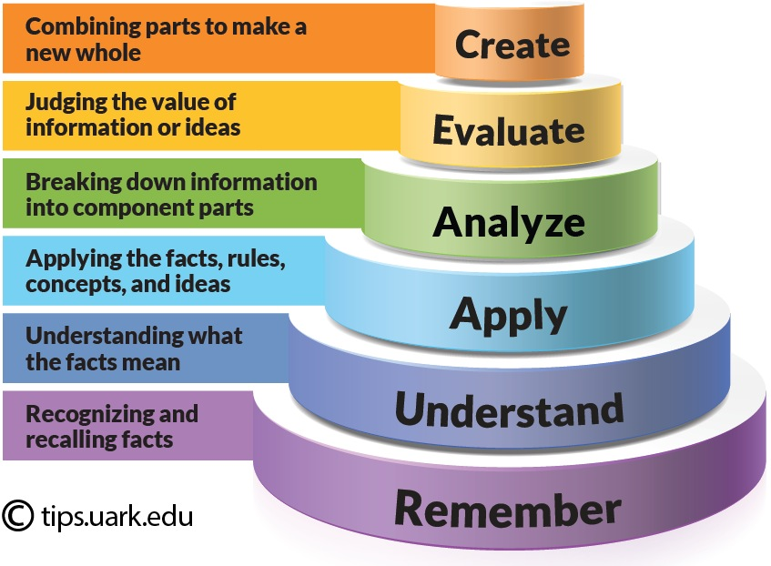
I used this method as it allows students to develop knowledge and skills whether it was new knowledge or knowledge that they already had about Dyslexia and evaluate the implication that they could have on learning.
The lesson that I planned and created was made up of three different emergent technologies in which I thought would be best for teaching my lesson and to create knowledge and engagement for my peers. According to Somwkh (2007) teaching with ICT encourages students to learn creatively and goes away from the ‘traditional’ pen and paper way of teaching. It also gives a chance to engage powerful ideas with the students and they can then reflect on their own learning by looking back on what they have learned.
The first Emergent Technology that I used was ‘Microsoft PowerPoint’, this is a software that is used by most teachers as it is easy to use with lots of design features which can make the presentation look intriguing, it can be made easy to read and can use it to insert links, audios, images or videos that maybe relevant to a lesson. It also keeps you on topic and gives you structure of the lesson, as you can plan on what you are going to focus on next (Oxley, n.d.). This is the main reason why I used PowerPoint to give myself structure.
On the other hand, I find that with using PowerPoint I sometimes rely on the screen too much. I found myself filling my slides with too much information which could then look back too rather than using my own knowledge from small points. From this I feel like that in future lessons maybe I will use a different method of delivery that I will be less reliant on. I could have used a traditional white board and pen to write down my points for the class but then that will take up useful time or if I do use PowerPoint I will keep my points to a minimum and then elaborate them further.
The next use of Technology that I used was an anagram game that was found online called ‘Chicktionary’. The aim of the game was to show my peers a strategy that teachers could use to make learning more fun for people who have Dyslexia. I found that the game worked well in my lesson and that it kept my peers really engaged as from my feedback from my lesson most people said that they enjoyed and that it broke the lesson up by bringing in a sense of fun. This was my aim for the lesson and I felt a sense of achievement from as I was nervous about the feedback from it.
According to Jabary (2016) Playing video games offers physiological benefits associated with the stimulation of the brain. It can also encourage decision-making, can improve cognitive development and helps people learn valuable skills and lessons applicable to real life. When playing games, it is easier to interact with others. Therefore, the use of games in education improves the mind and the self-esteem of the student, who tries to explore and find alternative approaches to solving different situations in the learning process.

Although the game worked well, if I was to use it again in a lesson I would have double checked that the link worked and would have prepared it before hand as I did experience some technical difficulties whilst trying to get the game to load. I could have found a similar game that I could have integrated into my presentation to save time. Overall, I feel that the ‘Chicktionary’ game worked and that I will use it again in a lesson.
Finally, as part of my assessment of my lesson and to ensure that the lesson objective had been met I created a quick quiz which was made up of five questions that were based on points that I had covered throughout the lesson. The quiz was another engagement strategy that worked well for my peers, but I feel like I could have made the questions more complicated as they did not challenge my peers.
If I was to do an assessment strategy through a quick quiz again I would use a different technique. I would use the online programme ‘Kahoot’ so that the answers would be clearer, and the organisation of the class would be more structured. Although my peers answered the questions correctly, it seemed like only some of them engaged, rather than all of them.
In conclusion, I feel that my first micro-teach lesson went well considering I have had no teaching experience with adult learners. The engagement from my peers is what gave me confidence to carry through my lesson but also because I learned that adult learners are more independent learners, therefore it takes the pressure off as a teacher as they only teach them ‘how to learn’.
The use of technology also helped me through the lesson as I felt prepared beforehand and everything was structured into place, I knew what I had to do next. Without that I would have been looking for what to do next. The use of emergent technologies is also what I felt like created the most engagement to my lesson, the PowerPoint had the information that was required, ‘Chicktionary’ made the learning fun and the Quick Quiz revisited the knowledge of the lesson and assessed what had been learned.

References
Bloom, B. S., 1956. Taxonomy of Educational Objectives. Vol 1 ed. New York: McKay
Heacademy.ac.uk. (2017). Flipped learning | Higher Education Academy. [online] Available at: https://www.heacademy.ac.uk/knowledge-hub/flipped-learning-0 [Accessed 11 Oct. 2018].
Jabary, I. (2016). Game-Based Learning Encourages Engagement. Training, 53(5), 12,14.
Johns, C. (2004). Becoming a reflective practitioner. Oxford, UK: Blackwell.
: Kingsley, E. (2016). The need to lesson planning. [online] Efobikingsley.blogspot.com. Available at: http://efobikingsley.blogspot.com/2016/09/the-need-to-lesson-planning.html [Accessed 8 Oct. 2018].
Skillsforlearning.leedsbeckett.ac.uk. (2018). Example 3 - Johns' model for structured reflection | Models for structuring reflection | Skills for Learning Preview. [online] Available at: https://skillsforlearning.leedsbeckett.ac.uk/preview/content/models/04.shtml [Accessed 7 Oct. 2018].
Somekh, B. (2007). Pedagogy and learning with ICT : Researching the art of innovation. London: Routledge.
Oxley, M. (n.d.). [online] Depts.washington.edu. Available at: http://depts.washington.edu/lingta/10_PPT_dos_donts_Oxley.pdf [Accessed 9 Oct. 2018].
Ubi, I. (2014). The Power and Purpose of Instructional Objectives in Social Studies Education. Journal of Education and Practice, [online] 5(20), p.1. Available at: https://iiste.org/Journals/index.php/JEP/article/download/14257/14565 [Accessed 11 Oct. 2018].

