1708707_CAMF6002_2

REFLECTIVE JOURNAL
ZEST Magazine
by
ALANY AZZUDDIN

Self-Reflective Journal (1708707)
Moving on to Part 2 of the creative project, where the process of actually creating the magazine starts. Having a clear objective and goal for this project has helped ease the process of creating ZEST magazine. The goal of wanting to share my experience through food has not change from the submission of the first module. Taking a step back from the magazine, and evaluating the progress and the final product of my project, left me asking myself questions. Allowing me to reflect on the decisions I made throughout the project.
What do I think about the content (articles) that I created?
Throughout the years, my experience in writing has been limited to academic style writing, especially since I started university. Therefore, writing creatively was a struggle at the beginning of this project. After trying out several writing exercise and getting advice from my lecturer, Matt Jones, I was able to start writing creatively, again. I was told to go back to the basics of writing and to do it without overthinking. Allowing my words to flow naturally has helped me overcome the “writer’s block”. The final articles you see throughout the magazine has gone through a few editing process before I was able to create the final material. To improve the articles, I had a few people look through them and review each and every one of the articles. The changes suggested by everyone was taken into account and I was able to make those changes.
I am pleased with the outcome of each and every article. All of the articles had the tone I intended for, which was casual and informal. However, I did want my articles to be slightly shorter, since my targeted audience were millennials (a generation that prefers visual content than literature), but as I thought it through, cutting the articles shorter than it already is, would’ve left me with articles that did not have enough concrete content. Therefore, I maintained the length of all my articles and made sure that it was light and organic, so that the readers would be interested in reading the articles despite the length of the articles.
How did the design process of the whole project go?
The software used for the design process of this magazine is a very important factor. Which is why my lack of knowledge in a few Adobe software such as, Photoshop, Illustrator, Premier Pro and InDesign has definitely slowed down the designing process since I needed to go through online tutorials to learn how to use them. I did some researched on tips for using InDesign to create a magazine on YouTube by Sonduckfilm, (2015) How to Design a Magazine in InDesign CC Tutorial. Available at: https://www.youtube.com/watch?v=qF8DjE0KlPk (Accessed: 3 April 2018) and White, T. (2013) How To Get Started With Adobe InDesign CC - 10 Things Beginners Want To Know How To Do. Available at: https://www.youtube.com/watch?v=qzE6nZofaI0 (Accessed: 5 April 2018). I found these videos useful, it helped me understand how to use the software and added extra knowledge to what Brett has already thought me during the first InDesign class.
Other than that, the lack of experience in using Photoshop slowed down the process of editing the photos used in the magazine. I was able to search for other alternative, which was when I found out about Adobe Lightroom. After watching a few tutorial videos, We Eat Together. (2017) Lightroom Classic CC Rocks Food Photography. Available at: https://www.youtube.com/watch?v=gz2EUcTT-o0 (Accessed: 12 April 2018) and
Le Petit Oeuf (2017). Food Photography Lightroom Tutorial. Available at: https://www.youtube.com/watch?v=6yOOM7IS0-4 (Accessed: 12 April 2018), then I realise that it was an easier software to use compared to Photoshop, especially if it is for simple photo editing. A lot of time was used to edit the photos as there were a lot of them.
During the design process, I noticed that my work progress was going very slowly. It could be due to the fact that I was learning to use 2 new software (InDesign and Lightroom), which I wasn’t familiar with. However, it was also because my plans were not organized at that time and I was going back and forth between the 2 software, thinking that I would get more work done. But once I organized everything and did my work following a system, I got more work done in a shorter time. Which taught me to always organize my work and do it one step at time.
Moreover, throughout the process of all this, I have accepted the fact that designing is not my forte but I still have a lot of room for improvement. I think that with future research and more hands-on practice, I’ll be able to improve on my design skills and my skills on using the other adobe software (Photoshop, Illustrator, and Premier Pro).
Lastly, during the end of the process, there was a problem uploading the pdf file on to both Yumpu and Issuu as the file was too big, I needed to remove the videos from the files and upload it manually through the websites. In the end, I decided to use both Yumpu and Issuu, just in case one or the other website/link doesn’t work. My main choice would be Yumpu because the quality of the photos for Yumpu was better than Issuu. Due to Issuu’s limited file memory, the resolution of the photos had to be decreased. However, I still uploaded ZEST on Issuu as security/plan B.
What was the decision behind the aesthetic and design elements of the magazine?
Referring to my mood board on Pinterest, https://www.pinterest.co.uk/alanyazzuddin/magazine-ideas/ (Magazine Layout) was where I got most of my inspiration from, in terms of layout, colour and fonts. A few changes have been made to the initial plans in the Developing Creative Projects portfolio. One of it being the fonts used in the magazine. Initially, Lemon/milk light was intended to be used for headings and titles of the magazine but was changed to Minion Pro in BOLD. This decision was made due to the fact that Lemon/milk light did not go with the layout of the pages and the fact that it was not available on the computer I was using. Furthermore, I did some research on what type of font combination would be appropriate for digital content, Awwards Team, (2017) 20 Best Web Fonts from Google Web Fonts and @font-face. Available at: https://www.awwwards.com/20-best-web-fonts-from-google-web-fonts-and-font-face.html (Accessed: 9 May 2018) and Typewolf, (2018) A Curated Collection of the 40 Best Google Fonts. Available at: https://www.typewolf.com/google-fonts (Accessed: 9 May 2018), therefore I downloaded the fonts that were recommended, eg. Lato, Open Sans, PT Serif.
Doing further research on ways I can design my layout and the fonts I should use, has helped in making my vision for the magazine a reality. For the layout, it is more formal, in the sense that most of it is aligned and in squares and rectangles because I was not confident enough with experimenting with other shapes as my knowledge of Photoshop was lacking. Therefore I went with a simple and formal layout. But I balanced out the formality of it with the use of bright colours and adding coloured calligraphy fonts, to make it look more fun and bright.
Keeping to the theme of the magazine being fun and bright, which was how I made my decision on the front cover. I had 16 different cover pages with different design placements. Thus, my decision to go for the most colourful one and ones with different types of ingredients. Even though the front cover with the flower settings looked nice, I realise that I needed to choose the cover with food ingredients to create a brand identity, so that the readers know it is a food magazine.
(Front Covers)
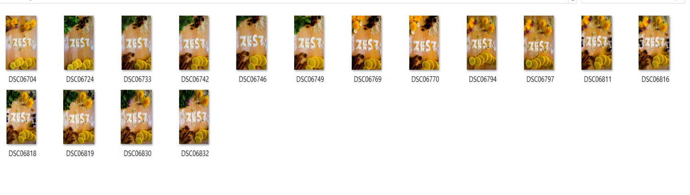
(Front Cover Editing)
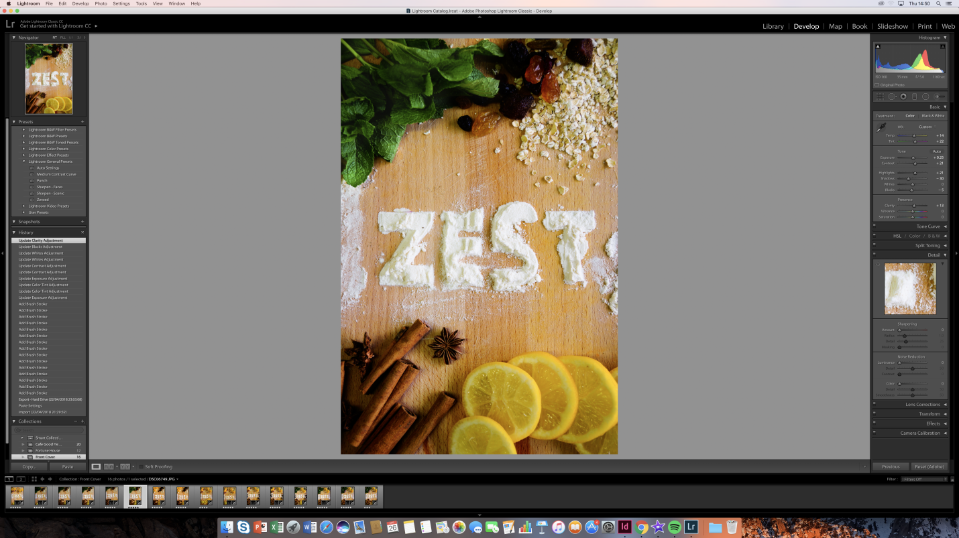

Each article has a different colour scheme to it because I wanted my readers to be able to identify the different categories. In addition, it was easier to design each article when a specific colour is assigned to it.
(Fortune House)
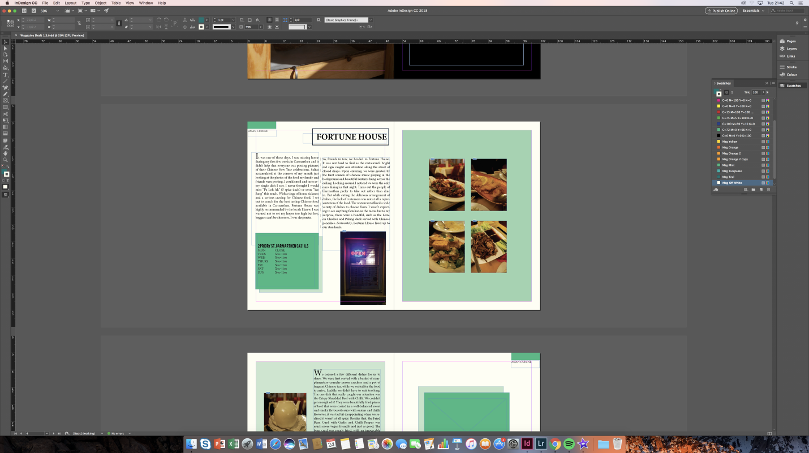
(Caffi Iechyd Da)
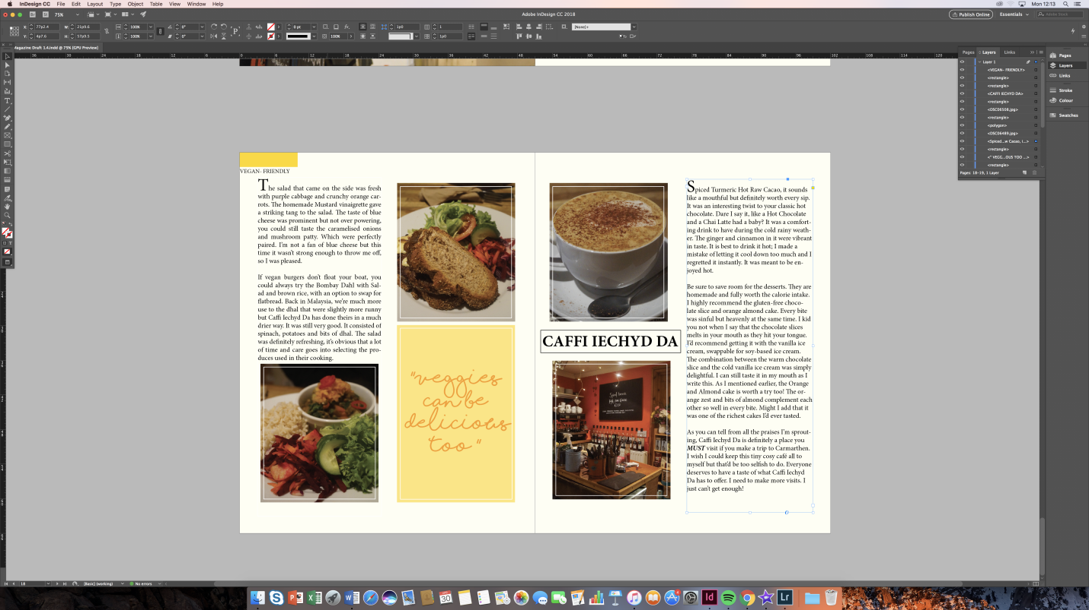

What were the feedbacks I received from my peers?
Criticism is something I don’t take well, therefore showing my work to my peers was a struggle. I was afraid that they would be too harsh on my work and would not like it. But after getting advice from both of my supervisors, I felt more comfortable showing my work to others, so that I can receive feedback, which would help me improve ZEST magazine.
I couldn’t make a decision on which front cover I wanted to use for my magazine, so I sent it out and asked different groups of friends to choose which their favourite were. With the help of their feedback, I was able to make my final decision on which front cover to use.
Other than that, in the beginning there were a lot of empty spaces in my layout which was because I kept my layout too formal. My friend suggested that I add the coloured calligraphy to the articles to not make the layout look boring. They also suggested that I try to use both pages when designing the articles and not be limited to a rigid format. I wasn’t using the spaces to my advantage. Which I then learned to utilise and add different elements to the layout, to avoid empty spaces.
Moreover, I received feedback regarding the articles. The articles looked too long, according to one of the feedbacks. This was one of the problems I was worried about but then I realised, content wise, it wasn’t that long. The articles only looked long but if it was read, it wasn’t that long and all the information in it, was necessary. But taking the feedback into consideration, instead of cutting the articles down, I designed the articles into short columns for it to be easier to read. Even though my targeted audience are millennials, I still have to take account for other readers that actually want to know about the places I’ve been to and want to get information out of my articles. I want ZEST to be a magazine that has both quality content and an aesthetical design.
Has ZEST reached industry standards?
Overall, I would think that ZEST is at par with other food magazines in the industry. However, with every project, there is room for improvement. In terms of content, I wish I could have produced a variety of content, instead of just reviews of restaurants and recipes. Unfortunately, due to the time constraint, lack of funds and lack of man-power, I was not able to do so. But in this circumstance of it being an individual project, the amount of work produced, is satisfactory. Since I do plan to continue creating content for ZEST, I’m hoping that I’ll get more contributors and writers in the future. Which would then give me the opportunity to have a lot more variety of content for ZEST.
In terms of the design of ZEST, I wish I have better knowledge in using Photoshop or Illustrator, which would then have helped me create a much more interesting layout. I definitely need to improve my skills on those 2 software, so that I can create better quality work in the future. Nonetheless, the layout and content I created for ZEST is definitely my style, which I realise at the end of the project and after receiving feedbacks. With its light, fun and bright layouts, I think that my targeted audience will appreciate and like ZEST. In the future, the design and layout of the magazine will change, depending on the content the magazine issue.
Over the course of creating this magazine, I have realised what my strengths and weaknesses are. My strengths include, being organised, a fast learner, and is articulate with details. Whereas my weaknesses are time management, overthinking and design skills (Photoshop and Illustrator). I am thankful for both my strengths and weaknesses. My strengths have helped me power through this project whereas my weaknesses has driven me to want to work on them and make them my strengths. Everything I learned and experienced throughout this project are has taught me a lot. I would not change any of it, as it will be helpful and valuable for my future.
Word Count: 2047

