University of Wales Trinity Saint David

Motorsport Engineering

Sustainability in Engineering

ACHA6012

Materials Testing and Sustainability in Composites for Motorsport & Automotive Industries

William Arley

2219871

Contents
Introduction 3
Methodology 3
Literature Review 4
Results 4
Maximum Loading 4
Loading Comparison 5
Displacement Comparison 6
Woven vs Non-woven 6
Bio vs Epoxy resin 7
Results Validation 8
Analysis 9
Max Loading and Displacement 9
Load Comparison 10
Displacement Comparison 11
Woven vs Non-woven 11
Bio vs Epoxy resin 12
Results Validation 12
Evaluation of Sustainable Material Performance 13
Analysis Sum-up 13
Conclusion 14
References 14

Introduction

As sustainability becomes crucial in materials engineering, the motorsport and automotive industries are shifting from traditional metals and synthetic composites toward environmentally friendly alternatives (Dingle, 2009). Composites remain key for their strength-to-weight benefits (Bailey, 2015), but their production and disposal carry significant environmental costs (Chua, 2015). Figure 1, based on Granta Edupak (2022), highlights carbon fibre’s high water, energy useand CO₂ emissions during manufacturing.
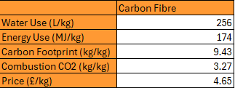
Figure 1. Manufacturing data for Carbon Fibre

This report examines the performance and sustainability of various composite materials for automotive and motorsport applications. Through literature review, testing, and analysis, it evaluates traditional and emerging composites based on performance, lifecycle emissions, recyclability, and future compliance. The aim is to offer evidence-based recommendations to advance sustainable engineering in high-performance sectors.

Methodology

The experimental methodology involved tensile testing of various composite materials to evaluate their mechanical performance and sustainability in comparison to the baseline material, aluminium. Testing was carried out in an engineering science lab using the Denison Tensile/Compression testing machine. The materials tested included traditional and natural fibre composites produced via a resin infusion process, with mesh grips added for secure clamping. The materials being tested include:
- Baseline – Aluminium.
- Twill materials with Bio Resin – Kevlar, Flax and Carbon.
- Twill materials with Traditional Resin – Carbon.
- Non-woven materials with Bio Resin – Flax, Hemp and Carbon.

Twill composites (Kevlar, Flax, Carbon) were reinforced with traditional or bio-epoxy resins and layered at 45° to achieve quasi-isotropic properties—uniform in-plane behaviour (Deng, 2004). Non-woven Flax, Hemp, and Carbon variants were also tested with bio-epoxy. Each material underwent two tensile tests, totalling 14 tests per material. Width and depth were measured beforehand to calculate cross-sectional areas for stress analysis.
Area = Width × Depth
Dog bone-shaped samples were fixed into the tensile testing machine to minimise stress at the grips and promote failure in the gauge length for accurate mechanical assessment (Klemensø, 2007). After deformation, the machine stopped and loading and displacement data were exported.
The analysis evaluates loads and compares performance across twill and non-woven structures, bio-epoxy and traditional resins, and natural and synthetic fibres. Sample behaviour, including defects and failure modes, is also recorded to support the evaluation.

Literature Review

Composite materials have become essential in the automotive and motorsport industries due to their high strength-to-weight ratios, excellent stiffness, and fatigue resistance (Caliskan, 2002). Traditional composites such as carbon fibre reinforced polymers and Kevlar have been widely adopted in structural components, body panels, and aerodynamic parts, where weight reduction directly translates to performance and efficiency gains. However, the environmental impact of producing these synthetic composites—particularly their energy-intensive manufacturing processes and poor recyclability—has prompted research into more sustainable alternatives. Natural fibre composites, including those reinforced with flax, hemp, and jute, are gaining attention for their biodegradability, lower embodied energy, and potential for renewable sourcing. While these materials typically offer lower mechanical performance compared to carbon fibre, advancements in fibre treatment, hybrid layups, and bio-based resin systems are helping to close the performance gap. Recent studies have also explored the full lifecycle assessment of composite materials, evaluating factors such as carbon emissions, end-of-life recyclability, and compliance with evolving environmental regulations. Despite growing interest, gaps remain in understanding the long-term durability, moisture resistance, and high-temperature performance of natural fibre composites, especially under the demanding conditions typical of motorsport environments. This highlights a need for further experimental research and development to optimise their use in high-performance applications while meeting sustainability goals.

Results

Maximum Loading

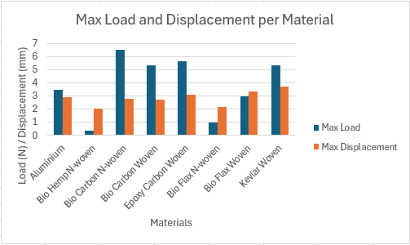
Figure 2. Max load and displacement per material

The graph above provides a direct comparison of each material's mechanical efficiency by displaying both the maximum load it could withstand and the maximum displacement it experienced. Notably, Epoxy Carbon Woven and Bio Carbon Woven stand out by achieving some of the highest maximum loads (around 5.6 N) while maintaining relatively moderate displacement values, indicating strong and stable structural performance. In contrast, Bio Hemp Non-Woven and Bio Flax Non-Woven show significantly lower load-bearing capacity with higher displacement, suggesting greater ductility but lower stiffness. Aluminium, used as the baseline, sits in the middle of the spectrum with balanced but unexceptional load and displacement values. These trends underline the trade-offs between strength and deformation in different materials and highlight how bio-composites, while more sustainable, may require performance compromises compared to high-end synthetics.

Loading Comparison

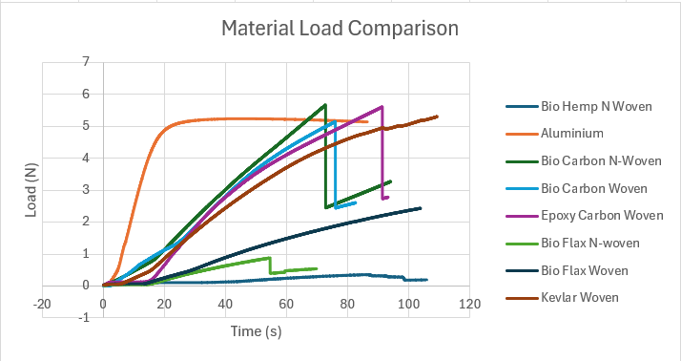
Figure 3. Material load comparison

The Material Load Comparison graph demonstrates how each material reacts to increasing load over time. Bio Hemp Non-Woven and Bio Carbon Non-Woven exhibit more gradual load responses, suggesting that these bio-composites experience slower initial stiffening. In contrast, materials like Epoxy Carbon Woven and Bio Flax Non-Woven show sharper increases in load, indicating more immediate resistance to deformation. Aluminium, being less stiff, begins to deform earlier, showing a slower initial increase in load. These results indicate the varying stress-strain characteristics of the materials, with synthetic composites generally offering higher initial resistance to load.

Displacement Comparison

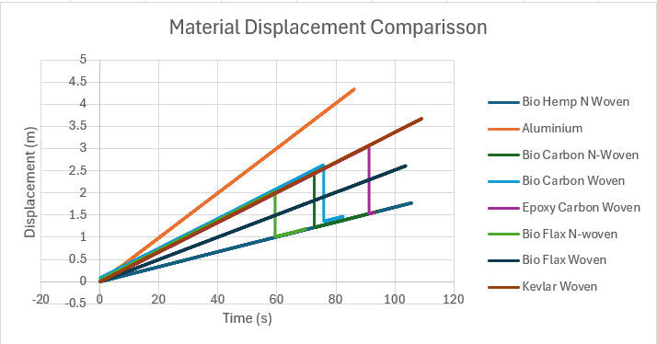
Figure 4. Material displacement comparison

The Material Displacement Comparison graph highlights the displacement response of various materials under tensile load. Aluminium, which shows a relatively steady increase in displacement over time, is surpassed by the bio-based composites, particularly Bio Hemp Non-Woven and Bio Carbon Non-Woven, which exhibit a more rapid increase in displacement, indicating greater elongation under stress. The Epoxy Carbon Woven and Kevlar Woven materials show more controlled displacement rates, suggesting better resistance to deformation, which aligns with their higher mechanical strength in comparison to the natural fibre composites.

Woven vs Non-woven

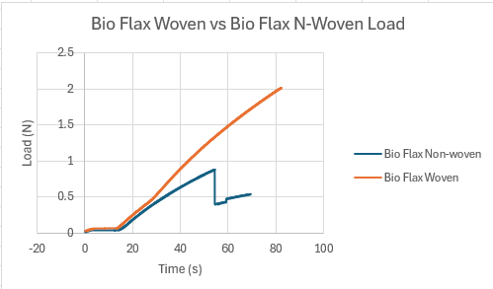
Figure 5. Woven vs non-woven

The first graph comparing Bio Flax Woven vs. Bio Flax Non-Woven Load clearly shows that the woven variant outperforms the non-woven form in terms of load-bearing capacity. Bio Flax Woven reaches a maximum load of around 2.4 N, while the non-woven equivalent peaks just below 1 N. This suggests that the woven fibre structure contributes to better load distribution and structural integrity, making it more suitable for applications requiring moderate strength and flexibility. The performance gap also implies that fibre orientation and bonding play a critical role in mechanical performance.

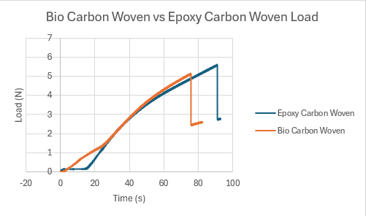
Figure 6. Carbon woven vs non-woven

In the second graph, which compares Bio Carbon Woven vs. Bio Carbon Non-Woven, the performance difference is less pronounced, but the non-woven variant still maintains a slight edge in maximum load, peaking at just over 5.6 N compared to around 5 N for the woven. This narrower gap may reflect the higher strength of carbon fibre, which compensates for the structural drawbacks of the woven format. Nonetheless, the non-woven Bio Carbon still demonstrates more reliable structural performance, reinforcing the value of controlled fibre alignment and interlocking in composite design for motorsport or automotive use.

Bio vs Epoxy resin

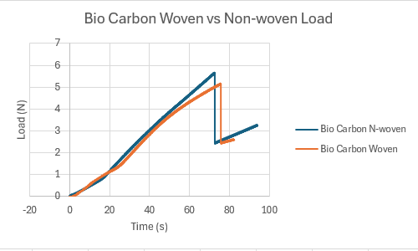
Figure 7. Bio vs Epoxy

The comparison between Bio Carbon Woven and Epoxy Carbon Woven shows that while both materials follow a similar loading trend, Epoxy Carbon Woven consistently achieves a slightly higher maximum load. The steeper slope of the Epoxy Carbon Woven curve indicates greater stiffness and faster load-bearing capacity, which is critical in high-performance applications. However, the close proximity of the two curves suggests that bio-resin composites are approaching the performance levels of traditional epoxy systems, supporting the potential for more sustainable alternatives without major compromises in mechanical strength.

Results Validation

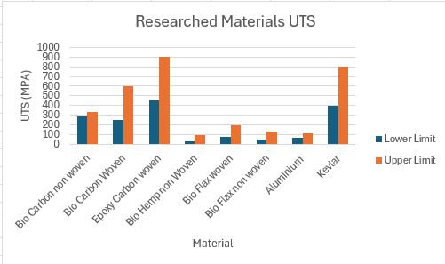
Figure 8. Researched material UTS

The Researched Materials UTS (Ultimate Tensile Strength) graph presents a broad comparison of upper and lower strength limits from secondary sources for all materials tested. It shows that synthetic composites, particularly Kevlar and Epoxy Carbon Woven, possess significantly higher tensile strength ranges compared to natural fibre composites like Bio Flax and Bio Hemp. The wide gap in UTS between carbon-based and natural materials suggests that while sustainable composites offer environmental advantages, they currently do not match the peak mechanical performance of traditional composites, particularly for load-critical motorsport applications.

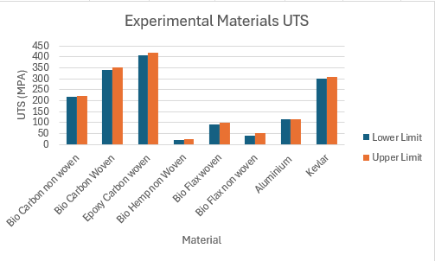
Figure 9. Experimental material UTS

The Experimental Materials UTS graph displays the ultimate tensile strength values obtained from laboratory testing. Here, the experimental results reflect a similar trend to the researched data but at generally lower absolute values, likely due to testing conditions, manufacturing variances, or material inconsistencies. Bio Carbon Woven again demonstrates strong performance, closely trailing Epoxy Carbon Woven, while sustainable options like Bio Flax Woven and Bio Hemp Non-Woven show substantially lower UTS values. This experimental validation supports the earlier analysis, confirming that while bio-composites are promising, they require further optimisation to fully meet the demands of high-stress environments.

Analysis

This analysis evaluates the mechanical performance of different composite materials, comparing natural fibre and synthetic options. It focuses on how fibre structure and resin type affect strength and assesses the potential of sustainable composites for high-performance applications.

Max Loading and Displacement
Synthetic composites exhibit superior mechanical performance in terms of maximum load when compared to natural fibre alternatives (Begum, 2020). Epoxy Carbon Woven recorded the highest maximum load of 5.6 N, followed closely by Bio Carbon Woven and Kevlar Woven, which reached 5.3 N and 5.3 N respectively. In contrast, Bio Flax Non-Woven and Bio Hemp Non-Woven recorded significantly lower maximum loads of 2.975 N and 0.977 N, respective. This data indicates that traditional synthetic composites such as carbon fibre reinforced polymers continue to offer higher structural strength under tensile load, which is critical in motorsport applications where materials are exposed to intense dynamic stresses (Feih, 2012; Wood, 2011). However, the performance of Bio Carbon Woven, which achieved comparable strength to synthetics, demonstrates potential for more sustainable alternatives that do not significantly compromise mechanical integrity (Rodríguez-García, 2021).
Natural fibre composites vary considerably in performance depending on the fibre type and form (Pickering, 2016). Bio Carbon Woven performed considerably better (5.315 N) than Bio Carbon Non-Woven (3.492 N), and a similar trend was seen with flax composites — Bio Flax Woven achieved 3.5 N while Bio Flax Non-Woven reached only 2.975 N. This highlights the importance of fibre architecture in determining material strength (Lau, 2018). Woven structures offer better load distribution and inter-fibre bonding, resulting in greater tensile strength (Chowdhury, 2024). Non-woven forms, while potentially easier and cheaper to manufacture, generally perform poorly in high-stress environments and may be better suited for secondary structural or interior components in automotive applications (Das, 2018).
Aluminium, the baseline material, offers lower maximum load capacity compared to most composite alternatives tested (Bhatt, 2017). The aluminium sample achieved a maximum load of 3.492 N, which was outperformed by all woven composite types tested, including natural fibres like Bio Flax and Bio Carbon. This supports the shift toward composite materials in high-performance engineering sectors (National Research Council, 2005). While aluminium has historically been favoured for its light weight and ease of fabrication, composites not only match but often exceed its mechanical capabilities while offering added benefits in design flexibility and, in the case of bio-composites, environmental sustainability (Humphreys, 2003).
Bio-based composites are approaching competitiveness with synthetics but currently require further development to fully match high-performance requirements (Drzal, 2001). Although Bio Carbon Woven nears the performance of Epoxy Carbon Woven, materials like Bio Hemp Non-Woven (0.977 N) fall significantly short. This performance gap suggests that while some natural composites can rival synthetic materials, others remain limited by factors such as fibre quality, bonding strength, or manufacturing consistency. Continued research into fibre treatments, hybrid layups, and bio-resin optimisation is necessary to enhance their viability for structural components in motorsport and automotive applications.

Load Comparison
Synthetic composites show significantly faster load accumulation compared to natural fibre composites (Salman, 2021). Epoxy Carbon Woven and Bio Carbon Woven achieve high load values of approximately 5–6 N within a relatively short time frame, while natural fibre composites such as Bio Flax Non-Woven only reach around 2–3 N much later in the test. This indicates that synthetic composites possess greater stiffness and immediate load-bearing capability, a critical requirement for motorsport and automotive applications where rapid force resistance is necessary to maintain structural integrity during high-speed events (Begum, 2020).
Natural fibre composites tend to exhibit a more gradual and steady loading curve (Gassan, 2002). Materials like Bio Hemp Non-Woven demonstrate a slow and continuous rise in load with no sharp increases, peaking at much lower forces compared to synthetic alternatives. The gradual load increase suggests a softer material response, allowing for more flexibility and energy absorption but at the cost of structural strength (Fan, 2024). This property could make them valuable in less critical, more sustainable vehicle components that prioritize environmental impact over mechanical performance.
Aluminium, while traditionally a structural material, is often less superior when compared to composites in load-bearing efficiency (Pedersen, 2011; Piggott, 2002). In the comparison graphs, aluminium shows a modest and steady load increase, reaching only around 3.5 N, which is notably lower than most carbon-based composites. This performance highlights why composite materials are becoming the preferred choice in motorsport and automotive design — offering not only weight savings but also superior mechanical properties (Wood, 2011). Composites, as shown, present a compelling alternative from both a performance and sustainability standpoint (Suárez, 2021).

Displacement Comparison

Natural fibre composites show significantly higher displacement under tensile loads than synthetic composites (Müssig, 2006). Bio Hemp Non-Woven and Bio Carbon Non-Woven demonstrate displacement values exceeding 3 mm, whereas Epoxy Carbon Woven and Kevlar Woven remain around or below 2 mm throughout testing. Higher displacement reflects lower stiffness and greater ductility, meaning these natural materials can stretch and deform more before failing (Lakes, 2001). While this flexibility could be advantageous for specific safety applications, it limits their effectiveness in rigid, load-critical structures like chassis or suspension components (Jiregna, 2020).
Synthetic composites maintain dimensional stability far better under load compared to natural fibre alternatives (Toki, 2003). The displacement curves for Epoxy Carbon Woven and Kevlar Woven show minimal deviation and a linear relationship with load, suggesting strong resistance to elongation even as forces increase. This stability is vital in high-performance motorsport applications, where maintaining precise shapes under stress can affect aerodynamic performance, safety, and handling (Chawla, 2012). Therefore, synthetic composites continue to dominate where rigidity and predictable behaviour are essential (Nemir, 2010).
Aluminium displays intermediate displacement behaviour between natural and synthetic composites (Tanner, 2003; Toki, 2003). The aluminium sample exhibits steady but notable displacement as the load increases, more pronounced than synthetic composites but less dramatic than natural fibres. This result suggests that while aluminium offers acceptable stiffness for many structural uses, composites — particularly synthetic ones — can now outperform it in both strength-to-weight ratio and resistance to deformation, reinforcing the shift toward advanced composite materials in sustainable automotive and motorsport engineering (Al-Shammari, 2018).

Woven vs Non-woven
Woven composites outperform non-woven composites in terms of maximum load capacity (Li, 2018). Bio Flax Woven reached a maximum load of approximately 2.4 N, whereas Bio Flax Non-Woven peaked just under 1 N. The superior performance of woven materials can be attributed to better fibre alignment and stronger inter-fibre bonding, enabling more efficient load transfer (Goutianos, 2007). This makes woven composites more suitable for applications requiring higher strength and durability, especially in primary automotive or motorsport components (Bailey, 2015).
The strength difference between woven and non-woven composites is less pronounced for carbon fibres than for natural fibres (Lee, 2008). Bio Carbon Woven and Bio Carbon Non-Woven achieved maximum loads of around 5.6 N and 5 N respectively, showing a narrower gap compared to flax composites. Carbon fibres inherently possess high er tensile strength and stiffness, meaning even when the fibre arrangement is less optimal (non-woven), the material still maintains high mechanical performance (Li, 2018). This suggests that material choice (carbon vs natural fibre) plays a significant role alongside architecture (woven vs non-woven).
Non-woven composites may offer advantages in terms of flexibility and manufacturing ease but at a performance cost (Chen, 2005). Both non-woven Bio Flax and Bio Carbon samples showed lower maximum loads and potentially greater displacement than their woven counterparts. Non-woven structures, while easier and cheaper to manufacture, sacrifice mechanical properties due to less ordered fibre alignment (Mijares, 2018). Their greater ductility might be advantageous for non-structural parts or applications needing energy absorption, but they are less suitable for load-bearing applications in motorsport environments (Ekoi, 2021).

Bio vs Epoxy resin
Composites using traditional epoxy resin generally achieve higher maximum loads than those using bio-resin systems (Kanchanomai, 2005). Epoxy Carbon Woven achieved a maximum load of 5.6 N compared to Bio Carbon Woven’s 5.3 N, despite both using similar fibre architectures.
This demonstrates that while bio-resins are progressing, traditional epoxy systems still provide superior bonding strength and mechanical properties (Nikafshar, 2017). The slight reduction in performance with bio-resins highlights the need for continued resin development to match the mechanical demands of motorsport-grade applications (German, 2022).
The performance gap between bio-resin and epoxy-resin composites is narrowing, particularly with high-performance fibres (Nikafshar, 2017). Despite using a bio-resin, Bio Carbon Woven achieved a load very close to that of its epoxy counterpart, indicating only a minor sacrifice in performance. This suggests that with strong fibres like carbon, the type of resin becomes less critical in determining peak mechanical strength (Nam, 2019). It reflects positively on the potential for adopting more sustainable bio-resins without drastically compromising structural integrity in high-performance settings.
Natural fibre composites show greater performance sensitivity to the type of resin used compared to synthetic fibre composites (Kumar, 2018). Bio Flax composites displayed more noticeable reductions in load-bearing capacity when using bio-resins compared to epoxy-resin carbon composites. Natural fibres may interact less efficiently with bio-resins, resulting in weaker matrix-fibre adhesion and reduced mechanical properties (Foruzanmehr, 2016). This indicates that successful sustainable composite designs must carefully consider both fibre and resin compatibility, especially for critical applications in automotive and motorsport industries (Wood, 2011).

Results Validation
Both the researched and experimental UTS graphs show a consistent trend where synthetic composites outperform natural fibre composites in tensile strength (Begum, 2020). In both graphs, Epoxy Carbon Woven and Kevlar display the highest tensile strengths, while sustainable materials like Bio Flax and Bio Hemp fall considerably lower in comparison. This consistency between external data and experimental results reinforces the reliability of the testing process and confirms that synthetic materials still dominate in terms of mechanical performance, particularly for load-critical applications (Rabianski, 2003).
The relative positioning of materials in both graphs is largely maintained, even though the absolute UTS values differ slightly. While experimental UTS values are generally lower than researched values, the ranking order—where carbon-based composites outperform flax and hemp-based ones—remains the same. This suggests that material behaviour trends are predictable and that the testing methodology used in the experiment effectively reflects real-world material performance, despite small discrepancies due to laboratory conditions, sample preparation, or processing variability.
The strong alignment between researched and experimental data highlights the emerging competitiveness of some sustainable composites, particularly bio-carbon variants. Bio Carbon Woven shows UTS values close to Epoxy Carbon Woven in both graphs, with only a small performance gap. This indicates that bio-composite technologies, especially those using high-performance fibres like carbon, are progressing toward matching traditional composites (Reddy, 2021). It supports the idea that bio-resin and natural fibre developments could soon offer viable sustainable alternatives without major performance compromises.

Evaluation of Sustainable Material Performance

Sustainable composites like woven flax, non-woven flax, and woven hemp showed lower mechanical performance than synthetic alternatives. Woven flax achieved moderate strength, outperforming non-woven flax, which suffered from poor fibre structure and load transfer. Woven hemp had the lowest load-bearing capacity, highlighting its tensile limitations. While synthetic composites reached peak loads of 5.3–5.6 N, natural fibres stayed below 3 N. Despite this, flax and hemp offer key sustainability benefits, making them better suited for secondary structures where environmental impact is prioritised over strength.

Analysis Sum-up

This study shows that epoxy-based carbon fibre still offers the highest mechanical performance, but sustainable alternatives like woven flax and hemp show growing potential with fibre optimisation. While natural composites are currently weaker, their environmental benefits make them ideal for less critical uses, and further development could expand their role in high-performance sectors like motorsport and automotive industries.

Conclusion

This study has shown that synthetic composites, particularly epoxy-based carbon fibre, continue to offer the highest mechanical performance. However, sustainable alternatives such as Woven Flax and Woven Hemp demonstrate growing potential, especially when fibre structure is optimised. Although natural fibre composites currently fall short in strength, they offer clear environmental advantages, making them suitable for less critical applications. With further development, sustainable composites could become increasingly viable for high-performance use in motorsport and automotive industries.

References

Al-Shammari, M.A. and Abdullah, S.E., 2018, November. Stiffness to weight ratio of various mechanical and thermal loaded hyper composite plate structures. In IOP Conference Series: Materials Science and Engineering (Vol. 433, No. 1, p. 012051). IOP Publishing.
Bailey, N., 2015. Increasing composite versatility through motorsport developments. Reinforced Plastics, 59(3), pp.128-130.
Begum, S., Fawzia, S. and Hashmi, M.S.J., 2020. Polymer matrix composite with natural and synthetic fibres. Advances in Materials and Processing Technologies, 6(3), pp.547-564.
Bhatt, P. and Goe, A., 2017. Carbon fibres: production, properties and potential use. Mater. Sci. Res. India, 14(1), pp.52-57.
Caliskan, A.G., 2002. Design & analysis of composite impact structures for formula one using explicit FEA techniques. SAE Transactions, pp.2360-2367.
Chawla, K.K., 2012. Composite materials: science and engineering. Springer Science & Business Media.
Chen, Y., Chiparus, O., Sun, L., Negulescu, I., Parikh, D.V. and Calamari, T.A., 2005. Natural fibers for automotive nonwoven composites. Journal of Industrial Textiles, 35(1), pp.47-62.
Chowdhury, I.R. and Summerscales, J., 2024. Woven fabrics for composite reinforcement: A review. Journal of Composites Science, 8(7), p.280.
Chua, M.H., Smyth, B.M., Murphy, A. and Butterfield, J., 2015. Understanding aerospace composite components' supply chain carbon emissions. In Irish Manufacturing Conference, IMC32.
Das, S., Kandan, K., Kazemahvazi, S., Wadley, H.N.G. and Deshpande, V.S., 2018. Compressive response of a 3D non-woven carbon-fibre composite. International Journal of Solids and Structures, 136, pp.137-149.
Deng, S., Li, X., Lin, H. and Weitsman, Y.J., 2004. The non-linear response of quasi-isotropic composite laminates. Composites science and technology, 64(10-11), pp.1577-1585.
Dingle, G., 2009. Sustaining the race: a review of literature pertaining to the environmental sustainability of motorsport. International journal of sports marketing and sponsorship, 11(1), pp.75-91.
Drzal, L.T., Mohanty, A.K. and Misra, M., 2001. Bio-composite materials as alternatives to petroleum-based composites for automotive applications. Magnesium, 40(60), pp.1-3.
Ekoi, E.J., Dickson, A.N. and Dowling, D.P., 2021. Investigating the fatigue and mechanical behaviour of 3D printed woven and nonwoven continuous carbon fibre reinforced polymer (CFRP) composites. Composites Part B: Engineering, 212, p.108704.
Fan, Q., Duan, H. and Xing, X., 2024. A review of composite materials for enhancing support, flexibility and strength in exercise. Alexandria Engineering Journal, 94, pp.90-103.
Feih, S. and Mouritz, A.P., 2012. Tensile properties of carbon fibres and carbon fibre–polymer composites in fire. Composites Part A: Applied Science and Manufacturing, 43(5), pp.765-772.
Foruzanmehr, M., Elkoun, S., Fam, A. and Robert, M., 2016. Degradation characteristics of new bio-resin based-fiber-reinforced polymers for external rehabilitation of structures. Journal of Composite Materials, 50(9), pp.1227-1239.
Gassan, J., 2002. A study of fibre and interface parameters affecting the fatigue behaviour of natural fibre composites. Composites part A: applied science and manufacturing, 33(3), pp.369-374.
German, M.J., 2022. Developments in resin-based composites. British Dental Journal, 232(9), pp.638-643.
Goutianos, S., Peijs, T., Nystrom, B. and Skrifvars, M., 2007. Textile reinforcements based on aligned flax fibres for structural composites. Composites innovation, pp.1-13.
Granta EduPack 2022 R2 software, Granta Design Limited, Cambridge, UK, 2022.
Humphreys, M., 2003. The use of polymer composites in construction. In Proceedings of the CIB 2003 Int'l conference on Smart and Sustainable Built Environment (pp. 1-9). Queensland University of Technology.
Jiregna, I. and Sirata, G., 2020. A review of the vehicle suspension system. Journal of Mechanical and Energy Engineering, 4(2).
Kanchanomai, C., Rattananon, S. and Soni, M., 2005. Effects of loading rate on fracture behavior and mechanism of thermoset epoxy resin. Polymer Testing, 24(7), pp.886-892.
Klemensø, T., Lund, E. and Sørensen, B.F., 2007. Optimal shape of thin tensile test specimen. Journal of the American Ceramic Society, 90(6), pp.1827-1835.
Kumar, S., Krishnan, S., Mohanty, S. and Nayak, S.K., 2018. Synthesis and characterization of petroleum and biobased epoxy resins: a review. Polymer International, 67(7), pp.815-839.
Lakes, R.S., Lee, T., Bersie, A. and Wang, Y.C., 2001. Extreme damping in composite materials with negative-stiffness inclusions. Nature, 410(6828), pp.565-567.
Lau, K.T., Hung, P.Y., Zhu, M.H. and Hui, D., 2018. Properties of natural fibre composites for structural engineering applications. Composites Part B: Engineering, 136, pp.222-233.
Lee, S.H., Lee, J.H., Cheong, S.K. and Noguchi, H., 2008. A toughening and strengthening technique of hybrid composites with non-woven tissue. Journal of materials processing technology, 207(1-3), pp.21-29.
Li, Z., Haigh, A., Soutis, C. and Gibson, A., 2018. Principles and applications of microwave testing for woven and non-woven carbon fibre-reinforced polymer composites: A topical review. Applied Composite Materials, 25, pp.965-982.
Mijares, J.L., Agaliotis, E., Bernal, C.R. and Mollo, M., 2018. Self‐reinforced polypropylene composites based on low‐cost commercial woven and non‐woven fabrics. Polymers for Advanced Technologies, 29(1), pp.111-120.
Müssig, J., Rau, S. and Herrmann, A.S., 2006. Influence of fineness, stiffness and load-displacement characteristics of natural fibres on the properties of natural fibre-reinforced polymers. Journal of Natural Fibers, 3(1), pp.59-80.
Nam, G., Kim, J. and Song, J.I., 2019. Mechanical performance of bio‐waste‐filled carbon fabric/epoxy composites. Polymer Composites, 40(S2), pp.E1504-E1511.
National Research Council, Division on Engineering, Physical Sciences, National Materials Advisory Board and Committee on High-Performance Structural Fibers for Advanced Polymer Matrix Composites, 2005. High-performance structural fibers for advanced polymer matrix composites. National Academies Press.
Nemir, S. and West, J.L., 2010. Synthetic materials in the study of cell response to substrate rigidity. Annals of biomedical engineering, 38, pp.2-20.
Nikafshar, S., Zabihi, O., Hamidi, S., Moradi, Y., Barzegar, S., Ahmadi, M. and Naebe, M., 2017. A renewable bio-based epoxy resin with improved mechanical performance that can compete with DGEBA. RSC advances, 7(14), pp.8694-8701.
Pedersen, K.O., Børvik, T. and Hopperstad, O.S., 2011. Fracture mechanisms of aluminium alloy AA7075-T651 under various loading conditions. Materials & Design, 32(1), pp.97-107.
Pickering, K.L., Efendy, M.A. and Le, T.M., 2016. A review of recent developments in natural fibre composites and their mechanical performance. Composites Part A: Applied Science and Manufacturing, 83, pp.98-112.
Piggott, M., 2002. Load bearing fibre composites. Springer Science & Business Media.
Rabianski, J.S., 2003. Primary and secondary data: Concepts, concerns, errors, and issues. The Appraisal Journal, 71(1), p.43.
Reddy, M.S.B., Ponnamma, D., Choudhary, R. and Sadasivuni, K.K., 2021. A comparative review of natural and synthetic biopolymer composite scaffolds. Polymers, 13(7), p.1105.
Rodríguez-García, V. and de Villoria, R.G., 2021. Automated manufacturing of bio-inspired carbon-fibre reinforced polymers. Composites Part B: Engineering, 215, p.108795.
Salman, S.D., 2021. Partial replacement of synthetic fibres by natural fibres in hybrid composites and its effect on monotonic properties. Journal of Industrial Textiles, 51(2), pp.258-276.
Suárez, L., Castellano, J., Díaz, S., Tcharkhtchi, A. and Ortega, Z., 2021. Are natural-based composites sustainable?. Polymers, 13(14), p.2326.
Tanner, D.A. and Robinson, J.S., 2003. Modelling stress reduction techniques of cold compression and stretching in wrought aluminium alloy products. Finite elements in analysis and design, 39(5-6), pp.369-386.
Toki, S. and Hsiao, B.S., 2003. Nature of strain-induced structures in natural and synthetic rubbers under stretching. Macromolecules, 36(16), pp.5915-5917.
Wood, B.M., 2011. Overcoming the barriers to sustainable motorsport (Doctoral dissertation, University of Warwick).

