

Certificate of Higher Education in Health and Social Care
Module: Problem Solving and Decision Making
Module code: BMSW4004

Lecturer: Laila Surani

Student name: Flor de Maria Galindo Manuel de Killick
Student Number: 2124309

Table of contents

- Introduction…………………………………………………………………………....1
- Problem-solving……………………………………………………………………….2
- Decision Making……………………………………………………………………….3
- implementing a solution……………………………………………………………….4
- Communicating plan with the stakeholders…………………………………………5
- Monitoring and reviewing the tech to ensure successful implementation of the solution………………………………………………………………………………….6
- Conclusion………………………………………………………………………………7
- References……………………………………………………………………………...8

Introduction
The goal of this study is to understand how to solve problems using techniques and make the best decisions using the seven processes as well as getting help from stakeholders. However, we must first understand ourselves and be confident in understanding the dangers associated with providing answers. Cut each solution in half and select the best one. Consider your talents, feelings, and experiences.

Complex problem
A complex problem is distinguished by the absence of a clear definition, the absence of an obvious goal, and the absence of clear procedures to follow. The global economic crisis is perhaps the most recent example of a difficult problem.
Sandra is 40 years old and works as a health assistant in a care home for elderly people. However, a year and a half ago, she underwent surgery that left her unable to perform her usual functions, so she can no longer help patients stand up because they are severely overweight. Initially, her contract was full-time, but due to health problems, her manager gave her a part-time job. However, all the staff began to complain to the manager, arguing that Sandra had had surgery a long time ago and therefore she had to work like everyone else. The manager listened to the speech and told her that she had to assist all the residents, so she began to assist all the residents, but since there was no good implementation of equipment to help her to do her duties, she felt worse and went to the doctor, who He recommended resting because if She continues to lift heavy things, her health could be affected and would have to do another surgery. She is confused about the treatment that the staff gives her at work because she does not want her health to get worse. Now she does not know what decision she will make. She had been looking for work in community care agencies for some time, but she decided to wait until the doctor will plan about her health.
Using the six problem-solving techniques, I will analyze the case of Sandra. In the first step, the perceived problem is that the staff does not have any empathy for her health situation and the manager does not give her any support. The other problem I perceive is that the residence has poor management throughout its organization. Those two big problems have forced her to work hard. As a result, her health is being affected.
In the second step, I use the fishbone diagram to find the causes that generated the health problem of Sandra getting worse.

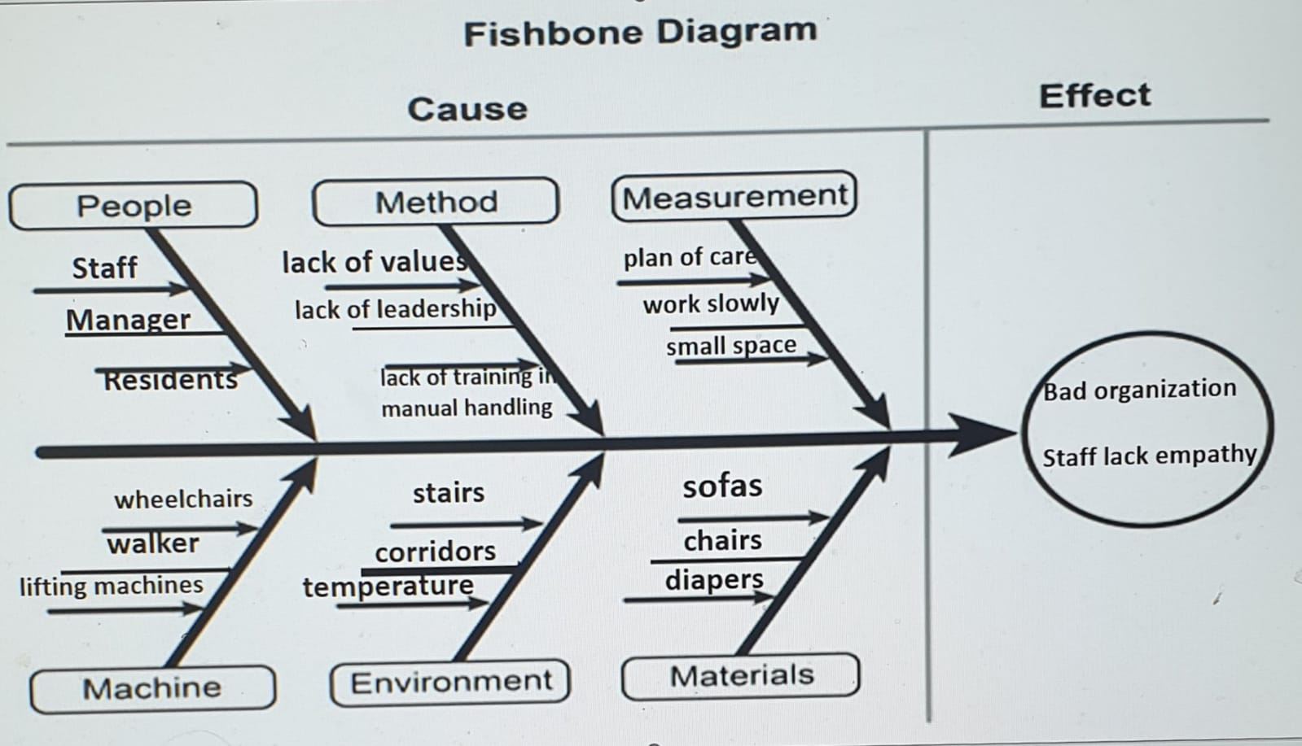
People - The staff does not have a vocation; therefore, they do not have empathy, and they lack the skills to communicate with the care team. The manager does not have leadership, and she has preferences with some staff members and does not give any support to Sandra, who is a vulnerable person. The residents are elderly people who sometimes need a lot of help getting up.
Method - the staff does not have good training in values also they do not have good training in manual handling techniques, which would ease the burden of weight. The manager lacks leadership; She does not know how to lead the organization and does not comply with the policy.
Machines - The wheelchairs are not easy to operate because they are old and too heavy. The walker is also old and not easy to operate, and the lifting machines are much more difficult to operate because they are heavy, and the rooms are small.
Environment - There are too many stairs that make it difficult for residents to walk, the corridors are narrower so that wheelchairs do not pass, and the temperature is too high, which makes people get tired faster.
Measurement - The staff does not follow the plan of care, they work on their own, which creates a great overload and confusion for all the staff. They work slowly and there is not much space to put the machines that are used to help the residents.
Materials - They have large, low-rise sofas that make it difficult for the healthcare to assist the resident or for residents to get up from the sofa on their own, necessitating more effort. The chairs are also heavy and large, making movement difficult.
In step three, I will present various solutions to the problem of Sandra:
1. The manager must receive training on how to be a leader
2. Values training for employees is required.
3. Buy new machines that are up to date in technology so that the hard work of the employees is satisfied.
4. Rearrange the spaces so that the machines can be moved more easily.
5. Replace materials with those that are more convenient for patients, thereby avoiding unnecessary efforts.
6. Manual handling training to ensure that employees do not injure their backs while caring for patients.
7. Allow Sandra six months to recover from her illness.
8. Install an elevator in a location where residents with limited mobility can travel.
9. Buy tablets so workers can read other workers' care plans and notes.
10. Appoint a supervisor.
In the fourth step, I will evaluate all the possible solutions and narrow them down to the most feasible ones.
An advantageous solution would be for the manager to receive leadership training. In this way, he would manage the residence efficiently, thus avoiding exploiting his workers and giving them mutual trust to be able to communicate, also considering that all workers must be treated with great respect and equality. Another advantage would be that all staff receive training in values and ethics, thus avoiding bullying. The disadvantage is that the Organization will pay a lot of money to the stakeholders.
In the fifth step, an implementation plan will be made that will aim to empower the manager and staff to become aware of their behaviour and also change their attitudes so that the organisation improves. This plan should be made with the stakeholders. However, the risks of this plan can be affected by costs, vacations, sick pay, and worker weaknesses that will cause the plan to fail.
Step 6, I'll evaluate the results of the solution process that will help me keep groups on track, gather feedback, and ask myself questions like Will these options work with these solutions I'm working on? Will this plan address all the needs of the organization?
In the case study of Sandra, the decision I would make for her would be to request paid sick leave from her job until she regains her health, which would be a very important decision for her. The causes that caused Sandra's health to be affected are overwork, staff stress, too many working hours, staff empathy, and bullying.
Decision-making
People go through decision-making when they must choose between several options that require gathering information, evaluating alternatives, and finally making a final decision. Decision-making occurs when conflicts arise in various areas of life and the best possible solution is sought to solve the problem.
Using the seven decision-making processes, in Step 1, I will analyze the case of Sandra. The decision she would make to solve her health problem would be for her to take sick leave and continue to receive her disability wages. In Step 2, the causes that affected Sandra's health are overwork, staff stress, too many hours of work, and lack of empathy on the part of the staff or manager. The lack of communication with the staff makes her job more stressful for her. In step 3, it would be up to the boss to offer Sandra another area so that he does not harm her health and shows her empathy. However, the best solution would be for her to take sick leave.
In step 4, PMI (plus, minus, interesting) the pros and cons
Plus | Minus | Interesting
Surgery may be required if the condition is causing your health to deteriorate, as well as psychological counselling. | Not working and receiving paid sick leave. | Continue to receive her salary.  More time to recover her health.

Step 6, the best decision I have made is for Sandra to stop working and for her to recover. Of course, the company must contribute to continue paying her salary and thus avoid unnecessary stress. Step 7, I will consider and evaluate the decision I made. Will giving Sandra sick leave help restore her health? What would happen if the workers did not change their attitudes after the training? Will the manager take his training seriously and be a good leader? Will a new operation be the best for her? We will also review how Sandra's health is progressing through blood tests and CT scans, and for the organization, I will ask stakeholders if they understand the training through knowledge quizzes, milestone schedules, feedback, and surveys.
Implementing a solution

- Meeting with the manager to explain again his health situation and the treatment of his colleagues.
- Engage stakeholders to provide communication skills training and values ​​training. communication.
- In interviews, give feedback and do surveys and comments.
- To know if the plan is progressing or how much time it needs, we must measure with milestone programs.
- Create a list of tasks for each team member to measure performance and closely monitor progress.

Communicating plan with the stakeholders
The first step in the communication plan with stakeholders is to identify the main service providers that are the basis of the residence, such as counsellors, trainers, social workers, advisers, and legislators, such as the Law for the Regulation and Inspection of Care Social (Wales) Act 2016 and the Mental Health Act (1983). Its communication objective is to keep employees informed of how the training will take place through conferences and to keep the owner of the residence informed about the company's formation.
Monitoring and reviewing the tech to ensure successful implementation of the solution.
The follow-up and review of the technology to guarantee the successful implementation of the solution consists of carrying out technological audits to collect data, carrying out interviews, and analysing the information available to establish the degree of optimization in the use of technology. This process can be carried out both internally and externally and results in the identification of their weak points.
Conclusion
This report has been very useful in my learning development as healthcare. I have learned to solve complex problems using six techniques and the fishbone model. In making decisions with the help of seven techniques, I feel that I have chosen an important solution for Sandra's health situation, and with the help of the stakeholders, the organization will improve and there will be empathy.

References

- Graeme, S. (20014) "What are complex problems?" [Online] Available from: https://sustainingcommunity.wordpress.com/2014/11/06/complex-problems/ (Accessed: 9 August 2022).
- Sorin, D. (3020). "The six steps problem-solving model” [Online] Available from: https://bootcamp.uxdesign.cc/the-six-step-problem-solving-model-7c457b6bf134 (Accessed: 10 August 2022).
- Sarah, L. (2020) "fishbone diagram (Ishikawa cause and effect" [Online] Available from: https://www.techtarget.com/whatis/definition/fishbone-diagram (Accessed: 10 August 2022).
- TechTarget Contributor. (2012) "PMI (plus, minus, interesting)" [Online] Available from: https://www.techtarget.com/whatis/definition/PMI-plus-minus-interesting-retrospective (Accessed: 20 August 2022).
- William, M. (2022) "What Is an Implementation Plan & How Do I Create One? (Example Included)" [Online] Available from: https://www.projectmanager.com/blog/implementation-plan (Accessed: 20 August 2022).
- Kimberlee, L. (2019) "The Roles of Stakeholders in the Planning Process" [Online] Available from: ttps://smallbusiness.chron.com/roles-stakeholders-planning-process-32051.html ( Accessed: 21 August 2022).
- Patricia, T. (2021) "7 ways to effectively communicate with your stakeholders" [Online] Available from: https://infrastructuremagazine.com.au/2021/08/13/7-ways-to-effectively-communicate-with-your-stakeholders/ ( Accessed: 1 September 2022).
- Ed, B. Kate, B. (2020) “decision-making process” [Online] Available from: https://www.techtarget.com/searchbusinessanalytics/definition/decision-making-process (Accessed: 3 September 2022).
- NHS. (2022) "Mental Health Act" [Online] Available from: https://www.nhs.uk/mental-health/social-care-and-your-rights/mental-health-and-the-law/mental-health-act/ (Accessed: 9 September 2022).

