

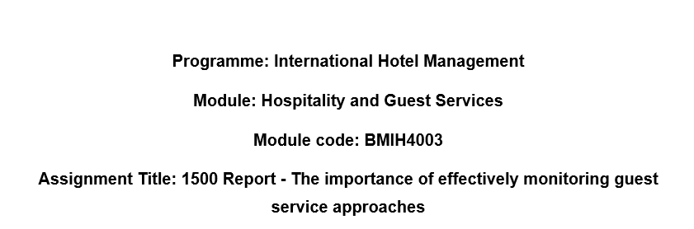

Executive Summary
Constantly adapting to new methods of customer service is crucial if the business want to succeed in the cutthroat hospitality sector. With an emphasis on reputation management and a solid service culture, this research goes into the essentials of efficient guest service monitoring. Reputation management is the process of monitoring and controlling a company's public image, both online and off. A strong service culture promotes an all-in dedication to satisfying customers. We also discuss issues of brand uniformity, hotel quality, client retention, and the influence of technology on the hospitality sector. Paying close attention to these details is essential for staying ahead in the competitive hospitality industry, satisfying customers, and ensuring long-term business viability.

Table of Contents
Executive Summary 2
1. Introduction 4
2. Main Findings 5
2.1 Reputation Management 5
2.2 Service Culture 5
2.3 Brand Consistency 6
2.4 Hotel Standards 6
2.5 Customer Loyalty 7
2.6 Future Technological Impacts 8
2.7 Service Failure 9
3. Conclusion 9
4. Recommendations 9
5. References 11

Introduction
In order to effectively meet consumer expectations and sustain a prosperous business within the fiercely competitive hospitality industry, it is imperative to always adapt to evolving market conditions. The crucial factor in delivering a remarkable and pleasurable experience to clients lies in the provision of exceptional guest service. This study examines significant aspects related to the monitoring and improvement of these systems, with a particular focus on reputation management and service culture (Chepkwei, 2021). In the contemporary era characterised by the abundance of information, the online reputation of a firm has become a critical determinant of its success, thereby elevating the significance of reputation management to unprecedented levels. In conclusion, this discourse will briefly address several topics pertaining to the sustenance of success within the hospitality sector. These include the importance of maintaining brand consistency, adhering to hotel standards, fostering client loyalty, and considering the potential ramifications of evolving technologies.
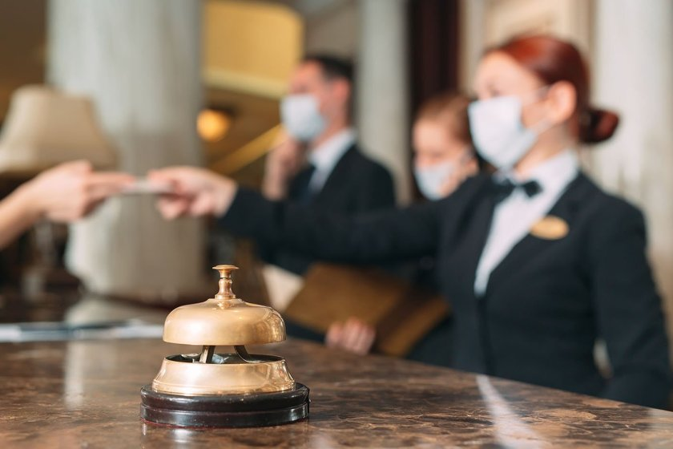
Figure 1 Hospitality Industry (The Economic Review, 2021)

Main Findings

2.1 Reputation Management
In the hospitality industry, visitor opinions matter greatly to the bottom line, making reputation management crucial. In today's technological world, it is crucial that hotels actively manage their online and offline reputations. Businesses must keep a close eye on their reputation in the age of social media, online review sites, and word-of-mouth recommendations (Dewi et al., 2022). Following, engaging with, and learning from consumer comments is essential. Negative remarks can be lessened if responded to promptly and expertly, while favourable comments can be used to strengthen the brand. A hotel's long-term success and client loyalty are both bolstered by its reputation, which is why it's important to invest in reputation management.

2.2 Service Culture
A strong service culture is the lifeblood of any thriving hotel or other hospitality business. It represents the collective beliefs, mindsets, and actions that motivate staff to provide consistently excellent service to customers. When employees feel invested in the company's mission, they are more likely to take steps that are consistent with that vision (Kimes and Ho, 2018). It involves more than just knowing what to do; it also requires an in-depth familiarity with visitor requirements and the ability to anticipate and surpass those requirements. With customer loyalty increasingly dependent on memorable experiences, it is more important than ever to build a service culture that makes customers feel appreciated and cared for.

2.3 Brand Consistency
The efficacy of the hotel industry is significantly contingent upon the preservation of a cohesive brand identity. The objective is to preserve a uniform brand voice and commitment throughout all interactions with customers and clients. The decision-making process of hotel visitors is influenced by the promises made by the hotel brand. Consequently, any inconsistency between the brand's claims and the actual experience could potentially have a detrimental impact on the hotel's reputation (Henderson 2018). The establishment of a consistent brand experience is crucial, encompassing several aspects such as the decor, customer service approach, and linguistic choices. In the hotel industry, adherence to brand standards can serve as a strategic approach for businesses to enhance client loyalty and differentiate themselves from competitors.

2.4 Hotel Standards
The criteria for a hotel's standards encompass the essential prerequisites for ensuring a gratifying experience for each guest. These benchmarks encompass several aspects such as the cleanliness of guest rooms, availability of services, adherence to prescribed safety procedures, and other related concerns (Punzon, 2020). The maintenance of these standards at all times is crucial for meeting the expectations of guests and maintaining the reputation of the hotel (Gačnik, 2019). They establish the foundation for instructing individuals to meet the prescribed benchmarks of excellence and efficiency. The sustained viability of a hotel within the contemporary and fiercely competitive landscape of the hospitality industry is contingent upon the ability to not just fulfil but beyond the expectations of guests, all the while minimising expenses and enhancing efficiency.

2.5 Customer Loyalty
The achievement of a hospitality enterprise is contingent upon the ability to sustain customer satisfaction. This phenomenon signifies the profound bond that patrons establish with a company and the level of trust they place in this company. The significance of repeat clients lies in their ability to contribute to a company's financial growth through increased spending and their potential to generate positive word-of-mouth on the company's exceptional service (Derval and Derval, 2018). The key factors in fostering customer loyalty are consistently surpassing visitor expectations, delivering customised experiences, and expressing gratitude for their patronage. Loyalty programmes, promotions, and personalised customer care have all demonstrated efficacy in achieving this objective (Susilowat and Pratomo, 2022). In a sector where the acquisition of repeat clientele and positive word-of-mouth recommendations are of utmost importance, it is imperative for a hotel establishment to establish and sustain a dedicated customer base in order to ensure a steady flow of revenue and enhance its standing within the industry.

Figure 2 Hotel Guest Loyalty (Amadeus-hospitality, 2022)

2.6 Future Technological Impacts
The hotel industry is on the brink of a forthcoming technological revolution that will significantly alter the manner in which customer care is delivered. Artificial intelligence (AI), the Internet of Things (IoT), and augmented reality (AR) are poised to significantly transform the manner in which we engage with and cater to our clientele. The efficiency of meeting guests' demands can be enhanced through the utilisation of chatbots and virtual concierges powered by artificial intelligence (Denizci Guillet et al., 2016). The utilisation of Internet of Things (IoT) devices enables individuals to enhance the comfort of their surroundings while simultaneously achieving cost savings on utility expenses. Augmented reality enables the realisation of virtual tours and various immersive experiences. Nevertheless, the continuous surveillance of these technologies is important in order to ensure their seamless integration and safeguard sensitive data (Nobar and Rostamzadeh, 2020). In order to maintain competitiveness and effectively address the increasing needs of technologically proficient contemporary travellers, it is imperative to be abreast of these advancements while also minimising potential service disruptions.

2.7 Service Failure
The surveillance of service failure holds significant importance within the realm of the hospitality industry. Regardless of the level of preparedness, unforeseen obstacles will invariably arise. When effectively managed, dissatisfied customers have the potential to transform into loyal advocates for a company. The expeditious identification, assumption of responsibility, and settlement of problems are integral elements (Chepkwei, 2021). This demonstrates a commitment to client satisfaction and mitigates the potential for adverse publicity. The perception of the firm by the customer may potentially be enhanced following a successful service recovery procedure, which could encompass financial restitution or a formal expression of regret (Latif et al., 2020). To mitigate future service disruptions and ascertain the underlying factors contributing to existing ones, it is imperative to maintain a continuous monitoring system for service failures.

Conclusion
It is imperative to be updated on the latest trends and industry dynamics within the highly competitive hospitality sector. This research has comprehensively examined various aspects, including reputation management and service culture, shedding light on the key elements that contribute to the success of a business. A firm's success relies on several critical factors, including brand consistency, adherence to high standards, fostering client loyalty, and maintaining a receptive attitude towards potential future technological improvements. Furthermore, it is imperative to proactively address service-related issues to maintain a favourable reputation. The sector can effectively meet the demands of contemporary discerning tourists by adhering to the following set of rules.

Recommendations
The hotel sector is characterised by intense competition, necessitating adherence to some fundamental principles for firms to achieve success. The significance of adopting technology to enhance the visitor experience and optimise business operations cannot be exaggerated (Sa and Chai, 2020). Cultivating a service-oriented culture that places utmost importance on client happiness is of equal significance. Ensuring brand integrity, enhancing hotel quality, and fostering client loyalty are paramount. By incorporating loyalty programmes, delivering personalised experiences, and actively seeking customer feedback, businesses can enhance customer retention and generate favourable word-of-mouth (Kulakhmetova et al., 2022). By adhering to these prescribed principles, enterprises can not only endure but also flourish inside an escalatingly competitive industry, thereby delivering the type of indelible encounters that contemporary astute travellers have grown accustomed to anticipating.

References
Amadeus Hospitality., 2022. 2023’s Key to Hotel Guest Loyalty: A Comprehensive Guide. [online] www.amadeus-hospitality.com. Available at: https://www.amadeus-hospitality.com/guest-loyalty/# [Accessed 12 Oct. 2023].
Chepkwei, A., 2021. STRATEGY IMPLEMENTATION IN HOSPITALITY INDUSTRY: GLOBAL PERSPECTIVE. Journal of Strategic Management, 6(1), pp.33-45.
Denizci Guillet, B., Kucukusta, D. and Liu, L., 2016. An examination of social media marketing in China: how do the top 133 hotel brands perform on the top four Chinese social media sites?. Journal of Travel & Tourism Marketing, 33(6), pp.783-805.
Derval, D. and Derval, D., 2018. Designing luxury brands (pp. 77-104). Springer International Publishing.
Dewi, K.I.D., Komala, I.G.A.M.K., Susyarini, N.P.W.A., Armoni, N.L.E. and Antara, D.M.S., 2022. The influence of excellent service by butler service on guest satisfaction at Tanadewa Villas & Spa. Journal of Applied Sciences in Travel and Hospitality, 5(1), pp.1-9.
Gačnik, A., 2019. Historic Hotels: Between Authenticity, Creativity, Innovation and Participation. In Creating and Managing Experiences in Cultural Tourism (pp. 137-153).
Henderson, J.C., 2018. Remembering the colonial past: Heritage hotels and the legacy of the Sarkies brothers in South East Asia. Asian Journal of Tourism Research, 3(2), pp.23-44.
Kimes, S.E. and Ho, J., 2018. Revenue management in luxury hotels. Journal of Revenue and Pricing Management, 17, pp.291-295.
Kulakhmetova, G., Aktymbayeva, A., Assipova, Z., Baoleer, B. and Koshkimbayeva, U., 2022. Current Problems In The Tourism And Hotel Industry Taking The World's Tourist Cities As An Example. GeoJournal of Tourism and Geosites, 43(3), pp.841-849.
Latif, K.F., Pérez, A. and Sahibzada, U.F., 2020. Corporate social responsibility (CSR) and customer loyalty in the hotel industry: A cross-country study. International Journal of Hospitality Management, 89, p.102565.
Nobar, H.B.K. and Rostamzadeh, R., 2018. The impact of customer satisfaction, customer experience and customer loyalty on brand power: empirical evidence from hotel industry. Journal of Business Economics and Management, 19(2), pp.417-430.
Punzon, J.G., 2021. Digital Customer Journey in the Luxury Hotel Experience: A Case Study Approach. In Advanced Digital Marketing Strategies in a Data-Driven Era (pp. 246-260). IGI Global.
Sa, M.L.L. and Chai, Y.K., 2020. Managerial orientations and business performance in small and medium tourism accommodation businesses (SMTABs): A resource advantage-knowledge creation approach. The International Journal of Entrepreneurship and Innovation, 21(1), pp.17-37.
Susilowati, S. and Pratomo, A., 2022. Hubungan Komunikasi Interpersonal Dan Kinerja Raffles Service Agent Pada Hotel Raffles Jakarta. Cakrawala: Jurnal Humaniora Bina Sarana Informatika, 22(1), pp.33-42.
The Economic Review., 2021. Optimism in the Hospitality Industry. [online] The Economics Review. Available at: https://theeconreview.com/2021/04/02/optimism-in-the-hospitality-industry/ [Accessed 12 Oct. 2023].

