RESEARCH PROJECT PROPOSAL
THE RITZ-CARLTON HOTEL

Student: Mariana Carolina Andrei
No:2024720
PERSONNEL RESOURCING AND DEVELOPMENT BMIH5005
LECTURER: KATHRYN ROBERTS

Table of Contents
Introduction and background 3
Aims and objectives 3
Research question 4
Discussion 4
Evaluation and conclusion 7
References 9

Introduction and background
The Ritz-Carlton Hotel Chain is so well-known in its industry that it has developed whatever is known as "The Ritz Mystique" (Ritzcarlton.com, 2022). The Ritz-Carlton hotels & restaurants are one of the globe's majestic guesthouses and are renowned for their luxurious lifestyle, breathtaking settings, and iconic provider. The Ritz-Carlton Hotel Company, L.L.C. was founded in 1983 after William B. Johnson bought The Ritz-Carlton, Boston and the privileges to the Ritz-Carlton title (Huang, 2021). This Boston icon sets the bar for all Ritz-Carlton hospitality industries around the globe in terms of providers, eateries, and amenities. Ever since the company has diversified its selection of the best accommodations on earth. As a result of The Ritz-Carlton Hotel Group's dedication to conserving iconic building structures, a few of these accommodations have been designated as national monuments. The Ritz-Carlton, Huntington Hotel & Spa is an instance of this.
Known for its iconic offerings and opulent accommodations that create truly memorable experiences in the best places to visit on earth, Ritz-Carlton is an award-winning, five-star luxury hotel and resort chain with locations all over the globe. The Ritz hotel in London has around four hundred ten employees. There are 136 private rooms at The Ritz London, including 25 penthouses and 111 guest rooms (The Ritz Hotel London. 2022). The three basic types of guestrooms are Superior, Executive, and Deluxe. Approximately sixty chefs are employed in their hotel in London.
Recently it has been observed that the hospitality industry has been facing severe challenges due to labour shortages worldwide. As per recent reports, in the UK a persistent shortage issue has arisen that has put the Hotel change and organizations from the hospitality industry on the verge of slowing down their businesses. Within the UK the vacancies only in the hospitality industry especially among hotel change have reached 1.1 million and per the reports of the office for National statistics of the UK stated that it has been regarded as the highest level of vacancy date as of the records of job vacancies within the UK since 2001 (Bbc.com, 2021). Labour shortage has been identified as a greater aspect of lower employee satisfaction and motivation within the organizations and companies and it also indicates the high employee turnover rate within the organizations. Therefore, for lowering their employee turnover rate and increasing their employee retention rate companies from the UK hospitality industry have been focusing on implementing strategies for providing higher satisfaction to their caste employees for mitigating the issue of shortage of labour within the market.

Aims and objectives
The paper aims to demonstrate the employee engagement functions of the Ritz hotel in London. Additionally, it seeks to outline employee engagement, explain why it's essential, and pinpoint elements that are essential for its successful execution. The goal of this paper is to recognize the key factors that influence employee engagement and appropriate methods for assessing it; to suggest pertinent folks staffing, advancement, achievement, and interaction tactics to boost employee engagement; to define obstacles that are impeding the achievement of employee engagement approaches' acquiescence and suggest methods for overcoming or reduce them, and to lay out an "employee experience" to encourage elevated amounts of employee engagement.
The objectives of this paper are to;
- Understand the influence of employee engagement on organisation success.
- Determine the role of employee engagement in the hotel business.
- Demonstrate the advantages and disadvantages of employee engagement in a business.

Research question
- How does employee engagement impact the revenue of a hotel business?
- What is the role of employee engagement in the hotel business?
- What are the advantages and disadvantages of employee engagement in a business?
- How does employee engagement influence organisation success?

Discussion

Importance of employee engagement in the hospitality industry
The hospitality sector in the UK, but all sectors, places a premium on employee engagement. Because the hospitality sector is focused on providing the best services, the staff members are the exclusive brand awareness. One mistake could help bridge the gap between a satisfied and enraged client. According to Madhani (2020), engaging established, qualified workers is the key to maintaining people on staff and loyal to the company because they are more adept at giving consumers a better encounter. A great team must be recruited, developed, and kept by businesses. A potential worker needs time to develop a very good result and understanding. For instance, a decent staff member will inspire customers to try more products in the restaurant, which will raise profits, and a terrific receptionist will be more accommodating and entice customers to come back, which will generate leads and promote customer loyalty.
Workers who interact with customers have the opportunity to infuse their individuality into the firm, and individuals who excel at it allow organizations to differentiate themselves from their rivals. Stevens et al. (2018), have stated that maintaining the staff content is essential to maintaining a high reputation because they serve as brand advocates. Staff members are a company's primary concern, not clients. If the manager is dedicated to unlocking the benefits of their workforce, the workforce is dedicated to supporting the success of the company. As per Rogers (2018), satisfied employees feel more included and are appreciative to work for the firm and believe they have a tone and an objective there. These individuals are more driven than most others and thus have a similar objective to the company's overall goal. Engagement enables hotels to operate at their maximum capabilities by fostering positive relations, improving production, and retaining skilled personnel.
Employees who are actively involved consistently outperform their peers and go above and beyond. They are assertive and often take the lead, which impresses both their higher-ups and their clients. The hospitality sector is in elevated need of employees who share these principles. Jagadale et al. (2021), have stated that members of the community of life depend on the aforementioned sector, as they all understand, to give them memorable experiences for consumers that are worthwhile spending their time on.

Impact of employee engagement on organisation profitability
Engagement is influenced favourably when staff members are aware of how effectively a firm's resources have been tended. Efficiency and involvement are closely related. Employee engagement is positively impacted by their awareness of the efficiency levels of the company. Employee engagement is influenced by four key job embeddedness, including organisation behaviour, ongoing implementation of individual initiatives, constructive performance measures, and organisation effectiveness. According to Przytuła et al. (2020), employees need to believe they have the necessary physical, mental, and sentimental assets to do their jobs as well as possible. An organisation must also understand how to share with and inspire its staff members about its successes. Staff members can thus pertain their successes to their achievement and comprehend how their effectiveness directly affects the success of the organisation overall. It helps to increase employee engagement in this way. Greater economic results, increased productivity, increased customer satisfaction, and reduced staff turnover are all linked to increased interaction.
The three facets of employee engagement are cognitive, emotional, and behavioural. The cognitive component focuses on how individuals perceive and hold certain opinions about the company, its executives, and the labour environment. The emotional component has to do with the individual's outlook upwards to the company and its leaders—whether it is favourable or unfavourable. Kooij et al. (2018), the behavioural domain affects the personal viewpoint. The behavioural component of interaction encourages the employee's courage to take forth voluntary effort on the job, providing the organisation with a value-added advantage.
Employers encounter investments that increase a company's profitability by four times over non-investments. Establishing the help and services one's squad try to remain involved has therefore obvious value. Staff members are more inclined to take part in advertising campaigns and promote brands when they are well-informed and deeply active. El Junusi (2020), has stated that once staff members engage in meaningful media marketing and product contribute to a positive, they can improve more people and generate more revenue for the company. Employee engagement also helps the organisation to successfully retain employees.
Businesses that have engaged employees perform better. Increased output is achieved. Staff morale is higher when they are happy and engaged in their work. Engaged workers will use their systems to recommend quality players to the company. Since motivated workers provide mutual quality and reliability, consumer trust rises. Additionally, motivated workers are more likely to consider the big picture and they are aware of one‘s role in the organisation, the significance of what they do, and how it can impact the firm's performance. The state of the company's finances is affected by this one.

Employee engagement development
The concept of employee engagement created the impression that it is an aspect the company must handle, nurture, and improve, in addition to a concept that Behavioral Economics does a good job of explaining. According to this concept, a sequence of conversations among stakeholders can result in commitments that are interdependent on one another. According to Khodakarami and Dirani (2020), employee engagement is seen as a means by which individuals can repay their employers by developing loyal, trustworthy, and reciprocal obligations. Employee engagement calls for both calls and behaviour because people are an organization's most important resource. To help them assume what they do, top leadership must inform employees of the proposed regulations that they will be implementing. Management, which serves as the greatest source of achievement, must be connected to employee engagement.
People have voiced and use themselves during appearances when they are intellectually, psychologically, and biologically engaged. Committed employees are always excited about their jobs and offer improvements to assist the company advance. Peláez et al. (2020), have stated that studies are the most effective way to learn about employees' opinions and experiences toward the company to gauge employee engagement. A role-based approach that paid close attention to the kinds of behaviours that workers should exhibit to support organisation effectiveness. Work role bearer position, that is described in the position description, businessman involvement, that includes coming up with a new idea, group member involvement, that perceived competitive in and taking actions as a group, chosen profession role, that also aids in enhancing one's training and expertise, and institutional participant involvement, that entails conducting charitable work that advances the growth of the business, are the main aspects.
The results of worker, economic, and company culture are anticipated by employee engagement. As per Tse (2022), in response to a rising international market, expensive and rare funds, and high cost of production, numerous companies have reorganised themselves, allowing them to implement personnel cutbacks. As a result, the workers feel less motivated to work toward the organization's objectives because they believed they would have to leave the company once they reached retirement age. However, business effectiveness mainly results from meeting basic human needs at work, including clarifying intended results and increasing personal development opportunities. In addition to this, many companies place a high priority on the welfare of their workers because they overspend on recruiting new staff, developing, making money, and keeping clients loyal. The vast majority of staff want to grow personally through their employment, and many anticipate that their jobs will be fulfilling and communally helpful. Staff members who have a favourable reaction to their work were given better financial performance than those who have an adverse reaction.

Methodology
The study would follow a primary research method measuring the influence of the employee engagement within the hotel, “The Ritz Mystique”. The primary data of this research would be collected from the staff of this hotel by conducting a survey. Service has been identified to be a relatively easy strategy for administration and surveys can be conducted within less time in comparison to other Data Collection methods especially interviews. This method has been regarded to be more cost-effective than other Data Collection methods. Survey also enables the study table upper for conducting their study remotely and therefore prevent or reduce geographical dependence on the result and provide non-bias data to the study (Moraga et al. 2020). Most importantly advanced Statistical Techniques have been observed to be utilized for analyzing survey data for determining statistical significance reliability and validity. Therefore analyzing survey data is much easier in comparison to other methods. Along with some advantages they are some desert advantages as well the method decreases the encouragement among the respondents for providing honest and accurate answers and within the survey, the responses have been limited and most of the time, the respondents are unable in providing their true feelings in the survey answers.
Within this study, the staff of this hotel company would be contacted via email which would be collected from their job profiles on LinkedIn. A questionnaire set would be developed and distributed among the staff members of these hotels and the collected data would be utilized for statistical analysis. A set of secondary sources especially journals should also be utilized for reviewing the reliability of the data and also get an expert opinion on the obtained responses (Baker, 2019).

Evaluation and conclusion
This data depicts the Countrywide Newly built Current societal employee engagement rating in the UK from 2011 to 2020. The employee engagement rating varied over the evaluation period, achieving a proportion of 77 per cent in 2020, as shown. Between 2014 and 2020, the employee engagement performance was better than the high-performing standard. The year with the highest employee engagement score was 2016, up 16 per cent from 2011 when a scoring system of 80 per cent has been documented.
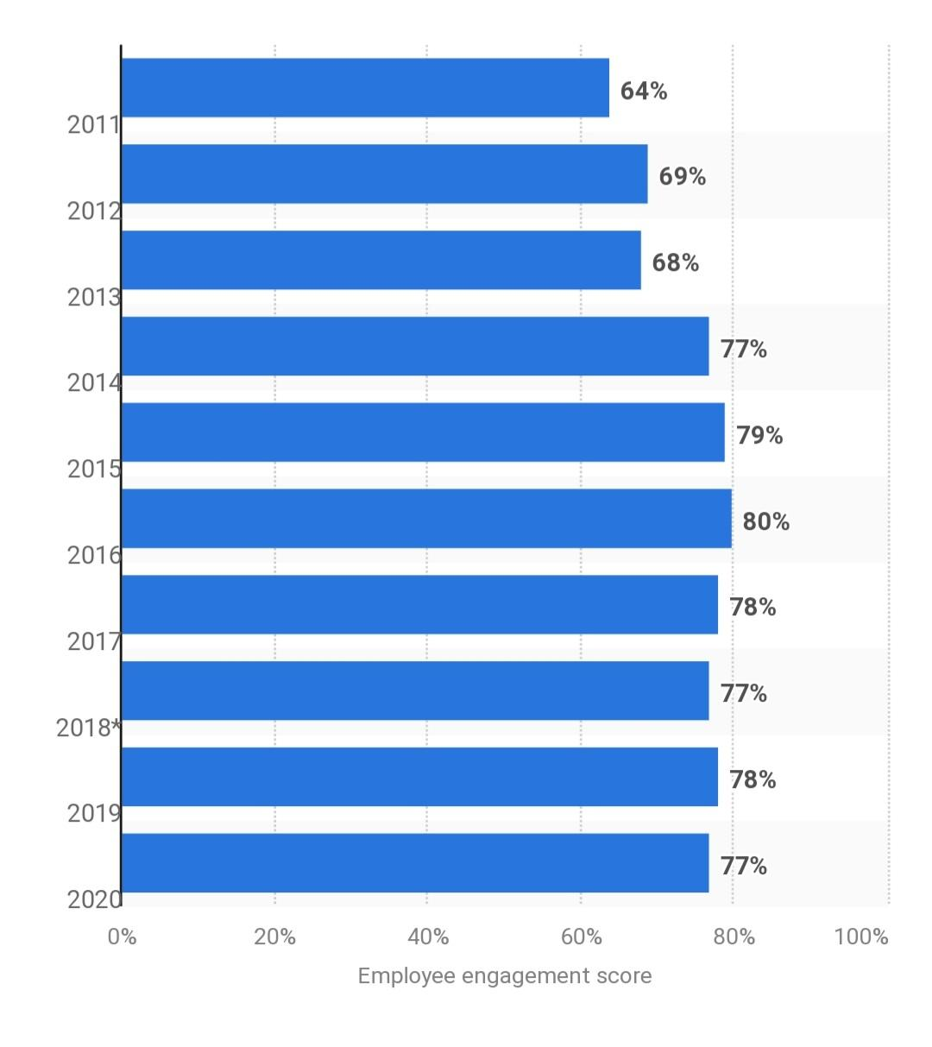
Figure: Employee engagement ratings in the UK
Source: (Statista Research Department, 2021)
By going through the data from statistics it can be concluded that the employee engagement rate in the United Kingdom is high. Therefore, the Ritz hotel in London has a higher chance of enhancing its present employee engagement scenario in the country. After reviewing the results of the various types of research and polls on employee engagement, it is clear that an increase in employee engagement will lead to greater worker participation and commitment to the workplace and, as a result, create an engaged team that will cooperate to attain organizational goals. In today's modern vibrant industry functioning democratic, hiring qualified workers is simply not that much; much more must be bound to preserve them engaged and motivated to support the organisational mission. Therefore, engagement is a condition in which a person is not only emotionally invested in their work but also cognitively dedicated to it, going further than the request of responsibility to advance the interests of the business.

References
Baker, V.R., 2019, May. The abductive approach to synthetic autonomous reasoning. In Micro-and Nanotechnology Sensors, Systems, and Applications XI (Vol. 10982, p. 1098224). International Society for Optics and Photonics.
Bbc.com, 2021. UK job vacancies reach 20-year high [online] Available at: https://www.bbc.com/news/business-58881124 [Accessed 20 October 2022].
El Junusi, R., 2020. Digital marketing during the pandemic period; A study of islamic perspective. Journal of Digital Marketing and Halal Industry, 2(1), pp.15-28.
Huang, Z., 2021. A Study On The Impact Of The Ritz-Carlton Hotel Culture On The Work Engagement Of The New Generation Employees. Turkish Journal of Computer and Mathematics Education (TURCOMAT), 12(11), pp.4032-4040.
Jagadale, S.R., Roy‐Chaudhuri, H. and Kadirov, D., 2021. Quality‐of‐life as chronotopefication and futurization: subsistence consumer experiences in India. Journal of Consumer Affairs, 55(1), pp.59-86.
Khodakarami, N. and Dirani, K., 2020. Drivers of employee engagement: Differences by work area and gender. Industrial and Commercial Training.
Kooij, D.T., Kanfer, R., Betts, M. and Rudolph, C.W., 2018. Future time perspective: A systematic review and meta-analysis. Journal of Applied Psychology, 103(8), p.867.
Madhani, P.M., 2020. Effective rewards and recognition strategy: Enhancing employee engagement, customer retention and company performance. The Journal of Total Rewards, 29(2), pp.39-48.
Moraga, J.A., Quezada, L.E., Palominos, P.I., Oddershede, A.M. and Silva, H.A., 2020. A quantitative methodology to enhance a strategy map. International Journal of Production Economics, 219, pp.43-53.
Peláez, M.J., Coo, C. and Salanova, M., 2020. Facilitating work engagement and performance through strengths-based micro-coaching: a controlled trial study. Journal of Happiness Studies, 21(4), pp.1265-1284.
Przytuła, S., Strzelec, G. and Krysińska-Kościańska, K., 2020. Re-vision of future trends in human resource management (HRM) after COVID-19. Journal of Intercultural Management, 12(4).
Ritzcarlton.com, 2022. Overview of the company [online] Available at: https://www.ritzcarlton.com/ [Accessed 20 October 2022].
Rogers, K., 2018. Do your employees feel respected. Harvard Business Review, 96(4), pp.62-70.
Statista Research Department, 2021 | Statista.com
Stevens, J.L., Spaid, B.I., Breazeale, M. and Jones, C.L.E., 2018. Timeliness, transparency, and trust: A framework for managing online customer complaints. Business Horizons, 61(3), pp.375-384.
The Ritz Hotel London. 2022. The Ritz London | 5 Star Hotel | Luxury Hotel In London. [online] Available at: <https://www.theritzlondon.com/?gclid=CjwKCAjw6MKXBhA5EiwANWLODLuwMT0EgDC7aJy34r_9PqUfLJZj6xmJS1wlyrtwCbrBHhT5C3NCFBoCU5UQAvD_BwE [Accessed 8 August 2022].
Tse, T., 2022. Work faster, harder, cheaper? Global, local and sectoral co-configurations of job insecurities among Hong Kong creative workers. Critical Sociology, p.08969205221087345.

