Student Name: Olufemi Idowu Afolabi Odubitan
Student Number: 2321211
Module Code: BMHP5015
Module Title: Changemakers: Building your Personal Brand for Sustainable Employment
Assignment Title: Component 2 – Assignment Report

Table of Contents
Title Page ……………………………………………………………………………………………..1
Table of Contents …………………………………………………………………………………….2
- Executive Summary ……………………………………………………………………………..3
- Job Role Overview ………………………………………………………………………………3
- Employability Skills Required …………………………………………………………………...4
- Self-Evaluation Against the Role ……………………………………………………………….5
- Evidence and Qualifications ………………………………………………………………….5-6
- Building My Personal Brand and Professional Identity …………………………………….6-7
- Networking Strategy ……………………………………………………………………………..7
- Action Plan / Timeline / Resources …………………………………………………………..7-8
- Conclusion ………………………………………………………………………………………..8
References ………………………………………………………………………………….9 – 10
Appendix ……………………………………………………………………………………11 - 19

1. Executive Summary
This report is a structured analysis of my progression towards the role of Nursing Associate, based on the experience that I have acquired over 7 years of working within health and social care. The Nursing Associate position is a clear pathway into higher level clinical practice and this is the route I want to take in my long-term career in the sector. The report starts with a brief discussion of the role and the competencies needed for effective practice. It then gives an evaluation of my current abilities, identifying my strengths as well as my developmental needs, through reflective analysis and reference to evidence of workplace ability. Attention is also paid to the development of my professional identity and personal brand because this is of key importance for employability in today's care environment. The final section presents a realistic action plan, with supporting timeline of the steps, training and preparation needed to achieve successful progression into the Nursing Associate role.
2. Job Role Overview
The Nursing Associate job advertised by Central London Community Healthcare NHS Trust (CLCH) is a Band 4 community-based role supporting the delivery of evidence-based nursing care in a wide range of patients in London. The post demands that applicants take responsibility for an assigned caseload, provide safe and effective care in accordance with the NMC standards and work within the boundaries of their competence (CLCH, 2025). Key duties include performing a variety of clinical procedures, monitoring the conditions of patients, maintaining accurate records, supporting care planning and escalating concerns appropriately to registered professionals (See Appendix A). The role is part of a multidisciplinary team and requires the effective use of resources, good communication skills and the ability to work alone and collaboratively (CLCH, 2025).
The person specification highlights the requirements for applicants to be on the NMC register, have a Level 5 foundation degree specific to Nursing Associate practice and to have GCSE-level Maths and English. Essential experience requires previous experience working in a health or care setting, demonstrating continuing professional development, and being confident about working self-directed or as part of a team (CLCH, 2025).
The Trust emphasise the importance of digital competence, reflective practice, awareness of professional boundaries and following the NMC Code (Nursing and Midwifery Council, 2018). CLCH’s commitment to equality, inclusion, supervision, and career development reflects the supportive culture in which this role is situated.

3. Employability Skills Required
The job vacancy advertised by Central London Community Healthcare NHS Trust to fill the position of a Nursing Associate requires a combination of clinical competence, professional values and good interpersonal abilities (CLCH, 2025). The person specification highlights the importance of having a good understanding of the Nursing Associate scope of practice, as well as being able to work within a safe professional capacity in accordance with the NMC Code (Nursing and Midwifery Council, 2018). The role is based on clinical skills including monitoring observations, wound care support, delegated procedure execution, and identification of changes in the condition of a patient (See Appendix A). These skills must be applied with accuracy, attention to detail, and a commitment to evidence-based practice (CLCH, 2025).
Effective communication is essential. The job advert indicates the need for clear written, verbal and non-verbal communication when dealing with patients, families and professionals (See Appendix A). This is reflective of the broader need in the field of community care for practitioners who can be sensitive in adapting information to people with differing requirements and backgrounds (Cipta et al, 2024). Emotional resilience and empathy are also important as the role requires the support of individuals with varying levels of complexity, anxiety or health deterioration (CLCH, 2025).
The post requires the ability to work independently as well as being part of a wider multidisciplinary team. This implies that the employer expects reliability, accountability and confidence in the use of clinical judgement within the limits of competence (CLCH, 2025). Digital literacy is another important employability requirement of the role as the advertisement emphasises the importance of having staff who can use the NHS electronic system to record and retrieve information safely (Hariyati et al 2024; CLCH, 2025).
Commitment to ongoing professional development is also necessary. The job advert mentions that applicants are expected to provide evidence of continued learning, which is in line with national expectations for Nursing Associates to keep their knowledge and skills up to date throughout their careers (See Appendix A). Together, these employability requirements reflect the high level of professionalism and adaptability that are expected in community nursing roles today.

4. Self-Evaluation Against the Role
My qualifications and long experience in care give me a realistic chance of stepping into this role. Nursing Associate role. I completed a BTEC Level 3 Diploma in Health and Social Care in 2017 which covered practical topics I still use daily (See Appendix B). That course helped me gain confidence speaking with relatives, following safe care routines, and supporting people with dementia. My Certificate of Higher Education in Skills for the Workplace in January 2025 was built on this foundation and improved my written work and understanding of topics such as public health and professional development (See Appendix B). Functional Skills level 2 in English and Mathematics, awarded in 2024, completes the essential academic requirements listed in the CLCH person specification (See Appendix B).
Over seven years working as a care assistant I have routinely taken observations, supported medication rounds under supervision, assisted with personal care and recorded information accurately. These tasks have sharpened my communication and observation skills and taught me how to raise concerns promptly. Colleagues and supervisors have commented on my reliability and calm approach during busy shifts, which suits the community focus of the advertised post.
There are clear areas I need to strengthen. I have limited experience of some clinical procedures expected at Band 4 and little direct community nursing exposure. Electronic record keeping is something I can use more confidently; my university modules introduced digital skills, but practical workplace use remains a development need. Moving into a regulated role will also require a deeper working knowledge of the NMC Code and confidence in clinical judgement when working with greater autonomy.
My plan is to use the next academic year and workplace opportunities to gain supervised experience with more advanced procedures, increase my use of NHS electronic systems, and study the NMC Code in depth so I can meet the full expectations of a Nursing Associate role.
5. Evidence and Qualifications
My qualifications provide a strong foundation for progressing into the Nursing Associate role, and the full evidence for each award is included in Appendix B. I completed the BTEC Level 3 Diploma in Health and Social Care in 2017, which introduced me to essential areas of adult care such as communication, safeguarding, infection control and supporting individuals with complex needs (See Appendix B). These subjects continue to influence my practice and align with the expectations set out in the CLCH job advert.
I recently achieved a Certificate of Higher Education in Skills for the Workplace (Health and Social Care), awarded in January 2025. This course strengthened my academic writing, digital skills, teamwork and understanding of health and social care frameworks.
My transcript, in appendix B, confirms successful completion of modules in the areas of professional development, psychology, public health and research methods, which are relevant to community-based roles.
To meet the entry requirements for the Nursing Associate programme I also completed Functional Skills level 2 in English and Mathematics in 2024. These qualifications show the literacy and numeracy requirements for safe record-keeping, medication tasks and accurate reporting (See Appendix B). Alongside formal qualifications, my seven years of experience as a care assistant gives me practical evidence of competence to carry out observations, record keeping, communication and supporting patient wellbeing.
Together, these qualifications and experiences form a strong basis for further development within the Nursing Associate pathway.
6. Building My Personal Brand and Professional Identity
Building a clear personal brand is crucial to be able to present myself professionally in front of employers (Philbrick & Cleveland, 2015). My brand will revolve around the strengths I can bring to care such as being reliable, compassionate, communicating effectively and having consistent standards of practice (Varghese & Khakha, 2025). To develop this brand, I will make sure that all my professional documents and online profiles display these qualities clearly and consistently.
One of the most important resources in developing my brand will be my CV (Philbrick & Cleveland, 2015). I will update it to include the years of care experience I have, my qualifications listed in Appendix B as well as specific duties I can confidently perform. I will also include a brief personal profile at the top of my CV that will outline my values, career goals and suitability for Nursing Associate pathway.
Another important resource is LinkedIn. I will use it for professional online presence, to connect with healthcare staff, follow NHS Trusts and share posts relating to training, learning or care practice (DeMilto, 2021). This way, employers can see my interest in continuous development. I will upload a clear professional photo, write a short summary of my experience, and list all training and certificates.
I also plan to keep a small portfolio which includes reflection notes, certificates, feedback from supervisors and evidence of training. This will be helpful in future applications and interviews (Jenkins, 2025). Maintaining positive relationships at work is another aspect of my brand as word of mouth and professional reputation plays a part in opportunities in health and social care.
7. Networking Strategy
A good networking strategy will help with my progression into the Nursing Associate role especially as the health and social care sector is reliant on professional relationships and the ability to work in a multidisciplinary team (Collin et al, 2025). My approach will be to work on bonding, bridging, and linking social capital, in accordance with the concepts covered in Week 2.
Bonding capital will be strengthened through maintaining good relationships with colleagues, seniors and supervisors in my current workplace (Thang, 2025). Regular communication, teamwork during busy shifts and asking for guidance when needed will help me access informal support, feedback and potential shadowing opportunities.
Bridging capital will be developed through engaging with staff across different departments and care settings. Attending in-house training sessions, Trust open days and internal workshops will help me meet professionals outside my immediate team. This increases awareness of different roles, including the experiences of current Nursing Associates.
Linking capital will involve connecting with individuals who hold authority or specialist knowledge, such as practice educators, clinical leads and university programme coordinators. Contacting them for advice on applications, entry requirements and learning expectations will support my long-term development. LinkedIn will also be used to follow NHS Trusts, join healthcare groups and connect with practitioners who can offer insight into the role, as previously mentioned. Appendix C provides a visual outline of professional relationships that will support this strategy.
8. Action Plan / Timeline / Resources
The plan outlined here is supported by the Gantt chart included in Appendix D, which sets out the key tasks, timescales and dependencies.
The first step for me is to complete Level 6, starting in January 2026. This is a significant requirement in the development of academic confidence and the strengthening of the study skills required in higher level clinical training. In addition to this, I plan to participate in Nursing Associate information sessions and workshops provided by NHS Trusts and local training hubs. These activities would help me to increase my understanding of the role and help me to prepare for the application process.
Further workplace experience is another priority. I will try to find opportunities within my current setting to take on more responsibilities associated with Nursing Associate such as assisting observations, reporting changes in patient's conditions and employing digital systems more often. This will help to address the development needs identified in my self-evaluation.
From May until July 2026, I will start to get ready with my application documents. This will involve updating my CV, writing a focused personal statement and collating evidence of qualifications and employment, which will be stored in my portfolio. The application will be submitted in mid-2026 followed by an interview preparation between July and August.
The final stage involves ongoing professional development, including review of the NMC Code as well as completion of short clinical courses if available. This will ensure that I am well prepared for the expectations of a regulated role.
9. Conclusion
This report has described my preparedness and future needs for growth as I strive to become a Nursing Associate. The role demands a high level of clinical skills, professionalism and communication skills, which are all backed by my qualifications and years of experience of caring for service users. The self-evaluation identified areas that are still to be strengthened, in particular clinical skills and digital confidence. My personal brand, networking strategy and organised action plan offer a clear way to achieve these goals. With continued learning, reflective practice and the steps set out in my Gantt chart, I am well prepared to progress into the Nursing Associate training route.

References
Central London Community Healthcare NHS Trust. (2025). Nursing Associate (Band 4) [Job advert]. NHS Jobs. https://www.nhsjobs.com/job/UK/London/London/Central_London_Community_Healthcare_NHS_Trust/Nursing_Associate/Nursing_Associate-v7570743
Cipta, D. A., Andoko, D., Theja, A., Utama, A. V. E., Hendrik, H., William, D. G., Reina, N., Handoko, M. T., & Lumbuun, N. (2024). Culturally sensitive patient-centered healthcare: a focus on health behavior modification in low and middle-income nations-insights from Indonesia. Frontiers in medicine, 11, 1353037. https://doi.org/10.3389/fmed.2024.1353037
Collin, V., Meiring, S., Noden, S., Barber, S., & Hayhoe, B. W. J. (2025). Training health and social care professionals in multidisciplinary team working: a document analysis of undergraduate educational requirements. Journal of Interprofessional Care, 39(3), 448–458. https://doi.org/10.1080/13561820.2025.2469298
DeMilto, L. (2021). How to Make LinkedIn a Career-Building Tool. AMWA Journal. 36(4) https://doi.org/10.55752/amwa.2021.91
Hariyati, R. T. S., Handiyani, H., Wildani, A. A., Afriani, T., Nuraini, T., & Amiruddin, M. H. (2024). Disparate Digital Literacy Levels of Nursing Manager and Staff, Specifically in Nursing Informatics Competencies and Their Causes: A Cross-Sectional Study. Journal of healthcare leadership, 16, 415–425. https://doi.org/10.2147/JHL.S470456
Jenkins L. S. (2025). Portfolio of learning in clinical training. South African family practice : official journal of the South African Academy of Family Practice/Primary Care, 67(1), e1–e5. https://doi.org/10.4102/safp.v67i1.6080
Nursing and Midwifery Council. (2018). The Code: Professional standards of practice and behaviour for nurses, midwives and nursing associates. Nursing and Midwifery Council. https://www.nmc.org.uk/globalassets/sitedocuments/nmc-publications/nmc-code.pdf
Philbrick, J., & Cleveland, A. (2015). Personal Branding: Building Your Pathway to Professional Success. Medical Reference Services Quarterly, 34, 181 - 189. https://doi.org/10.1080/02763869.2015.1019324
Thang, D. (2025). The Impact of Social Capital on Workplace Engagement, Productivity, and Organisational Success. International Journal of Humanities, Social Sciences and Education. https://doi.org/10.20431/2349-0381.1202004
Varghese, A., & Khakha, D. C. (2025). Attributes of compassionate care in clinical nursing practice from the perspectives of patients and nurses-A systematic review. Journal of education and health promotion, 14, 110. https://doi.org/10.4103/jehp.jehp_1872_23

Appendix A – Nursing Associate Job Advert
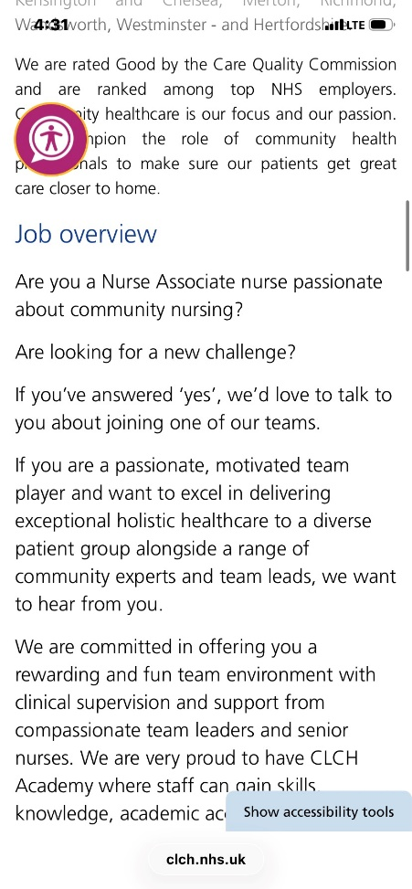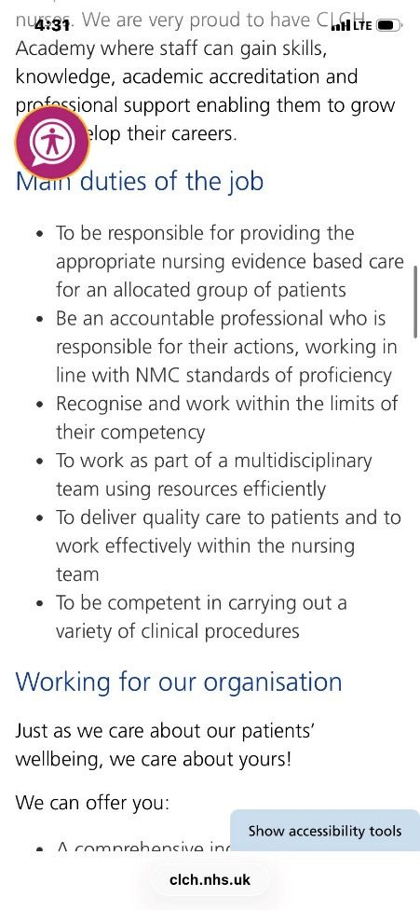
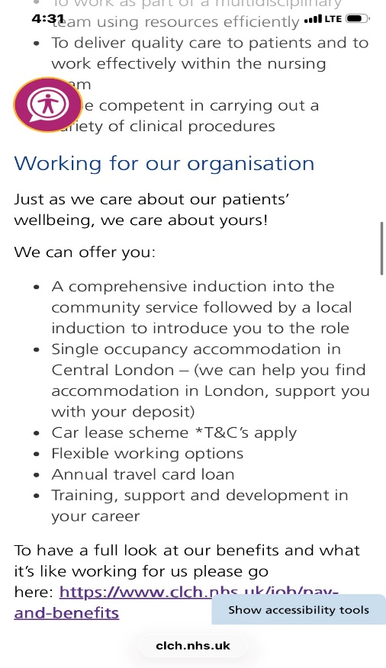

Appendix B - Certificates and Qualification Evidence
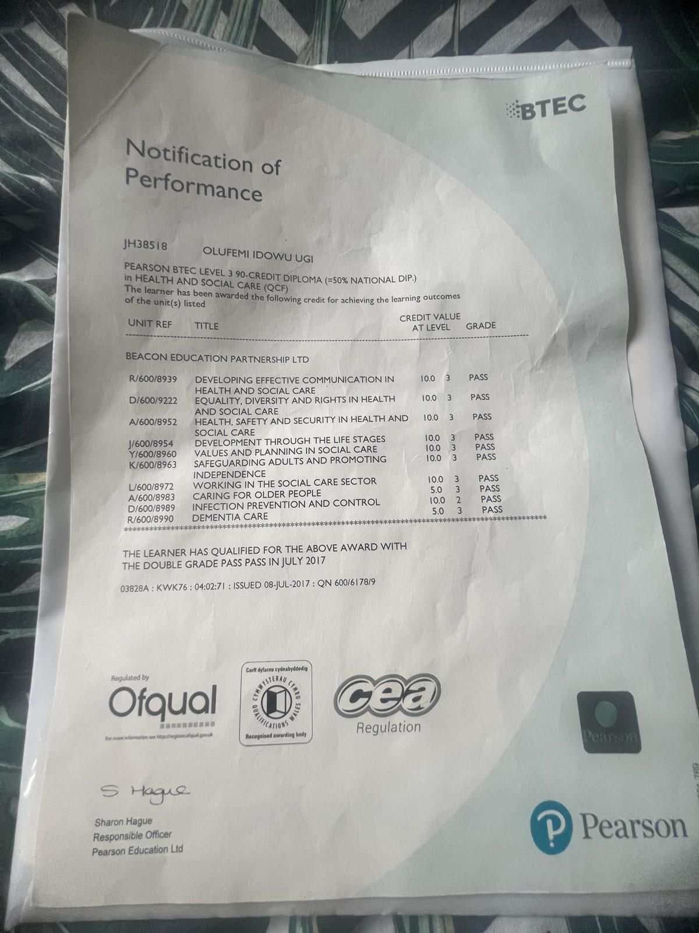
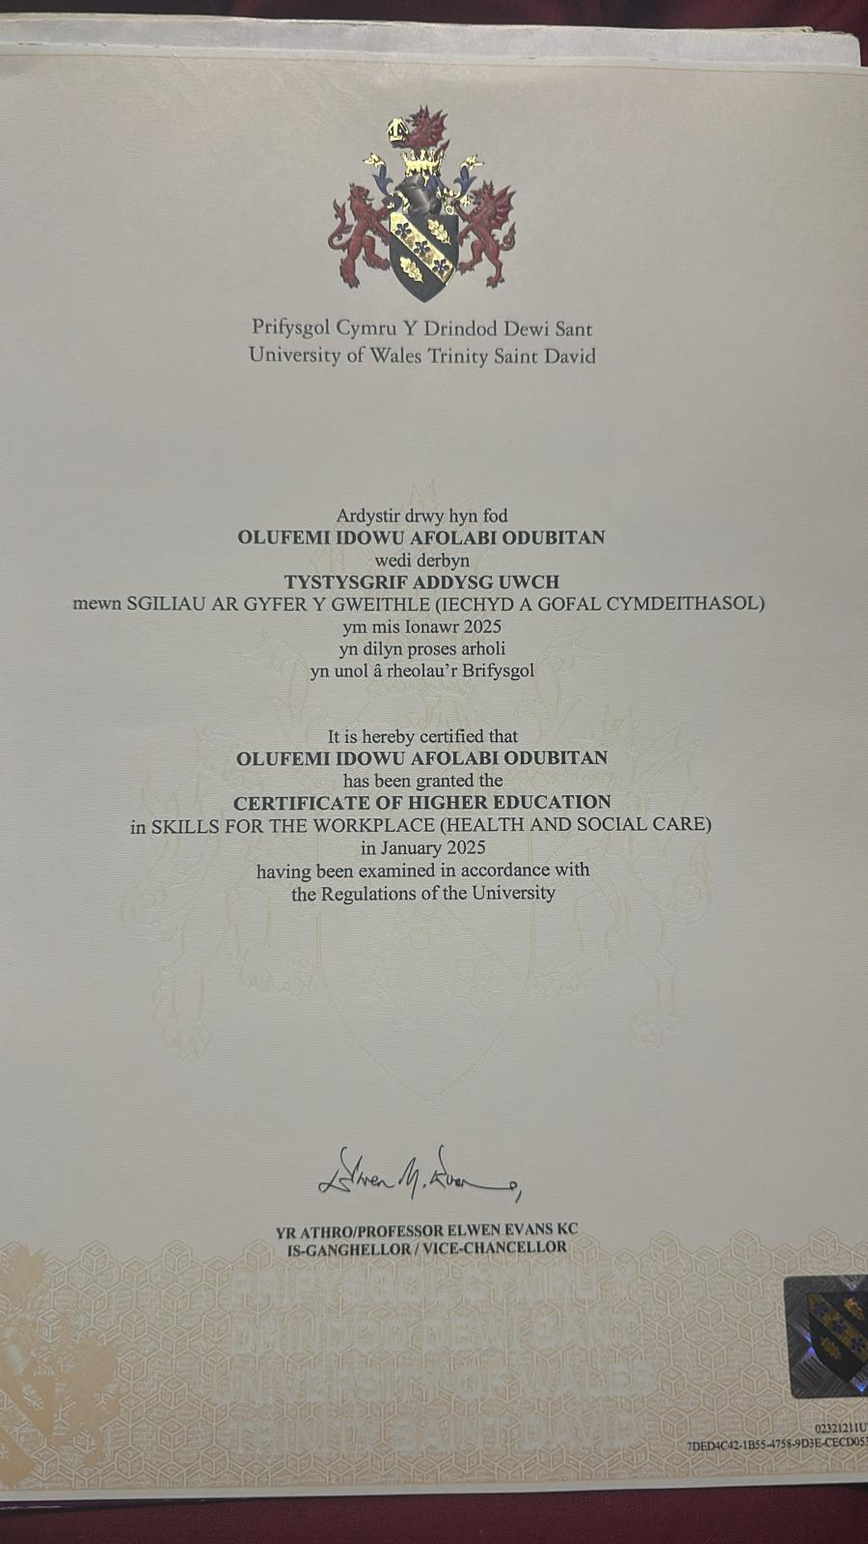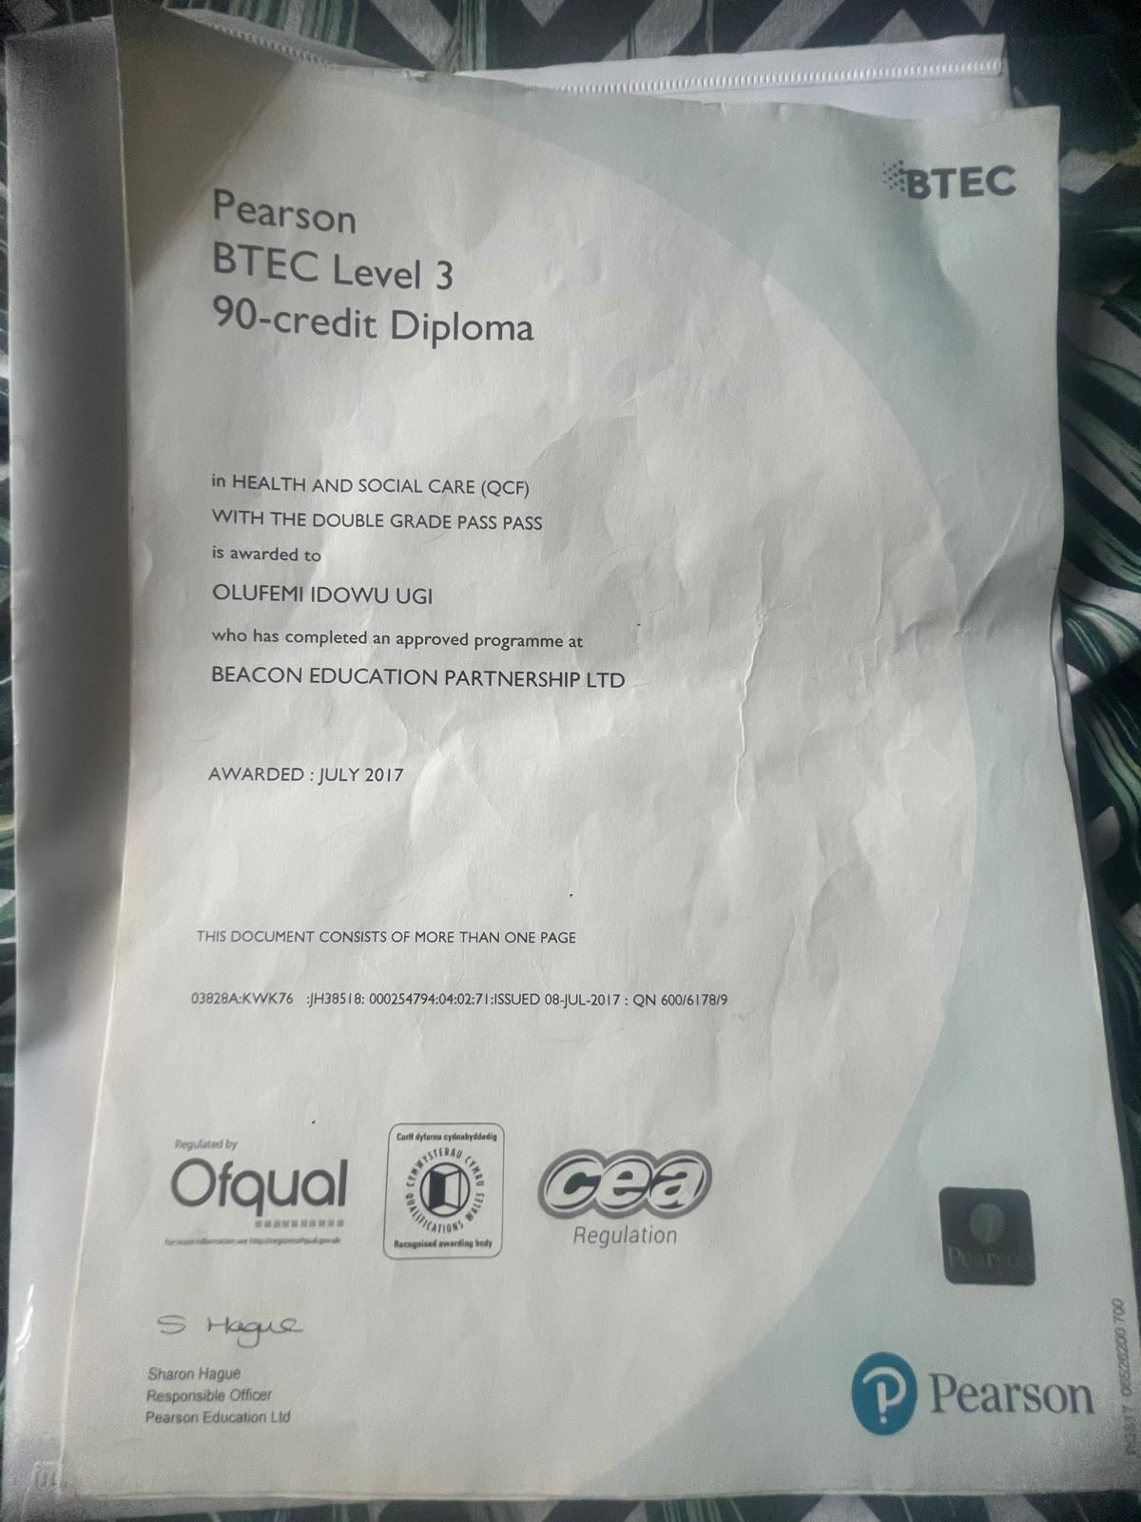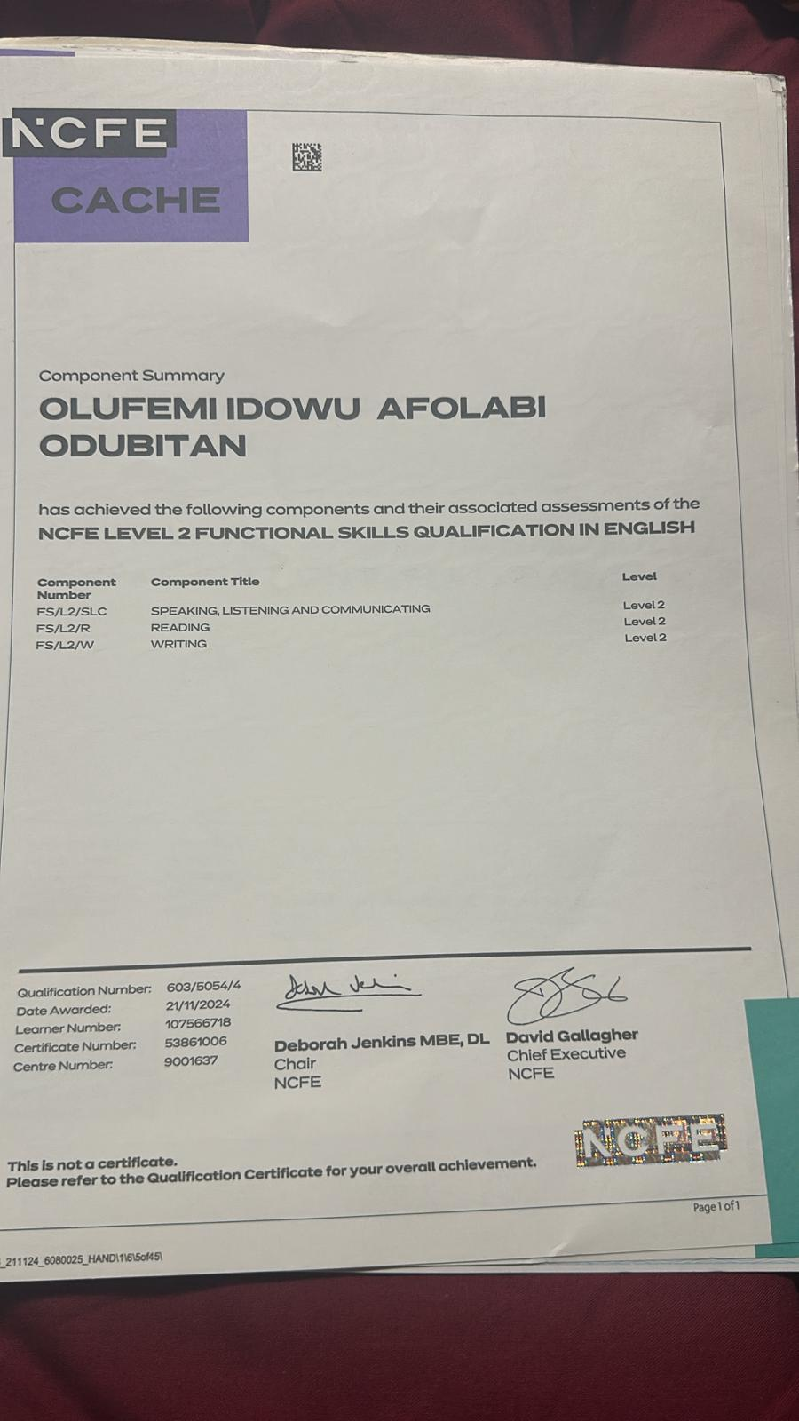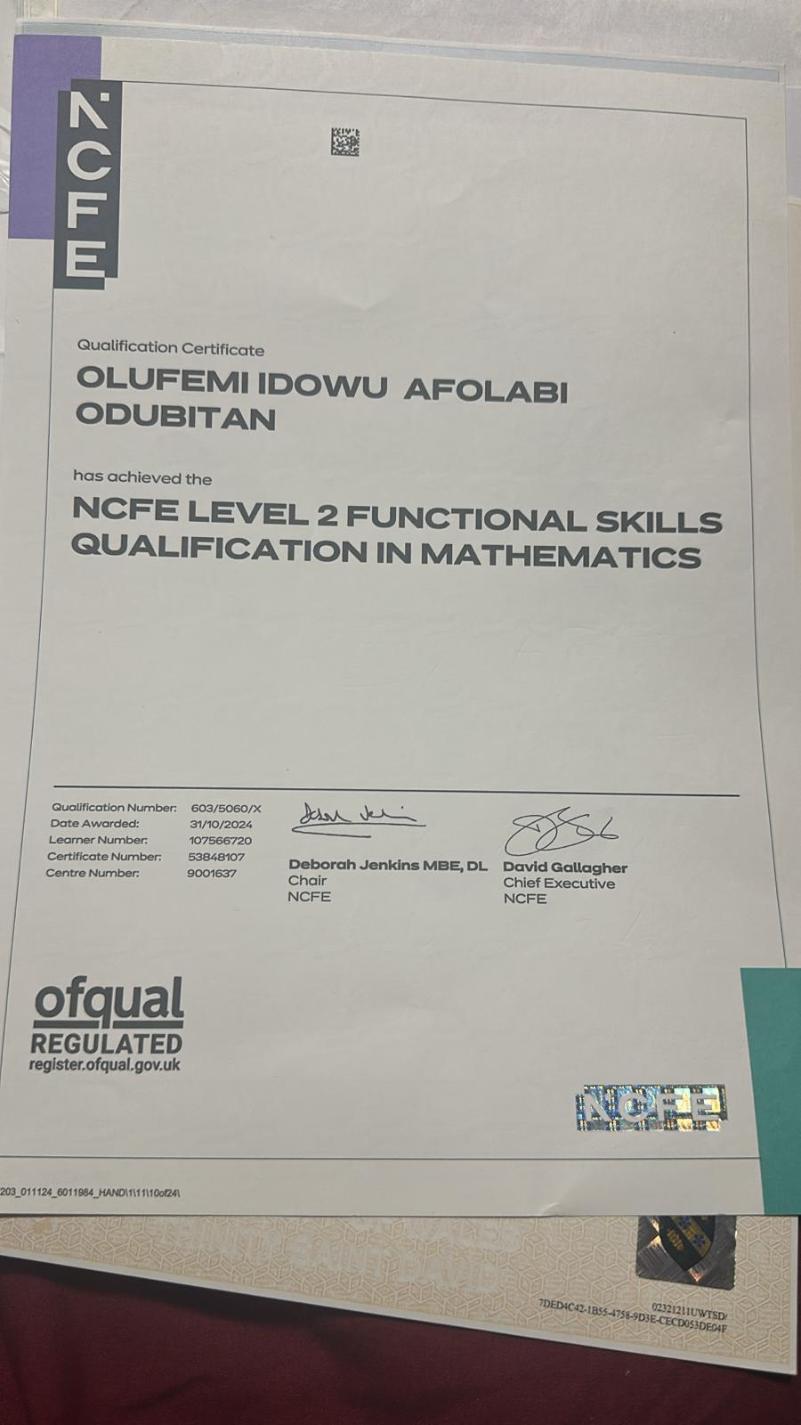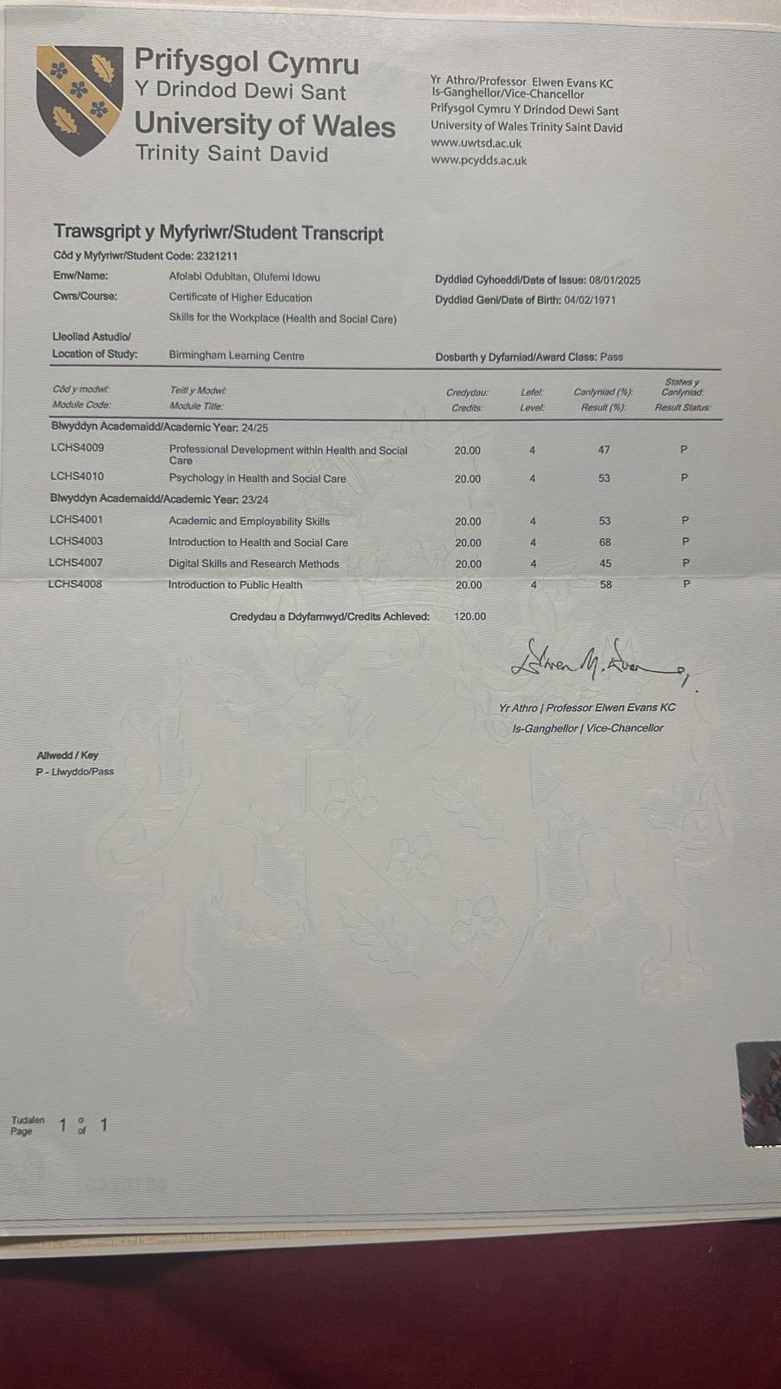
Appendix C - Professional Network Map
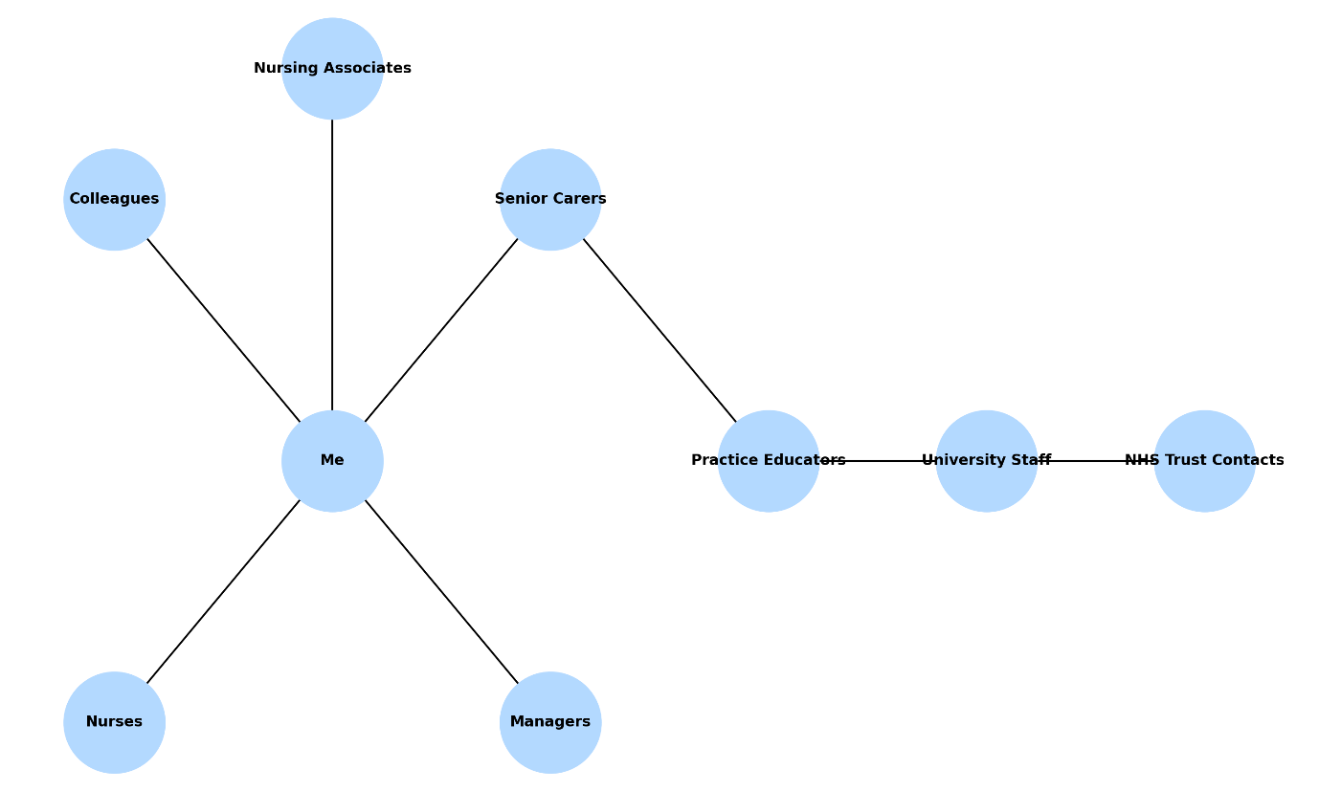

Appendix D – Career Progression Gantt Chart


