Report title: Organisational Report
Your name: Samadi Tawfiq
Student number: 2212531
Name of the recipients of the report (lecturer): Ernest Wavei
Date of the report(submission date): 31. 05.2024.
Module code & module name: Management & Organisational Behaviour BMIH5004
Wordcount: 1813

Introduction
Hilton Hotels, a globally renowned hospitality company, is a significant player in the hotel and tourism industry. Established in 1919 by Conrad Hilton, the company has expanded its footprint across the globe with a diverse portfolio of brands. This report critically evaluates Hilton Hotels at both corporate and individual unit levels, focusing on its organizational structure, culture, goals, recent change initiatives, and strategic direction. The assessment leverages relevant organizational theories to provide a thorough analysis.

Organizational Structure
Hilton Hotels operates under a divisional organizational structure, which is characteristic of large multinational corporations. This structure is segmented into various brands and geographical regions, each with its own operational independence but aligned with the overall corporate strategy. The divisional structure allows Hilton to cater to different market segments effectively, from luxury brands like Waldorf Astoria to more budget-friendly options like Hampton by Hilton.
Hilton’s activities, into three domains:
- Properties that Hilton directly owns are referred to as owned.
- Hotels are either operated by the properties or are franchised to third parties.
- Timeshare: Grand Vacations (a timeshare brand owned by Hilton).
Hilton Hotels & Resorts is in charge of the first two divisions—ownership, management, and franchise—while Hilton Grand Vacations, which was formed in 2008 after Hilton Hotels & Resorts became a publicly traded company, is in charge of the third division, timeshare. (Organimi 2024)

Advantages of divisional organization structure:
Flexibility: Divisions operate semi-autonomously, allowing them to quickly adapt to market changes and customer needs. This agility provides a competitive edge by enabling timely strategic or product adjustments.
Specialization: Each division focuses on a specific product line or market segment, fostering deep expertise and improving product development and customer service. Enhanced quality and customer experience can lead to increased customer loyalty and sustainable growth.
Internal Competition: Divisional structures promote internal competition, driving innovation and productivity as divisions strive to outperform each other. This friendly rivalry can boost overall company growth and profitability.
Growth Opportunities: This structure facilitates seamless expansion by allowing new products or markets to be integrated as new divisions. This approach minimizes operational disruptions and supports smooth organizational growth.
Performance Tracking: The semi-autonomous nature of divisions allows for clear performance assessment, making it easier to identify strong and weak performers. This transparency aids in targeted improvement strategies and maintains accountability. ( Indeed 2023)

However divisional organization structure has some challenges, let me give you some examples:
Resource Duplication: Each division operates with its own resources, leading to potential inefficiencies and higher costs due to duplicated functions like IT, marketing, and HR.
Inter-divisional Conflict: Competition for resources among divisions can lead to conflicts, diverting time and effort from strategic goals.
Misaligned Goals: Divisions may prioritize their own goals over the organization's overall objectives, potentially harming long-term strategy. Ensuring alignment between divisional and organizational goals is crucial.
Higher Costs: A divisional structure can be expensive, as each division needs its own management team and resources. The benefits must outweigh these additional costs.
Knowledge Sharing Issues: Independent operation of divisions may hinder the flow of knowledge and best practices, limiting opportunities for synergy and innovation. (Noumair 2017)

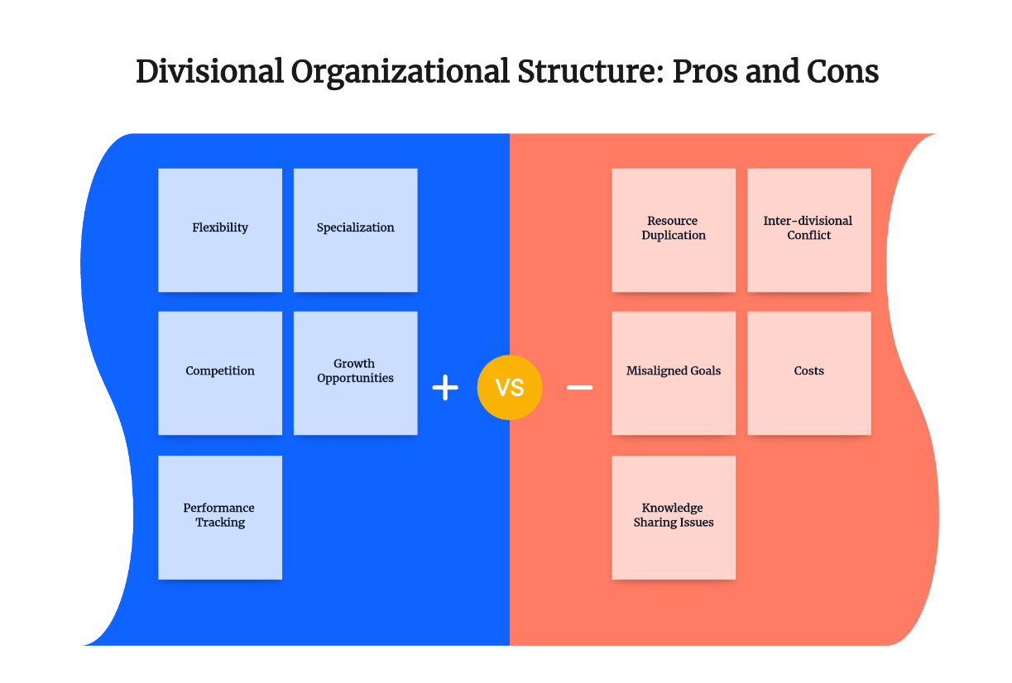
Boardmix (2024)
Companies who choose for a divisional structure, in my opinion, should weigh the benefits and drawbacks of the arrangement before deciding if it would be beneficial for their particular line of business.

Organizational Culture

Organizational culture is the collective self-image and style of the organisation; its shared values and beliefs, norms. (McLean, 1993) Edgar Schein's ( Schein 1980) made a level of culture, the model offers insightful information on the different corporate culture levels. It assists managers and leaders in evaluating, analysing, and reshaping the culture of their company to better reflect its mission, core values, and objectives. Schein's Model highlights the fact that organizational culture permeates all levels of an organization and is not only a surface-level phenomenon. It is composed of three interrelated layers: underlying assumptions, espoused beliefs, and artifacts and actions.
Why is organizational culture important?
- Culture shapes behaviour (Handy 1987)
- Strong brand identity
- Increases the authority of management (Cartwright 1999)
- Transformational power
- Employees engagement (Indeed 2023)

Hilton's culture is anchored in its mission "to be the most hospitable company in the world," with a focus on delivering exceptional guest experiences. The company's values, encapsulated in the shortening HILTON (Hospitality, Integrity, Leadership, Teamwork, Ownership, Now), reflect its commitment to service excellence, ethical conduct, leadership, teamwork, accountability, and prompt action. Hilton has an award-winning culture that is the result of a continuous effort to find talent who shares these values rather than a one-time initiative. Employing wisely in the short term helps successful businesses succeed in the long run. ( Gay 2016)
Hilton Hotels' organizational culture can be examined through Charles Handy’s four types of culture: Power, Role, Task, and Person. Hilton Hotels can be best described as having a combination of Role Culture and Task Culture.

Role Culture:
Structure and Hierarchy: Hilton Hotels has a well-defined structure with clear roles, responsibilities, and a strong emphasis on procedures and standards. This is characteristic of a Role Culture, where organizations rely on formalized processes and hierarchies to ensure smooth operations.
Consistency and Efficiency: The emphasis on maintaining high standards and consistency across all Hilton properties aligns with the Role Culture, which values efficiency and reliability in operations.

Task Culture:
Teamwork and Flexibility: Hilton Hotels also fosters a culture of teamwork and collaboration, especially in service delivery and problem-solving situations. Task Culture is evident in their focus on achieving specific goals and projects through flexible and dynamic team efforts.
Customer-Centric Approach: The company's commitment to providing exceptional guest experiences requires a flexible approach to meet diverse customer needs, aligning with the principles of Task Culture where achieving specific tasks and goals is prioritized.
Hilton Hotels exemplifies a blend of Role Culture, with its structured and standardized processes ensuring consistency and efficiency, and Task Culture, with its emphasis on teamwork, flexibility, and customer-focused service. This combination allows Hilton to maintain high operational standards while also adapting to the dynamic needs of its guests. (turor2u 2018)

Organizational Goals
Hilton’s strategic goals are oriented towards growth, sustainability, and stakeholder value creation. The company's key objectives include:

- Global Expansion: Increasing its footprint in emerging and established markets.
- Sustainability: Achieving significant environmental and social sustainability targets, such as reducing carbon emissions and water usage.
- Digital Transformation: Leveraging technology to enhance guest experiences and operational efficiencies.
- Customer Loyalty: Strengthening the Hilton Honors loyalty program to build long-term customer relationships. (Hilton 2023)
.

Digital Transformation
Hilton has been at the forefront of adopting digital technologies to enhance guest experiences and operational efficiency. Initiatives such as the Hilton Honors app, digital check-in and check-out, and digital room keys have revolutionized the guest experience by offering greater convenience and personalization. (Johnson 2017)

Sustainability Programs
Hilton's "Travel with Purpose" initiative aims to drive sustainable operations and create a positive social impact. The company has set ambitious targets, such as reducing carbon emissions by 61% and doubling investment in social impact initiatives by 2030. ( Hilton Worldwide 2021)
- Positive Impact: Enhanced corporate reputation, cost savings from energy efficiency, and stronger community relations.
- Management Approach: Integration of sustainability goals into corporate strategy, continuous monitoring and reporting of progress, and engagement with stakeholders to ensure broad-based support.
Strategic Direction
Hilton's strategic direction is shaped by its vision to lead the global hospitality industry with innovative, sustainable, and customer-centric approaches. (Astrogrowth 2024)

Growth and Expansion
Hilton continues to pursue aggressive growth strategies, particularly in high-growth markets such as Asia-Pacific and the Middle East. The company is expanding its brand portfolio and entering new markets to diversify its revenue streams and capitalize on emerging opportunities. (Hilton 2024)

Sustainability and Corporate Social Responsibility (CSR)
Sustainability and CSR are integral to Hilton's strategic agenda. The company’s "Travel with Purpose" framework aligns with the United Nations Sustainable Development Goals (SDGs) and focuses on creating shared value for all stakeholders. (Hilton 2023)
Innovation and Technology
Hilton is committed to leveraging technology to enhance the guest experience and streamline operations. Investments in artificial intelligence, machine learning, and advanced data analytics are central to Hilton's strategy to stay ahead of the competition and meet evolving customer expectations. (Hilton 2023)

Customer Loyalty and Brand Strength
Hilton continues to enhance its Hilton Honors loyalty program to foster customer loyalty and increase repeat business. By offering personalized experiences, exclusive benefits, and seamless integration across its brand portfolio, Hilton aims to strengthen its brand equity and customer base. ( Hilton Honors 2024)

Analysis and Critical Evaluation

I use SWOT analysis (Humphrey 1960) to analyse Hilton Hotels.
Strengths
Strong Brand Portfolio: Hilton’s diverse range of brands caters to various market segments, ensuring broad market coverage and customer appeal.
Innovation and Technology: Continuous investment in technology enhances operational efficiency and guest satisfaction, providing a competitive edge.
Sustainability Leadership: Commitment to sustainability initiatives enhances Hilton’s reputation and aligns with global trends towards responsible tourism.
Weaknesses
Dependency on Global Travel Trends: Hilton’s performance is significantly influenced by global travel trends, making it vulnerable to economic downturns and geopolitical uncertainties.
High Operating Costs: Maintaining high service standards and extensive global operations involves substantial costs, which can impact profitability, especially during economic downturns.
Opportunities
Emerging Markets: Expansion into emerging markets presents significant growth opportunities due to increasing travel demand and economic development.
Technological Advancements: Leveraging new technologies can further enhance customer experiences and operational efficiencies, driving competitive advantage.
Sustainability Trends: Growing consumer preference for sustainable practices offers opportunities for Hilton to differentiate itself through its "Travel with Purpose" initiatives.
Threats
Economic Uncertainty: Economic fluctuations and global crises (e.g., pandemics) can significantly impact travel demand and hotel occupancy rates.
Intense Competition: The hospitality industry is highly competitive, with numerous global and local players vying for market share.
Regulatory Changes: Changes in regulations related to travel, labor, and environmental standards can pose operational challenges and increase compliance costs. (Momin 2024)

My Recommendations:
Enhance Digital Capabilities: Continue investing in digital transformation initiatives to enhance guest experiences, operational efficiencies, and data-driven decision-making.
Expand Sustainability Efforts: Further integrate sustainability into core business operations and communicate these efforts to enhance brand reputation and attract environmentally conscious travellers.
Strengthen Customer Loyalty Programs: Innovate and personalize the Hilton Honors program to increase customer retention and loyalty.
Diversify Market Presence: Explore new markets and diversify revenue streams to mitigate risks associated with economic and geopolitical uncertainties.
Employee Engagement and Development: Invest in employee training and development to maintain high service standards and enhance employee satisfaction and retention.
Conclusion
Hilton Hotels has demonstrated resilience and adaptability in navigating the dynamic hospitality industry landscape. Through its divisional organizational structure, strong organizational culture, and strategic initiatives focused on growth, innovation, and sustainability, Hilton has established itself as a leader in the global hospitality market. However, continuous efforts are required to address emerging challenges and leverage new opportunities to sustain its competitive advantage. By enhancing digital capabilities, expanding sustainability efforts, and strengthening customer loyalty, Hilton is well-positioned to achieve its strategic objectives and maintain its leadership position in the industry.

References:
Astrogrowth 2024. Hilton Mission Statement, Vision Statement Analysis, and Core Values. Hilton Mission Statement, Vision Statement Analysis, and Core Values - AstroGrowth [Accessed 24 May 2023]
Boardmix 2024. Divisional Organizational Structure: Pros and Cons Divisional Organizational Structure: Pros and Cons | Boardmix [Accessed 19 May 2024]
Cartwright J., 1999. Cultural Transformation
Daft, R. L., 2015. Organization Theory and Design (12th ed.). Cengage Learning.
Gay W., 2016. 4 Things Companies Can Learn From Hilton's Award-Winning Culture. 4 Things Companies Can Learn From Hilton's Award-Winning Culture (forbes.com) [Accessed 16 may 2024]
Indeed 2023. Pros and Cons of Implementing a Divisional Structure. Pros and Cons of Implementing a Divisional Structure | Indeed.com [ Accessed 20 May 2024]
Indeed 2023. 8 Reasons Why Organizational Culture is Important. 8 Reasons Why Organizational Culture is Important | Indeed.com [Accessed 23. May 2024]
Noumair D. A., 2017. Organization Development, 1st edition. Published by Pearson FT Press (May 17, 2017) © 2015
Organimi 2024. Hilton’s Organizational Structure. Hilton's Organizational Structure [Interactive Chart] | Organimi [Accessed 18 May 2024]
Handy C., 1996. Gods of Management. Published by Oxford University Press,
Hilton Worldwide. 2021. Travel with Purpose: 2021 Environmental, Social, and Governance (ESG) Report.
Hilton Worldwide Holdings Inc. 2023. Annual Report. Retrieved from Hilton's official website: Hilton Annual Report
Hilton 2023. Our Progress. Our Progress | Travel with Purpose | Hilton ESG [Accessed 23 May 2023]
Hilton 2023. Report. 2023 Hilton Travel with Purpose Report [Accessed 23 May 2024]
Hilton 2024. Hilton Expands Its Global Footprint with Plans to Enter 5 New Markets in 2024. Hilton Expands Its Global Footprint with Plans to Enter 5 New Markets in 2024 | Stories From Hilton [Accessed 23 May 2024]
Hilton Honors 2024. Hilton Honors - Earn Points, Hotel Rewards, and More [Accessed 23 May 2024]
Humphrey A., 1960. Swot Analysis
Johnson K., 2017 A Hilton exec explains how technology keeps the hotel chain relevant after nearly 100 years. How Technology Keeps Hilton Hotels Relevant (businessinsider.com) [Available 24 May 2024]
McLean A., 1993 “Intervening in cultures,” University of Bath Working Paper.
Momin A., 2024. Hilton SWOT Analysis: Your Helpful Guide to the Hotel Chain. Hilton SWOT Analysis: Your Helpful Guide to the Hotel Chain (pestleanalysis.com) [Accessed 23 May 2024]
Schein E., 1980. Schein model of organizational culture.
Tutor2u 2018. Handy’s Model of Organizational cultures. https://youtu.be/kRIc0W48qYY [Accessed 23 May 2024]

