Word Count Report 3836

Report into PESTLE Analysis as a Strategic Management Tool and Recommendations on the external threats and opportunities from Economic, Socio-Cultural and Technological Impacts to the Welsh Ambulance Service.



Executive Summary

This paper explores and analyses the external environment in which the Welsh Ambulance Service operates, highlighting why People Professionals optimise sustainability and strategy both the use of tools such as PESTLE and SWOT.
This report evaluates three key elements of the external environment that currently has and will have an impact on the strategic business and People goals’:
Economic, Socio-Cultural and Technology.

PESTLE is evaluated as a tool with some reference to the opportunity and threat sections of SWOT to plan the risks associated with the Economy, Socio-Cultural and Technological external emergent risks that are out of the business control as part of environmental scanning and emergent strategic purpose.

Recommendations are made on how the Trust can maximise its use of Human Capital by making cost savings and efficiency through advancing and innovative technology such as AI, enhancing the limited budget by transferring savings in automating access to services to workforce spend. These changes will create opportunities to boost current staff morale, increase recruitment and reduce attrition. Whilst external forces are out of the control of the organisation, by critically analysing the external impacts and horizon scanning the future can place WAST at a strategic forefront of access to emergency and urgent care in Wales.

Glossary

PESTLE Political, Economic, Social, Technology, Legal, Environment
PP People Professionals
SWOT Strengths, Weakness, Opportunity, Threats
ROI Return on Investment
VUCA Volatile, Uncertain, Complex, Ambiguous
WAG Welsh Assembly Government
WAST Welsh Ambulance Service NHS Trust
IMTP Integrated Medium Term Plan
ELDEST PIG Economic, Legal, Demographic, Ethical, Social, Technological, Political, International, Green
RPB Regional Partnership Boards

Contents
Executive Summary Page 2
Glossary Page 3
Section 1 Introduction Page 5
Section 1.1 Use of Strategic Planning Tools Page 6
Section 1.2 PESTLE as a Strategic Planning Tool Page 6
Section 1.3- Strategic Planning in Context – Environmental Scanning Page 7
Section 2.0 Socio-Cultural Impacts Page 8

Section 2.1 A Good Business Strategy Is Informed by People Factors Page 9

Section 2.2 Socio-demographic Impacts Page 9

Section 2.3 Impact of the Sociocultural Environment and Page 10
Complex Service Delivery

Section 3.0 Economy – Global Crisis of Economic Scale Page 12
Section 3.1 Globalisation - Economic Crisis Page 13

Section 3.2 Economic Growth and Employment Page 14

Section 3.3 Leaving the EU behind – Leaving Recruitment Challenged Page 14

Section 3.4 Balancing the books – Efficiency and Efficacy Page 15

Section 4.0 Technology Page 16
Section 4.1 The Digital Era- Industry 4.0 Page 16
Section 4.2 Transforming Healthcare – An Opportunity from a Threat Page 17
Section 4.3 Innovations in Technology Page 18
Section 4.4 The Future is Artificial Page 19

Section 5.0 Conclusion and Recommendations - Embracing Page 20
External Impacts as Opportunities

Section 5.1. Economy Page 20
Section 5.2 Socio-Cultural Page 21
Section 5.3 Technology Page 21
Section 5.4 Final Words Page 22
References Page 23
Appendix 1 PESTLE Analysis Page 39
Appendix 2 SWOT Analysis Page 42

- Introduction

1.1 Use of Strategic Planning Tools
The business environment thus People Professionals (PP) are in a constant state of flux, a business must be in a place to respond to current issues,
strategize to plan for the future (Chidiac, 2018; Taylor and Perkins 2019; CIPD, 2021; Cheese, 2021; CIPD, 2022). One way of analysing the managerial and business environment is by using tools such as ELDEST PIG, SWOT or PESTLE.

ELDEST PIG is an acronym for an expansion to PESTLE proposed by Taylor & Perkins (2019); Economic, Legal, Demographic, Ethical, Social, Technological, Political, International, Green. This is not a commonly used tool though the authors argue that due to changes such as an ageing population and globalisation that further headings need to be included in the analysis. PESTLE when used in the specific business context of the Welsh Ambulance Service (WAST) is sufficient as a tool to analyse changes to the external business environment (CIPD, 2021a), see appendix 1 for full PESTLE analysis on WAST.

SWOT is an acronym of Strengths, Weakness, Opportunity, Threat, a tool that seeks to identify rather than analyse, used to match goals with programmes and organisational capacities, and core knowledge on CIPD professional map (CIPD, 2021b), see appendix 2.
It differs from PESTLE in that it can lack detail and structure though similar as it allows an organisation to predict future threats. It aligns with PESTLE where opportunities might be through impacts such as innovative technologies and threats due to increases in interest rates.

1.2 PESTLE as a Strategic Planning Tool
PESTLE is an acronym for Political, Economic, Social, Technology, Legal and Environment which studies the key external factors that influence an organisation. It can be used in a range of different scenarios in strategic decision-making (CIPD (2021a), see Fig 1 below.

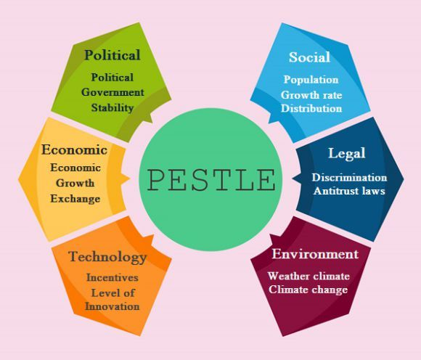
Fig. 1. PESTLE Infographic (Pinterest).

PESTLE was created by Aguilar (1967) and when considered against the three tools discussed briefly above, it develops strategic thinking of the external environment, enabling an organisation to forecast opportunities and threats, easing a more complex understanding of the wider business environment, though it does have its limitations.
In the field of organisational development and change, fixed methodologies such as PESTLE no longer adequately address the uncertainty and uniqueness of today's more complex change situations and more adaptive approaches to change are needed (Chidiac, 2018). Other disadvantages, such as insufficient data, analysis paralysis are clear (CIPD, 2021a), in today’s climate the pace of change can make this process a challenge to anticipate the future yet without it, the risks are far higher (CIPD, 2021a) (Cheese, 2021).

1.3 Strategic Planning in Context – Environmental Scanning
Aguilar (1967) cited in Aldehayyat (2015) defined environmental scanning as ‘the process of searching for and collecting information about events, trends and changes external to the firm that guide its future course of action’.
PESTLE analysis is part of this strategic planning process (Karami, 2012). An external business environment is an aggregate environment; a set of external factors that may have a direct or indirect impact on the performance and efficiency of an organisation which cannot be controlled (Janković, Mihajlović and Cvetković, 2016). Though there are limitations to using any tool, such as the need to repeat regularly particularly as an analysis is outdated quickly, when considered in the wider strategic process it is invaluable (CIPD, 2021a).

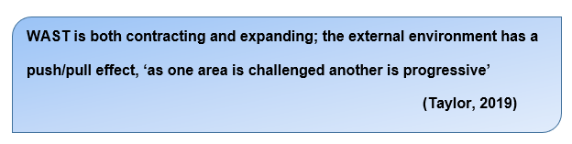

2.0– Socio-Cultural Impacts

Social issues have the potential to influence major change in how WAST operates, the most significant in WAST is the growing need for more flexible working practices and agile working (Mayne, 2022), this is impacted on by technology discussed further in section 4.0 and the likelihood of five generations in one workforce (Mercer, 2015; Cheese, 2021).
A study looking at flexible working concepts indicate that cultural effects and demographics differ across cultures, but workplace factors are constant across cultures (Nelson et al., 2017). Flexible working is a prominent issue for employees (CIPD, 2022a), looking at demographic factors and work context factors a study by Human Resource Management International Digest (2018) found that demographic factors vary among countries, but work context factors remain universal supporting the findings of Nelson et al (2018).
People factors are discussed in the next section to highlight where PP need to be at the forefront of workforce modelling and planning (CIPD, 2022b) ) informing strategies for the impacts such as changes in population demographics, cultural trends can have on WASTs People and Culture Strategy (WAST, 2022) due to changes in where our people are working, the way they are working, the impact the cost of living crisis and industrial unrest over pay rises. The lack of sustainable health and care workforce will be a significant barrier for enabling time, space and capacity for innovation within organisations (Kings Fund, 2022a)

2.1 A Good Business Strategy Is Informed by People Factors

CIPD (2021) propose that in order to create sustainable value creation, human capital is the ‘most important asset’. Bhattacharya & Wright (2005) argue that if human capital – our workforce is an asset then as with any asset it is considered as a risk to the return on investment (ROI) and therefore part of the Strategic Management Planning Process. The economy has had a significant impact on employment and remains so with sickness remaining high, with WAST having the highest sickness rate across the whole of the Welsh NHS at 9.7% (Welsh Assembly Government, 2022). Deakin (2022) report the impacts sickness can have on the economy, patient care, safety and staffing levels with line managers having a significant role in supporting the people profession (Waters, 2022; CIPD, 2022).

2.2 Socio-demographic Impacts
Socio-demographic impacts are the ways in which differences based on gender, race, nationality and location (Johnson et al., 2019), according to this study emergency admissions and attendance at Emergency Departments pre-pandemic were increasing, particularly in the under 25s and children of lower socio-economic status resulting in poor outcomes.
How WAST organise and improves accessibility services and safe staffing levels is vital to manage the increase in service demand and the knock-on effect on the wider health and social care system (WAST, 2022). Widening inequality is referred to as the “defining challenge of our generation” (Gimpelson & Treisman, 2015).
Areas of social deprivation as well as areas where access to healthcare is reduced will impact on health and wellbeing of the population it serves and the staff who live in these areas (Johnson et al., 2019; Pan, Biru & Lettu, 2021).
When considering socio-demographics with retention of staff, research from 2011 highlighted the main factors affecting recruitment and retention such as ageing population and inadequate numbers being attracted into the sector and high turnover of existing staff (Brunetto, Farr-Wharton and Shacklock, 2011), little has changed in 11 years, it has accelerated, compounded by the pandemic and subsequent further global recession from that in 2010 (Deakin, 2022).
Taylor & Perkins (2021) and Willett (2022) bring this to more recent times by concluding that these social problems lead to ill-health, poor mental health which in turn impacts on employee engagement, performance and increased absences, a significant challenge for PP and line managers (CIPD, 2022; (Waters, 2022; Deakin, 2022) and an issue across the whole health economy (NHS, 2022).

2.3 Impact of the Sociocultural Environment and Complex Service Delivery
The external environment is becoming increasingly complex and unpredictable, advancements in technology, political uncertainty, economic, ecological and political systems are becoming increasingly interconnected (Dicken 2007), cited in (Child & Rodrigues, 2011).
Sociocultural and demographics present complexity though embraces diversity and inclusion. A way of analysing the impact of the external environment is to recognise complexity, patterns and interrelationships rather than focusing on cause and effect. (Health Foundation, 2019).
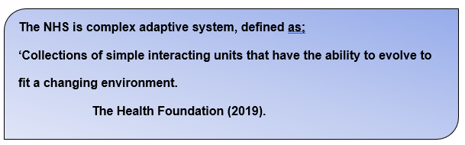
Whilst the above definition appears to simplify how WAST could evolve, the complexity is in how external factors impact the wider health and social care economy, all six elements of a PESTLE Analysis inter-relate to some extent, for example staff vacancies.
Recruitment and retention is impacting on safe staffing levels and future workforce needs already exceeding the current capacity to employ with vacancies currently at an all-time high (NHS, 2022; Deakin, 2022), based on workforce demand in the previous decade, the NHS workforce is required to double, with social care sector staffing requirements four times more than the previous decade (Rocks et al, 2021).
Employee turnover impacts on the organisation in many ways with turnover in health and social care experiencing significant shortages (CIPD, 2021; NHS, 2022; Deakin, 2022).
This is further supported by HEIW reporting an annual increase of just 90 staff (0.3%) across nursing and midwifery yet an overall increase across all grades as 2.8%, of which 4.7% are in the administration and estates groups. Recruitment into key patient facing roles are challenging and set to worsen due to the pay dispute and impending industrial action ( Department of Health and Social Care Media Centre, 2022).
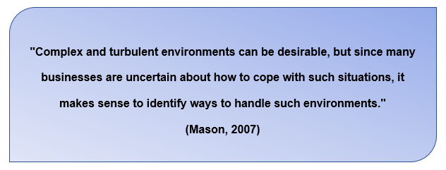
Mason (2002) cited above captures complexity and VUCA, Cheese (2021) posits that the era of societal change has been further affected by the pandemic, adding that socio-cultural changes and changes in societies beliefs, expectations and affiliations adds a possible loss of trust in establishments, this will affect employer brand and recruitment into high skill roles. A company’s failure to act in a socially responsible way will most probably entail significant costs and a financial burden which is bound to cause efficiency issues (Forbes, 2015).
The economic crisis further impacts how staff can be recruited into key roles in the NHS, this autumn budget announcement tackles the economic crisis and how to create sustainable growth (The King’s Fund, 2022a).

3.0 Economy – Global Crisis of Economic Scale

According to the latest figures, cost of living is the most important issue facing 93% of adults the UK today (Office for National Statistics, 2022). The Kings Fund (2016) reported a 10% loss in real terms for NHS staff, with the current economic forecast and cost of living the gap of earnings to costs continue to widen (Cheese,
2021).

3.1 Globalisation - Economic Crisis

According to Tan (2010), globalisation was one of the major enabling factors of the global economic crisis of 2010. Fang et al. (2022) argue that in today’s climate of uncertainty, globalisation negatively affects labour market flexibility, further affected by Covid19.
Public finances in 2010 were managed by focusing on protecting day to day costs of running the NHS, ringfencing budgets within the Department of Health and Social Care in the face of cuts to other services, not recognising the year on year increase in demand line with NHS growth (The Kings Fund, 2022b).
As discussed in section 2.3 above the NHS is part of an ecosystem with public health that depends on a complexity of services. WAST is part of this complex system and the impact the global economy has on central funding; labour costs and current efficiency drives must be a key focus in strategic planning and how our services are commissioned (The Kings Fund, 2022b). This is vital in order for sustainability through current austerity on the back of patient waiting times, access to care targets not being met, underfunding of social care affecting on how people access our services and how delays in transfer of care impact on day-to-day service delivery (The Kings Fund, 2022c) . PP will need to adopt the ‘pathfinder’ approach to address challenges by finding new and innovative ways to manage business complexity by exploring new opportunities such as emergent disruptive technologies (Liu et al 2020; Balasundaram, 2020).

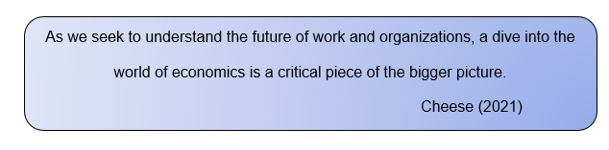
3.2 Economic Growth and Employment

IES (2022) report a stall in economic growth, this inactivity has risen with employment levels as a result of record levels of vacancies, fall in unemployment and the tightest labour market for 50 years. WAST is in a challenged position with regards to recruitment and retention, the current vacancies for key roles hold gaps in workforce planning (WAST IMTP 2022-2025). The external impacts of rising cost of living discussed below, the great resignation (CIPD, 2022) and flexible working are all external impacts out of our control yet something within the circle of influence (Covey & Collins (2020). One way to increase recruitment and retention is our Employee Value Proposition (EVP) in order to win the ‘talent war’ we find ourselves in (Howlett, 2022).

3.3 Leaving the EU behind – Leaving Recruitment Challenged

Taylor & Perkins (2021) argue that the UK economy has heavily relied on inward migration of skills including health and social care, though this trajectory is questionable in the long-term. They add that it is possible that outward migration, cost of living and spiralling labour costs will make it more expensive to hire from overseas, partly due to UK leaving the EU and the end of free movement.
Fahy et al (2021) disagree by expecting a relatively minor effect for cross bordering with the exception of Northern Ireland.
As we face a further recession, workforce costs require further focus to ensure WAST has the skills needed to encompass new ways of working and agility, with an organisational image that will place WAST in a global talent economy in attracting and recruiting talented people locally and internationally (Younis and Hammad 2021).
The loss of the European Regional Development Fund (ERDF) money impacts funding to public and private bodies in all EU regions originally aimed to reduce economic, social and territorial disparities (European Regional Development Fund (ERDF), 2021).
A further impact is the focus of Covid19, the government continues to face challenges in its response to the pandemic and its fallout whilst negotiating future relationships with the EU, with likely major negative impacts for NHS and Social Care funding and capital financing (Fahy et al., 2021).

3.4 Balancing the books – Efficiency and Efficacy
The Health and Social Care (Quality and Engagement) (Wales) Act (2020), comes into force in 2023 further governing the NHS and a duty of the Welsh Ministers’ duty to secure quality in health services. As the cost of funding the NHS continues to increase, external impacts such as technology, which is discussed in section 4.0, the energy crisis, recruitment challenges and rising inflation all impact on how services are delivered, our people are rewarded and patient safety (The Kings Fund, 2022c).
Efficiencies must be made, there are possibilities of delivering savings but not at the expense of controlling public sector pay, services and safety (WAG, 2022c).
With inflation currently 10.7% (Bank of England, 2022) capital funding in cash terms will not be met by central government therefore the aim to improve NHS estates, equipment and IT will need to be cut back, a further impact on digitalising the NHS, changing how services are delivered and where savings need to be made. Any additional funding for the NHS is met by increases in living wage, cost of living, energy price rises and ongoing inflationary pressures (The King’s Fund, 2022c).
These measures further emphasise shifting sands of spending and the inefficient boom-and-bust approach to NHS (The Kings Fund, 2022c) with the focus for Performance, Planning and Finance Directorate to collaborate with PP to consider efficiencies for WAST (WAST, 2022-2025).

4.0 Technology

4.1 The Digital Era- Industry 4.0

The statement above is now referred to as the fourth industrial revolution, or Industry 4.0. (Cheese, 2021). The TOPOL Review (2019) supplied recommendations on how technology is likely to revolutionise the NHS over the next two decades. It offered implications such as skills required for these changes and roles that may be created to learn to live with uncertainty knowing that skills needs are going to change more rapidly, even though we don’t know exactly what the skills needs will be because jobs and roles will change (Cheese, 2021).
Kutieshat & Farmanesh, (2022) further added the impact covid19 has on organisations and workplaces, an area WAST includes within the Digital Transformation Strategy embedded in the IMTP (WAST, 2022).
Technology has had a significant impact on the NHS over the years particularly since the Covid-19 pandemic which has resulted in the rapid use of digital technology which in turn has caused considerable changes in the delivery of services, enabled remote working (Hutchings, 2020). Digitalising the NHS is progressive and further work is needed to explore integrated care services (WAG, 2021d).
An emerging technology is one that will enable neural translation (Dalibor, 2022). This will be a significant cost saving for WAST when communicating with the variety of languages that currently require a costly translation service. This new device will translate the language of the communicator into the language of the other party simultaneously (Taylor & Perkins, 2019), a further tool to enhance diversity and inclusion and communications tools for our diverse population.

4.2 Transforming Healthcare – An Opportunity from a Threat

Prior to the pandemic digital transformation started with a proposed ‘Once for Wales’ digital extensible platform for NHS Wales built on infrastructure implemented incrementally (WAG, 2021d).
This envisaged service improvement and workforce change to allow agile, integrated plans that required WAST to set out capital funding requirements for improvement such as EPCR and Remote Working (WAST, 2018). This was initially explored to include European sources of funding, the exit from the EU impacted on this and delayed how WAST could innovate and digitalise the ambulance service (WAG, 2021a).
Carter (2018) found that Ambulance Services are digital innovators but there are inconsistencies in how these are implemented. The success of auto dispatch technology transformed response times to the most unwell, concluding that further weaknesses found are to be addressed if WAST are to plan for tomorrow’s services today, improving resilience.
Carter (2018) cited in Newton (2020) offered nine recommendations that would offer a saving of £300m a year by 2021 and a further £200m savings from staff productivity and digital infrastructure improvements. The pandemic made what was a threat to become an opportunity by allowing digital transformation that would have taken years (NHS England, 2021) (Cheese, 2021).

4.3 Innovations in Technology
The challenge for PP is how further trends in technology will make a positive impact and at what cost (Garrison et al 2017). Taylor & Perkins (2021) argue that innovations such as artificial intelligence (AI) are likely to bring positive changes to the workplace, robotics can automate some roles and there will be rising demands for greater technology skills in the workforce. There is role for medical drones for use in rural and isolated communities, one author proposes their use within the next five years (Amukele, 2019) which will improve accessibility, delivery of medical equipment and medicines and opportunities for workforce development.
PP must ensure workforce planning include upskilling and talent management of the existing workforce also considering worries of how employees fit into this new world of technology (Cheese, 2021). In challenge to this, there is an argument that new systems may supply opportunities for staff to develop and learn new skills which has actually seen an increase in staff satisfaction as employees are able to focus on less mundane tasks and focus on more fulfilling duties (Howlett, 2019).
Edwards & Edwards (2019) counter argue that there is possible detriment in using AI in People Professions due to the use of algorithms; this big data requires social and emotional intelligence in order to automate it, something AI doesn’t offer, there are also ethical considerations.

4.4 The Future is Artificial
(Deloitte, 2022) propose that the value of Artificial Intelligence (AI) is now indisputable as AI evolves further as ‘cognitive agents’. As more businesses adopt AI technology further improvements include natural language processing, recall of information and understanding of colloquialisms (Deloitte, 2020). As AI continues to innovate workplaces, PP can explore its use for data sets that support decision making on policy, practice and developments though legislation is expected to protect consumers from discrimination such as age ( People Management, 2022). Susskind (2020) talk about the creation of systems that will eliminate many jobs not just data creation but also of healthcare professionals, predicating that ‘living experts’ will find AI able to do major parts of their roles better than they can, something Del Rosal (2019) calls ‘General AI’ and a good match to a human mind, a genuine disruptive technology (Taylor & Perkins, 2019).
Mittal et al (2022) believe AI has multiple benefits for business growth, employees and society, this can be achieved by removing the restraints of how we have managed business before.

5.0 Conclusion and Recommendations - Embracing External Impacts as Opportunities

5.1. Economy

Funding of the NHS, commissioning and staffing need to represent not only the current picture but the emerging horizon of service delivery and resourcing of a skilled workforce. With tighter budgets, increased pressures in services, increasing impact of the pandemic the economic downturn has made it more difficult to recruit skilled and experienced staff.
By realigning our workforce away from roles that can be performed by technology/AI such as intelligent use of algorithm-based access to healthcare (WAG, 2022b), budgets can be shifted to workforce priorities. The risk of not looking at ways where technology can improve how we execute our duty as a public service has been explore by Carter (2018) and Topol (2019 will result in continuing inconsistencies and inefficiencies preventing growth of both the workforce and the opportunities to innovate.
WAST as an emergency service as well as the ‘gateway to care’ (WAG, 2021b) has to submit plans to WAG that has a three-year forward view, building on the minimum requirements of an Annual Plan as set out by Welsh Government. However, we need to be aware that this forward work programme will be heavily shaped by ongoing discussions, and further consideration of our developing service ambition and offer before a budget can be explored (WAST, 2022).
5.2 Socio-Cultural

As WAST integrate with Regional Partnership Boards (RPB) (WAST IMTP, 2022) the ability both to hold their own budgets and employ staff will mean it will be even more important that WAST continues to have a voice at RPB tables across Wales and a Strategic Workforce Agenda. thus, opening the labour market to specialties not considered core services for an emergency service. This diversity and inclusion open more pooling of talent, positive Employer Branding with more pull in a tight labour market. In order to remain employable, and particularly to access higher-paying jobs, people are going to have to develop new skills. There will be higher demand for people who are technically specialised and lower demand for people to fill roles that can be substituted by machines.

5.3 Technology

By building on recommendations of Carter (2018) and Topol (2019) with innovations in technology –Once for Wales will allow an extensible platform for records, transfer of care and digital records, these Digital platforms for access would create opportunities to shift funds from areas of high admin reliance to patient facing roles where technology can perform the role with clinical oversight from a boosted workforce form reallocated funds.

5.4 Final Words
These three elements are inextricably linked, the risks are also linked. If funding for new technologies is not secured, innovation will be stalled, and the workforce will not grow resulting in poor recruitment and higher attrition rates and a dissatisfied workforce not equipped to embrace the digital futures on the NHS.

References
- Aguilar (1967) Scanning the Business Environment. New York: Macmillan.

- Aldehayyat, J.S. (2015) Environmental scanning in business organisations: Empirical evidence from a Middle Eastern country context. Management Research Review, 38(5), pp. 459-481.

- Amukele, T. (2019) ‘Current State of Drones in Healthcare: Challenges and Opportunities’, The Journal of Applied Laboratory Medicine, 4(2), pp. 296–298. Available at: https://doi.org/10.1373/jalm.2019.030106.

- Balasundaram, S. (2020) ‘HR 20/20: Developing future-ready HR Capabilities’, Ushus-Journal of Business Management, 19(4), pp. v–xviii. Available at: https://doi.org/10.12725/ujbm.53.0.

- Bank of England (2022) What is inflation? | Bank of England. (Accessed December 15th, 2022).

- Bhattacharya, M. and Wright, P.M. (2005) ‘Managing human assets in an uncertain world: applying real options theory to HRM’, International journal of human resource management, 16(6), pp. 929–948. Available at: https://doi.org/10.1080/09585190500120574.

- Brunetto, Y., Farr-Wharton, R. and Shacklock, K. (2011) ‘Using the Harvard HRM model to conceptualise the impact of changes to supervision upon HRM outcomes for different types of Australian public sector employees’, International journal of human resource management, 22(3), pp. 553–573. Available at: https://doi.org/10.1080/09585192.2011.543633.

- Carter, L. (2018) Operational productivity and performance in English NHS Ambulance Trusts: Unwarranted variations. Available at; Operational_productivity_and_performance_NHS_Ambulance_Trusts_final.pdf (england.nhs.uk). (Accessed December 8th, 2022).

- Cibenko, T., Dunlop, A. & Kunkel, N. (2020). Human Experience Platforms; Affective Computing Changes the Rules of Engagement. Available at; Human experience platforms | Deloitte Insights
(Accessed December 2nd, 2022).

- Cheese, P. (2021) The New World of Work: Shaping A Future That Helps People, Organisations and Our Societies to Thrive. Great Britain and the United States: Kogan Page Limited.

- Child, J. and Rodrigues, S.B. (2011) ‘How Organizations Engage with External Complexity: A Political Action Perspective’, Organization Studies, 32(6), pp. 803–824. Available at: https://doi.org/10.1177/0170840611410825.

- Chidiac, A, M. (2018) Relational Organisational Gestalt: An Emergent Approach to Organisational Development. Routledge. London.

- CIPD. (2021a) PESTLE Analysis. Factsheet. London: Chartered Institute of Personnel and Development. Available at; https://www.cipd.co.uk/knowledge/strategy/organisational-development/pestle-analysis-factsheet#grefttps://www.cipd.co.uk/knowledge/strategy/organisational-development/pestle-analysis-factsheet#gref.
Accessed December 2nd, 2022
.
- CIPD (2021b) SWOT Analysis. London: Chartered Institute of Personnel and Development. London. Available at; https://www.cipd.co.uk/knowledge/strategy/organisational-development/swot-analysis-factsheet
Accessed December 2nd, 2022.

- CIPD (2022c) Flexible Working Practices. London: Chartered Institute of Personnel and Development. Available at.
Flexible Working Practices | Factsheets | CIPD Accessed December 14th, 2022).

- CIPD (2021d) People Profession 2021: UK and Ireland survey report [online]. Report. Chartered Institute of Personnel and Development. London:
Available at: https://www.cipd.co.uk/knowledge/ strategy/hr/people-profession-survey#_ga=2.187108392.1268387770.1640195374- 243412346.1623762165

- CIPD (2021e) The Great Resignation: fact or Fiction. Chartered Institute of Personnel and Development. London: Available at: https://www.cipd.co.uk/news-views/cipd-voice/Issue-33/great-resignation-fact-fiction (Accessed: 7 December 2022).

- CIPD (2022f) Line managers Role in Supporting the People Profession. London: Chartered Institute of Personnel and Development.
Available at.
https://www.cipd.co.uk/knowledge/fundamentals/people/hr/line-managers-factsheet
(Accessed December 7th, 2022).

- CIPD (2022g) Workforce Planning. London: Chartered Institute of Personnel and Development. Available at; Workforce Planning | Factsheets | CIPD
(Accessed December 14th, 2022).

- Covey, S.R. and Collins, J. (2020) The 7 Habits of Highly Effective People: Powerful Lessons in Personal Change. New York: Simon & Schuster.

- Dalibor (2022) Translation Technology: A Look at Its Past, Present, and Future, Phrase. Available at: https://phrase.com/blog/posts/translation-technology/ (Accessed: 8 December 2022).

- Dans, E. (2015) Volkswagen and The Failure of Corporate Social Responsibility. Available at.
Volkswagen And the Failure of Corporate Social Responsibility (forbes.com)
(Accessed December 8th, 2022).

- Deakin, M. (2022) NHS workforce shortages and staff burnout are taking a toll. British Medical Journal, 377, 945. Available at; https://doi.org/10.1136/bmj.o945

- Deloitte (2022a) Tech Trends 2023. Deloitte Insights. Available at: https://www2.deloitte.com/us/en/insights/focus/tech-trends.html (Accessed: 8th December 2022).

- Deloitte (2022b) Thriving in the Era of Pervasive AI. Deloitte Insights. Available at; DI_State-of-AI.pdf (deloitte.com). (Accessed December 8th, 2022).

- Del Rosal, V (2015) Disruption: Emerging technologies and the future of work, Emtechub, Dublin.

- Department of Health and Social Care Media Centre (2022). NHS Nurses’ Industrial Action - Media Fact Sheet. Available at: https://healthmedia.blog.gov.uk/2022/11/09/nhs-industrial-action-media-fact-sheet/ (Accessed: 2 December 2022).

- Dicken, P. (2007) Global Shift: Mapping the Changing Contours of The World Economy. 5th Edition. London: Sage

- Edwards, M R and Edwards, K (2019) Predictive HR Analytics, 2nd Edition, Kogan Page, London.

- European Regional Development Fund (ERDF) (2021) European Commission - European Commission. Available at: https://ec.europa.eu/info/funding-tenders/find-funding/eu-funding-programmes/european-regional-development-fund-erdf_en (Accessed: 7 December 2022).

- Fahy, N. et al. (2021) ‘Assessing the potential impact on health of the UK’s future relationship agreement with the EU: analysis of the negotiating positions’, Health Economics, Policy and Law, 16(3), pp. 290–307. Available at: https://doi.org/10.1017/S1744133120000171.

- Fang, J., Gozgor, G. and Nolt, J.H. (2022) ‘Globalisation, economic uncertainty and labour market regulations: Implications for the COVID-19 crisis’, The World Economy, 45(7), pp. 2165–2187. Available at: https://doi.org/10.1111/twec.13230.

- Garrison LP, Kamal-Bahl S and Towse A (2017). ‘Toward a broader concept of value: identifying and defining elements for an expanded cost-effectiveness analysis’. Value in Health vol 20 no 2, pp 213–216. Available at; https://doi-org.ezproxy.uwtsd.ac.uk/10.1016/j.jval.2016.12.005.

- Gimpelson, V. and Treisman, D. (2015) ‘Misperceiving Inequality’. National Bureau of Economic Research (Working Paper Series). Available at: https://doi.org/10.3386/w21174.

- Health and Social Care (Quality and Engagement) (Wales) Act 2020 (no date). Queen’s Printer of Acts of Parliament. Available at: https://www.legislation.gov.uk/asc/2020/1/enacted. (Accessed: 7 December 2022).

- Howlett, E. (2020) The New Face of Leadership Development. People Management. Available at:
https://www.peoplemanagement.co.uk/article/1744352/new-face-leadership-development
(Accessed December 6th, 2022).

- Howlett, E. (2022) Could A Four-Day Week Make People Happier Than a Pay Rise? People Management. Available at; Could a four-day week make people happier than a pay rise? (peoplemanagement.co.uk)

- Hutchings, R. (2020) ‘The impact of Covid-19 on the use of digital technology in the NHS’, p. 23.

- Human Resource Management International Digest (2018), "Flexible working and the family: Factors affecting family-friendly work perceptions", Human Resource Management International Digest, Vol. 26 No. 1, pp. 31-33. https://doi.org/10.1108/HRMID-12-2017-0177

- Institute for Employment Studies (2022) Labour Market Statistics, November 2022. Available at; Labour Market Statistics, November 2022 | Institute for Employment Studies (IES) (employment-studies.co.uk). (Accessed December 6th, 2022).

- Janković, M., Mihajlović, M. and Cvetković, T. (2016) ‘Influence of external factors on business of companies in Serbia’, Ekonomika, 62(4), pp. 31–38. Available at: https://doi.org/10.5937/ekonomika1604031J.

- Johnson, L. et al. (2019) ‘Socio-demographic patterns in hospital admissions and accident and emergency attendances among young people using linkage to NHS Hospital Episode Statistics: results from the Avon Longitudinal Study of Parents and Children’, BMC health services research, 19(1), pp. 134–13. Available at: https://doi.org/10.1186/s12913-019-3922-7
- Karami, A. (2012), "Chapter 8 An Investigation on Environmental Scanning and Growth Strategy in High-Tech Small and Medium-Sized Enterprises", Groen, A.Oakey, R., Van Der Sijde, P. and Cook, G. (Ed.) New Technology-Based Firms in the New Millennium (New Technology Based Firms in the New Millennium, Vol. 9), Emerald Group Publishing Limited, Bingley, pp. 99-108. https://doi.org/10.1108/S1876-0228(2012)0000009010

- Kutieshat, R. and Farmanesh, P. (2022) ‘The Impact of New Human Resource Management Practices on Innovation Performance during the COVID 19 Crisis: A New Perception on Enhancing the Educational Sector’, Sustainability, 14(5), p. 2872. Available at: https://doi.org/10.3390/su14052872.
- Liu, W. et al. (2020) ‘Perspectives on disruptive technology and innovation: Exploring conflicts, characteristics in emerging economies’, The International journal of conflict management, 31(3), pp. 313–331. Available at: https://doi.org/10.1108/IJCMA-09-2019-0172.

- Mason, R.B. (2007) ‘The external environment’s effect on management and strategy: A complexity theory approach’, Management decision, 45(1), pp. 10–28. Available at: https://doi.org/10.1108/00251740710718935.

- Mayne, M (2022) Flexible working bill: what do employers need to know? Available at: https://www.peoplemanagement.co.uk/article/1807194?utm_source=website&utm_medium=social. (Accessed: 7 December 2022).

- Mercer. (2015). Inside Employees Minds. Webinar. https://www.mercer.com/content/dam/mercer/attachments/global/webcasts/new-research-reveals-surprising-views-on-careers-mercer.pdf (Accessed: 7 December 2022).

- Mittal,N., Saif, I. & Ammanath, B., Becoming an AI-fuelled organization: State of AI in the enterprise, 5th edition, Deloitte Insights. Available at; us-ai-institute-state-of-ai-fifth-edition.pdf (deloitte.com). (Accessed December 6th, 2022).

- Newton, A. (2021), "Lord Carter's report into NHS ambulance service efficiency; will its findings make a difference and stimulate the service to escape “the mediocrity trap?”", International Journal of Emergency Services, 10, (1), pp. 77-92. Available at; https://doi.org/10.1108/IJES-08-2019-0045.

- Nelson, D.M. et al. (2017) ‘Family-friendly work perceptions: a cross country analysis’, Gender in Management, 32(4), pp. 300–316. Available at: https://doi.org/10.1108/GM-03-2016-0066.

- NHS England Transformation Directorate (2021) What Good Looks Like Framework. Available at; Home - NHS Transformation Directorate (england.nhs.uk)
(Accessed December 8th, 2022).

- NHS Vacancy Statistics England April 2015 – September 2022 (2022) Experimental Statistics, NHS Digital. Available at: https://digital.nhs.uk/data-and-information/publications/statistical/nhs-vacancies-survey/april-2015---september-2022-experimental-statistics (Accessed: 2 December 2022).

- Office of National Statistics (2022) UK economy latest. A roundup of the latest data and trends on the economy, business and jobs. Available at.
https://www.ons.gov.uk/economy/economicoutputandproductivity/output/articles/ukeconomylatest/2021-01-25
(Accessed: 7 December 2022).

- Palazzani, L (2022) ‘The future of work in the era of emerging technologies’ Pensamiento (Madrid), 78(298 S. Esp), pp. 777–784. Available at: https://doi.org/10.14422/pen.v78.i298.y2022.026.

- Pan, L., Biru, A. and Lettu, S. (2021) ‘Energy poverty and public health: Global evidence’, Energy Economics, 101, p. 105423. Available at: https://doi.org/10.1016/j.eneco.2021.105423.
- People Management (2022) The latest age discrimination tribunal cases. Available at: https://www.peoplemanagement.co.uk/article/1807184?utm_source=website&utm_medium=social (Accessed: 8 December 2022).

- Rocks, S., Shembavnekar, N., Boccherini, G. (2021) How much does the NHS and social care workforce need to grow by over the next decade to meet demand? The Health Foundation. REAL Centre. Available at:
https://www.health.org.uk/news-and-comment/charts-and-infographics/how-much-does-the-nhs-and-social-care-workforce-need-to-grow.
(Accessed December 10th, 2022).

- Susskind, D (2020) A World Without Work: Technology, Automation and How We Should Respond. Penguin House. London.

- Tan, C. (2010) ‘Stephen Roach, Stephen Roach on the Next Asia: Opportunities and Challenges for a New Globalization’, Business Economics, 45(4), pp. 296–297. Available at: https://doi.org/10.1057/be.2010.27.

- Taylor, S. (2019) Resourcing and Talent Management. 7th Ed. Logan Page.

- Taylor, S. & Perkins, G. (2021) Work and Employment in a Changing Business Environment. London, United Kingdom; Kogan Page.

- The Health Foundation (2019) Complex Adaptive Systems. Available at; Complex adaptive systems - The Health Foundation. (Accessed December 2nd, 2022).

- The King’s Fund (2016) Deficits in the NHS 2016. Available at.
Deficits in the NHS 2016 | The King's Fund (kingsfund.org.uk)
(Accessed December 2nd, 2022).

- The King’s Fund. (2022a) The King’s Fund responds to the Autumn Statement. Available at: https://www.kingsfund.org.uk/press/press-releases/kings-fund-responds-government-autumn-statement. (Accessed: 7th December 2022).

- The King’s Fund (2022b). The Pritchard challenge: the next NHS efficiency drive. Available at: https://www.kingsfund.org.uk/blog/2022/11/pritchard-challenge-next-nhs-efficiency-drive (Accessed: 3 December 2022).

- The King’s Fund (2022c). Austerity 2.0: why it’s critical for our health that the government learns the lessons of Austerity 1.0. Available at: https://www.kingsfund.org.uk/blog/2022/11/critical-for-health-government-learns-lessons-austerity (Accessed: 7 December 2022).

Available at; Six goals for urgent and emergency care: policy handbook for 2021 to 2026 | GOV.WALES (Accessed December 10th, 2022).
- Topol, E. (2019). The Topol Review: Preparing the healthcare workforce to deliver the digital future. An independent report on behalf of the Secretary of State for Health and Social Care. Available at:
https://topol.hee.nhs.uk/wp-content/uploads/HEETopol-Review-2019.pdf .
(Accessed December 12th, 2022).

- Welsh Assembly Government (2021a) ‘Regional Investment in Wales After Brexit’, p. 28. Available at; Regional investment in Wales after Brexit | GOV.WALES
(Accessed December 10th, 2022).

- Welsh Assembly Government (2021b) Digital strategy for Wales. Available at; Digital strategy for Wales | GOV.WALES (Accessed December 2nd 2022).

- Welsh Assembly Government (2022c) ‘Right care, right place, first time: Six Goals for Urgent and Emergency Care - A policy handbook 2021-2026’, p. 46. Available at; Written Statement: Six goals for urgent and emergency care and expectations for the system (February 2022) | GOV.WALES. (Accessed December 2nd, 2022).

- Welsh Assembly Government (2021d) ‘Informed-Health-And-Care-A-Digital-Health-And-Social-Care-Strategy-For-Wales. Available at: A Digital Health and Social Care Informed Heath and Care; A Digital Health and Social Care Strategy for Wales (gov.wales) (Accessed: 8 December 2022).

69. Welsh Assembly Government (2022) Percentage Absent by Organisation and Date. Available at: https://statswales.gov.wales/Catalogue/Health-and-Social-Care/NHS-Staff/Sickness-Absence/percentageabsent-by-organisation-date (Accessed: 2 December 2022).

70. Welsh Ambulance Services NHS Trust. (2018) Integrated Medium Term Plan, 2017/17 - 2018/19. Available at: 97d29d3b-0732-4621-92da-cd16461dee89636083383399707427.pdf (wales.nhs.uk). (Accessed December 9th, 2022).

71. Welsh Ambulance Services NHS Trust. (2021) Integrated Medium Term Plan, 2021/22 - 2023/24. Available at: https://www.ambulance.wales.nhs.uk/assets/documents/ee37a642-439f-41a0-8bc2-f873c604a7a5636342424824864700.pdf.
(Accessed December 9th, 2022).

72. Welsh Ambulance Services NHS Trust. (2022) People and Culture Strategy.

73. Waters, A. (2022) NHS Staff Survey Underlines Need for National Workforce Strategy. British Medical Journal. 377:871. https://doi.org/10.1136/bmj.o871

74. Willett, T.D. (2022), "New developments in financial economics", Journal of Financial Economic Policy, Vol. 14 No. 4, pp. 429-467. https://doi.org/10.1108/JFEP-04-2021-0113.

75. Younis, R., & Hammad, R. (2021) ‘Employer image, corporate image and organisational attractiveness: the moderating role of social identity consciousness’, Personnel Review, 50(1), pp.244-263. https://doi.org/10.1108/PR-02-2019-0058.

Norrie, C., Hammond, J., D'Avray, L., Collington, V. and Fook, J. (2012) 'Doing it differently? A review of literature on teaching reflective practice across health and social care professions', Reflective Practice, 13(4), pp. 565–578.

Appendix 1 PESTLE Analysis Welsh Ambulance Service December 2022
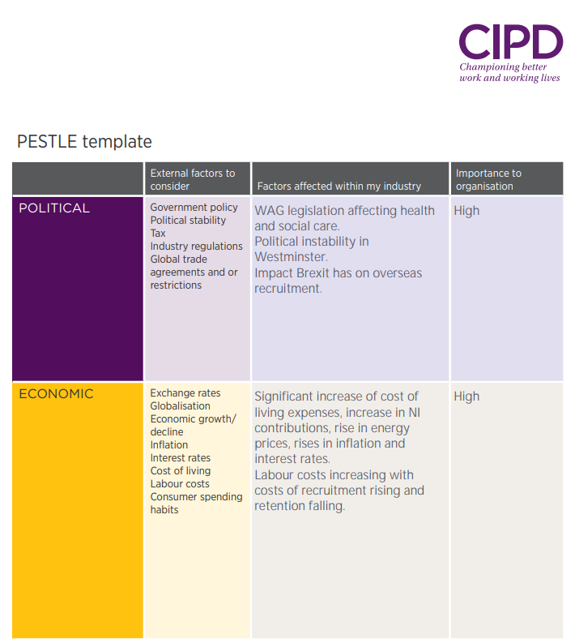
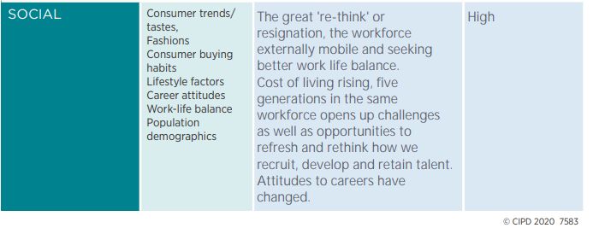
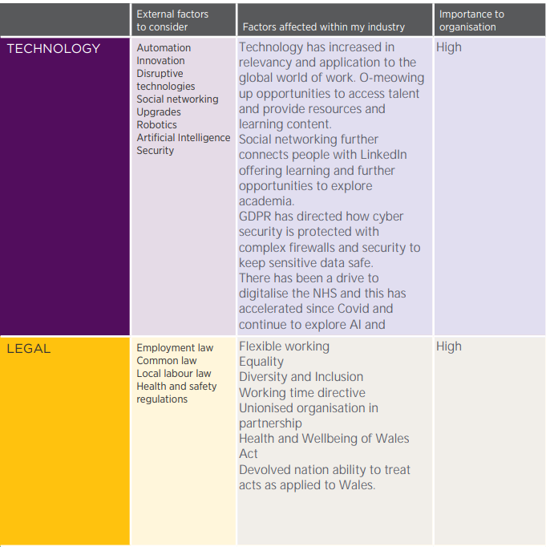
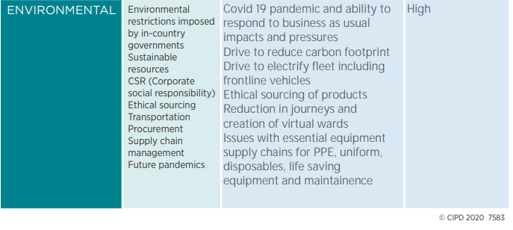

Appendix 2 SWOT Analysis Welsh Ambulance Service December 2022

