

Student Name: Kamal Hussain
Student ID: 2503973

Programme: Master of Business Administration
Module Name: International Marketing: Principles and Practices
Module Code: LCMB7026
Assignment Title: Assessment component 1:
Individual report
Lecturer: Dian Mayasari

Contents
1. Introduction 1
2. Brand and Country Overview: Zara in the United Kingdom and India 2
2.1 Brand History and Overview 2
2.2 Home Country: Spain 2
2.3 Host Countries: United Kingdom and India. 2
2.4 Internationalisation Approach 3
2.5 Rationale of Internationalisation. 3
3. Comparative PESTLE Analysis of the UK and India 3
3.1 Political & Legal Environment 3
3.2 Economic Environment 4
3.3 Social and cultural Environment. 4
3.4 Technological, Environmental Trends. 5
4. Comparison of Brand’s STP Strategies: Zara in the UK and India 6
4.1 Brand Context 6
5. Comparison of Marketing Mix Strategies: Zara in the UK and India 9
5.1 Brand Strategy 9
5.2 Product Strategy 10
5.3 Pricing Strategy 11
5.4 Promotion Strategy 12
5.5 Type of Appeal 12
5.6 Place (Distribution) Strategy. 12
5.7 Individuals, Process, and Physical Evidence. 13
6. Directional Development Strategy of Zara in India 14
6.1 Overview of Zara’s Market Position in India 14
6.2 Market Performance 14
7. Evaluation of Marketing Ethics Practices: Zara 16
7.1 Product and Supply Chain Practices: Ethical Issue 16
8. Recommendations and Conclusion 18
8.1 General Analysis of the Marketing Strategies. 18
8.2 Which Marketing Strategies Are Effective. 18
8.3 What Marketing Strategies are not that Effective? 19
8.4 Strategic Recommendations 19
Section 2 21
Reflective Account (Gibbs’ Reflective Cycle) 21
1. Description 21
2. Feelings 22
3. Evaluation 22
4. Analysis 23
5. Conclusion 23
6. Action Plan 24
References 25

1. Introduction
International marketing can be defined as the practice of marketing principles in a manner that bridges the national boundaries so that the firms can achieve flexibility in strategies based on the cultural, economic, and regulatory conditions. To discuss the implementation of international marketing principles in the United Kingdom and India, the current report is devoted to Zara, one of the major fast-fashion retailers globally. Agile supply chain, responsiveness to the market, and the emphasis on customer-focus product construction make Zara highly successful due to its ability to adjust to the local preferences of consumers very quickly (Kotler et al., 2021). UK is a very mature and highly competitive fashion market with trend-sensitive customers, and India is a fast growing emerging market with cultural diversity and rising disposable income (Czinkota and Ronkainen, 2022).

2. Brand and Country Overview: Zara in the United Kingdom and India

2.1 Brand History and Overview
Zara is a Spanish fast-fashion company that was established in 1975 by a man called Amancio Ortega in Spain. Zara is a core brand of Inditex Group that is one of the biggest fashion conglomerates in the world. It has a famous design-to-retail model, which makes this brand introduce new fashion trends to the stores in a few weeks. The product range in Zara covers clothes, shoes, accessories, and home products, and it primarily deals with fashionable, affordable, and quality products that are offered to men, women, and children (Czinkota and Ronkainen, 2022).
Zara is a rather traditional multinational company but not a born global one. Although it has a large international footprint, its internationalisation was done in stages, expanding first to Europe, followed by Asia, then the Americas and Africa (Hollensen, 2020).

2.2 Home Country: Spain
Zara is a Spanish company and it is its motherland, which offers the base of corporate culture, operational strategies, and design philosophy. Zara has developed its business model based on the focus of the Spanish fashion market on style, quality, and affordability. Zara has its headquarters in Arteixo, Galicia and therefore it makes use of the centralised design and production strengths of Spain to ensure it has a tight hold on the quality and responsiveness to global market trends.

2.3 Host Countries: United Kingdom and India.
The United Kingdom (UK) and India have been selected as host countries in analysing this. UK is a well-developed market, having a highly fashion conscious consumer base, high level of competition and good digital penetration. Zara started in the UK in 1988 by opening its wholly owned stores based on direct investment mode where it can keep its brand constant and control. (Armstrong and Kotler, 2023).
India on the other hand is an emerging market, whose disposable incomes are soaring, and the urbanisation together with the young trendy consumers are increasing. In 2010, Zara ventured into India through a joint venture with Tata Group and merged local market information with that of Zara, operating globally.

2.4 Internationalisation Approach
The internationalisation strategy of Zara partially follows the Uppsala model that focuses on the slow expansion following their market understanding and risk avoidance. The company started with similar countries in Europe in terms of culture and geographical location before expanding to other markets that were far-off and culturally different such as India and the US. The decision-making of Zara regarding expansion purposes is based on the prospects of the market, customer preferences, city-based retail and strategies of growth rather than on the opportunistic nature of decisions (Hollensen, 2020; Kotler et al., 2021).

2.5 Rationale of Internationalisation
The move to enter the UK and India can be seen as a mix of the market opportunity, the potential of revenue growth, and positioning the brand globally. The UK is offering a stable and high-spending market whereas India is offering a long-term growth potential in an underpenetrated market with increasing demand of international fashion. Having presence in those two countries, Zara enhances its brand equity across the world, revenue base diversification, and show flexibility to various cultural, economic, and regulatory conditions.

3. Comparative PESTLE Analysis of the UK and India

3.1 Political & Legal Environment
The United Kingdom operates under a stable parliamentary democracy, and legal institutions that secure intellectual property, consumer and business contract. It has a regulatory structure that promotes a fair competition and implements employment, environmental and data protection laws. (Czinkota and Ronkainen, 2022).
India on the other hand is a complex regulatory environment with a federal republic that is governed by both the central and the state laws. Although the business entry has been facilitated by new reforms like the Goods and Services Tax (GST) and liberalisation of foreign direct investment (FDI) policies, complex procedures and bureaucracy are pronounced. (Hollensen, 2020).
Implication for Zara: The advanced regulatory framework in UK facilitates uniformity of operational activities and India, due to its transitional nature of the law, might need to focus on localised compliance plans and an effective government relations efforts especially in labour and retail regulation activities.

3.2 Economic Environment
GDP, Income Levels and Development
The UK is a high-income and developed economy with one of the highest GDP per capita in the world. Its economy is quite services-driven with the purchasing power and extensive retailing infrastructure. The consumer expenditure on fashion is very strong, but the discretionary expenditure has been dampened by recent inflationary pressures.
India, on the contrary, is a lower-middle-income emerging economy, whose economy has grown very fast over the last few decades. Despite the fact that the GDP per capita is very low in comparison with UK, India has a big population and has a growing middle income, which has a huge market potential. (Kotler et al., 2021).
Trade Agreements & Economic Integration.
The UK is signatory to many trade agreements which have included its post Brexit agreements with the EU and the Commonwealth countries. India has regional trade ties (e.g. SAFTA) and talks some larger deals like RCEP affiliations.
Implication for Zara: The stable and affluent consumer base in the UK would justify premium pricing strategies and standardised global collections, but India has varying levels of income that would require different pricing, local sourcing and different collections of products to fit in the value perception.

3.3 Social and cultural Environment
Dimensions of National Culture.
Applying the Hofstede cultural dimensions gives an understanding in the consumer behaviour difference that can be critical to the marketing strategy:
- Power Distance: India ranks higher than the UK which means the ranking of hierarchies and value on authority. The consumers in the UK are more inclined towards equality and individualism (Hofstede Insights, 2025).
- Individualism vs Collectivism: UK is a very individualistic country, which emphasises personal choice and self-expression, and India balances the goals of the individual with the highly rated community and family values.
- Uncertainty Avoidance: UK has moderate uncertainty avoidance which encourages taking risks and acceptance of innovations; India, though slightly higher, is depicting various market experiences.
- These cultural indicators determine what people buy: a UK buyer can make the purchase based on brand recognition, fashion ability, and personal outfits, and an Indian can make the purchase based on family, cultural suitability of fashion, and cost-effectiveness (Hofstede Insights, 2025).
Language, Norms, and Values
The major language used in business in the UK is English, and also in the urban centres of India, which makes communication in marketing and retailing convenient. The linguistic diversity of India (Hindi, regional languages) however needs multilingual promotion techniques to appeal to segments.
Implication for Zara: Marketing communications and product messaging should be standardised in the main branding but linguistic and cultural differences optimised in India but can be utilised more generally in the UK

3.4 Technological, Environmental Trends
UK exhibits high-level retail technologies, well-developed e-commerce, and the ubiquity of e-payments, which supports the Omni channel strategies. India is experiencing a high rate of digital consumption, specifically mobile internet penetration, but infrastructure gaps and consumption of e-payments vary by regions.
Implication for Zara: Zara can be standardised technologically in its digital platforms but it has to be adapted to user interface, mobile-friendly and logistics strategies in India.

4. Comparison of Brand’s STP Strategies: Zara in the UK and India

4.1 Brand Context
Zara manages an international business through a fast-fashion approach and changes its marketing approach by the market. The United Kingdom is a well-established and high-income fashion market whereas India is an emerging market with a varying range of cultural and income consumers.
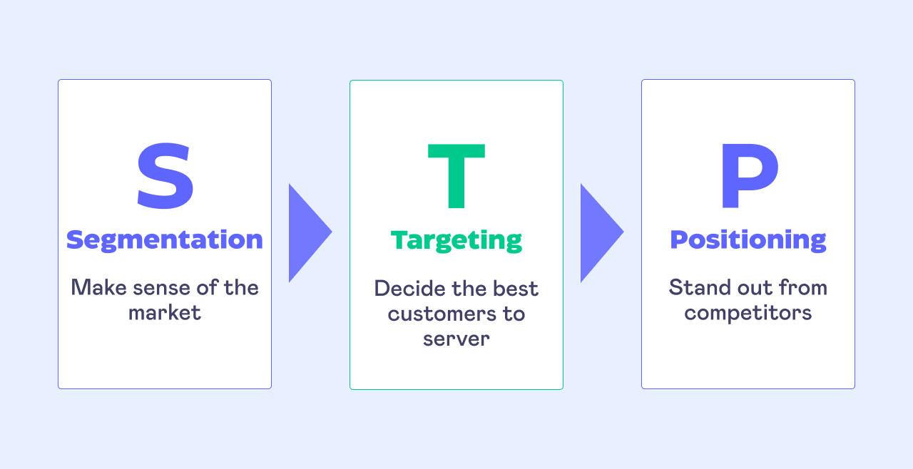
Sources- symson.com
1. Segmentation Strategy
United Kingdom
Zara uses the psychographic and lifestyle based segmentation strategy in the UK. Consumers will be divided on the basis of:
- Demographics: Young adults and professionals (18-45) middle to upper-middle income.
- Psychographics: Style conscious, fashion conscious, brand conscious.
- Behavioural: Frequent customers, high responsiveness to fast fashion behaviour, high online shopping behaviour.
The UK consumers are very individualistic and appreciate self-expression in terms of fashion and therefore lifestyle segmentation would be a good way to market the product.
India
Zara in India employs a multi-layered segmentation strategy, which is a combination of:
- Demographics: City middle and upper-middle classes, the majority aged 18-40.
- Geographic: Tier-1 and Tier-2 cities (e.g. metropolitan areas)
- Psychographic: Aspirational/ global-brand-seeking consumers.
- Behavioural: Occasional shopping (festivals, wedding, social gatherings)
The cultural diversity and income disparity complicate segmentation and make it region specific in India.
Comparison: Zara in UK is more homogeneous and lifestyle in its segmentation as compared to India, which is more fragmented and geographically and income based.
2. Target Market Strategy
United Kingdom
Zara targets:
- Fashion-conscious individuals
- Buyers of fashionable styles at affordable rates.
- Omni channel shoppers that are digitally active.
The target market in the UK appreciates the benefits of speed, variety and accuracy of the trend, which is a strong fit with Zara fast-fashion offer.
India
Zara targets:
- For upwardly mobile and urban middle and upper-middle-class consumers.
- Young people who are aspirational and are exposed to the fashion trends of the world.
- Customers who are ready to spend more money than the local brands.
Zara is an international brand that has positioned itself as semi-premium in India, and not a mass-market retailer.
Comparison: The age distribution is also comparable in the two markets with the age, however, in the UK, Zara is in a wider mainstream segment, and in India, a smaller, wealthier niche segment.
3. Positioning Strategy
United Kingdom Positioning
Zara is positioned as:
- A trendy, fast-fashion brand
- Providing runway-based designs at low prices.
- Competitors include H&M, Mango and Uniqlo.
Positioning emphasis:
- Speed to market
- Style variety
- Value for money
- India Positioning
Zara is in position in India as:
- An international, high value fast-fashion brand.
- The icon of modernity and global lifestyle.
- Less competitive, more aspirational.
The major competitors are high-quality foreign and powerful local brands.
Comparison: In the UK, Zara tends to focus on value and competitive positioning, whereas in India, it tends to focus on aspirational and premium positioning, although both countries offer an almost similar line of core products.
4. Perceptual / Positioning Map (Conceptual)
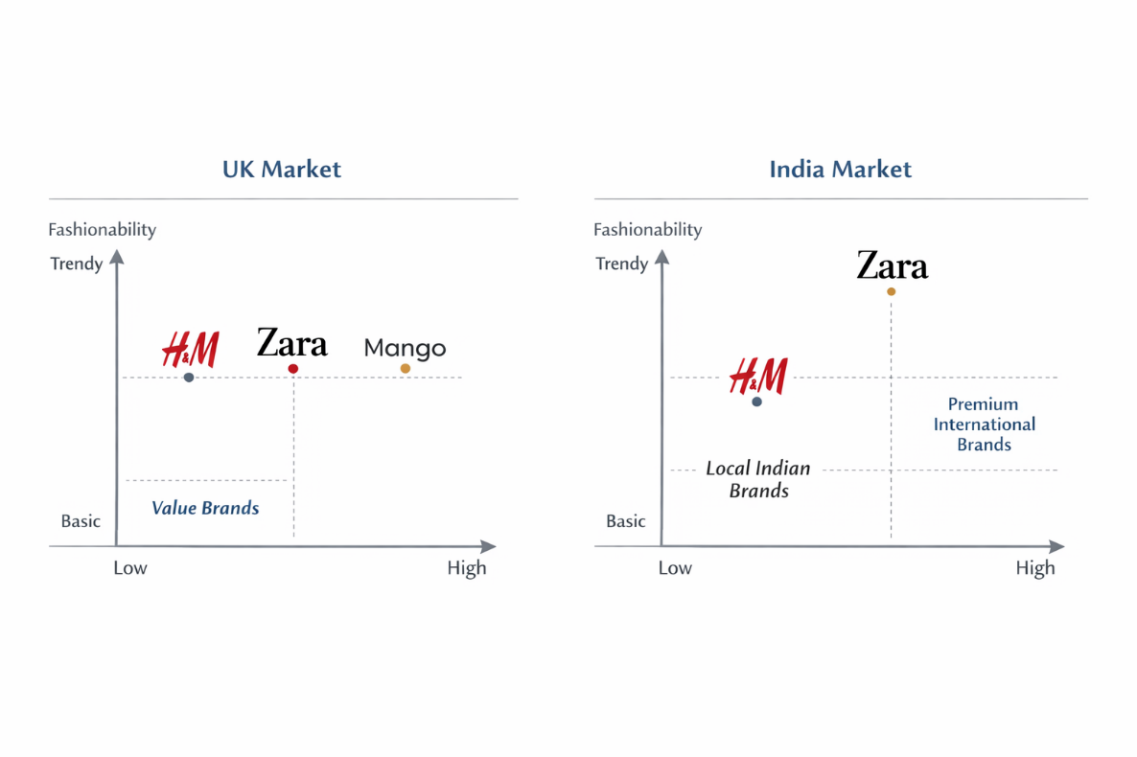

5. Comparison of Marketing Mix Strategies: Zara in the UK and India

5.1 Brand Strategy
Zara adheres to the global brand approach that is based on the fast fashion, responsiveness to trends, and limited branding. The brand has a steady presence in the United Kingdom and India, where the brand identity consists of high-end aesthetic appearance of the shops, minimal advertisement, and product-based communication. But perception of brand is different. In the UK, Zara is considered to be a mid-decorative fast-fashion brand, and in India, it is regarded as a semi-premium international brand that is determined by the local income levels and the competitive environments (Kotler et al., 2021; Hollensen, 2020).
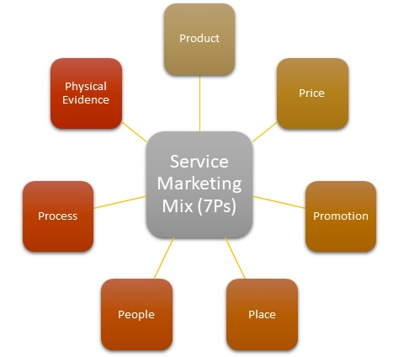
Sources- mbaskool.com

5.2 Product Strategy
Product Dimensions
- Core Product: Trendy and contemporary fashion inspired runway.
- Physical product: Clothes, shoes, and accessories of men, women, and children.
- Value added product: On-line ordering and returns, rapid movement of inventory in the store experience.
These focal dimensions are mostly similar in the two nations.
Product Lines
In both markets, Zara sells comparable products but the product range in India is less and the stock range is selective than in the UK which reflects uncertainty in demand and the cost of supply-chain (Czinkota and Ronkainen, 2022).
Standardisation vs Adaptation
The products tend to be largely standardised, although India adapts partially, including:
- Cuts that are more conservative and are longer.
- Local festivals and climate alignment.
- This is an aspect of culture and climatic variations (Armstrong and Kotler, 2023).

Packaging and Labelling
Packaging Elements
- Aesthetic: Bare, monochrome packaging (standardised)
- Informational: Materials and instructions of care.
- Defensive: The global uniformity of standards.
- Imagery: High-end, luxury, European style.
The packaging is very standardised, which helps in world brand uniformity.
Labelling
The labelling is done in accordance with the international standards but modified in India to contain:
- Local regulatory provisions.
- Maximum retail price (MRP)
- Import and tax information
Therefore, labelling demonstrates practical adaptation and preservation of global brand style.

5.3 Pricing Strategy
Pricing Objectives
- UK: Price competition to optimise market share.
- India: Value grabbing and high end positioning.
Pricing Method
The main pricing strategies at Zara are competition-based prices, which are compared to other brands such as H&M, Mango in the UK, and up-market international brands in India (Kotler et al., 2021).
Adaptation vs Standardisation (Evidence)
The prices in India are greatly inflated with importation fees, cost of logistics and premium pricing. To use the example of a simple Zara shirt that costs a mid-range amount in the UK, it is significantly more expensive in India than similar domestic competitors, which is the signal of price adaptation (Hollensen, 2020).

5.4 Promotion Strategy
- Promotion Objectives
- Build brand awareness
- Drive store traffic
- Enhance fashion leadership.
- Media and Advertising
Zara pursues the low-advertising policy in both nations with the help of:
- Prime store locations
- Window displays
- Social media presence

5.5 Type of Appeal
- UK: Passion and lifestyle advertising about the individuality.
- India: Dreamy and symbolic attractions to fashion status in the world.
Adaptation vs Standardisation.
Style of promotion is changed strategically:
- The UK campaigns lay stress on day-to-day fashion.
- India lays stress on exclusivity and modernity.
- This indicates differences in cultures and socio-economic (Hofstede Insights, 2025).

5.6 Place (Distribution) Strategy.
Channel Intensity
- In both the markets, Zara pursues selective distribution.
Channel Length
- UK: Short channel (company-owned stores + online)
- India: A little longer channel because of joint-venture business and regulatory frameworks.
Intermediary Arrangements
In India, it is conducted in the form of a joint venture with a local company to allow the country to comply with the regulations and possess local knowledge, whereas in the UK it is conducted through wholly owned subsidiaries (Czinkota and Ronkainen, 2022).
Physical Distribution
- UK: Well optimized logistics and quick replenishment.
- India: Lower inventory turnover due to imports dependency.
This denotes adaptation in operations.

5.7 Individuals, Process, and Physical Evidence

People
Front-office employees are trained on a worldwide basis and modified at the local level:
- UK: Concentrate on effectiveness and independence.
- India: Assisted selling is given more importance.
Process
Basic retail operations (inventory turnover, POS) are standardised, service operations however, are made to suit local consumer expectations.
Physical Evidence
Store design, interior design and ambience are very much standardised which strengthens the similar experience in the global brand across the two countries.

6. Directional Development Strategy of Zara in India

6.1 Overview of Zara’s Market Position in India
Zara has become one of the top global fast-fashion brands since it was launched in the Indian market in 2010. Zara worked in a JV with Tata Group and was able to utilize established local knowledge but retain the design independence of the company at the international level. (Czinkota and Ronkainen, 2022).

6.2 Market Performance
Annual Sales and Growth in the Market.
Exact company-specific revenues in India are not released at a regular basis; however, the Indian fashion retail market has been experiencing a very high growth. The total apparel industry in India was estimated at about US 88 billion in 2022 and will grow to US 185 billion in 2030 due to urbanisation, adoption of e-commerce, and increasing incomes (Statista, 2024).
Store Count and Online Presence.
By 2024, Zara could have more than 25 stores in large cities of India, such as Mumbai, Delhi, Bengaluru, Hyderabad, and Pune. The brand also enjoys an increasing e-commerce platform on platforms like Tata CLiQ, Mantra, as well as its own online store, and it reaches out to broader areas than physical locations, facilitating the expansion of Omni channel (Retailers Association of India, 2024).
Brand Knowledge and Customer Response.
Zara is already a highly recognized brand among the urban Indian population, specifically among millennials and Gen Z. The trend-responsiveness, cross-national design, and store atmosphere are frequently mentioned in customer recommendations compared to the domestic markets. The metrics of social media engagement as well as the number of followers of the Instagram profiles of the Zara India show good visibility, with the Instagram profile of Zara India containing millions of followers and high activities of the users on fashion posts and collection releases (Socialbakers, 2025).

Competitive and Cultural Environment.
Zara has to compete with other global fast-fashion retailers, as well as young national competitors, including Lifestyle, Pantaloons, and W Conscious. International brands have the advantage of aspirational positioning, but local competitors are less expensive and have more culturally-oriented assortment, which places Zara at a competitive disadvantage to reduce prices and provide more diversity in lines.
Fit with Strategic Market Dynamics.
The market penetration strategy chosen by Zara in India is a combination of market penetration and market development:
- Market Penetration: The increase of physical presence in the Tier-I and Tier-II cities and the improvement of the usability of the digital platform.
- Market Development: Tapping into new consumer groups via product differentiation in the form of selective pricing and use of direct promotional efforts at the time of festivals and high-end shopping seasons.
Given the directional strategy of Zara to date as seen through the prism of an Ansoff Matrix, the company has focused on intensifying its existing segments (urban fashion consumers) and expanding them to the adjacent ones (e-commerce and smaller formats), which allow it to cover more markets without undermining brand positioning.
Success Evaluation
The overall analysis of the Zara performance in India allows marking that the company is moving in the right direction successfully:
Dimension Evidence
- Annual Sales Growth Part of the fastest growing region performance of Inditex (Inditex, 2023)
- Store Network Development 25 or more stores in big cities (Retailers Assoc. India, 2024)
- Online Presence Collaboration with large online stores (Myntra, Tata CLiQ)
- Brand Awareness Good social media presence, leading positions in city fashion choices (KPMG India, 2023)
- Competitive Position Strong brand equity compared to the local and international competitors.
These signs imply that Zara has adjusted its marketing and operation techniques to the conditions of the Indian market successfully, i.e., balancing between the global brand and customized assortments, prices, and sales experiences.

7. Evaluation of Marketing Ethics Practices: Zara

Marketing ethics can be described as the use of moral principles in marketing decisions in order to be fair, transparent, socially responsible and respectful to the stakeholders. Ethical marketing is becoming a questionable subject in the case of global fashion brands because of the issue of labour, environmental sustainability, honest communication, and consumer well-being.
7.1 Product and Supply Chain Practices: Ethical Issue
Among the most important ethical issues impacting Zara is associated with the regime of fast-fashion, which is the core of the business, focusing on speed and product turnover. Although the model can help consumers to demand fashionable and affordable fashion, it also brings ethical issues of over consumption, generation of wastes, as well as impacting the environment (Hollensen, 2020).
Promotion and Marketing Communication Ethics.
Zara has a low advertising policy and depends on the store design, window displays, and online channel instead of the aggressive promotion message. This helps to avoid the ethical dangers of false advertising. Marketing communication usually does not make exaggerated assertions and significant emphasis on visual narrative and lifestyle imagery, which is regarded as morally acceptable in both markets.

Pricing Ethics
Consumer expectations on pricing are fairly mature in the UK and Zara has set and is largely perceived to have a transparent and competitive pricing policy. In India, the cost of Zara is much higher because of the import tax, the logistics and the high positioning. Although this pricing strategy is economically justified, the ethical issues surrounding this price strategy are of value fairness because similar products are being sold in developed markets at lower prices.
Cultural and Social Ethics
Local culture, norms and values are also sensitive to ethical marketing. By providing comparatively low-priced designs and collections that are within the season, Zara exhibits partial morally adjustment in India. Nevertheless, critics observe that Zara globalised fashion message does not always reflect the cultural identity of the location and this brings out the question of cultural homogenisation.
The Digital Ethics and Consumer Data.
The increase in the use of e-commerce and digital communication in Zara creates ethical concerns regarding privacy of data and consumer consent. In the UK, data protection laws (e.g. GDPR) are very strict, which guarantees high ethical practices in the management of consumer data. More so in India, data protection regulations are in transition, but the ethical aspect dictates that Zara should implement global norms and not provincial minimum standards.
Overall Ethical Evaluation
All in all, Zara has moderate to high levels of ethical marketing, especially in areas of open communication, adherence to regulations, and new sustainability efforts. Nonetheless, there are still some ethical weaknesses in such areas as:
- The environmental effects of fast fashion.
- The perception of potential greenwashing.
- Poor promotional image inclusivity.
- Emerging market cultural sensitivity.
The marketing ethics practices at Zara show that it has a balance between commercial and ethical responsibility.

8. Recommendations and Conclusion

8.1 General Analysis of the Marketing Strategies
According to the overall analysis of Zara in the United Kingdom and India, it can be noted that Zara has been quite successful in applying a hybrid international marketing strategy. The brand is well balanced with regard to international standardisation and localisation especially in the making of decisions on products, prices, promotion, and distribution. Nonetheless, the strategies are effective depending on the market because of the economic, cultural, and competitive differences.

8.2 Which Marketing Strategies Are Effective
1. Good Global Brand Standardisation.
The standardised brand image, in-store design, the packaging image, and fast-fashion value proposition by Zara have worked wonders in both markets. According to the marketing mix analysis, the effect of uniform store layouts, minimal branding and product rotation also supports the high image and brand recall globally. (Kotler et al., 2021).
2. India: adapted STP Strategy.
The adjusted segmentation, targeting, and positioning (STP) strategy in India has been one of the major success factors. Zara can also position itself as an up-market global fashion brand by focusing on its urban, wealthy and aspirational customers. This is consistent with the emerging market model and focus on global brand presence in Indian culture as it is mentioned in the STP and PESTLE section (Hofstede Insights, 2025).
3. Selective Distribution and Omni channel Growth.
The selective distribution approach adopted by Zara, which has been reinforced by increasing integration into the Omni channel, has helped it to build strong market presence. The directional development analysis has emphasized the expanding stores network and online presence of Zara in India, which means that the market has accepted and has a potential to grow. (Czinkota & Ronkainen, 2022).

8.3 What Marketing Strategies are not that Effective?
1. Pricing Strategy in India
Although premium pricing helps aspirational positioning in India, the pricing analysis showed there is a perceived value gap against the local competitors. Zara is also not accessible to a larger middle-class population due to its high price, which reduces market penetration. This is unlike in the UK where the pricing of Zara is perceived to be competitive and value-based (Hollensen, 2020).
2. Poor Cultural Acculturation in Advertisement.
Promotional strategy is somewhat standardised particularly in the visual communication. This restricts cultural resonance in India as was found in the ethics and STP analysis as the body type, fashion standards, culture identity are more varied. This can lower the emotional attachment to domestic consumers even in case of high brand recognition (Armstrong and Kotler, 2023).
3. Sustainability Communication
Despite the sustainability efforts by Zara, the ethics assessment raised issues relating to the perceptions of greenwashing. Sustainability communication does not have transparency of communication and measurability of impact, which can destabilize trust especially in the UK where the issue of awareness of the environment is strong.

8.4 Strategic Recommendations
1. Premier Pricing in India.
- To penetrate India, Zara will have to implement a progressive pricing strategy because:
- Launching small selections of collections locally at reduced prices.
- Maintaining high prices on flagship and seasonal collections.
This would enhance affordability but brand prestige, to enable market expansion without brand dilution.

2. Improve Localised Promotion Content.
To promote itself in India, Zara should engage in more cultural adaptation in marketing, especially in India, by:
- With more varied models and culturally appealing style.
- Matching campaigns to local festivals and social events.
This recommendation directly responds to gaps that are found in both the STP and ethics section and would enhance cultural relevance and inclusiveness.
3. Enhance Sustainability Disclosure.
- Zara ought to improve ethical credibility through:
- Offering more concrete sustainability measures (e.g., material sourcing, lifecycle impact).
- Separating truly sustainable lines of collections and normal fast-fashion lines.
This would deal with ethical issues in Section 9 and match international consumer demands, particularly in the developed market.
4. Speed up the Omni channel Integration.
Based on the directional growth analysis, Zara needs to:
- Extend online-offline interactions.
- Localise inventory and demand forecasting using data analytics.
- This helps in efficiency, customer satisfaction and scalability in the two markets.
To sum up, the international marketing strategy of Zara is characterized by a high level of strategic coherence and flexibility.

Section 2

Reflective Account (Gibbs’ Reflective Cycle)
Reflective practice enables a researcher to critically examine his or her experiences during the research process and give insights on the learning outcomes as well as the areas that require improvement in future. Gibbs Reflective Cycle (1988) offers a systematic methodology consisting of six steps namely: Description, Feeling, Evaluation, Analysis, Conclusion, and the Action Plan.
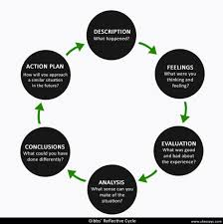
Sources- ukessays.co.uk

1. Description
The research procedure itself started with choosing Zara as the target brand because of its popularity as a fast-fashion multinational corporation and its presence in various markets in the world. The objective was to examine its approaches in two countries when comparing the UK, which is a developed Western market, and India, which is an emerging Asian market. I first aimed to investigate the brand positioning of Zara, marketing mix (4Ps), STP strategies, and ethical practices and compare the macro environmental factors (PESTLE analysis) in the two countries.
The data collection was done through secondary research and use of online sources, which included company reports, industry articles, market research databases, and academic journals. I have concentrated on recent and reliable sources of 2020-25 to make sure that the information is modern and up to date. I used Hofstede Insights to explore cultural dimensions in the two nations as well.
The analysis stage involved the synthesis of information into their structured parts: brand overview, macro environmental comparison, STP and marketing mix strategies, directional development, and marketing ethics evaluation. The focus on each section was to integrate evidence and critical analysis, as opposed to describing it.

2. Feelings
I experienced a feeling of being overwhelmed by the scope of information on Zara and inability to compare two very different markets at the beginning of the project. The first thing that I was not certain about was how to organize the report in order to attract a coherent analysis and at the same time not to omit any of the mandatory sections. The involvement of both developed and emerging markets instilled in me the fear of having a balanced comparison more so that there are differences in the economic, cultural, as well as regulatory environments.
Nonetheless, I felt more confident as I began to gather data in an organized manner and design every section. The division of the research into phases, which included the macro environmental analysis, STP, marketing mix, and directional strategy, helped me cope with the amount of work. Applying the reflective framework by Gibbs was also a way to have a feeling of order and have time to think about the process itself and my feelings toward the challenges.

3. Evaluation
A number of aspects of the research process turned out to be successful. To begin with, the application of recent scholarly journals, market reports, and firm information was credible and reflected on the most recent information. Indicatively, the annual reports and market expansion data of Zara were used to analyse its direction development and marketing performance in India and UK precisely. The PESTLE analysis has helped me to be aware of the economic, political and cultural differences between the two countries, which influenced my judgment of marketing strategy adaptation.
The other achievement was the use of theoretical models which included the cultural dimensions presented by Hofstede and STP framework. These tools enabled me to go beyond descriptive reporting and gave me a critical perspective about why Zara does not follow its marketing strategy in India as it does in the UK.
Nevertheless, there were certain problems. Little publicly available inside-country-specific financial information on India meant that it was not easy to do a complete quantitative comparison of market share and revenue. Likewise, the cultural implications had to be interpreted with great consideration, because the generalizations on the national culture may not be the best predictors of the target consumer groups of Zara. Such limitations pointed to the importance of critical assessment and triangulation of several sources.

4. Analysis
The analytic steps included connecting the theoretical information and the practical data. The PESTLE analysis of the UK as one of the most developed markets, demonstrated that consumer purchasing power and high regulatory requirements Favor the standardised pricing and sustainability policies of Zara, which are supported by the high purchasing power and stringent regulatory policy of the UK. Conversely, the situation in the emerging market of India demands some adaptability when it comes to pricing and promotional material to meet the needs and tastes of a wide range of socio-economic units (Hollensen, 2020).
The STP analysis highlighted that Zara in India is more selective in its segmentation whereby the company targets urban and middle/high income consumers whereas the UK market segmentations target wider market segments as there is a greater overall market stability and familiarity with the brand.(Kotler et al., 2021).

5. Conclusion
When looking back upon the research process, I find that the combination of reflective cycle of Gibbs, theoretical frameworks and systematic data collection allowed the work to be better and deeper in its analysis. Several important learning points were strengthened in this project:
- The significance of the contextualization of marketing strategies to economic, political, and cultural contexts.
- The importance of the triangulation of data sources in order to address the gaps in state-of-the-art information.
- The importance of the connection between the theory and practice, especially the application of such models like STP, PESTLE, and the cultural dimensions of Hofstede.
- The important role of morality in determining the credibility of marketing strategy and consumer trust.
Simultaneously, the difficulties of data availability and interpretation presented the importance of selecting the sources carefully and evaluating them critically.

6. Action Plan
In future research projects, I will apply a number of improvements, basing on this reflective process:
- Preliminary Data Collection and Organization- Begin the collection and organization of data at the initial phase to eliminate time constraints at the last moment.
- Integration of Original Data - Where feasible, carry out surveys or interviews with the consumers to sharpen information especially in new markets.
- Better Cultural Analysis - Segment segmentation in countries to better reflect the diversity in the regions.
- Depth of the Ethical Analysis- Incorporate case studies on corporate social responsibility to enhance critical assessment.
- Time Management - Take more time in doing comparative analysis of markets so that there is some balanced evaluation.
Such strategies would enhance research efficiency and the strength of the analytic insight into future international marketing research.

References
Armstrong, G. and Kotler, P. (2023) Marketing: An Introduction. 15th Edition. Pearson. Available at: https://www.pearson.com
Czinkota, M.R. and Ronkainen, I.A. (2022) International Marketing. 12th Edition. Cengage Learning. Available at: https://www.cengage.com
Hollensen, S. (2020) Global Marketing: A Decision-Oriented Approach. 8th Edition. Pearson. Available at: https://www.pearson.com
Kotler, P., Keller, K.L., Hoon, A.C. and Burton, S. (2021) Marketing Management. 16th Edition. Pearson. Available at: https://www.pearson.com
Inditex (2023) Annual Report 2023. Available at: https://www.inditex.com/investor-relations/annual-reports
Statista (2024) Apparel market revenue in India. Available at: https://www.statista.com/statistics/
Retailers Association of India (2024) Retail Sector Report. Available at: https://rai.net.in
KPMG India (2023) Fashion Retail Consumer Survey 2023. Available at: https://home.kpmg/in
Socialbakers (2025) Social Media Insights for Fashion Brands. Available at: https://www.socialbakers.com
Hofstede Insights (2025) Country Comparison Tool. Available at: https://www.hofstede-insights.com/product/compare-countries
Nielsen India (2022) Apparel Consumer Insights Report. Available at: https://www.nielsen.com/in/en
Fletcher, K. and Tham, M. (2021) Fashion and Sustainability: Design for Change. Laurence King. Available at: https://www.laurenceking.com
Turker, D. and Altuntas, C. (2020) ‘Sustainable Supply Chain Management in Fast Fashion’, Journal of Cleaner Production, 275, 124098. Available at: https://www.sciencedirect.com/science/article/pii/S0959652620321965
Shen, B. (2021) ‘Sustainable Fashion Supply Chain: Issues and Practices’, International Journal of Retail & Distribution Management, 49(10), pp. 1303-1325. Available at: https://www.emerald.com/insight/
Ghemawat, P. (2020) Redefining Global Strategy. Harvard Business Review Press. Available at: https://hbr.org/shop/books
Rugman, A.M. and Collinson, S. (2021) International Business. 8th Edition. Pearson. Available at: https://www.pearson.com
Peng, M.W. (2022) Global Business. 5th Edition. Cengage Learning. Available at: https://www.cengage.com
Cavusgil, S.T. et al. (2021) International Business: The New Realities. 4th Edition. Pearson. Available at: https://www.pearson.com
Solomon, M. (2020) Consumer Behavior: Buying, Having, and Being. 13th Edition. Pearson. Available at: https://www.pearson.com
Jackson, T. and Papadopoulos, N. (2022) ‘Cross-National Consumer Culture’, International Marketing Review, 39(2), pp. 245-269. Available at: https://www.emerald.com/insight/
Kotler, P. et al. (2022) ‘Marketing Strategies in Emerging Markets’, Journal of International Marketing, 30(3), pp. 15-33. Available at: https://journals.sagepub.com/home/jig
Thomas, D. (2021) ‘A New Look at Fast Fashion’, Fashion Theory, 25(5), pp. 599-622. Available at: https://www.tandfonline.com/loi/rfft20
Burt, S. and Sparks, L. (2020) ‘Retailing in the UK: Trends and Strategies’, European Retail Research, 34(1), pp. 1-26. Available at: https://link.springer.com/journal/10663
Chatterjee, P. and Kar, A.K. (2021) ‘E-commerce Adoption in India’, International Journal of Retail & Distribution Management, 49(9), pp. 1205-1227. Available at: https://www.emerald.com/insight/
Low, G. and Mohr, J. (2020) Market Entry Strategies. Routledge. Available at: https://www.routledge.com
Czinkota, M.R. et al. (2023) ‘PESTLE Analysis in International Marketing’, Journal of Strategic Marketing, 31(4), pp. 405-419. Available at: https://www.tandfonline.com/loi/wjsm20
Belk, R. (2021) Consumer Culture Theory. SAGE Publications. Available at: https://us.sagepub.com/
Mintel (2024) UK Fashion Market Report. Available at: https://reports.mintel.com
Deloitte (2023) Global Fashion Retail Outlook. Available at: https://www2.deloitte.com
HSBC (2023) Retail and Consumer Trends Global Report. Available at: https://www.hsbc.com/insights

